
CoderDojo GitHub – Getting Started
Document information
9999
8.1.1+
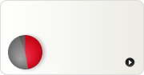
DLHE Returns User Guide
CoderDojo GitHub – Getting Started
How to complete your DHLE statutory returns.
New!
April 2012
Work-in-Progress
1500
Document version | 0.1
Document title | CoderDojo GitHub – Getting Started

Table of contents
1 Creating a local repo 4
1.1 Create a repository 4
1.2 Location on disk 5

Set up

Set up your GitHub account
Go to GitHub (https://github.com/) and set up an account.
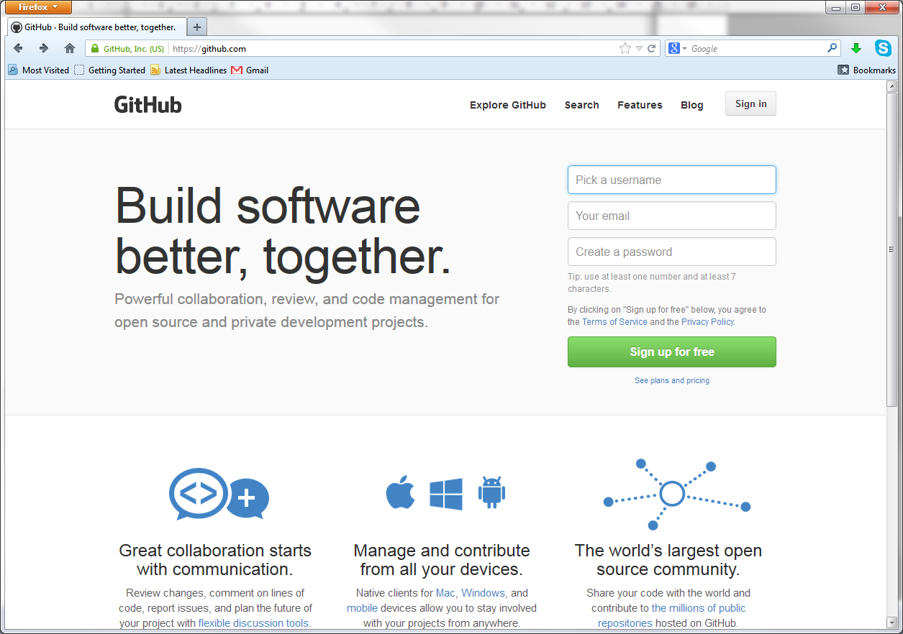

Download the GitHub client
Download GitHub Windows (http://windows.github.com/) or GitHub Mac (http://mac.github.com/). Sadly no Linux version yet.
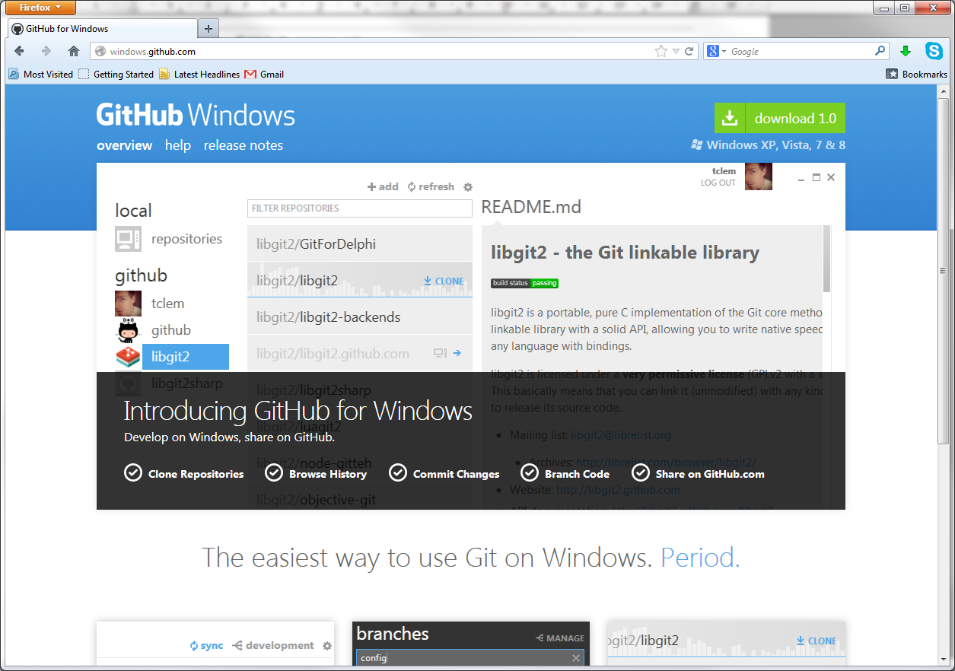
Choose all the default options when you install.

Creating a local repository (repo)

Create a repository
Open the GitHub client Add a local repository by clicking the
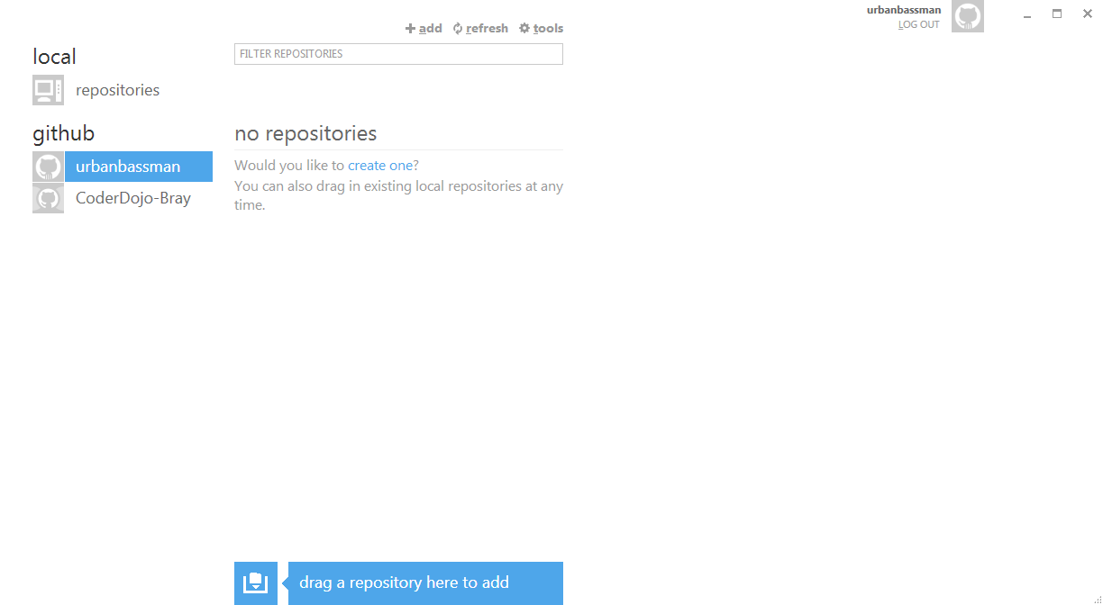
Enter details and click Create.
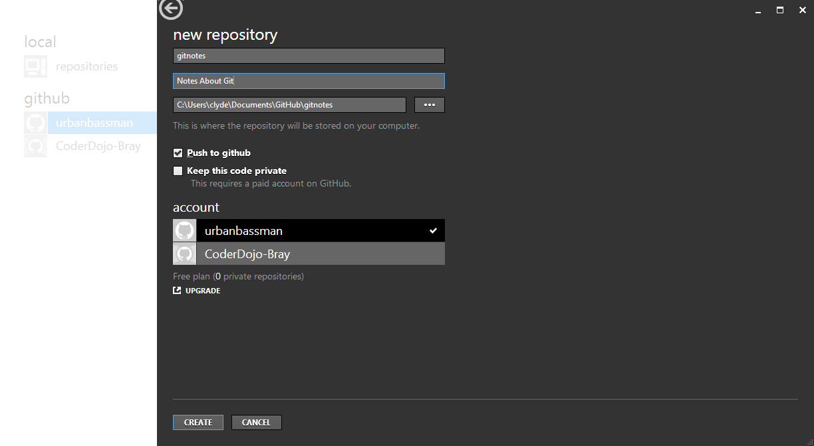
Appears in Github.
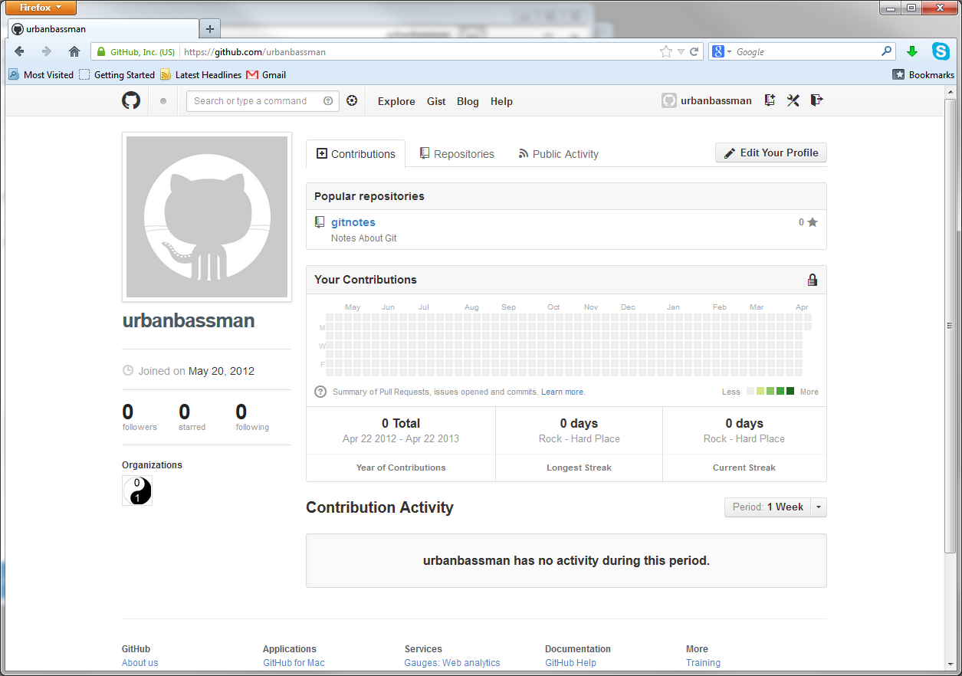

Location on disk
Hover over the repository label.
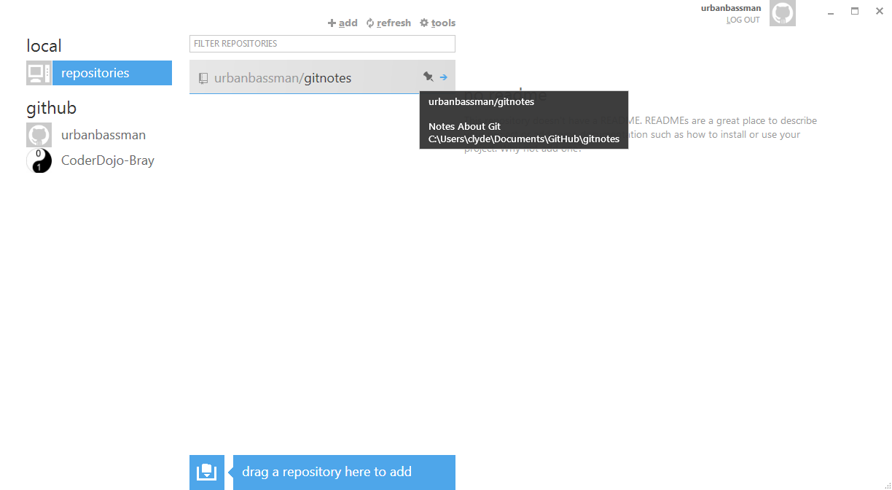
Add a README.md
Just add it to the repository by add it to the folder. (git add README.md)
Then commit it (not the .gitattributes and .gitignore). (git commit -m "First Commit")
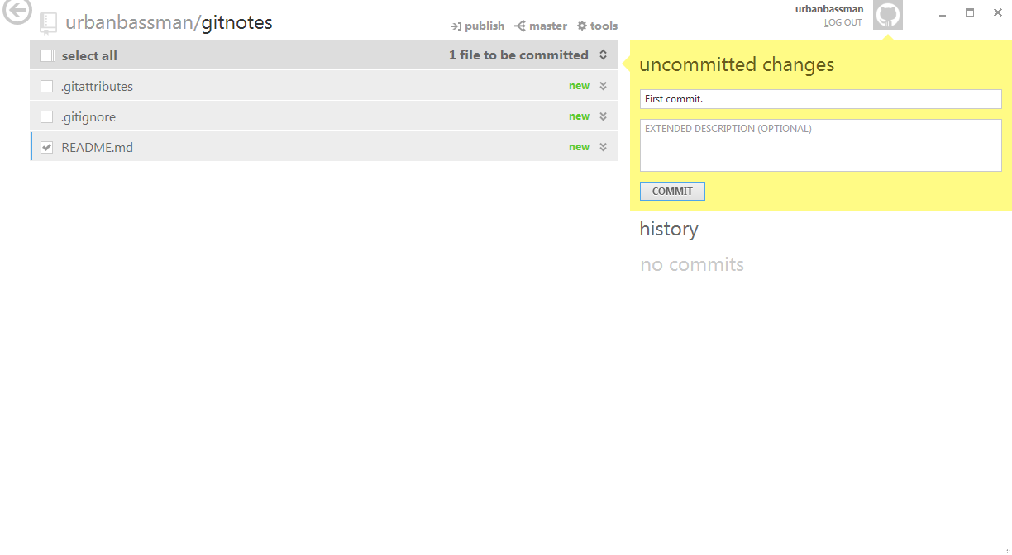
Then publish (this, I think, is git push origin master – although is the local repo the master here???)
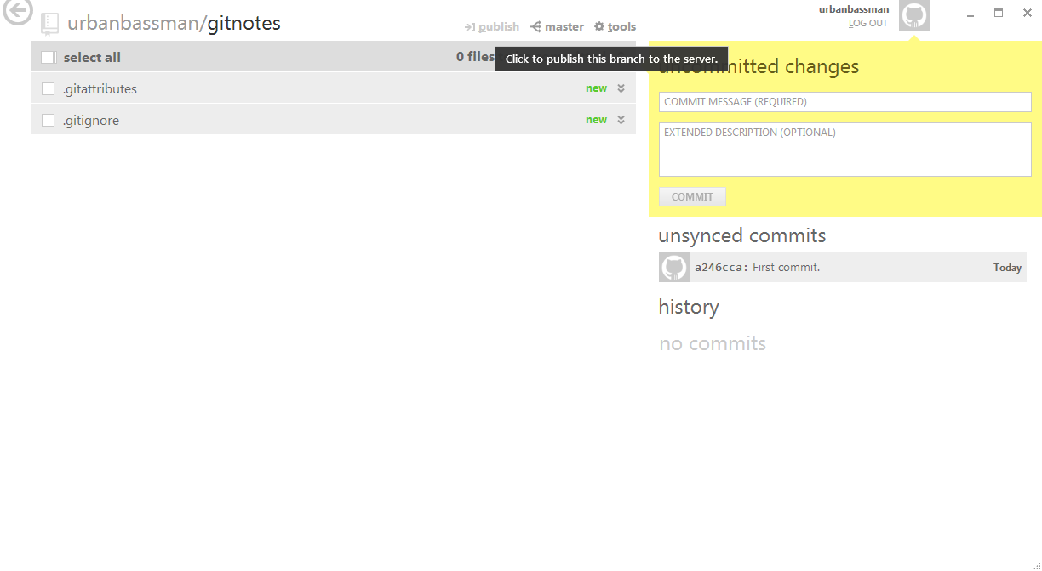
This gives us the following on github.
