Antenna Performance : Angle of Radiation

Angle of Radiation
Most of us think that our antenna’s “shoot” the signal straight off the end (if its a beam), at right angles from the antenna. I have even seen some operators (mainly ones who live in valleys) bend their mast so that their antenna does not sit with the boom parallel to the ground (don’t do it, read on). They hope to shoot the signal up out of the valley. Well, this is not how things work. The angle that the signal comes off the antenna, is mainly controlled by how high the antenna is from the ground. This angle that the signal takes off the antenna is sometimes called the “Angle of Radiation” or “Take-Off Angle”. You can see what I mean by take off angle by looking at figure 1. Most of you probably thought the signal came off at a 0 (Zero) degree angle, right? You would have to have your antenna over 500 feet in the air for this to happen!
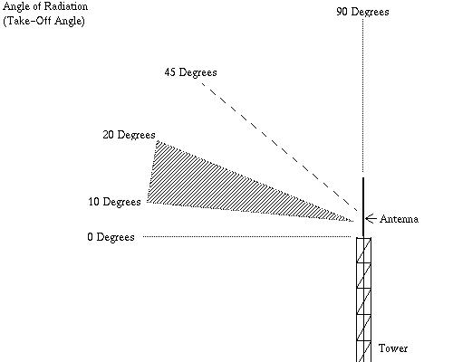
Figure 1 – The angle of radiation. This figure shows a vertical antenna, but the concept is the same for all types of antennas. The shaded area shows the most useful angles (10 – 20 degrees). To get this angle of radiation you will need to have your antenna from about 70 ft – 25 ft, respectively.
Quite simply, the higher then antenna is, the lower the angle of radiation. Why is this angle of radiation important? Simple. Lower angles of radiation are better for two things. One, low angle of radiation is great for long distant groundwave talking. If you concentrate your signal at a lower angle, it travels farther on the ground before it finally bends (the earth actually curves away from the signal) away from the earth. Secondly, a lower angle of radiation strikes the ionosphere (the part of the atmosphere that your signal bounces off when you are talking “skip” (DX)) at a lower angle, and thus is able to “skip” to a DX station with less hops. For every hop a your signal it has to take, the more its strength is reduced. So, if you are trying to talk to very very distant stations (other side of the earth), low angle of radiation is very very important. Figure 2 shows how a low angle of radiation takes a lot less hops to make it to a DX station as opposed to a high angle of radiation (figure 3).
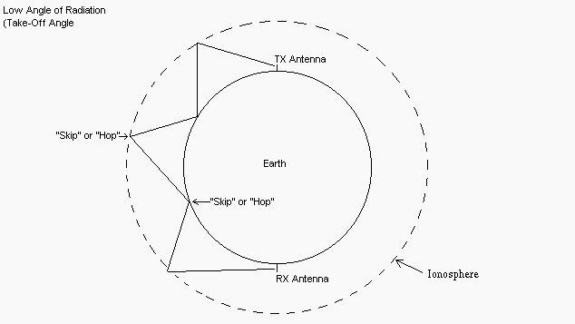
Figure 2 – The low angle hits the ionosphere at an angle that makes it travel further for each hop. Each hop attenuates your signal a great deal. If you didn’t even know it, this is how signals travel large distances. You can see large areas are hopped over by your signal, it does not just travel on the ground. The ionosphere is charged (given the ability to reflect signals) by the sun (sunspots). This is why skip is influenced by the the sun.
However, if you mainly want to communicate with DX stations that are close to you (DX stations that are say 500 – 1000 miles from you) with the strongest signal, your best bet is to have your antennas lower. A higher angle of radiation (caused by have your antennas low) makes a stronger signal for close DX stations. Keep that in mind when your neighbor with his antenna on his roof crushes you with your Moonraker 4 on a 70 foot tower to a DX station a few hundred miles away. Antenna height plays an important role!
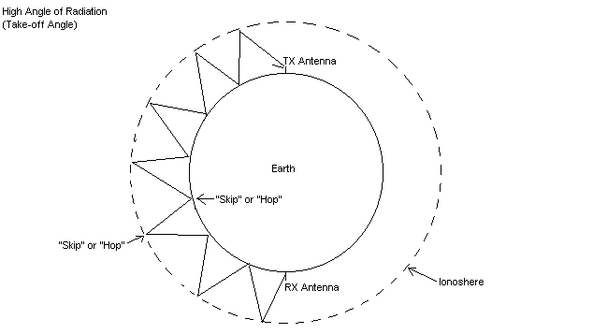
Figure 3 – The high angle travel less distance each hop. You can see, the first hop is much shorter resulting in stronger signals to closer stations (500-1000 miles). Technically, at this high of an angle you signal would be attenuated too much to talk after about 4 hops, so your signal would never make it as far as this figure shows!
When we say that antenna height determines angle of radiation, this is a generalization. This rule holds for all antennas. But, lets say we have a 4 element beam at 40 feet and a 1/2 vertical at 40 feet also. Do these antennas have the same angle of radiation? No, they do not. Actually, vertical antennas have lower angles of radiation than beams when mounted at the same height above ground. Verticals are great DX antennas for this reason (to make your vertical antenna an even better DX antenna read the “Earth Ground” section). Quads have a lower angle of radiation than Yagi’s when mounted at the same height also.
So lets put things in to perspective. What is “high” and what is “low” for 27MHz? Generally for a low angle, you want to get your antenna over 1 Wavelength from the ground (36 feet). Its best to get it up around 60 – 70 feet. If you live on a mountain top, or your home is elevated above the surrounding landscape, you can use the lowest minimum height (36 – 40 feet) because the lower ground around the antenna fools the antenna into thinking its higher and makes a low angle of radiation. Conversely, if you live in a valley where the surrounding landscape is elevated around your antenna, you must go as high as possible (I know that is obvious, but you can’t think if your antenna is 70 foot up in the air you are getting a low angle of radiation – your antenna “knows” its low compared to the surrounding landscape). Now if you wanted a high angle of radiation for strong contacts to close DX stations (500-1000) miles, you can set your antenna about 20 – 36 feet about the ground. Do not go below 18 feet though, because your antenna will start losing its radiation pattern (it will turn into an inefficient antenna).

