Output:

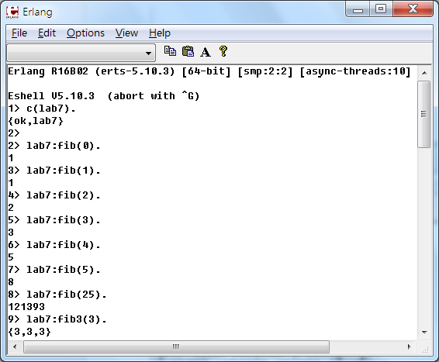

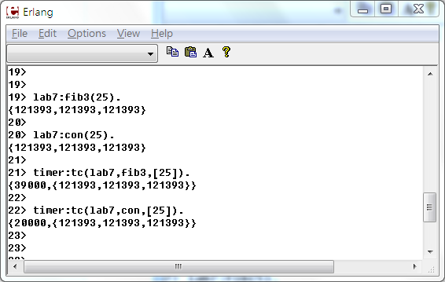

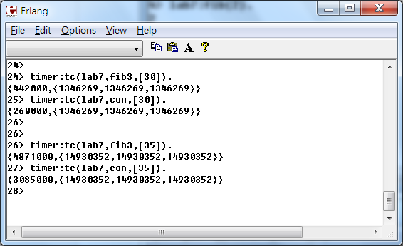

Source code:

-module(lab7).

-export([fib/1,fib3/1,loop/0,con/1]).

% a recursive method computes fibonacci Nth number

fib(0)->1;

fib(1)->1;

fib(N) when N>1 ->fib(N-1)+fib(N-2).

% fib3 returns a tuple contained fib(N) computed 3 times

fib3(N)-> {fib(N),fib(N),fib(N)}.

% loop() is an entry point for a process.

loop()->

receive

{Pid,N}-> Pid!{self(),fib(N)}

end.

% con(N) spawns three processes

con(N) ->

Pid1=spawn(fun loop/0),

Pid2=spawn(fun loop/0),

Pid3=spawn(fun loop/0),

Pid1!{self(),N},

Pid2!{self(),N},

Pid3!{self(),N},

receive

{Pid1,V1} -> V1

end,

receive

{Pid2,V2} -> V2

end,

receive

{Pid3,V3} -> V3

end,

{V1,V2,V3}.