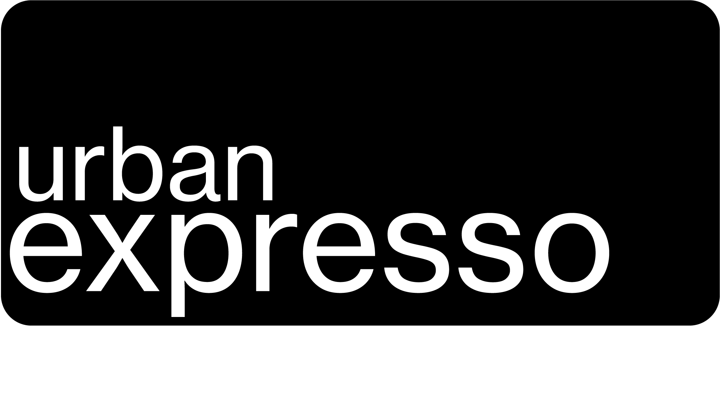**Terms & Conditions**

**Please read the following terms and conditions carefully. If you have any questions or queries, contact us directly by email at** [**urbanexpresso@proton.me**](mailto:urbanexpresso@proton.me)

**General terms and conditions:**Urban Expresso reserves the right to remove content that has already been included in the catalogue if objectionable content is subsequently identified or other violations of criteria are discovered.

**Reclaim of a previously submitted painting by the artist:** As long as the painting is in the catalogue and has not been ordered by a café, it can be reclaimed by the artist at any time. In this case, the painting cannot be ordered any longer by cafés and a collection date will be arranged (presentation of ID and signature of the collection confirmation at UE storage). If a painting has been ordered or is already on display in a café, Urban Expresso will contact the café in order for the painting to be collected as soon as possible by the artist (small fee of CHF 5 to the café; presentation of ID and signing of the collection confirmation on site). After an offer has been accepted by the artist, the painting is officially sold to the café-customer and the artist's right of reclaim expires.

**Exclusion of liability:**Urban Expresso and the participating cafés are not responsible for any damage or theft of the submitted painting. The artist may wish to consider personal insurance to protect the painting in the event of damage or theft.

**Intellectual property (copyright):**The artist retains full copyright to his/her painting(s) under Swiss law. Urban Expresso acknowledges that the submission of the painting does not transfer any intellectual property rights to Urban Expresso. The paintings will only be used for the purpose stated in the agreement (e.g. display in the catalogue and/or in participating cafés). Any further use or reproduction of the painting, whether online, in print or in any other media, requires the express written consent of the artist.

**Data protection:**Urban Expresso is committed to protecting your personal data in accordance with the New Federal Act on Data Protection (nFADP). Personal details provided by the artist will be used solely for the purpose of direct communication with the artist and for facilitating the transfer of money in the event of a sale of the painting. We will not share personal information with third parties unless the artist requests the return of a painting already on display in a café. In such cases, only the initials identifying the artist will be sent to the café to facilitate the collection of the painting upon the presentation of the artist’s identity card. Urban Expresso ensures that all personal data will be securely stored and used only for the stated purposes. If you have any concerns regarding your data, please contact us directly.