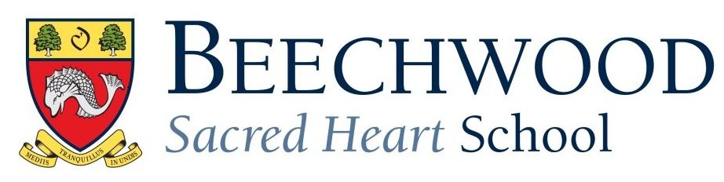

**A Level Results 2020**

|  |  |  |  |  |  |  |  |  |
| --- | --- | --- | --- | --- | --- | --- | --- | --- |
|  | **A\*** | **A** | **B** | **C** | **D** | **E** | **U** | **Total** |
| Art | 0 | 2 | 1 | 0 | 0 | 0 | 0 | 3 |
| Biology | 0 | 0 | 1 | 4 | 3 | 1 | 0 | 9 |
| Business Studies | 1 | 1 | 2 | 1 | 0 | 0 | 0 | 5 |
| Classical Civilisation | 2 | 0 | 0 | 0 | 0 | 0 | 0 | 2 |
| Chemistry | 0 | 1 | 0 | 2 | 0 | 1 | 0 | 4 |
| Chinese | 0 | 3 | 0 | 0 | 0 | 0 | 0 | 3 |
| Computer Science | 0 | 1 | 0 | 1 | 0 | 0 | 0 | 2 |
| Drama | 3 | 3 | 2 | 0 | 0 | 0 | 0 | 8 |
| Product Design | 0 | 0 | 0 | 1 | 1 | 1 | 0 | 3 |
| English | 0 | 2 | 1 | 0 | 0 | 0 | 0 | 3 |
| Further Maths | 0 | 1 | 1 | 0 | 0 | 0 | 0 | 2 |
| Geography | 0 | 0 | 2 | 0 | 0 | 0 | 0 | 2 |
| History | 0 | 0 | 2 | 2 | 0 | 0 | 0 | 4 |
| Mathematics | 2 | 2 | 1 | 2 | 1 | 1 | 0 | 9 |
| Media Studies | 0 | 1 | 0 | 0 | 0 | 0 | 0 | 1 |
| Physics | 0 | 1 | 1 | 1 | 0 | 1 | 0 | 4 |
| Psychology | 0 | 0 | 2 | 1 | 0 | 0 | 0 | 3 |
| Photography | 1 | 1 | 0 | 0 | 0 | 0 | 0 | 2 |
| Russian | 1 | 0 | 0 | 0 | 0 | 0 | 0 | 1 |
| Spanish | 0 | 0 | 0 | 0 | 0 | 0 | 0 | 0 |
| Textiles | 0 | 2 | 0 | 0 | 0 | 0 | 0 | 2 |
| EPQ | 3 | 2 | 3 | 0 | 0 | 0 | 0 | 8 |
|  |  |  |  |  |  |  |  |  |
| Total (with EPQ) | 13 | 23 | 19 | 15 | 5 | 5 | 0 | 80 |
| Total without EPQ | 10 | 21 | 16 | 15 | 5 | 5 | 0 | 72 |
|  |  |  |  |  |  |  |  |  |
|  |  | No EPQ | All |  | Boys |  | Girls |  |
|  |  | A* | 14% |  | 0% |  | 26% |  |
|  |  | A*/A | 43% |  | 26% |  | 58% |  |
|  |  | A*/B | 65% |  | 53% |  | 76% |  |
|  |  | A*/C | 86% |  | 88% |  | 84% |  |
|  |  | A*/D | 93% |  | 91% |  | 95% |  |
|  |  | A*/E | 100% |  | 100% |  | 100% |  |