**Motor Renewal Schedule (Third Party):**

**Policy Number: {{PolicyNo}}**

**Insured Name: {{InsuredName}}**

|  |  |  |  |
| --- | --- | --- | --- |
| **Vehicle Details** | | | |
| Registration Number: | {{RegistrationNo}} | Chassis Number: | {{ChasisNo}} |
| Vehicle Make: | {{VehicleMake}} | Vehicle Model: | {{VehicleModel}} |
| Engine Capacity: | {{EngineCapacity}} | Year Of Make: | {{YearOfMake}} |
| Start Date: | {{StartDate}} | Expiry Date: | {{ExpiryDate}} |
| Insurance Coverage: | Third Party | Premium: | {{Premium}} |

|  |
| --- |
| **Optional Covers** |
| Road Side Assistance - {{RoadAssistance}} |

**Important Notice**

This Policy Schedule contains a summary of cover only. For full Terms, Conditions and Exclusions please refer to the Policy Terms and conditions. All material facts must be disclosed and failure to do so will invalidate this policy. Contact numbers for road side and car replacement: 80001218 & for road accident claims +973 17875000.

“The parties hereby acknowledge and agree that all payment under this Agreement are exclusive of any Value Added or other indirect taxes imposed upon such payment and that the Second Party shall bear the cost of, and be responsible for the payment of any and all tax imposed. In the event of any change in circumstances of any existing applicable laws, or introduction of new laws that could govern the remuneration of this contract, such amendments would be applied on top of the existing agreed upon commercial terms & borne by the Second Party.”

Issued by Online Services in Manama, Bahrain on {{CurrentDateTime}}

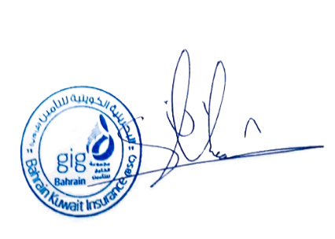

Bahrain Kuwait Insurance Co (BSC) www.gigbh.com

P.O.Box 10166, Bahrain

Tel: +973 17 119999 Fax: +973 17 921111