**CIS 4640**

**Assignment 2**

**2015-10-20**

**Todd Urbanowicz**

# Section 1: Independent t-Tests

## Workflow

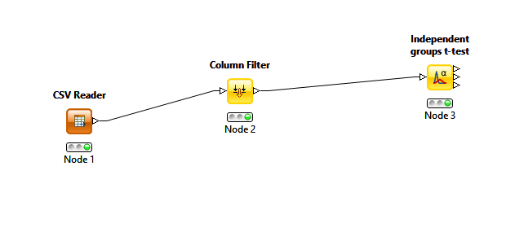

## t-Test Results

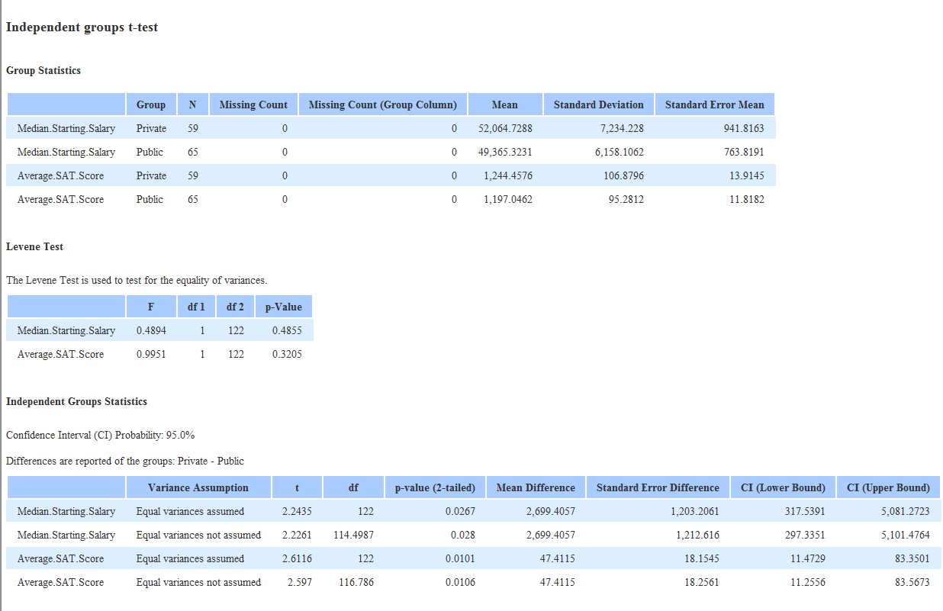

## Hypothesis

### Levine

|  |  |  |
| --- | --- | --- |
|  | **Median.Starting.Salary** | **Average.SAT.Score** |
| **H0: σ21 = σ22** |  |  |
| **H1: σ21 != σ22** | X | X |
| **CI** | 0.95 | 0.95 |
| **P-Value** | 0.4855 | 0.3205 |
| **Conclusion** | P > 0.05 => We accept the NULL hypothesis | P > 0.05 => We accept the NULL hypothesis |

#### Findings and Conclusion

We are 95% confident that median starting salary, when compared with public and private schools are equal to one another. This tells us that school type does not relate to median starting salary.

We are 95% confident that average SAT score, when compared with public and private schools are equal to one another. This tells us that school type does not relate to average SAT score.

### Independent Group Statistics

|  |  |  |  |  |  |  |
| --- | --- | --- | --- | --- | --- | --- |
|  | | Median.Starting.Salary | | Median.Starting.Salary | Average.SAT.Score | Average.SAT.Score |
| **Equal Variances** | | Assumed | Not Assumed | Assumed | Not Assumed |
| **H0: σ21 = σ22** | |  |  |  |  |
| **H1: σ21 != σ22** | | X | X | X | X |
| **CI** | | 0.95 | 0.95 | 0.95 | 0.95 |
| **P-Value** | | 0.0267 | 0.028 | 0.0101 | 0.0106 |
| **Conclusion** | | P < 0.05 => We reject the NULL hypothesis in favor of H1 | P < 0.05 => We reject the NULL hypothesis in favor of H1 | P < 0.05 => We reject the NULL hypothesis in favor of H1 | P < 0.05 => We reject the NULL hypothesis in favor of H1 |

#### Findings and Conclusions

We are 95% confident that while assuming equal variances, median starting salary, when compared with public and private schools are not equal to one another. This tells us that school type does relate to median starting salary.

We are 95% confident that while not assuming equal variances, median starting salary, when compared with public and private schools are not equal to one another. This tells us that school type does relate to median starting salary.

We are 95% confident that while assuming equal variances, average SAT score, when compared with public and private schools are not equal to one another. This tells us that school type does relate to average SAT score.

We are 95% confident that while assuming equal variances, average SAT score, when compared with public and private schools are not equal to one another. This tells us that school type does relate to average SAT score.

# Section 2: Multiple Regression

## Workflow

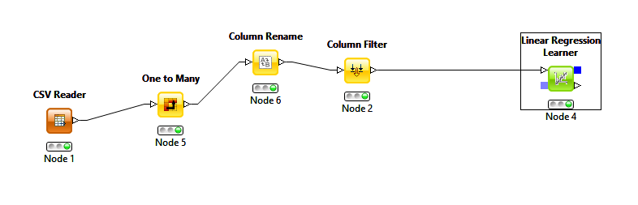

## Results

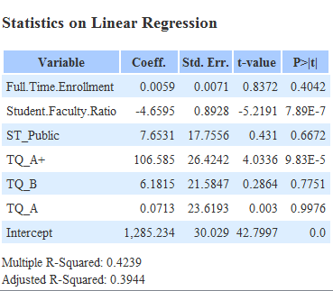

## Analysis

|  |  |  |  |  |
| --- | --- | --- | --- | --- |
|  | **Intercept** | **Full.Time.Enrollment** | **Student.Faculty.Ratio** | **ST_PUBLIC** |
| **H0: Beta0 = 0** | X |  | X |  |
| **H1: Beta0 != 0** |  | X |  | X |
| **CI** | 0.95 | 0.95 | 0.95 | 0.95 |
| **P-Value** | 0 | 0.4042 | 7.89E-07 | 0.6672 |
| **Conclusion** | P < 0.05 => We reject the NULL hypothesis in favor of H1 | P > 0.05 => We do not reject the NULL hypothesis | P < 0.05 => We reject the NULL hypothesis in favor of H1 | P > 0.05 => We do not reject the NULL hypothesis |

|  |  |  |  |
| --- | --- | --- | --- |
|  | **TQ_A+** | **TQ_B** | **TQ_A** |
| **H0: Beta0 = 0** | X |  |  |
| **H1: Beta0 != 0** |  | X | X |
| **CI** | 0.95 | 0.95 |  |
| **P-Value** | 9.83E-05 | 0.7751 | 9.98E-01 |
| **Conclusion** | P < 0.05 => We reject the NULL hypothesis in favor of H1 | P > 0.05 => We do not reject the NULL hypothesis | P > 0.05 => We do not reject the NULL hypothesis |

### Equation

STARTING SALARY = 0.0059*FTE + 7.6531*ST_PUBLIC + 6.1815* TQ_B + 0.0713* TQ_A

Multiple R-Squared = 0.4239

Adjusted R-Squared = 0.3944

I do not feel the data the fits the regression line well. The graph is very noisy and unpredictable.

### Findings

We found that the highest factor in starting salary is ST_PUBLIC. We do not reject the NULL hypothesis with intercept, Student.Faculty.Ration, and TQ_A+, so we can exclude them from our equation. With R-squared under 50%, we can also determine that people are unpredictable.