KV260 module connections
  - A practical signal guide for the KV260 graphics project
The register module stores the CPU's job settings. The engine fetches and processes geometry. The memory module turns the engine's requests into AXI transactions with the Zynq DDR system. This guide shows which module drives each signal and when data is accepted.
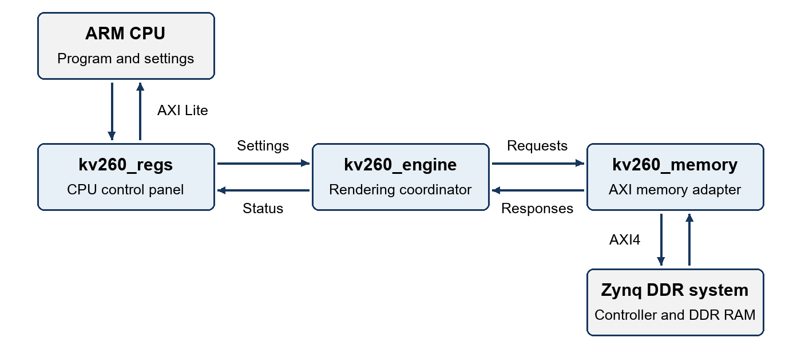

What each module does
Module | Responsibility
kv260_regs | Accept CPU register reads and writes. Hold DDR locations and job settings. Pulse START and expose engine status.
kv260_engine | Load 16 matrix words, fetch XYZ vertices, feed the graphics stages and wait for writes to finish.
kv260_memory | Hold memory requests, perform AXI handshakes and pass responses or errors back to the engine.

Matrix coefficients, vertices and pixels live in DDR. Their values pass through the memory interface; the register module receives locations, counts and settings. The CPU writes the inputs into DDR before START.

How to read the tables
A direction shows which module drives the signal. Reg means kv260_regs; Engine means kv260_engine; Mem means kv260_memory. A 32-bit signal is a bus carrying one word.
VALID means the sender has a request or response available. READY means the receiver can accept it. A transfer occurs at a rising clock edge when both are 1.

CPU and register connections
The CPU accesses the GPU at base address 0xA0000000 through the Zynq interconnect. The register module receives an 8-bit byte offset, such as 0x1C for vertex_count. The top level names these connections s_axi_ followed by the port name below.

CPU writes
Signal | Bits | Direction | Meaning
awaddr | 8 | CPU → Reg | Register byte offset to write.
awvalid | 1 | CPU → Reg | Write address is available.
awready | 1 | Reg → CPU | The address holding slot is free.
wdata | 32 | CPU → Reg | Value to write into the selected register.
wstrb | 4 | CPU → Reg | One byte enable per 8 bits of wdata; 1111 selects all bytes.
wvalid | 1 | CPU → Reg | Write data and byte enables are available.
wready | 1 | Reg → CPU | The data holding slot is free.
bresp | 2 | Reg → CPU | 00 means success; 10 means a rejected write.
bvalid | 1 | Reg → CPU | Write response is available.
bready | 1 | CPU → Reg | CPU can accept the write response.

Address and data are captured independently. Once both are stored, the module applies the write and returns a response. Settings writes are rejected while the engine is busy or START is pending. Addresses must be aligned to four bytes.

CPU reads
Signal | Bits | Direction | Meaning
araddr | 8 | CPU → Reg | Register byte offset to read.
arvalid | 1 | CPU → Reg | Read address is available.
arready | 1 | Reg → CPU | A new read address can be accepted.
rdata | 32 | Reg → CPU | Snapshot of the selected setting, status or counter.
rresp | 2 | Reg → CPU | 00 means success; 10 means an invalid or misaligned address.
rvalid | 1 | Reg → CPU | Read response is available.
rready | 1 | CPU → Reg | CPU can accept the read response.

A successful START write response confirms the command was accepted. The CPU reads the separate DONE status to find out when rendering has finished.

Register and engine connections
The two instances connect to the same parent wires in KV260_GPU.v. The register module drives job settings continuously. On START, the engine validates and captures those settings.

Reg sends settings to Engine
Signal | Bits | Direction | Meaning
start | 1 | Reg → Engine | One-clock pulse that launches a job.
region_base | 32 | Reg → Engine | Base DDR byte address of the graphics region.
matrix_offset | 32 | Reg → Engine | Byte offset to the first of 16 matrix words.
vertex_offset | 32 | Reg → Engine | Byte offset to the first XYZ vertex.
vertex_count | 32 | Reg → Engine | Number of complete vertices to submit.
near_q16 | 32 | Reg → Engine | Signed Q16.16 clipping distance; 65536 means 1.0.
target_buffer | 1 | Reg → Engine | Destination framebuffer: 0 selects A; 1 selects B.

The engine finds each input by adding its offset to region_base. It reads forward from that starting address. The fixed matrix length and vertex_count determine when it stops.

Engine returns status to Reg
Signal | Bits | Direction | Meaning
busy | 1 | Engine → Reg | A job is in progress.
done | 1 | Engine → Reg | One-clock completion pulse, including failed jobs.
error_code | 4 | Engine → Reg | 0 none; 1 configuration error; 2 read fault; 3 write fault.
accepted | 32 | Engine → Reg | Vertices accepted into the graphics pipeline.
written | 32 | Engine → Reg | Pixel-write requests accepted by Mem; pixels may overlap.
skipped | 32 | Engine → Reg | Points rejected or outside the framebuffer.

Reg remembers the DONE pulse in done_latched until reset or the next accepted START. The CPU reads busy and completion at offset 0x04, and the three counters at 0x28, 0x2C and 0x30. The CPU also checks error status before using the frame.

Shared clock and reset
Reg, Engine and Mem all receive clk and resetn from the top level. clk runs at 100 MHz in the board design. resetn is active low; their clocked state resets on a rising edge while it is 0.

Engine and memory connections
These 14 transaction signals form the simple internal memory interface. Mem performs the external AXI transactions. Both modules also share clk and resetn.

Read request
Signal | Bits | Direction | Meaning
rd_addr | 32 | Engine → Mem | DDR byte address of the word to fetch.
rd_valid | 1 | Engine → Mem | Read request is available.
rd_ready | 1 | Mem → Engine | Mem can accept the read request.

Read response
Signal | Bits | Direction | Meaning
rsp_data | 32 | Mem → Engine | One returned matrix coefficient or vertex coordinate.
rsp_valid | 1 | Mem → Engine | Returned word and read status are available.
rsp_ready | 1 | Engine → Mem | Engine can accept the response.
rsp_error | 1 | Mem → Engine | The read response reports an error.

Write request
Signal | Bits | Direction | Meaning
wr_addr | 32 | Engine → Mem | DDR byte address of the pixel to store.
wr_data | 32 | Engine → Mem | 32-bit pixel value to write.
wr_valid | 1 | Engine → Mem | Write address and data are available.
wr_ready | 1 | Mem → Engine | Mem can accept the write request.

Write completion
Signal | Bits | Direction | Meaning
wr_done | 1 | Mem → Engine | Pulse when the AXI write response is accepted.
wr_error | 1 | Mem → Engine | That completed write reported an error.
write_idle | 1 | Mem → Engine | No write transaction is outstanding.

Read requests transfer on rd_valid and rd_ready; read responses on rsp_valid and rsp_ready; write requests on wr_valid and wr_ready. Each pair must be 1 at the same rising edge.
wr_ready accepts a request; wr_done reports its later response. The current Engine uses write_idle to wait for outstanding writes and has no other use for its wr_done input.

A job with one matrix and three vertices
This example assumes three visible vertices and no errors. The CPU first writes the inputs into DDR and makes those writes visible before issuing START.
Item | Example setting
region_base | 0x10000000
matrix_offset | 0 bytes
vertex_offset | 64 bytes
vertex_count | 3
near_q16 and target_buffer | 65536 and 1 (framebuffer B)

What happens next
- CPU writes settings into Reg, then writes bit 0 at offset 0x00. Reg pulses start for one clock.
- Engine captures the settings, asserts busy and reads 16 matrix words starting at 0x10000000. It loads each word into Matrix_Vertex using matrix_valid and matrix_ready.
- Engine fetches X, Y and Z for the first vertex at 0x10000040, 0x10000044 and 0x10000048. It saves the returned words in vx, vy and vz.
- Engine offers each complete vertex using vertex_valid. After vertex_ready accepts it, accepted increases. After the third vertex, Engine stops fetching and enters DRAIN.
- Engine waits for every point to be written or skipped and for memory writes to finish. It pulses done; Reg remembers completion. For this example, accepted = 3, written = 3 and skipped = 0.

Timing for one coordinate read
This is an illustrative response delay. Rising edges are 10 ns apart at 100 MHz; the real AXI and DDR system may insert more waiting cycles.
Edge | Transfer or state change
1 | rd_valid and rd_ready accept the request. Mem saves the address; Engine waits for a response.
2 | AXI arvalid and arready accept the address. Mem waits for returned data.
3 and 4 | No response yet. Engine holds its coordinate registers and pointer.
5 | AXI rvalid and rready accept the word. rsp_valid and rsp_ready let Engine save it at the same edge.

Mem forwards returned AXI read data directly; it has no separate read-data holding register. If Engine is not ready, the AXI responder must hold its valid response and data stable. The current Engine normally stays ready while waiting for its requested word.

Source files
Top-level wiring: kv260/rtl/KV260_GPU.v
Modules: kv260/rtl/kv260_regs.v, kv260_engine.v and kv260_memory.v
CPU setup: kv260/software/main.c

