**Homework #2 POOCasino**

B01902080 資工四 王于青

1. **How to play the game**
2. In the correct folder (i.e., hw2/), enter “make” and “make run” to start the game.
3. Follow the screenshots and instructions highlighted below:
4. Enter your name:
5. Enter your bet in current round:
6. Choose the cards you want to keep (in “abcde”):
7. 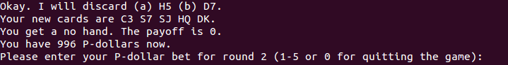The results and payoff will be showed on the screen:
8. You can start a new round, or enter “0” bet to quit the game:
9. **Methods used to test the correctness of my program**

I implement two classes, HandCreator.java and StatusChecker.java, to check the following things respectively:

1. 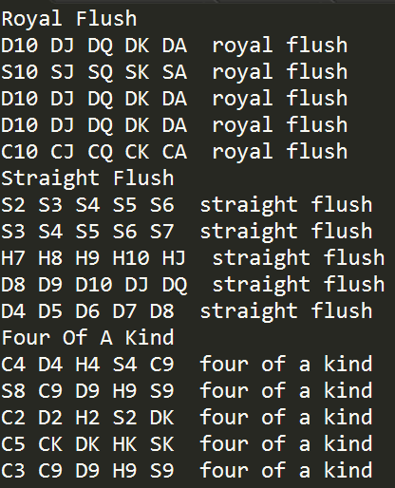The correctness of computer’s determination of player’s hand.

The class HandCreator can create all kinds of special hands by calling target method (e.g., handCreator.royalFlush() ).

Therefore, for each kind of hand, I first assign the hand created by HandCreator to player.

Then, I call computer. calculateHand() used in my game to determine which kind of hand the player gets.

Finally, I check if the returned type of hand is the same as what I ask HandCreator to create.

The output of testing is as shown on the right.

1. The correctness of player’s P-dollar account.

The class StatusChecker will store the current player’s account, bet, hand, and payoff.

Therefore, when calling statusChecker.isCorrect(), StatusChecker will calculate the account and payoff based on its database and check if they are identical to player’s current data.

1. **The output from three rounds of the game**

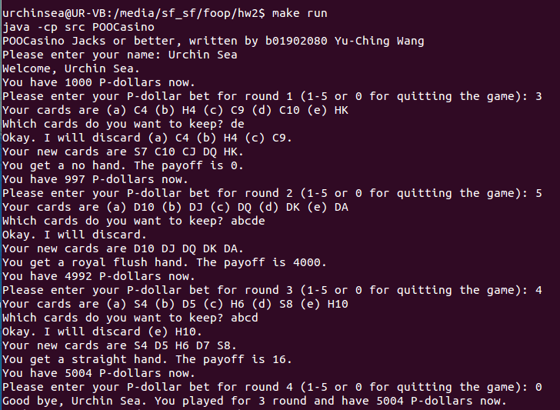

1. **BONUS implementation**

The test classes HandCreator.java and StatusChecker.java are my bonus implementation.

Also, I add some checking mechanisms to detect the validity of user inputs.

