URDU SHADIKHANA
Online Reservation Portal

End-to-End Functionality Reference
──────────────────────────────────────────
Document version | 1.1
Generated | 21 June 2026
Platform | Salesforce Experience Cloud
Integrations | Email · SMS (Twilio / Android Gateway)

Confidential — For internal reference and future maintenance

Table of Contents
How to use this document
Section 2 contains master flow diagrams. Section 3 walks through every user scenario with screenshots and component lists. Section 4 is a complete technical reference. Use the navigation table below or update the automatic table for page numbers.

Quick navigation
Section | Title
1 | 1. Solution Overview
2 | 2. Master Flow Diagrams
3 | 3. Functional Scenarios
4 | 4. Complete Component Reference
5 | 5. Screenshot Capture Guide
6 | 6. Related Documentation
— | Scenario S01: Portal Home & Header
— | Scenario S02: Venue Gallery & Address
— | Scenario S03: Booking Wizard — Step 1
— | Scenario S04: Booking Wizard — Step 2
— | Scenario S05: Booking Wizard — Step 3
— | Scenario S06: Booking Wizard — Step 4
— | Scenario S07: Notifications on New Booking
— | Scenario S08: Experience Cloud Login
— | Scenario S09: Admin — Booking Queue
— | Scenario S10: Admin — Booking Report
— | Scenario S11: Admin — Pricing
— | Scenario S12: Admin — Site Branding
— | Scenario S13: Admin — SMS Settings
— | Scenario S14: Admin — Email Settings
— | Scenario S15: Admin — Portal Login Notes
— | Scenario S16: Admin — Booking Data
— | Scenario S17: Android SMS Gateway
— | Scenario S18: Scheduled Cleanup

Tip: Click any section title above to jump to that section. For page numbers, update the automatic table below (Ctrl+A → F9 in Word).

Automatic table (with page numbers)

[ Table of contents — open in Word and press Ctrl+A then F9 to update ]

1. Solution Overview
At a glance
Urdu Shadikhana is a Salesforce Experience Cloud portal for a community event hall in Nandalur, Andhra Pradesh. Customers submit booking requests online; administrators review, confirm or cancel, manage pricing, and configure email/SMS notifications.

1.1 User Roles
Role | Portal access | Sign-in method
Guest (public) | Home, venue info, 4-step booking wizard | No login required
Community user | Same as guest (Home tab) | Experience Cloud login
System Administrator | Home + Booking Data + Administration (7 sub-sections) | Salesforce System Administrator profile

1.2 Technology Stack
Layer | Technology
Portal UI | Experience Cloud (Urdu_Shadikhana1) + LWC shadikhanaBookingPortal
Backend | Apex — ShadikhanaBookingController + service classes
Data model | Shadikhana_Booking__c, Shadikhana_Settings__c, Sms_Outbound__c
Email | Messaging.sendEmail via ShadikhanaBookingEmailService
SMS | Twilio callout OR Android Gateway (Sms_Outbound__c queue)
Mobile gateway | Kotlin app — android/shadikhana-sms-gateway

2. Master Flow Diagrams

2.1 System Architecture
Figure 2.1 — High-level architecture
┌─────────────────┐ HTTPS ┌──────────────────────────────┐
│ Web Browser │ ─────────────► │ Experience Cloud Portal │
│ (Guest/Admin) │ │ c:shadikhanaBookingPortal │
└─────────────────┘ └──────────────┬───────────────┘
│ @AuraEnabled
▼
┌──────────────────────────────┐
│ ShadikhanaBookingController │
└──────────────┬───────────────┘
┌────────────────────────────┼────────────────────────────┐
▼ ▼ ▼
ShadikhanaBookingPricing ShadikhanaBookingEmailService ShadikhanaBookingSmsService
│ │ │
▼ ▼ ▼
Shadikhana_Booking__c Email (requester/admin) Twilio OR Sms_Outbound__c
Shadikhana_Daily_Rate__c │
▼
┌──────────────────┐
│ Android SMS App │
└──────────────────┘

2.2 Booking Lifecycle
Figure 2.2 — Booking status lifecycle
[Guest submits form]
│
▼
┌──────────┐
│ Pending │ ◄── Admin + Requester: SMS & Email notifications
└────┬─────┘
│ Admin confirms (no overlap with other Confirmed)
▼
┌───────────┐
│ Confirmed │ ◄── Requester SMS + Email; calendar blocked
└─────┬─────┘
│ Admin cancels
▼
┌───────────┐
│ Cancelled │ ◄── Requester SMS + Email; Final Amount = ₹0
└───────────┘

2.3 Notification Matrix
Event | Email → Requester | Email → Admin | SMS → Requester | SMS → Admin
New booking | Yes (if email provided) | Yes + review link | Yes — pending ack | Yes + review link
Confirmed | Yes | No | Yes | No
Cancelled | Yes | No | Yes | No

2.4 Android SMS Gateway
Figure 2.4 — Android gateway message flow
Apex: ShadikhanaBookingSmsService → ShadikhanaSmsGatewayService.enqueueMessage()
→ INSERT Sms_Outbound__c (Status = Pending)
Android app polls every ~30–60 seconds:
GET /services/apexrest/shadikhana/sms/v1/pending
→ Send SMS via device SIM
POST /services/apexrest/shadikhana/sms/v1/ack
→ UPDATE Sms_Outbound__c (Sent | Failed)

2.5 Portal Navigation
Figure 2.5 — Portal navigation map
Sidebar navigation (LWC client-side)
├── Home ........................ Everyone
├── Booking Data ................ System Administrator only
└── Administration
├── Booking Queue
├── Booking Report
├── Pricing
├── Site Branding
├── SMS Notifications
├── Email Notifications
└── Portal Login Notes

3. Functional Scenarios
Each scenario documents the end-user flow, Salesforce components involved, and UI screenshots. Placeholder images can be replaced under docs/screenshots/ and the document regenerated.
S01 | Portal Home & Header

Attribute | Description
Actor | Guest / All users
Purpose | View venue branding, login button, and navigation sidebar.
Notifications | None

Process flow
1. User opens Experience Cloud URL (/urdushadikhana).
2. home.json loads c:shadikhanaBookingPortal.
3. getCurrentUserInfo determines guest vs admin.
4. Header shows venue name, clock, and Login button (guests).
Related components
Layer | Component | Path / Role
Experience | Urdu_Shadikhana1 / home.json | experiences/Urdu_Shadikhana1/views/home.json
LWC | shadikhanaBookingPortal | lwc/shadikhanaBookingPortal/
Apex | getCurrentUserInfo | ShadikhanaBookingController.cls

User interface
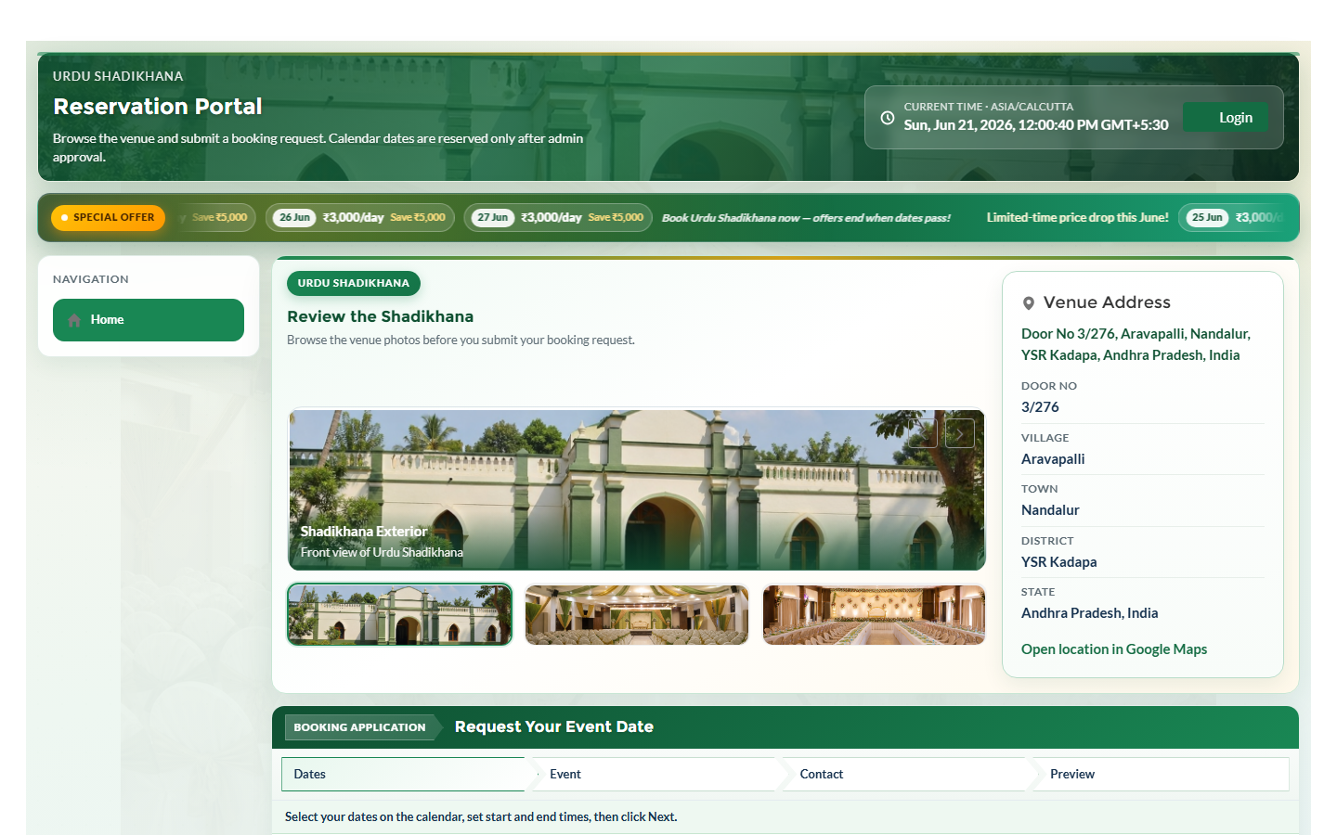
Figure S01a — Portal header and sidebar

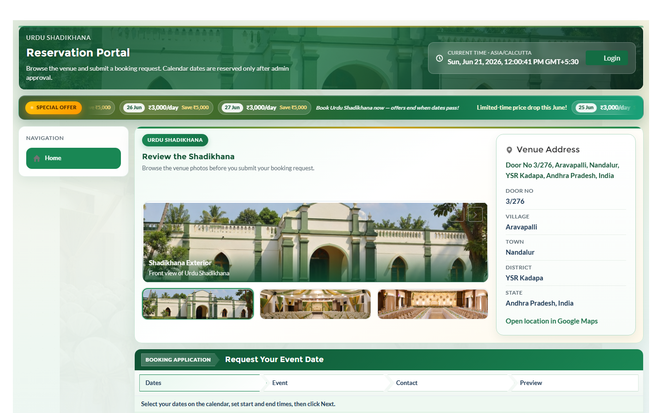
Figure S01b — Home top section

S02 | Venue Gallery & Address

Attribute | Description
Actor | Guest / All users
Purpose | Review hall photos and venue location before booking.
Notifications | None

Process flow
1. Scroll to 'Review the Shadikhana' gallery.
2. Navigate photos via thumbnails or arrows.
3. View Venue Address card and Google Maps embed.
Related components
Layer | Component | Path / Role
LWC | Gallery section | shadikhanaBookingPortal.html/js
Static Resource | Hall images | ShadikhanaHallExterior, Interior, DiningArea
Apex | getPortalBrandingConfig | ShadikhanaPortalBrandingService

User interface
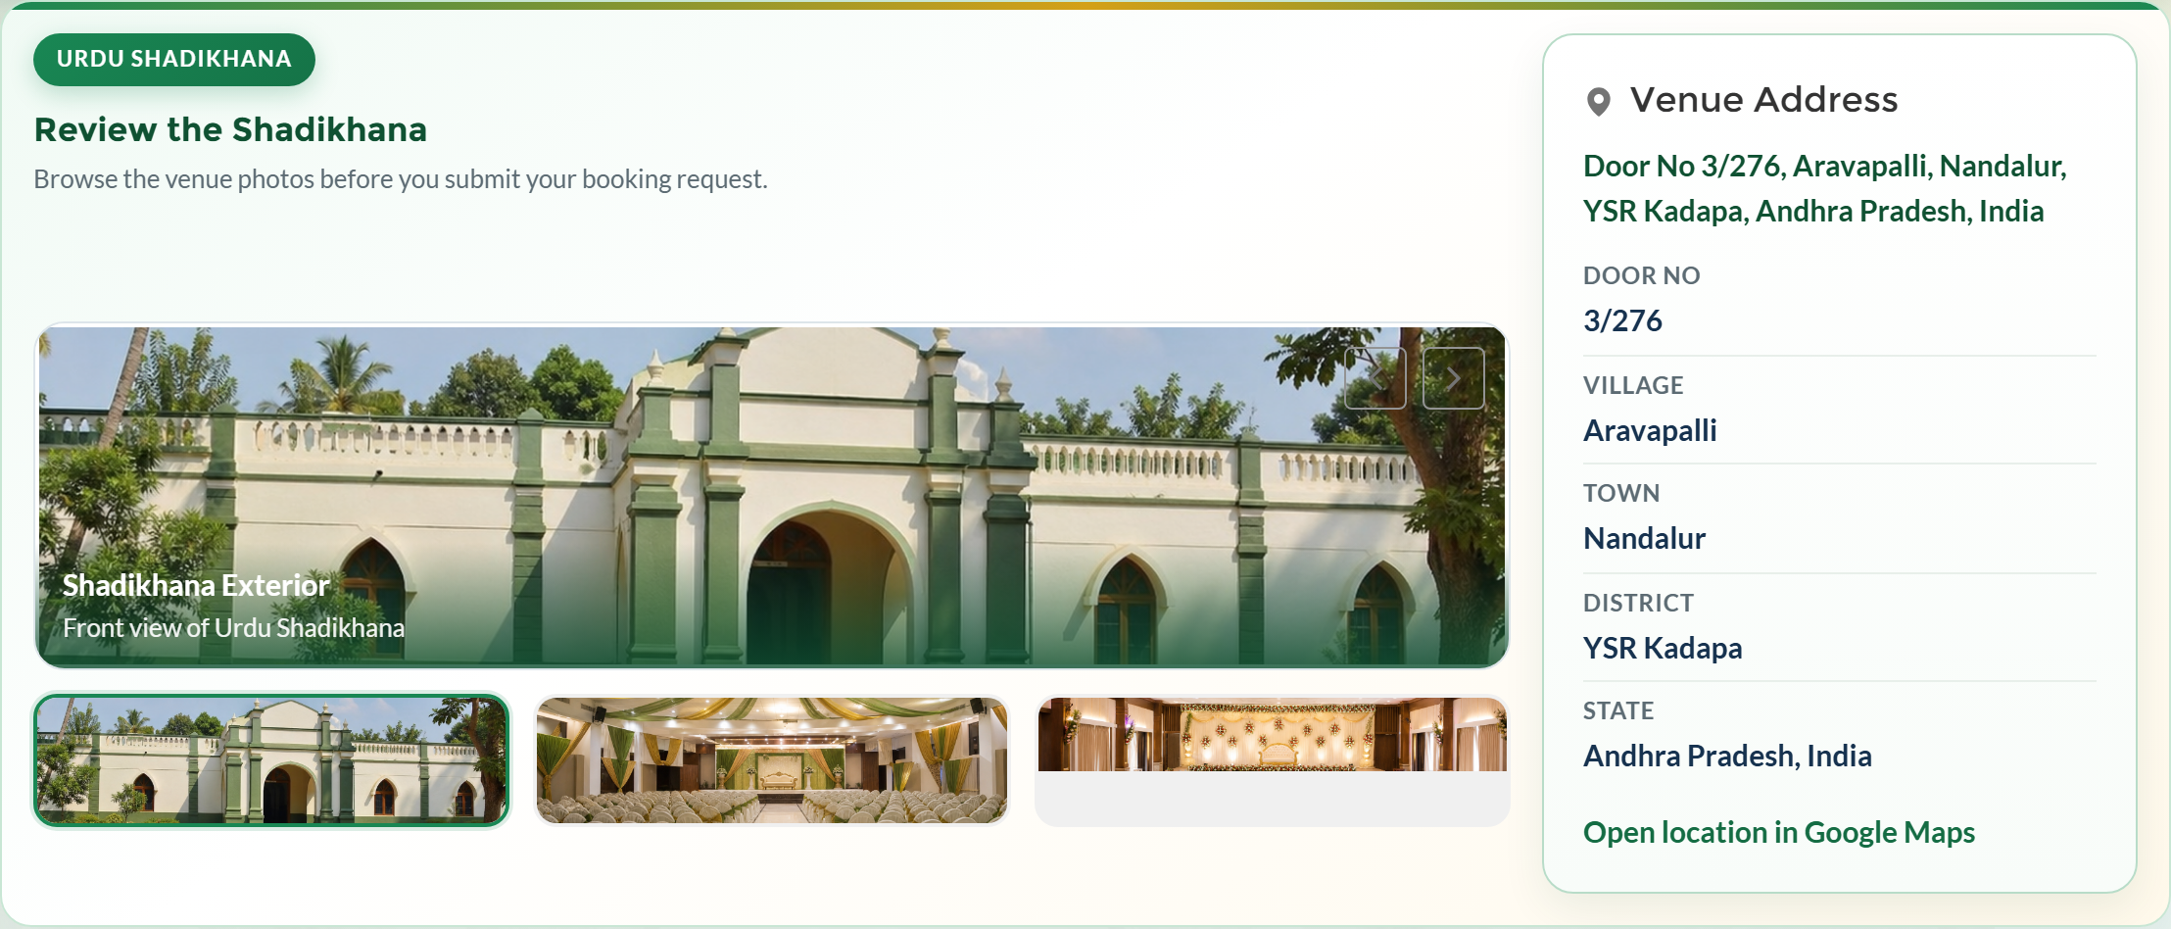
Figure S02a — Photo gallery

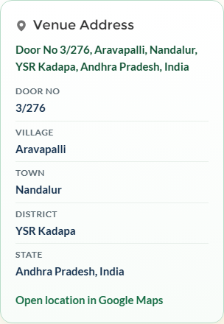
Figure S02b — Venue address and map

S03 | Booking Wizard — Step 1 (Dates & Times)

Attribute | Description
Actor | Guest / Community user
Purpose | Select available date range and event timing.
Notifications | None

Process flow
1. Open Booking Request Form — Step 1 of 4.
2. Pick From Date and To Date on inline calendar.
3. Unavailable: past dates, confirmed, or pending bookings.
4. Set Start Time and End Time.
5. Right panel shows availability calendar with colour legend.
Related components
Layer | Component | Path / Role
LWC | validateBookingWizardStep1 | shadikhanaBookingPortal.js
Apex | getBookings, isDateRangeAvailable | ShadikhanaBookingController
Apex | calculateBookingPrice | ShadikhanaBookingPricing
Object | Shadikhana_Booking__c | Booking_Date__c, End_Date__c, Status__c

User interface
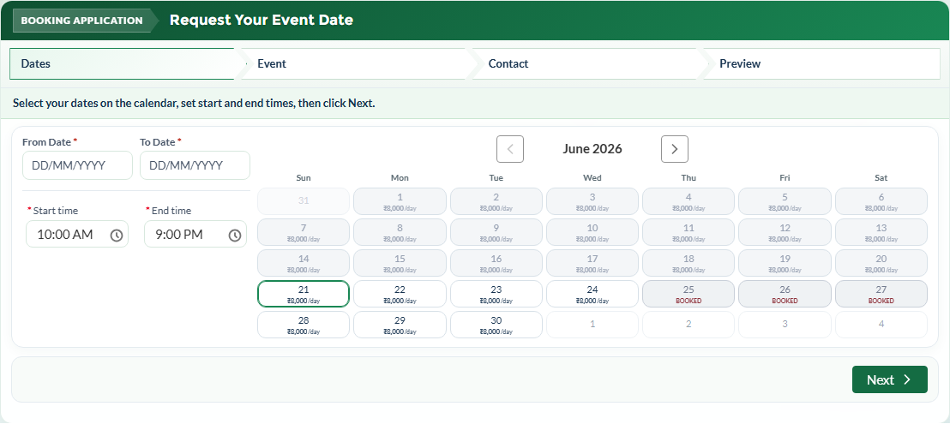
Figure S03a — Booking form step 1

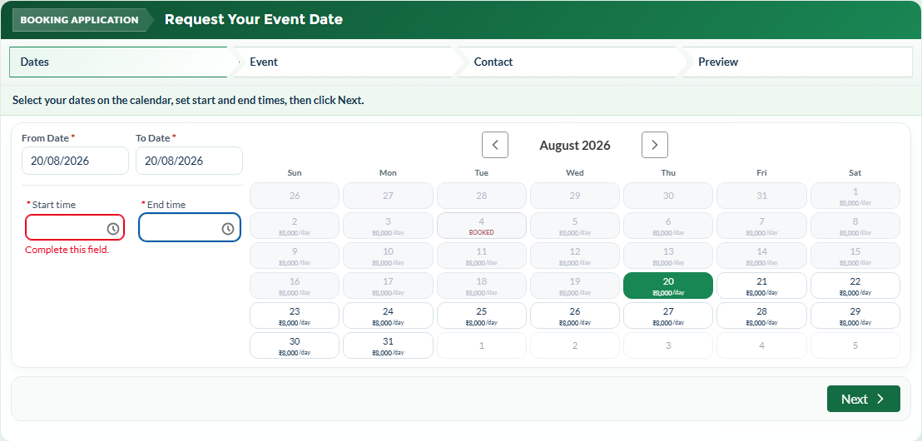
Figure S03b — Date selection

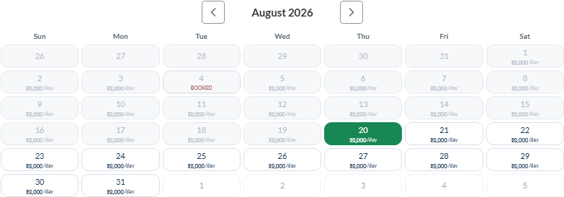
Figure S03c — Availability panel

S04 | Booking Wizard — Step 2 (Event Information)

Attribute | Description
Actor | Guest / Community user
Purpose | Enter event type, name, guest count, decoration and catering.
Notifications | None

Process flow
1. Select Event Type from picklist.
2. Enter Event Name and Expected Guest Count.
3. Choose Decoration and Catering arrangements.
4. Optional: Event Details textarea.
5. Estimated price updates automatically.
Related components
Layer | Component | Path / Role
LWC | validateBookingWizardStep2 | shadikhanaBookingPortal.js
Apex | calculateBookingPrice | ShadikhanaBookingPricing
Settings | Hall_* charge fields | Shadikhana_Settings__c

User interface
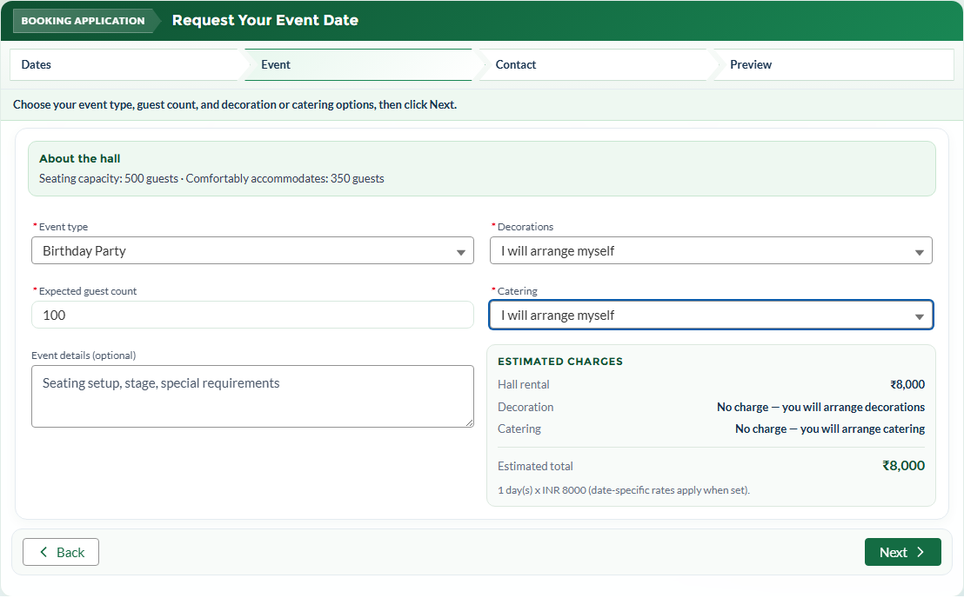
Figure S04 — Event information step

S05 | Booking Wizard — Step 3 (Contact Information)

Attribute | Description
Actor | Guest / Community user
Purpose | Provide contact details for notifications.
Notifications | None

Process flow
1. Enter Contact Name (required).
2. Enter 10-digit Mobile Number (required).
3. Enter Email (optional — used for acknowledgment).
4. Optional notes for admin team.
Related components
Layer | Component | Path / Role
LWC | validateBookingWizardStep3 | Phone and name validation
Apex | createBooking contact fields | Contact_Name__c, Contact_Phone__c, Contact_Email__c

User interface
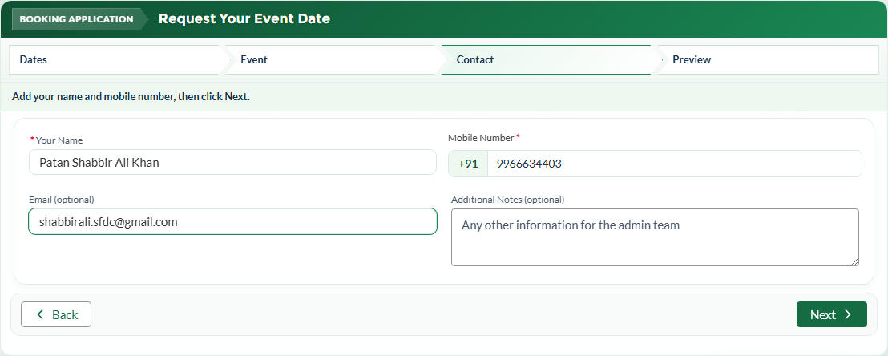
Figure S05 — Contact information

S06 | Booking Wizard — Step 4 (Review & Submit)

Attribute | Description
Actor | Guest / Community user
Purpose | Review summary, accept consent, and submit booking request.
Notifications | Email + Admin SMS + Requester SMS (see S07)

Process flow
1. Review booking preview and estimated price.
2. Accept terms/consent checkbox.
3. Click Submit Booking Request.
4. createBooking inserts record with Status = Pending.
5. Success toast displayed; calendar refreshes.
Related components
Layer | Component | Path / Role
LWC | handleSubmitBooking | shadikhanaBookingPortal.js
Apex | createBooking | ShadikhanaBookingController.cls
Object | Shadikhana_Booking__c | All pricing and status fields

User interface
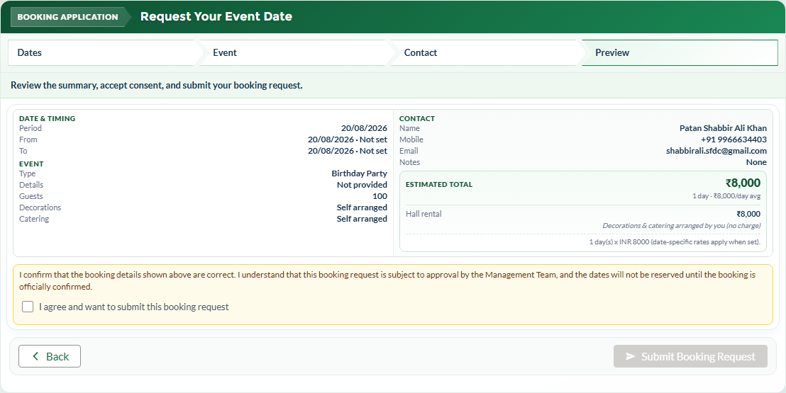
Figure S06a — Review step

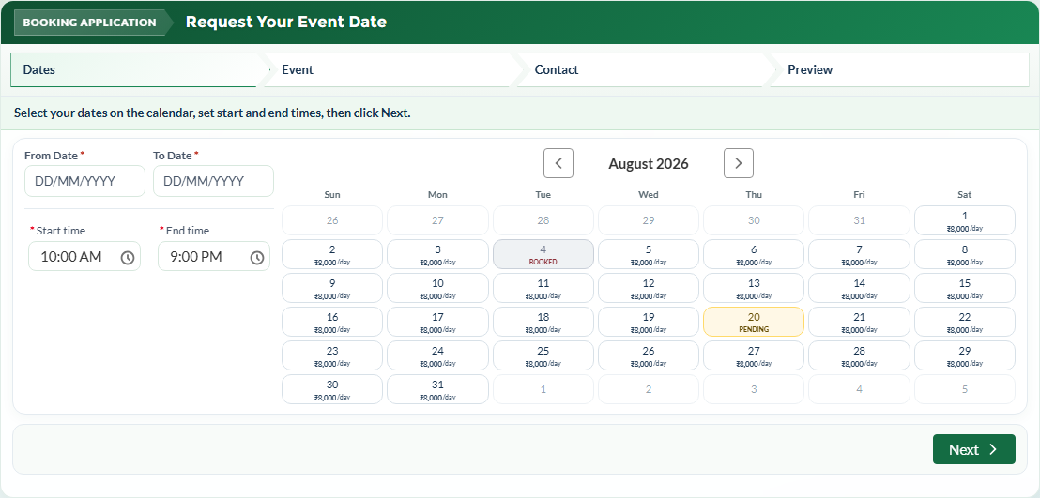
Figure S06b — Success confirmation

S07 | Notifications on New Booking

Attribute | Description
Actor | System (automated)
Purpose | Alert admin and acknowledge requester after booking creation.
Notifications | See Section 2.3 notification matrix

Process flow
1. notifyBookingRequestSubmitted queues requester + admin emails.
2. notifyAdminNewBooking sends SMS to all admin mobile numbers.
3. notifyRequesterBookingSubmitted sends acknowledgment SMS.
4. Android path: Sms_Outbound__c Pending → app polls → Sent.
Related components
Layer | Component | Path / Role
Apex | ShadikhanaBookingEmailService | BookingRequestEmailQueueable
Apex | ShadikhanaBookingSmsService | Admin + Requester queueables
Apex | ShadikhanaSmsGatewayRest | REST /pending and /ack
Object | Sms_Outbound__c | SMS queue for Android gateway
Android | SmsGatewayService | android/shadikhana-sms-gateway/

User interface
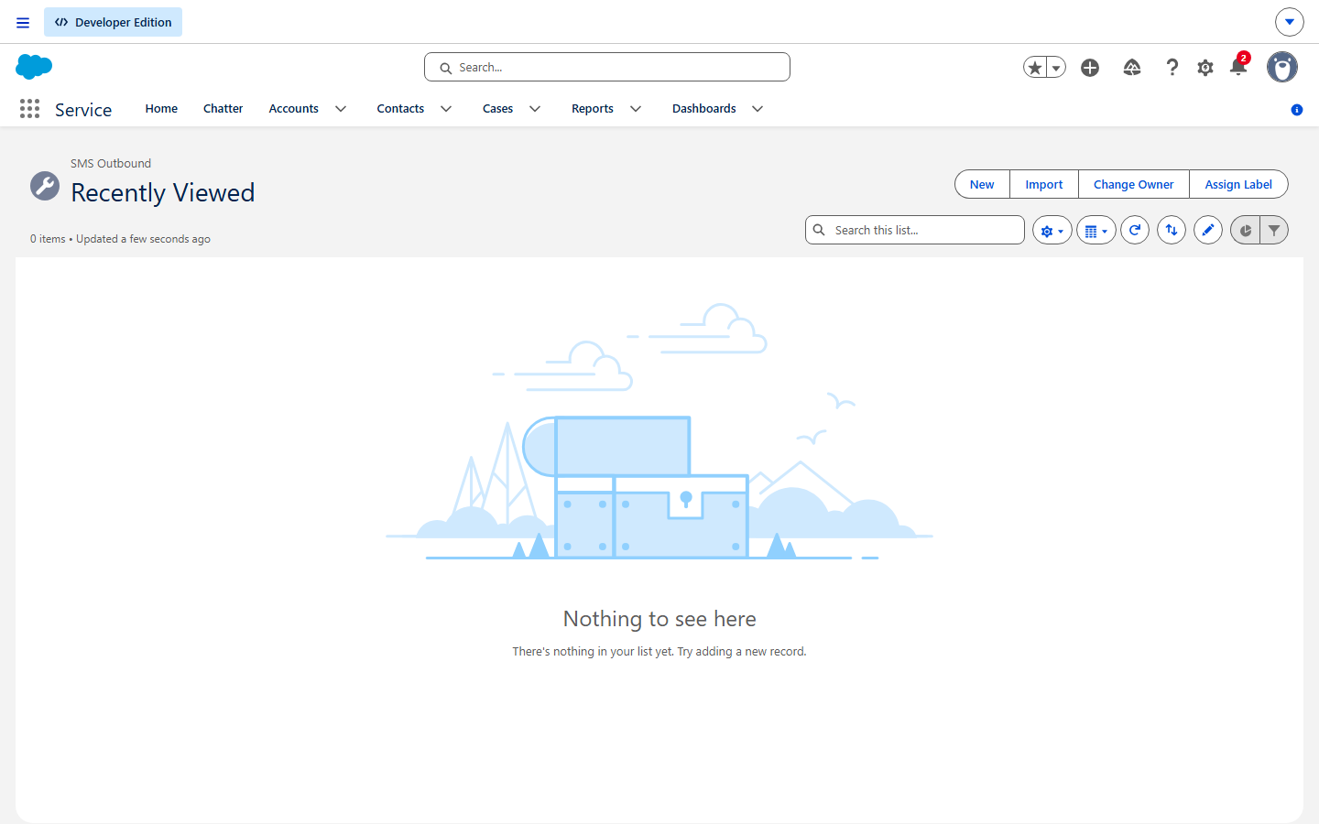
Figure S07a — Sms_Outbound__c records

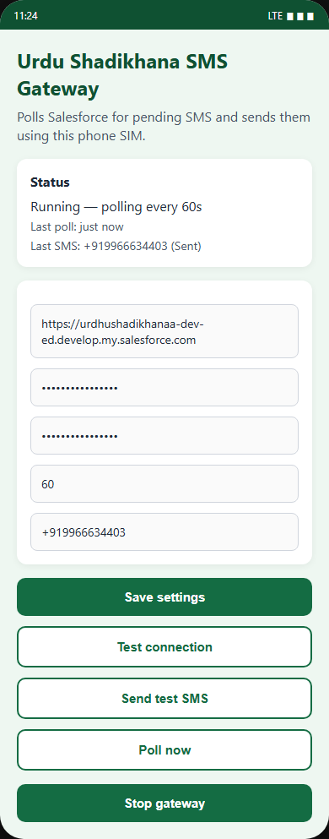
Figure S07b — Android gateway app

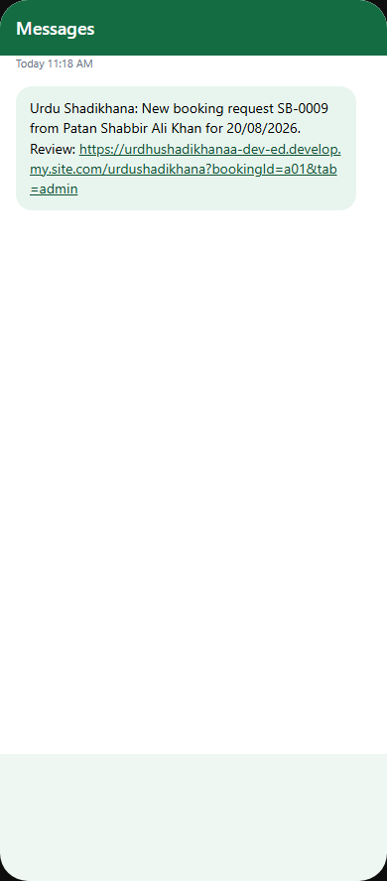
Figure S07c — Admin SMS with link

S08 | Experience Cloud Login

Attribute | Description
Actor | Community user
Purpose | Sign in to the portal.
Notifications | None

Process flow
1. Click Login in portal header.
2. login.json shows logo, shadikhanaLoginNotes, and login form.
3. User authenticates via Salesforce Identity.
4. Redirected back to portal Home.
Related components
Layer | Component | Path / Role
Experience | login.json | experiences/Urdu_Shadikhana1/views/login.json
LWC | shadikhanaLoginNotes | lwc/shadikhanaLoginNotes/
Settings | Portal_Login_Notes__c | Shadikhana_Settings__c

User interface

Figure S08 — Login page

S09 | Admin — Booking Queue

Attribute | Description
Actor | System Administrator
Purpose | Review pending requests; confirm, cancel, or set final price.
Notifications | None

Process flow
1. Open Administration → Booking Queue.
2. getAdminBookings loads cards grouped by status.
3. Confirm → overlap check + requester notifications.
4. Cancel → Final_Amount__c = 0.
5. Deep link ?bookingId=&tab=admin highlights booking card.
Related components
Layer | Component | Path / Role
LWC | handleConfirmBooking, handleCancelBooking | shadikhanaBookingPortal.js
Apex | updateBookingStatus, updateBookingPrice | ShadikhanaBookingController
Apex | Email + SMS services | Status-change notifications

User interface
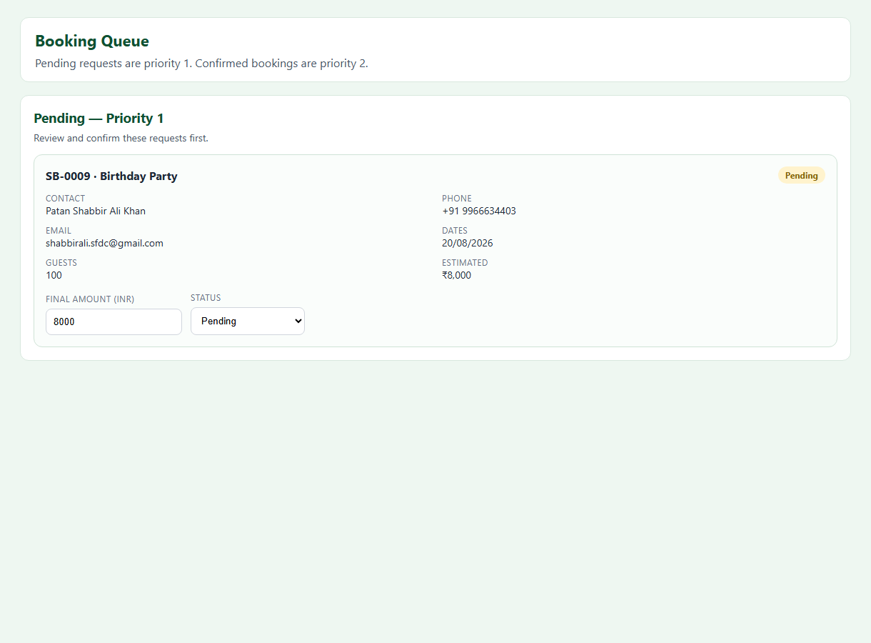
Figure S09a — Booking Queue

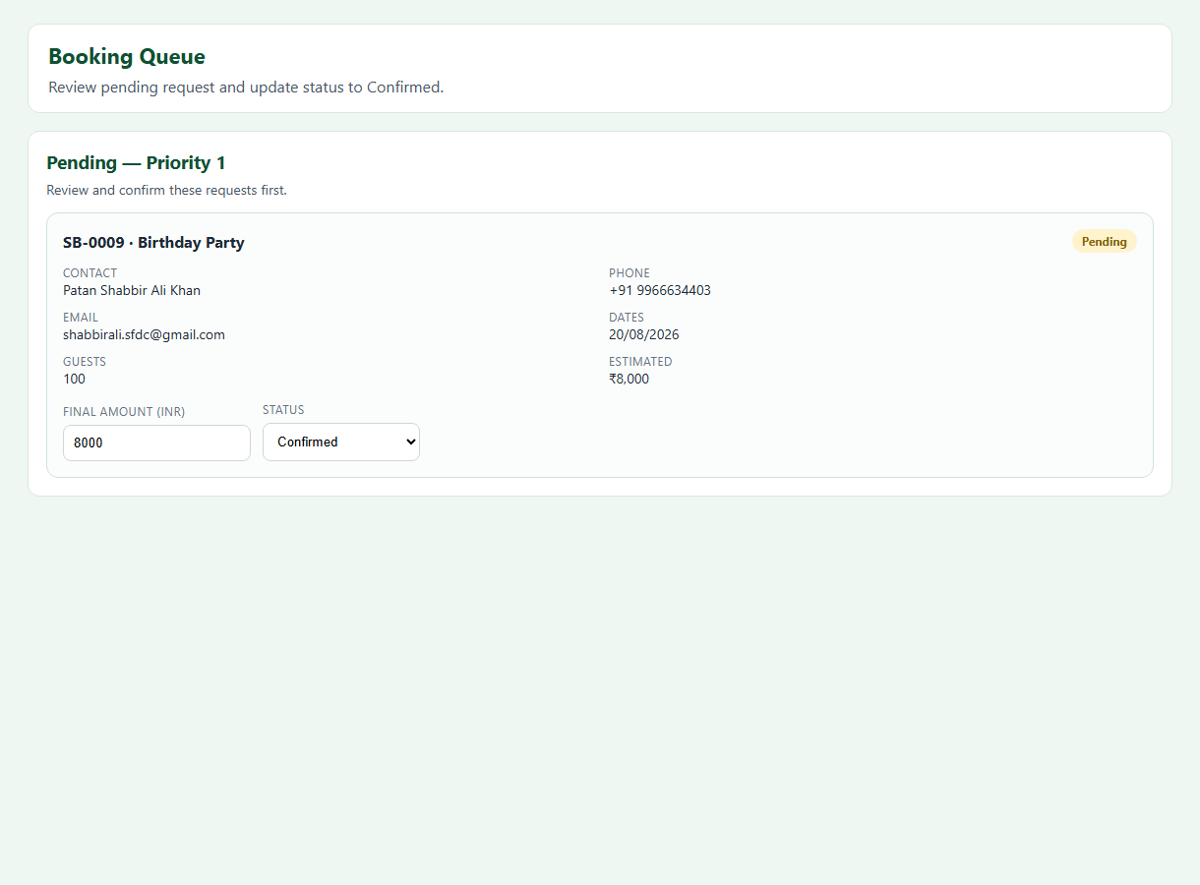
Figure S09b — Confirm action

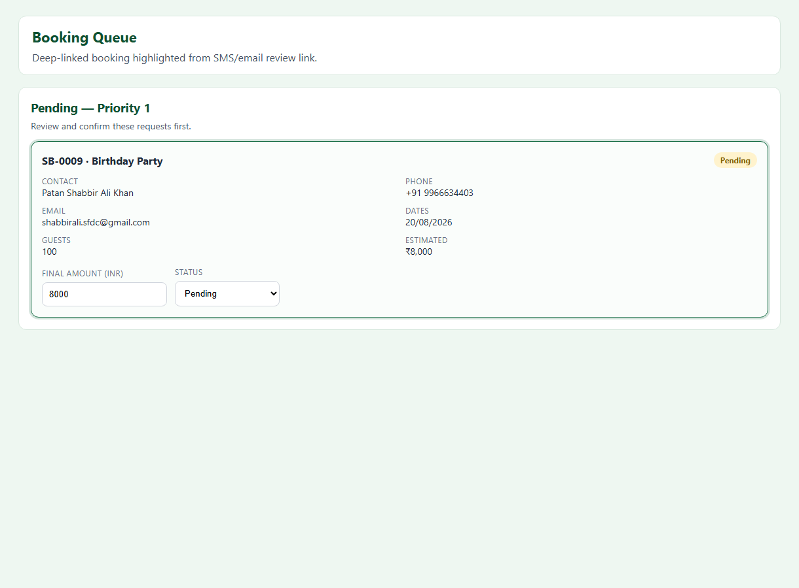
Figure S09c — Deep link highlight

S10 | Admin — Booking Report

Attribute | Description
Actor | System Administrator
Purpose | View monthly or custom-range booking analytics.
Notifications | None

Process flow
1. Open Administration → Booking Report.
2. Select month/year or custom range.
3. View summary and day-by-day breakdown.
Related components
Layer | Component | Path / Role
Apex | getMonthlyAdminReport | ShadikhanaBookingController

User interface
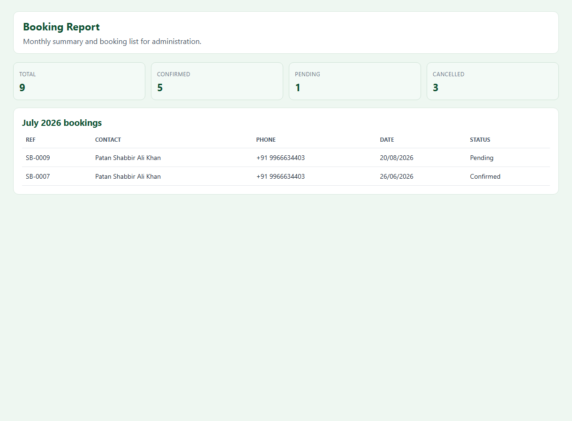
Figure S10 — Booking Report

S11 | Admin — Pricing Management

Attribute | Description
Actor | System Administrator
Purpose | Configure default daily rate and per-date overrides.
Notifications | None

Process flow
1. Open Administration → Pricing.
2. Edit default daily rate.
3. Set per-date overrides on calendar.
Related components
Layer | Component | Path / Role
Apex | saveDateRateOverride | ShadikhanaBookingController
Object | Shadikhana_Daily_Rate__c | Per-date rates

User interface
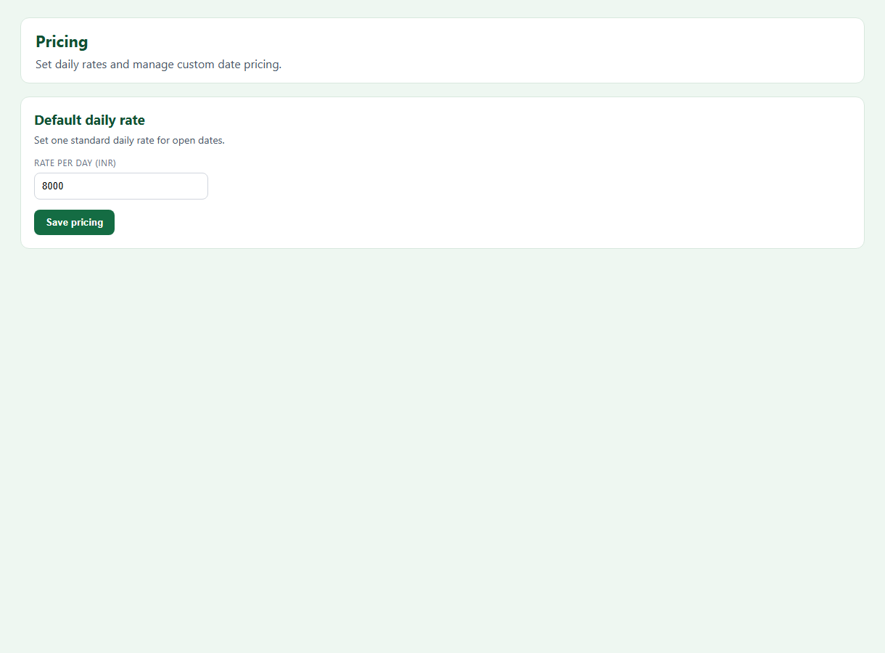
Figure S11 — Pricing section

S12 | Admin — Site Branding

Attribute | Description
Actor | System Administrator
Purpose | Update venue name, address, and gallery images.
Notifications | None

Process flow
1. Open Administration → Site Branding.
2. Edit venue name and addresses.
3. Upload gallery images.
Related components
Layer | Component | Path / Role
Apex | ShadikhanaPortalBrandingService | Branding persistence

User interface
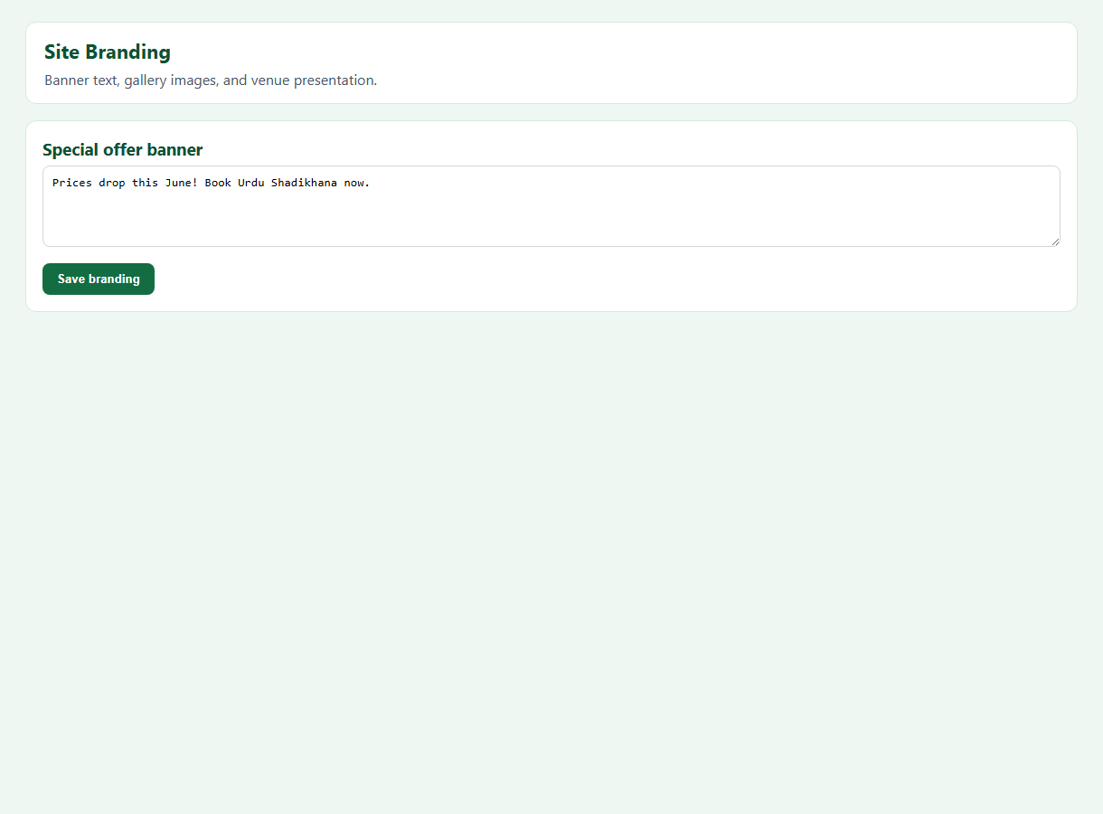
Figure S12 — Site Branding

S13 | Admin — SMS Notifications Settings

Attribute | Description
Actor | System Administrator
Purpose | Configure SMS provider and admin mobile numbers.
Notifications | None

Process flow
1. Open SMS Notifications section.
2. Toggle SMS Enabled.
3. Set admin mobiles; configure Twilio or Android Gateway.
Related components
Layer | Component | Path / Role
LWC | isAdminSmsSection | shadikhanaBookingPortal
Permission Set | Shadikhana_Sms_Gateway | Android REST access

User interface
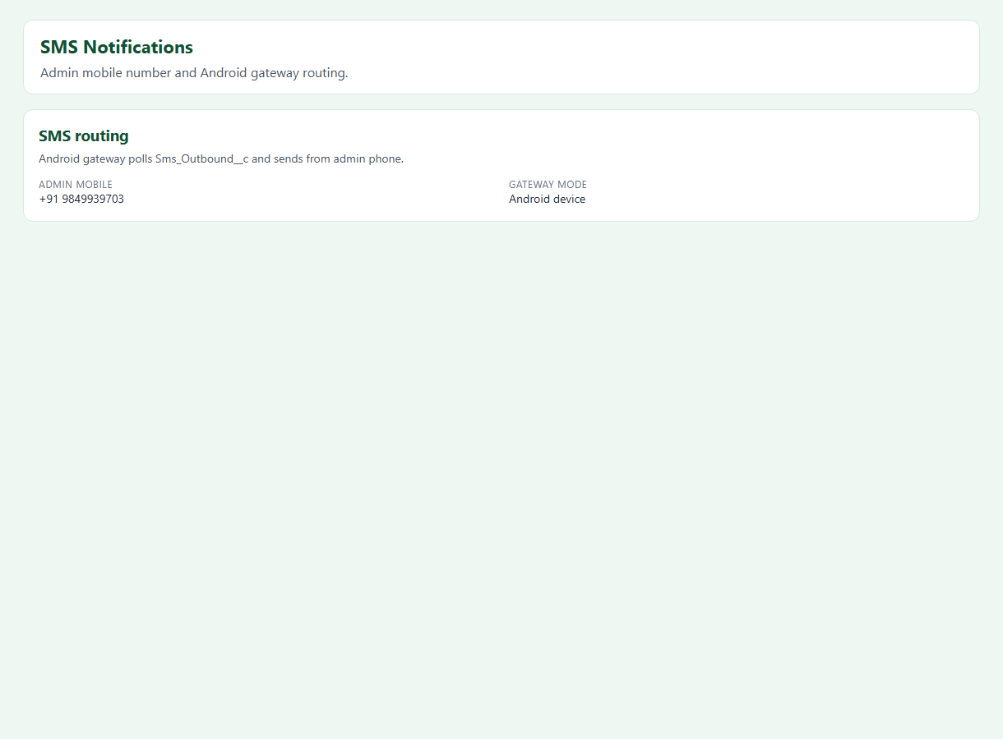
Figure S13 — SMS settings

S14 | Admin — Email Notifications Settings

Attribute | Description
Actor | System Administrator
Purpose | Configure email notifications and portal URLs.
Notifications | None

Process flow
1. Open Email Notifications section.
2. Toggle Email Enabled; set Admin Email.
3. Set Portal Site URL for deep links.
Related components
Layer | Component | Path / Role
Apex | ShadikhanaBookingEmailService | Email queueables

User interface
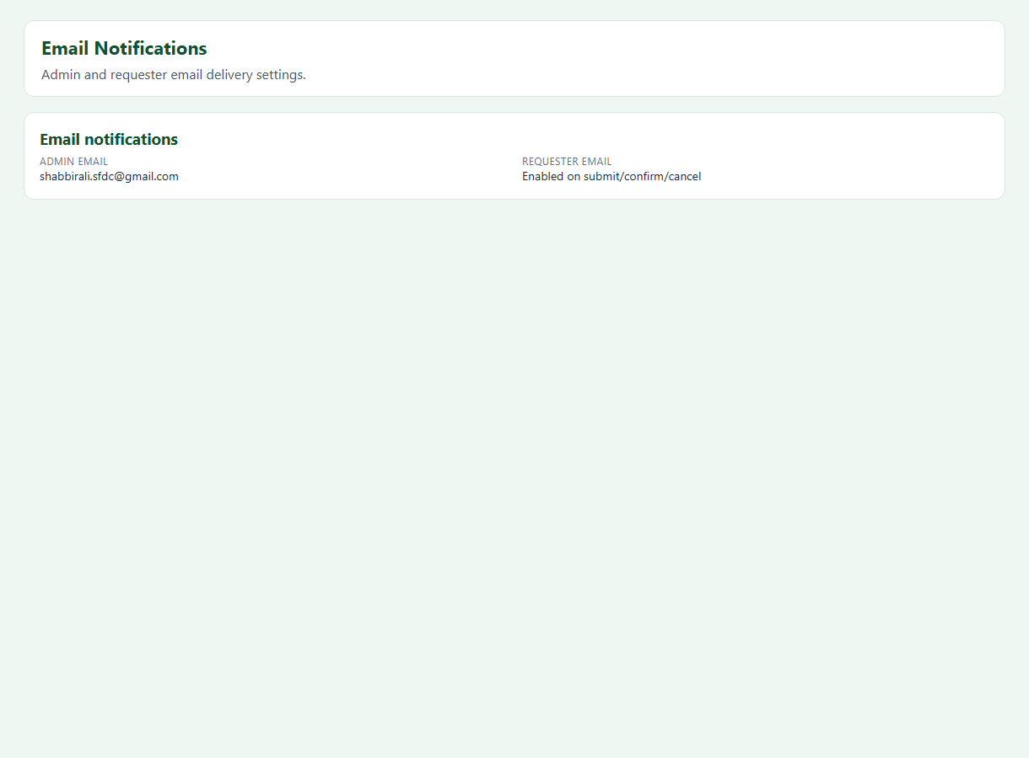
Figure S14 — Email settings

S15 | Admin — Portal Login Notes

Attribute | Description
Actor | System Administrator
Purpose | Customize text on the Experience login page.
Notifications | None

Process flow
1. Open Portal Login Notes.
2. Edit heading, message, credential hints.
3. Save — reflected on login page.
Related components
Layer | Component | Path / Role
LWC | shadikhanaLoginNotes | Login page component

User interface
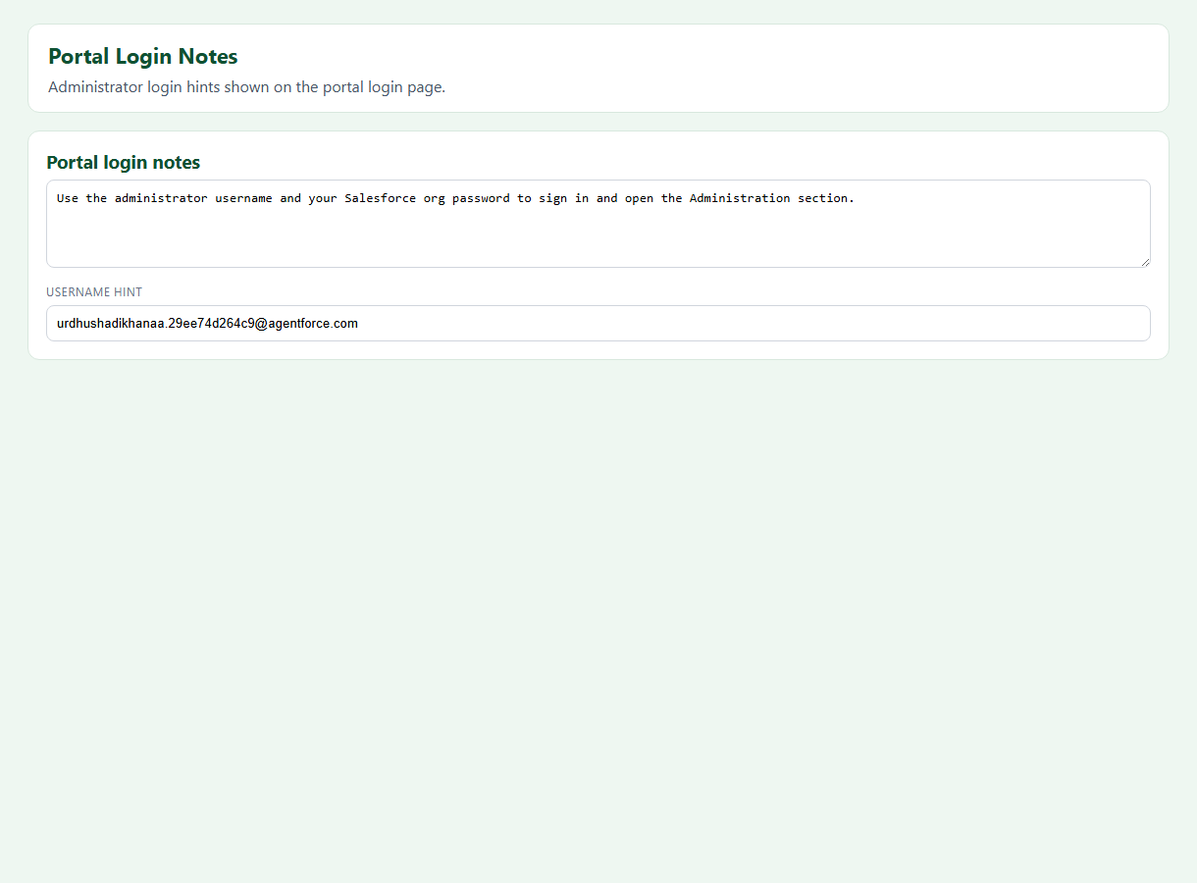
Figure S15 — Login notes editor

S16 | Admin — Booking Data Tab

Attribute | Description
Actor | System Administrator
Purpose | Paginated read-only view of all booking records.
Notifications | None

Process flow
1. Open Booking Data sidebar tab.
2. getBookingData (admin-only).
3. Paginate 5–50 records per page.
Related components
Layer | Component | Path / Role
Apex | getBookingData | ShadikhanaBookingController

User interface
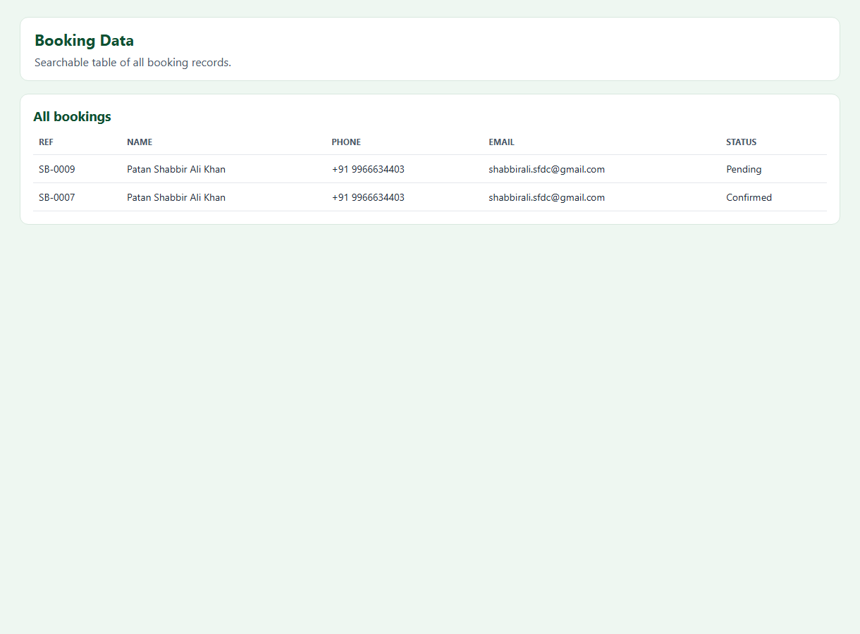
Figure S16 — Booking Data table

S17 | Android SMS Gateway — Setup & Operation

Attribute | Description
Actor | Technical admin
Purpose | Send SMS via physical Android phone SIM.
Notifications | None

Process flow
1. Deploy Sms_Outbound__c, gateway Apex, permission set.
2. Set SMS_Provider__c = Android Gateway in settings.
3. Install APK; configure instance URL, OAuth token, API key.
4. Start foreground polling service.
Related components
Layer | Component | Path / Role
Android | MainActivity.kt, SmsGatewayService.kt | android/shadikhana-sms-gateway/
Apex | ShadikhanaSmsGatewayRest | REST endpoints

User interface

Figure S17a — Gateway app

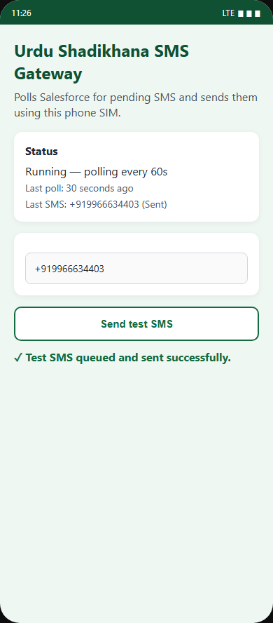
Figure S17b — Test SMS

S18 | Scheduled Cancelled Booking Cleanup

Attribute | Description
Actor | System (scheduled)
Purpose | Remove old cancelled bookings monthly.
Notifications | None

Process flow
1. Scheduler runs 5th of each month.
2. Batch deletes prior month Cancelled bookings.
Related components
Layer | Component | Path / Role
Apex | ShadikhanaCancelledCleanupScheduler | Scheduled job

User interface
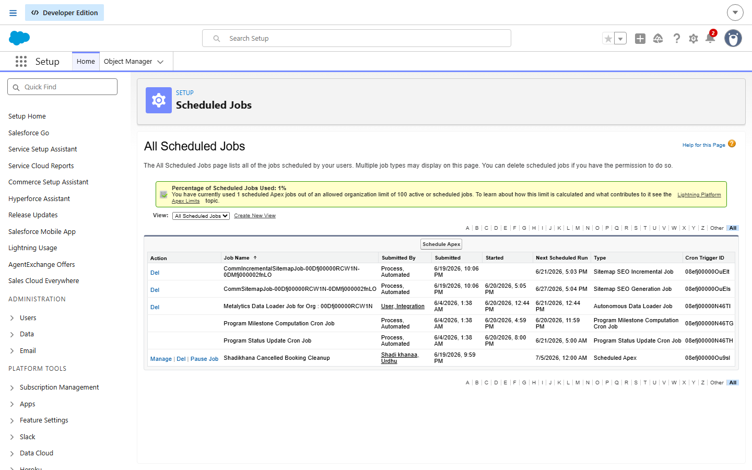
Figure S18 — Scheduled Jobs

4. Complete Component Reference

4.1 Lightning Web Components
Component | Purpose | Path
shadikhanaBookingPortal | Main portal (all tabs, wizard, admin) | lwc/shadikhanaBookingPortal/
shadikhanaLoginNotes | Login page notes | lwc/shadikhanaLoginNotes/
shadikhanaLoginBranding | Login branding (optional) | lwc/shadikhanaLoginBranding/

4.2 Apex Classes
Class | Purpose
ShadikhanaBookingController | All @AuraEnabled portal APIs
ShadikhanaBookingPricing | Price calculation and rate overrides
ShadikhanaBookingEmailService | Email notifications
ShadikhanaBookingSmsService | SMS (Twilio + gateway routing)
ShadikhanaSmsGatewayService | Sms_Outbound__c queue
ShadikhanaSmsGatewayRest | REST API for Android app
ShadikhanaPortalBrandingService | Branding and gallery
ShadikhanaCancelledBookingCleanupBatch | Monthly cleanup

4.3 Custom Objects
Object | Purpose
Shadikhana_Booking__c | Booking requests and pricing
Shadikhana_Settings__c | Org-wide portal and notification settings
Shadikhana_Daily_Rate__c | Per-date pricing overrides
Sms_Outbound__c | Android SMS outbound queue
Portal_Banner__c | Portal banner messages

4.4 Permission Sets
Permission Set | Purpose
Shadikhana_Guest_Portal | Public guest booking access
Shadikhana_Community_Booking | Logged-in community users
Shadikhana_Booking_User | Internal admin booking CRUD
Shadikhana_Twilio_Callout | Twilio named credential
Shadikhana_Sms_Gateway | Android integration user

5. Screenshot Capture Guide
Regenerating this document
1. Add PNG files to docs/screenshots/
2. Run: python scripts/generate-e2e-word-doc.py
3. Open in Word and press Ctrl+A then F9 to refresh page numbers

- Public pages: node scripts/capture-doc-screenshots.js
- Admin pages: capture manually while logged in as System Administrator
- See docs/screenshots/README.md for filename list

5.1 Screenshot Index
Filename | Status | Notes
01-portal-home-header.png | ✓ Captured
02-portal-home-top.png | ✓ Captured
02b-sidebar-navigation.png | ✓ Captured
03-venue-gallery.png | ✓ Captured
04-venue-address-map.png | ✓ Captured
05-booking-form-step1-dates.png | ✓ Captured
06-calendar-date-picker.png | ✓ Captured
07-availability-calendar-panel.png | ✓ Captured
08-portal-footer.png | ✓ Captured
09-login-page.png | ✓ Captured
10-booking-step2-event.png | ✓ Captured
11-booking-step3-contact.png | ✓ Captured
12-booking-step4-review.png | ✓ Captured
13-booking-submit-success.png | ✓ Captured
14-sms-outbound-pending.png | ✓ Captured
15-android-gateway-app.png | ✓ Captured
16-admin-sms-received.png | ✓ Captured
20-admin-booking-queue.png | ✓ Captured
21-admin-confirm-booking.png | ✓ Captured
22-admin-deep-link-highlight.png | ✓ Captured
23-admin-booking-report.png | ✓ Captured
24-admin-pricing.png | ✓ Captured
25-admin-branding.png | ✓ Captured
26-admin-sms-settings.png | ✓ Captured
27-admin-email-settings.png | ✓ Captured
28-admin-login-notes.png | ✓ Captured
29-admin-booking-data.png | ✓ Captured
30-android-test-sms.png | ✓ Captured
31-scheduled-jobs.png | ✓ Captured

6. Related Documentation
Document | Path | Audience
Functionality Guide | docs/FUNCTIONALITY-GUIDE.md | Business users
Technical Documentation | docs/TECHNICAL-DOCUMENTATION.md | Developers
Deployment Guide | docs/DEPLOYMENT-GUIDE.md | DevOps
Android Gateway README | android/shadikhana-sms-gateway/README.md | Mobile / SMS
Post-Deploy Checklist | deploy/urdu-shadikhana/POST-DEPLOY-CHECKLIST.md | Deploy

