Part A — Short Theory Answers
1. Mean Median Mode
Mean:
Mean is the average value of data. It is calculated by dividing total values by number of observations. In this project, mean income shows the average income of customers.
Median:
Median is the middle value of arranged data. It helps identify the central value without effect of extreme values.
Mode:
Mode is the most frequently occurring value in data. It shows which value appears maximum times.
2. Variance and Standard Deviation
Variance:
Variance measures how far data values are spread from the mean. Higher variance means data is more spread out.
Standard Deviation:
Standard deviation is the square root of variance. It shows how much data values differ from the average value.
3. Random Variable
A random variable is a variable whose value depends on chance or probability.
Example: Loan default status of customers can be considered a random variable because it may be “Yes” or “No”.
4. Conditional Probability
Conditional probability means probability of an event occurring under a specific condition.
Formula:
P(A|B) = P(A and B) / P(B)
Example: Probability of loan default when credit score is less than 600.
5. Bayes Theorem
Bayes theorem helps calculate probability based on prior knowledge.
Formula:
P(A|B) = [P(B|A) × P(A)] / P(B)
Banks use Bayes theorem to predict loan default risk based on customer data.
6. Empirical Probability and Theoretical Probability
Empirical Probability:
Probability calculated using actual observed data.
Theoretical Probability:
Probability calculated using mathematical formulas without experiments.
7. Poisson Distribution
Poisson distribution is used to measure number of events occurring in a fixed interval of time.
Example: Number of loan defaults in a month.
8. Eigenvalues and Eigenvectors
Eigenvalues and eigenvectors are important concepts in linear algebra used in data analysis and machine learning. They help identify important patterns and relationships in data.

Part B — Practical Task Outputs
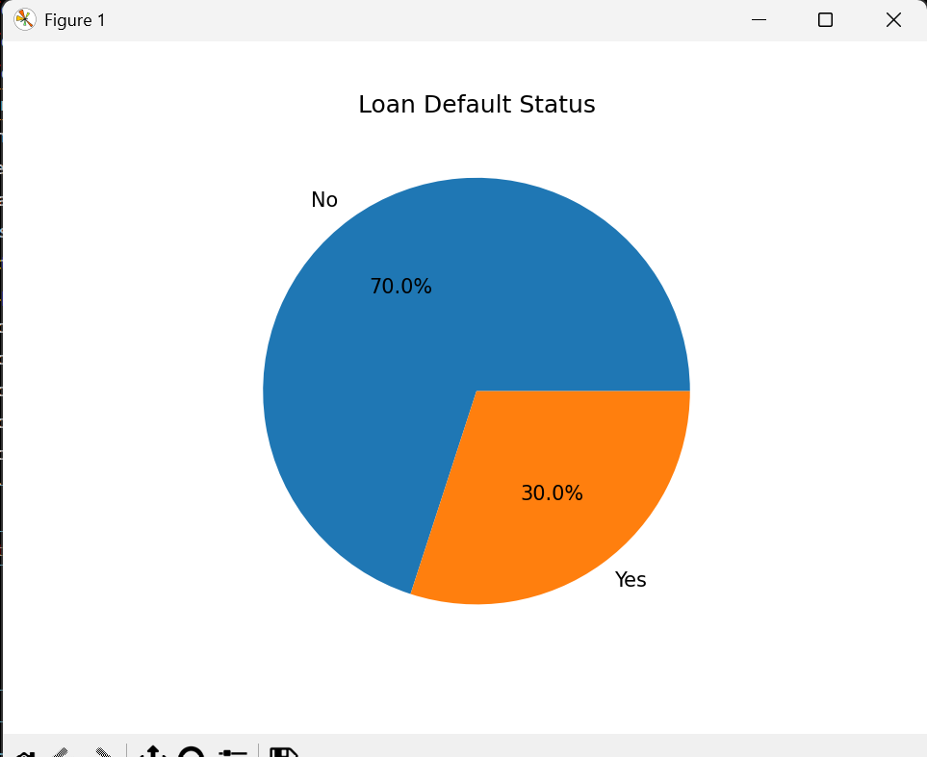
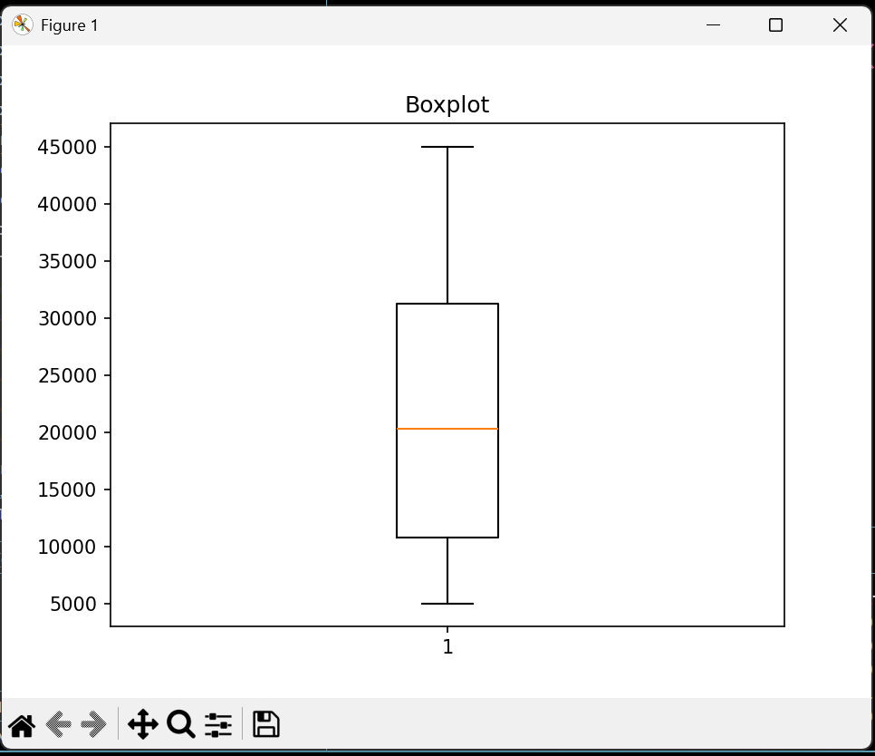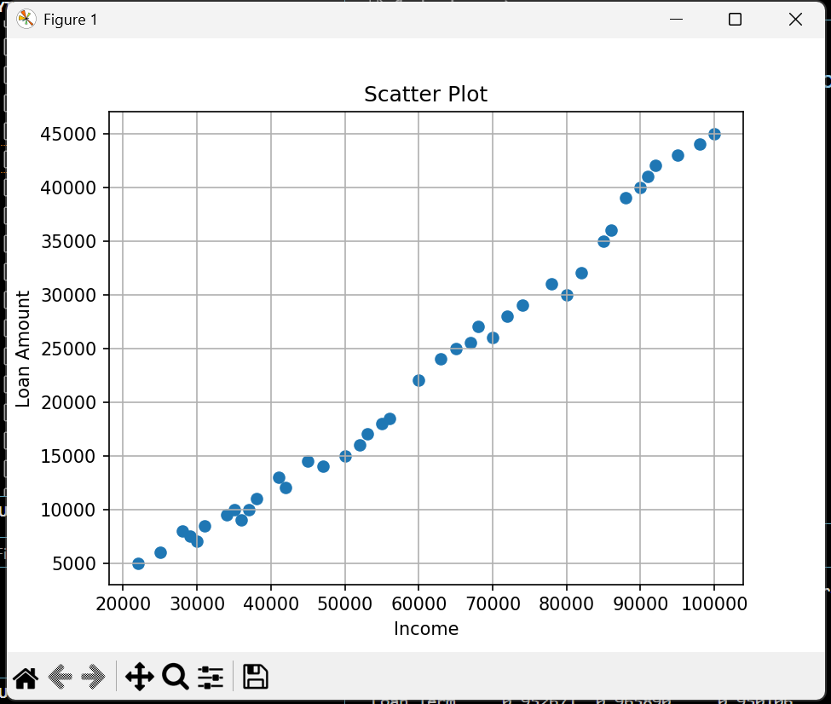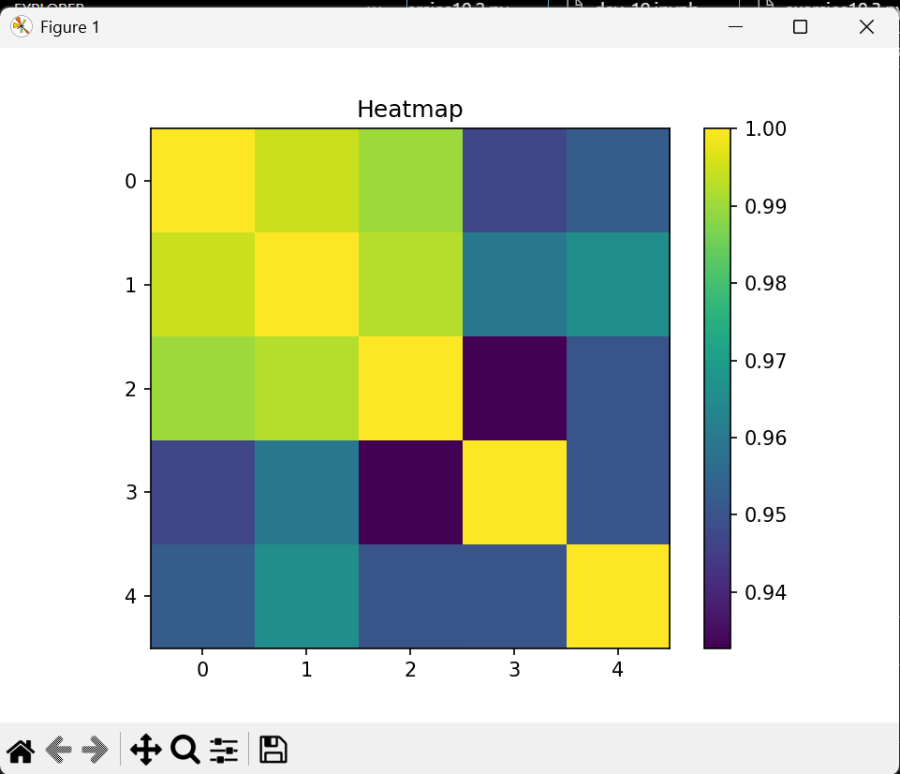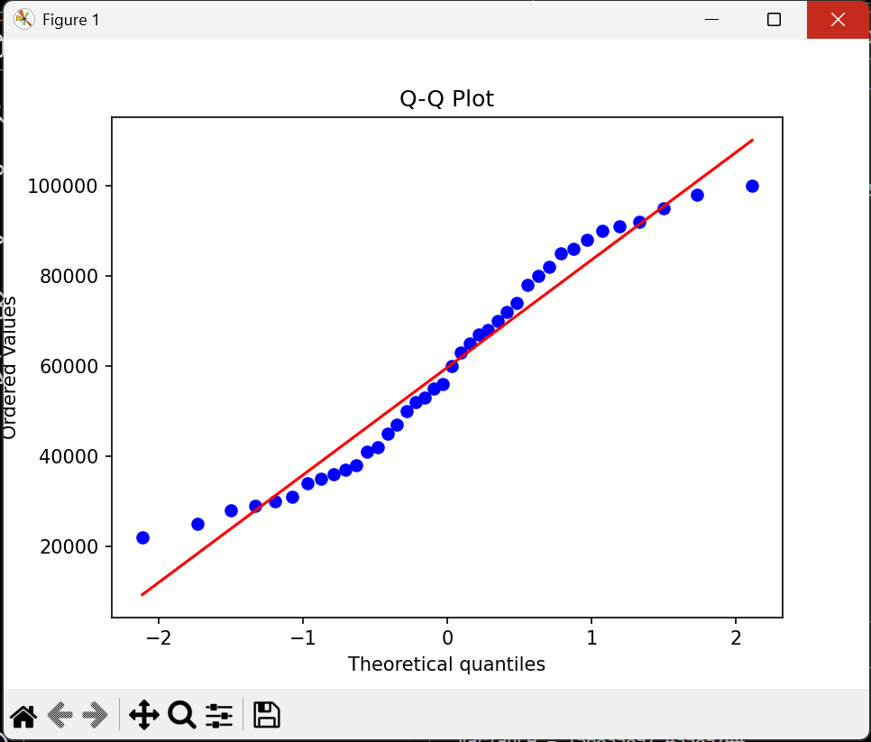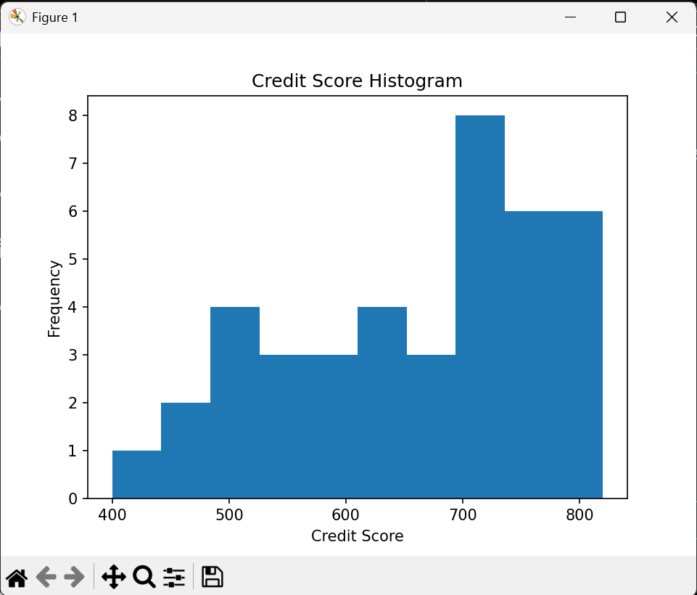
Dataset Information
Dataset Shape = (40, 7)
Dataset Fields:
Customer_ID
Age
Income
Loan_Amount
Credit_Score
Loan_Term
Default_Status
Mean Median Mode Output
Mean = 59750.0
Median = 58000.0
Mode = 22000
Variance and Standard Deviation Output
Variance = 156835897.43589744
Standard Deviation = 12523.413968878353
Probability Output
Default Probability = 0.3
Conditional Probability = 1.0
Linear Algebra Output
Dot Product = 1900000000
Norm = 36400.54944640259
Angle = 0.7538483330703917
Correlation Matrix Output
Age Income Loan_Amount Credit_Score Loan_Term
Age 1.000000 0.994608 0.990046 0.947002 0.952671
Income 0.994608 1.000000 0.992444 0.959788 0.965890
Loan_Amount 0.990046 0.992444 1.000000 0.932693 0.950106
Credit_Score 0.947002 0.959788 0.932693 1.000000 0.950369
Loan_Term 0.952671 0.965890 0.950106 0.950369 1.000000
Graphs Included
1. Histogram
2. Q-Q Plot
3. Scatter Plot
4. Heatmap
5. Boxplot
6. Pie Chart
Final Insights
1. Customers with low credit scores have higher default risk.
2. Customers with higher income usually take larger loan amounts.
3. Probability and statistics help banks identify risky customers.
4. Correlation analysis helps understand relationships between variables.
5. Linear algebra concepts help represent customer financial data mathematically.

