📊 DATA PREPROCESSING AND FEATURE ENGINEERING PROJECT REPORT
🎓 Submitted By
Name: [Your Name]
Course: BCA
Subject: Data Preprocessing and Feature Engineering
College / University: [Your College Name]
Academic Year: 2025 – 2026

🌟 Project Title
Customer Credit Risk Analysis using Data Preprocessing and Feature Engineering

📌 Introduction
Data preprocessing is one of the most important steps in Data Science and Machine Learning. Raw data collected from real-world systems often contains missing values, inconsistent records, outliers, and categorical variables that cannot directly be used for Machine Learning.
This project focuses on cleaning, transforming, encoding, and scaling a customer credit risk dataset to make it machine learning ready. Multiple preprocessing techniques were implemented using Python libraries.

🎯 Objective of Project
The objective of this project is:
✅ To understand complete data preprocessing workflow
✅ To clean and prepare raw data
✅ To handle missing values
✅ To detect and treat outliers
✅ To convert categorical data into numerical form
✅ To scale numerical features
✅ To prepare final dataset for machine learning

📂 Dataset Description
This project uses a Customer Credit Risk Dataset containing 50 customer records.
Dataset includes:
- Customer ID
- Age
- Gender
- Region
- Education Level
- Employment Type
- Annual Income
- Loan Amount
- Loan Purpose
- Credit Score
- Repayment History
- Transaction Count
- Spending Ratio
- Join Date
- Default Flag
The dataset simulates banking customer data used for credit risk analysis.

🧩 Part A – Conceptual Foundation
In this section theoretical understanding was studied.
Topics covered:
📖 What is Data Analysis?
Data analysis is the process of collecting, cleaning, organizing, and analyzing data to extract useful information.
📖 How to Plan a Data Science Project?
A proper data science project follows steps such as:
- Problem Understanding
- Data Collection
- Data Cleaning
- Feature Engineering
- Model Building
- Model Evaluation
📖 Machine Learning Problem Framing
Machine learning problem framing helps define:
- Input Features
- Output Variable
- Classification or Regression Problem
📖 Tensor Operations
Tensor operations were performed using NumPy.
Implemented:
- 1D Tensor
- 2D Tensor
- 3D Tensor
- Shape Detection
- Dimension Checking
- Mathematical Operations

📥 Part B – Data Acquisition
Data was collected from multiple sources.
Different sources used:
CSV File
Customer dataset was loaded using Pandas library.
JSON File
Metadata information was loaded using JSON.
SQL Database
SQLite database was created to store loan records.
Operations performed:
- Database Connection
- Table Creation
- Data Insertion
- Data Retrieval
This stage demonstrated handling multiple data sources.

🧹 Part C – Missing Value Handling
The dataset initially contained missing values in several columns.
Missing values found in:
- Age
- Employment Type
- Credit Score
Different imputation methods were used.
Methods Applied
- Mean Imputation
- Median Imputation
- Mode Imputation
- KNN Imputer
- Iterative Imputer (MICE)
After preprocessing all missing values were removed successfully.

📸 SCREENSHOT 1 – Missing Value Detection Matrix
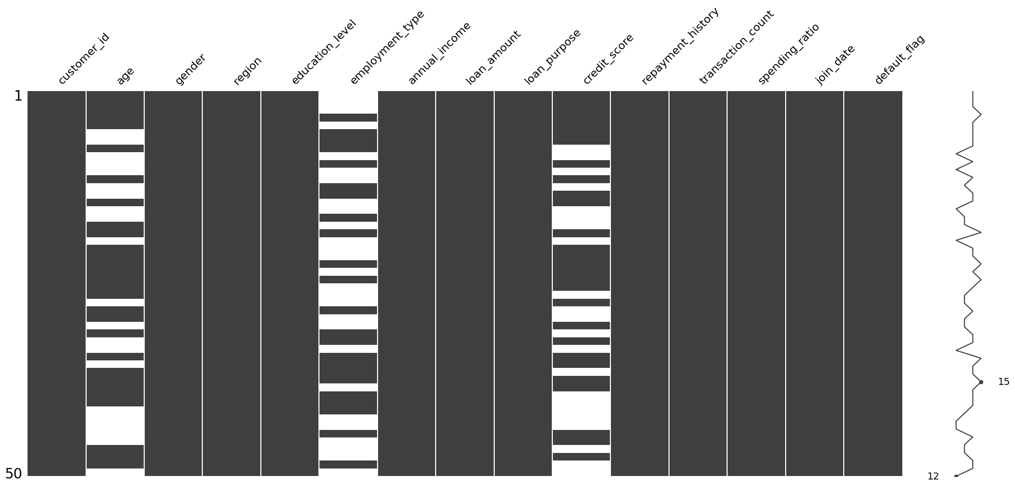

File to Paste:
Missing Value Matrix (Black/White Graph with empty spaces in Age, Employment Type, Credit Score)
Explanation:
This graph shows missing values present in the dataset before preprocessing. White spaces indicate missing data records.

📸 SCREENSHOT 2 – Missing Values After Cleaning
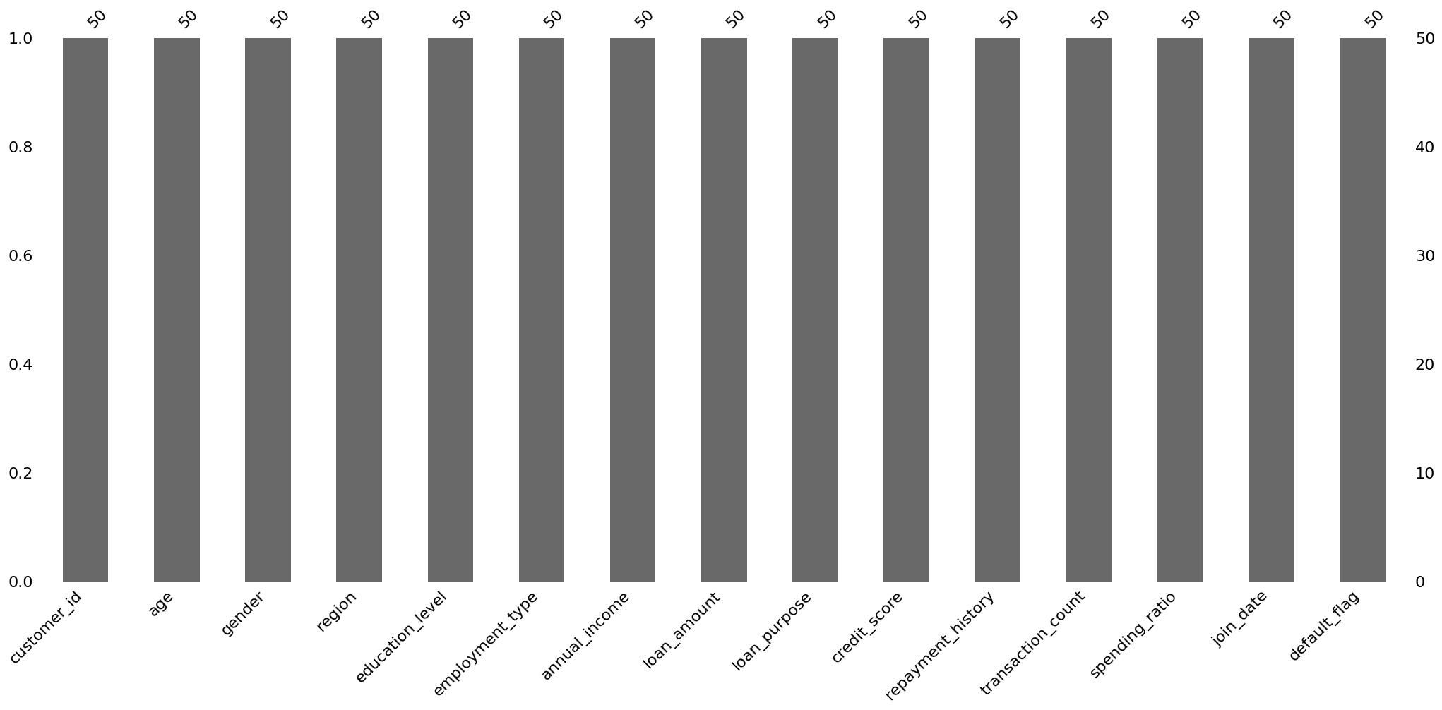
File to Paste:
Bar Graph showing all columns with value 50
Explanation:
This graph shows that after applying imputation methods all missing values were successfully removed and every column contains complete data.

📊 Part D – Outlier Detection and Treatment
Outliers are abnormal values that can negatively affect machine learning models.
Different outlier detection methods were used.
Methods Used
- Boxplot Visualization
- Z-Score Method
- IQR Method
- Winsorization Technique
These methods helped identify and treat extreme values.

📸 SCREENSHOT 3 – Annual Income Boxplot
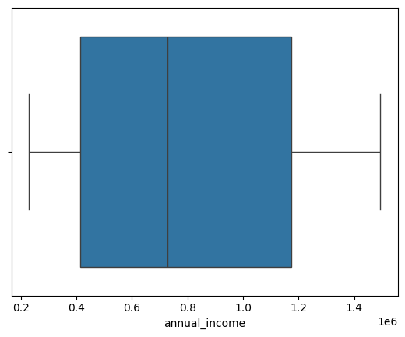

File to Paste:
Boxplot with annual_income label
Explanation:
This boxplot was used to detect outliers present in annual income values of customers.

📸 SCREENSHOT 4 – Loan Amount Boxplot
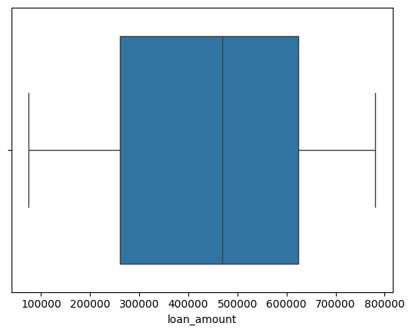
File to Paste:
Boxplot with loan_amount label
Explanation:
This graph helped detect abnormal loan amount values and analyze data distribution.

📸 SCREENSHOT 5 – Winsorization Output
Boxplot annual_income after outlier treatment

Explanation:
This graph shows data distribution after Winsorization where extreme outlier values were controlled.

📸 SCREENSHOT 6 – Final Winsor Income Boxplot
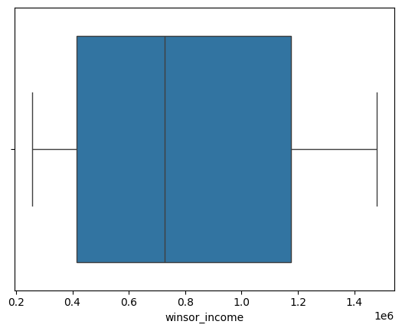Explanation:
This final boxplot confirms that outliers were successfully reduced after preprocessing.

🔢 Part E – Categorical Data Encoding
Machine Learning models require numerical input values.
Categorical data was converted into numerical format.
Methods used:
Label Encoding
Applied on:
- Gender
- Employment Type
One Hot Encoding
Applied on:
- Region
Generated columns:
- Region East
- Region North
- Region South
- Region West
Ordinal Encoding
Applied on Education Level.
Order used:
Primary → 0
Secondary → 1
Graduate → 2
Post-Graduate → 3
This transformed text data into numerical representation.

⚙ Part F – Feature Scaling and Transformation
Different scaling techniques were applied to normalize numerical data.
Methods used:
StandardScaler
Centers data around mean 0.
MinMaxScaler
Converts values between 0 and 1.
MaxAbsScaler
Scales values based on maximum value.
RobustScaler
Handles outliers better.
PowerTransformer
Converts skewed distribution closer to normal distribution.
These techniques improve machine learning performance.

🏆 Results Achieved
Project successfully completed complete preprocessing pipeline.
Results achieved:
✅ Missing values removed successfully
✅ Outliers detected and treated
✅ Categorical data encoded successfully
✅ Numerical features scaled properly
✅ Final machine learning ready dataset created
Total records processed:
50 Customer Records

💡 Learning Outcomes
Through this project I learned:
- Data cleaning techniques
- Missing value handling methods
- Outlier detection methods
- Feature engineering concepts
- Data transformation techniques
- Encoding categorical data
- Feature scaling methods
- Complete preprocessing workflow

📌 Conclusion
This project successfully demonstrated a complete Data Preprocessing and Feature Engineering pipeline using Python.
Raw customer credit risk data was transformed into a clean, structured, and machine learning ready dataset.
Proper preprocessing improves data quality and directly improves machine learning model performance.
This project helped understand practical implementation of real-world Data Science workflows.

🚀 Technologies Used
- Python
- Pandas
- NumPy
- Matplotlib
- Seaborn
- Scikit Learn
- SQLite
- JSON
- Jupyter Notebook

🙏 Thank You

