Data Preprocessing and Feature Engineering Project Report

Student Project Overview
This project focuses on cleaning healthcare patient data by handling missing values and detecting/treating outliers so the dataset becomes suitable for machine learning.

Objective
To apply multiple missing value imputation methods and outlier handling techniques on a healthcare dataset and prepare a final cleaned dataset.

Dataset Description
Dataset contains patient_id, age, gender, region, bmi, blood_pressure, cholesterol, glucose and disease_risk.

Methods Used
Missing Value Handling:
1. Mean Imputation (BMI)
2. Most Frequent Imputation (Region, Gender)
3. Missing Indicator Method
4. Random Sample Imputation (Age)
5. KNN Imputer
6. MICE Algorithm
Outlier Handling:
1. Z Score Method
2. IQR Method
3. Percentile Method
4. Winsorization

Results Summary
- Missing values successfully detected and treated.
- KNN and MICE generated multivariate estimations.
- IQR method detected BMI outlier.
- Boxplot identified cholesterol outliers.
- Final dataset had zero missing values.

Output Interpretation
The missing values graph showed incomplete fields before cleaning. The cholesterol boxplot highlighted extreme outliers around higher cholesterol levels.

Conclusion
1. Dataset quality improved significantly.
2. Missing values handled using advanced preprocessing techniques.
3. Outliers detected and treated successfully.
4. Final cleaned dataset is ready for machine learning analysis.

Learning Outcome
- Learned practical data preprocessing
- Learned imputation techniques
- Learned outlier detection methods
- Built machine-learning ready dataset

Project Screenshots
Figure 1: Missing Values Before Cleaning
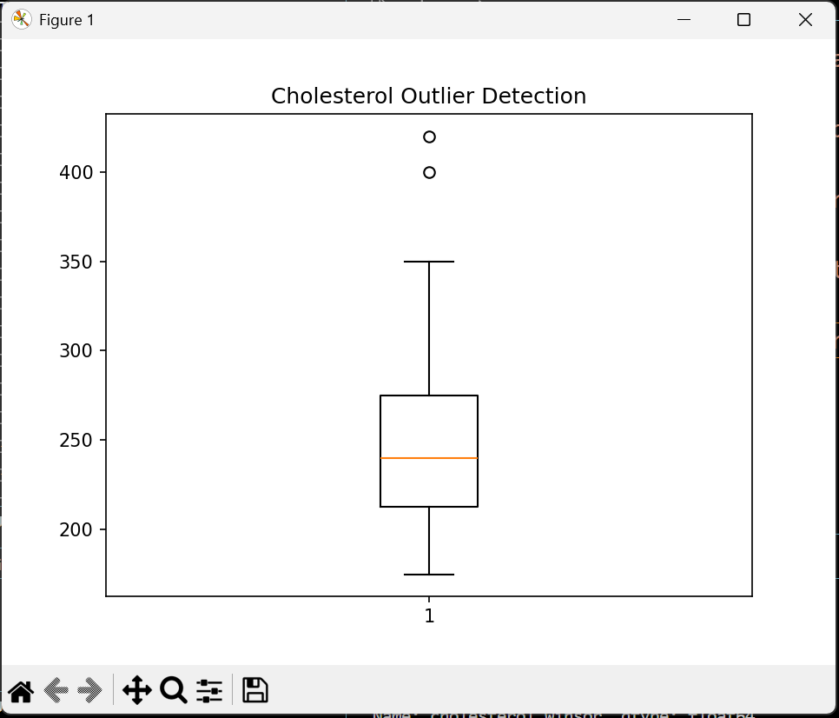
Figure 2: Cholesterol Outlier Detection
