🏥 HEALTHCARE DATA PREPROCESSING AND FEATURE ENGINEERING PROJECT REPORT

📖 1. Introduction
Data preprocessing is an important step in data analytics and machine learning. Real-world data often contains missing values, incorrect values, duplicate records and outliers. If data is not cleaned properly, machine learning models can give poor accuracy.
This project focuses on cleaning healthcare patient data using preprocessing and feature engineering techniques. Different statistical and machine learning based methods are applied to make data clean and ready for future analysis.

🎯 2. Project Objective
The main objective of this project is to understand and apply practical preprocessing techniques on healthcare patient data.
Objectives:
✅ Detect missing values in dataset
✅ Calculate missing value percentage
✅ Apply different imputation techniques
✅ Detect outliers using statistical methods
✅ Treat extreme values
✅ Compare original and cleaned dataset
✅ Generate final machine learning ready dataset

❗ 3. Problem Statement
Healthcare datasets often contain incomplete patient information. Missing values and abnormal medical values reduce data quality and affect prediction performance.
This project solves this problem by cleaning the dataset and transforming raw healthcare data into high quality structured data.

📊 4. Dataset Description
The dataset contains 50 patient healthcare records.
Dataset file used:
patient_health_records.csv
📌 Total Records = 50
📌 Total Columns = 9

📋 5. Dataset Columns Description
Column Name | Description
patient_id | Unique patient ID
age | Age of patient
gender | Male or Female
region | Region of patient
bmi | Body Mass Index
blood_pressure | Blood pressure
cholesterol | Cholesterol level
glucose | Glucose level
disease_risk | Disease prediction target

🔍 6. Basic Dataset Analysis
Dataset loaded successfully using Pandas.
Output:
Shape = (50,9)
Dataset contains:
✅ Numerical Data
✅ Categorical Data

⚠️ 7. Missing Value Analysis
The dataset contained missing values.
Results:
Column | Missing Values
age | 4
gender | 3
region | 4
bmi | 4
cholesterol | 3
glucose | 4
This proves preprocessing is required.

📈 8. Missing Value Percentage Analysis
Percentage calculated successfully.
Column | Percentage
age | 8%
gender | 6%
region | 8%
bmi | 8%
cholesterol | 6%
glucose | 8%

🧮 9. Mean Imputation
Mean Imputation replaces missing numerical values using average.
Applied on:
BMI Column
Mean value:
31.55
Example:
❌ Before → BMI = NaN
✅ After → BMI = 31.55

🔄 10. Most Frequent Imputation
Missing categorical values replaced using most frequent category.
Applied on:
Region Column
Example:
❌ Before → Region = NaN
✅ After → Region = North

🚻 11. Gender Imputation
Applied on:
Gender Column
Example:
❌ Before → Gender = NaN
✅ After → Gender = Male

🏷️ 12. Missing Indicator Method
Binary column created.
Applied on:
Age Column
Logic:
0 = Value Present
1 = Missing Value Present

🎲 13. Random Sample Imputation
Missing age values replaced using random existing values.
Example:
❌ Before → Age = NaN
✅ After → Age = 40

🤖 14. KNN Imputer
KNN = K Nearest Neighbor
Used columns:
- age
- bmi
- cholesterol
- glucose
Example:
Patient 3 glucose estimated = 107
KNN gives realistic estimated values.

🧠 15. MICE Algorithm
MICE = Multiple Imputation by Chained Equations
Example:
Patient 3 glucose estimated = 105.02
This is an advanced imputation technique.

📉 16. Missing Values Visualization
Graph created to visualize missing values.
Purpose:
✅ Identify incomplete columns
✅ Understand missing value distribution

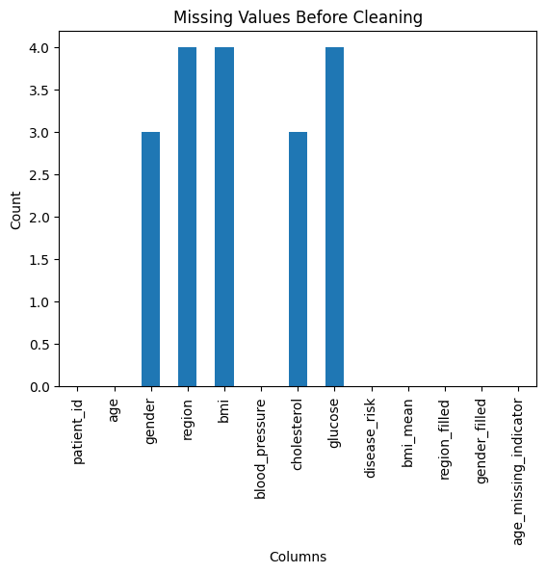

🚨 17. Outlier Detection Introduction
Outliers are abnormal values different from normal data.
They reduce model performance and affect analysis quality.

📏 18. Z Score Method
Applied on:
Cholesterol Column
Result:
No Outliers Detected
Output:
Empty DataFrame

📦 19. IQR Method
IQR = Interquartile Range
Applied on:
BMI Column
Result:
No Outliers Detected

📐 20. Percentile Method
Used to cap extreme glucose values.
Example:
❌ Before → 390
✅ After → 380.20

🛡️ 21. Winsorization Method
Used to reduce extreme cholesterol values.
Example:
❌ Before → 460
✅ After → 420

📊 22. Outlier Visualization
Boxplot created for cholesterol distribution.
Purpose:
✅ Detect extreme values visually
✅ Understand data spread

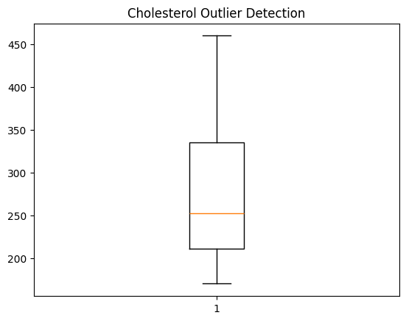

🗂️ 23. Final Dataset Creation
Final cleaned dataset created successfully.
Output file:
cleaned_patient_dataset.csv

🔄 24. Comparison Between Original and Cleaned Dataset

Original Dataset
patient_health_records.csv
Contains:
❌ Missing values
❌ Extreme values
❌ Raw unprocessed data

Cleaned Dataset
cleaned_patient_dataset.csv
Contains:
✅ No missing values
✅ Outliers treated
✅ Machine learning ready data

✅ 25. Final Verification
Output:
Remaining Missing Values = 0
All missing values successfully removed.

📊 26. Statistical Comparison
Original dataset:
- Maximum cholesterol = 460
- Maximum glucose = 390
Cleaned dataset:
- Maximum cholesterol = 420
- Maximum glucose = 380.20
This proves preprocessing worked successfully.

💻 27. Technologies Used
- Python
- Pandas
- NumPy
- Matplotlib
- Scikit Learn
- SciPy
- Jupyter Notebook

🎓 28. Learning Outcome
This project helped understand:
✅ Data preprocessing workflow
✅ Missing value handling
✅ Statistical analysis
✅ Advanced imputation methods
✅ Outlier detection
✅ Machine learning data preparation

🏆 29. Project Result
Successfully completed preprocessing of healthcare dataset.
Achievements:
✅ Missing values handled
✅ Advanced imputation implemented
✅ Extreme values treated
✅ Final cleaned dataset created

📌 30. Final Conclusion
This project successfully demonstrated real-world implementation of data preprocessing and feature engineering techniques on healthcare data.
Different missing value handling methods such as Mean Imputation, Random Sample Imputation, KNN Imputer and MICE Algorithm were implemented successfully.
Outlier handling techniques such as Z Score, IQR Method, Percentile Method and Winsorization were applied successfully.
The final dataset was cleaned and made ready for machine learning analysis.

