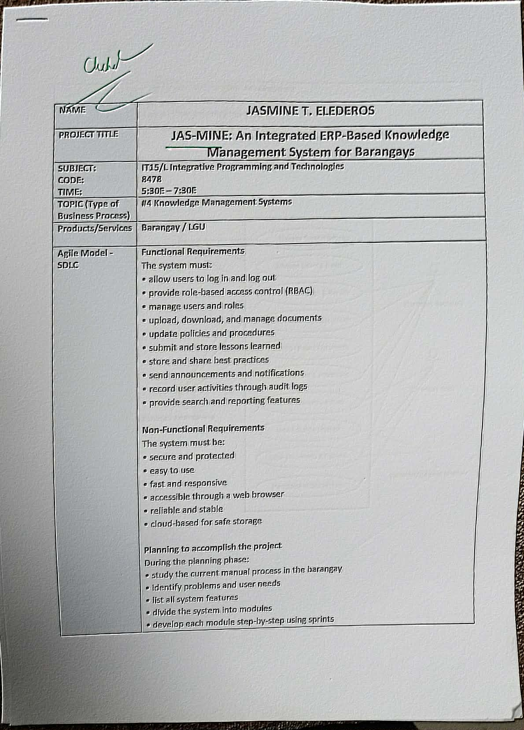

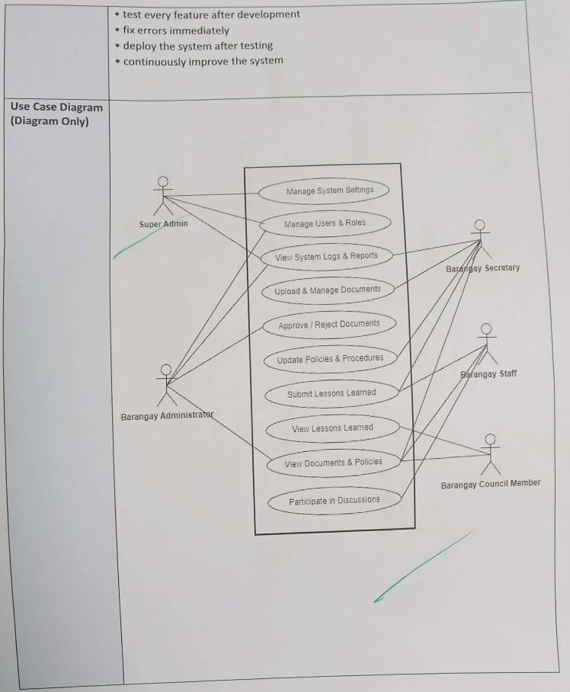

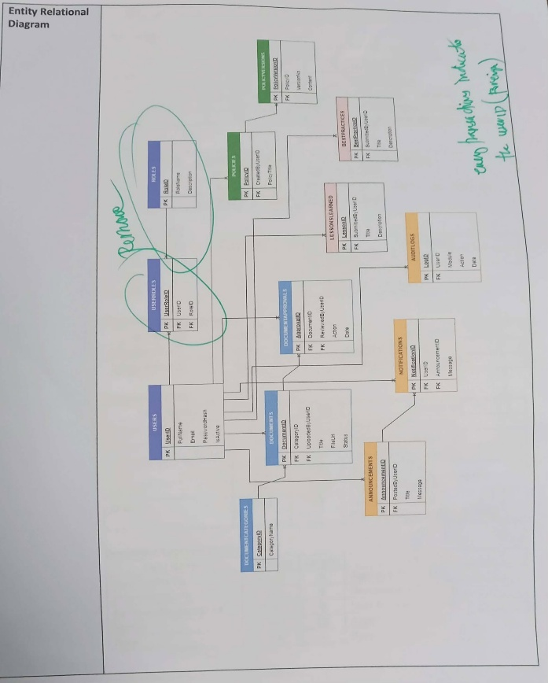

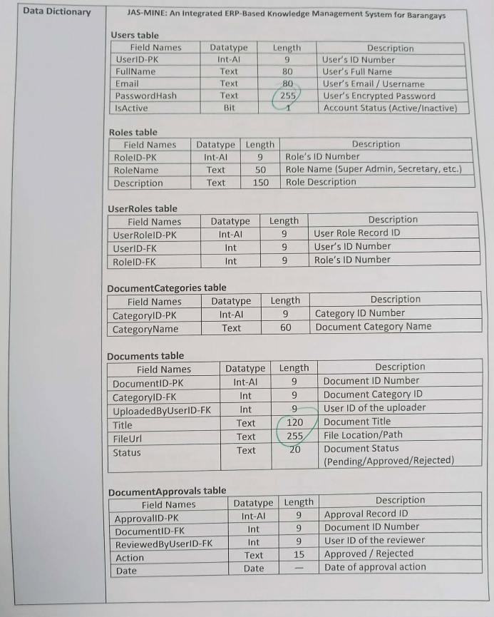

NAME | JASMINE T. ELEDEROS
PROJECT TITLE | JAS-MINE: An Integrated ERP-Based Knowledge Management System for Barangays
SUBJECT:  CODE:  TIME: | IT15/L Integrative Programming and Technologies  8478  5:30E – 7:30E
TOPIC (Type of Business Process) | #4 Knowledge Management Systems
Products/Services | Barangay / LGU
Agile Model - SDLC | Functional Requirements  The system must:  • allow users to log in and log out  • provide role-based access control (RBAC)  • manage users and roles  • upload, download, and manage documents  • update policies and procedures  • submit and store lessons learned  • store and share best practices  • send announcements and notifications  • record user activities through audit logs  • provide search and reporting features  Non-Functional Requirements  The system must be:  • secure and protected  • easy to use  • fast and responsive  • accessible through a web browser  • reliable and stable  • cloud-based for safe storage  Planning to accomplish the project  During the planning phase:  • study the current manual process in the barangay  • identify problems and user needs  • list all system features  • divide the system into modules  • develop each module step-by-step using sprints  • test every feature after development  • fix errors immediately  • deploy the system after testing  • continuously improve the system
Use Case Diagram  (Diagram Only) | 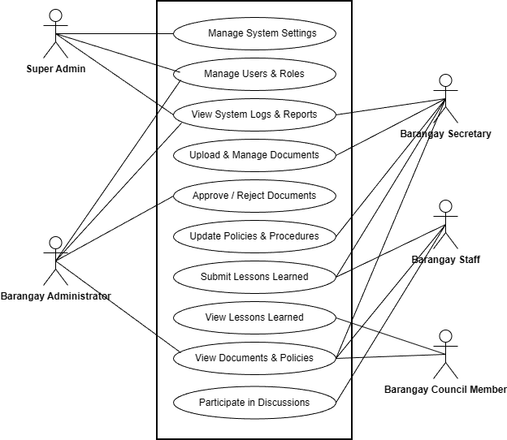
Entity Relational Diagram | 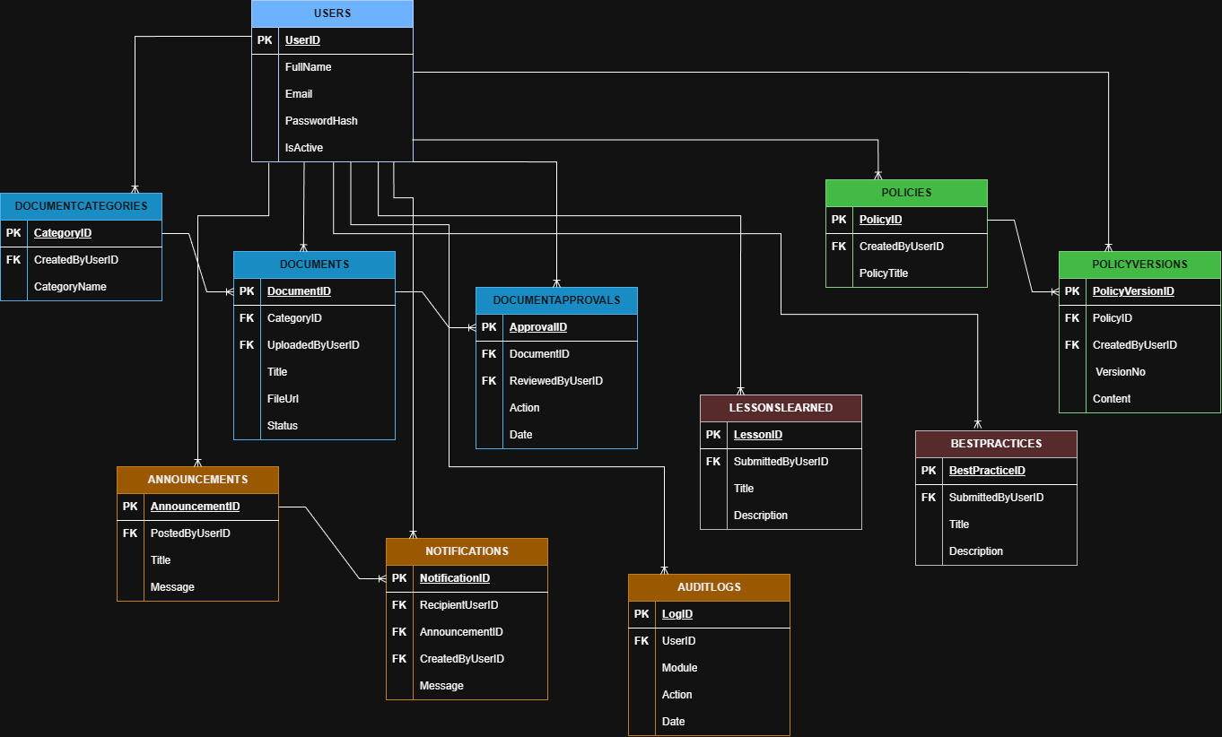
Data Dictionary | JAS-MINE: An Integrated ERP-Based Knowledge Management System for Barangays  Barangays table  Field Names Datatype Length Description  BarangayID-PK Int-AI — Barangay’s ID Number  BarangayName NVARCHAR 100 Barangay name  City NVARCHAR 50 City/Municipality  Province NVARCHAR 50 Province  IsActive Bit — Barangay status (Active/Inactive)  CreatedAt DATETIME — Date created  Users table  Field Names Datatype Length Description  UserID-PK Int-AI — User’s ID Number  BarangayID-FK Int — Barangay ID (FK)  RoleID-FK Int 4 User’s role  FullName NVARCHAR 20 User’s Full Name  Email NVARCHAR 20 User’s Email / Username  PasswordHash NVARCHAR 10 User’s Encrypted Password  IsActive Bit — Account Status (Active/Inactive)  CreatedAt DateTime — Date account created  Roles table  Field Names Datatype Length Description  RoleID-PK Int-AI 9 Role’s ID Number  RoleName NVARCHAR 10 Role Name (Super Admin, Secretary, etc.)  Description NVARCHAR — Role Description  DocumentCategories table  Field Names Datatype Length Description  CategoryID-PK Int-AI 9 Category ID Number  CategoryName Text 50 Document Category Name  CreatedByUserID-FK Int 4 User who created the category  Documents table  Field Names Datatype Length Description  DocumentID-PK Int-AI 9 Document ID Number  BarangayID-FK Int 9 Barangay ID  CategoryID-FK Int 9 Document Category ID  UploadedByUserID-FK Int 9 User ID of the uploader  Title Text 120 Document Title  Description — Document short description  FileUrl Text — File Location/Path  Status Text 10 Status (draft/pending/approved/rejected)  CreatedAt DATETIME 8 Upload date  DocumentApprovals table  Field Names Datatype Length Description  ApprovalID-PK Int-AI 9 Approval Record ID  BarangayID-FK Int 9 Barangay ID  DocumentID-FK Int 9 Document ID Number  ReviewedByUserID-FK Int 9 User ID of the reviewer  Action Text 10 Approved / Rejected  Date Date — Date of approval action  Policies table  Field Names Datatype Length Description  PolicyID-PK Int-AI 9 Policy ID Number  BarangayID-FK 9 Barangay ID  CreatedByUserID-FK Int 9 User ID who created the policy  PolicyTitle Text 50 Policy Title  Status Text 10 Status (draft/pending/approved/rejected)  CreatedAt DATETIME 8 Date created  PolicyVersions table  Field Names Datatype Length Description  PolicyVersionID-PK Int-AI 9 Policy Version ID  BarangayID-FK Int 9 Barangay ID  PolicyID-FK Int 9 Policy ID Number  CreatedByUserID-FK Int 9 User ID who created this version  VersionNo Int 9 Version Number  Content Text 100 Policy Content / Details  CreatedAt DATETIME 8 Version created date  LessonsLearned table  Field Names Datatype Length Description  LessonID-PK Int-AI 9 Lesson Learned ID  BarangayID-FK Int 9 Barangay ID  SubmittedByUserID-FK Int 9 User ID who submitted  Title Text 50 Lesson Title  Description Text 100 Lesson Details / Explanation  Status Text 10 Status (draft/published)  CreatedAt DATETIME 8 Date submitted  BestPractices table  Field Names Datatype Length Description  BestPracticeID-PK Int-AI 9 Best Practice ID  BarangayID-FK Int 9 Barangay ID  SubmittedByUserID-FK Int 9 User ID who submitted  Title Text 50 Best Practice Title  Description Text 100 Best Practice Details  CreatedAt DATETIME 8 Date submitted  Announcements table  Field Names Datatype Length Description  AnnouncementID-PK Int-AI 9 Announcement ID  BarangayID-FK Int 9 Barangay ID  PostedByUserID-FK Int 9 User ID who posted  Title Text 50 Announcement Title  Message Text 100 Announcement Message  CreatedAt DATETIME 8 Date posted  AnnouncementViews table  Field Names Datatype Length Description  ViewID-PK Int-AI 9 View record ID  AnnouncementID-FK Int 9 Announcement ID source  ViewedByUserID-FK Text 100 Viewer user ID  ViewedAt DATETIME — View date/time  Notifications table  Field Names Datatype Length Description  NotificationID-PK Int-AI 9 Notification ID  UserID-FK Int 9 Barangay ID  SourceAnnouncementID-FK Int 9 Source announcement ID  Message Text 100 Notification Message  CreatedAt DATETIME 8 Date created  UserNotifications table  Field Names Datatype Length Description  UserNotificationID-PK Int-AI 9 User-notification record ID  BarangayID-FK Int 9 Barangay ID  NotificationID-FK Int 9 Notification ID  UserID-FK Int 9 Receiver user ID  IsRead Text 50 Read status (Yes/No)  ReadAt DATETIME — Read date/time  AuditLogs table  Field Names Datatype Length Description  LogID-PK Int-AI 9 Log Record ID  BarangayID-FK Barangay ID  UserID-FK Int 9 User ID who performed the action  Module Text 50 Module affected (Documents, Policies, etc.)  Action Text 80 Action done (Upload/Update/Delete/Approve)  Target Date — Target record/title  CreatedAt DateTime 8 Date recorded  KS_DiscussionPosts table  Field Names Datatype Length Description  PostID-PK Int 4 Post ID  ThreadID-FK Int 4 Parent thread  PostedByUserID-FK Int 4 User who posted  Content NVARCHAR(MAX) 50 Post content  CreatedAt DateTime 8 Date created  KS_SharedDocuments table  Field Names Datatype Length Description  SharedDocID-PK Int 4 Shared document record ID  DocumentID-FK Int 4 Shared document ID  SharedByUserID-FK Int 4 User who shared  SharedAt DATETIME 8 Date shared
KS_Announcements table
Field Names | Datatype | Length | Description
KSAnnouncementID-PK | Int | 4 | Knowledge Sharing announcement ID
BarangayID-FK | Int | 4 | Barangay scope
PostedByUserID-FK | Int | 4 | User who posted
Title | VARCHAR | 50 | Announcement title
Content | NVARCHAR(MAX) | 8 | Announcement content
CreatedAt | DATETIME |  | Date created

Date Submitted: | February 16, 2026

