1 | docker –version  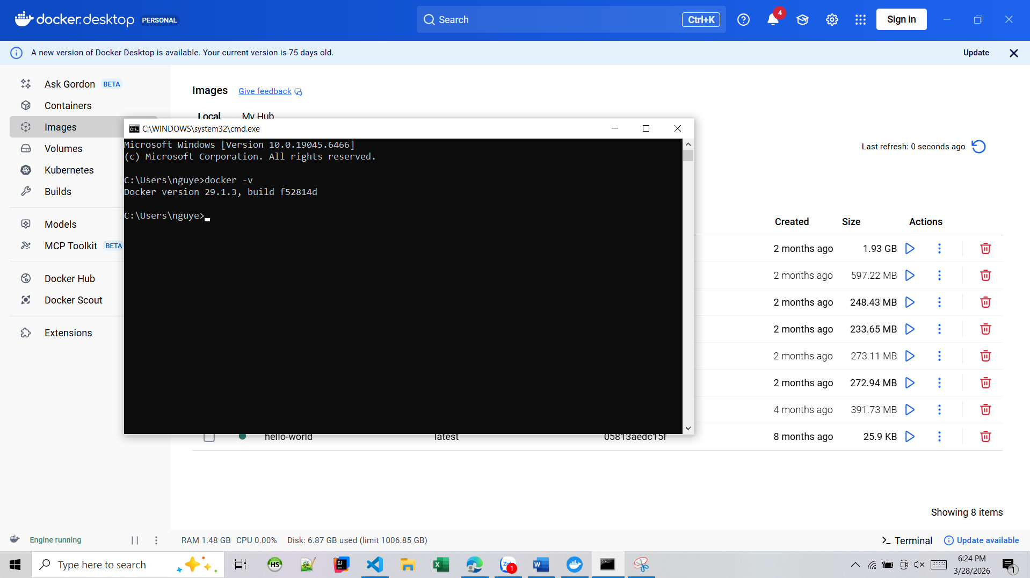
2 | docker run hello-world  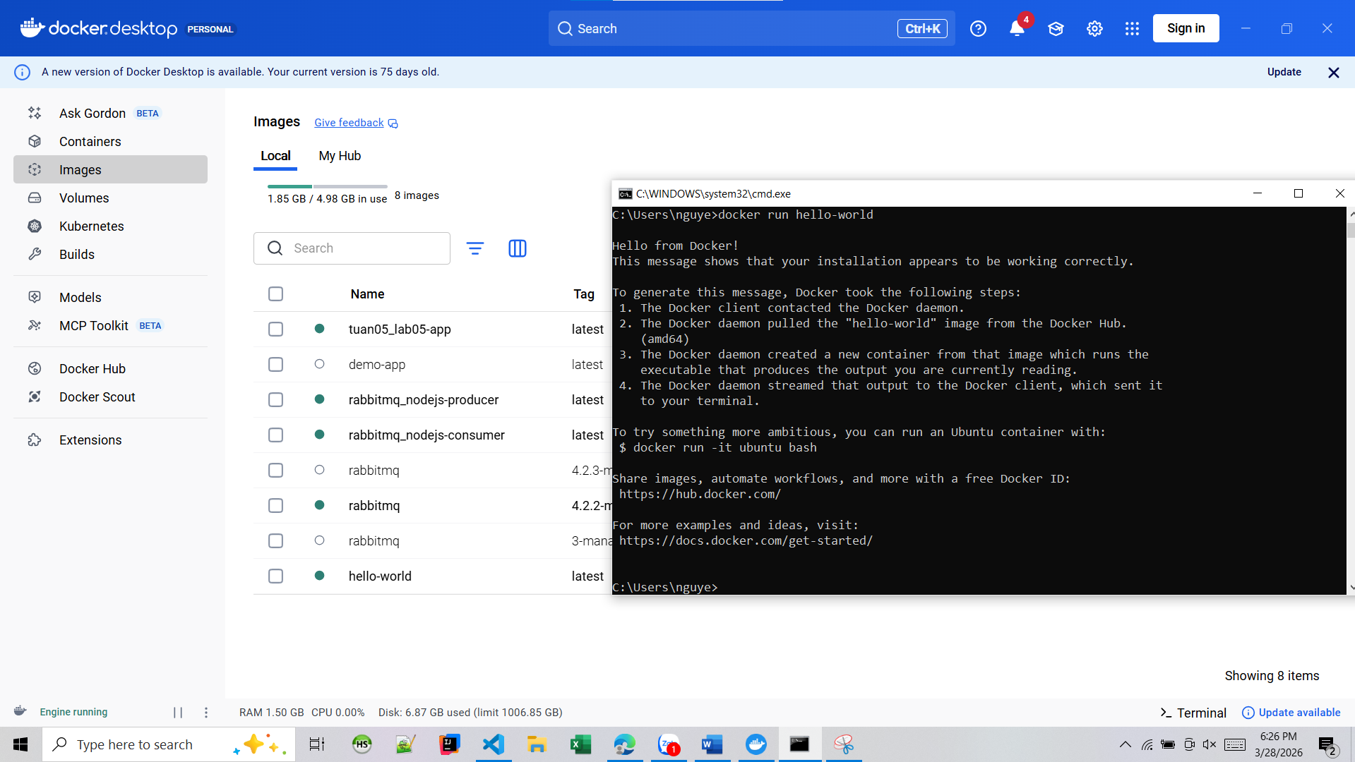
3 | docker pull nginx  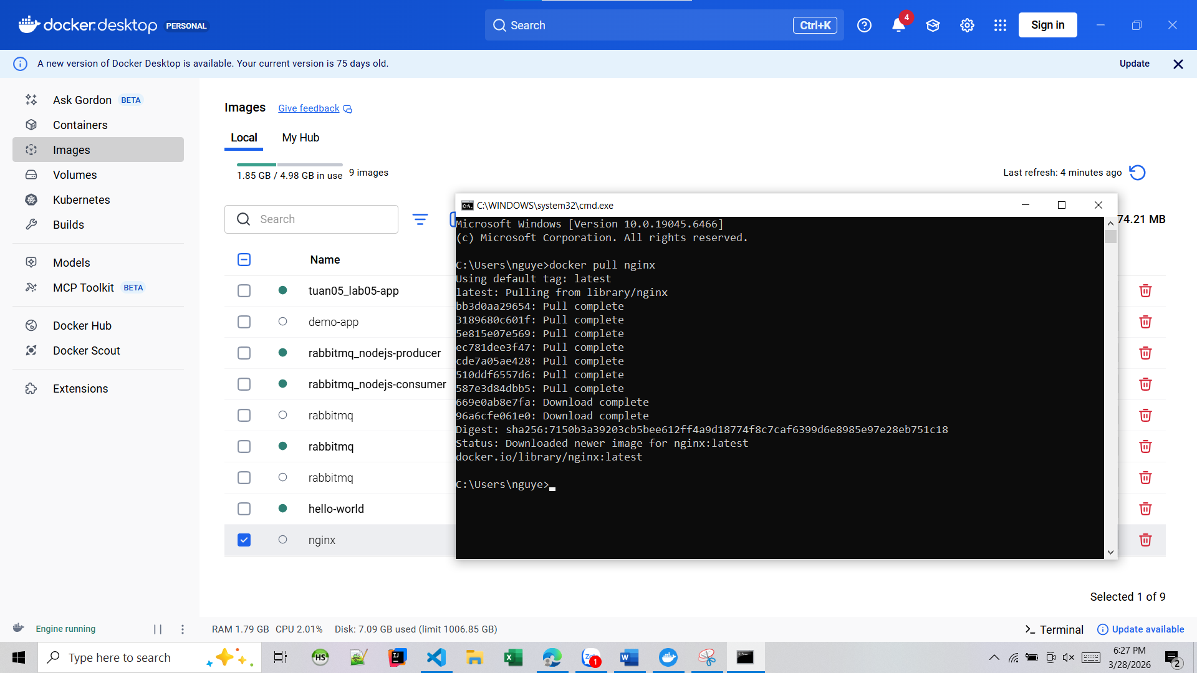
4 | docker images  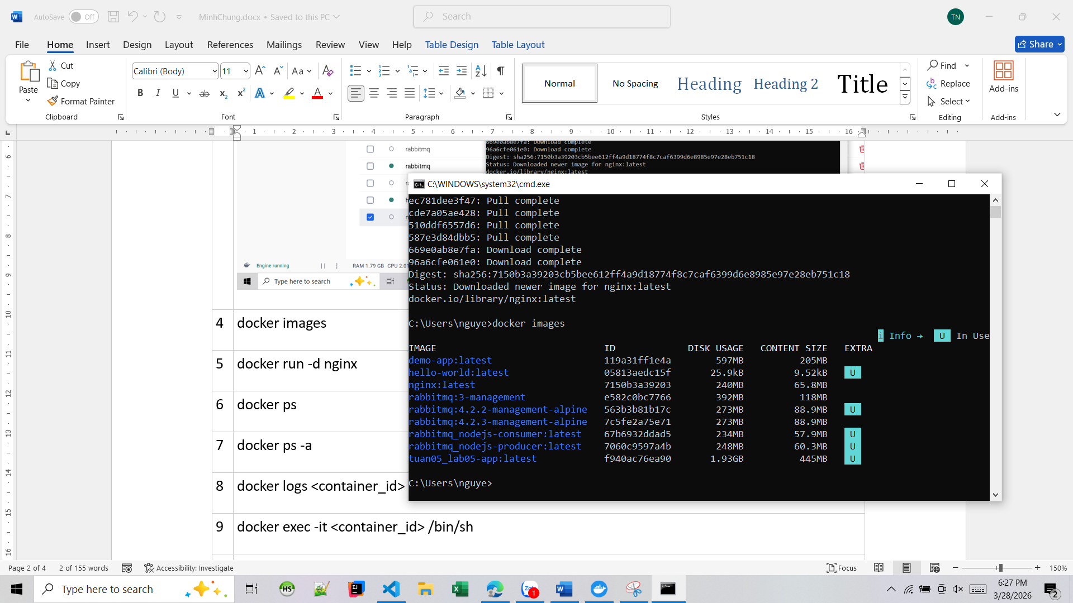
5 | docker run -d nginx  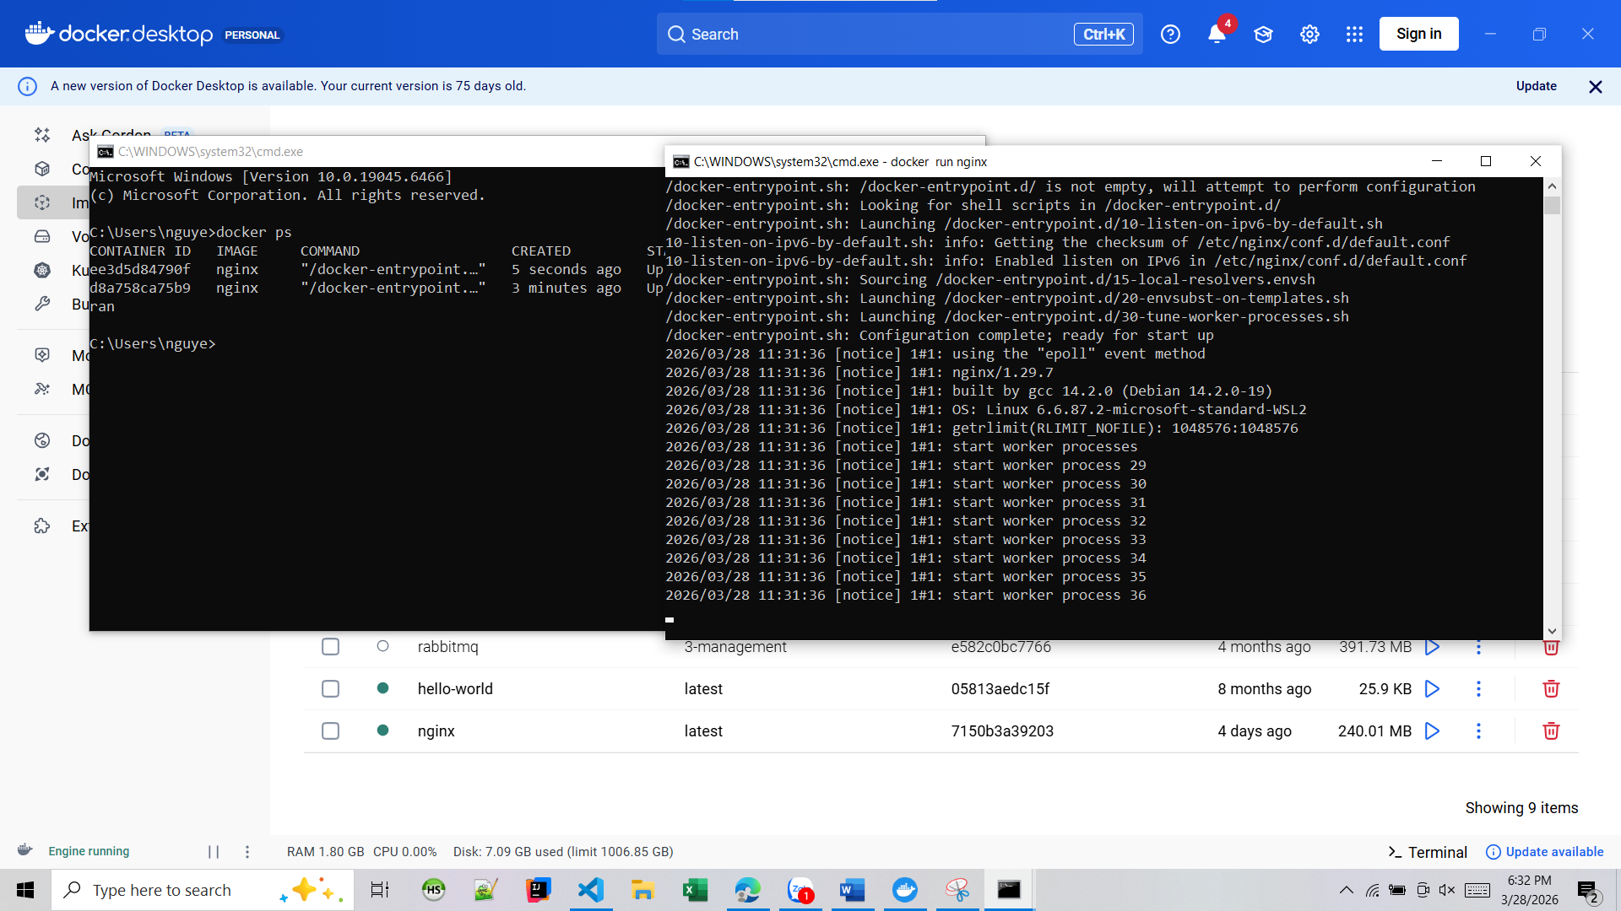
6 | docker ps  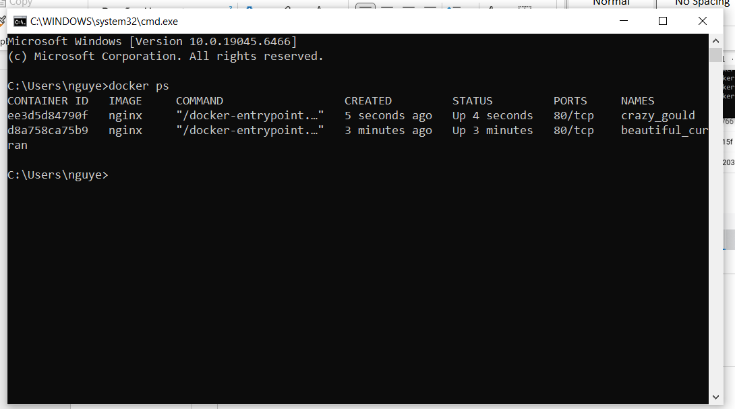
7 | docker ps -a  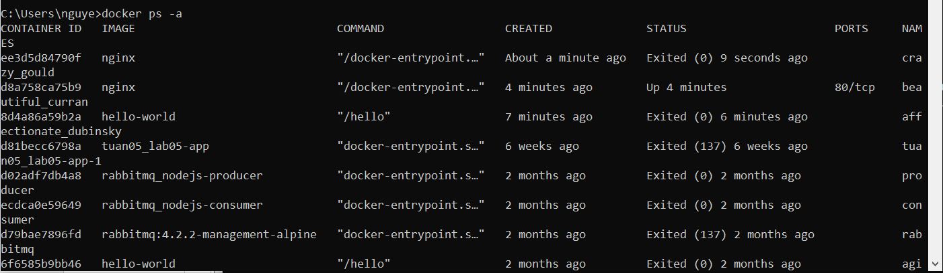
8 | docker logs <container_id>  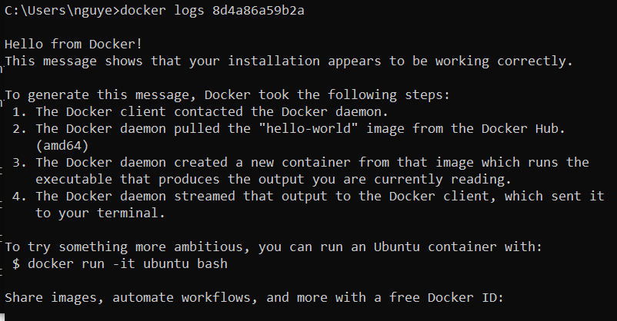
9 | docker exec -it <container_id> /bin/sh  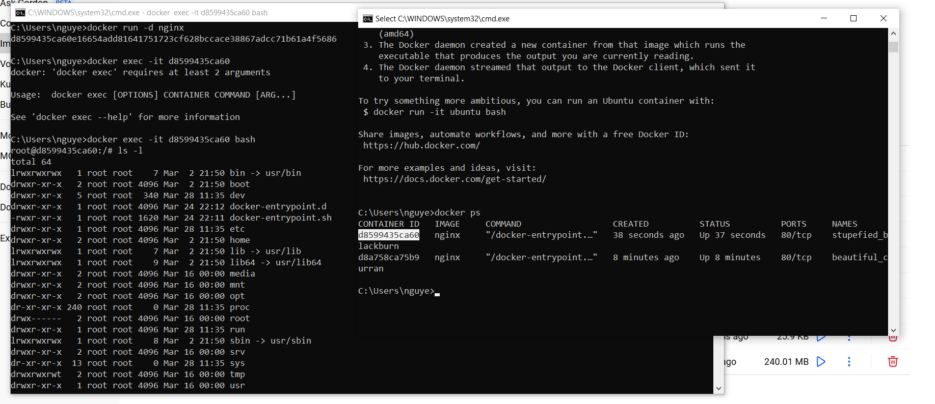
10 | docker stop <container_id>  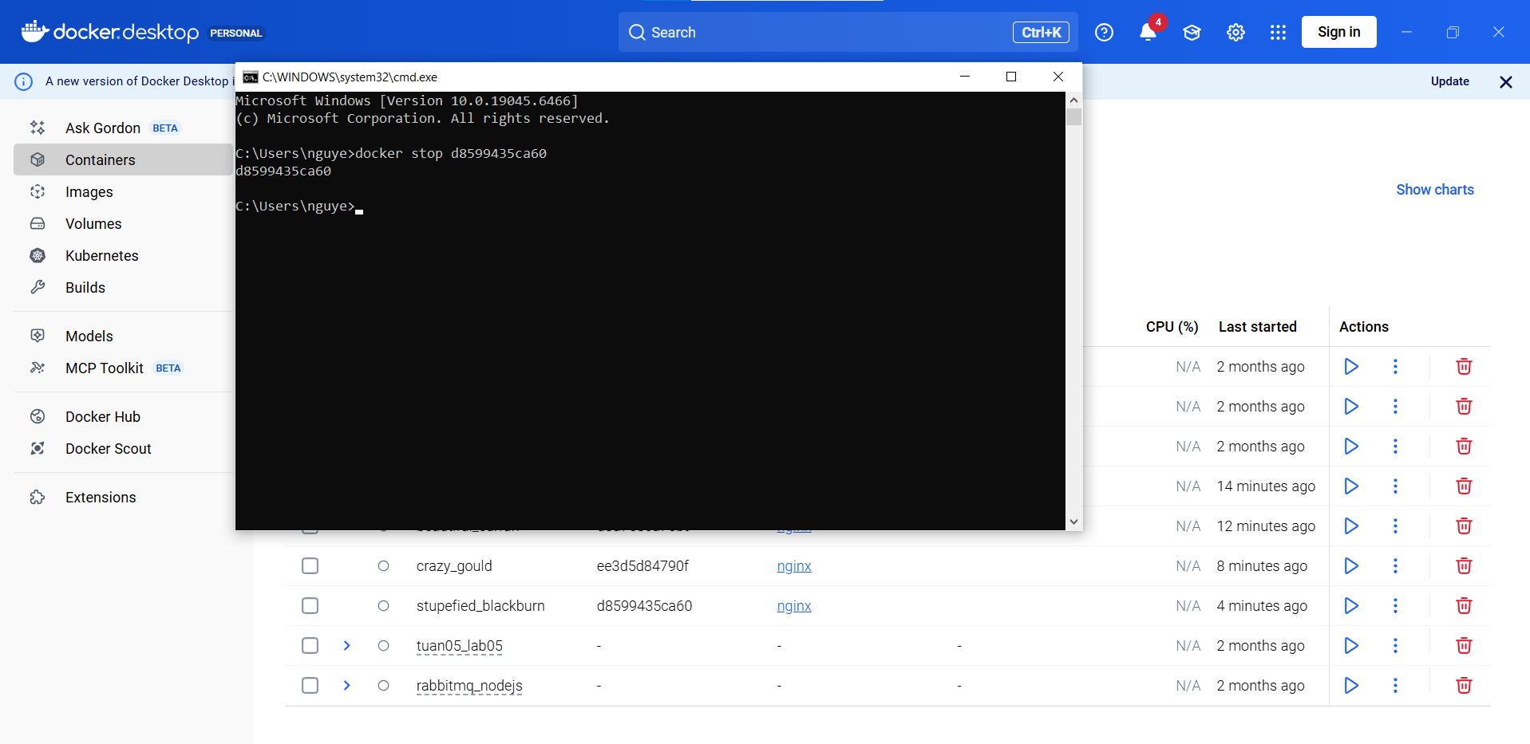
11 | docker restart <container_id>  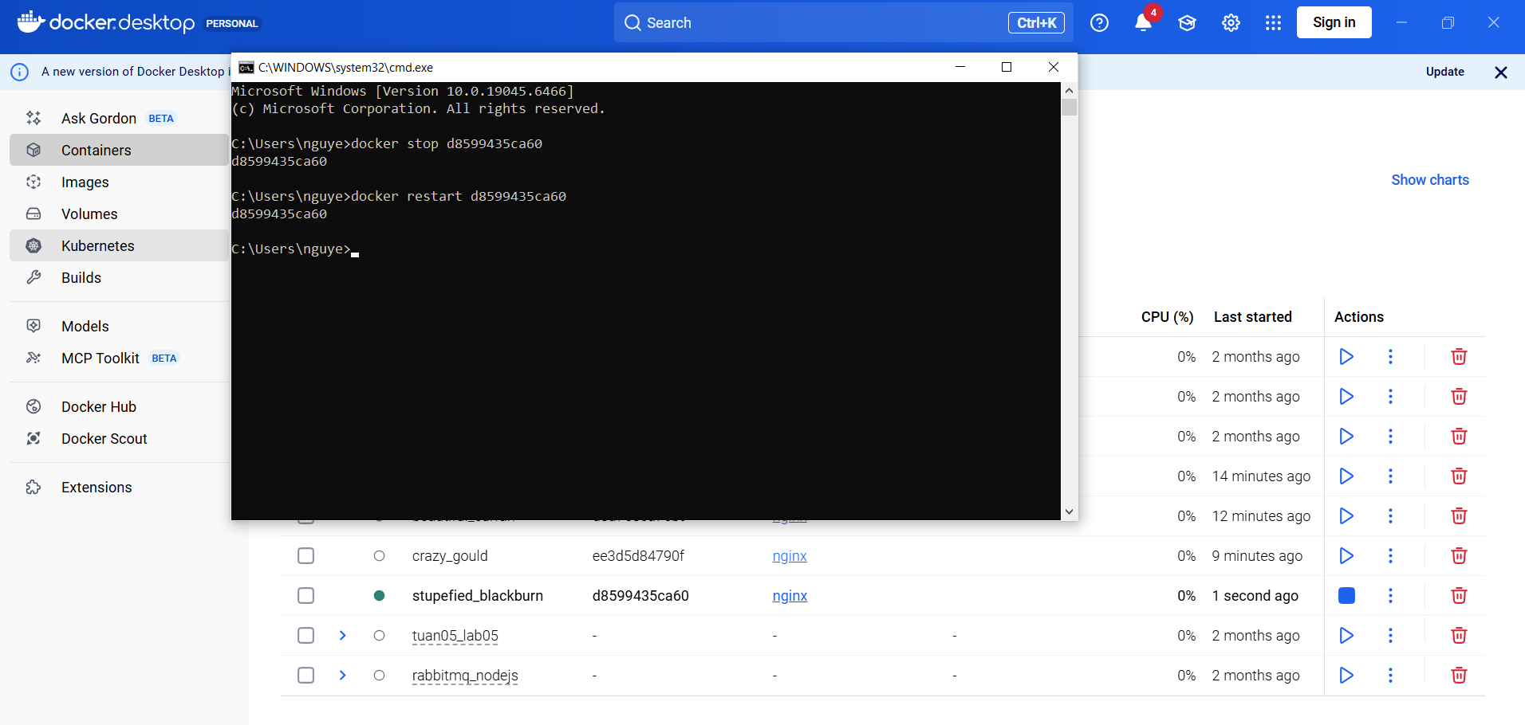
12 | docker rm <container_id>  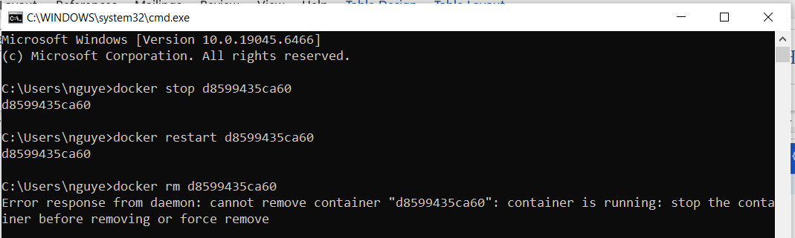  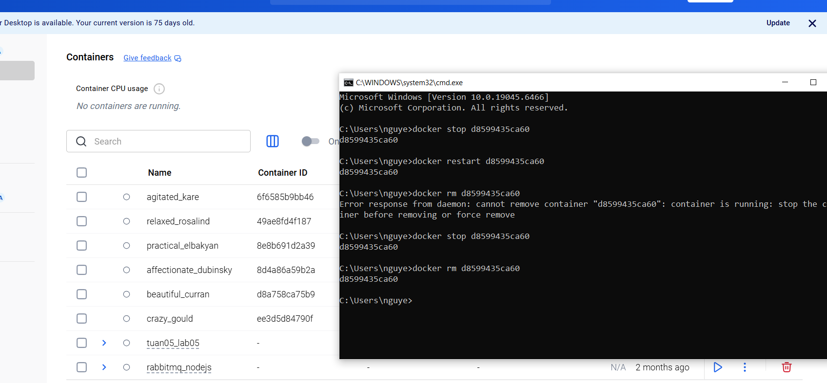
13 | docker container prune  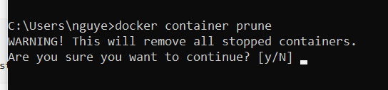
14 | docker rmi <image_id>  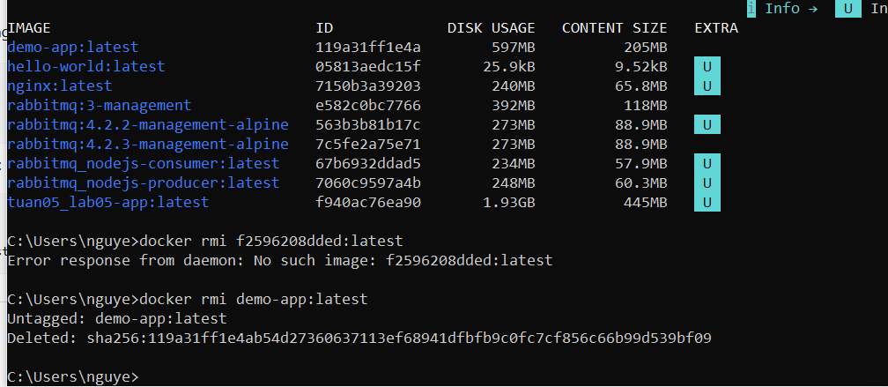
15 | docker image prune -a  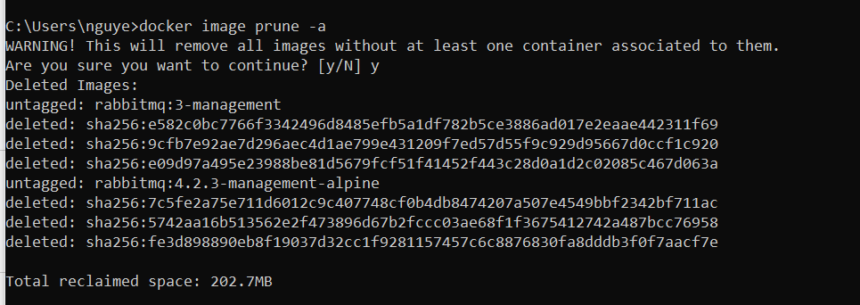
16 | docker run -d -p 8080:80 nginx  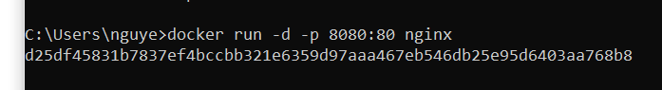  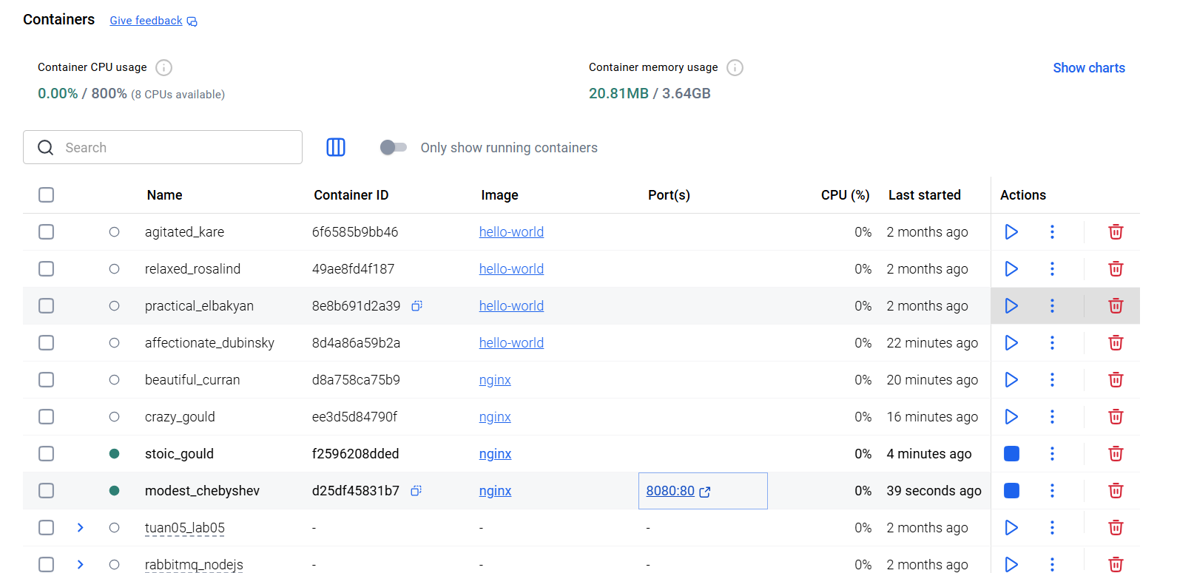  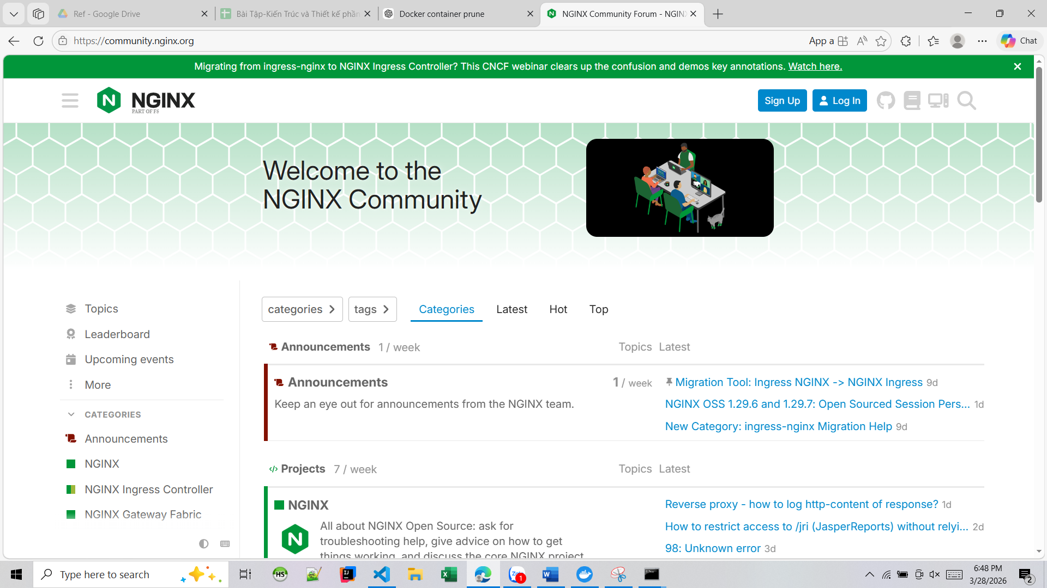
17 | docker inspect <container_id>  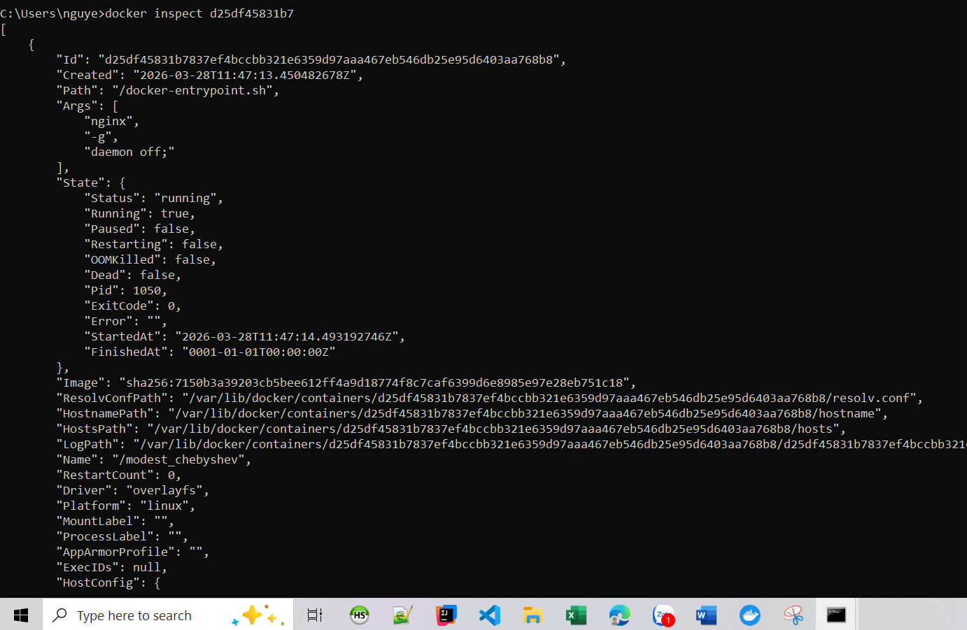
18 | docker run -d -v mydata:/data nginx  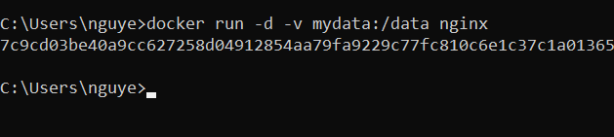  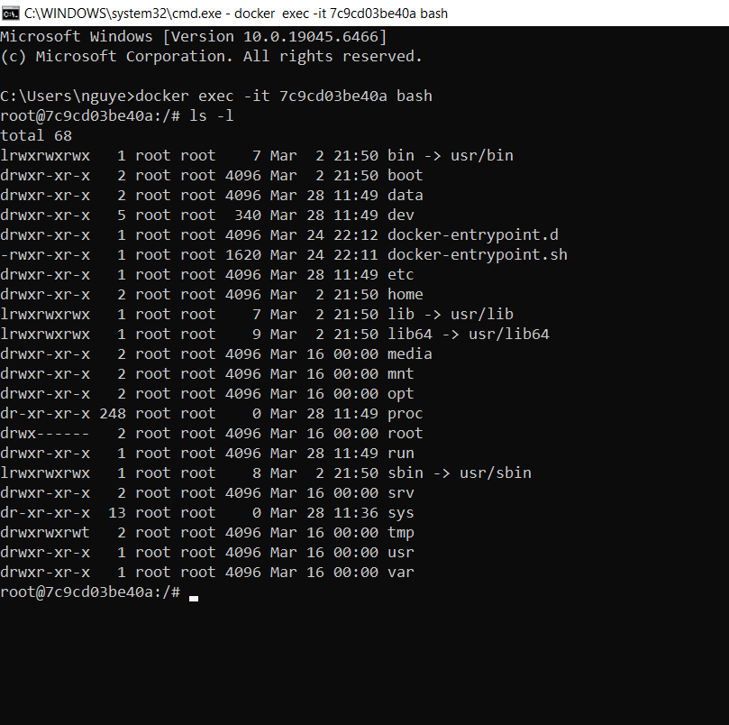
19 | docker volume ls  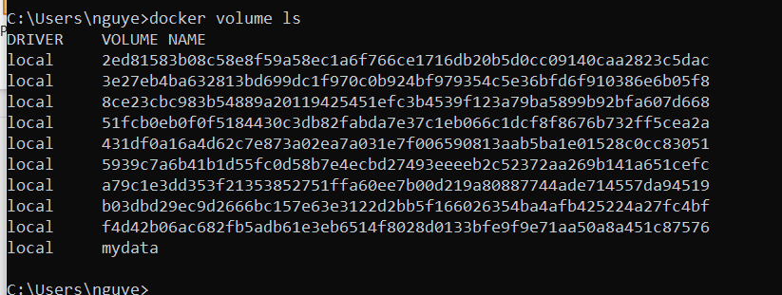
20 | docker volume prune  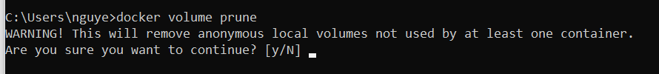
21 | docker run -d --name my_nginx nginx  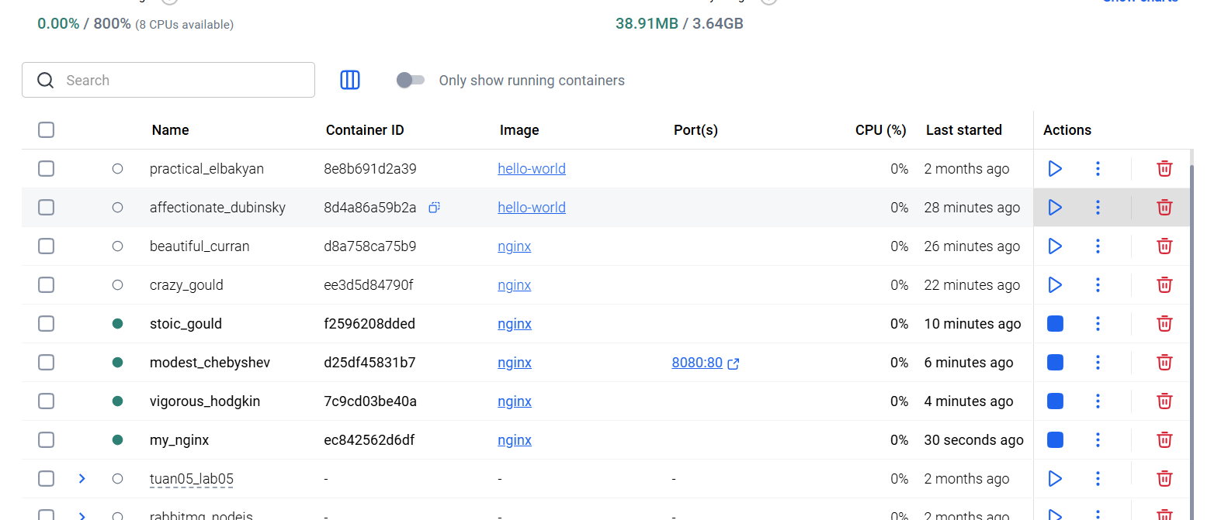
22 | docker stats  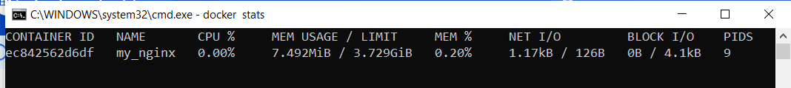
23 | docker network ls  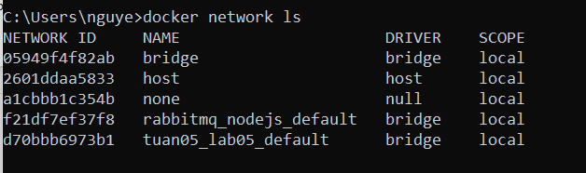
24 | docker network create my_network  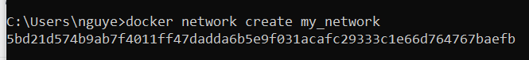
25 | docker run -d --network my_network --name my_container nginx  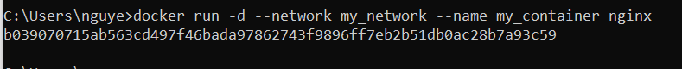
26 | docker network connect my_network my_nginx  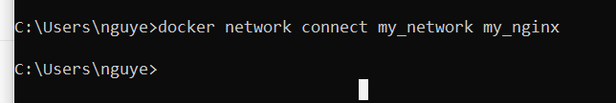
27 | docker run -d -e MY_ENV=hello_world nginx  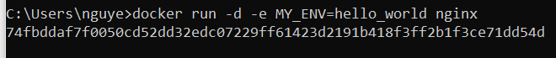
28 | docker logs -f my_nginx  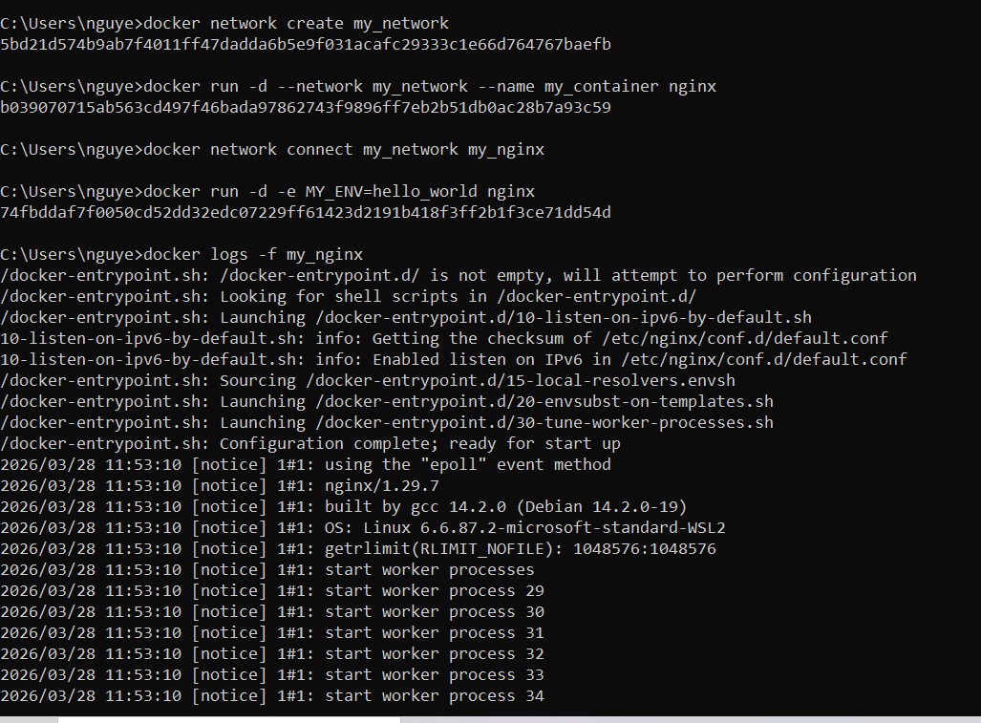
29 | FROM nginx
 | COPY index.html /usr/share/nginx/html/index.html
30 | docker build -t my_nginx_image .  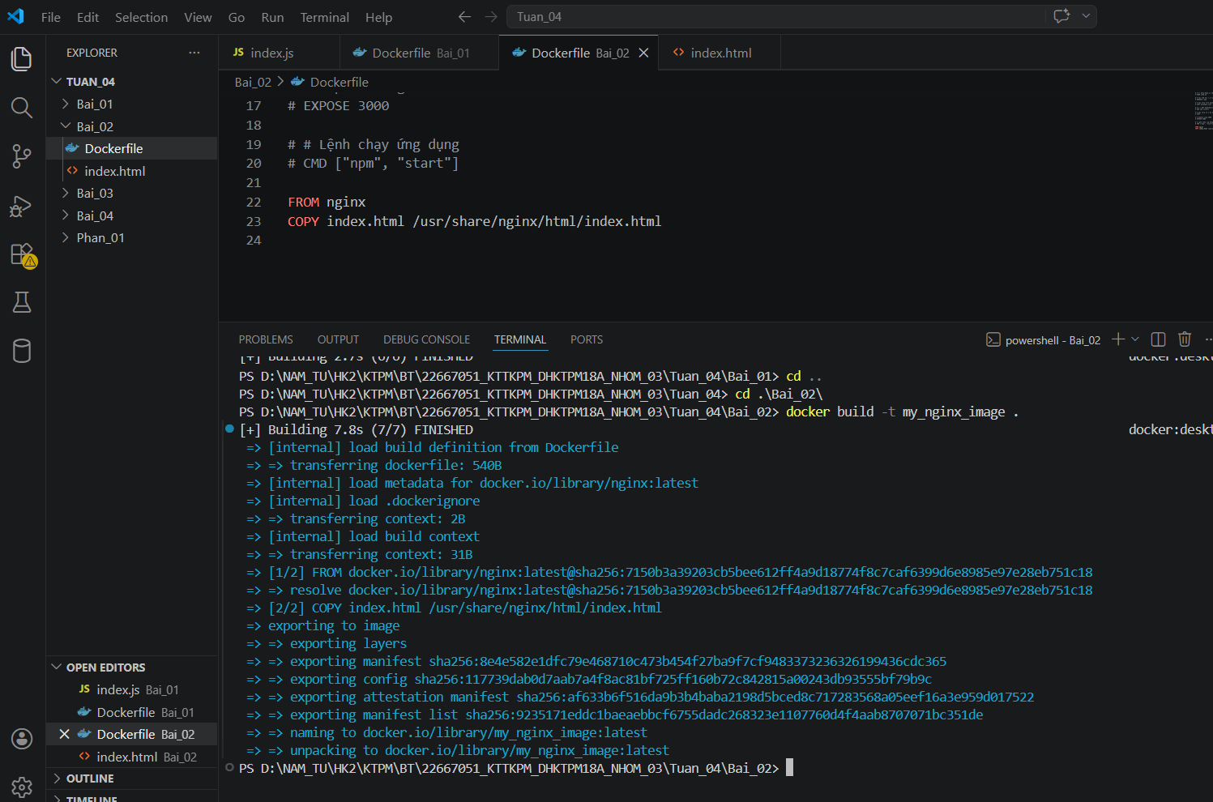
31 | docker run -d -p 8080:80 my_nginx_image  