|  |  |  |  |  |  |  |  |
| --- | --- | --- | --- | --- | --- | --- | --- |
| **Matthew Bell** | |  |  | | --- | --- | | C:\Users\Matt\Dropbox\StudioStuff\Web\Resume\Current\Icons\mail.png | mattbthe1st@gmail.com | | C:\Users\Matt\Dropbox\StudioStuff\Web\Resume\Current\Icons\web.JPG | urgrund.github.io/ | | C:\Users\Matt\Dropbox\StudioStuff\Web\Resume\Current\Icons\In32.png | /in/mattbell007 | |
| Game developer who's self-taught & self-motivated with many years of experience across AAA, console, mobile and education. I have always had a strong interest in video games and in particular the technical aspects involving lighting, rendering, shading and tools. My goal is to work with creative and ambitious studios on exciting projects. |  |

Career

Singapore **Lead Technical Artist**  2016-2018



|  |  |
| --- | --- |
| **C:\Users\Matt\AppData\Local\Microsoft\Windows\INetCache\Content.Word\box_ace7.jpg Ace Combat 7** | * Establish, promote and drive the technical goals of studio titles * Stand in as acting lead artist/art director in-lieu of assigned staff * Go-to person with outsourcing for technical guidance * Re-working of core materials/shaders to align with performance targets * Identified and pushed recruiting of some of the top talent still at the studio * Assist HR with recruitment, relocation and on-boarding policies * Assist management with studio direction and staffing structure |

Singapore **Senior Technical Artist** 2015-2016

|  |  |
| --- | --- |
| E:\Documents\Dropbox\StudioStuff\Misc\Resume\Web\_Current\box\box_AssassinsCreedSYND.png C:\TestWork\U\Web\trunk\box\box_AssassinsCreedORI.jpg**Assassins Creed Syndicate Assassins Creed Origins** | * Owner of data shaders for Singapore team focusing on usability and scalability * Technical role managing the performance and budget cost of Xbox One & PS4 content * Performance profiling with PIX/Razor * Work with artist to build shaders/tech that supports visual benchmarks * Establish myself as the go-to guy for technical and performance related questions for the art team |

Abu Dhabi **Head of Gaming Academy** 2012-2015

|  |  |
| --- | --- |
|  | The Gaming Academy is an initiative of twofour54 to help stimulate talent growth in the creative industries, in particular video games. I ran the course on both administrative and content delivery sides and managed stakeholder interest.   * Working relationship with Ubisoft Abu Dhabi staff to collaborate and manage involvement * Integrated systems and procedures into the learning environment that mimicked a small development studio * Designed, maintained and delivered curriculum with a flexible approach to maximize adaptability to current development practices * Student progress and expectation management through review and consultation sessions * Outreach efforts to local universities to promote the course and games development as a career opportunity |

Brisbane, Australia **Founder / Developer**  2010-2012

|  |  |
| --- | --- |
|  | Flame Shark was a mobile games start-up I spearheaded in an attempt to enter the casual games market. The studio was alive for about 2 years though did not bring any products to market.   * Company registration/setup/reporting procedures * Project documentation development and maintenance for technical, design and art * Team management and task delegation * Gameplay programmer role designing and implementing gameplay mechanics in C# |

Brisbane, Australia **Lecturer / Tutor** *(part time)* 2010-2012

|  |  |
| --- | --- |
|  | * Student mentoring and consultation on projects and assessment * Student grading and marking in line with the provided curriculum * Development of lecture and tutorial/workshop content |

Singapore **Assistant Technical Art Director** 2009-2010

|  |  |
| --- | --- |
| box_AssassinsCreed2.jpgbox_AssassinsCreedBH.jpgbox_PrinceOfPersiaTHFS.jpg**Assassins Creed : Brotherhood Prince of Persia Assassins Creed 2** | * Performance of AAA content on Xbox360 & Playstation 3 consoles * Daily profiling of performance concerns with environment/fx data * Educate and delegate performance tasks to art team * Introduce new staff to internal tools, technology and processes at Ubisoft * Establish myself as go-to guy for technical and performance related concerns * Surgical scene deconstruction (using PIX and other tools) * Lighting role on many environments to assist art team with milestones * Environment artist role (textures, mesh, lighting, profiling) * Pre-production work on ocean shading technology for Assassins Creed 3 |

Brisbane, Australia **Lead Environment/Tech Artist**  2006-2009

|  |  |
| --- | --- |
| box_SWCL_RepublicHereos.jpg box_SWCL_LightSaber.jpg box_HellboyScienceOfEvil.jpg**Star Wars : Republic Heroes Star Wars :Lightsaber Duels Hellboy :The Science of Evil** | * Environment art roles taking on daily tasks of architectural and landscape construction * Lead role managing team of environment artists * PlayStation 3 / Wii / Xbox360 development * Profiling to expose areas of low performance and delegation of tasks to rectify * Authoring of shaders and required materials and textures when needed * Generalist role (props/textures/lighting) as the projects required |

Melbourne, Australia **Environment/Tech Artist** 2004-2006

|  |  |
| --- | --- |
| **Tribal Clash Retribution** | U235 was a small start-up studio in Melbourne, Australia. Due to the very small team size I took the initiative to learn technologies where these skills were absent from the team. After a pitching round in Lyon, France was unsuccessful we ceased production.   * Took ownership of C# and shaders due to lack of staff to cover * Pitched in Lyon, France with Producer to potential investors at Game Connect 2005 * Responsible for all art and managed/mentored other staff members * Managed outsourcing of assets with reviews and quality control |

Brisbane, Australia **Environment Artist** 2003-2004

|  |  |
| --- | --- |
| **Secret Service 2** | First foray into the professional realm of the games industry! This was a low-budget studio charged with developing an Activision Value game. My role as an environment artists included the modelling and surfacing of world props and geometry including material creation (and all maps required). In the closing months I was also tasked with AI setup and lighting. |

Education & Skills

|  |  |
| --- | --- |
| E:\Projects\Other\Resume\Icons\UQ.gif | University of Queensland CSEE 2004  **Bachelor of Information Environments** |

|  |  |  |
| --- | --- | --- |
| Visual | Technical | Project |
| * 3D and 2D content creation * Game art pipelines * Strong environment art skills * Good eye for colour and shape * Experienced in 3dsMax/Photoshop * Strong art optimisation skills | * C# gameplay/tools * Shaders * Problem solving * Lighting * Performance Profiling * Rendering pipeline | * Team Management in Lead roles * Task delegation * Training / Lecturing experience * SVN/source control * Task tracking and delegation |

Extra Activities

Hobby Projects  
As video game development is not just a day job for me, I am constantly engaging myself in personal projects. This keeps my skills fresh whilst allowing me to explore certain areas of development that may not be part of my primary duties at work. These projects may range from an environment scene to small prototypes in Unity.   
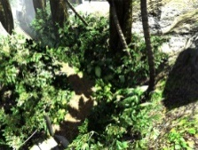 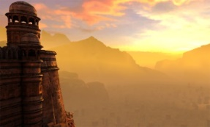 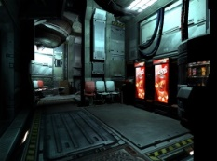

Photography  
Photography is an activity I actively engage in as I find it offers both relaxation and excitement depending on what you are trying to capture. Pursuing this hobby both technically and aesthetically has toned my digital art skills as it helps me to appreciate object form, silhouettes, lighting and framing which, in games development, translates directly to scene quality with regards to those aspects.  
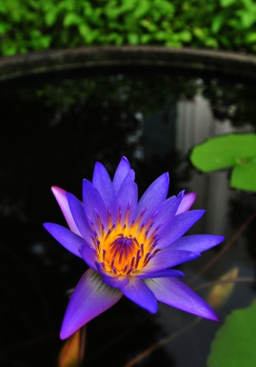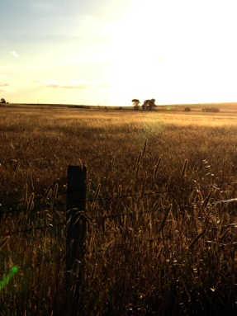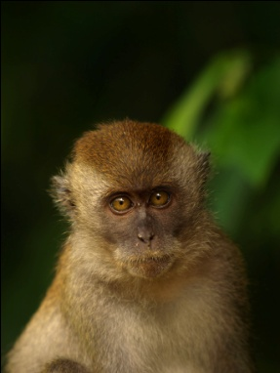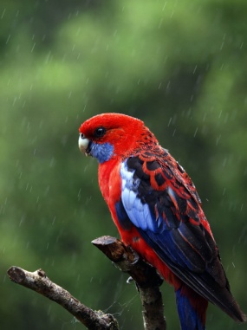

Auto-Mechanics  
I began to have an interest in mechanics about 2007 and subsequently purchased a roaring V8! I found the technical challenges involved with fixing problems, albeit small, was fun and engaging and I often found many parallels with combustion engine design and game engine design! I guess the principles of engineering hold true in most fields where they are applied!

Music  
Music has been a part of my life for many years with my mother being a music teacher. I play a few instruments and have played in many bands often touring and recording with them. My instrument of choice is drums and I continue to get practice in when I can.

Gaming

I’m regularly enjoying playing through games, though not as frequent as I used to! Nowadays, I find I will pick certain titles and then really exhaust what they have to offer – I want to experience everything the team may have wanted the player to discover. The below platinum achievements demonstrate this. As a game developer, getting through to 100% on such titles allows you to study the games’ mechanics and progression as well as the efforts put into the art.

|  |  |
| --- | --- |
| C:\Users\Matt\AppData\Local\Microsoft\Windows\INetCache\Content.Word\plat.png | God of War NG+ |
| C:\Users\Matt\AppData\Local\Microsoft\Windows\INetCache\Content.Word\plat.png | Dark Souls III + DLC |
| C:\Users\Matt\AppData\Local\Microsoft\Windows\INetCache\Content.Word\plat.png | Bloodborne + DLC |