Print Service Definition Version 1.2
For Web Services on Devices
Date: July 23, 2013

© 2005-2006, 2012-2013 Microsoft Corporation. All rights reserved. By using these materials, you agree to the attached license agreement.

Microsoft Corporation Non-Confidential Technical Documentation License Agreement (Non-Standard)
READ THIS! THIS IS A LEGAL AGREEMENT BETWEEN MICROSOFT CORPORATION ("MICROSOFT") AND THE RECIPIENT OF THESE MATERIALS, WHETHER AN INDIVIDUAL OR AN ENTITY ("YOU"). IF YOU HAVE ACCESSED THIS AGREEMENT IN THE PROCESS OF DOWNLOADING MATERIALS ("MATERIALS") FROM A MICROSOFT WEB SITE, BY CLICKING "I ACCEPT", DOWNLOADING, USING THE MATERIALS, YOU AGREE TO THESE TERMS. IF THIS AGREEMENT IS ATTACHED TO MATERIALS, BY ACCESSING OR USING THE ATTACHED MATERIALS, YOU AGREE TO THESE TERMS.
For good and valuable consideration, the receipt and sufficiency of which are acknowledged, You and Microsoft agree as follows:
1. You may review these Materials only as a reference to assist You in planning and designing Your product, service or technology ("Product") to interface with a Microsoft Product as described in these Materials. All other rights are retained by Microsoft; this agreement does not give You rights under any Microsoft patents. You may not (i) duplicate any part of these Materials, (ii) remove this agreement or any notices from these Materials, or (iii) give any part of these Materials, or assign or otherwise provide Your rights under this agreement, to anyone else.
2. The information contained in these Materials is also available through the Microsoft Windows Driver Kit (WDK). You will receive additional intellectual property rights by agreeing to the terms of the WDK.
3. All Materials are provided entirely "AS IS." To the extent permitted by law, MICROSOFT MAKES NO WARRANTY OF ANY KIND, DISCLAIMS ALL EXPRESS, IMPLIED AND STATUTORY WARRANTIES, AND ASSUMES NO LIABILITY TO YOU FOR ANY DAMAGES OF ANY TYPE IN CONNECTION WITH THESE MATERIALS OR ANY INTELLECTUAL PROPERTY IN THEM.
4. If You are an entity and (a) merge into another entity or (b) a controlling ownership interest in You changes, Your right to use these Materials automatically terminates and You must destroy them.
5. This agreement is governed by the laws of the State of Washington. Any dispute involving it must be brought in the federal or state superior courts located in King County, Washington, and You waive any defenses allowing the dispute to be litigated elsewhere. If there is litigation, the losing party must pay the other party’s reasonable attorneys’ fees, costs and other expenses. If any part of this agreement is unenforceable, it will be considered modified to the extent necessary to make it enforceable, and the remainder shall continue in effect. This agreement is the entire agreement between You and Microsoft concerning these Materials; it may be changed only by a written document signed by both You and Microsoft.

Contents
1. Overview and Scope 11
2. Device Service Modeling Definitions 12
2.1. Device Service-Class 12
2.2. Terminology 12
2.2.1. Conformance Terminology 12
2.2.2. Other terminology 12
2.2.3. Notation: use of quotation marks 13
2.3. References 13
2.4. Intent of a Print Job 13
2.4.1. Production vs. Layout Job Elements 14
2.4.2. Precedence of Production vs. Layout Job Elements 14
3. Service Schema 16
3.1. The Printer’s Elements 16
3.2. The PrinterDescription Elements 17
3.2.1. ColorSupported 17
3.2.2. DeviceId 17
3.2.3. MultipleDocumentJobsSupported 18
3.2.4. PagesPerMinute 18
3.2.5. PagesPerMinuteColor 18
3.2.6. PrinterName 18
3.2.7. PrinterInfo 18
3.2.8. PrinterLocation 19
3.3. The PrinterConfiguration Elements 20
3.3.1. PrinterEventRate 21
3.3.2. Storage 21
3.3.2.1. StorageEntry 21
3.3.2.1.1. Name 21
3.3.2.1.2. Removed 21
3.3.2.1.3. Type 21
3.3.2.1.4. Size 22
3.3.2.1.5. Free 22
3.3.3. Consumables 22
3.3.3.1. ConsumableEntry 22
3.3.3.1.1. Name 22
3.3.3.1.2. Removed 22
3.3.3.1.3. Type 22
3.3.3.1.4. Color 23
3.3.3.1.5. Level 23
3.3.3.1.6. Model 23
3.3.4. InputBins 23
3.3.4.1. InputBinEntry 23
3.3.4.1.1. Name 23
3.3.4.1.2. Removed 24
3.3.4.1.3. FeedDirection 24
3.3.4.1.4. MediaSize 24
3.3.4.1.5. MediaType 25
3.3.4.1.6. MediaColor 25
3.3.4.1.7. Capacity 25
3.3.4.1.8. Level 25
3.3.5. Finishings 26
3.3.5.1. CollationSupported 26
3.3.5.2. JogOffsetSupported 26
3.3.5.3. DuplexerInstalled 26
3.3.5.4. StaplerInstalled 26
3.3.5.5. HolePunchInstalled 26
3.3.6. OutputBins 26
3.3.6.1. OutputBinEntry 26
3.3.6.1.1. Name 26
3.3.6.1.2. Removed 27
3.3.6.1.3. Capacity 27
3.3.6.1.4. Level 27
3.4. The PrinterStatus Elements 28
3.4.1. PrinterCurrentTime 28
3.4.2. PrinterState 28
3.4.3. PrinterPrimaryStateReason 29
3.4.4. PrinterStateReasons 29
3.4.4.1. PrinterStateReason 29
3.4.5. QueuedJobCount 30
3.4.6. ActiveCondition 30
3.4.6.1. DeviceCondition 30
3.4.6.1.1. Id 30
3.4.6.1.2. Time 30
3.4.6.1.3. Name 30
3.4.6.1.4. Component 31
3.4.6.1.4.1. Group 31
3.4.6.1.4.2. Name 31
3.4.6.1.5. Severity 31
3.4.7. ConditionHistory 31
3.4.7.1. ConditionHistoryEntry 31
3.4.7.1.1. Id 31
3.4.7.1.2. Time 31
3.4.7.1.3. Name 31
3.4.7.1.4. Component 32
3.4.7.1.4.1. Group 32
3.4.7.1.4.2. Name 32
3.4.7.1.5. Severity 32
3.4.7.1.6. ClearTime 32
3.5. The Job’s Elements 32
3.5.1. JobStatus 34
3.5.1.1. JobId 34
3.5.1.2. JobState 34
3.5.1.3. JobStateReasons 35
3.5.1.3.1. JobStateReason 35
3.5.1.4. KOctetsProcessed 36
3.5.1.5. MediaSheetsCompleted 36
3.5.1.6. NumberOfDocuments 36
3.5.2. PrintTicket 36
3.5.2.1. JobDescription 36
3.5.2.1.1. JobName 36
3.5.2.1.2. JobOriginatingUserName 36
3.5.2.2. JobProcessing 37
3.5.2.2.1. Copies 37
3.5.2.2.2. JobFinishings 37
3.5.2.2.2.1. Collate 37
3.5.2.2.2.2. JogOffset 37
3.5.2.2.3. Staple 37
3.5.2.2.3.1. Location 37
3.5.2.2.3.2. Angle 37
3.5.2.2.4. HolePunch 38
3.5.2.2.4.1. Edge 38
3.5.2.2.4.2. Pattern 38
3.5.2.2.5. Priority 38
3.5.2.3. DocumentProcessing 39
3.5.2.3.1. MediaSizeName 39
3.5.2.3.2. MediaType 39
3.5.2.3.3. MediaColor 39
3.5.2.3.4. NumberUp 39
3.5.2.3.4.1. PagesPerSheet 39
3.5.2.3.4.2. Direction 39
3.5.2.3.5. Orientation 40
3.5.2.3.6. Resolution 40
3.5.2.3.6.1. Width 40
3.5.2.3.6.2. Height 40
3.5.2.3.7. PrintQuality 40
3.5.2.3.8. Sides 40
3.6. The Document’s Elements 40
3.6.1. DocumentDescription 42
3.6.1.1. DocumentId 42
3.6.1.2. Compression 42
3.6.1.3. Format 42
3.6.1.4. DocumentName 43
3.6.1.5. DocumentUrl 43
3.6.2. DocumentProcessing 43
3.7. Job Table 44
3.8. PrintTicket 45
3.8.1. Example PrintTicket 48
3.9. Default Values and Allowed Values for Job Submission 48
3.9.1. DefaultPrintTicket 48
3.9.2. Example DefaultPrintTicket 48
3.9.3. PrinterCapabilities 49
3.9.4. Example PrinterCapabilities 51
4. Eventing 52
4.1. Event Model 53
4.2. CompleteState Events 53
4.3. Cumulative Events 53
4.4. PrinterElementsChangeEvent 53
4.4.1. ElementChanges 54
4.4.2. Example PrinterElementsChangeEvent 54
4.4.3. Example PrinterElementsChangeEvent – OutputBin Removed 55
4.5. PrinterStatusSummaryEvent 55
4.5.1. StatusSummary 55
4.5.1.1. PrinterState 55
4.5.1.2. PrinterPrimaryStateReason 56
4.5.1.3. PrinterStateReasons 56
4.5.1.3.1. PrinterStateReason 56
4.5.2. Example PrinterStatusSummaryEvent 56
4.6. PrinterStatusConditionEvent 56
4.6.1. DeviceCondition 57
4.6.2. Example PrinterStatusConditionEvent 57
4.7. PrinterStatusConditionClearedEvent 57
4.7.1. DeviceConditonCleared 58
4.7.1.1. ConditonId 58
4.7.1.2. ConditionClearTime 58
4.7.2. Example PrinterStatusConditionClearedEvent 58
4.8. JobStatusEvent 58
4.8.1. JobStatus 59
4.8.2. Example JobStatusEvent 59
4.9. JobEndStateEvent 59
4.9.1. JobId 60
4.9.2. JobCompletedState 60
4.9.2.1. JobCompletedStateReasons 60
4.9.2.1.1. JobStateReason 60
4.9.3. JobName 60
4.9.4. JobOriginatingUserName 60
4.9.5. KOctetsProcessed 60
4.9.6. MediaSheetsCompleted 60
4.9.7. NumberOfDocuments 60
4.9.8. Example JobEndStateEvent 61
5. Operations 61
5.1. Operation Error Reporting 61
5.1.1. Common Operation Error Codes 63
5.1.1.1. wsa:ActionNotSupported 63
5.1.1.2. InvalidArgs 63
5.1.1.3. OperationFailed 63
5.1.1.4. ServerErrorTemporaryError 63
5.1.1.5. ServerErrorInternalError 64
5.2. CreatePrintJob 64
5.2.1. Request Elements 65
5.2.1.1. PrintTicket 65
5.2.1.1.1. JobDescription 65
5.2.1.1.2. JobProcessing 65
5.2.1.1.3. DocumentProcessing 65
5.2.2. Response Elements 65
5.2.2.1. JobId 65
5.2.3. Example Request 65
5.2.4. Example Response 66
5.2.5. Errors 66
5.2.5.1. ServerErrorNotAcceptingJobs 66
5.2.5.2. ClientErrorConflictingRequiredParameters 67
5.3. SendDocument 67
5.3.1. Request Elements 68
5.3.1.1. JobId 68
5.3.1.2. DocumentDescription 68
5.3.1.3. DocumentProcessing 68
5.3.1.4. LastDocument 68
5.3.1.5. DocumentData 68
5.3.2. Example Request 68
5.3.3. Example Response 69
5.3.4. Errors 69
5.3.4.1. ServerErrorDocumentActive 69
5.3.4.2. ServerErrorJobCancelled 70
5.3.4.3. ClientErrorJobIdNotFound 70
5.3.4.4. ClientErrorMultipleDocumentsNotSupported 70
5.3.4.5. ClientErrorLastDocumentAlreadySent 70
5.3.4.6. ClientErrorFormatNotSupported 71
5.3.4.7. ClientErrorCompressionNotSupported 71
5.3.4.8. ClientErrorConflictingRequiredParameters 71
5.4. AddDocument 71
5.4.1. Request Elements 72
5.4.1.1. JobId 72
5.4.1.2. DocumentDescription 72
5.4.1.3. DocumentProcessing 72
5.4.1.4. LastDocument 72
5.4.1.5. DocumentUrl 72
5.4.2. Example Request 72
5.4.3. Example Response 73
5.4.4. Errors 73
5.4.4.1. ServerErrorAddDocumentNotSupported 73
5.4.4.2. ServerErrorDocumentActive 74
5.4.4.3. ServerErrorJobCancelled 74
5.4.4.4. ClientErrorJobIdNotFound 74
5.4.4.5. ClientErrorMultipleDocumentsNotSupported 74
5.4.4.6. ClientErrorLastDocumentAlreadySent 75
5.4.4.7. ClientErrorFormatNotSupported 75
5.4.4.8. ClientErrorCompressionNotSupported 75
5.4.4.9. ClientErrorDocumentURLSchemeNotSupported 75
5.4.4.10. ClientErrorDocumentURLNotFound 75
5.5. CancelJob 76
5.5.1. Request Elements 76
5.5.1.1. JobId 76
5.5.2. Example Request 76
5.5.3. Example Response 76
5.5.4. Errors 77
5.5.4.1. ClientErrorJobIdNotFound 77
5.5.5. Effect on State 77
5.6. GetPrinterElements 77
5.6.1. Request Elements 77
5.6.1.1. RequestedElements 77
5.6.1.2. Name 77
5.6.2. Response Elements 78
5.6.2.1. PrinterElements 78
5.6.2.2. ElementData 78
5.6.2.3. Name 78
5.6.2.4. Valid 78
5.6.3. Example Request - PrinterDescription 78
5.6.4. Example Response – PrinterDescription 78
5.6.5. Example Request - PrinterConfiguration 79
5.6.6. Example Response – PrinterConfiguration 79
5.6.7. Example Request – Multiple requests 80
5.6.8. Example Response – Multiple Requests 81
5.6.9. Errors 82
5.7. GetJobElements 82
5.7.1. Request Elements 82
5.7.1.1. JobId 82
5.7.1.2. RequestedElements 82
5.7.1.3. Name 82
5.7.2. Response Elements 83
5.7.2.1. JobElements 83
5.7.2.2. ElementData 83
5.7.2.3. Name 83
5.7.2.4. Valid 83
5.7.3. Example Request - JobStatus 83
5.7.4. Example Response – JobStatus 83
5.7.5. Example Request – Multiple Requests 84
5.7.6. Example Response – Multiple Requests 84
5.7.7. Errors 85
5.7.7.1. ClientErrorJobIdNotFound 85
5.8. GetActiveJobs 85
5.8.1. Response Elements 86
5.8.1.1. ActiveJobs 86
5.8.1.1.1. JobSummary 86
5.8.1.1.1.1. JobId 86
5.8.1.1.1.2. JobState 86
5.8.1.1.1.3. JobStateReasons 86
5.8.1.1.1.3.1. JobStateReason 86
5.8.1.1.1.4. JobName 86
5.8.1.1.1.5. JobOriginatingUserName 86
5.8.1.1.1.6. KOctetsProcessed 86
5.8.1.1.1.7. MediaSheetsCompleted 86
5.8.1.1.1.8. NumberOfDocuments 86
5.8.2. Example Request 87
5.8.3. Example Response – No Active Jobs 87
5.8.4. Example Response – 2 Active Jobs 87
5.8.5. Errors 88
5.9. GetJobHistory 88
5.9.1. Response Elements 88
5.9.1.1. JobHistory 88
5.9.1.1.1. JobSummary 88
5.9.2. Example Request 88
5.9.3. Example Response – No Job History 89
5.9.4. Example Response – 2 Completed Jobs 89
5.9.5. Errors 89
5.10. SetEventRate 89
5.10.1. Request Elements 90
5.10.1.1. EventRate 90
5.10.2. Example Request 90
5.10.3. Example Response 90
5.10.4. Errors 90
5.11. Non-Standard Operations Implemented by a WSD Vendor 90
6. Theory of Operation 91
6.1. Jobs 91
6.2. Operations 91
6.3. Events 91
6.4. Security 92
6.5. Localization 92
Appendix A. WSDL Service Description 93
Appendix B. Windows Vista™ Support Requirements 99
1. PnP-X installation support 99
1.1. PnP-X Namespace 99
1.2. PnP-X CompatibleId definition and value 99
1.3. Sample Device Metadata response 99
2. Network Explorer category support 99
2.1. PnP-X Namespace 100
2.2. PnP-X Category definition and value 100
2.3. Sample Device Metadata response 100
3. Print Device discoverability in the Add Network Printer Wizard 100
3.1. Local subnet Discovery support 100
3.1.1. WSD Print Namespace 101
3.1.2. WSD Print Device porttype 101
3.1.3. Device Hello example 101
3.1.4. Device ProbeMatches example 101
3.2. Directed Discovery support 102
3.2.1. Unsecured Directed Discovery URL 102
3.2.2. Secure Directed Discovery URL 102
Appendix C. Supporting WS-Print V1.1 103
4. WS-Print V1.1 103
4.1. WS-Print V1.1 Namespace 103
4.2. WS-Print V1.1 Schema elements 103
4.2.1. SupportsWSPrintv11 103
4.2.2. DeviceModelId 103
4.2.3. DriverConfiguration 103
4.2.3.1. GPDConfigFile 104
4.2.3.2. PPDConfigFile 104
4.2.4. ColorRepresentation 104
4.3. Backwards Compatibilty 105
4.4. WS-Print V1.1 Request/Response examples 105
4.4.1. Example Request - PrinterDescription 105
4.4.2. Example Response – PrinterDescription supports WS-Print v1.1 105
4.4.3. Example Response – PrinterDescription supports WS-Print v1.1and Device Model Id 106
4.4.4. Example Request - DriverConfiguration 106
4.4.5. Example Response – DriverConfiguration with only a PPD config file 107
4.4.6. An example of a PrinterConfiguration element for a WS-Print V1.1 device is as follows: Example Request - PrinterConfiguration 107
4.4.7. Example Response – PrinterConfiguration with ColorRepresentation 107
4.5. WS-Print v1.1 XSD 109
Appendix D. Supporting WS-Print V1.2 110
5. WS-Print V1.2 110
5.1. WS-Print V1.2 Namespace 110
5.2. WS-Print V1.2 Schema elements 110
5.2.1. SupportsWSPrintV12 110
5.3. WS-Print V1.2 Operation 110
5.3.1. SetPrinterElements operation 110
5.3.1.1. Request Elements 111
5.3.1.1.1. ElementsToSet 111
5.3.1.1.2. ElementToSet 111
5.3.1.1.3. ElementPath 111
5.3.1.1.4. Boolean 111
5.3.1.1.5. Integer 111
5.3.1.1.6. String 112
5.3.1.1.7. Float 112
5.3.1.1.8. Binary 112
5.3.1.2. Response Elements 112
5.3.1.2.1. ElementsToSetResults 112
5.3.1.2.2. ElementToSetResult 112
5.3.1.2.3. ElementPath 112
5.3.1.2.4. Result 113
5.3.1.3. Example SetPrinterElementsRequest – PrinterDescription/PrinterName 113
5.3.1.4. Example SetPrinterElementsResponse – PrinterDescription/PrinterName 113
5.3.1.5. Example SetPrinterElementsRequest – Read-Only data 114
5.3.1.6. Example SetPrinterElementsResponse – Read-Only data 114
5.3.1.7. Example SetPrinterElementsRequest – Incompatible Type 114
5.3.1.8. Example SetPrinterElementsResponse – Incompatible Type 115
5.3.1.9. Example SetPrinterElementsRequest – Invalid/Unknown Element Paths 115
5.3.1.10. Example SetPrinterElementsResponse – Invalid/Unknown Element Paths 116
5.4. Backwards Compatibility 116
5.5. WS-Print V1.2 Request/Response examples 116
5.5.1. Example Request - PrinterDescription 116
5.5.2. Example Response – PrinterDescription supports WS-Print v1.2 117
5.6. WS-Print v1.2 XSD 117
5.7. WS-Print v1.2 WSDL 119

List of Tables
Table 1 – Precedence of Production and Layout Job Elements 14
Table 2 – Operations 61
List of Figures
Figure 1 – Printer Model 16
Figure 2 – PrinterDescription Elements 17
Figure 3 – PrinterConfiguration Elements 20
Figure 4 – PrinterStatus Elements 28
Figure 5 – Job Elements 33
Figure 6 - Job States 35
Figure 7 - Document Elements 41
Figure 8 – JobTable Elements 45
Figure 9 - PrintTicket Elements 47
Figure 10 - PrinterCapabilities (allowed values) 50
Figure 11 - PrinterElementsChangeEvent Elements 54
Figure 12 - PrinterStatusSummaryEvent Elements 55
Figure 13 – PrinterStatusConditionEvent Elements 57
Figure 14 – PrinterStatusConditonClearedEvent Elements 58
Figure 15 - JobStatusEvent Elements 59
Figure 16 - JobEndStateEvent Elements 60
Figure 17 - CreatePrintJobRequest Elements 65
Figure 18 - CreatePrintJobResponse Elements 65
Figure 19 - SendDocumentRequest Elements 68
Figure 20 - AddDocumentRequest Elements 72
Figure 21 - CancelJobRequest Elements 76
Figure 22 - GetPrinterElementsRequest Elements 77
Figure 23 - GetPrinterElementsResponse Elements 78
Figure 24 - GetJobElementsRequest Elements 82
Figure 25 - GetJobElementsResponse Elements 83
Figure 26 - GetActiveJobsResponse Elements 86
Figure 27 - GetJobHistoryResponse Elements 88
Figure 28 - SetEventRateRequest Elements 90
Figure 22 - SetPrinterElementsRequest Elements 111
Figure 23 - SetPrinterElementsResponse Elements 112

Overview and Scope
This service definition is compliant with the Devices Profile for Web Services [DEVICE].
This service-type enables the following functions:
- Printing
This service template does not address:
- Scanning
- copying
- Faxing
- Inbound
- Outbound
- Multi-function Devices

Device Service Modeling Definitions

Device Service-Class
This Web Service for Devices (WSD) term maps to the WSDL “porttype” element. This combines operations, events and properties into a functional unit. A device service-class that is compliant with this template is identified with the following target namespace: “http://schemas.microsoft.com/windows/2006/08/wdp/print”.

Terminology
This section defines terms that are used throughout this specification. These terms are always capitalized in order to indicate that they have the meaning defined in this section.

Conformance Terminology
The following terms have special meaning relating to conformance and so are always indicated in all capital letters:
- MUST - This word, or the term "REQUIRED", mean that the definition is an absolute requirement of the specification.
- MUST NOT - This phrase means that the definition is an absolute prohibition of the specification.
- SHOULD - This word, or the adjective "RECOMMENDED", mean that there may exist valid reasons in particular circumstances to ignore a particular item, but the full implications must be understood and carefully weighed before choosing a different course.
- SHOULD NOT - This phrase, or the phrase "NOT RECOMMENDED" mean that there may exist valid reasons in particular circumstances when the particular behavior is acceptable or even useful, but the full implications should be understood and the case carefully weighed before implementing any behavior described with this label.
- MAY - This word, or the adjective "OPTIONAL", mean that an item is truly optional. One vendor may choose to include the item because a particular marketplace requires it or because the vendor feels that it enhances the product while another vendor may omit the same item. An implementation which does not include a particular option MUST be prepared to interoperate with another implementation which does include the option, though perhaps with reduced functionality. An implementation which does include a particular option MUST be prepared to interoperate with another implementation which does not include the option

Other terminology
This document uses the terminology defined in the Devices Profile for Web Services [DEVICE], such as: operation, device description, and argument. This sub-section defines the following additional terms that are capitalized in order to indicate their specific meaning as defined in this section.
- Control Point (CP) - the entity that initiates requests to the Printer on behalf of the end user.
- Print Service (or Printer) - the [DEVICE] entity that accepts operations from CP (clients), returns responses, and sends events.
- PDL Data Stream - the stream of data to be printed as represented in a specified document format.
- Production Job Elements - job elements that are not inherent to the PDL Data Stream. The CP MAY override PDL Data Stream instructions for these elements, if any, by supplying corresponding elements when submitting the job (see section 2.4).
- Layout Job Elements - job elements that are inherent to the PDL Data Stream and cannot be overridden by supplying corresponding elements when submitting the job (see section 2.4).
- Impression – everything printers create on a single side of a sheet of media.
- Tracked Job - a WSD or non-WSD job that is visible to an WSD control point, i.e., has a JobId and appears in the list of jobs, and on which the control point can perform any of the Job operations defined in this document.
- Untracked Job - a non-WSD job that is not visible to a WSD control point, i.e., does not have a JobId and does not appear in the list of jobs, and on which the control point cannot perform any of the Job operations defined in this document. It is recommended that a WSD Print service not support Untracked Jobs.

Notation: use of quotation marks
Throughout this document, single quotes (‘) are used around literal string and integer values in running text, but not in Tables. The single quotes are not part of the values. Double quotes (“) are used around words in running text to indicate special English meanings. Element names and arguments names are italicized, and operation names are in bold type.

References
This section lists the references that this document refers to and the tag inside square brackets that is used for each such reference:
[DEVICE] – J. Schlimmer, et all, “Devices Profile for Web Services”, February 2006.
(See http://specs.xmlsoap.org/ws/2006/02/devprof/devicesprofile.pdf.)
[MTOM] - N. Mendelsohn, et al, "SOAP Message Transmission Optimization Mechanism," January 2005.
(See http://www.w3.org/TR/2005/REC-soap12-mtom-20050125/.)
[ADDRESS] - D. Box, et al, "Web Services Addressing (WS-Addressing)," August 2004.
(See http://www.w3.org/Submission/2004/SUBM-ws-addressing-20040810/.)
[DISCOVERY] - J. Beatty, et al, "Web Services Dynamic Discovery (WS-Discovery)," April 2005.
(See http://schemas.xmlsoap.org/ws/2005/04/discovery.)
[WSDL] - E. Christensen, et al, "Web Services Description Language (WSDL) 1.1," March 2001.
(See http://www.w3.org/TR/2001/NOTE-wsdl-20010315.)
[WSDL Binding for SOAP 1.2] - K. Ballinger, et al, "WSDL Binding for SOAP 1.2," April 2002.
(See http://groups.yahoo.com/group/soapbuilders/files/soap12WSDL.htm.)
[EVENTING] - L. Cabrera, et al, "Web Services Eventing (WS-Eventing)," August 2004.
(See http://msdn.microsoft.com/ws/2004/08/ws-eventing/.)
[PNPX] – C. Brodeur, “PnP-X: Plug and Play Extensions for Windows”, July 2006.
(See http://www.microsoft.com/whdc/Rally/pnpx-spec.mspx.)
[HTTP] - R. Fielding, et al, "Hypertext Transfer Protocol -- HTTP/1.1," June 1999. (See http://www.ietf.org/rfc/rfc2616.txt.)
[URI] - T. Berners-Lee, et al, "Uniform Resource Identifiers (URI): Generic Syntax," January 2005.
(See ftp://ftp.rfc-editor.org/in-notes/rfc3986.txt.)
[PWG5105.1] – IEEE-ISTO 5105.1-2004 “PWG Semantic Model”, Candidate Standard, Zehler, Hastings and. Albright, version 1.0, January 20,2004. (See ftp://ftp.pwg.org/pub/pwg/candidates/cs-sm10-20040120-5105.1.pdf.)
[PWG5101.1] IEEE-ISTO 5101.1-2002 “Media Standardized Names” Candidate Standard, Bergman and Hastings, February 26, 2002, (See ftp://ftp.pwg.org/pub/pwg/candidates/cs-pwgmsn10-20020226-5101.1.pdf.)

Intent of a Print Job
The intent of a Print job is indicated by the job elements as represented by either:
- the arguments of the CreatePrintJob operation and/or
- the print instructions in the PDL Data stream.
Many job elements MAY be specified by either or both methods. This section defines the precedence between these two representations of the intent of a print job.

Production vs. Layout Job Elements
This specification distinguishes two classes of such job elements—Production and Layout. A Layout Job Element is one that is inherent to the print output and cannot be overridden by the arguments when the job is created. A Production Job Element is one that can reasonably change at the different times when the job is printed without affecting important job characteristics. Obvious examples of Production Elements are number of copies, number of sides and number of logical pages per physical sheet of paper, provided that when such Production Elements are represented in the PDL Data Stream they are represented as print instructions. However, if number of copies or number of logical pages per physical sheet of paper is represented by repetitions of the PDL Data Stream, instead of a print instruction in the PDL Data Stream, such a representation is not considered a Production Job Element and so an argument does not override such a representation.
Job elements are partitioned between Production and Layout as follows:
Production Job Elements (Job Elements takes precedence):
JobName
JobOriginatingUserName
Copies
Sides
NumberUp
PrintQuality
Layout Job Elements (data stream takes precedence):
Orientation
MediaSize
MediaType

Precedence of Production vs. Layout Job Elements
When the CP supplies an allowed value in the arguments defined for the CreatePrintJob operation (see section 5.2) the PDL Data Stream MAY also have a value for any Production or Layout elements represented as a print instruction. The CP MAY omit optional member elements in the job creation operations arguments to request the Printer to use its current value in case the corresponding print instruction in the PDL Data Stream is absent. The CP can determine the Printer’s current (default) values for all these elements by requesting the DefaultPrintTicket (see section 3.9.1). The Printer SHOULD take the following action depending on the values supplied by the CP in the CreatePrintJob IN argument and supplied in the PDL Data Stream for each given job element:
Table 1 – Precedence of Production and Layout Job Elements
Type of job element | IN argument | PDL Data Stream | Printer SHOULD
Production element: | absent | absent | use current value in default PrintTicket
 | X | absent | use X
 | absent | Y | use Y
 | X | X | use X
 | X | Y | use X (IN higher than PDL) **
Layout element: | absent | absent | use current value in default PrintTicket
 | X | absent | use X
 | absent | Y | use Y
 | X | X | use X
 | X | Y | use Y (PDL higher than IN) **
** Only when both are supplied, does the precedence depend on whether the element is a Production Element or a Layout Element. Production IN arguments take precedence, while Layout PDL print instructions take precedence.
NOTE: Even for Layout Elements, the IN argument value supplied in the CreatePrintJob operation will be used as long as no overriding value is found in the PDL Data Stream itself.

Service Schema
A conforming WSD Printer Service implementation MUST conform to the WSD subset of the PWG Semantic Model. The PWG Semantic Model provides a standardized vocabulary for a printer. It provides elements that describe Printers, Jobs and Documents. The figure below indicates the objects and their relationship. A Printer contains zero or more Jobs. A Job contains zero or more Documents.
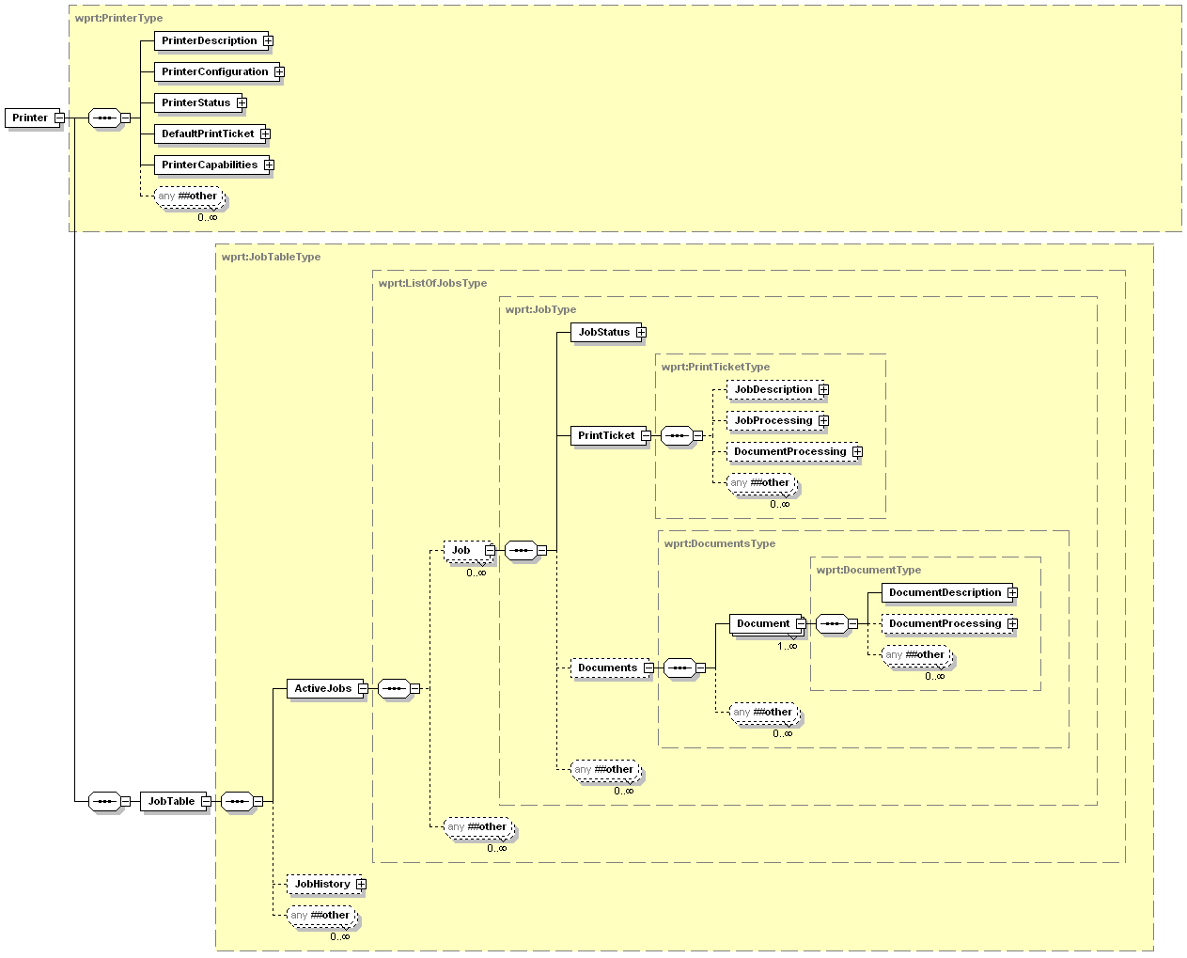
Figure 1 – Printer Model
The Printer, Job, and Document elements are grouped together. These element groups collect similar elements together. “Description” elements for the Printer contain descriptive information for a device model that is either static or administratively set by a CP. “Description” elements for Jobs and Documents contain descriptive information that is administratively set or supplied by a CP during job submission. The Printer “Configuration” elements contain information that describes the current physical configuration of the printer and its options. The Printer and Job “Status” elements contain information primarily controlled by automata. These can be indirectly affected by a CP through operations such as “CancelJob”. The Job’s ”Processing” elements specify features that are applied to the entire job (e.g. Priority) or to Document(s) in the Job (e.g. MediaType). Finally the Printer “Capabilities” elements provide the allowed values for all the elements used in Job creation and the DefaultPrintTicket provides the default values for all the elements used in Job creation. The figure above illustrates the relationships between these elements. The member elements of Printer, Job, and Document are detailed in the following sections.

The Printer’s Elements
This section defines the elements that comprise the WSD Printer Service. Figure 2 shows the PrinterDescription elements for the printer. Figure 3 shows the PrinterConfiguration elements for the printer. Figure 4 shows the PrinterStatus elements for the printer. Figure 9 shows the PrintTicket elements which define the DefaultPrintTicket for the printer. Figure 10 shows the PrinterCapabilities elements for the printer.

The PrinterDescription Elements
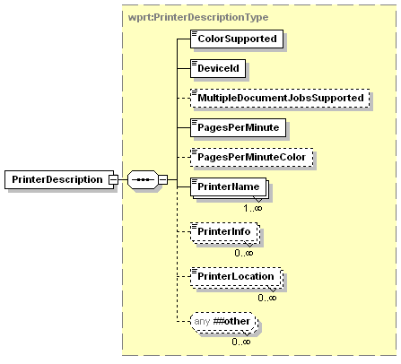
Figure 2 – PrinterDescription Elements
All the Printer elements contained within the PrinterDescription element are described in the following sections.

ColorSupported
This element identifies whether or not the device is capable of multi-hued color printing. A printer that is capable of full color output has a value of 1 or true. A grayscale capable or business graphics capable printer has the value of 0 or false, as would a highlight printer.
(Note: though this element is named the same as the corresponding IPP “color-supported” (boolean) Printer element, the semantics differ: An WSD Printer MUST be capable of FULL color output in order to have a 1 or true value. See [PWG5105.1] section 7.4)
Values: 0, 1, true, false

DeviceId
The value of this element MUST exactly match the IEEE 1284-2000 Device ID string, except the length field MUST NOT be specified.. The value is assigned by the Printer vendor and MUST NOT be localized by the Print Service.
The IEEE 1284-2000 Device ID is a length field followed by a case-sensitive string of ASCII characters defining peripheral characteristics and/or capabilities. For the purposes of this specification, the length bytes MUST NOT be included. The Device ID sequence is composed of a series of keys and values of the form:
key: value {,value} repeated for each key
As indicated, each key will have one value, and MAY have more than one value. The minimum necessary keys (case-sensitive) are MANUFACTURER and MODEL. (These keys MAY be abbreviated as MFG and MDL respectively.) Each implementation MUST supply these two keys and possibly additional ones as well. Each key (and each value) is a string of characters. Any characters except colon (:), comma (,), and semi-colon (;) MAY be included as part of the key (or value) string. Any leading or trailing white space (SPACE[x'20'], TAB[x'09'], VTAB[x'0B'], CR[x'0D'], NL[x'0A'], or FF[x'0C']) in the string is ignored by the parsing program (but is still counted as part of the overall length of the sequence).
An example ID String, showing optional command set, comment and active command set keys and their associated values (the text is actually all on one line):
MANUFACTURER:ACME Manufacturing;
COMMAND SET:PCL,PJL,PS,XHTML-Print+xml;
MODEL:LaserBeam 9;
COMMENT:Anything you like;
ACTIVE COMMAND SET:PCL;
(See IEEE 1284-2000 clause 7.6)
Note: One of the purposes of the DeviceId element is to select a printer driver for those CPs that need a printer driver. The values of the MANUFACTURER and MODEL keys are use to create a Windows-centric Plug-n-Play HardwareID interpreted by the printer driver provided by the vendor and so are vendor-defined, rather than being standardized.
Allowed Values: any character string
All WSD printers MUST populate it with an appropriate value.

MultipleDocumentJobsSupported
This element indicates whether or not the printer allows a job to contain more than one Document. A printer that is capable of processing jobs with multiple documents has a value of 1 or true for this element. A printer that only supports a single document per job has a value of 0 or false for this element.
Values: 0, 1, true, false
Default Value: false

PagesPerMinute
This element specifies the nominal number of black and white or grayscale impressions which may be generated by this Printer per minute.
Values: 1 – 2147483647
Vendors MUST NOT extend the allowed values for this element.

PagesPerMinuteColor
This element specifies the nominal number of color impressions which may be generated by this Printer per minute.
Values: 1 – 2147483647
Vendors MUST NOT extend the allowed values for this element.

PrinterName
This element is the administratively assigned user-friendly name of the Printer. How the value for this element is configured is implementation-specific, e.g., local console, Presentation Service (web access). If the Device Service has only one hosted service, then the <ThisDevice><friendlyName> and PrinterName are recommended to have the same value. However, if the Device contains several hosted services, the PrinterName identifies the Printer. A print device can return multiple version of this element to allow support for multiple localized languages by using the xml:lang attribute.
Allowed Values: any character string

PrinterInfo
The administratively assigned descriptive information about this Printer (example: “Out of courtesy for others, please print only small (1-5 page) jobs at this printer"). How the value for this element is configured is implementation-specific, e.g., local console, Presentation Service (web access). A print device can return multiple version of this element to allow support for multiple localized languages by using the xml:lang attribute.
Allowed Values: any character string

PrinterLocation
This element indicates the location of the device (for example, “Bobby’s room”). How the value for this element is configured is implementation-specific, e.g., local console, Presentation Service (web access). A print device can return multiple version of this element to allow support for multiple localized languages by using the xml:lang attribute.
Allowed Values: any character string

The PrinterConfiguration Elements
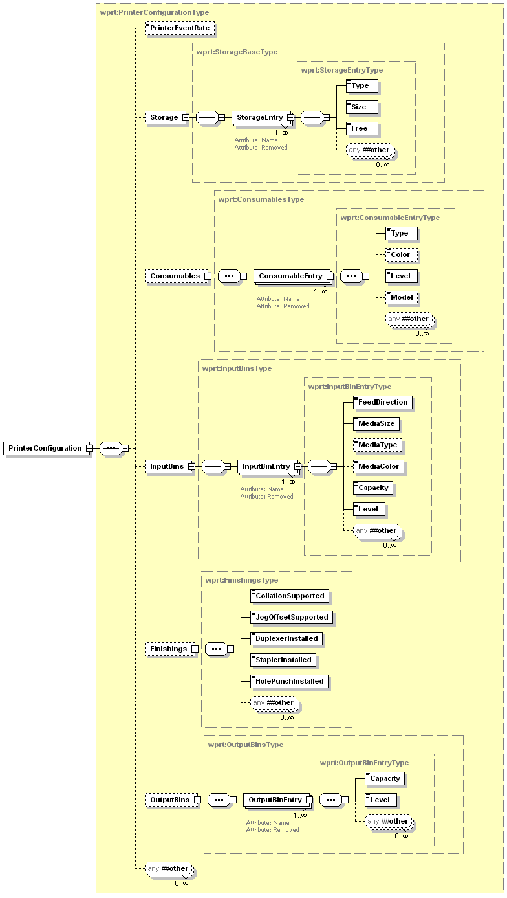
Figure 3 – PrinterConfiguration Elements
All of the Printer elements contained within the PrinterConfiguration element are described in the following sections.
It is required that every WSD Print Service return the complete PrinterConfiguration structure when the client requests the data via the GetPrinterElements operation. The print service should support at least one entry for each of the configuration element arrays and the PrinterConfiguration/Finishings element.
The element is defined with most fields optional to make the sending of a PrinterElementsChangeEvent easier.

PrinterEventRate
This data element contains the amount of time the printer will wait between sending occurrences of CompleteState events. See section 4.2 for a full discussion of CompleteState events. This value is in seconds. This value is global for the device and affects all CompleteState events.

Values: 1 – 600
Default Value: 1

Storage
This element is a collection that describes the storage capabilities available at the device. This includes not only the volatile system memory storage, but also any non-volatile storage that can be taken advantage of by applications. The sub-elements are described in detail in the following sections.

StorageEntry
This is an element that describes the details about one of the available storage mechanisms.

Name
This attribute indicates the name associated with the current Storage entry. This allows the CP to differentiate/display the various storage elements. This name should be unique within the device.
REQUIRED attribute.
Allowed Values: any character string

Removed
This attribute indicates the current Storage entry has been removed from the device. This attribute is only valid in a PrinterElementsChangeEvent and can be used to report that the device has changed configuration with the identified storage entry being removed from the device. The absence of this attribute indicates the storage entry is still valid.
OPTIONAL attribute.
Values: 0, 1, true, false
Default Value: false

Type
This element indicates the type of the current Storage entry. Storage entries depict any kind of mass storage available in the print device. This included internal RAM, hard disks, memory cards, or other types of storage.
Values:
RAM - Internal printer memory buffer
PSMemory – Portion of the device RAM set aside for Postscript interpreter usage
NonRemoveableFlash – Non-removable, non-volatile memory
HardDisk - Hard disk drive
SmartMedia – Removable SmartMedia memory card
CompactFlash – Removable CompactFlash memory card
MemoryStick – Removable MemoryStick memory card
SecureDigital – Removable SecureDigital memory card
Vendors MAY extend the allowed values for this element
Vendors MAY subset the allowed values for this element

Size
This element indicates the size of the current Storage entry. This is an integer value whose unit is Kilobytes (KB). One Kilobytes equals 1024 bytes.

Values: 1 – 2147483647

Free
This element indicates the amount of free space associated with the current Storage entry. This is an integer value and the unit is a percentage. If the device can not determine the level the value -1 should be used. To limit the rate of events generated by changes in this element, this value MUST step down/up at a rate of 10% or more.

Values: -1 - 100

Consumables
This element is a collection that describes the current Consumables at the device. This includes not only the marker supplies but also any other type of supply that gets consumed during the printing process.

ConsumableEntry
This is an element that describes the details about one of the available consumables.

Name
This attribute indicates the name associated with the current Consumables entry. This allows the CP to differentiate/display the various consumables elements. This name should be unique within the device.
REQUIRED attribute.
Allowed Values: any character string

Removed
This attribute indicates the current Consumables entry has been removed from the device. This attribute is only valid in a PrinterElementsChangeEvent and can be used to report that the device has changed configuration with the identified Consumables entry being removed from the device. The absence of this attribute indicates the consumable entry is still valid.
OPTIONAL attribute.
Values: 0, 1, false, true
Default Value: false

Type
This element indicates the type of consumable associated with the current Consumables entry. The type allows the CP to differentiate between the different consumable entries.

Values:
Toner
WasteToner
Ink
WasteInk
Opc
Developer
FuserOil
Wax
WasteWax
Staples

Values: any value listed above
Vendors MAY extend the allowed values for this element.

Color
This element indicates the color of the consumable associated with the current Consumables entry. This element will not be applicable for some of the consumable types (example: Developer).

Values:

Black
Blue
Color
Cyan
Gray
Green
Magenta
PhotoBlack
PhotoBlue
PhotoColor
PhotoCyan
PhotoMagenta
PhotoYellow
Red
White
Yellow

Allowed Values: any value listed above
Vendors MAY extend the allowed values for this element.

Level
This element indicates the current level of the consumable associated with the current Consumables entry. This is an integer value and the unit is a percentage. If the device can not determine the level the value -1 should be used. To limit the rate of events generated by changes in this element, this value MUST step down/up at a rate of 10% or more.

Values: -1 - 100
Vendors MUST NOT extend the allowed values for this element.

Model
This element is the optional Model name of the current Consumables entry. This can be used to differentiate between versions of the same color/type of consumable such as normal & high capacity cartridges, etc…
Allowed Values: any string

InputBins
This element is a collection that describes the capabilities of all input bins available at the device.

InputBinEntry
This is an element that describes the details about one of the available InputBins.

Name
This attribute indicates the name of the current InputBins entry. This name will be used by the CP to differentiate the various input bins. The value of this element should be unique and descriptive with the device.
Values:
TrayXXX - where XXX is any number without leading zeros
Top
Middle
Bottom
LargeCapacity
Manual
Envelope
EnvelopeManual
MultiPurpose
Bypass

REQUIRED attribute.
Vendors MAY extend the allowed values for this element.
Vendors MAY subset the allowed values for this element

Removed
This attribute indicates the current InputBins entry has been removed from the device. This attribute is only valid in a PrinterElementsChangeEvent and can be used to report that the device has changed configuration with the identified InputBin entry being removed from the device. The absence of this attribute indicates the input bin entry is still valid.
OPTIONAL attribute.
Allowed Values: 0, 1, false, true
Default Value: false

FeedDirection
This element indicates the media feed direction of the current InputBins entry.
Values:
LongEdgeFirst – the long edge of the media enters the printer first
ShortEdgeFirst – the short edge of the media enters the printer first
Vendors MAY subset the allowed values for this element

MediaSize
This element indicates the size of the media installed in the current InputBins entry. Each value MUST include the name of the size followed by the dimensions in inches or millimeters followed by the “in” or “mm” suffix to indicate the units. Both the Inch and Millimeter dimension MAY include a non-zero decimal fraction set off by a period (.). The name of the size consists of a class part and a name part separated by an underscore (_). The class part MUST be “na”, “asme”, or “oe” for inch units and “iso”, “jis”, “jpn”, “prc”, or “om” for metric units (see [PWG5101.1] for additional class names). The name part is set off by a second underscore (_) and the dimensions are separated by the lower case letter x. The shorter dimension MUST come first. See the Allowed Values for examples.
For sizes that do not have standard names, a CP or a Print Service can create a customized name using the 'custom_xxx' class and name, where xxx indicates the custom name of the medium, followed by the dimensions in inches or millimeters as for standard names. For example, a custom 3.5 by 5.0 inch medium that, say, represents an index card, could be indicated by the string value:
custom_index-card_3.5x5in
The customized values configured for the Printer MUST be added to the Printer’s list of allowed values.
If a Printer supports the control point supplying custom names that are not one of the values in the Printer’s <allowedValueList> element, the Printer’s <allowedValueList> element MUST include both the ‘custom_max_IIIxJJJmm’ and ‘custom_min_IIIxJJJmm’ (and/or ‘custom_max_IIIxJJJin’ and ‘custom_min_IIIxJJJin’) Allowed Values to indicate the minimum and maximum custom sizes that the Printer will allow the control point to supply.
(See [PWG5101.1] for suggested media size names and their dimensions. These names SHOULD NOT use the “custom” class name.)
Values: All valid values according to [PWG5101.1].
Some examples - iso_a4_210x297mm, iso_c5_162x229mm, iso_dl_110x220mm, jis_b4_257x364mm, na_legal_8.5x14in, na_letter_8.5x11in
Vendors MAY extend the allowed values for this element.
Vendors MAY subset the allowed values for this element

MediaType
This element indicates the type of the media installed in the current InputBins entry. The values are a subset of and the descriptions are taken verbatim from the Media Type Names in [PWG5101.1].
Values:
stationery Separately cut sheets of an opaque material
transparency Separately cut sheets of a transparent material
envelope Envelopes that can be used for conventional mailing purposes
labels Label stock [For example, a sheet of peel-off labels].
photographic Separately cut sheets of an opaque material to produce photographic quality images
photographic-glossy Separately cut sheets of an opaque material to produce photographic quality images with a glossy coating
photographic-matte Separately cut sheets of an opaque material to produce photographic quality images with a matte finish
cardstock Separately cut sheets of an opaque material that is heavier and stiffer than stationery
unknown The device can not detect the media type
Vendors MAY extend the allowed values for this element.
Vendors MAY subset the allowed values for this element

MediaColor
This element indicates the color of the media installed in the current InputBins entry. The values are a subset of and the descriptions are taken verbatim from the Media Color Names in [PWG5101.1].
Values:
white
pink
yellow
buff
goldenrod
blue
green
red
gray
ivory
orange
other
no-color Media has no color (i.e. clear transparency)
unknown Device can not determine the media color
Vendors MAY extend the allowed values for this element.
Vendors MAY subset the allowed values for this element

Capacity
This element indicates the total capacity of the current InputBins entry. This is an integer value and the unit is sheets. If the device can not determine the capacity the value -1 should be used.

Allowed Values: -1, 1 – 2147483647
Vendors MUST NOT extend the allowed values for this element.

Level
This element indicates the current level of the current InputBins entry. This is an integer value and the unit is a percentage. If the device can not determine the level the value -1 should be used. To limit the rate of events generated by changes in this element, this value MUST step down/up at a rate of 10% or more.

Values: -1 - 100

Finishings
This element describes the overall finishing capabilities available at the device. This includes whether the device supports duplexing, collation or jogoffset printing, and also any stapling or holepunch capabilities.
If the Finishings section is missing from a PrinterConfiguration element the value of all the contained elements is assumed to be false.

CollationSupported
This element indicates the whether the print device supports hardware collation for print jobs.
Allowed Values: 0, 1, false, true

JogOffsetSupported
This element indicates the whether the print device supports offsetting copies of a print job.
Allowed Values: 0, 1, false, true

DuplexerInstalled
This element indicates the whether the print device currently has a hardware duplexing option installed allowing duplex printing of print jobs.
Allowed Values: 0, 1, false, true

StaplerInstalled
This element indicates the whether a stapling attachment is installed on the print device.
Allowed Values: 0, 1, false, true

HolePunchInstalled
This element indicates the whether a hole punch attachment is installed on the print device.
Allowed Values: 0, 1, false, true

OutputBins
This element is a collection that describes the capabilities of all output bins available at the device.

OutputBinEntry
This is an element that describes the details about one of the available OutputBins.

Name
This attribute indicates the name of the current OutputBins entry. This name will be used by the CP to differentiate the various output bins. The value of this attribute should be unique and descriptive with the device.
Values:
BinXXX - where XXX is any number without leading zeros
Top
Middle
Bottom
LargeCapacity
FaceUp
FaceDown
MailboxYYY - where YYY is any number without leading zeros

REQUIRED attribute.
Vendors MAY extend the allowed values for this element.
Vendors MAY subset the allowed values for this element

Removed
This attribute indicates the current OutputBins entry has been removed from the device. This attribute is only valid in a PrinterElementsChangeEvent and can be used to report that the device has changed configuration with the identified OutputBin entry being removed from the device. The absence of this attribute indicates the output bin entry is still valid.
OPTIONAL attribute.
Values: 0, 1, true, false
Default Value: false

Capacity
This element indicates the total capacity of the current OutputBins entry. This is an integer value and the unit is sheets. If the device can not determine the capacity the value -1 should be used.

Values: -1, 1 – 2147483647
Vendors MUST NOT extend the allowed values for this element.

Level
This element indicates the current level of the current OutputBins entry. This is an integer value and the unit is a percentage. If the device can not determine the level the value -1 should be used. To limit the rate of events generated by changes in this element, this value MUST step down/up at a rate of 10% or more.

Values: -1 - 100
Vendors MUST NOT extend the allowed values for this element.

The PrinterStatus Elements
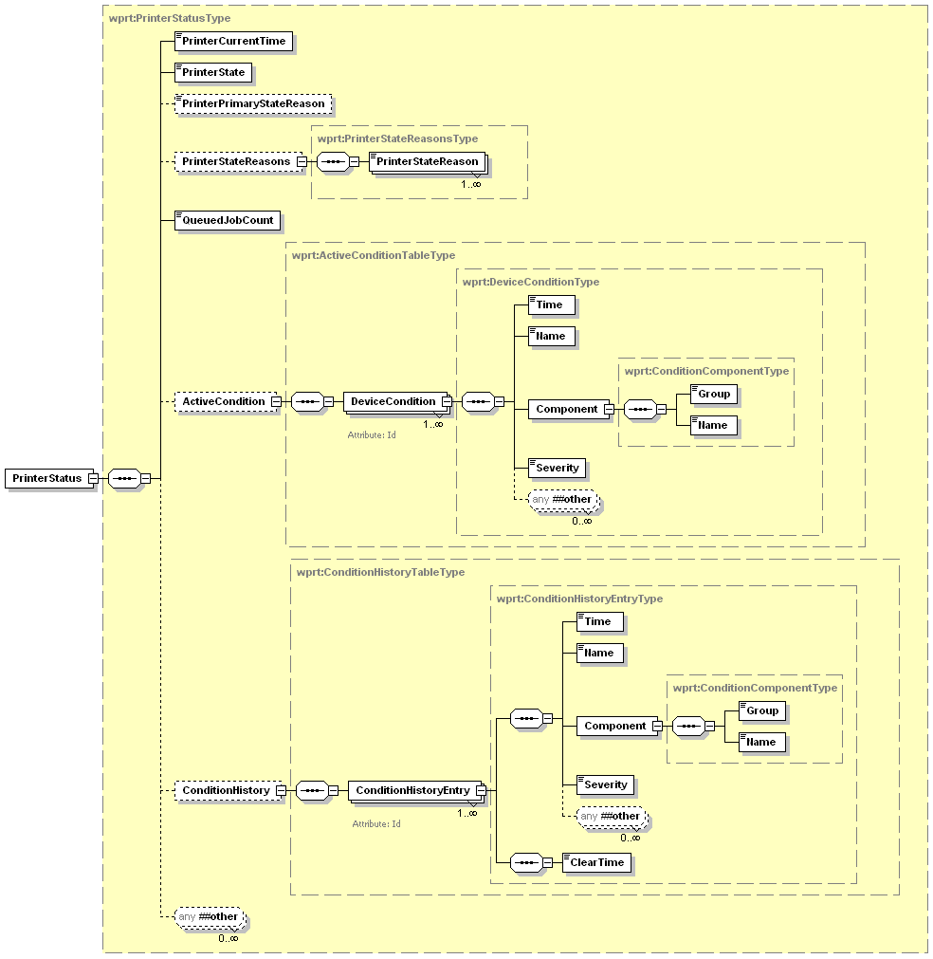
Figure 4 – PrinterStatus Elements
All of the Printer elements contained within the PrinterStatus element are described in the following sections.

PrinterCurrentTime
This element indicates the current date and time according the printer’s internal clock. It is not required that this be a real time clock. The data in this element can simply be an increasing time starting with when the device was powered on.
Allowed Values: Any valid dateTime value

PrinterState
This element identifies the current state of the service.
Values:
Idle - new jobs can start processing immediately without waiting.
Processing - jobs (Tracked or Untracked) are processing; new jobs will wait before processing, i.e., are said to be pending.
Stopped - no jobs can be processed and intervention is needed.
Vendors MAY extend the allowed values for this element.
Vendors MAY subset the allowed values for this element

PrinterPrimaryStateReason
This element is the most important current PrinterStateReason (see section 3.4.4.1). The relative importance of all current reasons is decided by the device implementation; however a general rule would be that any condition with a severity of Critical would be more important than a condition with a severity of Warning which is in turn more important than any condition with a severity of Informational.
Default Value: None

PrinterStateReasons
This element is a collection that describes all of the additional information about why the Printer is in its current state. If this element is not present the device PrinterStateReason is assumed to be None.

PrinterStateReason
Indicates a single additional piece of information about why the Printer is in its current state
Note: some of these reasons describe state of the printer that cannot be entered on the basis of the currently defined WSD operations set. For example the printer can be Paused; however there is no PausePrinter operation. The reason these states are presented is because some other protocol (or console action) may have caused the printer to enter that state.
Values:
AttentionRequired - The device has stopped for a reason other than the PrinterStateReasons listed here and requires human intervention before it can continue.
DoorOpen - One or more covers on the device are open.
MarkerSupplyLow- The device is low on at least one marker supply, e.g., toner, ink, ribbon.
MarkerSupplyEmpty - The device is out of at least one marker supply, e.g., toner, ink, ribbon.
MediaEmpty - At least one input tray is empty.
MediaJam - The device has a media jam.
MediaLow - At least one input tray is low on media.
MediaNeeded - A job has been submitted that is requesting media that is currently not loaded. The job has specified a particular MediaSize and MediaType argument value combination that is not loaded, although the Printer supports that combination.
None- Indicates that there are no current state reasons
OutputAreaAlmostFull - One or more output area is almost full (e.g. tray, stacker, collator).
OutputAreaFull - One or more output area is full, e.g.,. tray, stacker, collator.
Paused - Someone has paused the printer and the PrinterState is Stopped. In this state, a Printer will not produce printed output.
Default Value: None
Vendors MUST support the values that represent conditions that are detectable in their implementation. Therefore, vendors MAY subset allowed values if specific PrinterStateReasons are undetectable in their implementation.
Vendors MAY extend allowed values. However, Printer vendors need to understand the implications of extending this list on a CP. The CP usually localizes the PrinterStateReasons value (as with other string variable values) to the human language of the user. However, such a Printer vendor extension value will not be recognized by the CP. As a Fallback presentation, the CP MAY display the value received as is, which should be in English and therefore, might not be understandable by the user. Alternatively, the vendor might use the general PrinterStateReasons value: AttentionRequired and then explain the problem on the Printer console which the user would see when they are by the Printer.

QueuedJobCount
This element specifies the number of tracked jobs this printer has currently accepted but not yet finished printing.
Values: 0 – 2147483647
Vendors MUST NOT extend the allowed values for this element.

ActiveCondition
This element is a collection of detailed descriptions that describe all of the currently active conditions/errors on the device. These conditions could vary in severity from Informational to Critical.

DeviceCondition
This element describes the details about one of the currently active conditions.

Id
This attribute specifies the unique Id of the current DeviceCondition entry or ConditionHistoryEntry entry. This Id will be used by the CP to determine if an error condition is new, or has gone away. This Id is an integer value and needs to not be re-used over a reasonable duration of time to allow CPs to keep track of individual DeviceCondition(s).
REQUIRED attribute.
Values: 1 – 2147483647
Vendors MUST NOT extend the allowed values for this element.

Time
This element specifies the time a condition occurred. This time is according to the internal clock of the printer. It is not required that this be a real time clock. The data in this element can simply be an increasing time starting with when the device was powered on. However, this value should be in sync with the time the printer reports in element PrinterCurrentTime.
Values: Any valid dateTime value
Vendors MUST NOT extend the allowed values for this element

Name
This element specifies the name of the current DeviceConditon entry. This name describes the type of the current error condition. There are different error names for each component.
Values:
CoverOpen
InterlockOpen
Jam
DoorOpen
InputTrayMissing
InputTrayMediaSizeChange
InputTrayMediaTypeChange
InputTraySupplyLow
InputTraySupplyEmpty
OutputTrayMissing
OutputTrayAlmostFull
OutputTrayFull
FuserUnderTemperature
FuserOverTemperature
ConsumableLow
ConsumableEmpty
WasteReceptacleAlmostFull
WasteReceptacleFull
Unknown
Vendors MAY extend the allowed values for this element.
Vendors MAY subset the allowed values for this element

Component
This element specifies the component that is described by the current DeviceCondition entry.

Group
This element specifies the component group that is described by the current DeviceCondition entry.
Values:
PrintService
InputBin
MediaPath
OutputBin
Consumable
CoverDoor
Vendors MAY extend the allowed values for this element.
Vendors MAY subset the allowed values for this element

Name
This element specifies the name of the component that is described by the current DeviceCondition entry. The Name of the component is combined with the Group to determine the exact location of the problem. Example: Group-InputBin & Name-Tray1. The values for this element are determined by the name elements of the PrintConfiguration elements.
Values:
Determined by the various Name values in the PrinterConfiguration element
Vendors MAY extend the allowed values for this element.
Vendors MAY subset the allowed values for this element

Severity
This element specifies the level of severity of the current DeviceCondition entry. The printer determines the severity level assigned to each error condition.

Values:
Informational
Warning
Critical
Vendors MAY extend the allowed values for this element.
Vendors MAY subset the allowed values for this element

ConditionHistory
This element is a collection of detailed descriptions that describe a set of the most recent conditions/errors on the device. These conditions could vary in severity from Informational to Critical.

ConditionHistoryEntry
This is an element that describes the details about one of the past conditions.

Id
This attribute is described in Section 3.4.6.1.1

Time
This data element is described in Section 3.4.6.1.2

Name
This data element is described in Section 3.4.6.1.3

Component
This data element is described in Section. 3.4.6.1.4

Group
This data element is described in Section 3.4.6.1.4.1

Name
This data element is described in Section 3.4.6.1.4.2

Severity
This data element is described in Section 3.4.6.1.5

ClearTime
This element specifies the time a condition was cleared. This time is according to the internal clock of the printer. It is not required that this be a real time clock. The data in this element can simply be an increasing time starting with when the device was powered on. However, this value should be in sync with the time the printer reports in element PrinterCurrentTime.

Values: Any valid dateTime value
Vendors MUST NOT extend the allowed values for this element

The Job’s Elements
This section defines the elements of the WSD Print Job Object. Figure 5 shows all the elements for the Job and their grouping. Jobs can contain one or more Documents. As indicated in the figure below the processing instructions for both the Job and the Document are done at the Job level. This provides a migration path forward if multi-document Jobs are added. The Job level DocumentProcessing instructions will be the default for every Document in the Job. The Document Object is covered in detail in section 3.6.
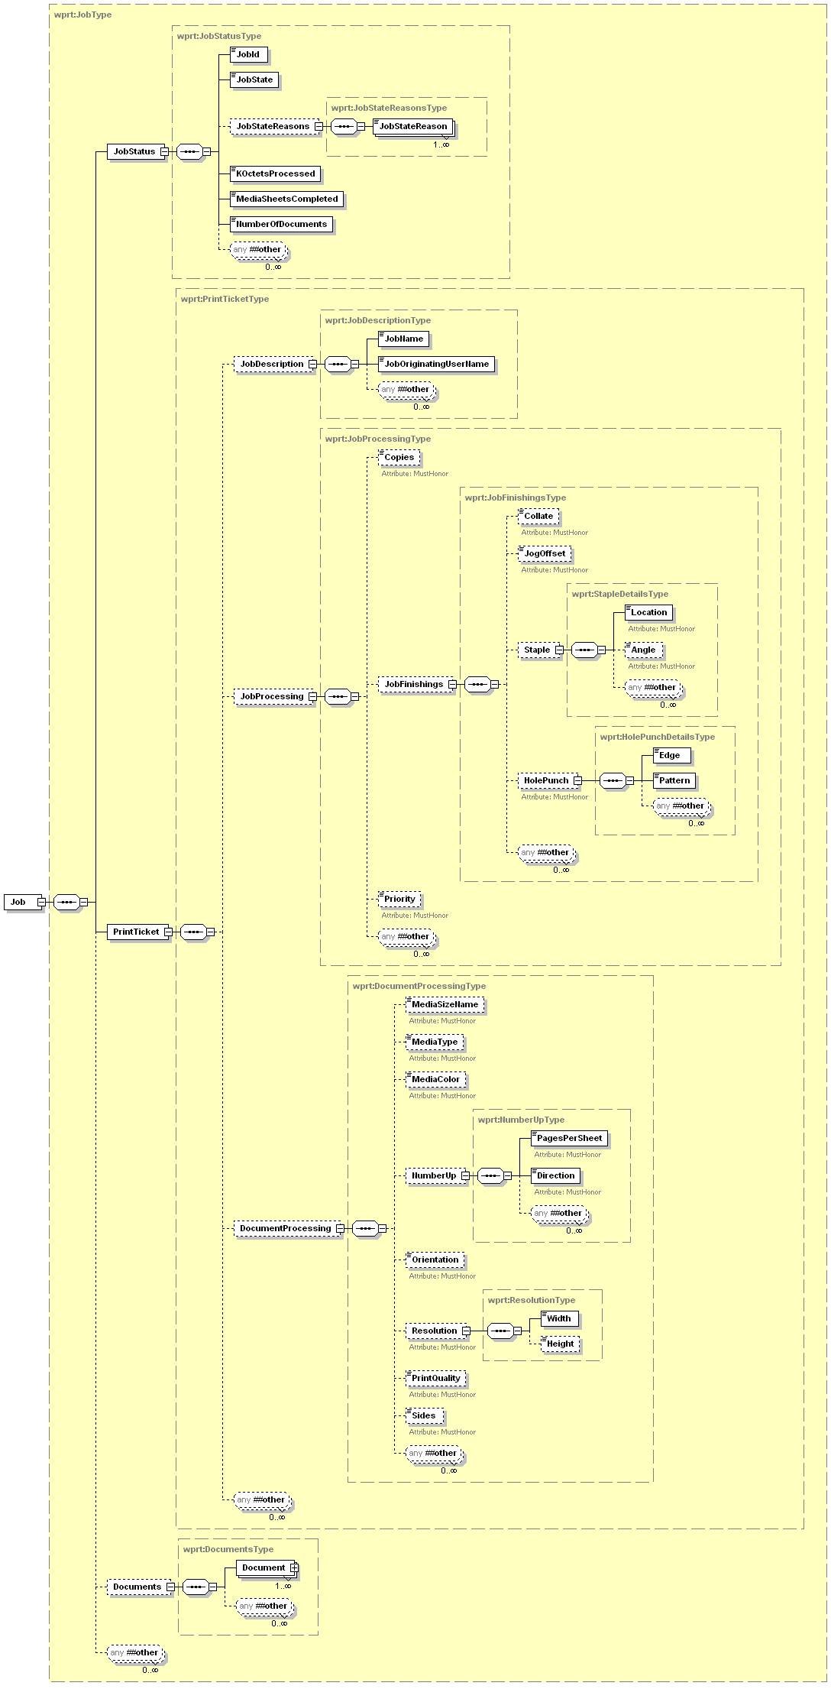
Figure 5 – Job Elements
The sections below list all the Job’s elements. The JobProcessing or DocumentProcessing elements of a Job are populated from corresponding elements explicitly supplied in a Job creation request by a CP. If the CP does not supply a processing element this indicates that the CP does not have a preference and the Printer will use its default value. Note that the default value may be overridden if a corresponding value is encountered in the PDL Data Stream (See section 2.4.2). How the Printer's default and allowed values for processing elements are set is implementation-specific, e.g., local console, Presentation Service (web access).
The JobDescription elements are populated from corresponding elements supplied in a Job creation request. These values may be changed by the Printer if more reliable information can be obtained. The JobStatus elements are maintained by automata. The values may be indirectly affected by a CP operation (e.g. CancelJob).

JobStatus
This section of the schema defines all the information that pertains to the status of the currently identified Job.

JobId
Uniquely identifies a Job within a Printer. This number is not globally unique.
Values: 0 – 2147483647
Default Value: implementation specific
Vendors MUST NOT extend the allowed values for this element.

JobState
Specifies the current state of the Job or the completion state of the Job. When contained in the JobEndState event or a JobHistory entry it represents the completion state of the Job.
Values:
Aborted – The Job was aborted by the system.
Canceled – The Job was canceled either by a CP using the CancelJob operation or by means outside the scope of WSD.
Completed – The Job is finished processing and the last sheet of the Job has been stacked in the output tray.
Pending – The Job is waiting to be processed
Pending-Held – The Job is waiting to be processed but is unavailable for scheduling. This state can only be reached by methods outside the scope of WSD
Processing – The Job is being accessed, interpreted, transformed, rendered, marked or having a finishing applied.
ProcessingStopped- The same as Processing above except the Printer is unable to continue due to some error condition or by methods outside the scope of WSD
Started – The print device has begun processing the Job. This is a transient state, and will usually be seen only within a JobStatus Event.
Terminating – The Job has been canceled or is being aborted and the device is still in the process of removing the Job from its internal processing state. This state is transient and the job will eventually end in a state of either Canceled or Aborted.
Vendors MAY extend the allowed values for this element.
Vendors MAY subset the allowed values for this element

Figure 6 - Job States

JobStateReasons
This element is a collection that describes all of the additional information about why the Job is in its current state.

JobStateReason
Indicates additional information about why the Job is in its current state
Values:
CompressionError – An error occurred while attempting to decompress a Document in the Job
DocumentAccessError – An error occurred while attempting retrieve a Document referenced in the Job
DocumentFormatError – An error occurred while attempting to interpret a Document in the Job
DocumentTimeoutError – The client failed to start a document within the CreatePrintJob timeout period. The job was aborted.
DocumentTransferError – The data transfer of a document in the job failed. If this occurs the job is aborted.
JobCanceledAtDevice – The job was canceled at the device operatior panel.
JobCanceledByUser – The job was canceled with a CancelJob operation.
JobCompletedSuccessfully – The Job is complete without any warnings or errors
JobCompletedWithErrors – The Job completed with at least one error. The type of error determines how much of the Job is available in the output bin (e.g. a Postscript stack overflow halfway through the Job).
JobCompletedWithWarnings – The Job completed with at least one warning. The Job is expected to be available in the output bin. The warning may have altered the content (e.g. a font substitution occurred).
JobIncoming – The Job is currently being received by the Printer.
JobPasswordWait – The Job is waiting at the device for the User to input a password.
JobPrinting – The Printer is accessing, interpreting, transforming, rendering, marking or applying a finishing to the Job.
None – The Job has no additional information on the JobState.
PrinterStopped – The Printer’s PrinterState is Stopped.
UnsupportedCompression – The Job’s Document is compressed using an unsupported compression method.
UnsupportedDocumentFormat – The Job’s Document contains an unsupported document format.
Default Value: None
Vendors MUST support the values that represent conditions that are detectable in their implementation. Therefore, vendors MAY subset allowed values if specific JobStateReasons are undetectable in their implementation.
Vendors MAY extend allowed values. However, Printer vendors need to understand the implications of extending this list on a CP. The CP usually localizes the JobStateReasons value (as with other string variable values) to the human language of the user. However, such a Printer vendor extension value will not be recognized by the CP. As a fallback presentation, the CP MAY display the value received as is, which should be in English and therefore, might not be understandable by the user.

KOctetsProcessed
This element is the total amount of the Document content, expressed in 1024 octet units, which has been processed by the Printer.
Values: 0 – 2147483647
Vendors MUST NOT extend the allowed values for this element.

MediaSheetsCompleted
This element is the number of media sheets completed and stacked for the job so far.
(Note: This information may not be known until the Printer has completed processing the Job. The Printer MUST update this element when more exact information is available)
Values: 0 – 2147483647
Vendors MUST NOT extend the allowed values for this element.

NumberOfDocuments
This element is the number of Documents in the Job. (It may be zero during Job creation prior to receiving the Document(s)).
Values: 0 – 2147483647
Vendors MUST NOT extend the allowed values for this element.

PrintTicket
This section of the schema defines all the information that pertains to the description and processing parameters of the currently identified Job. This is the PrintTicket definition that was supplied with the CreatePrintJob operation which started the Job.

JobDescription
This section of the schema defines all the data that pertains to the basic creation information of the currently identified Job. This element is defined as optional to make it easier to send back PrinterElementsChangeEvents for changes in the DefaultPrintTicket. Any time a PrintTicket is included in either a CreatePrintJob request or GetPrinterElements response the JobDescription must be present.

JobName
This is the user-friendly name of the job supplied by the CP. It is RECOMMENDED that the CP supply a value to help a user easily distinguish between the jobs that have been submitted.
Allowed Values: any character string

JobOriginatingUserName
This is the name of the user that submitted the job. Either supplied by the CP or by the security infrastructure, if any. It is RECOMMENDED that the CP supply a value to help a user easily distinguish between the jobs that he/she has submitted and jobs that others have submitted. The JobOriginatingUserName is set to the most reliable value accessible to the Printer.
Allowed Values: any character string

JobProcessing
This section of the schema defines all the requested processing attributes that are applicable at a job level.

Copies
This element specifies the requested number of copies of the Job
Values: 1 – 2147483647
Default Value: 1
All WSD printers MUST support at least the ‘1’ value.
Vendors MUST NOT extend the allowed values for this element.

JobFinishings
This element is a collection that describes all of the finishing options requested for the current Job.

Collate
This element identifies whether the printer should group the pages of each copy of the job if more than one copy of the Job is printed.
Values: 0, 1, true, false
Default Value: false

JogOffset
This element identifies whether each copy of the Job will be offset in the output tray from the previous copy.
Allowed Values: 0, 1, false, true
Default Value: false

Staple
This element contains the detailed information that specifies how to staple for the current Job.

Location
This element indicates the location staples are to be placed on the printed page. The top/bottom & right/left directions should be in reference to the origin of the logical page.
Values:
None Don’t staple the job
StapleBottomLeft Place staples in the bottom left corner of printed page
StapleBottomRight Place staples in the bottom right corner of printed page
StapleDualBottom Place 2 staples along the bottom edge of the printed page
StapleDualLeft Place 2 staples along the left edge of the printed page
StapleDualRight Place 2 staples along the right edge of the printed page
StapleDualTop Place 2 staples along the top edge of the printed page
StapleTopLeft Place staples in the top left corner of printed page
StapleTopRight Place staples in the top right corner of printed page

Default Value: None
Vendors MAY extend the allowed values for this element.
Vendors MAY subset the allowed values for this element

Angle
This element indicates the angle the staples are to be placed on the printed page.
Values:
Horizontal Place staples parallel to the top edge of the page
Vertical Place staples parallel to the left edge of the page
Slanted Place staples in a 45º angle to the edge of the page
Any The device can place the staples at what ever angle works best
NotApplicable This value is only used in the DefaultPrintTicket or PrinterCapabilities element when Staple/Location is None

Default Value: Any
Vendors MAY extend the allowed values for this element.
Vendors MAY subset the allowed values for this element

HolePunch
This element contains the detailed information that specifies how to hole punch for the current Job.

Edge
This element indicates along what edge the hole punch attachment should punch holes in output pages. The top/bottom & right/left directions should be in reference to the origin of the logical page.
Values:
None Don’t punch holes in the job
Top
Bottom
Left
Right

Default Value: None
Vendors MAY extend the allowed values for this element.
Vendors MAY subset the allowed values for this element

Pattern
This element indicates what pattern the hole punch attachment is should punch in output pages. If the value of the HolePunch/Edge element is None the HolePunch/Pattern element is ignored.
Values:
TwoHoleUSTop
ThreeHoleUS
TwoHoleDIN
FourHoleDIN
TwentyTwoHoleUS
NineteenHoleUS
TwoHoleMetric
Swedish4Hole
TwoHoleUSSide
FiveHoleUS
SevenHoleUS
Mixed7H4S
Norweg6Hole
Metric26Hole
Metric30Hole
NotApplicable This value is only used in the DefaultPrintTicket or PrinterCapabilities element when HolePunch/Edge is None

Vendors MAY extend the allowed values for this element.
Vendors MAY subset the allowed values for this element

Priority
This element specifies the relative priority of a Job. The priority ranges from 1 to 100 where 100 is the highest priority.
Values: 1 - 100
Default Value: 50
Vendors MUST NOT extend the allowed values for this element.

DocumentProcessing
This section of the schema defines all the requested processing attributes that are applicable at a document level.

MediaSizeName
This element identifies the medium size name and dimensions that the Printer Service should use for all sheets of the job. See Section 3.3.4.1.4 – InputBinMediaSize for an explanation of how to specify paper sizes.
Values: All valid values according to [PWG5101.1].
Some examples - iso_a4_210x297mm, iso_c5_162x229mm, iso_dl_110x220mm, jis_b4_257x364mm, na_legal_8.5x14in, na_letter_8.5x11in
Default Value: implementation specific
Vendors MAY extend the allowed values for this element.
Vendors MAY subset the allowed values for this element

MediaType
This element identifies the medium type that the Printer Service uses for all impressions of the job. See Section 3.3.4.1.5 for details on the format of this element.

Default Value: unknown

MediaColor
This element identifies the medium color that the Printer Service uses for all impressions of the job. See Section 3.3.4.1.6 for details on the format of this element.

Default Value: unknown

NumberUp
This element contains the detailed information that specifies how to arrange the logical pages on the physical page.

PagesPerSheet
This element indicates the number of PDL Data Stream pages to impose upon a single side of an instance of a selected medium for the job.
Values: 1, 2, 4
All WSD printers MUST support the 1 value.
Default Value: 1
Vendors MAY extend the allowed values for this element.
Vendors MAY subset the allowed values for this element.

Direction
This element indicates the direction the multiple pages will be placed on the current media sheet.
Values:
RightDown – Place the first page in the upper left-hand corner of the sheet, place subsequent pages across the sheet to the right then move down for subsequent rows of pages.
DownRight – Place the first page in the upper left-hand corner of the sheet, place subsequent pages down the sheet then move right for subsequent columns of pages.
LeftDown - Place the first page in the upper right-hand corner of the sheet, place subsequent pages across the sheet to the left then move down for subsequent rows of pages.
DownLeft – Place the first page in the upper right-hand corner of the sheet, place subsequent pages down the sheet then move left for subsequent columns of pages.
All WSD printers MUST support the RightDown value.
Default Value: RightDown
Vendors MAY extend the allowed values for this element.
Vendors MAY subset the allowed values for this element.

Orientation
This element indicates the desired orientation for printed pages for the job.
Values: Portrait, Landscape, ReversePortrait, ReverseLandscape
All WSD printers MUST support the Portrait and Landscape values.
Default Value: Portrait
Vendors MAY extend the allowed values for this element.

Resolution
This element describes a WidthxHeight pair that makes up the print resolution. If the Height element is missing, it is assumed this resolution pair (WidthxHeight) is a square resolution (i.e. 100x100) based on the Width element.
Resolution is specified in pixels per inch.

Width
This element indicates the resolution the job will be printed at in the horizontal direction.

Height
This element indicates the resolution the job will be printed at in the vertical direction.

PrintQuality
Specifies the print quality requested for the job
Values:
Draft
Normal – Print quality at a normal
High – Print quality at the devices highest setting
Photo – Optimize the device settings for photo realistic quality
Default Value: Normal
Vendors MAY extend the allowed values for this element.
Vendors MAY subset the allowed values for this element.

Sides
Specifies how pages are to be imposed upon the sides of a selected medium for the job
Values:
OneSided
TwoSidedLongEdge
TwoSidedShortEdge
All WSD printers MUST support at least the OneSided value.
Default Value: OneSided
Vendors MAY extend the allowed values for this element.
Vendors MAY subset the allowed values for this element.

The Document’s Elements
This section defines the elements of the printer service Document object. Figure 7 shows all the elements for the Document and their grouping. Jobs contain one or more Documents. As previously noted default processing instructions for the Document are done at the Job level. The Document contains a DocumentDescription element and a DocumentProcessing element. The instructions in the Document’s DocumentProcessing element should be applied only to the current document and should override any settings supplied in the Job’s DocumentProcessing element. If neither element specifies a parameter then the device should use its default value.
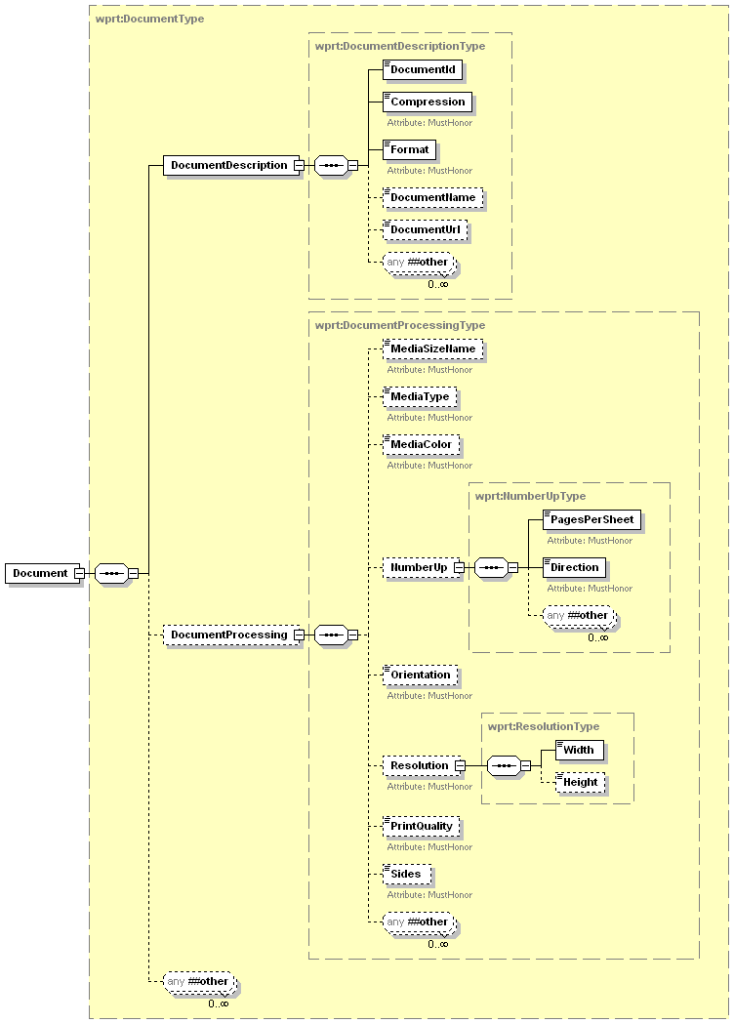
Figure 7 - Document Elements
The DocumentDescription elements and the DocumentProcessing elements are populated from corresponding elements supplied in a Document creation request. The DocumentDescription values may be changed by the Printer if more reliable information can be obtained. All of the Printer elements contained within the Document element are described in the following sections.

DocumentDescription
This section of the schema defines all the description attributes that pertain to the basic creation information of the currently identified Document.

DocumentId
This element uniquely identifies a Document within the current Job. This number is not guaranteed to be globally unique, simply unique within the context of the current job.
Values: 1 – 2147483647
Vendors MUST NOT extend the allowed values for this element.

Compression
This element identifies the compression algorithm used on the Document contents.
Values: Gzip, None, Compress, Deflate
All WSD printers MUST support the None value.
Default Value: None
Vendors MAY extend the allowed values for this element.
Vendors MAY subset the allowed values for this element.

Format
This element identifies the Format of the current document as a mime media type. One special value is application/octet-stream. If the Printer service supports this value, the Printer service MUST be capable of auto-sensing the format of the document data.
Another special value is unknown. This value is intended for the CP to supply if the CP does not know the document format of the document data. The behavior of the Printer when receiving the unknown value is IMPLEMENTATION DEFINED. However, if the Printer can perform auto sensing of the data, (the application/octet-stream behavior), it is RECOMMENDED that it do so.
If the CP (client) does not know the document format, it SHOULD supply the application/octet-stream value and let the Printer determine the format, unless the Printer doesn’t support the application/octet-stream value, in which case the CP’s only recourse is to supply the special unknown value.
Values:
application/octet-stream
application/postscript
application/vnd.hp-PCL
application/vnd.ms-xpsdocument
application/vnd.pwg-xhtml-print+xml
image/g3fax
image/gif
image/jpeg
image/png
image/tiff
image/tiff-fx
text/html
text/plain
text/plain; charset=utf-8
unknown

All WSD printers MUST support the unknown value.
Default Value: unknown
The vendors MAY extend the allowed values for this element.
The vendor MAY subset the allowed values for this element.

DocumentName
This is the user-friendly name of the job supplied by the CP. It is RECOMMENDED that the CP supply a value to help a user easily distinguish between the jobs that he/she has submitted.
Allowed Values: any character string

DocumentUrl
This element contains the URL to the Document data if the document is to be printed by reference. This value is only applicable if the document is supplied as part of an AddDocument operation (see section 5.3.4.8) and this element is populated with the value supplied by the CP as a parameter of the operation. The Print Service will attempt to retrieve the document data from this URL using the specified scheme. This element must be an Absolute URL detailing the entire context for locating the referenced document.
Allowed Values: Any properly formatted Absolute URL as defined by [URI]

DocumentProcessing
This section of the schema defines all the requested processing attributes that are applicable at a document level. See section 3.5.2.3 – DocumentProcessing for a detailed description of this element. Any processing element present in this section should override the respective job value for just this document.

Job Table
This section describes how the printer keeps track of all the current and finished jobs submitted to the Printer service. below shows how the JobTable fits into the Printer service. The JobTable has two lists of jobs. The first list (ActiveJobs) holds all the jobs which have not yet completed processing. The state of active jobs could be printing, pending, or stopped. The key is they are not completed yet. The second optional list (JobHistory) contains a subset of the most recent jobs that have finished processing. These jobs could have printed, been aborted, or failed for other reasons. The maximum number of jobs in this list is dependent upon the device.
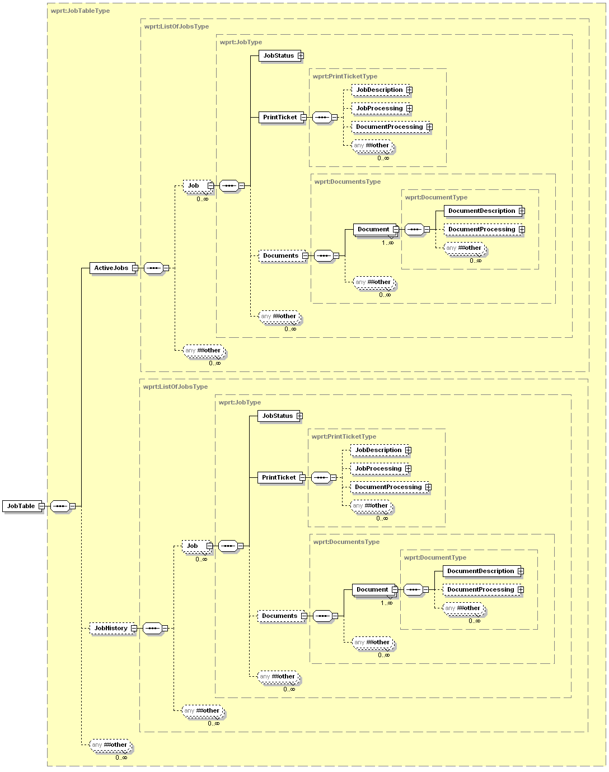
Figure 8 – JobTable Elements

PrintTicket
The PrintTicket is an instance document conforming to a proper subset of the print job schema supported by the printer. The PrintTicket contains the values that the CP has selected for the printer settings for the current job. The PrintTicket is composed of these subsections:
JobDescription – This section of the PrintTicket contains general job information.
JobProcessing – This section of the PrintTicket defines all the requested processing attributes that are applicable at a job level.
DocumentProcessing – This section specifies the processing attributes that will be applied against the job at a document level.
Figure 9 below illustrates the member elements of the PrintTicket element. Note that the member elements directly map to an instance of a Job and they are exactly what are required to be sent in a Job Creation operation.
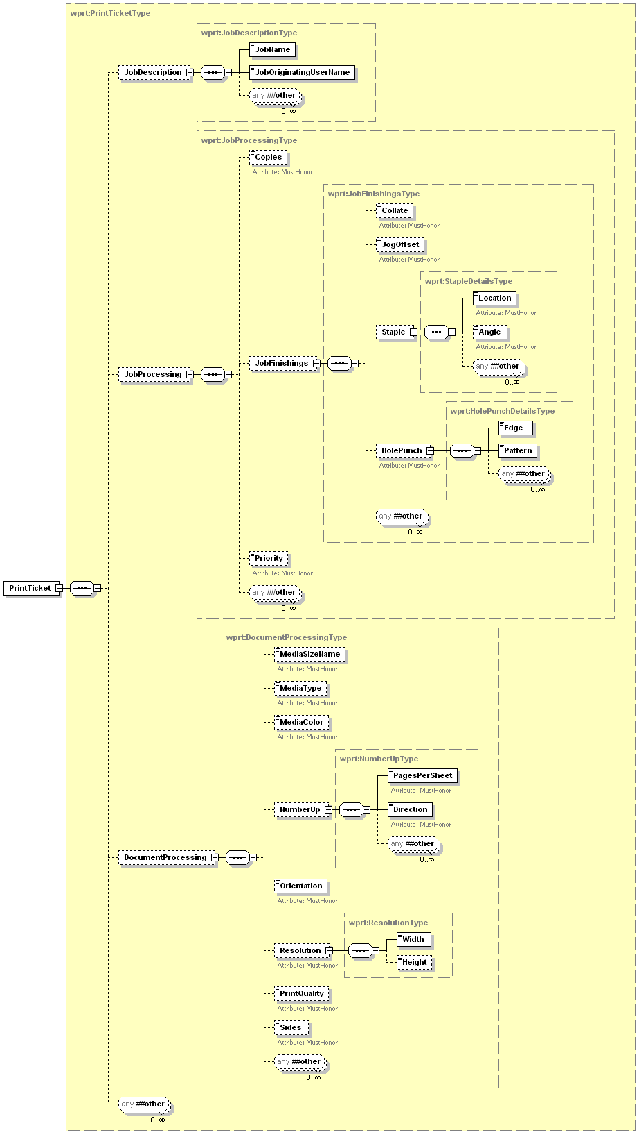
Figure 9 - PrintTicket Elements

Example PrintTicket
<wprt:PrintTicket>
<wprt:JobDescription>
<wprt:JobName>Example Document</wprt:JobName>
<wprt:JobOriginatingUserName>John.Smith</wprt:JobOriginatingUserName>
</wprt:JobDescription>
<wprt:JobProcessing>
<wprt:Copies>1</wprt:Copies>
<wprt:JobFinishings>
<wprt:Collate>false</wprt:Collate>
<wprt:JogOffset>false</wprt:JogOffset>
<wprt:Staple>
<wprt:Location>StapleTopLeft</wprt:Location>
<wprt:Angle>Slanted</wprt:Angle>
</wprt:Staple>
</wprt:JobFinishings>
<wprt:Priority>25</wprt:Priority>
</wprt:JobProcessing>
<wprt:DocumentProcessing>
<wprt:MediaSizeName>na_letter_8.5x11in</wprt:MediaSizeName>
<wprt:NumberUp>
<wprt:PagesPerSheet>4</wprt:PagesPerSheet>
<wprt:Direction>RightDown</wprt:Direction>
</wprt:NumberUp>
<wprt:Orientation>Portrait</wprt:Orientation>
<wprt:Resolution>
<wprt:Width>600</wprt:Width>
</wprt:Resolution>
<wprt:PrintQuality>Draft</wprt:PrintQuality>
<wprt:Sides>TwoSidedLongEdge</wprt:Sides>
</wprt:DocumentProcessing>
</wprt:PrintTicket>

Default Values and Allowed Values for Job Submission
A CP that submits a Print Job may need to know the possible values and default values for the JobDescription, JobProcessing, DocumentProcessing and DocumentDescription elements that are included in Job creation and Document creation operations. The Printer has a DefaultPrintTicket element and a PrinterCapabilities element to allow CPs to retrieve this information. The DefaultPrintTicket element describes the current set of default values the print service will apply when a job is created without specify specific job creation elements. The PrinterCapabilities element defines all of the allowed values for the Job and Document elements which can be specified to affect the print processing. You will note that this element contains JobValues and DocumentValues elements that contain the related “Description” and “Processing” elements. The member elements of these “Description” and “Processing” elements define the allowed values for each applicable element. All integer element types have an optional MinValue and a required MaxValue. By retrieving the PrinterCapabilities a CP can obtain the features and associated values available on the Printer.

DefaultPrintTicket
The DefaultPrintTicket element is an instance of a PrintTicket element filled in with all the current default values for Job and Document creation. A CP can request the DefaultPrintTicket and then use it as part of a CreatePrintJob operation without error. Although the JobDescription element is optional in the PrintTicket definition, the print service must return a JobDescription element whenever the DefaultPrintTicket is requested via the GetPrinterElements operation. If a DefaultPrintTicket is missing any of the ‘Processing’ elements the CP can assume these elements are the default values described in this spec. It is encouraged for the print device to return as much data in the DefaultPrintTicket as possible.
Note that this element is equivalent to the “xxx-default” of the PWG Semantic Model [PWG5105.1].

Example DefaultPrintTicket
<wprt:DefaultPrintTicket>
<wprt:JobDescription>
<wprt:JobName>DefaultName</wprt:JobName>
<wprt:JobOriginatingUserName>DefaultUser</wprt:JobOriginatingUserName>
</wprt:JobDescription>
<wprt:JobProcessing>
<wprt:Copies>1</wprt:Copies>
<wprt:JobFinishings>
<wprt:Collate>false</wprt:Collate>
<wprt:JogOffset>true</wprt:JogOffset>
<wprt:Staple>
<wprt:Location>None</wprt:Location>
<wprt:Angle>NotApplicable</wprt:Angle>
</wprt:Staple>
<wprt:HolePunch>
<wprt:Edge>None</wprt:Edge>
<wprt:Pattern>NotApplicable</wprt:Pattern>
</wprt:HolePunch>
</wprt:JobFinishings>
<wprt:Priority>50</wprt:Priority>
</wprt:JobProcessing>
<wprt:DocumentProcessing>
<wprt:MediaSizeName>na_letter_8.5x11in</wprt:MediaSizeName>
<wprt:MediaType>stationery</wprt:MediaType>
<wprt:MediaColor>unknown</wprt:MediaColor>
<wprt:NumberUp>
<wprt:PagesPerSheet>1</wprt:PagesPerSheet>
<wprt:Direction>RightDown</wprt:Direction>
</wprt:NumberUp>
<wprt:Orientation>Portrait</wprt:Orientation>
<wprt:Resolution>
<wprt:Width>720</wprt:Width>
<wprt:Height>1440</wprt:Height>
</wprt:Resolution>
<wprt:PrintQuality>Normal</wprt:PrintQuality>
<wprt:Sides>OneSided</wprt:Sides>
</wprt:DocumentProcessing>
</wprt:DefaultPrintTicket>

PrinterCapabilities
Figure 10 below illustrates the member elements of the PrinterCapabilities element It is possible for a CP to retrieve the PrinterCapabilities and use values from it to populate a valid PrintTicket element in the CreatePrintJob request.
Note that this element is equivalent to the “xxx-supported” of the PWG Semantic Model [PWG5105.1].
It is required that every WSD Print Service return the complete PrinterCapabilities structure when the client requests the data via the GetPrinterElements operation. The only fields that can be reasonably omitted would be PrinterCapabilites/JobValues/JobProcessing/JobFinishings/Staple and PrinterCapabilites/JobValues/JobProcessing/JobFinishings/HolePunch. Both of which may not be present if the Print Service doesn’t support stapling or hole punching respectively. The print service should support at least one value for each of the other PrinterCapabilities elements.
The element is defined with most fields optional to make the sending of a PrinterElementsChangeEvent easier.
As a rule, any MinValue element missing defaults to the value 1.
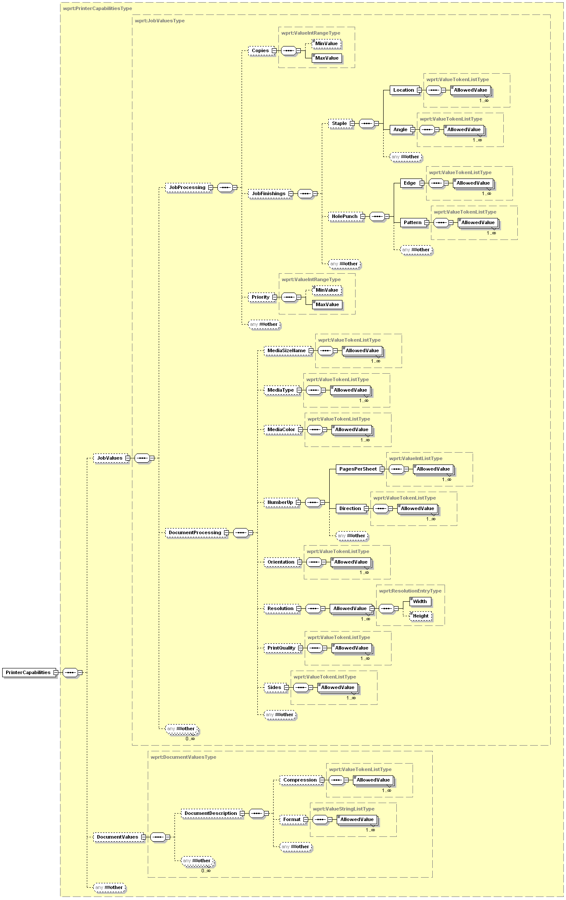
Figure 10 - PrinterCapabilities (allowed values)

Example PrinterCapabilities
<wprt:PrinterCapabilities>
<wprt:JobValues>
<wprt:JobProcessing>
<wprt:Copies>
<wprt:MaxValue>100</wprt:MaxValue>
</wprt:Copies>
<wprt:JobFinishings>
<wprt:Staple>
<wprt:Location>
<wprt:AllowedValue>None</wprt:AllowedValue>
<wprt:AllowedValue>StapleDualLeft</wprt:AllowedValue>
<wprt:AllowedValue>StapleTopLeft</wprt:AllowedValue>
<wprt:AllowedValue>StapleBottomLeft</wprt:AllowedValue>
<wprt:Location>
<wprt:Angle>
<wprt:AllowedValue>Any</wprt:AllowedValue>
<wprt:AllowedValue>Horizontal</wprt:AllowedValue>
<wprt:AllowedValue>Slanted</wprt:AllowedValue>
<wprt:AllowedValue>NotApplicable</wprt:AllowedValue>
</wprt:Angle>
</wprt:Staple>
<wprt:HolePunch>
<wprt:Edge>
<wprt:AllowedValue>None</wprt:AllowedValue>
<wprt:AllowedValue>Top</wprt:AllowedValue>
<wprt:AllowedValue>Bottom</wprt:AllowedValue>
<wprt:AllowedValue>Left</wprt:AllowedValue>
<wprt:AllowedValue>Right</wprt:AllowedValue>
<wprt:Edge>
<wprt:Pattern>
<wprt:AllowedValue>TwoHoleUSTop</wprt:AllowedValue>
<wprt:AllowedValue>ThreeHoleUS</wprt:AllowedValue>
<wprt:AllowedValue>TwoHoleDIN</wprt:AllowedValue>
<wprt:AllowedValue>FourHoleDIN</wprt:AllowedValue>
<wprt:AllowedValue>SevenHoleUS</wprt:AllowedValue>
<wprt:AllowedValue>Metric30Hole</wprt:AllowedValue>
<wprt:AllowedValue>NotApplicable</wprt:AllowedValue>
</wprt:Pattern >
</wprt:HolePunch>
</wprt:JobFinishings>
<wprt:Priority>
<wprt:MinValue>1</wprt:MinValue>
<wprt:MaxValue>100</wprt:MinValue>
</wprt:Priority>
</wprt:JobProcessing>
<wprt:DocumentProcessing>
<wprt:MediaSizeName>
<wprt:AllowedValue>iso_a4_210x297mm</wprt:AllowedValue>
<wprt:AllowedValue>iso_c5_162x229mm</wprt:AllowedValue>
<wprt:AllowedValue>iso_dl_110x220mm</wprt:AllowedValue>
<wprt:AllowedValue>jis_b4_257x364mm</wprt:AllowedValue>
<wprt:AllowedValue>na_legal_8.5x14in</wprt:AllowedValue>
<wprt:AllowedValue>na_letter_8.5x11in</wprt:AllowedValue>
</wprt:MediaSizeName>
<wprt:MediaType>
<wprt:AllowedValue>envelope</wprt:AllowedValue>
<wprt:AllowedValue>labels</wprt:AllowedValue>
<wprt:AllowedValue>photographic</wprt:AllowedValue>
<wprt:AllowedValue>stationery</wprt:AllowedValue>
<wprt:AllowedValue>stationery-inkjet</wprt:AllowedValue>
<wprt:AllowedValue>transparency</wprt:AllowedValue>
<wprt:AllowedValue>other</wprt:AllowedValue>
<wprt:AllowedValue>unknown</wprt:AllowedValue>
</wprt:MediaType>
<wprt:MediaColor>
<wprt:AllowedValue>white</wprt:AllowedValue>
<wprt:AllowedValue>yellow</wprt:AllowedValue>
<wprt:AllowedValue>green</wprt:AllowedValue>
<wprt:AllowedValue>ivory</wprt:AllowedValue>
<wprt:AllowedValue>no-color</wprt:AllowedValue>
<wprt:AllowedValue>red</wprt:AllowedValue>
<wprt:AllowedValue>other</wprt:AllowedValue>
<wprt:AllowedValue>unknown</wprt:AllowedValue>
</wprt:MediaColor>
<wprt:NumberUp>
<wprt:PagesPerSheet>
<wprt:AllowedValue>1</wprt:AllowedValue>
<wprt:AllowedValue>2</wprt:AllowedValue>
<wprt:AllowedValue>4</wprt:AllowedValue>
<wprt:AllowedValue>8</wprt:AllowedValue>
<wprt:AllowedValue>9</wprt:AllowedValue>
<wprt:AllowedValue>16</wprt:AllowedValue>
</wprt:PagesPerSheet>
<wprt:Direction>
<wprt:AllowedValue>RightDown</wprt:AllowedValue>
<wprt:AllowedValue>DownRight</wprt:AllowedValue>
<wprt:AllowedValue>LeftDown</wprt:AllowedValue>
<wprt:AllowedValue>DownLeft</wprt:AllowedValue>
</wprt:Direction>
<wprt:NumberUp>
<wprt:Orientation>
<wprt:AllowedValue>Landscape</wprt:AllowedValue>
<wprt:AllowedValue>Portrait</wprt:AllowedValue>
<wprt:AllowedValue>ReverseLandscape</wprt:AllowedValue>
</wprt:Orientation>
<wprt:Resolution>
<wprt:AllowedValue>
<wprt:Width>150</wprt:Width>
</wprt:AllowedValue>
<wprt:AllowedValue>
<wprt:Width>300</wprt:Width>
</wprt:AllowedValue>
<wprt:AllowedValue>
<wprt:Width>300</wprt:Width>
<wprt:Height>600</wprt:Height>
</wprt:AllowedValue>
<wprt:AllowedValue>
<wprt:Width>600</wprt:Width>
</wprt:AllowedValue>
<wprt:AllowedValue>
<wprt:Width>600</wprt:Width>
<wprt:Height>1200</wprt:Height>
</wprt:AllowedValue>
</wprt:Resolution>
<wprt:PrintQuality>
<wprt:AllowedValue>Draft</wprt:AllowedValue>
<wprt:AllowedValue>High</wprt:AllowedValue>
<wprt:AllowedValue>Normal</wprt:AllowedValue>
<wprt:AllowedValue>Photo</wprt:AllowedValue>
</wprt:PrintQuality>
<wprt:Sides>
<wprt:AllowedValue>OneSided</wprt:AllowedValue>
<wprt:AllowedValue>TwoSidedLongEdge</wprt:AllowedValue>
<wprt:AllowedValue>TwoSidedShortEdge</wprt:AllowedValue>
</wprt:Sides>
</wprt:DocumentProcessing>
</wprt:JobValues>
<wprt:DocumentValues>
<wprt:DocumentDescriprion>
<wprt:Compression>
<wprt:AllowedValue>Gzip<wprt:AllowedValue>
<wprt:AllowedValue>None<wprt:AllowedValue>
</wprt:Compression>
<wprt:Format>
<wprt:AllowedValue>application/octet-stream</wprt:AllowedValue>
<wprt:AllowedValue>application/postscript</wprt:AllowedValue>
<wprt:AllowedValue>application/vnd.hp-PCL</wprt:AllowedValue>
<wprt:AllowedValue>application/vnd.pwg-xhtml-print+xml</wprt:AllowedValue>
<wprt:AllowedValue>text/plain</wprt:AllowedValue>
<wprt:AllowedValue>text/plain;charset=utf-8</wprt:AllowedValue>
<wprt:AllowedValue>unknown</wprt:AllowedValue>
</wprt:Format>
</wprt:DocumentDescriprion>
</wprt:DocumentValues>
</wprt:PrinterCapabilities>

Eventing
The Printer service will implement eventing as defined in the WS-Eventing specification [EVENT]. The Printer service will be a WS-Eventing event source. This will add the operations defined in the [EVENT] spec to the print service for use in creating and managing Event subscriptions.

Event Model
The eventing model for the print service serves three main purposes: First is to inform the CP when the Configuration changes on the print device. This could include changes in input media sizes, changes in storage available, etc. Second is to inform the CP when there is a change in the condition of the print device. Examples include the printer becomes idle, a paper jam occurs or the printer is low on paper. The PrinterState, PrinterStateReasons and DeviceConditon elements provide this information. Third is for job tracking. Events inform a CP when a job is submitted, completed or removed from the job queue. The Job, JobStatus and JobEndStateEvent elements provide this information. JobEndStateEvent indicates the final status of each job. It lets control points know whether it completed successfully or was canceled or aborted. The MediaSheetsCompleted element in the JobStatus is an example of information that updates an interested CP on the number of impressions printed for the current job.
The events fall into roughly 2 categories: CompleteState and Cumulative. A CompleteState event describes something that could change quite rapidly and so could overwhelm a CP with the rate of events. The information in this type of event is the current state of a schema object, and so simply having the most recent event information is sufficient. The states that the information went through from time point A to time point B are usually not as important. A Cumulative event describes information that usually changes at a much slower rate, and the transition from one state to the next is often important. The CP needs to receive each occurrence of this event since missing one of the transitions could cause the CP to have incorrect state for an object.

CompleteState Events
The events PrinterStatusSummaryEvent and JobStatusEvent are the only currently defined events that fall into the category of CompleteState events.
To enable a CP to effectively manage how many of these types of events it receives the element PrinterEventRate is configurable using the SetEventRate operation. The value of this element is the minimum time the device should wait between sending occurrences of any individual CompleteState event. Due to the nature of CompleteState events the most recently generated event is all the device needs to buffer until the PrinterEventRate time has passed. If it has been more than PrinterEventRate time since the last event the device should send the new event immediately.

Cumulative Events
All other events currently defined fall into the category of Cumulative events. These events are important not to be missed since many times it is the actual state/condition transition that is important to the CP. These events are never buffered.

PrinterElementsChangeEvent
This event is defined to inform the CP that something has changed in the PrinterDescription element, the PrinterConfiguration element, the DefaultPrintTicket element, the PrinterCapabilities element or an IHV vendor extension in the Printer. The body of the PrinterElementsChangeEvent consists of the XML to describe the elements that have changed value. The device should return only the data that has changed in the event. The data returned must still be valid according to the Print Service schema, but it doesn’t have to be a complete element. For example the device could return the information about a single InputBinEntry even though the device supports multiple InputBins. The client will pull the Print Service data elements out of the returned XML and update its internal data store.
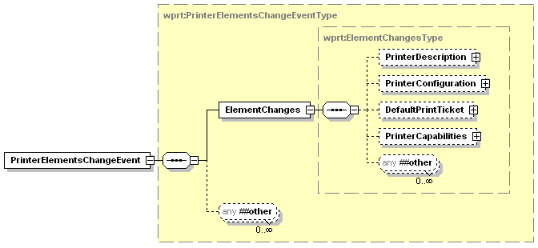
Figure 11 - PrinterElementsChangeEvent Elements

ElementChanges
The information returned in this data element should be only the elements in the Printer schema, including vendor extensions, which actually changed values. This could be because a new option was installed, a consumable is running low, an input bin changed paper size, a value changed in the DefaultPrintTicket, one or more PrintCapabilities changed or an IHV extension has changed value.

Example PrinterElementsChangeEvent
In this example the device is reporting two changes to its configuration. The first is that the black ink consumable is now at 30% of capacity. The second is that a duplexing unit is now installed on the device.
<soap:Envelope
xmlns:soap="http://www.w3.org/2003/05/soap-envelope"
xmlns:wsa="http://schemas.xmlsoap.org/ws/2004/08/addressing"
xmlns:wse="http://schemas.xmlsoap.org/ws/2004/08/eventing"
xmlns:wprt="http://schemas.microsoft.com/windows/2006/08/wdp/print”>
<soap:Header>
<wsa:To>AddressofEventSink</wsa:To>
<wsa:Action>
http://schemas.microsoft.com/windows/2006/08/wdp/print/PrinterElementsChangeEvent
</wsa:Action>
<wsa:MessageID>uuid:UniqueMsgId</wsa:MessageID>
</soap:Header>
<soap:Body>
<wprt:PrinterElementsChangeEvent >
<wprt:ElementChanges>
<wprt:PrinterConfiguration>
<wprt:Consumables>
<wprt:ConsumableEntry Name=”InkSlot1”>
<wprt:Type>Ink</wprt:Type>
<wprt:Color>Black</wprt:Color>
<wprt:Level>30</wprt:Level>
</wprt:ConsumableEntry>
</wprt:Consumables>
<wprt:Finishings>
<wprt:CollationSupported>false</wprt:CollationSupported>
<wprt:JogOffsetSupported>true</wprt:JogOffsetSupported>
<wprt:DuplexerInstalled>true</wprt:DuplexerInstalled>
<wprt:StaplerInstalled>false</wprt:StaplerInstalled>
<wprt:HolePunchInstalled>false</wprt:HolePunchInstalled>
</wprt:Finishings>
</wprt:PrinterConfiguration>
</wprt:ElementChanges>
</wprt:PrinterElementsChangeEvent>
</soap:Body>
</soap:Envelope>

Example PrinterElementsChangeEvent – OutputBin Removed
In this example the device is reporting that an output bin has been removed from the device. This is accomplished by sending an event that has the required Name attribute for the OutputBinEntry and also a Removed attribute that tells the CP that the entry has been removed from the device.
<soap:Envelope
xmlns:soap="http://www.w3.org/2003/05/soap-envelope"
xmlns:wsa="http://schemas.xmlsoap.org/ws/2004/08/addressing"
xmlns:wse="http://schemas.xmlsoap.org/ws/2004/08/eventing"
xmlns:wprt="http://schemas.microsoft.com/windows/2006/08/wdp/print”>
<soap:Header>
<wsa:To>AddressofEventSink</wsa:To>
<wsa:Action>
http://schemas.microsoft.com/windows/2006/08/wdp/print/PrinterElementsChangeEvent
</wsa:Action>
<wsa:MessageID>uuid:UniqueMsgId</wsa:MessageID>
</soap:Header>
<soap:Body>
<wprt:PrinterElementsChangeEvent>
<wprt:ElementChanges>
<wprt:PrinterConfiguration>
<wprt:OutputBins>
<wprt:OutputBinEntry Name=”Bin4” Removed=”true”>
<wprt:Capacity>-1</wprt:Capacity>
<wprt:Level>-1</wprt:Level>
</wprt:OutputBinEntry>
</wprt:OutputBins>
</wprt:PrinterConfiguration>
</wprt:ElementChanges>
</wprt:PrinterElementsChangeEvent>
</soap:Body>
</soap:Envelope>

PrinterStatusSummaryEvent
This event is defined to inform the CP that the device status has changed. The body of the PrinterStatusSummaryEvent consists of the StatusSummary element.
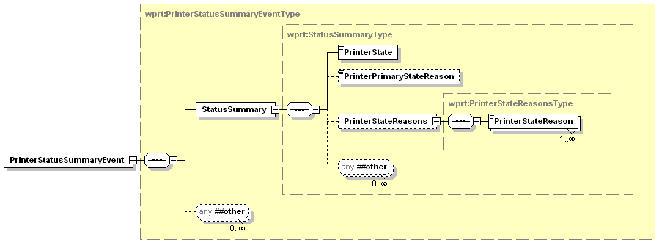
Figure 12 - PrinterStatusSummaryEvent Elements

StatusSummary
This data element contains the current summary of the printer status.

PrinterState
This data element is described in Section 3.4.2

PrinterPrimaryStateReason
This data element is described in Section 3.4.3

PrinterStateReasons
This data element is described in Section 3.4.4

PrinterStateReason
This data element is described in Section 3.4.4.1

Example PrinterStatusSummaryEvent
In this example the device is in a user intervention error state because it is out of paper in a paper tray. One of its consumables is also low, but that is secondary to the MediaNeeded condition.
<soap:Envelope
xmlns:soap="http://www.w3.org/2003/05/soap-envelope"
xmlns:wsa="http://schemas.xmlsoap.org/ws/2004/08/addressing"
xmlns:wse="http://schemas.xmlsoap.org/ws/2004/08/eventing"
xmlns:wprt="http://schemas.microsoft.com/windows/2006/08/wdp/print”>
<soap:Header>
<wsa:To>AddressofEventSink</wsa:To>
<wsa:Action>
http://schemas.microsoft.com/windows/2006/08/wdp/print/PrinterStatusSummaryEvent
</wsa:Action>
<wsa:MessageID>uuid:UniqueMsgId</wsa:MessageID>
</soap:Header>
<soap:Body>
<wprt:PrinterStatusSummaryEvent>
<wprt:StatusSummary>
<wprt:PrinterState>Stopped</wprt:PrinterState>
<wprt:PrinterPrimaryStateReason>MediaNeeded</wprt:PrinterPrimaryStateReason>
<wprt:PrinterStateReasons>
<wprt:PrinterStateReason>MarkerSupplyLow</wprt:PrinterStateReason>
<wprt:PrinterStateReason>MediaNeeded</wprt:PrinterStateReason>
</wprt:PrinterStateReasons>
</wprt:StatusSummary>
</wprt:PrinterStatusSummaryEvent>
</soap:Body>
</soap:Envelope>

PrinterStatusConditionEvent
This event is defined to inform the CP detailed information about a status change in the device. The body of the PrinterStatusConditionEvent consists of the DeviceConditon element for the changed status.
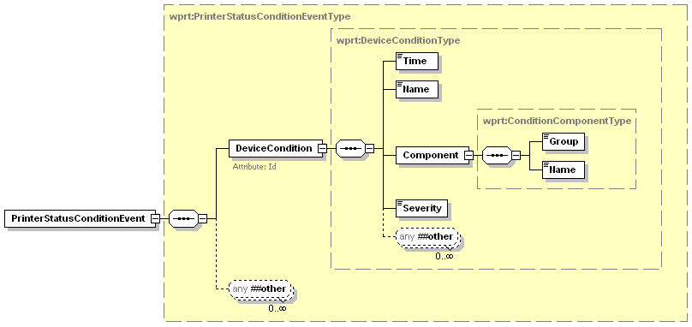
Figure 13 – PrinterStatusConditionEvent Elements

DeviceCondition
This is an element that describes the details about one of the currently active conditions. This data element is described in Section 3.4.6.1

Example PrinterStatusConditionEvent
In this example the device is notifying the CP of the exact tray that needs media.
<soap:Envelope
xmlns:soap="http://www.w3.org/2003/05/soap-envelope"
xmlns:wsa="http://schemas.xmlsoap.org/ws/2004/08/addressing"
xmlns:wse="http://schemas.xmlsoap.org/ws/2004/08/eventing"
xmlns:wprt="http://schemas.microsoft.com/windows/2006/08/wdp/print”>
<soap:Header>
<wsa:To>AddressofEventSink</wsa:To>
<wsa:Action>
http://schemas.microsoft.com/windows/2006/08/wdp/print/PrinterStatusConditionEvent
</wsa:Action>
<wsa:MessageID>uuid:UniqueMsgId</wsa:MessageID>
</soap:Header>
<soap:Body>
<wprt:PrinterStatusConditionEvent>
<wprt:DeviceCondition Id=”1543”>
<wprt:Time>2006-01-21T17:22:27.5242689Z</wprt:Time>
<wprt:Name>MediaNeeded</wprt:Name>
<wprt:Component>
<wprt:Group>InputBin</wprt:Group>
<wprt:Name>Tray1</wprt:Name>
</wprt:Component>
<wprt:Severity>Critical</wprt:Severity>
</wprt:DeviceCondition>
</wprt:PrinterStatusConditionEvent>
</soap:Body>
</soap:Envelope>

PrinterStatusConditionClearedEvent
This event is defined to inform the CP that a previously reported DeviceCondition has been cleared. The body of the PrinterStatusConditionClearedEvent consists of a ConditonId element that identifies the condition that has been cleared, and an element representing the time the condition was cleared.
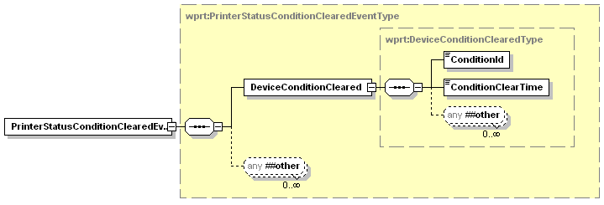
Figure 14 – PrinterStatusConditonClearedEvent Elements

DeviceConditonCleared
This data element contains the Id and time of the condition that cleared.

ConditonId
This data element is equivalent to the Id attribute of a DeviceCondition entry. See Section 3.4.6.1.1 for an explanation of the format.

ConditionClearTime
This data element is a dateTime element that describes when the condition was cleared. See Section 3.4.7.1.6 for an explanation of the format.

Example PrinterStatusConditionClearedEvent
In this example the device is notifying the CP that the previous condition identified by Id 1543 has cleared.
<soap:Envelope
xmlns:soap="http://www.w3.org/2003/05/soap-envelope"
xmlns:wsa="http://schemas.xmlsoap.org/ws/2004/08/addressing"
xmlns:wse="http://schemas.xmlsoap.org/ws/2004/08/eventing"
xmlns:wprt="http://schemas.microsoft.com/windows/2006/08/wdp/print”>
<soap:Header>
<wsa:To>AddressofEventSink</wsa:To>
<wsa:Action>
http://schemas.microsoft.com/windows/2006/08/wdp/print/PrinterStatusConditionClearedEvent
</wsa:Action>
<wsa:MessageID>uuid:UniqueMsgId</wsa:MessageID>
</soap:Header>
<soap:Body>
<wprt:PrinterStatusConditionClearedEvent>
<wprt:DeviceConditionCleared>
<wprt:ConditionId>1543</wprt:ConditionId>
<wprt:ConditionClearTime>2006-01-21T17:22:35.8345Z</wprt:ConditionClearTime>
</wprt:DeviceConditionCleared>
</wprt:PrinterStatusConditionClearedEvent>
</soap:Body>
</soap:Envelope>

JobStatusEvent
This event is defined to inform the CP that a job’s status has changed. The body of the JobStatusEvent is the same as the JobStatus element.
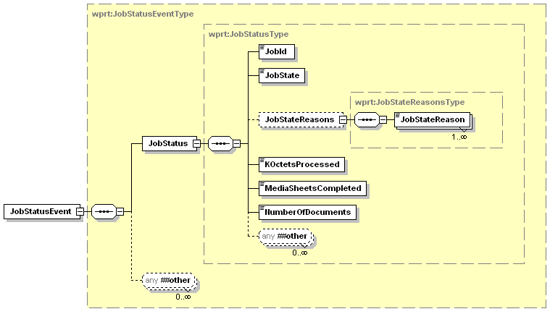
Figure 15 - JobStatusEvent Elements

JobStatus
This data element is contains the current status of a Job. This data element is described in Section 3.5.1

Example JobStatusEvent
In this example the device is notifying the CP of the current state of Job 253.
<soap:Envelope
xmlns:soap="http://www.w3.org/2003/05/soap-envelope"
xmlns:wsa="http://schemas.xmlsoap.org/ws/2004/08/addressing"
xmlns:wse="http://schemas.xmlsoap.org/ws/2004/08/eventing"
xmlns:wprt="http://schemas.microsoft.com/windows/2006/08/wdp/print”>
<soap:Header>
<wsa:To>AddressofEventSink</wsa:To>
<wsa:Action>
http://schemas.microsoft.com/windows/2006/08/wdp/print/JobStatusEvent
</wsa:Action>
<wsa:MessageID>uuid:UniqueMsgId</wsa:MessageID>
</soap:Header>
<soap:Body>
<wprt:JobStatusEvent>
<wprt:JobStatus>
<wprt:JobId>253</wprt:JobId>
<wprt:JobState>Processing</wprt:JobState>
<wprt:JobStateReasons>
<wprt:JobStateReason>JobSpooling</wprt:JobStateReason>
<wprt:JobStateReason>JobPrinting</wprt:JobStateReason>
</wprt:JobStateReasons>
<wprt:KOctetsProcessed>385</wprt:KOctetsProcessed>
<wprt:MediaSheetsCompleted>4</wprt:MediaSheetsCompleted>
<wprt:NumberOfDocuments>1</wprt:NumberOfDocuments>
</wprt:JobStatus>
</wprt:JobStatusEvent>
</soap:Body>
</soap:Envelope>

JobEndStateEvent
This event is defined to inform the CP that a Job has finished processing.
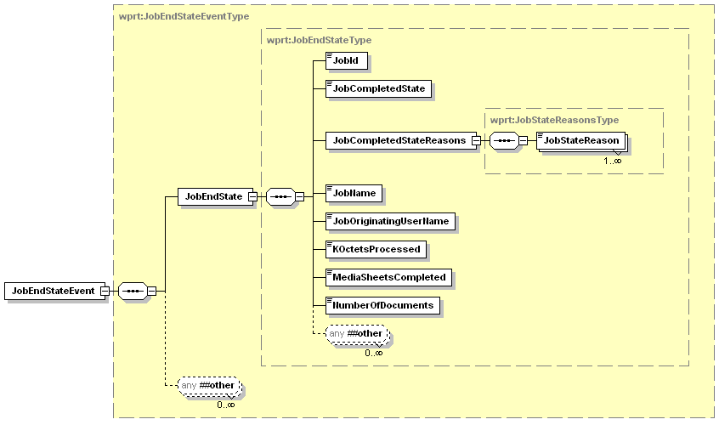
Figure 16 - JobEndStateEvent Elements

JobId
This data element is described in Section 3.5.1.1

JobCompletedState
This data element is the final JobState for the job and has the same semantics and values as the JobState element from JobStatus. The JobState element is described in Section 3.5.1.2

JobCompletedStateReasons
This element is a collection that describes all of the additional information about how/why the Job completed.

JobStateReason
This element indicates additional information about how/why the Job completed and has the same semantics and values as the JobStateReason element from JobStatus. The JobStateReason element is described in Section 3.5.1.3.1

JobName
This data element is described in Section 3.5.2.1.1

JobOriginatingUserName
This data element is described in Section 3.5.2.1.2

KOctetsProcessed
This data element is the final KOctetsProcessed for the job. This data element is described in Section 3.5.1.4

MediaSheetsCompleted
This data element is the final MediaSheetsCompleted for the job. This data element is described in Section 3.5.1.5

NumberOfDocuments
This data element is the final NumberOfDocuments for the job. This data element is described in Section 3.5.1.6

Example JobEndStateEvent
In this example the device is notifying the CP of the final state/status of Job 253.
<soap:Envelope
xmlns:soap="http://www.w3.org/2003/05/soap-envelope"
xmlns:wsa="http://schemas.xmlsoap.org/ws/2004/08/addressing"
xmlns:wse="http://schemas.xmlsoap.org/ws/2004/08/eventing"
xmlns:wprt="http://schemas.microsoft.com/windows/2006/08/wdp/print”>
<soap:Header>
<wsa:To>AddressofEventSink</wsa:To>
<wsa:Action>
http://schemas.microsoft.com/windows/2006/08/wdp/print/JobEndStateEvent
</wsa:Action>
<wsa:MessageID>uuid:UniqueMsgId</wsa:MessageID>
</soap:Header>
<soap:Body>
<wprt:JobEndStateEvent>
<wprt:JobEndState>
<wprt:JobId>253</wprt:JobId>
<wprt:JobCompletedState>Completed</wprt:JobCompletedState>
<wprt:JobCompletedStateReasons>
<wprt:JobCompletedStateReason>
JobCompletedSuccessfully
</wprt:JobCompletedStateReason> </wprt:JobCompletedStateReasons>
<wprt:JobName>MyLetter</wprt:JobName>
<wprt:JobOriginatingUserName>Mike.Fenelon</wprt:JobOriginatingUserName>
<wprt:KOctetsProcessed>1235</wprt:KOctetsProcessed>
<wprt:MediaSheetsCompleted>7</wprt:MediaSheetsCompleted>
<wprt:NumberOfDocuments>2</wprt:NumberOfDocuments>
</wprt:JobEndState>
</wprt:JobEndStateEvent>
</soap:Body>
</soap:Envelope>

Operations
Immediately following this table is detailed information about these operations, including short descriptions of the operations, the effects of the operations on printer state, and error codes defined by the operations.
Table 2 – Operations
¹ R = REQUIRED, O = Optional
Name | Req. or Opt. ¹
CreatePrintJob | R
SendDocument | R
AddDocument | O
CancelJob | R
GetPrinterElements | R
GetJobElements | R
GetActiveJobs | R
GetJobHistory | R
SetEventRate | R

Operation Error Reporting
Error codes are returned in the <soap:Fault> element. A vendor MAY subset or extend these error codes by supporting private error subcodes. All fault messages defined in this specification MUST be sent according to the rules described in [ADDRESS] section 4 and [DEVICE]. They are sent to the [fault endpoint], if present and valid. Otherwise they are sent to the [reply endpoint] if present. If neither is present faults may be sent to the [source endpoint].
Endpoints compliant with this specification MUST include required message information headers on all fault messages. Fault messages are correlated as replies using the [relationship] property as defined in WS-Addressing. The [action] property below designates fault messages:
http://schemas.xmlsoap.org/ws/2004/08/addressing/fault
The definitions of faults use the following properties:
[Code] | The fault code.
[Subcode] | The fault subcode.
[Reason] | The English language reason element.
[Detail] | The detail element. If absent, no detail element is defined for the fault.
The properties above bind to a SOAP 1.2 fault as follows:
<S:Envelope>
<S:Header>
<wsa:Action>http://schemas.xmlsoap.org/ws/2004/08/addressing/fault</wsa:Action>
<!-- Headers excluded for clarity -->
</S:Header>
<S:Body>
<S:Fault>
<S:Code>
<S:Value>[Code]</S:Value>
<S:Subcode>
<S:Value>[Subcode]</S:Value>
</S:Subcode>
</S:Code>
<S:Reason>
<S:Text xml:lang="en">[Reason]</S:Text>
</S:Reason>
<S:Detail> [Detail] </S:Detail>
</S:Fault>
</S:Body>
</S:Envelope>

Example SOAP Fault:
<soap:Envelope xmlns:soap="http://www.w3.org/2003/05/soap-envelope"
xmlns:xml=”http://www.w3.org/XML/1998/namespace”
xmlns:wsa="http://schemas.xmlsoap.org/ws/2004/08/addressing"
xmlns:wprt="http://schemas.microsoft.com/windows/2006/08/wdp/print">
<soap:Header>
<wsa:Action>http://schemas.xmlsoap.org/ws/2004/08/addressing/fault</wsa:Action>
<!-- Headers excluded for brevity -->
</soap:Header>
<soap:Body>
<soap:Fault>
<soap:Code>
<soap:Value>soap:Receiver</soap:Value>
<soap:Subcode>
<soap:Value>wprt:OperationFailed</soap:Value>
</soap:Subcode>
</soap:Code>
<soap:Reason>
<soap:Text xml:lang="en">Service can not perform the requested operation</soap:Text>
</soap:Reason>
</soap:Fault>
</soap:Body>
</soap:Envelope>

Common Operation Error Codes
The following table lists error codes common to all operations for this service type. If an operation results in multiple errors, the most specific error SHOULD be returned.

wsa:ActionNotSupported
This fault is sent when a Client requests an operation that is not supported by the current service.
[Code] | soap:Sender
[Subcode] | wsa:ActionNotSupported
[Reason] | The [action] cannot be processed at the receiver
[Detail] | The invalid operation name

InvalidArgs
This fault is sent when a Client sends an invalid argument as part of an operation. The invalid argument could be any of the following: not enough in args, too many in args, no in arg by that name, one or more in args are of the wrong data type.
[Code] | soap:Sender
[Subcode] | wprt:InvalidArgs
[Reason] | At least one input argument is invalid
[Detail] | The invalid argument

OperationFailed
This fault may be returned if the current state of the service prevents invoking that action.
[Code] | soap:Receiver
[Subcode] | wprt:OperationFailed
[Reason] | Service can not perform the requested operation
[Detail] | None

ServerErrorTemporaryError
This fault is sent when the server experiences a temporary error that occurs while the printer processes the operation. The client MAY try the unmodified request again at some later point in time with an expectation that the temporary internal error condition MAY have been cleared. If there is a more specific error defined that applies to a temporary error, such as disk full, that code SHOULD be used.
[Code] | soap:Receiver
[Subcode] | wprt:ServerErrorTemporaryError
[Reason] | The service had an unexpected error
[Detail] | None

ServerErrorInternalError
This fault is sent when the Printer encounters an unexpected condition that prevented it from fulfilling the request. This error differs from ServerErrorTemporaryError in that it implies a more permanent type of internal error and resending the operation will return the same fault.
[Code] | soap:Receiver
[Subcode] | wprt:ServerErrorInternalError
[Reason] | The service had an unexpected error
[Detail] | None

CreatePrintJob
This operation is the first step in submitting a job to the printer. The Printer returns a unique JobId to identify the job for this service. The Printer generates the JobId in an implementation-defined manner. The Printer MUST return values in the range 1 to 2³¹-1; 0 and negative values are invalid values to be returned as a result of a CreatePrintJob operation. Furthermore, the Printer SHOULD NOT re-use values recently assigned, since CPs would confuse such jobs with older jobs.
The allowed values returned in a GetPrinterElements(PrinterCapabilities) (see section 3.9.3) indicate the values of the arguments that the Print Service instance (Printer) supports (see section 3.9) for a Job creation operation. The Printer performs the following validation in the indicated order:
- If the client (CP) supplies elements that are unsupported or their values are unsupported the Printer
  - MUST reject the Job if the MustHonor attribute with a value of 1 or true is in effect.
  - MUST ignore or substitute with supported values, respectively, if the MustHonor attribute with a value of 0 or false is in effect
  - The MustHonor attribute is in effect if the attribute is supplied at the element level. Note that if the MustHonor attribute is not explicitly specified in the element, the default is 0 or false.
- If a client (CP) supplies a conflicting combination of elements in the arguments (such as MediaSize and MediaType), the Printer MUST reject the Job if the MustHonor attribute with a value of 1 or true is in effect for all conflicting elements.
The client (CP) MUST send print data to the print service using one or more SendDocument or AddDocument operations. Once the device has responded to the CreatePrintJob request, the client has 60 seconds to send the first document of the job. If the device does not receive a SendDocument or AddDocument operation within this time, it should abort the job with a JobStateReason of DocumentTimeoutError. If the job consists of multiple documents this timeout applies between each successive Document also.
For all multi-document jobs the order in which the documents are printed is the same as the order the SendDocument and/or AddDocument operations are received. In the simplest form a device can limit itself to accepting only one SendDocument/AddDocument operation at a time. If a CP sends another operation while one is still active the print service can respond with a ServerErrorDocumentActive fault. This informs the CP to wait a period of time (less than the document timeout period) and retry the document operation. It should always work to send each successive document operation immediately after the previous has finished.
If the print service is currently processing a print job when another CreatePrintJob request is received, the print server has the option to either accept the new job or reject the request with a wprt:ServerErrorNotAcceptingJobs SOAP fault. If the print server accepts the job it must be able to accept the associated SendDocument and/or AddDocument requests and data.

Request Elements
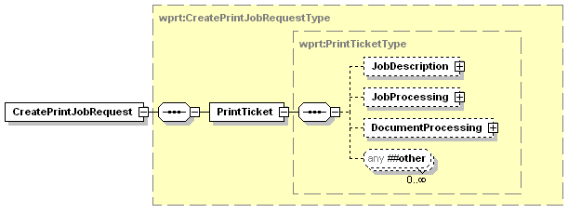
Figure 17 - CreatePrintJobRequest Elements

PrintTicket
This is a collection that defines the description and processing parameters for the print job being created. The complete definition of this element is Section 3.8.

JobDescription
This data element contains the basic job creation data for this print job. This data element is described in Section 3.5.2.1. Although this element is optional in the PrintTicket, it is required during CreatePrintJob processing and the request will be rejected if a JobDescription is missing.

JobProcessing
This data element contains the basic processing attributes to be applied at the job level for this print job. This data element is described in Section 3.5.2.2

DocumentProcessing
This data element contains the basic processing attributes to be applied at the document level for this print job. These attributes constitute the default DocumentProcessing parameters for each document added to the print job. The default parameters can be overridden on a document by document level in the SendDocument or AddDocument operation. This data element is described in Section 3.5.2.3

Response Elements
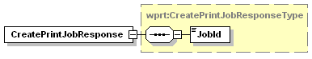
Figure 18 - CreatePrintJobResponse Elements

JobId
This element is the Id of the newly created job. This data element is described in Section 3.5.1.1

Example Request
<soap:Envelope
xmlns:soap="http://www.w3.org/2003/05/soap-envelope"
xmlns:wsa="http://schemas.xmlsoap.org/ws/2004/08/addressing"
xmlns:wprt="http://schemas.microsoft.com/windows/2006/08/wdp/print”>
<soap:Header>
<wsa:To>AddressofPrinterService</wsa:To>
<wsa:Action>
http://schemas.microsoft.com/windows/2006/08/wdp/print/CreatePrintJob
</wsa:Action>
<wsa:MessageID>uuid:UniqueMsgId</wsa:MessageID>
</soap:Header>
<soap:Body>
<wprt:CreatePrintJobRequest>
<wprt:PrintTicket>
<wprt:JobDescription>
<wprt:JobName>Example Job</wprt:JobName>
<wprt:JobOriginatingUserName>Smith</wprt:JobOriginatingUserName>
</wprt:JobDescription>
<wprt:JobProcessing>
<wprt:Copies MustHonor="1">3</wprt:Copies>
<wprt:JobFinishings>
<wprt:JogOffset>true</wprt:JogOffset>
</wprt:JobFinishings>
<wprt:Priority>50</wprt:Priority>
</wprt:JobProcessing>
<wprt:DocumentProcessing>
<wprt:MediaSizeName>iso_a4_210x297mm</wprt:MediaSizeName>
<wprt:MediaType>cardstock</wprt:MediaType>
<wprt:NumberUp>
<wprt:PagesPerSheet>1</wprt:PagesPerSheet>
<wprt:Direction>RightDown</wprt:Direction>
</wprt:NumberUp>
<wprt:Orientation>Landscape</wprt:Orientation>
<wprt:PrintQuality>Draft</wprt:PrintQuality>
<wprt:Sides>OneSided</wprt:Sides>
</wprt:DocumentProcessing>
</wprt:PrintTicket>
</wprt:CreatePrintJobRequest>
</soap:Body>
</soap:Envelope>

Example Response
<soap:Envelope
xmlns:soap="http://www.w3.org/2003/05/soap-envelope"
xmlns:wsa="http://schemas.xmlsoap.org/ws/2004/08/addressing"
xmlns:wprt="http://schemas.microsoft.com/windows/2006/08/wdp/print”>
<soap:Header>
<wsa:To>http://schemas.xmlsoap.org/ws/2004/08/addressing/role/anonymous</wsa:To>
<wsa:Action>
http://schemas.microsoft.com/windows/2006/08/wdp/print/CreatePrintJobResponse
</wsa:Action>
<wsa:MessageID>uuid:UniqueMsgId</wsa:MessageID>
<wsa:RelatesTo>uuid:MsgIdOfTheCreatePrintJobRequest</wsa:RelatesTo>
</soap:Header>
<soap:Body>
<wprt:CreatePrintJobResponse>
<wprt:JobId>1</wprt:JobId>
</wprt:CreatePrintJobResponse>
</soap:Body>
</soap:Envelope>

Errors
All the Codes described in section 5.1.1 - Common Operation Error Codes could be returned from this operation. The following error could also be returned from this operation.

ServerErrorNotAcceptingJobs
This fault is sent when the server can’t accept a new print job. This could occur because the printer has been put into service mode, or there is a user intervention condition and all the memory buffers have been exhausted. The client MAY try the unmodified request again at some later point in time with an expectation that the server has become unblocked and the printer is accepting jobs again.
[Code] | soap:Receiver
[Subcode] | wprt:ServerErrorNotAcceptingJobs
[Reason] | The service is temporarily blocked and can’t accept a new job request.
[Detail] | None

ClientErrorConflictingRequiredParameters
This fault is sent when the there is a conflict between 2 or more JobProcessing or DocumentProcessing elements which each have the MustHonor attribute set to true. Using all of the settings supplied with MustHonor attributes set to true will cause a conflict in the printer mechanism. This conflict cannot be resolved so the PrintTicket is invalid.
[Code] | soap:Sender
[Subcode] | wprt:ClientErrorConflictingRequiredParameters
[Reason] | Multiple elements in the JobProcessing or DocumentProcessing elements have MustHonor set to true but applying all settings causes a conflict in the printer device.
[Detail] | None

SendDocument
This operation is the next step in submitting a job to the printer using the CreatePrintJob operation. One or more SendDocument or AddDocument operations are used to send the print data to the print service. Each SendDocument will contain the JobId of the job to which the Document should be attached. If a printer does not support multi-document jobs, only one SendDocument or AddDocument operation should follow each CreateJobOperation, and the LastDocument element of the SendDocument should be set to 1 or true.
The allowed values returned in a GetPrinterElements(PrinterCapabilities) (see section 3.9.3) indicate the values of the arguments that the Print Service instance (Printer) supports (see section 3.9) for a Document processing. The Printer performs the following document validation in the indicated order:
- If the Format is not supported, the Printer MUST reject the SendDocument request and return the ClientErrorDocumentFormatNotSupported error code.
- If the Compression is not supported, the Printer MUST reject the SendDocument request and return the ClientErrorCompressionNotSupported error code.
If there is a communication failure during the transfer of the document data the device will complete as many pages as possible in the document and then abort the job with a JobStateReason of DocumentTransferError. The client can use the final job state to determine how much of the job printed and reprint what failed.

Request Elements
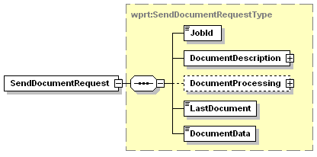
Figure 19 - SendDocumentRequest Elements

JobId
This data element contains the JobId to which the currently submitted document should be attached. This data element is described in Section 3.5.1.1

DocumentDescription
This data element contains the description attributes that pertain to the basic creation information of the currently identified Document. This data element is described in Section 3.6.1

DocumentProcessing
This data element contains the basic processing attributes to be applied to this individual document. These parameters override any parameters set during the CreatePrintJob operation. The override is valid for this document only. This data element is described in Section 3.5.2.3

LastDocument
This data element defines whether more documents will be submitted for the current print job. It the data value is 0 or false then more SendDocument or AddDocument operations will follow this operation. If the data value is 1 or true, this is the last document, and the print job can complete when all supplied documents have finished.
Values: 0, 1, false, true

DocumentData
This element is the binary data that represents the document to be printed which is part of the request as a binary attachment to the SOAP Envelope/Body.

Example Request
mime-version: 1.0
Content-Type: Multipart/Related;
boundary=e1ac1c8d-11be-4313-999f-a8b0857d5360-3c31c1fe-39ef-4c34-8efd-918cf79f6;
type="application/xop+xml";
start="<xml@example.org>";
start-info="application/soap+xml"

--e1ac1c8d-11be-4313-999f-a8b0857d5360-3c31c1fe-39ef-4c34-8efd-918cf79f6
Content-Type: application/xop+xml; type=application/soap+xml
charset=UTF-8
Content-Transfer-Encoding: binary
Content-ID: <xml@example.org>

<?xml version="1.0" encoding="utf-8"?>
<soap:Envelope
xmlns:soap="http://www.w3.org/2003/05/soap-envelope"
xmlns:wsa="http://schemas.xmlsoap.org/ws/2004/08/addressing"
xmlns:wprt="http://schemas.microsoft.com/windows/2006/08/wdp/print"
xmlns:xop=”http://www.w3.org/2004/08/xop/include”>
<soap:Header>
<wsa:To>AddressofPrinterService</wsa:To>
<wsa:Action>
http://schemas.microsoft.com/windows/2006/08/wdp/print/SendDocument
</wsa:Action>
<wsa:MessageID>uuid:UniqueMsgId</wsa:MessageID>
</soap:Header>
<soap:Body>
<wprt:SendDocumentRequest>
<wprt:JobId>1</wprt:JobId>
<wprt:DocumentDescription>
<wprt:DocumentId>1</wprt:DocumentId>
<wprt:Compression>None</wprt:Compression>
<wprt:Format>application/octet-stream</wprt:Format>
<wprt:DocumentName>Example.xml</wprt:DocumentName>
</wprt:DocumentDescription>
<wprt:DocumentProcessing>
<wprt:Sides>TwoSidedLongEdge</wprt:Sides>
</wprt:DocumentProcessing>
<wprt:LastDocument>false</wprt:LastDocument>
<wprt:DocumentData>
<xop:Include href=”cid:1c696bd7-005a-48d9-9ee9-9adca11f8892@uuid”/>
</wprt:DocumentData>
</wprt:SendDocumentRequest>
</soap:Body>
</soap:Envelope>

--e1ac1c8d-11be-4313-999f-a8b0857d5360-3c31c1fe-39ef-4c34-8efd-918cf79f6
Content-Type: application/octet-stream;
Content-Transfer-Encoding: binary
Content-ID: <1c696bd7-005a-48d9-9ee9-9adca11f8892@uuid>

Document PDL Data
--e1ac1c8d-11be-4313-999f-a8b0857d5360-3c31c1fe-39ef-4c34-8efd-918cf79f6--

Example Response
<soap:Envelope
xmlns:soap="http://www.w3.org/2003/05/soap-envelope"
xmlns:wsa="http://schemas.xmlsoap.org/ws/2004/08/addressing"
xmlns:wprt="http://schemas.microsoft.com/windows/2006/08/wdp/print”>
<soap:Header>
<wsa:To>http://schemas.xmlsoap.org/ws/2004/08/addressing/role/anonymous</wsa:To>
<wsa:Action>
http://schemas.microsoft.com/windows/2006/08/wdp/print/SendDocumentResponse
</wsa:Action>
<wsa:MessageID>uuid:UniqueMsgId</wsa:MessageID>
<wsa:RelatesTo>uuid:MsgIdOfTheSendDocumentRequest</wsa:RelatesTo>
</soap:Header>
<soap:Body>
<wprt:SendDocumentResponse/>
</soap:Body>
</soap:Envelope>

Errors
All the Codes described in section 5.1.1 - Common Operation Error Codes could be returned from this operation. The following error could also be returned from this operation.

ServerErrorDocumentActive
This fault is sent when the server is currently processing a document for the current print job. The client SHOULD try the unmodified request again within the document timeout period with an expectation that the server has finished accepting the previous document is ready for the next document.
[Code] | soap:Receiver
[Subcode] | wprt:ServerErrorDocumentActive
[Reason] | The service is processing a document for the current job and can’t accept new document requests.
[Detail] | None

ServerErrorJobCancelled
This fault will be returned if the job associated with this document is canceled while the document data is being transferred.
[Code] | soap:Receiver
[Subcode] | wprt:ServerErrorJobCancelled
[Reason] | Job which this document is a part of has been canceled
[Detail] | None

ClientErrorJobIdNotFound
This fault is sent when the printer can not find a job matching the JobId argument (including when the argument is not in the range: 1 to 2^³¹-1).
[Code] | soap:Sender
[Subcode] | wprt:ClientErrorJobIdNotFound
[Reason] | Specified JobId not found
[Detail] | Jobid:Incorrect JobId

ClientErrorMultipleDocumentsNotSupported
The printer does not support jobs which contain more than one document. If the LastDocument element of the document is not true for the first document of the job; this error is returned.
[Code] | soap:Sender
[Subcode] | wprt:ClientErrorMultipleDocumentsNotSupported
[Reason] | Print Service does not support jobs with multiple documents.
[Detail] | None

ClientErrorLastDocumentAlreadySent
The printer has already received a document with the LastDocument element set to true.
[Code] | soap:Sender
[Subcode] | wprt:ClientErrorLastDocumentAlreadySent
[Reason] | LastDocument already received for specified JobId
[Detail] | None

ClientErrorFormatNotSupported
This fault is sent when the supplied document Format value is not supported by the Printer object.
[Code] | soap:Sender
[Subcode] | wprt:ClientErrorFormatNotSupported
[Reason] | Format parameter value not supported
[Detail] | Optional: Return a list of supported formats.  The data in this element should be of type wprt:ValueStringListType.

ClientErrorCompressionNotSupported
This fault is sent when the supplied Compression value is not supported by the Printer object.
[Code] | soap:Sender
[Subcode] | wprt:ClientErrorCompressionNotSupported
[Reason] | Compression parameter value not supported
[Detail] | Optional: Could return a list of supported compression values

ClientErrorConflictingRequiredParameters
This fault is sent when the there is a conflict between 2 or more JobProcessing or DocumentProcessing elements which each have the MustHonor attribute set to true. Using all of the settings supplied with MustHonor attributes set to true will cause a conflict in the printer mechanism. This conflict cannot be resolved so the PrintTicket is invalid.
[Code] | soap:Sender
[Subcode] | wscn: ClientErrorConflictingRequiredParameters
[Reason] | Multiple elements in the JobProcessing or DocumentProcessing elements have MustHonor set to true but applying all settings causes a conflict in the printer device.
[Detail] | None

AddDocument
This operation is nearly identical to the SendDocument operation except that the client (CP) supplies a URL reference to the document instead of the document data. This operation is the next step in submitting a job to the printer using the CreatePrintJob operation. One or more SendDocument or AddDocument operations are used to send the print data to the print service. Each AddDocument will contain the JobId of the job to which the Document should be attached. If a printer does not support multi-document jobs, only one SendDocument or AddDocument operation should follow each CreatePrintJob operation, and the LastDocument element of the AddDocument should be set to 1 or true.
The allowed values returned in a GetPrinterElements(PrinterCapabilities) (see section 3.9.3) indicate the values of the arguments that the Print Service instance (Printer) supports (see section 3.9) for a Document processing. The Printer performs the following document validation in the indicated order:
- If the Format is not supported, the Printer MUST reject the AddDocument request and return the ClientErrorDocumentFormatNotSupported error code.
- If the Compression is not supported, the Printer MUST reject the AddDocument request and return the ClientErrorCompressionNotSupported error code.

Request Elements
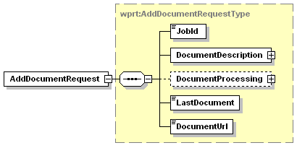
Figure 20 - AddDocumentRequest Elements

JobId
This data element contains the JobId to which the currently submitted document should be attached. This data element is described in Section 3.5.1.1

DocumentDescription
This data element contains the description attributes that pertain to the basic creation information of the currently identified Document. This data element is described in Section 3.6.1

DocumentProcessing
This data element contains the basic processing attributes to be applied to this individual document. These parameters override and parameters set during the CreatePrintJob operation. The override is valid for this document only. This data element is described in Section 3.5.2.3

LastDocument
This data element defines whether more documents will be submitted for the current print job. It the data value is 0 or false then more SendDocument or AddDocument operations will follow this operation. If the data value is 1 or true, this is the last document, and the print job can complete when all supplied documents have finished.
Values: 0, 1, false, true

DocumentUrl
This data element contains the URL that points to the document data to print.

Example Request
<soap:Envelope
xmlns:soap="http://www.w3.org/2003/05/soap-envelope"
xmlns:wsa="http://schemas.xmlsoap.org/ws/2004/08/addressing"
xmlns:wprt="http://schemas.microsoft.com/windows/2006/08/wdp/print”
soap:encodingStyle='http://www.w3.org/2002/12/soap-encoding'>
<soap:Header>
<wsa:To>AddressofPrinterService</wsa:To>
<wsa:Action>
http://schemas.microsoft.com/windows/2006/08/wdp/print/AddDocument
</wsa:Action>
<wsa:MessageID>uuid:UniqueMsgId</wsa:MessageID>
</soap:Header>
<soap:Body>
<wprt:AddDocumentRequest>
<wprt:JobId>1</wprt:JobId>
<wprt:DocumentDescription>
<wprt:DocumentId>1</wprt:DocumentId>
<wprt:Compression>None</wprt:Compression>
<wprt:Format>application/octet-stream</wprt:Format>
<wprt:DocumentName>Example.xml</wprt:DocumentName>
</wprt:DocumentDescription>
<wprt:DocumentProcessing>
<wprt:NumberUp>
<wprt:PagesPerSheet>2</wprt:PagesPerSheet>
<wprt:Direction>RightDown</wprt:Direction>
</wprt:NumberUp>
</wprt:DocumentProcessing>
<wprt:LastDocument>true</wprt:LastDocument>
<wprt:DocumentUrl>
http://www.example.com/PrintJobs/ExamplePrint.ps
</wprt:DocumentUrl>
</wprt:AddDocumentRequest>
</soap:Body>
</soap:Envelope>

Example Response
<soap:Envelope
xmlns:soap="http://www.w3.org/2003/05/soap-envelope"
xmlns:wsa="http://schemas.xmlsoap.org/ws/2004/08/addressing"
xmlns:wprt="http://schemas.microsoft.com/windows/2006/08/wdp/print”>
<soap:Header>
<wsa:To>http://schemas.xmlsoap.org/ws/2004/08/addressing/role/anonymous</wsa:To>
<wsa:Action>
http://schemas.microsoft.com/windows/2006/08/wdp/print/AddDocumentResponse
</wsa:Action>
<wsa:MessageID>uuid:UniqueMsgId</wsa:MessageID>
<wsa:RelatesTo>uuid:MsgIdOfTheAddDocumentRequest</wsa:RelatesTo>
</soap:Header>
<soap:Body>
<wprt:AddDocumentResponse/>
</soap:Body>
</soap:Envelope>

Errors
All the Codes described in section 5.1.1 - Common Operation Error Codes could be returned from this operation. The following errors could also be returned from this operation.

ServerErrorAddDocumentNotSupported
This fault will be returned if the print service does not support retrieving document data by a URL reference.
[Code] | soap:Receiver
[Subcode] | wprt:ServerErrorAddDocumentNotSupported
[Reason] | Print Service does not support the AddDocument operation
[Detail] | None

ServerErrorDocumentActive
This fault is sent when the server is currently processing a document for the current print job. The client SHOULD try the unmodified request again within the document timeout period with an expectation that the server has finished accepting the previous document is ready for the next document.
[Code] | soap:Receiver
[Subcode] | wprt:ServerErrorDocumentActive
[Reason] | The service is processing a document for the current job and can’t accept new document requests.
[Detail] | None

ServerErrorJobCancelled
This fault will be returned if the job associated with this document is canceled while the document data is being transferred.
[Code] | soap:Receiver
[Subcode] | wprt:ServerErrorJobCancelled
[Reason] | Job which this document is a part of has been canceled
[Detail] | None

ClientErrorJobIdNotFound
This fault is sent when printer can not find a job matching the JobId argument (including when the argument is not in the range: 1 to 2^³¹-1).
[Code] | soap:Sender
[Subcode] | wprt:ClientErrorJobIdNotFound
[Reason] | Specified JobId not found
[Detail] | Jobid:Incorrect JobId

ClientErrorMultipleDocumentsNotSupported
The printer does not support jobs which contain more than one document. If the LastDocument element of the document is not true for the first document of the job; this error is returned.
[Code] | soap:Sender
[Subcode] | wprt:ClientErrorMultipleDocumentsNotSupported
[Reason] | Print Service does not support jobs with multiple documents.
[Detail] | None

ClientErrorLastDocumentAlreadySent
The printer has already received a document with the LastDocument element set to 1 or true.
[Code] | soap:Sender
[Subcode] | wprt:ClientErrorLastDocumentAlreadySent
[Reason] | LastDocument already received for specified JobId
[Detail] | None

ClientErrorFormatNotSupported
This fault is sent when the supplied document Format value is not supported by the Printer object.
[Code] | soap:Sender
[Subcode] | wprt:ClientErrorFormatNotSupported
[Reason] | Format parameter value not supported
[Detail] | Optional: Could return a list of supported formats.

ClientErrorCompressionNotSupported
This fault is sent when the supplied Compression value is not supported by the Printer object.
[Code] | soap:Sender
[Subcode] | wprt:ClientErrorCompressionNotSupported
[Reason] | Compression parameter value not supported
[Detail] | Optional: Could return a list of supported compression values

ClientErrorDocumentURLSchemeNotSupported
The Print Service does not support the scheme specified in the DocumentUrl parameter.
[Code] | soap:Sender
[Subcode] | wprt:ClientErrorDocumentURLSchemeNotSupported
[Reason] | Print Service does not support the specified URL scheme.
[Detail] | Optional: Could return a list of supported schemes

ClientErrorDocumentURLNotFound
The DocumentUrl parameter could not be resolved to a valid resource. The main reason for this would be that the resource identifier is incorrect; however this could also indicate that the printer could not establish a path to the resource.
[Code] | soap:Sender
[Subcode] | wprt:ClientErrorDocumentURLNotFound
[Reason] | The DocumentUrl specified does not resolve to a valid resource.
[Detail] | None

CancelJob
This operation allows a client to cancel a print job from the time the job is created up to the time it is completed, canceled or aborted.

Request Elements
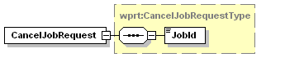
Figure 21 - CancelJobRequest Elements

JobId
This data element contains the JobId which the client is trying to cancel. This data element is described in Section 3.5.1.1

Example Request
<soap:Envelope
xmlns:soap="http://www.w3.org/2003/05/soap-envelope"
xmlns:wsa="http://schemas.xmlsoap.org/ws/2004/08/addressing"
xmlns:wprt="http://schemas.microsoft.com/windows/2006/08/wdp/print”>
<soap:Header>
<wsa:To>AddressofPrinterService</wsa:To>
<wsa:Action>
http://schemas.microsoft.com/windows/2006/08/wdp/print/CancelJob
</wsa:Action>
<wsa:MessageID>uuid:UniqueMsgId</wsa:MessageID>
</soap:Header>
<soap:Body>
<wprt:CancelJobRequest>
<wprt:JobId>1</wprt:JobId>
</wprt:CancelJobRequest>
</soap:Body>
</soap:Envelope>

Example Response
<soap:Envelope
xmlns:soap="http://www.w3.org/2003/05/soap-envelope"
xmlns:wsa="http://schemas.xmlsoap.org/ws/2004/08/addressing"
xmlns:wprt="http://schemas.microsoft.com/windows/2006/08/wdp/print”>
<soap:Header>
<wsa:To>http://schemas.xmlsoap.org/ws/2004/08/addressing/role/anonymous</wsa:To>
<wsa:Action>
http://schemas.microsoft.com/windows/2006/08/wdp/print/CancelJobResponse
</wsa:Action>
<wsa:MessageID>uuid:UniqueMsgId</wsa:MessageID>
<wsa:RelatesTo>uuid:MsgIdOfTheCancelJobRequest</wsa:RelatesTo>
</soap:Header>
<soap:Body>
<wprt:CancelJobResponse/>
</soap:Body>
</soap:Envelope>

Errors
All the Codes described in section 5.1.1 - Common Operation Error Codes could be returned from this operation. The following error could also be returned from this operation.

ClientErrorJobIdNotFound
This fault is sent when printer can not find a job matching the JobId argument (including when the argument is not in the range: 1 to 2^³¹-1).
[Code] | soap:Sender
[Subcode] | wprt:ClientErrorJobIdNotFound
[Reason] | Specified JobId not found
[Detail] | Jobid:Incorrect JobId

Effect on State
The specified job moves to the Canceled state if the Job was Pending or Processing. It is an error to attempt to cancel a completed or canceled job or to try and cancel any Job the CP does not have rights to.

GetPrinterElements
The GetPrinterElements operation allows a client (CP) to request information about the printer. This info includes the description, configuration, status, default PrintTicket, PrinterCapabilities of the Printer or IHV extensions to the Printer schema.
The GetPrinterElements operation allows a client to discover standard and vendor extended elements.

Request Elements
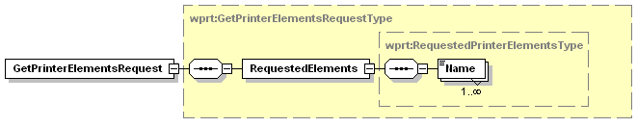
Figure 22 - GetPrinterElementsRequest Elements

RequestedElements
This data element is a collection of elements that describes the data in which the CP is interested.

Name
This data element is a QName that represents a location within the Printer schema. The keyword represents a top level section of the printer schema such as the PrinterConfiguration or DefaultPrintTicket.

Allowed Values:
wprt:PrinterDescription– Get all the Description information for the print device.
wprt:PrinterConfiguration– Get all the Configuration information for the print device.
wprt:PrinterStatus – Entire status section including all ActiveConditons and the ConditionHistory
wprt:DefaultPrintTicket – The current default values for Job creation and processing
wprt:PrinterCapabilities – The current allowed values for Job creation and processing
xmlns:VendorSection– A Vendor defined extension to the Printer Schema

Response Elements
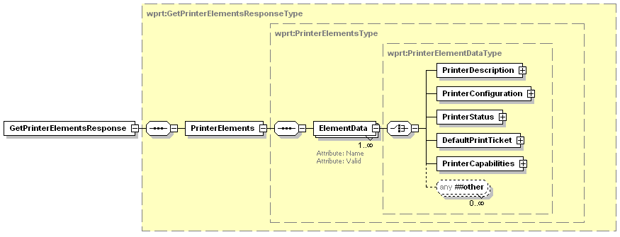
Figure 23 - GetPrinterElementsResponse Elements

PrinterElements
This data element is a collection of all the responses generated by the print device for the schema queries in the GetPrinterElements request.

ElementData
This data element contains the data returned for one of the schema requests. There will be the same number of ElementData elements in the response as there were Name elements in the request.

Name
This attribute contains the schema keyword used to create the data that is returned in the element.

Valid
This attribute indicates whether the schema query value was for a valid or invalid schema keyword within the device schema. This attribute will be false if the requested schema keyword does not map to a valid schema section in the Printer schema supported by the device.

Example Request - PrinterDescription
<soap:Envelope
xmlns:soap="http://www.w3.org/2003/05/soap-envelope"
xmlns:wsa="http://schemas.xmlsoap.org/ws/2004/08/addressing"
xmlns:wprt="http://schemas.microsoft.com/windows/2006/08/wdp/print”>
<soap:Header>
<wsa:To>AddressofPrinterService</wsa:To>
<wsa:Action>
http://schemas.microsoft.com/windows/2006/08/wdp/print/GetPrinterElements
</wsa:Action>
<wsa:MessageID>uuid:UniqueMsgId</wsa:MessageID>
</soap:Header>
<soap:Body>
<wprt:GetPrinterElementsRequest>
<wprt:RequestedElements>
<wprt:Name>wprt:PrinterDescription</wprt:Name>
</wprt:RequestedElements>
</wprt:GetPrinterElementsRequest>
</soap:Body>
</soap:Envelope>

Example Response – PrinterDescription
<soap:Envelope
xmlns:soap="http://www.w3.org/2003/05/soap-envelope"
xmlns:wsa="http://schemas.xmlsoap.org/ws/2004/08/addressing"
xmlns:wprt="http://schemas.microsoft.com/windows/2006/08/wdp/print”>
<soap:Header>
<wsa:To>http://schemas.xmlsoap.org/ws/2004/08/addressing/role/anonymous</wsa:To>
<wsa:Action>
http://schemas.microsoft.com/windows/2006/08/wdp/print/GetPrinterElementsResponse
</wsa:Action>
<wsa:MessageID>uuid:UniqueMsgId</wsa:MessageID>
<wsa:RelatesTo>uuid:MsgIdOfTheGetPrinterElementsRequest</wsa:RelatesTo>
</soap:Header>
<soap:Body>
<wprt:GetPrinterElementsResponse>
<wprt:PrinterElements>
<wprt:ElementData Name=”wprt:PrinterDescription” Valid=”true”>
<wprt:PrinterDescription>
<wprt:ColorSupported>true</wprt:ColorSupported>
<wprt:DeviceId>MFG:Acme;MDL:PrintMaster 9020</wprt:DeviceId>
<wprt:MultipleDocumentJobsSupported>true</wprt:MultipleDocumentJobsSupported>
<wprt:PagesPerMinute>20</wprt:PagesPerMinute>
<wprt:PagesPerMinuteColor>8</wprt:PagesPerMinuteColor>
<wprt:PrinterName xml:lang="en-AU, en-CA, en-GB, en-US">
Accounting Printer in Copy Room 2
</wprt:PrinterName>
<wprt:PrinterInfo xml:lang="en-AU, en-CA, en-GB, en-US">
Printer for use of Accounting only
</wprt:PrinterInfo>
<wprt:PrinterLocation xml:lang="en-AU, en-CA, en-GB, en-US">
LA Campus – Building 3
</wprt:PrinterLocation>
</wprt:PrinterDescription>
</wprt:ElementData>
</wprt:PrinterElements>
</wprt:GetPrinterElementsResponse>
</soap:Body>
</soap:Envelope>

Example Request - PrinterConfiguration
<soap:Envelope
xmlns:soap="http://www.w3.org/2003/05/soap-envelope"
xmlns:wsa="http://schemas.xmlsoap.org/ws/2004/08/addressing"
xmlns:wprt="http://schemas.microsoft.com/windows/2006/08/wdp/print”
soap:encodingStyle='http://www.w3.org/2002/12/soap-encoding'>
<soap:Header>
<wsa:To>AddressofPrinterService</wsa:To>
<wsa:Action>
http://schemas.microsoft.com/windows/2006/08/wdp/print/GetPrinterElements
</wsa:Action>
<wsa:MessageID>uuid:UniqueMsgId</wsa:MessageID>
</soap:Header>
<soap:Body>
<wprt:GetPrinterElementsRequest>
<wprt:RequestedElements>
<wprt:Name>wprt:PrinterConfiguration</wprt:Name>
</wprt:RequestedElements>
</wprt:GetPrinterElementsRequest >
</soap:Body>
</soap:Envelope>

Example Response – PrinterConfiguration
<soap:Envelope
xmlns:soap="http://www.w3.org/2003/05/soap-envelope"
xmlns:wsa="http://schemas.xmlsoap.org/ws/2004/08/addressing"
xmlns:wprt="http://schemas.microsoft.com/windows/2006/08/wdp/print”>
<soap:Header>
<wsa:To>http://schemas.xmlsoap.org/ws/2004/08/addressing/role/anonymous</wsa:To>
<wsa:Action>
http://schemas.microsoft.com/windows/2006/08/wdp/print/GetPrinterElementsResponse
</wsa:Action>
<wsa:MessageID>uuid:UniqueMsgId</wsa:MessageID>
<wsa:RelatesTo>uuid:MsgIdOfTheGetPrinterElementsRequest</wsa:RelatesTo>
</soap:Header>
<soap:Body>
<wprt:GetPrinterElementsResponse>
<wprt:PrinterElements>
<wprt:ElementData Name=”wprt:PrinterConfiguration” Valid=”true”>
<wprt:PrinterConfiguration>
<wprt:PrinterEventRate>1</wprt:PrinterEventRate>
<wprt:Storage>
<wprt:StorageEntry Name=”BaseRAM”>
<wprt:Type>RAM</wprt:Type>
<wprt:Size>32768</wprt:Size>
<wprt:Free>80</wprt:Free>
</wprt:StorageEntry>
</wprt:Storage>
<wprt:Consumables>
<wprt:ConsumableEntry Name=”InkSlot1”>
<wprt:Type>Ink</wprt:Type>
<wprt:Color>Black</wprt:Color>
<wprt:Level>40</wprt:Level>
<wprt:Model>HiCapacityBlack</wprt:Model>
</wprt:ConsumableEntry>
<wprt:ConsumableEntry Name=”InkSlot2”>
<wprt:Type>Ink</wprt:Type>
<wprt:Color>Yellow</wprt:Color>
<wprt:Level>80</wprt:Level>
<wprt:Model>HiCapacityYellow</wprt:Model>
</wprt:ConsumableEntry>
<wprt:ConsumableEntry Name=”InkSlot3”>
<wprt:Type>Ink</wprt:Type>
<wprt:Color>Cyan</wprt:Color>
<wprt:Level>20</wprt:Level>
<wprt:Model>StarterCyan</wprt:Model>
</wprt:ConsumableEntry>
<wprt:ConsumableEntry Name=”InkSlot4”>
<wprt:Type>Ink</wprt:Type>
<wprt:Color>Magenta</wprt:Color>
<wprt:Level>50</wprt:Level>
<wprt:Model>WaterproofMagenta</wprt:Model>
</wprt:ConsumableEntry>
</wprt:Consumables>
<wprt:InputBins>
<wprt:InputBinEntry Name=”Tray1”>
<wprt:FeedDirection>ShortEdgeFirst</wprt:FeedDirection>
<wprt:MediaSize>na_legal_8.5x14in</wprt:MediaSize>
<wprt:Capacity>500</wprt:Capacity>
<wprt:Level>70</wprt:Level>
</wprt:InputBinEntry>
</wprt:InputBins>
<wprt:Finishings>
<wprt:CollationSupported>false</wprt:CollationSupported>
<wprt:JogOffsetSupported>true</wprt:JogOffsetSupported>
<wprt:DuplexerInstalled>true</wprt:DuplexerInstalled>
<wprt:StaplerInstalled>false</wprt:StaplerInstalled>
<wprt:HolePunchInstalled>false</wprt:HolePunchInstalled>
</wprt:Finishings>
<wprt:OutputBins>
<wprt:OutputBinEntry Name=”Bin1”>
<wprt:Capacity>100</wprt:Capacity>
<wprt:Level>-1</wprt:Level>
</wprt:OutputBinEntry>
</wprt:OutputBins>
</wprt:PrinterConfiguration>
</wprt:ElementData>
</wprt:PrinterElements>
</wprt:GetPrinterElementsResponse>
</soap:Body>
</soap:Envelope>

Example Request – Multiple requests
<soap:Envelope
xmlns:soap="http://www.w3.org/2003/05/soap-envelope"
xmlns:wsa="http://schemas.xmlsoap.org/ws/2004/08/addressing"
xmlns:wprt="http://schemas.microsoft.com/windows/2006/08/wdp/print”
xmlns:myns=" http://www.example.com/2006/08/mynamespace”>
<soap:Header>
<wsa:To>AddressofPrinterService</wsa:To>
<wsa:Action>
http://schemas.microsoft.com/windows/2006/08/wdp/print/GetPrinterElements
</wsa:Action>
<wsa:MessageID>uuid:UniqueMsgId</wsa:MessageID>
</soap:Header>
<soap:Body>
<wprt:GetPrinterElementsRequest>
<wprt:RequestedElements>
<wprt:Name>wprt:PrinterStatus</wprt:Name>
<wprt:Name>wprt:DefaultPrintTicket</wprt:Name>
<wprt:Name>myns:InvalidQname</wprt:Name>
</wprt:RequestedElements>
</wprt:GetPrinterElementsRequest>
</soap:Body>
</soap:Envelope>

Example Response – Multiple Requests
<soap:Envelope
xmlns:soap="http://www.w3.org/2003/05/soap-envelope"
xmlns:wsa="http://schemas.xmlsoap.org/ws/2004/08/addressing"
xmlns:wprt="http://schemas.microsoft.com/windows/2006/08/wdp/print”
xmlns:myns=" http://www.example.com/2006/08/mynamespace”>
<soap:Header>
<wsa:To>http://schemas.xmlsoap.org/ws/2004/08/addressing/role/anonymous</wsa:To>
<wsa:Action>
http://schemas.microsoft.com/windows/2006/08/wdp/print/GetPrinterElementsResponse
</wsa:Action>
<wsa:MessageID>uuid:UniqueMsgId</wsa:MessageID>
<wsa:RelatesTo>uuid:MsgIdOfTheGetPrinterElementsRequest</wsa:RelatesTo>
</soap:Header>
<soap:Body>
<wprt:GetPrinterElementsResponse>
<wprt:PrinterElements>
<wprt:ElementData Name=”wprt:PrinterStatus” Valid=”true”>
<wprt:PrinterStatus>
<wprt:PrinterCurrentTime>2006-01-21T17:22:27.5242689Z</wprt:PrinterCurrentTime>
<wprt:PrinterState>Stopped</wprt:PrinterState>
<wprt:PrinterPrimaryStateReason>MediaJam</wprt:PrinterPrimaryStateReason>
<wprt:PrinterStateReasons>
<wprt:PrinterStateReason>MediaJam</wprt:PrinterStateReason>
<wprt:PrinterStateReason>OutputAreaAlmostFull</wprt:PrinterStateReason>
</wprt:PrinterStateReasons>
<wprt:QueuedJobCount>2</wprt:QueuedJobCount>
</wprt:PrinterStatus>
</wprt:ElementData>
<wprt:ElementData Name=”wprt:DefaultPrintTicket” Valid=”true”>
<wprt:DefaultPrintTicket>
<wprt:JobDescription>
<wprt:JobName>DefaultName</wprt:JobName>
<wprt:JobOriginatingUserName>DefaultUser</wprt:JobOriginatingUserName>
</wprt:JobDescription>
<wprt:JobProcessing>
<wprt:Copies>1</wprt:Copies>
<wprt:JobFinishings>
<wprt:Collate>false</wprt:Collate>
<wprt:JogOffset>true</wprt:JogOffset>
<wprt:Staple>
<wprt:Location>None</wprt:Location>
<wprt:Angle>NotApplicable</wprt:Angle>
</wprt:Staple>
<wprt:HolePunch>
<wprt:Edge>None</wprt:Edge>
<wprt:Pattern>NotApplicable</wprt:Pattern>
</wprt:HolePunch>
</wprt:JobFinishings>
<wprt:Priority>50</wprt:Priority>
</wprt:JobProcessing>
<wprt:DocumentProcessing>
<wprt:MediaSizeName>na_letter_8.5x11in</wprt:MediaSizeName>
<wprt:MediaType>stationery</wprt:MediaType>
<wprt:MediaColor>white</wprt:MediaColor>
<wprt:NumberUp>
<wprt:PagesPerSheet>1</wprt:PagesPerSheet>
<wprt:Direction>RightDown</wprt:Direction>
</wprt:NumberUp>
<wprt:Orientation>Portrait</wprt:Orientation>
<wprt:Resolution>
<wprt:Width>600</wprt:Width>
</wprt:Resolution>
<wprt:PrintQuality>Normal</wprt:PrintQuality>
<wprt:Sides>OneSided</wprt:Sides>
</wprt:DocumentProcessing>
</wprt:DefaultPrintTicket>
</wprt:ElementData>
<wprt:ElementData Name=”myns:InvalidQName” Valid=”false”/>
</wprt:PrinterElements>
</wprt:GetPrinterElementsResponse>
</soap:Body>
</soap:Envelope>

Errors
All the Codes described in section 5.1.1 - Common Operation Error Codes could be returned from this operation.

GetJobElements
The GetJobElements operation allows a client (CP) to determine the values of job-related variables of the specified job with a JobId from 1 to 2³¹-1.
If the specified job is not found, the error ClientErrorJobIdNotFound is returned. Any job not found either never existed or has reached its terminating state (i.e., completed, canceled, aborted) and is no longer known to the Print Service.
The GetJobElements operation allows a client to discover standard and vendor extended elements.

Request Elements
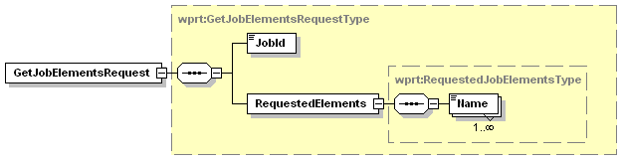
Figure 24 - GetJobElementsRequest Elements

JobId
This data element contains the JobId of the Job about which the client is request information. This data element is described in Section 3.5.1.1

RequestedElements
This data element is a collection of elements that describes the data in which the CP is interested.

Name
This data element is a QName that represents a location within the Job schema. The keyword represents a top level section of the Job schema such as the JobStatus or PrintTicket.

Allowed Values:
wprt:JobStatus – Get the current JobStatus element for the specified Job.
wprt:PrintTicket – Get the PrintTicket element for the specified Job
wprt:Documents - Get the Documents element for the specified Job
xmlns:VendorSection– A Vendor defined extension to the Job Schema

Response Elements
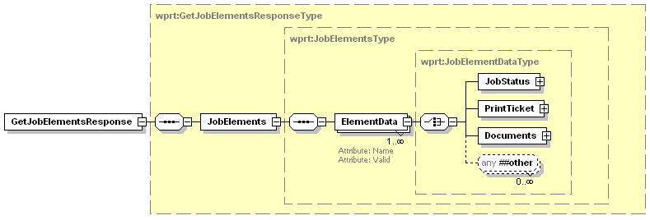
Figure 25 - GetJobElementsResponse Elements

JobElements
This data element is a collection of all the responses generated by the print device for the schema queries in the GetJobElements request.

ElementData
This data element contains the data returned for one of the schema requests. There will be the same number of ElementData elements in the response as there were Name elements in the request.

Name
This attribute contains the schema keyword used to create the data that is returned in the element.

Valid
This attribute indicates whether the schema query value was for a valid or invalid schema keyword within the device schema. This attribute will be false if the requested schema keyword does not map to a valid schema section in the Job schema supported by the device.

Example Request - JobStatus
<soap:Envelope
xmlns:soap="http://www.w3.org/2003/05/soap-envelope"
xmlns:wsa="http://schemas.xmlsoap.org/ws/2004/08/addressing"
xmlns:wprt="http://schemas.microsoft.com/windows/2006/08/wdp/print”>
<soap:Header>
<wsa:To>AddressofPrinterService</wsa:To>
<wsa:Action>
http://schemas.microsoft.com/windows/2006/08/wdp/print/GetJobElements
</wsa:Action>
<wsa:MessageID>uuid:UniqueMsgId</wsa:MessageID>
</soap:Header>
<soap:Body>
<wprt:GetJobElementsRequest>
<wprt:JobId>1</wprt:JobId>
<wprt:RequestedElements>
<wprt:Name>wprt:JobStatus</wprt:Name>
</wprt:RequestedElements>
</wprt:GetJobElementsRequest >
</soap:Body>
</soap:Envelope>

Example Response – JobStatus
<soap:Envelope
xmlns:soap="http://www.w3.org/2003/05/soap-envelope"
xmlns:wsa="http://schemas.xmlsoap.org/ws/2004/08/addressing"
xmlns:wprt="http://schemas.microsoft.com/windows/2006/08/wdp/print”>
<soap:Header>
<wsa:To>http://schemas.xmlsoap.org/ws/2004/08/addressing/role/anonymous</wsa:To>
<wsa:Action>
http://schemas.microsoft.com/windows/2006/08/wdp/print/GetJobElementsResponse
</wsa:Action>
<wsa:MessageID>uuid:UniqueMsgId</wsa:MessageID>
<wsa:RelatesTo>uuid:MsgIdOfTheGetJobElementsRequest</wsa:RelatesTo>
</soap:Header>
<soap:Body>
<wprt:GetJobElementsResponse>
<wprt:JobElements>
<wprt:ElementData Name=”wprt:JobStatus” Valid=”true”>
<wprt:JobStatus>
<wprt:JobId>1</wprt:JobId>
<wprt:JobState>Pending</wprt:JobState>
<wprt:JobStateReasons>
<wprt:JobStateReason>None</wprt:JobStateReason>
</wprt:JobStateReasons>
<wprt:KOctetsProcessed>0</wprt:KOctetsProcessed>
<wprt:MediaSheetsCompleted>0</wprt:MediaSheetsCompleted>
<wprt:NumberOfDocuments>1</wprt:NumberOfDocuments>
</wprt:JobStatus>
</wprt:ElementData>
<wprt:JobElements>
</wprt:GetJobElementsResponse>
</soap:Body>
</soap:Envelope>

Example Request – Multiple Requests
<soap:Envelope
xmlns:soap="http://www.w3.org/2003/05/soap-envelope"
xmlns:wsa="http://schemas.xmlsoap.org/ws/2004/08/addressing"
xmlns:myns=" http://www.example.com/2006/08/mynamespace”
xmlns:wprt="http://schemas.microsoft.com/windows/2006/08/wdp/print”
soap:encodingStyle='http://www.w3.org/2002/12/soap-encoding' >
<soap:Header>
<wsa:To>AddressofPrinterService</wsa:To>
<wsa:Action>
http://schemas.microsoft.com/windows/2006/08/wdp/print/GetJobElements
</wsa:Action>
<wsa:MessageID>uuid:UniqueMsgId</wsa:MessageID>
</soap:Header>
<soap:Body>
<wprt:GetJobElementsRequest>
<wprt:JobId>1</wprt:JobId>
<wprt:RequestedElements>
<wprt:Name>wprt:PrintTicket</wprt:Name>
<wprt:Name>wprt:Documents</wprt:Name>
<wprt:Name>myns:InvalidQName</wprt:Name>
</wprt:RequestedElements>
</wprt:GetJobElementsRequest>
</soap:Body>
</soap:Envelope>

Example Response – Multiple Requests
<soap:Envelope
xmlns:soap="http://www.w3.org/2003/05/soap-envelope"
xmlns:wsa="http://schemas.xmlsoap.org/ws/2004/08/addressing"
xmlns:myns=" http://www.example.com/2006/08/mynamespace”
xmlns:wprt="http://schemas.microsoft.com/windows/2006/08/wdp/print”>
<soap:Header>
<wsa:To>http://schemas.xmlsoap.org/ws/2004/08/addressing/role/anonymous</wsa:To>
<wsa:Action>
http://schemas.microsoft.com/windows/2006/08/wdp/print/GetJobElementsResponse
</wsa:Action>
<wsa:MessageID>uuid:UniqueMsgId</wsa:MessageID>
<wsa:RelatesTo>uuid:MsgIdOfTheGetJobElementsRequest</wsa:RelatesTo>
</soap:Header>
<soap:Body>
<wprt:GetJobElementsResponse>
<wprt:JobElements>
<wprt:ElementData Name=”wprt:PrintTicket” Valid=”true”>
<wprt:PrintTicket>
<wprt:JobDescription>
<wprt:JobName>GreatPresentation.ppt</wprt:JobName>
<wprt:JobOriginatingUserName>AdminUser</wprt:JobOriginatingUserName>
</wprt:JobDescription>
<wprt:JobProcessing>
<wprt:Copies>1</wprt:Copies>
<wprt:JobFinishings>
<wprt:Collate>false</wprt:Collate>
<wprt:JogOffset>true</wprt:JogOffset>
</wprt:JobFinishings>
<wprt:Priority>50</wprt:Priority>
</wprt:JobProcessing>
<wprt:DocumentProcessing>
<wprt:MediaSizeName>na_letter_8.5x11in</wprt:MediaSizeName>
<wprt:MediaType>stationery</wprt:MediaType>
<wprt:NumberUp>
<wprt:PagesPerSheet>1</wprt:PagesPerSheet>
<wprt:Direction>RightDown</wprt:Direction>
</wprt:NumberUp>
<wprt:Orientation>Landscape</wprt:Orientation>
<wprt:Resolution>
<wprt:Width>720</wprt:Width>
</wprt:Resolution>
<wprt:Sides>OneSided</wprt:Sides>
</wprt:DocumentProcessing>
<wprt:PrintTicket>
</wprt:ElementData>
<wprt:ElementData Name=”wprt:Documents” Valid=”true”>
<wprt:Documents>
<wprt:Document>
<wprt:DocumentDescription>
<wprt:DocumentId>24</wprt:DocumentId>
<wprt:Compression>GZip</wprt:Compression>
<wprt:Format>application/octet-stream</wprt:Format>
<wprt:DocumentName>Compressed Output</wprt:DocumentName>
</wprt:DocumentDescription>
</wprt:Document>
<wprt:Documents>
</wprt:ElementData>
<wprt:ElementData Name=”myns:InvalidQName” Valid=”false”/>
</wprt:JobElements>
</wprt:GetJobElementsResponse>
</soap:Body>
</soap:Envelope>

Errors
All the Codes described in section 5.1.1 - Common Operation Error Codes could be returned from this operation. The following error could also be returned from this operation.

ClientErrorJobIdNotFound
This fault is sent when printer can not find a job matching the JobId argument (including when the argument is not in the range: 1 to 2^³¹-1).
[Code] | soap:Sender
[Subcode] | wprt:ClientErrorJobIdNotFound
[Reason] | Specified JobId not found
[Detail] | Jobid:Incorrect JobId

GetActiveJobs
The GetActiveJobs operation allows a client (CP) to retrieve a list containing a summary of job-related variables for all currently active jobs. The list of Jobs returned contains information such as the JobId, JobOriginatingUserName and the JobName. To retrieve more detailed information on a Job use the GetJobElements operation (section 5.7).

Response Elements
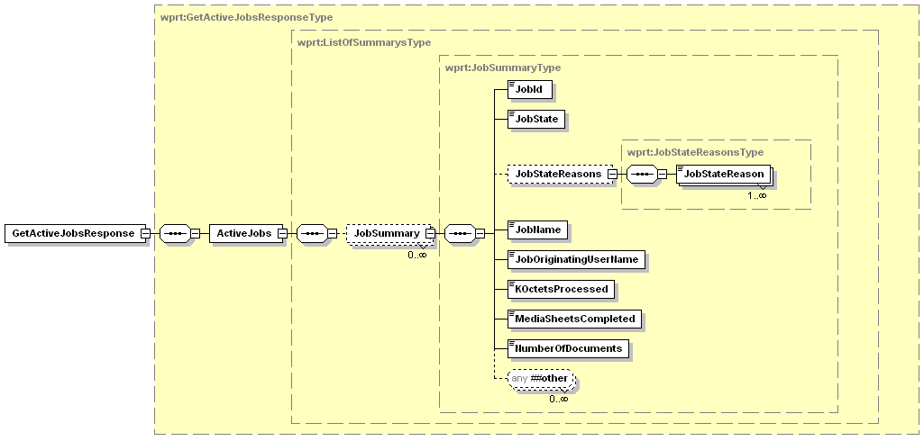
Figure 26 - GetActiveJobsResponse Elements

ActiveJobs
This data element is a collection of JobSummary elements that describe all the currently active jobs in the print device.

JobSummary
This data element collects a subset of information about a Job currently active within the print device. The individual elements are detailed in the following sections.

JobId
This data element identifies the JobId of the current job entry. This data element is described in Section 3.5.1.1

JobState
This data element is described in Section 3.5.1.2

JobStateReasons
This data element is described in Section 3.5.1.3

JobStateReason
This data element is described in Section 3.5.1.3.1

JobName
This data element is described in Section 3.5.2.1.1

JobOriginatingUserName
This data element is described in Section 3.5.2.1.2

KOctetsProcessed
This data element is described in Section 3.5.1.4

MediaSheetsCompleted
This data element is described in Section 3.5.1.5

NumberOfDocuments
This data element is described in Section 3.5.1.6

Example Request
<soap:Envelope
xmlns:soap="http://www.w3.org/2003/05/soap-envelope"
xmlns:wsa="http://schemas.xmlsoap.org/ws/2004/08/addressing"
xmlns:wprt="http://schemas.microsoft.com/windows/2006/08/wdp/print”>
<soap:Header>
<wsa:To>AddressofPrinterService</wsa:To>
<wsa:Action>
http://schemas.microsoft.com/windows/2006/08/wdp/print/GetActiveJobs
</wsa:Action>
<wsa:MessageID>uuid:UniqueMsgId</wsa:MessageID>
</soap:Header>
<soap:Body>
<wprt:GetActiveJobsRequest/>
</soap:Body>
</soap:Envelope>

Example Response – No Active Jobs
<soap:Envelope
xmlns:soap="http://www.w3.org/2003/05/soap-envelope"
xmlns:wsa="http://schemas.xmlsoap.org/ws/2004/08/addressing"
xmlns:wprt="http://schemas.microsoft.com/windows/2006/08/wdp/print”>
<soap:Header>
<wsa:To>http://schemas.xmlsoap.org/ws/2004/08/addressing/role/anonymous</wsa:To>
<wsa:Action>
http://schemas.microsoft.com/windows/2006/08/wdp/print/GetActiveJobsResponse
</wsa:Action>
<wsa:MessageID>uuid:UniqueMsgId</wsa:MessageID>
<wsa:RelatesTo>uuid:MsgIdOfTheGetActiveJobsRequest</wsa:RelatesTo>
</soap:Header>
<soap:Body>
<wprt:GetActiveJobsResponse>
<wprt:ActiveJobs/>
</wprt:GetActiveJobsResponse>
</soap:Body>
</soap:Envelope>

Example Response – 2 Active Jobs
<soap:Envelope
xmlns:soap="http://www.w3.org/2003/05/soap-envelope"
xmlns:wsa="http://schemas.xmlsoap.org/ws/2004/08/addressing"
xmlns:wprt="http://schemas.microsoft.com/windows/2006/08/wdp/print”>
<soap:Header>
<wsa:To>http://schemas.xmlsoap.org/ws/2004/08/addressing/role/anonymous</wsa:To>
<wsa:Action>
http://schemas.microsoft.com/windows/2006/08/wdp/print/GetActiveJobsResponse
</wsa:Action>
<wsa:MessageID>uuid:UniqueMsgId</wsa:MessageID>
<wsa:RelatesTo>uuid:MsgIdOfTheGetActiveJobsRequest</wsa:RelatesTo>
</soap:Header>
<soap:Body>
<wprt:GetActiveJobsResponse>
<wprt:ActiveJobs>
<wprt:JobSummary>
<wprt:JobId>1</wprt:JobId>
<wprt:JobState>Processing</wprt:JobState>
<wprt:JobStateReasons>
<wprt:JobStateReason>JobPrinting</wprt:JobStateReason>
</wprt:JobStateReasons>
<wprt:JobName>SampleJob 1</wprt:JobName>
<wprt:JobOriginatingUserName>Joe.Smith</wprt:JobOriginatingUserName>
<wprt:KOctetsProcessed>512</wprt:KOctetsProcessed>
<wprt:MediaSheetsCompleted>3</wprt:MediaSheetsCompleted>
<wprt:NumberOfDocuments>2</wprt:NumberOfDocuments>
</wprt:JobSummary>
<wprt:JobSummary>
<wprt:JobId>2</wprt:JobId>
<wprt:JobState>Pending</wprt:JobState>
<wprt:JobName>Sample Job 2</wprt:JobName>
<wprt:JobOriginatingUserName>Joe.Smith</wprt:JobOriginatingUserName>
<wprt:KOctetsProcessed>0</wprt:KOctetsProcessed>
<wprt:MediaSheetsCompleted>0</wprt:MediaSheetsCompleted>
<wprt:NumberOfDocuments>1/wprt:NumberOfDocuments>
</wprt:JobSummary>
</wprt:ActiveJobs>
</wprt:GetActiveJobsResponse>
</soap:Body>
</soap:Envelope>

Errors
All the Codes described in section 5.1.1 - Common Operation Error Codes could be retuned from this operation.

GetJobHistory
The GetJobHistory operation allows a client (CP) to retrieve a list containing a summary of job-related variables for previously completed jobs. The list of Jobs returned contains information such as the JobId, JobOriginatingUserName and the JobName. The number of jobs saved in the JobHistory table is device dependent. To retrieve more detailed information on a Job use the GetJobElements operation (section 5.7).

Response Elements
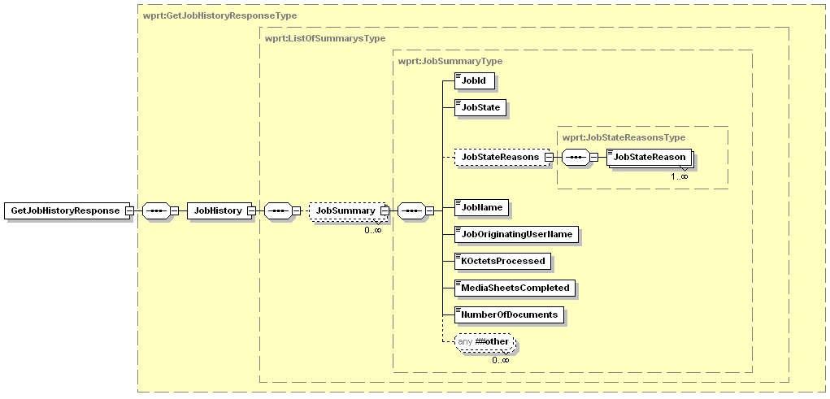
Figure 27 - GetJobHistoryResponse Elements

JobHistory
This data element is a collection of JobSummary elements that describes the most recently completed jobs in the print device.

JobSummary
This data element collects a subset of information about a recently completed Job within the print device. This data element is described in Section 5.8.1.1.1.

Example Request
<soap:Envelope
xmlns:soap="http://www.w3.org/2003/05/soap-envelope"
xmlns:wsa="http://schemas.xmlsoap.org/ws/2004/08/addressing"
xmlns:wprt="http://schemas.microsoft.com/windows/2006/08/wdp/print”>
<soap:Header>
<wsa:To>AddressofPrinterService</wsa:To>
<wsa:Action>
http://schemas.microsoft.com/windows/2006/08/wdp/print/GetJobHistory
</wsa:Action>
<wsa:MessageID>uuid:UniqueMsgId</wsa:MessageID>
</soap:Header>
<soap:Body>
<wprt:GetJobHistoryRequest/>
</soap:Body>
</soap:Envelope>

Example Response – No Job History
<soap:Envelope
xmlns:soap="http://www.w3.org/2003/05/soap-envelope"
xmlns:wsa="http://schemas.xmlsoap.org/ws/2004/08/addressing"
xmlns:wprt="http://schemas.microsoft.com/windows/2006/08/wdp/print”>
<soap:Header>
<wsa:To>http://schemas.xmlsoap.org/ws/2004/08/addressing/role/anonymous</wsa:To>
<wsa:Action>
http://schemas.microsoft.com/windows/2006/08/wdp/print/GetJobHistoryResponse
</wsa:Action>
<wsa:MessageID>uuid:UniqueMsgId</wsa:MessageID>
<wsa:RelatesTo>uuid:MsgIdOfTheGetJobHistoryRequest</wsa:RelatesTo>
</soap:Header>
<soap:Body>
<wprt:GetJobHistoryResponse>
<wprt:JobHistory/>
</wprt:GetJobHistoryResponse>
</soap:Body>
</soap:Envelope>

Example Response – 2 Completed Jobs
<soap:Envelope
xmlns:soap="http://www.w3.org/2003/05/soap-envelope"
xmlns:wsa="http://schemas.xmlsoap.org/ws/2004/08/addressing"
xmlns:wprt="http://schemas.microsoft.com/windows/2006/08/wdp/print”>
<soap:Header>
<wsa:To>http://schemas.xmlsoap.org/ws/2004/08/addressing/role/anonymous</wsa:To>
<wsa:Action>
http://schemas.microsoft.com/windows/2006/08/wdp/print/GetJobHistoryResponse
</wsa:Action>
<wsa:MessageID>uuid:UniqueMsgId</wsa:MessageID>
<wsa:RelatesTo>uuid:MsgIdOfTheGetJobHistoryRequest</wsa:RelatesTo>
</soap:Header>
<soap:Body>
<wprt:GetJobHistoryResponse>
<wprt:JobHistory>
<wprt:JobSummary>
<wprt:JobId>1</wprt:JobId>
<wprt:JobState>Completed</wprt:JobState>
<wprt:JobStateReasons>
<wprt:JobStateReason>JobCompletedSuccessfully</wprt:JobStateReason>
</wprt:JobStateReasons>
<wprt:JobName>SampleJob 1</wprt:JobName>
<wprt:JobOriginatingUserName>Joe Smith</wprt:JobOriginatingUserName>
<wprt:KOctetsProcessed>789</wprt:KOctetsProcessed>
<wprt:MediaSheetsCompleted>5</wprt:MediaSheetsCompleted>
<wprt:NumberOfDocuments>2</wprt:NumberOfDocuments>
</wprt:JobSummary>
<wprt:JobSummary>
<wprt:JobId>2</wprt:JobId>
<wprt:JobState>Aborted</wprt:JobState>
<wprt:JobStateReasons>
<wprt:JobStateReason>DocumentFormatError</wprt:JobStateReason>
</wprt:JobStateReasons>
<wprt:JobName>Sample Job 2</wprt:JobName>
<wprt:JobOriginatingUserName>Joe Smith</wprt:JobOriginatingUserName>
<wprt:KOctetsProcessed>0</wprt:KOctetsProcessed>
<wprt:MediaSheetsCompleted>0</wprt:MediaSheetsCompleted>
<wprt:NumberOfDocuments>1</wprt:NumberOfDocuments>
</wprt:JobSummary>
</wprt:JobHistory>
</wprt:GetJobHistoryResponse>
</soap:Body>
</soap:Envelope>

Errors
All the Codes described in section 5.1.1 - Common Operation Error Codes could be returned from this operation.

SetEventRate
This operation allows a client to set the minimum time in seconds the printer should wait between sending CompleteState type of events. See section 4.2 for a description of this category of events.

Request Elements
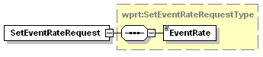
Figure 28 - SetEventRateRequest Elements

EventRate
This data element contains the amount of time to wait between sending occurrences of CompleteState events. This value is in seconds. This value sets a new global event rate for all CompleteState type of events.

Values: 1 – 600
Default Value: 1

Example Request
<soap:Envelope
xmlns:soap="http://www.w3.org/2003/05/soap-envelope"
xmlns:wsa="http://schemas.xmlsoap.org/ws/2004/08/addressing"
xmlns:wprt="http://schemas.microsoft.com/windows/2006/08/wdp/print”>
<soap:Header>
<wsa:To>AddressofPrinterService</wsa:To>
<wsa:Action>
http://schemas.microsoft.com/windows/2006/08/wdp/print/SetEventRate
</wsa:Action>
<wsa:MessageID>uuid:UniqueMsgId</wsa:MessageID>
</soap:Header>
<soap:Body>
<wprt:SetEventRateRequest>
<wprt:EventRate>3</wprt:EventRate>
</wprt:SetEventRateRequest>
</soap:Body>
</soap:Envelope>

Example Response
<soap:Envelope
xmlns:soap="http://www.w3.org/2003/05/soap-envelope"
xmlns:wsa="http://schemas.xmlsoap.org/ws/2004/08/addressing"
xmlns:wprt="http://schemas.microsoft.com/windows/2006/08/wdp/print”
soap:encodingStyle='http://www.w3.org/2002/12/soap-encoding' >
<soap:Header>
<wsa:To>http://schemas.xmlsoap.org/ws/2004/08/addressing/role/anonymous</wsa:To>
<wsa:Action>
http://schemas.microsoft.com/windows/2006/08/wdp/print/SetEventRateResponse
</wsa:Action>
<wsa:MessageID>uuid:UniqueMsgId</wsa:MessageID>
<wsa:RelatesTo>uuid:MsgIdOfTheSetEventRateRequest</wsa:RelatesTo>
</soap:Header>
<soap:Body>
<wprt:SetEventRateResponse/>
</soap:Body>
</soap:Envelope>

Errors
All the Codes described in section 5.1.1 - Common Operation Error Codes could be returned from this operation. The following error could also be returned from this operation.

Non-Standard Operations Implemented by a WSD Vendor
To facilitate certification, non-standard operations implemented by WSD vendors MUST be part of a new porttype that extends the porttype defined in this specification.

Theory of Operation
The WSD Printer device (‘printer’) has one REQUIRED service called PrinterService. Optional services MAY be included as illustrated in [DEVICE].
The model presented is very scalable. It is intended to allow simple users to send a job to a printer. Complex users can send a job along with detailed descriptive and processing information. Either user can be informed when the job has started printing and when it has finished printing.
In addition, a user can cancel a previously submitted job, determine the status of the printer and its jobs, and determine the default and allowed values for elements required in print job submission. Documents can be submitted for printing directly or by reference.

Jobs
The print service’s main task is to accept print jobs from clients, queue them up (if the printer is capable of handling more than one job at a time) and then print them. A job is identified by an integer, the JobId, which is allocated by the device. The [PWG5105.1] describes the rules for JobId production (1 to 2**31-1). The JobId is returned by the CreatePrintJob operation.
The set of jobs the printer has in its queue can be found by using the GetActiveJobs command.

Operations
The following operations are defined and MUST be supported by conforming PrinterService Service implementations:
- CreatePrintJob. This operation is used to create/validate a job for the printer. The allocated JobId is returned. This operation is followed by one or more SendDocument or AddDocument operations to provide the print data.
- SendDocument. This operation is used to send the data for a single print document to the printer.
- CancelJob. This can be used to cancel a job using the JobId.
- GetPrinterElelments. This operation can be used to query most of the printer elements.
- GetJobElements. This operation can be used to query some of the job elements of a specified job.
- GetActiveJobs. This operation can be used to obtain a list of all the Jobs currently active on the Printer
- GetJobHistory. This operation can be used to obtain a list of the most recently completed Jobs on the Printer. Each job listed will contain the JobState and updated info about the job when it finished.
- SetEventRate. This operation is used to control the rate CompleteState type events are generated by the device.
The following operation is defined and MAY be supported by conforming PrinterService Service implementations:
- AddDocument. This operation is used to submit a document to the printer using a reference URL.

Events
The primary goals of this specification are to allow a user to know the configuration of a print device, the status of a print device and when their print job has started and when it has finished. The [DEVICE] eventing mechanism can be used for this purpose. There are six events defined in this specification. Each serves a purpose for keeping the CP informed of the device and job states. A client implementation SHOULD therefore subscribe to events from the print service in order to monitor the device and/or the progress of a job. A CP can keep track of the device configuration by subscribing to the PrinterElementsChangeEvent event. The Printer status can be monitored through the PrinterStatusSummaryEvent, PrintStatusConditionEvent and PrintStatusConditionClearedEvent events. A CP can determine when a particular job that it submitted has started printing by registering for the JobStatusEvent event and waiting for the JobId returned in the CreatePrintJob response. Similarly a CP can determine that a job has completed, whether successful of not, by subscribing to the JobEndStateEvent event and matching it to the JobId.

Security
[DEVICE] describes how security works in the client to device framework. Authentication and data protection are accomplished within the frameworks of the secure channel. See [DEVICE] for more details.

Localization
A WSD printer is assumed to be operating within the locale of the user. No other localization mechanism is defined for the Print Service. The CP (client) is expected to localize the well-known string values (that correspond to IPP keyword values) to the locale of its user. The CP (client) is expected to convert the enum integer values to human readable string values in the locale of the user.
- WSDL Service Description
Print Device WSDL
<wsdl:definitions xmlns:wsdl="http://schemas.xmlsoap.org/wsdl/"
xmlns:wsoap12="http://schemas.xmlsoap.org/wsdl/soap12/"
xmlns:wsdp="http://schemas.xmlsoap.org/ws/2006/02/devprof"
xmlns:wsp="http://schemas.xmlsoap.org/ws/2004/09/policy"
xmlns:wsu="http://docs.oasis-open.org/wss/2004/01/oasis-200401-wss-wssecurity-utility-1.0.xsd"
xmlns:wprt="http://schemas.microsoft.com/windows/2006/08/wdp/print"
targetNamespace="http://schemas.microsoft.com/windows/2006/08/wdp/print"
name="WSDPrintDevice">

<wsp:Policy wsu:Id="DevicePolicy">
<wsdp:Profile />
</wsp:Policy>

<wsdl:portType name="PrintDeviceType" />

<wsdl:binding name="PrinterSoapBinding" type="wprt:PrintDeviceType" >
<wsoap12:binding style="document" transport="http://schemas.xmlsoap.org/soap/http" />
<wsp:PolicyReference URI="#DevicePolicy" wsdl:required="true" />
</wsdl:binding>

</wsdl:definitions>
Printer Service WSDL
<definitions xmlns="http://schemas.xmlsoap.org/wsdl/"
xmlns:wsoap12="http://schemas.xmlsoap.org/wsdl/soap12/"
xmlns:http="http://schemas.xmlsoap.org/wsdl/http/"
xmlns:xs="http://www.w3.org/2001/XMLSchema"
xmlns:wsdp="http://schemas.xmlsoap.org/ws/2006/02/devprof"
xmlns:wsp="http://schemas.xmlsoap.org/ws/2004/09/policy"
xmlns:wsd="http://schemas.xmlsoap.org/ws/2005/04/discovery"
xmlns:wse="http://schemas.xmlsoap.org/ws/2004/08/eventing"
xmlns:wsa="http://schemas.xmlsoap.org/ws/2004/08/addressing"
xmlns:wsu="http://docs.oasis-open.org/wss/2004/01/oasis-200401-wss-wssecurity-utility-1.0.xsd"
xmlns:wprt="http://schemas.microsoft.com/windows/2006/08/wdp/print"
targetNamespace="http://schemas.microsoft.com/windows/2006/08/wdp/print"
name="WSDPrinterService">

<xs:annotation>
<xs:documentation>
WSD Printer Service Web Service Description (WSDL) file
Copyright 2005-2006 Microsoft Corporation. All rights reserved
</xs:documentation>
</xs:annotation>

<wsp:Policy wsu:Id="ServicePolicy">
<wsdp:Profile />
</wsp:Policy>

<types>
<xs:schema targetNamespace="http://schemas.microsoft.com/windows/2006/08/wdp/print">
<xs:include schemaLocation="WDPPrint.xsd"/>
</xs:schema>
</types>
<message name="CreatePrintJobRequestMsg">
<part name="body" element="wprt:CreatePrintJobRequest"/>
</message>
<message name="CreatePrintJobResponseMsg">
<part name="body" element="wprt:CreatePrintJobResponse"/>
</message>
<message name="SendDocumentRequestMsg">
<part name="body" element="wprt:SendDocumentRequest"/>
</message>
<message name="SendDocumentResponseMsg">
<part name="body" element="wprt:SendDocumentResponse"/>
</message>
<message name="AddDocumentRequestMsg">
<part name="body" element="wprt:AddDocumentRequest"/>
</message>
<message name="AddDocumentResponseMsg">
<part name="body" element="wprt:AddDocumentResponse"/>
</message>
<message name="CancelJobRequestMsg">
<part name="body" element="wprt:CancelJobRequest"/>
</message>
<message name="CancelJobResponseMsg">
<part name="body" element="wprt:CancelJobResponse"/>
</message>
<message name="GetPrinterElementsRequestMsg">
<part name="body" element="wprt:GetPrinterElementsRequest"/>
</message>
<message name="GetPrinterElementsResponseMsg">
<part name="body" element="wprt:GetPrinterElementsResponse"/>
</message>
<message name="GetJobElementsRequestMsg">
<part name="body" element="wprt:GetJobElementsRequest"/>
</message>
<message name="GetJobElementsResponseMsg">
<part name="body" element="wprt:GetJobElementsResponse"/>
</message>
<message name="GetActiveJobsRequestMsg">
<part name="body" element="wprt:GetActiveJobsRequest"/>
</message>
<message name="GetActiveJobsResponseMsg">
<part name="body" element="wprt:GetActiveJobsResponse"/>
</message>
<message name="GetJobHistoryRequestMsg">
<part name="body" element="wprt:GetJobHistoryRequest"/>
</message>
<message name="GetJobHistoryResponseMsg">
<part name="body" element="wprt:GetJobHistoryResponse"/>
</message>
<message name="SetEventRateRequestMsg">
<part name="body" element="wprt:SetEventRateRequest"/>
</message>
<message name="SetEventRateResponseMsg">
<part name="body" element="wprt:SetEventRateResponse"/>
</message>
<message name="PrinterElementsChangeEventMsg">
<part name="body" element="wprt:PrinterElementsChangeEvent"/>
</message>
<message name="PrinterStatusSummaryEventMsg">
<part name="body" element="wprt:PrinterStatusSummaryEvent"/>
</message>
<message name="PrinterStatusConditionEventMsg">
<part name="body" element="wprt:PrinterStatusConditionEvent"/>
</message>
<message name="PrinterStatusConditionClearedEventMsg">
<part name="body" element="wprt:PrinterStatusConditionClearedEvent"/>
</message>
<message name="JobStatusEventMsg">
<part name="body" element="wprt:JobStatusEvent"/>
</message>
<message name="JobEndStateEventMsg">
<part name="body" element="wprt:JobEndStateEvent"/>
</message>

<portType name="PrinterServiceType" wse:EventSource="true" >
<operation name="CreatePrintJob">
<input message="wprt:CreatePrintJobRequestMsg"
wsa:Action="http://schemas.microsoft.com/windows/2006/08/wdp/print/CreatePrintJob" />
<output message="wprt:CreatePrintJobResponseMsg"
wsa:Action="http://schemas.microsoft.com/windows/2006/08/wdp/print/CreatePrintJobResponse" />
</operation>
<operation name="SendDocument">
<input message="wprt:SendDocumentRequestMsg"
wsa:Action="http://schemas.microsoft.com/windows/2006/08/wdp/print/SendDocument" />
<output message="wprt:SendDocumentResponseMsg"
wsa:Action="http://schemas.microsoft.com/windows/2006/08/wdp/print/SendDocumentResponse" />
</operation>
<operation name="AddDocument">
<input message="wprt:AddDocumentRequestMsg"
wsa:Action="http://schemas.microsoft.com/windows/2006/08/wdp/print/AddDocument" />
<output message="wprt:AddDocumentResponseMsg"
wsa:Action="http://schemas.microsoft.com/windows/2006/08/wdp/print/AddDocumentResponse" />
</operation>
<operation name="CancelJob">
<input message="wprt:CancelJobRequestMsg"
wsa:Action="http://schemas.microsoft.com/windows/2006/08/wdp/print/CancelJob" />
<output message="wprt:CancelJobResponseMsg"
wsa:Action="http://schemas.microsoft.com/windows/2006/08/wdp/print/CancelJobResponse" />
</operation>
<operation name="GetPrinterElements">
<input message="wprt:GetPrinterElementsRequestMsg"
wsa:Action="http://schemas.microsoft.com/windows/2006/08/wdp/print/GetPrinterElements" />
<output message="wprt:GetPrinterElementsResponseMsg"
wsa:Action="http://schemas.microsoft.com/windows/2006/08/wdp/print/GetPrinterElementsResponse" />
</operation>
<operation name="GetJobElements">
<input message="wprt:GetJobElementsRequestMsg"
wsa:Action="http://schemas.microsoft.com/windows/2006/08/wdp/print/GetJobElements" />
<output message="wprt:GetJobElementsResponseMsg"
wsa:Action="http://schemas.microsoft.com/windows/2006/08/wdp/print/GetJobElementsResponse" />
</operation>
<operation name="GetActiveJobs">
<input message="wprt:GetActiveJobsRequestMsg"
wsa:Action="http://schemas.microsoft.com/windows/2006/08/wdp/print/GetActiveJobs" />
<output message="wprt:GetActiveJobsResponseMsg"
wsa:Action="http://schemas.microsoft.com/windows/2006/08/wdp/print/GetActiveJobsResponse" />
</operation>
<operation name="GetJobHistory">
<input message="wprt:GetJobHistoryRequestMsg"
wsa:Action="http://schemas.microsoft.com/windows/2006/08/wdp/print/GetJobHistory" />
<output message="wprt:GetJobHistoryResponseMsg"
wsa:Action="http://schemas.microsoft.com/windows/2006/08/wdp/print/GetJobHistoryResponse" />
</operation>
<operation name="SetEventRate">
<input message="wprt:SetEventRateRequestMsg"
wsa:Action="http://schemas.microsoft.com/windows/2006/08/wdp/print/SetEventRate" />
<output message="wprt:SetEventRateResponseMsg"
wsa:Action="http://schemas.microsoft.com/windows/2006/08/wdp/print/SetEventRateResponse" />
</operation>
<operation name="PrinterElementsChangeEvent">
<output message="wprt:PrinterElementsChangeEventMsg"
wsa:Action="http://schemas.microsoft.com/windows/2006/08/wdp/print/PrinterElementsChangeEvent" />
</operation>
<operation name="PrinterStatusSummaryEvent">
<output message="wprt:PrinterStatusSummaryEventMsg"
wsa:Action="http://schemas.microsoft.com/windows/2006/08/wdp/print/PrinterStatusSummaryEvent" />
</operation>
<operation name="PrinterStatusConditionEvent">
<output message="wprt:PrinterStatusConditionEventMsg"
wsa:Action="http://schemas.microsoft.com/windows/2006/08/wdp/print/PrinterStatusConditionEvent" />
</operation>
<operation name="PrinterStatusConditionClearedEvent">
<output message="wprt:PrinterStatusConditionClearedEventMsg"
wsa:Action="http://schemas.microsoft.com/windows/2006/08/wdp/print/PrinterStatusConditionClearedEvent" />
</operation>
<operation name="JobStatusEvent">
<output message="wprt:JobStatusEventMsg"
wsa:Action="http://schemas.microsoft.com/windows/2006/08/wdp/print/JobStatusEvent" />
</operation>
<operation name="JobEndStateEvent">
<output message="wprt:JobEndStateEventMsg"
wsa:Action="http://schemas.microsoft.com/windows/2006/08/wdp/print/JobEndStateEvent" />
</operation>

</portType>
<binding name="PrinterServiceBinding" type="wprt:PrinterServiceType">
<wsoap12:binding style="document" transport="http://schemas.xmlsoap.org/soap/http"/>
<wsp:PolicyReference URI="#ServicePolicy" />
<operation name="CreatePrintJob">
<wsoap12:operation
soapAction="http://schemas.microsoft.com/windows/2006/08/wdp/print/CreatePrintJob"
soapActionRequired="true" />
<input>
<wsoap12:body use="literal" />
</input>
<output>
<wsoap12:body use="literal" />
</output>
</operation>
<operation name="SendDocument">
<wsoap12:operation
soapAction="http://schemas.microsoft.com/windows/2006/08/wdp/print/SendDocument"
soapActionRequired="true" />
<input>
<wsoap12:body use="literal" />
</input>
<output>
<wsoap12:body use="literal" />
</output>
</operation>
<operation name="AddDocument">
<wsoap12:operation
soapAction="http://schemas.microsoft.com/windows/2006/08/wdp/print/AddDocument"
soapActionRequired="true" />
<input>
<wsoap12:body use="literal" />
</input>
<output>
<wsoap12:body use="literal" />
</output>
</operation>
<operation name="CancelJob">
<wsoap12:operation
soapAction="http://schemas.microsoft.com/windows/2006/08/wdp/print/CancelJob"
soapActionRequired="true" />
<input>
<wsoap12:body use="literal" />
</input>
<output>
<wsoap12:body use="literal" />
</output>
</operation>
<operation name="GetPrinterElements">
<wsoap12:operation
soapAction="http://schemas.microsoft.com/windows/2006/08/wdp/print/GetPrinterElements"
soapActionRequired="true" />
<input>
<wsoap12:body use="literal" />
</input>
<output>
<wsoap12:body use="literal" />
</output>
</operation>
<operation name="GetJobElements">
<wsoap12:operation
soapAction="http://schemas.microsoft.com/windows/2006/08/wdp/print/GetJobElements"
soapActionRequired="true" />
<input>
<wsoap12:body use="literal" />
</input>
<output>
<wsoap12:body use="literal" />
</output>
</operation>
<operation name="GetActiveJobs">
<wsoap12:operation
soapAction="http://schemas.microsoft.com/windows/2006/08/wdp/print/GetActiveJobs"
soapActionRequired="true" />
<input>
<wsoap12:body use="literal" />
</input>
<output>
<wsoap12:body use="literal" />
</output>
</operation>
<operation name="GetJobHistory">
<wsoap12:operation
soapAction="http://schemas.microsoft.com/windows/2006/08/wdp/print/GetJobHistory"
soapActionRequired="true" />
<input>
<wsoap12:body use="literal" />
</input>
<output>
<wsoap12:body use="literal" />
</output>
</operation>
<operation name="SetEventRate">
<wsoap12:operation
soapAction="http://schemas.microsoft.com/windows/2006/08/wdp/print/SetEventRate"
soapActionRequired="true" />
<input>
<wsoap12:body use="literal" />
</input>
<output>
<wsoap12:body use="literal" />
</output>
</operation>
<operation name="PrinterElementsChangeEvent">
<wsoap12:operation
soapAction="http://schemas.microsoft.com/windows/2006/08/wdp/print/PrinterElementsChangeEvent"
soapActionRequired="true" />
<output>
<wsoap12:body use="literal" />
</output>
</operation>
<operation name="PrinterStatusSummaryEvent">
<wsoap12:operation
soapAction="http://schemas.microsoft.com/windows/2006/08/wdp/print/PrinterStatusSummaryEvent"
soapActionRequired="true" />
<output>
<wsoap12:body use="literal" />
</output>
</operation>
<operation name="PrinterStatusConditionEvent">
<wsoap12:operation
soapAction="http://schemas.microsoft.com/windows/2006/08/wdp/print/PrinterStatusConditionEvent"
soapActionRequired="true" />
<output>
<wsoap12:body use="literal" />
</output>
</operation>
<operation name="PrinterStatusConditionClearedEvent">
<wsoap12:operation
soapAction="http://schemas.microsoft.com/windows/2006/08/wdp/print/PrinterStatusConditionClearedEvent"
soapActionRequired="true" />
<output>
<wsoap12:body use="literal" />
</output>
</operation>
<operation name="JobStatusEvent">
<wsoap12:operation
soapAction="http://schemas.microsoft.com/windows/2006/08/wdp/print/JobStatusEvent"
soapActionRequired="true" />
<output>
<wsoap12:body use="literal" />
</output>
</operation>
<operation name="JobEndStateEvent">
<wsoap12:operation
soapAction="http://schemas.microsoft.com/windows/2006/08/wdp/print/JobEndStateEvent"
soapActionRequired="true" />
<output>
<wsoap12:body use="literal" />
</output>
</operation>

</binding>
<service name="PrinterService">
<port name="PrinterPort" binding="wprt:PrinterServiceBinding">
<wsoap12:address location="http://localhost/PrinterService/"/>
</port>
</service>
</definitions>
- Windows Vista™ Support Requirements

PnP-X installation support
Installation of WSD Print devices on Windows Vista™ takes advantage of a new feature called PNP-X. This enables networked devices to take part in the normal PnP experience just like locally connected devices. To enable this support a device that complies with [DEVICE] needs to add a specific XML element to their Relationship section of the Device Metadata. This element will allow the inbox WSD Print device driver to be loaded and kick off the install process for the WSD Print device and the correct printer driver.
Within the extensiability area of the wsdp:Relationship/wsdp:Hosted element the metadata should include a CompatibleId element as defined in [PNPX].

PnP-X Namespace
The current required namespace for all PnP-X related elements is: http://schemas.microsoft.com/windows/pnpx/2005/10

PnP-X CompatibleId definition and value
The current definition of the CompatibleId element is:
<xs:element name="CompatibleId" type="tns:CompatibleIdType" >
<xs:annotation>
<xs:documentation xml:lang="en" >
Used as the Compatible ID for INF file matching for devices. The length
of this string must not exceed 196 wide characters (392 bytes). To specify
more than one CompatibleID, separate them with a space character. For example:
PnPX_SampleService_CPID_1 PnPX_SampleService_CPID_2 PnPX_SampleService1_CPID_3
</xs:documentation>
</xs:annotation>
</xs:element>
<xs:simpleType name="CompatibleIdType" >
<xs:list itemType="xs:string" />
</xs:simpleType>

The value of this field in a supported Metadata section is: http://schemas.microsoft.com/windows/2006/08/wdp/print/PrinterServiceType

Sample Device Metadata response
<mex:MetadataSection Dialect="http://schemas.xmlsoap.org/ws/2006/02/devprof/Relationship">
<wsdp:Relationship Type="http://schemas.xmlsoap.org/ws/2006/02/devprof/host">
<wsdp:Hosted>
<wsa:EndpointReference>
.
.
.
</wsa:EndpointReference>
<wsdp:Types xmlns:wprt="http://schemas.microsoft.com/windows/2006/08/wdp/print">
wprt:PrinterServiceType
</wsdp:Types>
<wsdp:ServiceId>
.
</wsdp:ServiceId>
<pnpx:CompatibleId xmlns:pnpx="http://schemas.microsoft.com/windows/pnpx/2005/10">
http://schemas.microsoft.com/windows/2006/08/wdp/print/PrinterServiceType
</pnpx:CompatibleId>
</wsdp:Hosted>
</wsdp:Relationship>
</mex:MetadataSection>

Network Explorer category support
Another new feature of Windows Vista™ is the Network Explorer. This is a folder that can be used to discover and install network connected devices such as WSD capable printers & scanners. To improve the usability of the Network Explorer every device that is discovered can have belong to one or more Category(s). The way to indicate what category(s) a device belongs to is by adding one or more DeviceCategory elements to the device wsdp:ThisModel metadata section. The primary category for the device is equal to the first DeviceCategory element found. Each successive DeviceCategory element will be considered a secondary category. For more information on the definition of the device categories see [PNPX].
Each device should include the DeviceCategory element(s) as defined in [PNPX] within the extensiability area of the wsdp:ThisModel metadata section

PnP-X Namespace
The current required namespace for all PNP-X related elements is: http://schemas.microsoft.com/windows/pnpx/2005/10

PnP-X Category definition and value
The current definition of the DeviceCategory element is:
<xs:element name="DeviceCategory" type="tns:DeviceCategoryType" >
<xs:annotation>
<xs:documentation>
Used to identify the PnP-X category to which the device belongs. The device
categories are strings which are defined in the DeviceCategory section
of [PNPX]. To specify more than one device category, separate them with a
space character.
For example: Printers Storage
identifies a device with a primary category of Printers and a secondary
category of Storage. Devices can also specify a device subcategory for
a more descriptive device category.
For example: Displays.Television MediaDevices.DVR
identifies a device which is a Television and a Digital Video recorder.
The primary device category for this device would be Displays.
</xs:documentation>
</xs:annotation>
</xs:element>
<xs:simpleType name="DeviceCategoryType" >
<xs:list itemType="xs:string" />
</xs:simpleType>

Sample Device Metadata response
<mex:MetadataSection Dialect="http://schemas.xmlsoap.org/ws/2006/02/devprof/ThisModel">
<wsdp:ThisModel>
<wsdp:Manufacturer xml:lang="en">..</wsdp:Manufacturer>
<wsdp:ManufacturerUrl>..</wsdp:ManufacturerUrl>
<wsdp:ModelName xml:lang="en">..</wsdp:ModelName>
<wsdp:ModelNumber>..</wsdp:ModelNumber>
<pnpx:DeviceCategory>Printers</pnpx:DeviceCategory>
</wsdp:ThisModel>
</mex:MetadataSection>

Print Device discoverability in the Add Network Printer Wizard
The Add Network Printer Wizard is a new feature in Windows Vista™ that will allow a user/admin to search for WSD Print devices locally and also to discover and install a WSD Print device located on a more distant subnet. Searching for local devices takes advantage of the Multicast capabilities of [DISCOVERY] while the discovery of a distant device used the Unicast, or directed discovery capabilities.
Requirements to support each discovery method are explained in detail in the following sections.

Local subnet Discovery support
To advertise support for a particular service type a device includes a Print Device porttype in the wsdisco:Types element of the wsdisco:Hello and wsdisco:ProbeMatches messages. The porttype is defined in the same namespace as the WSD Printer Service.

WSD Print Namespace
The current namespace for WSD Print related elements is: http://schemas.microsoft.com/windows/2006/08/wdp/print

WSD Print Device porttype
The Device Type is defined as: “PrintDeviceType”.

Device Hello example
<?xml version="1.0" encoding="utf-8"?>
<soap:Envelope xmlns:soap="http://www.w3.org/2003/05/soap-envelope"
xmlns:wsa="http://schemas.xmlsoap.org/ws/2004/08/addressing"
xmlns:wsdisco="http://schemas.xmlsoap.org/ws/2005/04/discovery"
xmlns:wsdp=”http://schemas.xmlsoap.org/ws/2006/02/devprof”
xmlns:wprt="http://schemas.microsoft.com/windows/2006/08/wdp/print">
<soap:Header>
<wsa:MessageID>urn:uuid:ac8523ee-6813-498c-8c1b-6272a22353f7</wsa:MessageID>
<wsa:Action>
http://schemas.xmlsoap.org/ws/2005/04/discovery/Hello
</wsa:Action>
<wsa:To>urn:schemas-xmlsoap-org:ws:2005:04:discovery</wsa:To>
<wsdisco:AppSequence InstanceId="3094203799" MessageNumber="1" />
</soap:Header>
<soap:Body>
<wsdisco:Hello>
<wsa:EndpointReference>
<wsa:Address>uuid:D10000D1-ca45-5fee-a376-112233445555</wsa:Address>
</wsa:EndpointReference>
<wsdisco:Types>wsdp:Device wprt:PrintDeviceType</wsdisco:Types>
<wsdisco:XAddrs>http://IPAddress:80/TestDevice</wsdisco:XAddrs>
<wsdisco:MetadataVersion>1</wsdisco:MetadataVersion>
</wsdisco:Hello>
</soap:Body>
</soap:Envelope>

Device ProbeMatches example
<?xml version="1.0" encoding="utf-8"?>
<soap:Envelope xmlns:soap="http://www.w3.org/2003/05/soap-envelope"
xmlns:wsa="http://schemas.xmlsoap.org/ws/2004/08/addressing"
xmlns:wsdisco="http://schemas.xmlsoap.org/ws/2005/04/discovery"
xmlns:wsdp=”http://schemas.xmlsoap.org/ws/2006/02/devprof”
xmlns:wprt="http://schemas.microsoft.com/windows/2006/08/wdp/print">
<soap:Header>
<wsa:MessageID>urn:uuid:147823ee-83f7-498c-8c1b-6272a22353f7</wsa:MessageID>
<wsa:RelatesTo>urn:uuid:0a6dc791-2be6-4991-9af1-454778a1917a</wsa:RelatesTo>
<wsa:Action>
http://schemas.xmlsoap.org/ws/2005/04/discovery/ProbeMatches
</wsa:Action>
<wsa:To>http://schemas.xmlsoap.org/ws/2004/08/addressing/role/anonymous</wsa:To>
<wsdisco:AppSequence InstanceId="3094203799" MessageNumber="2" />
</soap:Header>
<soap:Body>
<wsdisco:ProbeMatches>
<wsdisco:ProbeMatch>
<wsa:EndpointReference>
<wsa:Address>uuid:D10000D1-ca45-5fee-a376-112233445555</wsa:Address>
</wsa:EndpointReference>
<wsdisco:Types>wsdp:Device wprt:PrintDeviceType</wsdisco:Types>
<wsdisco:XAddrs>http://IPAddress:80/TestDevice</wsdisco:XAddrs>
<wsdisco:MetadataVersion>1</wsdisco:MetadataVersion>
</wsdisco:ProbeMatch>
</wsdisco:ProbeMatches>
</soap:Body>
</soap:Envelope>

Directed Discovery support
A stable discovery URL is needed to enable a Windows Vista™ admin to easily discover a device in an enterprise environment. Having a defined URL allows the Add Network Printer Wizard to simply ask for the Hostname or IP Address of the device and then create the stable URL which a device will be listening at for a Probe message via HTTP. This also allows the device to listen at a single URL for discovery messages over HTTP.

Unsecured Directed Discovery URL
http://IPAddressOrHostname:80/StableWSDiscoveryEndpoint/schemas-xmlsoap-org_ws_2005_04_discovery

Secure Directed Discovery URL
https://IPAddressOrHostname:443/StableWSDiscoveryEndpoint/schemas-xmlsoap-org_ws_2005_04_discovery
- Supporting WS-Print V1.1

WS-Print V1.1
WS-Print V1.1 adds a number of new schema elements to the current WS-Print V1.0 service specification. The basic operation of a WS-Print V1.0 print device is not changed at all, but the data that can be returned as part of WS-Print V1.1 has been augmented. WS-Print V1.1 provides new elements that indicate the device supports WS-Print V1.1, that define a new ModelId field, that contain the GPD and/or PPD files that describe the print device and also a new numerical color representation of an ink/toner supply to allow a client UI to better reflect the color of the ink/toner.

WS-Print V1.1 Namespace
All of the new schema elements are defined in the following new namespace:
http://schemas.microsoft.com/windows/2010/06/wdp/printv11

WS-Print V1.1 Schema elements
The following new elements are defined in WS-Print V1.1 namespace.

SupportsWSPrintv11
This element indicates the current WS-Print device supports the new schemas/elements defined in the updated WS-Print V1.1 specification. The value of this xs:boolean type is used to determine if the device supports the new schema elements. A value of "true" or 1 means the device does support the new WS-Print V1.1 schema extensions.
This element is only expected as part of the PrinterDescription element of a WS-Print V1.1 print device.
Allowed Values: 0, 1, false, true
Schema Definition:
<xs:annotation>
<xs:documentation>
A Boolean element that denotes support for WS-Print V1.1 extensions
</xs:documentation>
</xs:annotation>
<xs:element name="SupportsWSPrintv11" type="xs:boolean"/>

DeviceModelId
This element defines a new value that can be used to differentiate a particular device model within a family of devices from a hardware vendor. This allows a printer driver created for a family of devices to determine exactly which of the supported models this device represents. The format of this value is a GUID without surrounding braces.
This element is only expected as part of the PrinterDescription element of a WS-Print V1.1 print device.
Allowed Values: any properly defined GUID value
Schema Definition:
<xs:annotation>
<xs:documentation> Print Device Model Id value for device differentiation</xs:documentation>
<xs:documentation> Always represented as a GUID</xs:documentation>
</xs:annotation>
<xs:element name="DeviceModelId" type="wprt11:DeviceModelIdGuidType"/>
<xs:simpleType name="DeviceModelIdGuidType">
<xs:restriction base="xs:string">
<xs:length value="36"/>
</xs:restriction>
</xs:simpleType>

DriverConfiguration
This element contains one or two device configuration strings that represent the GPD or PPD configuration files for the WS-Print device. These configuration files can be used by a Printer Driver on the client computer to configure the driver properties to accurately reflect the configuration and capabilities of the attached WS-Print device. The device can return either a GPD string, a PPD string or both.
This element must be supported as a new QName requestable as part of a GetPrinterElements operation. This element should be equivalent to PrinterDescription or PrinterConfiguration within the WS-Print schema hierarchy.
Schema Definition:
<xs:annotation>
<xs:documentation>Driver Configuration File definition</xs:documentation>
</xs:annotation>
<xs:element name="DriverConfiguration" type="wprt11:DriverConfigurationType"/>
<xs:complexType name="DriverConfigurationType">
<xs:sequence>
<xs:element name="GPDConfigFile" type="xs:string" minOccurs="0" />
<xs:element name="PPDConfigFile" type="xs:string" minOccurs="0" />
<xs:any namespace="##other" minOccurs="0" maxOccurs="unbounded"/>
</xs:sequence>
<xs:anyAttribute namespace="##other" processContents="lax" />
</xs:complexType>

GPDConfigFile
This element contains the GPD configuration file for use by a printer driver on the client computer. This allows a device to be self describing to a printer client that under stands the GPD file type.
This element is only expected as part of the DriverConfiguration element of a WS-Print V1.1 print device.
Schema Definition:
<xs:element name="GPDConfigFile" type="xs:string" minOccurs="0" />

PPDConfigFile
This element contains the PPD configuration file for use by a printer driver on the client computer. This allows a device to be self describing to a printer client that under stands the postscript PPD file type.
This element is only expected as part of the DriverConfiguration element of a WS-Print V1.1 print device.
Schema Definition:
<xs:element name="PPDConfigFile" type="xs:string" minOccurs="0" />

ColorRepresentation
This element defines a 6-digit hexadecimal representation of the RGB color value for a consumeable. This value can be used by application interfaces on the client computer to show a reasonable likeness of the color produced by the ink/toner entry specified.
Examples of these values are:
- Black – 000000
- Red – FF0000
- White – FFFFFF
- Magenta – FF00FF
- Cyan – 00FFFF
- Yellow – FFFF00
- Blue – 0000FF
This element is only expected as part of the ConsumableEntry element of a WS-Print V1.1 print device.

Schema Definition:
<xs:annotation>
<xs:documentation>
Ink/Toner Color Representation definition
A 6-digit hex representation of the RGB color value this Consumable entry represents.
Examples of these values are:
Black – 000000
Red – FF0000
White – FFFFFF
Magenta – FF00FF
Cyan – 00FFFF
Yellow – FFFF00
Blue – 0000FF
</xs:documentation>
</xs:annotation>
<xs:element name="ColorRepresentation" type="wprt11:ColorRepType"/>
<xs:simpleType name="ColorRepType">
<xs:restriction base="xs:string">
<xs:length value="6"/>
</xs:restriction>
</xs:simpleType>

Backwards Compatibilty
The new WS-Print V1.1 elements are added at a number of the extensibility points built into the WS-Print V1.0 schema to allow for future expansion. This allows current WS-Print V1.0 clients to work with both V1.0 & V1.1 devices. The new capabilities/elements will just be ignored by the V1.0 clients. And newer V1.1 clients will still be able to interact with V1.0 devices, there will just be no support for the new V1.1 elements.
To support backwards compatibility a WS-Print V1.1 device will indicatate support for V1.1 by returning the SupportsWSPrintv11 schema element in the V1.0 PrinterDecsription field. All clients that only understand WS-Print V1.0 will ignore the new fields and not request any of the new information, WS-Print V1.1 capable clients will recognize the new elements and process the data appropriately.

WS-Print V1.1 Request/Response examples
An example of a PrinterDescription element for a WS-Print V1.1 device is as follows:

Example Request - PrinterDescription
<soap:Envelope
xmlns:soap="http://www.w3.org/2003/05/soap-envelope"
xmlns:wsa="http://schemas.xmlsoap.org/ws/2004/08/addressing"
xmlns:wprt="http://schemas.microsoft.com/windows/2006/08/wdp/print">
<soap:Header>
<wsa:To>AddressofPrinterService</wsa:To>
<wsa:Action>
http://schemas.microsoft.com/windows/2006/08/wdp/print/GetPrinterElements
</wsa:Action>
<wsa:MessageID>uuid:UniqueMsgId</wsa:MessageID>
</soap:Header>
<soap:Body>
<wprt:GetPrinterElementsRequest>
<wprt:RequestedElements>
<wprt:Name>wprt:PrinterDescription</wprt:Name>
</wprt:RequestedElements>
</wprt:GetPrinterElementsRequest>
</soap:Body>
</soap:Envelope>

Example Response – PrinterDescription supports WS-Print v1.1
<soap:Envelope
xmlns:soap="http://www.w3.org/2003/05/soap-envelope"
xmlns:wsa="http://schemas.xmlsoap.org/ws/2004/08/addressing"
xmlns:wprt="http://schemas.microsoft.com/windows/2006/08/wdp/print"
xmlns:wprtv11="http://schemas.microsoft.com/windows/2010/06/wdp/printv11">
<soap:Header>
<wsa:To>http://schemas.xmlsoap.org/ws/2004/08/addressing/role/anonymous</wsa:To>
<wsa:Action>
http://schemas.microsoft.com/windows/2006/08/wdp/print/GetPrinterElementsResponse
</wsa:Action>
<wsa:MessageID>uuid:UniqueMsgId</wsa:MessageID>
<wsa:RelatesTo>uuid:MsgIdOfTheGetPrinterElementsRequest</wsa:RelatesTo>
</soap:Header>
<soap:Body>
<wprt:GetPrinterElementsResponse>
<wprt:PrinterElements>
<wprt:ElementData Name="wprt:PrinterDescription" Valid="true">
<wprt:PrinterDescription>
<wprt:ColorSupported>true</wprt:ColorSupported>
<wprt:DeviceId>MFG:Acme;MDL:PrintMaster 9020</wprt:DeviceId>
<wprt:MultipleDocumentJobsSupported>true</wprt:MultipleDocumentJobsSupported>
<wprt:PagesPerMinute>20</wprt:PagesPerMinute>
<wprt:PagesPerMinuteColor>8</wprt:PagesPerMinuteColor>
<wprt:PrinterName xml:lang="en-AU, en-CA, en-GB, en-US">
Accounting Printer in Copy Room 2
</wprt:PrinterName>
<wprt:PrinterInfo xml:lang="en-AU, en-CA, en-GB, en-US">
Printer for use of Accounting only
</wprt:PrinterInfo>
<wprt:PrinterLocation xml:lang="en-AU, en-CA, en-GB, en-US">
LA Campus – Building 3
</wprt:PrinterLocation>
<wprtv11:SupportsWSPrintv11>true</wprtv11:SupportsWSPrintv11>
</wprt:PrinterDescription>
</wprt:ElementData>
</wprt:PrinterElements>
</wprt:GetPrinterElementsResponse>
</soap:Body>
</soap:Envelope>

Example Response – PrinterDescription supports WS-Print v1.1and Device Model Id
<soap:Envelope
xmlns:soap="http://www.w3.org/2003/05/soap-envelope"
xmlns:wsa="http://schemas.xmlsoap.org/ws/2004/08/addressing"
xmlns:wprt="http://schemas.microsoft.com/windows/2006/08/wdp/print"
xmlns:wprtv11="http://schemas.microsoft.com/windows/2010/06/wdp/printv11">
<soap:Header>
<wsa:To>http://schemas.xmlsoap.org/ws/2004/08/addressing/role/anonymous</wsa:To>
<wsa:Action>
http://schemas.microsoft.com/windows/2006/08/wdp/print/GetPrinterElementsResponse
</wsa:Action>
<wsa:MessageID>uuid:UniqueMsgId</wsa:MessageID>
<wsa:RelatesTo>uuid:MsgIdOfTheGetPrinterElementsRequest</wsa:RelatesTo>
</soap:Header>
<soap:Body>
<wprt:GetPrinterElementsResponse>
<wprt:PrinterElements>
<wprt:ElementData Name="wprt:PrinterDescription" Valid="true">
<wprt:PrinterDescription>
<wprt:ColorSupported>true</wprt:ColorSupported>
<wprt:DeviceId>MFG:Acme;MDL:PrintMaster 9020</wprt:DeviceId>
<wprt:MultipleDocumentJobsSupported>true</wprt:MultipleDocumentJobsSupported>
<wprt:PagesPerMinute>20</wprt:PagesPerMinute>
<wprt:PagesPerMinuteColor>8</wprt:PagesPerMinuteColor>
<wprt:PrinterName xml:lang="en-AU, en-CA, en-GB, en-US">
Accounting Printer in Copy Room 2
</wprt:PrinterName>
<wprt:PrinterInfo xml:lang="en-AU, en-CA, en-GB, en-US">
Printer for use of Accounting only
</wprt:PrinterInfo>
<wprt:PrinterLocation xml:lang="en-AU, en-CA, en-GB, en-US">
LA Campus – Building 3
</wprt:PrinterLocation>
<wprtv11:SupportsWSPrintv11>true</wprtv11:SupportsWSPrintv11>
<wprtv11:DeviceModelId>
GUID
</wprtv11:DeviceModelId>
</wprt:PrinterDescription>
</wprt:ElementData>
</wprt:PrinterElements>
</wprt:GetPrinterElementsResponse>
</soap:Body>
</soap:Envelope>
An example of a DriverConfiguration element for a WS-Print V1.1 device is as follows:

Example Request - DriverConfiguration
<soap:Envelope
xmlns:soap="http://www.w3.org/2003/05/soap-envelope"
xmlns:wsa="http://schemas.xmlsoap.org/ws/2004/08/addressing"
xmlns:wprt="http://schemas.microsoft.com/windows/2006/08/wdp/print"
xmlns:wprtv11="http://schemas.microsoft.com/windows/2010/06/wdp/printv11">
<soap:Header>
<wsa:To>AddressofPrinterService</wsa:To>
<wsa:Action>
http://schemas.microsoft.com/windows/2006/08/wdp/print/GetPrinterElements
</wsa:Action>
<wsa:MessageID>uuid:UniqueMsgId</wsa:MessageID>
</soap:Header>
<soap:Body>
<wprt:GetPrinterElementsRequest>
<wprt:RequestedElements>
<wprt:Name>wprtv11:DriverConfiguration</wprt:Name>
</wprt:RequestedElements>
</wprt:GetPrinterElementsRequest>
</soap:Body>
</soap:Envelope>

Example Response – DriverConfiguration with only a PPD config file
<soap:Envelope
xmlns:soap="http://www.w3.org/2003/05/soap-envelope"
xmlns:wsa="http://schemas.xmlsoap.org/ws/2004/08/addressing"
xmlns:wprt="http://schemas.microsoft.com/windows/2006/08/wdp/print"
xmlns:wprtv11="http://schemas.microsoft.com/windows/2010/06/wdp/printv11">
<soap:Header>
<wsa:To>http://schemas.xmlsoap.org/ws/2004/08/addressing/role/anonymous</wsa:To>
<wsa:Action>
http://schemas.microsoft.com/windows/2006/08/wdp/print/GetPrinterElementsResponse
</wsa:Action>
<wsa:MessageID>uuid:UniqueMsgId</wsa:MessageID>
<wsa:RelatesTo>uuid:MsgIdOfTheGetPrinterElementsRequest</wsa:RelatesTo>
</soap:Header>
<soap:Body>
<wprt:GetPrinterElementsResponse>
<wprt:PrinterElements>
<wprt:ElementData Name="wprtv11:DriverConfiguration" Valid="true">
<wprtv11:DriverConfiguration>
<wprtv11:PPDConfigFile>
Text of the PPD file for this device
</wprtv11:PPDConfigFile>
</wprtv11:DriverConfiguration>
</wprt:ElementData>
</wprt:PrinterElements>
</wprt:GetPrinterElementsResponse>
</soap:Body>
</soap:Envelope>

An example of a PrinterConfiguration element for a WS-Print V1.1 device is as follows: Example Request - PrinterConfiguration
<soap:Envelope
xmlns:soap="http://www.w3.org/2003/05/soap-envelope"
xmlns:wsa="http://schemas.xmlsoap.org/ws/2004/08/addressing"
xmlns:wprt="http://schemas.microsoft.com/windows/2006/08/wdp/print"
soap:encodingStyle='http://www.w3.org/2002/12/soap-encoding'>
<soap:Header>
<wsa:To>AddressofPrinterService</wsa:To>
<wsa:Action>
http://schemas.microsoft.com/windows/2006/08/wdp/print/GetPrinterElements
</wsa:Action>
<wsa:MessageID>uuid:UniqueMsgId</wsa:MessageID>
</soap:Header>
<soap:Body>
<wprt:GetPrinterElementsRequest>
<wprt:RequestedElements>
<wprt:Name>wprt:PrinterConfiguration</wprt:Name>
</wprt:RequestedElements>
</wprt:GetPrinterElementsRequest >
</soap:Body>
</soap:Envelope>

Example Response – PrinterConfiguration with ColorRepresentation
<soap:Envelope
xmlns:soap="http://www.w3.org/2003/05/soap-envelope"
xmlns:wsa="http://schemas.xmlsoap.org/ws/2004/08/addressing"
xmlns:wprt="http://schemas.microsoft.com/windows/2006/08/wdp/print"
xmlns:wprtv11="http://schemas.microsoft.com/windows/2010/06/wdp/printv11">
<soap:Header>
<wsa:To>http://schemas.xmlsoap.org/ws/2004/08/addressing/role/anonymous</wsa:To>
<wsa:Action>
http://schemas.microsoft.com/windows/2006/08/wdp/print/GetPrinterElementsResponse
</wsa:Action>
<wsa:MessageID>uuid:UniqueMsgId</wsa:MessageID>
<wsa:RelatesTo>uuid:MsgIdOfTheGetPrinterElementsRequest</wsa:RelatesTo>
</soap:Header>
<soap:Body>
<wprt:GetPrinterElementsResponse>
<wprt:PrinterElements>
<wprt:ElementData Name="wprt:PrinterConfiguration" Valid="true">
<wprt:PrinterConfiguration>
<wprt:PrinterEventRate>1</wprt:PrinterEventRate>
<wprt:Storage>
<wprt:StorageEntry Name="BaseRAM">
<wprt:Type>RAM</wprt:Type>
<wprt:Size>32768</wprt:Size>
<wprt:Free>80</wprt:Free>
</wprt:StorageEntry>
</wprt:Storage>
<wprt:Consumables>
<wprt:ConsumableEntry Name="InkSlot1">
<wprt:Type>Ink</wprt:Type>
<wprt:Color>Black</wprt:Color>
<wprt:Level>40</wprt:Level>
<wprt:Model>HiCapacityBlack</wprt:Model>
<wprtv11:ColorRepresentation>000000</wprtv11:ColorRepresentation>
</wprt:ConsumableEntry>
<wprt:ConsumableEntry Name="InkSlot2">
<wprt:Type>Ink</wprt:Type>
<wprt:Color>Yellow</wprt:Color>
<wprt:Level>80</wprt:Level>
<wprt:Model>HiCapacityYellow</wprt:Model>
<wprtv11:ColorRepresentation>FFFF00</wprtv11:ColorRepresentation>
</wprt:ConsumableEntry>
<wprt:ConsumableEntry Name="InkSlot3">
<wprt:Type>Ink</wprt:Type>
<wprt:Color>Cyan</wprt:Color>
<wprt:Level>20</wprt:Level>
<wprt:Model>StarterCyan</wprt:Model>
<wprtv11:ColorRepresentation>00FFFF</wprtv11:ColorRepresentation>
</wprt:ConsumableEntry>
<wprt:ConsumableEntry Name="InkSlot4">
<wprt:Type>Ink</wprt:Type>
<wprt:Color>Magenta</wprt:Color>
<wprt:Level>50</wprt:Level>
<wprt:Model>WaterproofMagenta</wprt:Model>
<wprtv11:ColorRepresentation>FF00FF</wprtv11:ColorRepresentation>
</wprt:ConsumableEntry>
</wprt:Consumables>
<wprt:InputBins>
<wprt:InputBinEntry Name="Tray1">
<wprt:FeedDirection>ShortEdgeFirst</wprt:FeedDirection>
<wprt:MediaSize>na_legal_8.5x14in</wprt:MediaSize>
<wprt:Capacity>500</wprt:Capacity>
<wprt:Level>70</wprt:Level>
</wprt:InputBinEntry>
</wprt:InputBins>
<wprt:Finishings>
<wprt:CollationSupported>false</wprt:CollationSupported>
<wprt:JogOffsetSupported>true</wprt:JogOffsetSupported>
<wprt:DuplexerInstalled>true</wprt:DuplexerInstalled>
<wprt:StaplerInstalled>false</wprt:StaplerInstalled>
<wprt:HolePunchInstalled>false</wprt:HolePunchInstalled>
</wprt:Finishings>
<wprt:OutputBins>
<wprt:OutputBinEntry Name="Bin1">
<wprt:Capacity>100</wprt:Capacity>
<wprt:Level>-1</wprt:Level>
</wprt:OutputBinEntry>
</wprt:OutputBins>
</wprt:PrinterConfiguration>
</wprt:ElementData>
</wprt:PrinterElements>
</wprt:GetPrinterElementsResponse>
</soap:Body>
</soap:Envelope>

WS-Print v1.1 XSD
<?xml version="1.0" encoding="UTF-8"?>
<xs:schema targetNamespace="http://schemas.microsoft.com/windows/2010/06/wdp/printv11"
xmlns:wprt11="http://schemas.microsoft.com/windows/2010/06/wdp/printv11"
xmlns:xs="http://www.w3.org/2001/XMLSchema"
elementFormDefault="qualified">

<xs:annotation>
<xs:documentation>
WS-Print v1.1 Extensions for Driver Configuration and Consumable Definition
Copyright Microsoft Corp. All rights reserved
</xs:documentation>
</xs:annotation>

<xs:annotation>
<xs:documentation>
A Boolean element that denotes support for WS-Print V11 extensions
</xs:documentation>
</xs:annotation>
<xs:element name="SupportsWSPrintv11" type="xs:boolean"/>

<xs:annotation>
<xs:documentation>Driver Configuration File definition</xs:documentation>
</xs:annotation>
<xs:element name="DriverConfiguration" type="wprt11:DriverConfigurationType"/>
<xs:complexType name="DriverConfigurationType">
<xs:sequence>
<xs:element name="GPDConfigFile" type="xs:string" minOccurs="0" />
<xs:element name="PPDConfigFile" type="xs:string" minOccurs="0" />
<xs:any namespace="##other" minOccurs="0" maxOccurs="unbounded"/>
</xs:sequence>
<xs:anyAttribute namespace="##other" processContents="lax" />
</xs:complexType>

<xs:annotation>
<xs:documentation>
Ink/Toner Color Representation definition
A 6-digit hex representation of the RGB color value this Consumable entry represents.
Examples of these values are:
Black – 000000
Red – FF0000
White – FFFFFF
Magenta – FF00FF
Cyan – 00FFFF
Yellow – FFFF00
Blue – 0000FF
</xs:documentation>
</xs:annotation>
<xs:element name="ColorRepresentation" type="wprt11:ColorRepType"/>
<xs:simpleType name="ColorRepType">
<xs:restriction base="xs:string">
<xs:length value="6"/>
</xs:restriction>
</xs:simpleType>

<xs:annotation>
<xs:documentation>
Print Device Model Id value for device differentiation
Always represented as a GUID
</xs:documentation>
</xs:annotation>
<xs:element name="DeviceModelId" type="wprt11:DeviceModelIdGuidType"/>
<xs:simpleType name="DeviceModelIdGuidType">
<xs:restriction base="xs:string">
<xs:length value="36"/>
</xs:restriction>
</xs:simpleType>

</xs:schema>
- Supporting WS-Print V1.2

WS-Print V1.2
WS-Print V1.2 adds a number of new schema elements and a new operation that supplements the current WS-Print V1.0 service specification. The basic operation of a WS-Print V1.0 print device is not changed at all, but the new operation and schema elements in WS-Print V1.2 allow a client to set data elements in the print device. WS-Print V1.2 defines new schema elements and a new web service to allow clients to set data elements in a WS-Print V1.0 device. WS-Print V1.2 is not a standalone web service, but an extension service that allows new capabilities on a WS-Print V1.0 device.
The WS-Print V1.2 protocol does not describe the settability of any data elements during a GetPrinterElements operation. The device is required to handle any SetPrinterElements operation and return one of the specified errors if the element is not settable. Clients can also make use of external data to determine in advance the properties that are settable for a particular device; the client implementation is out of scope for this specification.

WS-Print V1.2 Namespace
All the new schema elements are defined in the following new namespace:
http://schemas.microsoft.com/windows/2012/10/wdp/printV12

WS-Print V1.2 Schema elements
The following new schema element is defined in the WS-Print V1.2 namespace.

SupportsWSPrintV12
This element indicates that the current WS-Print device supports the new schemas/elements/operation defined in the updated WS-Print V1.2 specification. The value of this xs:boolean type is used to determine whether the device supports the new web service and schema elements. A value of "true" or 1 means that the device does support the new WS-Print V1.2 schema and service extensions.
This element is only expected as part of the PrinterDescription element of a WS-Print V1.2 print device.
Allowed Values: 0, 1, false, true
Schema Definition:
<xs:annotation>
<xs:documentation>
A Boolean element that denotes support for WS-Print V1.2 extensions
</xs:documentation>
</xs:annotation>
<xs:element name="SupportsWSPrintV12" type="xs:boolean"/>

WS-Print V1.2 Operation
The following new operation and associated schema elements are defined in the WS-Print V1.2 namespace.

SetPrinterElements operation
The SetPrinterElements operation allows a client (CP) to set one or more data elements in the schema supported by the WS-Print device.

Request Elements
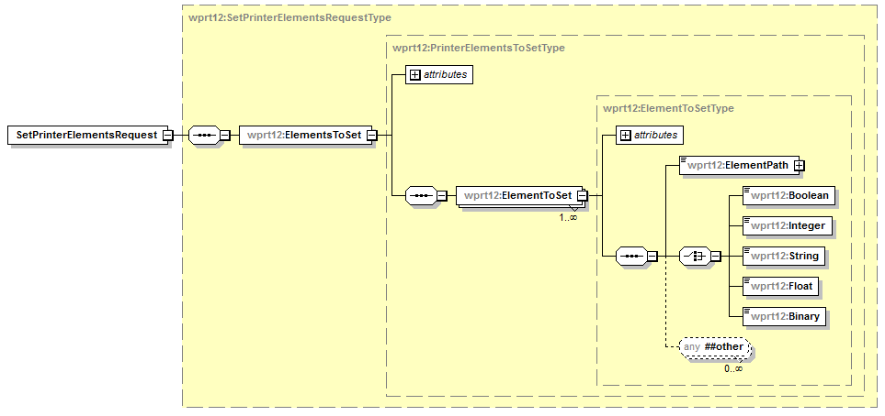
Figure 29 - SetPrinterElementsRequest Elements

ElementsToSet
This data element is a collection of elements that describe the data elements which the CP is interested in setting in the WS-Print device.

ElementToSet
This data element contains the ElementPath and data value to set for a single element in the WS-Print device schema.

ElementPath
This data element is an XPath string that represents a location within the Printer schema of the Data Element to set. The string can contain basic XPath constructs, but must resolve to a single data value within the WS-Print device. Array items must be set individually.

Example correct XPath statements:

wprt:PrinterConfiguration/wprt:OutputBins/wprt:OutputBinEntry[@wprt:Name="Tray1"]/wprt:Level
wprt:DefaultPrintTicket/wprt:JobProcessing/wprt:JobFinishings/wprt:HolePunch/wprt:Edge

Example incorrect statements:

//wprt:Level
//wprt:ConsumableEntry[@wprt:Name="$Name$"][wprt:Level < 10]

Boolean
This data element contains the data to be written to a schema element based on type xs:boolean. If the schema element identified by the data in the wprt12:ElementPath element is not based on type xs:boolean the result for this set request should be “IncompatibleType”.

Allowed Values: 0, 1, true, false

Integer
This data element contains the data to be written to a schema element based on type xs:int. If the schema element identified by the data in the wprt12:ElementPath element is not based on type xs:int the result for this set request should be “IncompatibleType”.

Allowed Values: Depends on the element being set.
Possible range: -214783648 thru 2147483647

String
This data element contains the data to be written to a schema element based on type xs:string. If the schema element identified by the data in the wprt12:ElementPath element is not based on type xs:string the result for this set request should be “IncompatibleType”.

Allowed Values: Any character string

Float
This data element contains the data to be written to a schema element based on type xs:float. If the schema element identified by the data in the wprt12:ElementPath element is not based type xs:float the result for this set request should be “IncompatibleType”.

Allowed Values: Any valid Float value

Binary
This data element contains the data to be written to a schema element based on type xs:base64binary. If the schema element identified by the data in the wprt12:ElementPath element is not based type xs:base64binary the result for this set request should be “IncompatibleType”.

Values: Base64 encoded binary data

Response Elements
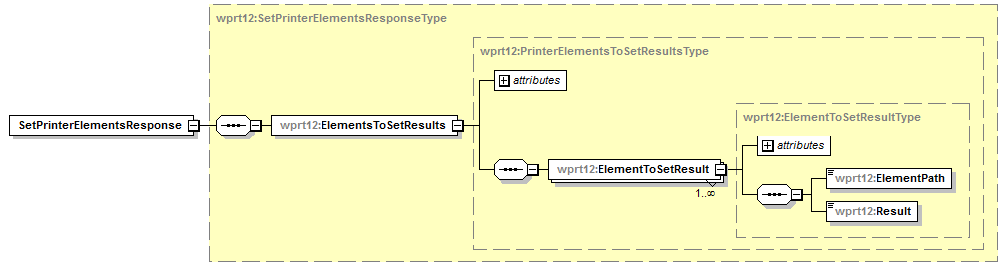
Figure 30 - SetPrinterElementsResponse Elements

ElementsToSetResults
This data element is a collection of all the responses generated by the WS Print device for the schema sets in the SetPrinterElements request.

ElementToSetResult
This data element contains the data returned for one of the schema set requests. There will be the same number of ElementToSetResult elements in the response as there were ElementToSet elements in the request.

ElementPath
This attribute contains the XPath string that represents the location within the Printer schema of the Data Element that was attempted to be set.

Result
This attribute indicates results of the action to set the data value in the data element identified by wprt12:ElementPath.

Values:
Succeeded – the SET operation completed successfully for this data element.
ElementReadOnly – the SET operation failed for this data element because it is a read only property.
IncompatibleType – the SET operation failed for this data element because the data to write was not the same type as the element definition.
InvalidElementPath - the SET operation failed for this data element because the ElementPath string does not describe a single data element. The string could either define multiple elements or it does not describe an element that conatins data.
UnknownElementPath - the SET operation failed for this data element because the WS-Print device could not find a property that matched the ElementPath data.
UnknownFailure - the SET operation failed for this data element for an unknown reason.
Vendors MAY extend the allowed values for this element.
Vendors MAY subset the allowed values for this element.

Example SetPrinterElementsRequest – PrinterDescription/PrinterName
This is an example of changing the PrinterName field if the device allows this update.
<soap:Envelope
xmlns:soap="http://www.w3.org/2003/05/soap-envelope"
xmlns:wsa="http://schemas.xmlsoap.org/ws/2004/08/addressing"
xmlns:wprt="http://schemas.microsoft.com/windows/2006/08/wdp/print”
xmlns:wprt12="http://schemas.microsoft.com/windows/2012/10/wdp/printV12”>
<soap:Header>
<wsa:To>AddressofPrinterService</wsa:To>
<wsa:Action>
http://schemas.microsoft.com/windows/2012/10/wdp/printV12/SetPrinterElements
</wsa:Action>
<wsa:MessageID>uuid:UniqueMsgId</wsa:MessageID>
</soap:Header>
<soap:Body>
<wprt12:SetPrinterElementsRequest>
<wprt12:ElementsToSet>
<wprt12:ElementToSet>
<wprt12:ElementPath>
wprt:PrinterDescrption/wprt:PrinterName
</wprt12:ElementPath>
<wprt12:String>
A new friendly name
</wprt12:String>
</wprt12:ElementToSet>
</wprt12:RequestedElements>
</wprt12:SetPrinterElementsRequest>
</soap:Body>
</soap:Envelope>

Example SetPrinterElementsResponse – PrinterDescription/PrinterName
<soap:Envelope
xmlns:soap="http://www.w3.org/2003/05/soap-envelope"
xmlns:wsa="http://schemas.xmlsoap.org/ws/2004/08/addressing"
xmlns:wprt="http://schemas.microsoft.com/windows/2006/08/wdp/print”
xmlns:wprt12="http://schemas.microsoft.com/windows/2012/10/wdp/printV12”>
<soap:Header>
<wsa:To>http://schemas.xmlsoap.org/ws/2004/08/addressing/role/anonymous</wsa:To>
<wsa:Action>
http://schemas.microsoft.com/windows/2012/10/wdp/printV12/SetPrinterElementsResponse
</wsa:Action>
<wsa:MessageID>uuid:UniqueMsgId</wsa:MessageID>
<wsa:RelatesTo>uuid:MsgIdOfTheSetPrinterElementsRequest</wsa:RelatesTo>
</soap:Header>
<soap:Body>
<wprt12:SetPrinterElementsResponse>
<wprt12:ElementsToSetResults>
<wprt12:ElementToSetResult>
<wprt12:ElementPath>
wprt:PrinterDescrption/wprt:PrinterName
</wprt12:ElementPath>
<wprt12:Result>Succeeded</wprt12:Result>
</wprt12:ElementToSetResult>
</wprt12:ElementsToSetResults>
</wprt12:SetPrinterElementsResponse>
</soap:Body>
</soap:Envelope>

Example SetPrinterElementsRequest – Read-Only data
<soap:Envelope
xmlns:soap="http://www.w3.org/2003/05/soap-envelope"
xmlns:wsa="http://schemas.xmlsoap.org/ws/2004/08/addressing"
xmlns:wprt="http://schemas.microsoft.com/windows/2006/08/wdp/print”
xmlns:wprt12="http://schemas.microsoft.com/windows/2012/10/wdp/printV12”>
<soap:Header>
<wsa:To>AddressofPrinterService</wsa:To>
<wsa:Action>
http://schemas.microsoft.com/windows/2012/10/wdp/printV12/SetPrinterElements
</wsa:Action>
<wsa:MessageID>uuid:UniqueMsgId</wsa:MessageID>
</soap:Header>
<soap:Body>
<wprt12:SetPrinterElementsRequest>
<wprt12:ElementsToSet>
<wprt12:ElementToSet>
<wprt12:ElementPath>
wprt:PrinterDescrption/wprt:DeviceId
</wprt12:ElementPath>
<wprt12:String>
A new friendly name
</wprt12:String>
</wprt12:ElementToSet>
</wprt12:RequestedElements>
</wprt12:SetPrinterElementsRequest>
</soap:Body>
</soap:Envelope>

Example SetPrinterElementsResponse – Read-Only data
<soap:Envelope
xmlns:soap="http://www.w3.org/2003/05/soap-envelope"
xmlns:wsa="http://schemas.xmlsoap.org/ws/2004/08/addressing"
xmlns:wprt="http://schemas.microsoft.com/windows/2006/08/wdp/print”
xmlns:wprt12="http://schemas.microsoft.com/windows/2012/10/wdp/printV12”>
<soap:Header>
<wsa:To>http://schemas.xmlsoap.org/ws/2004/08/addressing/role/anonymous</wsa:To>
<wsa:Action>
http://schemas.microsoft.com/windows/2012/10/wdp/printV12/SetPrinterElementsResponse
</wsa:Action>
<wsa:MessageID>uuid:UniqueMsgId</wsa:MessageID>
<wsa:RelatesTo>uuid:MsgIdOfTheSetPrinterElementsRequest</wsa:RelatesTo>
</soap:Header>
<soap:Body>
<wprt12:SetPrinterElementsResponse>
<wprt12:ElementsToSetResults>
<wprt12:ElementToSetResult>
<wprt12:ElementPath>
wprt:PrinterDescrption/wprt:DeviceId
</wprt12:ElementPath>
<wprt12:Result>ElementReadOnly</wprt12:Result>
</wprt12:ElementToSetResult>
</wprt12:ElementsToSetResults>
</wprt12:SetPrinterElementsResponse>
</soap:Body>
</soap:Envelope>

Example SetPrinterElementsRequest – Incompatible Type
<soap:Envelope
xmlns:soap="http://www.w3.org/2003/05/soap-envelope"
xmlns:wsa="http://schemas.xmlsoap.org/ws/2004/08/addressing"
xmlns:wprt="http://schemas.microsoft.com/windows/2006/08/wdp/print”
xmlns:wprt12="http://schemas.microsoft.com/windows/2012/10/wdp/printV12”>
<soap:Header>
<wsa:To>AddressofPrinterService</wsa:To>
<wsa:Action>
http://schemas.microsoft.com/windows/2012/10/wdp/printV12/SetPrinterElements
</wsa:Action>
<wsa:MessageID>uuid:UniqueMsgId</wsa:MessageID>
</soap:Header>
<soap:Body>
<wprt12:SetPrinterElementsRequest>
<wprt12:ElementsToSet>
<wprt12:ElementToSet>
<wprt12:ElementPath>
wprt:PrinterDescrption/wprt:PrinterInfo
</wprt12:ElementPath>
<wprt12:Integer>32</wprt12:Integer>
</wprt12:ElementToSet>
</wprt12:RequestedElements>
</wprt12:SetPrinterElementsRequest>
</soap:Body>
</soap:Envelope>

Example SetPrinterElementsResponse – Incompatible Type
<soap:Envelope
xmlns:soap="http://www.w3.org/2003/05/soap-envelope"
xmlns:wsa="http://schemas.xmlsoap.org/ws/2004/08/addressing"
xmlns:wprt="http://schemas.microsoft.com/windows/2006/08/wdp/print”
xmlns:wprt12="http://schemas.microsoft.com/windows/2012/10/wdp/printV12”>
<soap:Header>
<wsa:To>http://schemas.xmlsoap.org/ws/2004/08/addressing/role/anonymous</wsa:To>
<wsa:Action>
http://schemas.microsoft.com/windows/2012/10/wdp/printV12/SetPrinterElementsResponse
</wsa:Action>
<wsa:MessageID>uuid:UniqueMsgId</wsa:MessageID>
<wsa:RelatesTo>uuid:MsgIdOfTheSetPrinterElementsRequest</wsa:RelatesTo>
</soap:Header>
<soap:Body>
<wprt12:SetPrinterElementsResponse>
<wprt12:ElementsToSetResults>
<wprt12:ElementToSetResult>
<wprt12:ElementPath>
wprt:PrinterDescrption/wprt:PrinterInfo
</wprt12:ElementPath>
<wprt12:Result>IncompatibleType</wprt12:Result>
</wprt12:ElementToSetResult>
</wprt12:ElementsToSetResults>
</wprt12:SetPrinterElementsResponse>
</soap:Body>
</soap:Envelope>

Example SetPrinterElementsRequest – Invalid/Unknown Element Paths
<soap:Envelope
xmlns:soap="http://www.w3.org/2003/05/soap-envelope"
xmlns:wsa="http://schemas.xmlsoap.org/ws/2004/08/addressing"
xmlns:wprt="http://schemas.microsoft.com/windows/2006/08/wdp/print”
xmlns:wprt12="http://schemas.microsoft.com/windows/2012/10/wdp/printV12”>
<soap:Header>
<wsa:To>AddressofPrinterService</wsa:To>
<wsa:Action>
http://schemas.microsoft.com/windows/2012/10/wdp/printV12/SetPrinterElements
</wsa:Action>
<wsa:MessageID>uuid:UniqueMsgId</wsa:MessageID>
</soap:Header>
<soap:Body>
<wprt12:SetPrinterElementsRequest>
<wprt12:ElementsToSet>
<wprt12:ElementToSet>
<wprt12:ElementPath>
wprt:PrinterConfiguration/wprt:Consumables
</wprt12:ElementPath>
<wprt12:Boolean>
true
</wprt12:Boolean>
</wprt12:ElementToSet>
<wprt12:ElementToSet>
<wprt12:ElementPath>
wprt:PrinterStatus/wprt:StatusLocation
</wprt12:ElementPath>
<wprt12:String>
UnknownLocation
</wprt12:String>
</wprt12:ElementToSet>
</wprt12:RequestedElements>
</wprt12:SetPrinterElementsRequest>
</soap:Body>
</soap:Envelope>

Example SetPrinterElementsResponse – Invalid/Unknown Element Paths
<soap:Envelope
xmlns:soap="http://www.w3.org/2003/05/soap-envelope"
xmlns:wsa="http://schemas.xmlsoap.org/ws/2004/08/addressing"
xmlns:wprt="http://schemas.microsoft.com/windows/2006/08/wdp/print”
xmlns:wprt12="http://schemas.microsoft.com/windows/2012/10/wdp/printV12”>
<soap:Header>
<wsa:To>http://schemas.xmlsoap.org/ws/2004/08/addressing/role/anonymous</wsa:To>
<wsa:Action>
http://schemas.microsoft.com/windows/2012/10/wdp/printV12/SetPrinterElementsResponse
</wsa:Action>
<wsa:MessageID>uuid:UniqueMsgId</wsa:MessageID>
<wsa:RelatesTo>uuid:MsgIdOfTheSetPrinterElementsRequest</wsa:RelatesTo>
</soap:Header>
<soap:Body>
<wprt12:SetPrinterElementsResponse>
<wprt12:ElementsToSetResults>
<wprt12:ElementToSetResult>
<wprt12:ElementPath>
wprt:PrinterConfiguration/wprt:Consumables
</wprt12:ElementPath>
<wprt12:Result>InvalidElementPath</wprt12:Result>
</wprt12:ElementToSetResult>
<wprt12:ElementToSetResult>
<wprt12:ElementPath>
wprt:PrinterStatus/wprt:StatusLocation
</wprt12:ElementPath>
<wprt12:Result>UnknownElementPath</wprt12:Result>
</wprt12:ElementToSetResult>
</wprt12:ElementsToSetResults>
</wprt12:SetPrinterElementsResponse>
</soap:Body>
</soap:Envelope>

Backwards Compatibility
The new WS-Print V1.2 elements and operations are added as a new web service supported by the WS-Print V1.0 device. This allows current WS-Print V1.0 clients to work with all V1.0, V1.1 and V1.2 devices. The new operation/elements will simply be ignored by the V1.0 & V1.1 clients. And newer V1.2 clients will still be able to interact with V1.0 & V1.1 devices, there will just be no support for the new V1.2 operation/elements.
To support backwards compatibility, a WS-Print V1.2 device will indicate support for V1.2 by returning the SupportsWSPrintV12 schema element in the V1.0 PrinterDecsription field. All clients that only understand WS-Print V1.0 or V1.1 will ignore the new field and not request any of the new information, WS-Print V1.2 capable clients will recognize the new elements and process the data appropriately.
With the new WS-Print V1.2 web service being an extension/complement service for WS-Print V1.0 it does not get exposed in the Relationship section of the Devices Profile for Web Servies [DEVICE] metadata for the WS-Print device. The client can determine if the WS-Print device supports V1.2 by looking for the new SupportsWSPrintV12 element in the WS-Print V1.0 PrinterDescription. The WS-Print V1.2 web service should be exposed at the same endpoint address as the WS-Print V1.0 service that is advertised.

WS-Print V1.2 Request/Response examples
An example of a PrinterDescription element for a WS-Print V1.2 device is as follows:

Example Request - PrinterDescription
<soap:Envelope
xmlns:soap="http://www.w3.org/2003/05/soap-envelope"
xmlns:wsa="http://schemas.xmlsoap.org/ws/2004/08/addressing"
xmlns:wprt="http://schemas.microsoft.com/windows/2006/08/wdp/print">
<soap:Header>
<wsa:To>AddressofPrinterService</wsa:To>
<wsa:Action>
http://schemas.microsoft.com/windows/2006/08/wdp/print/GetPrinterElements
</wsa:Action>
<wsa:MessageID>uuid:UniqueMsgId</wsa:MessageID>
</soap:Header>
<soap:Body>
<wprt:GetPrinterElementsRequest>
<wprt:RequestedElements>
<wprt:Name>wprt:PrinterDescription</wprt:Name>
</wprt:RequestedElements>
</wprt:GetPrinterElementsRequest>
</soap:Body>
</soap:Envelope>

Example Response – PrinterDescription supports WS-Print v1.2
<soap:Envelope
xmlns:soap="http://www.w3.org/2003/05/soap-envelope"
xmlns:wsa="http://schemas.xmlsoap.org/ws/2004/08/addressing"
xmlns:wprt="http://schemas.microsoft.com/windows/2006/08/wdp/print"
xmlns:wprtV12="http://schemas.microsoft.com/windows/2012/10/wdp/printV12">
<soap:Header>
<wsa:To>http://schemas.xmlsoap.org/ws/2004/08/addressing/role/anonymous</wsa:To>
<wsa:Action>
http://schemas.microsoft.com/windows/2006/08/wdp/print/GetPrinterElementsResponse
</wsa:Action>
<wsa:MessageID>uuid:UniqueMsgId</wsa:MessageID>
<wsa:RelatesTo>uuid:MsgIdOfTheGetPrinterElementsRequest</wsa:RelatesTo>
</soap:Header>
<soap:Body>
<wprt:GetPrinterElementsResponse>
<wprt:PrinterElements>
<wprt:ElementData Name="wprt:PrinterDescription" Valid="true">
<wprt:PrinterDescription>
<wprt:ColorSupported>true</wprt:ColorSupported>
<wprt:DeviceId>MFG:Acme;MDL:PrintMaster 9020</wprt:DeviceId>
<wprt:MultipleDocumentJobsSupported>true</wprt:MultipleDocumentJobsSupported>
<wprt:PagesPerMinute>20</wprt:PagesPerMinute>
<wprt:PagesPerMinuteColor>8</wprt:PagesPerMinuteColor>
<wprt:PrinterName xml:lang="en-AU, en-CA, en-GB, en-US">
Accounting Printer in Copy Room 2
</wprt:PrinterName>
<wprt:PrinterInfo xml:lang="en-AU, en-CA, en-GB, en-US">
Printer for use of Accounting only
</wprt:PrinterInfo>
<wprt:PrinterLocation xml:lang="en-AU, en-CA, en-GB, en-US">
LA Campus – Building 3
</wprt:PrinterLocation>
<wprtV12:SupportsWSPrintV12>true</wprtV12:SupportsWSPrintV12>
</wprt:PrinterDescription>
</wprt:ElementData>
</wprt:PrinterElements>
</wprt:GetPrinterElementsResponse>
</soap:Body>
</soap:Envelope>

WS-Print v1.2 XSD
<?xml version="1.0" encoding="UTF-8"?>
<xs:schema targetNamespace="http://schemas.microsoft.com/windows/2012/10/wdp/printV12"
xmlns:wprt12="http://schemas.microsoft.com/windows/2012/10/wdp/printV12"
xmlns:xs="http://www.w3.org/2001/XMLSchema"
elementFormDefault="qualified">

<xs:annotation>
<xs:documentation>
WS-Print Extensions for Printer Elements Set operation messages
Copyright Microsoft Corp. All rights reserved
</xs:documentation>
</xs:annotation>

<xs:annotation>
<xs:documentation>
A Boolean element that denotes support for WS-Print V1.2 extensions
</xs:documentation>
</xs:annotation>
<xs:element name="SupportsWSPrintV12" type="xs:boolean"/>

<xs:complexType name="SetPrinterElementsRequestType">
<xs:sequence>
<xs:element name="ElementsToSet" type="wprt12:PrinterElementsToSetType"/>
</xs:sequence>
</xs:complexType>
<xs:element name="SetPrinterElementsRequest" type="wprt12:SetPrinterElementsRequestType"/>
<xs:complexType name="SetPrinterElementsResponseType">
<xs:sequence>
<xs:element name="ElementsToSetResults" type="wprt12:PrinterElementsToSetResultsType"/>
</xs:sequence>
</xs:complexType>
<xs:element name="SetPrinterElementsResponse" type="wprt12:SetPrinterElementsResponseType"/>

<xs:complexType name="PrinterElementsToSetType">
<xs:sequence>
<xs:element name="ElementToSet" type="wprt12:ElementToSetType" maxOccurs="unbounded"/>
</xs:sequence>
<xs:anyAttribute namespace="##other" processContents="lax"/>
</xs:complexType>

<xs:complexType name="ElementToSetType">
<xs:sequence>
<xs:element name="ElementPath" type="wprt12:ElementPathExtType"/>
<xs:choice>
<xs:element name="Boolean" type="xs:boolean"/>
<xs:element name="Integer" type="xs:int"/>
<xs:element name="String" type="xs:string"/>
<xs:element name="Float" type="xs:double"/>
<xs:element name="Binary" type="xs:base64Binary"/>
</xs:choice>
<xs:any namespace="##other" minOccurs="0" maxOccurs="unbounded"/>
</xs:sequence>
<xs:anyAttribute namespace="##other" processContents="lax"/>
</xs:complexType>

<xs:complexType name="ElementPathExtType">
<xs:simpleContent>
<xs:extension base="xs:string">
<xs:anyAttribute namespace="##other" processContents="lax"/>
</xs:extension>
</xs:simpleContent>
</xs:complexType>

<xs:complexType name="PrinterElementsToSetResultsType">
<xs:sequence>
<xs:element name="ElementToSetResult" type="wprt12:ElementToSetResultType" maxOccurs="unbounded"/>
</xs:sequence>
<xs:anyAttribute namespace="##other" processContents="lax"/>
</xs:complexType>

<xs:complexType name="ElementToSetResultType">
<xs:sequence>
<xs:element name="ElementPath" type="xs:string"/>
<xs:element name="Result" type="wprt12:ElementSetResultValuesType"/>
</xs:sequence>
<xs:anyAttribute namespace="##other" processContents="lax"/>
</xs:complexType>

<xs:simpleType name="ElementSetResultValuesType">
<xs:restriction base="xs:NMTOKEN">
<xs:maxLength value="255"/>
<xs:enumeration value="Succeeded"/>
<xs:enumeration value="ElementReadOnly"/>
<xs:enumeration value="IncompatibleType"/>
<xs:enumeration value="InvalidElementPath"/>
<xs:enumeration value="UnknownElementPath"/>
<xs:enumeration value="UnknownFailure"/>
</xs:restriction>
</xs:simpleType>
</xs:schema>

WS-Print v1.2 WSDL
<definitions xmlns="http://schemas.xmlsoap.org/wsdl/"
xmlns:wsoap12="http://schemas.xmlsoap.org/wsdl/soap12/"
xmlns:http="http://schemas.xmlsoap.org/wsdl/http/"
xmlns:xs="http://www.w3.org/2001/XMLSchema"
xmlns:wsdp="http://schemas.xmlsoap.org/ws/2006/02/devprof"
xmlns:wsp="http://schemas.xmlsoap.org/ws/2004/09/policy"
xmlns:wsa="http://schemas.xmlsoap.org/ws/2004/08/addressing"
xmlns:wsu="http://docs.oasis-open.org/wss/2004/01/oasis-200401-wss-wssecurity-utility-1.0.xsd"
xmlns:wprt="http://schemas.microsoft.com/windows/2006/08/wdp/print"
xmlns:wprt12="http://schemas.microsoft.com/windows/2012/10/wdp/printV12"
targetNamespace="http://schemas.microsoft.com/windows/2012/10/wdp/printV12"
name="WSDPrinterServiceV12">

<xs:annotation>
<xs:documentation>
WSD Printer Service V1.2 Extensions Web Service Description (WSDL) file
Copyright (c) Microsoft Corporation. All rights reserved
</xs:documentation>
</xs:annotation>

<wsp:Policy wsu:Id="ServicePolicy">
<wsdp:Profile />
</wsp:Policy>

<types>
<xs:schema targetNamespace="http://schemas.microsoft.com/windows/2012/10/wdp/printV12">
<xs:include schemaLocation="WDPPrintV12.xsd"/>
</xs:schema>
</types>
<message name="SetPrinterElementsRequestMsg">
<part name="body" element="wprt12:SetPrinterElementsRequest"/>
</message>
<message name="SetPrinterElementsResponseMsg">
<part name="body" element="wprt12:SetPrinterElementsResponse"/>
</message>

<portType name="PrinterServiceV12Type">
<operation name="SetPrinterElements">
<input message="wprt12:SetPrinterElementsRequestMsg"
wsa:Action="http://schemas.microsoft.com/windows/2012/10/wdp/printV12/SetPrinterElements" />
<output message="wprt12:SetPrinterElementsResponseMsg"
wsa:Action="http://schemas.microsoft.com/windows/2012/10/wdp/printV12/SetPrinterElementsResponse" />
</operation>
</portType>
<binding name="PrinterServiceV12Binding" type="wprt:PrinterServiceV12Type">
<wsoap12:binding style="document" transport="http://schemas.xmlsoap.org/soap/http"/>
<wsp:PolicyReference URI="#ServicePolicy" />
<operation name="SetPrinterElements">
<wsoap12:operation
soapAction="http://schemas.microsoft.com/windows/2012/10/wdp/printV12/SetPrinterElements"
soapActionRequired="true" />
<input>
<wsoap12:body use="literal" />
</input>
<output>
<wsoap12:body use="literal" />
</output>
</operation>
</binding>
<service name="PrinterServiceV12">
<port name="PrinterPortV12" binding="wprt:PrinterServiceV12Binding">
<wsoap12:address location="http://localhost/PrinterServiceV12/"/>
</port>
</service>
</definitions>

