Download link: <https://github.com/Dermaed/Ping-Pong/blob/master/Ping-Pong/Ping-Pong.py>

This is a game of Ping Pong, where the user moves the left and right rocketeer with the keyboard(W, S, UP, DOWN). In the screenshot below, the variables are defined previously and set by colors. And they are being used in a class, which then carries multiple IF statements which controls the movements of the rocketeer. A screenshot of a cell phone

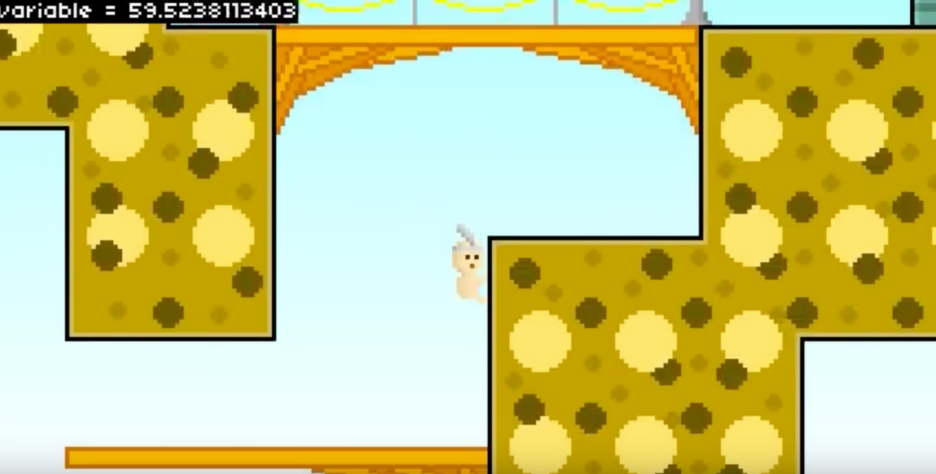

Download Link: <https://pastebin.com/VW9maqHf>

This game was designed by an entry level programmer using Pygame and Python, the purpose of the game is to get from one point to another without falling to your death. The screenshot above is his code for the movements of such character, including interaction with an Non-Player Character(NPC).

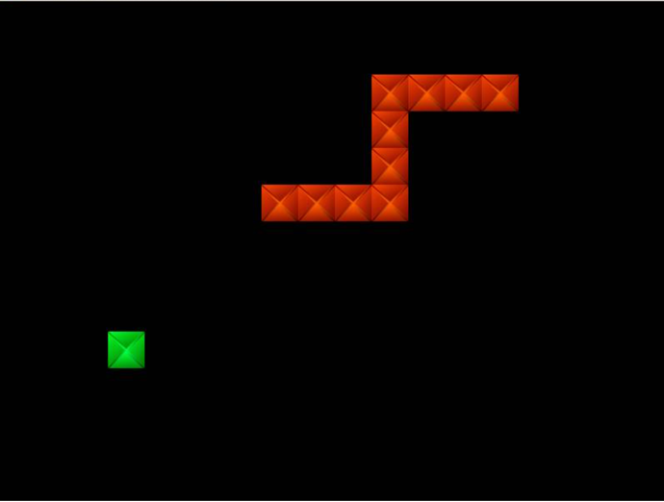

Download link: <https://pythonspot.com/snake-with-pygame/>

This game is a game called Snake, where the user needs to move the character and eat an object in order to grow. The code below is the creation of the character, and the continuous length after eating an object.

As an observation, these games and others are constant in using same lines of code, and many classes and IF and For statements. This is helpful because another programmer can use the same code to create a different game, with the same mechanics(or even an updated/expanded version of it).