Grasshopper

Grasshoppers are most often green or brown and quite plain to look at in this guise. But there are many species that use the full color palate to decorate themselves. The best of these insects are strikingly beautiful and if you happen to catch a group of them you will be in for a visual feast.

[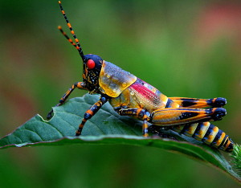](http://www.top10listland.com/wp-content/uploads/2013/12/grasshopper.jpg)

Grasshopper Hollow, [United States](http://www.wikiglobe.eu/United-States/map/co/US/) is located at 39.6750900 (latitude in decimal degrees), -78.2091700 (longitude in decimal degrees). [(more about Grasshopper Hollow latitude and longitude)](http://www.wikiglobe.eu/Grasshopper-Hollow/latitude-longitude/4807416/), [(more about Grasshopper Hollow gps coordinates)](http://www.wikiglobe.eu/Grasshopper-Hollow/gps-coordinates/4807416/)