PostgreSQL

## Uriel Aracena

## April 25 Intro

Class Example:

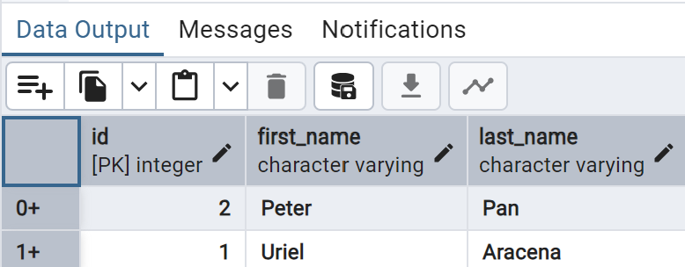

LAB 12A Exercise:

Course Table

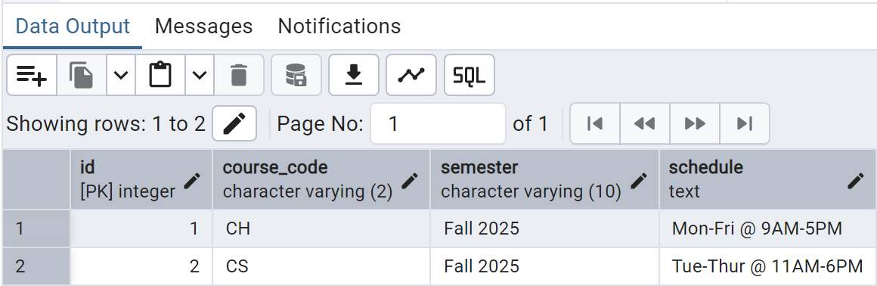

Tuition Table

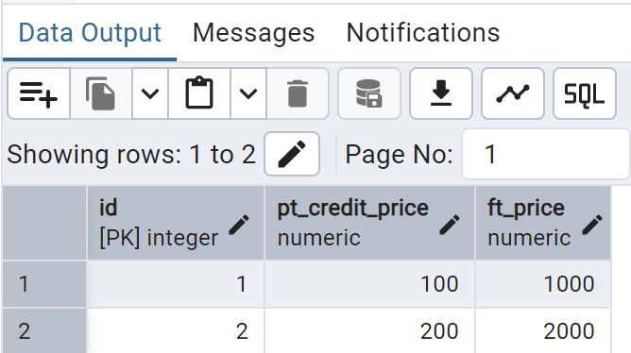

## 

## May 1 CRUD

Class Example:

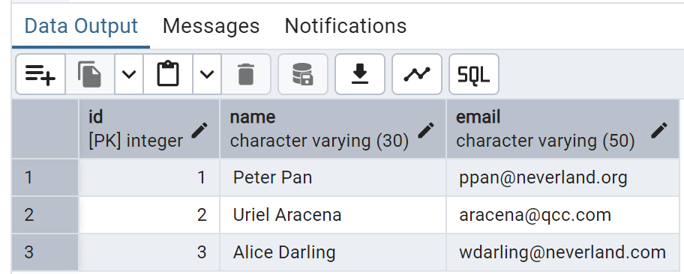

LAB 12B Exercise:

1. Create the Table

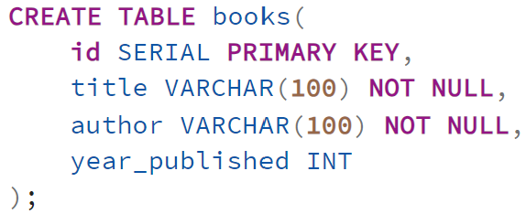

1. Insert Records

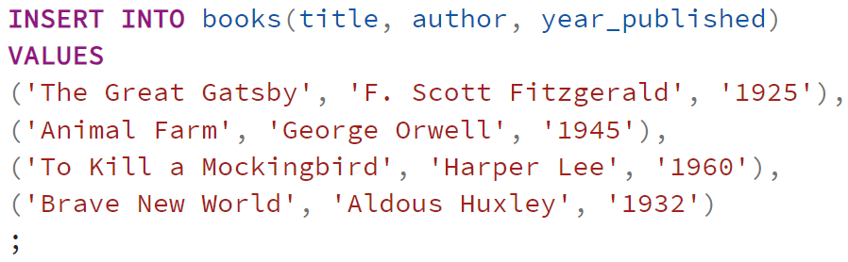

1. Read Data



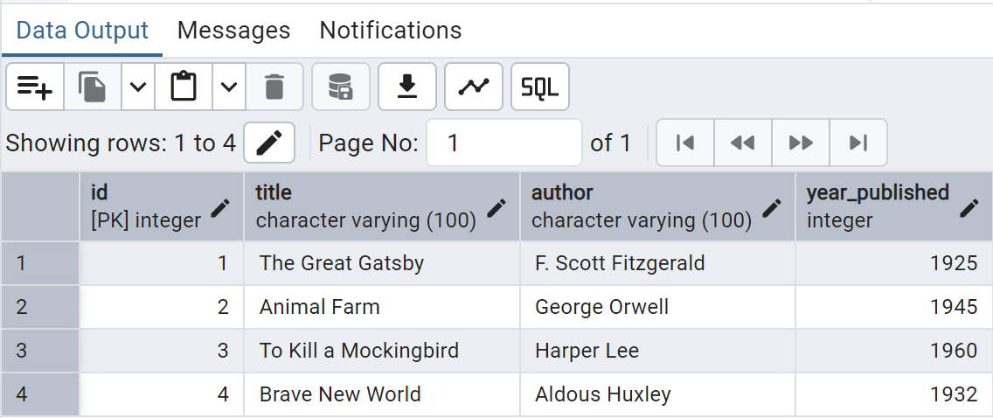

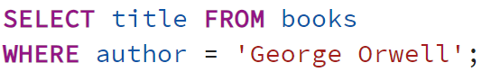

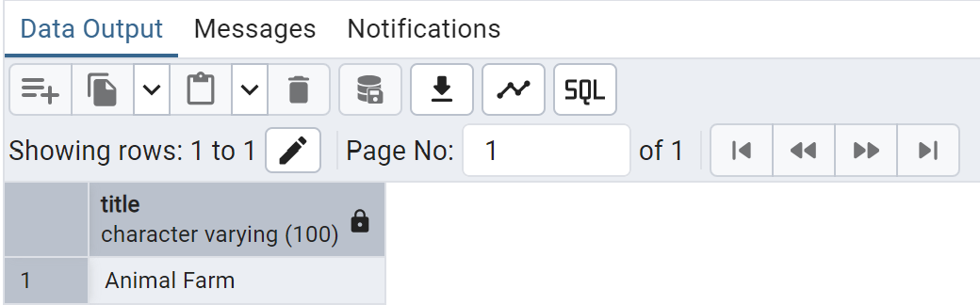

1. Delete Data

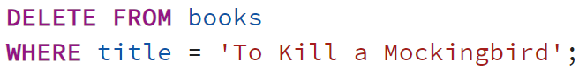

1. Update Data



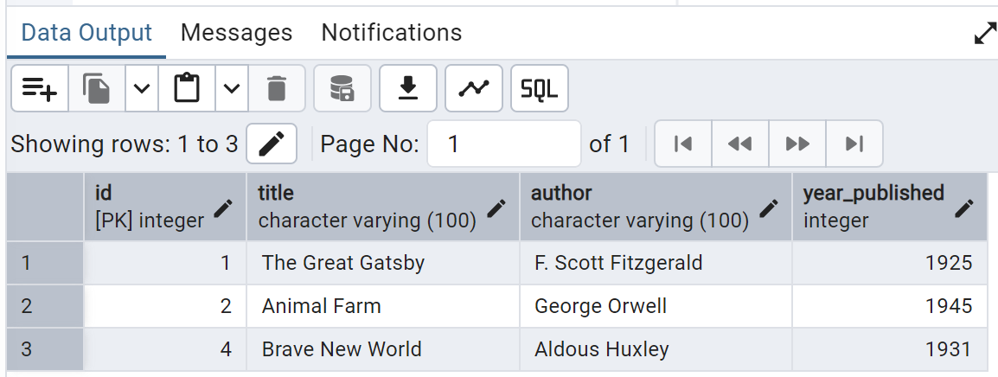

1. Bonus



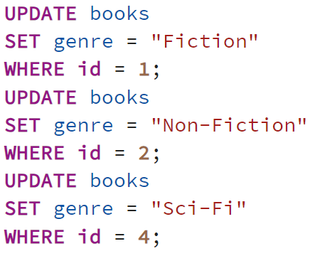



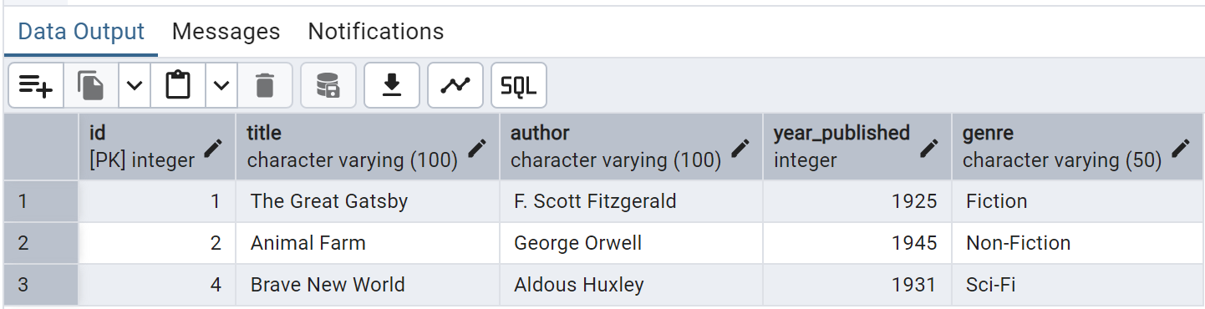

## May 2 Relational Databases

Class Example:

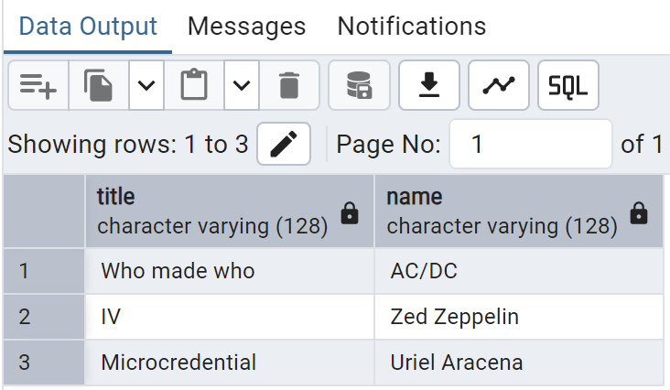

LAB 12C Exercise:

Student Table

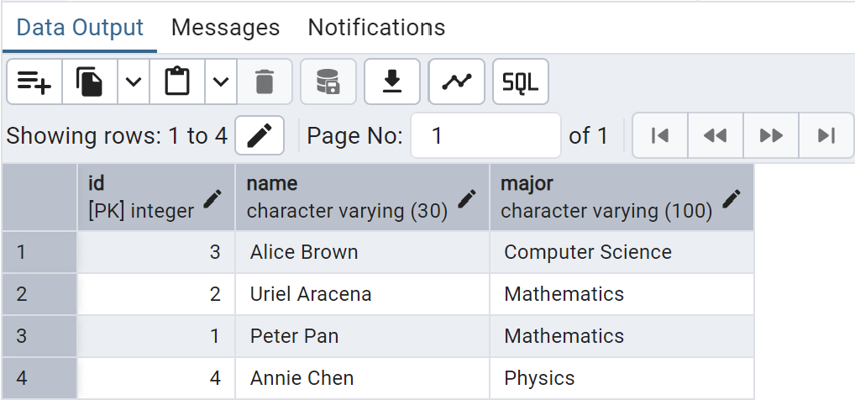

Course Table

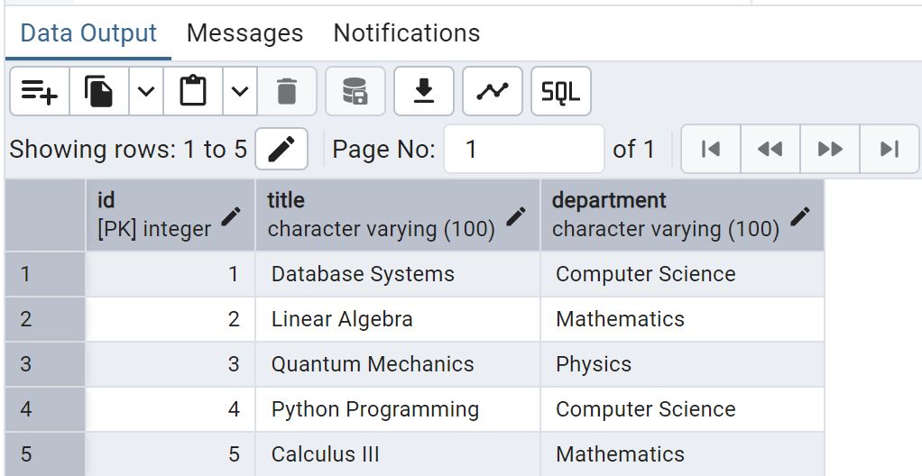

Enrollment Table

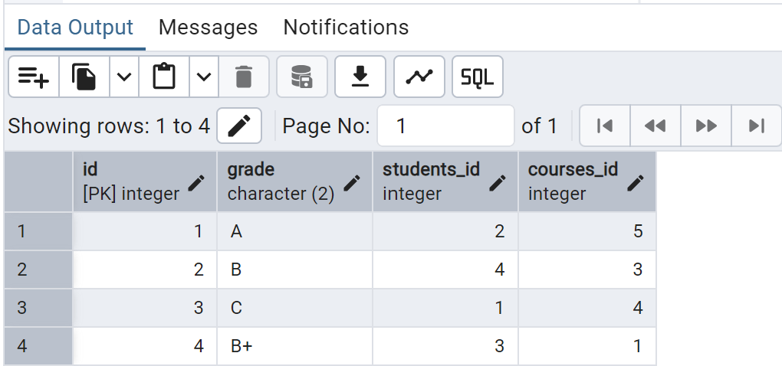

Queries



