TMRC-related TMAG Journal submission

Papers must be submitted before July 26th through the IEEE AUTHOR PORTAL website. The suggested lengths for contributed (posters) and invited papers are five pages and seven pages, respectively. The maximum paper length allowed by the journal is fourteen pages.

- After clicking on the IEEE AUTHOR PORTAL, the Sign In window will appear. The authors have to login using their own account. The author can create an IEEE account in case the account has never been crated.
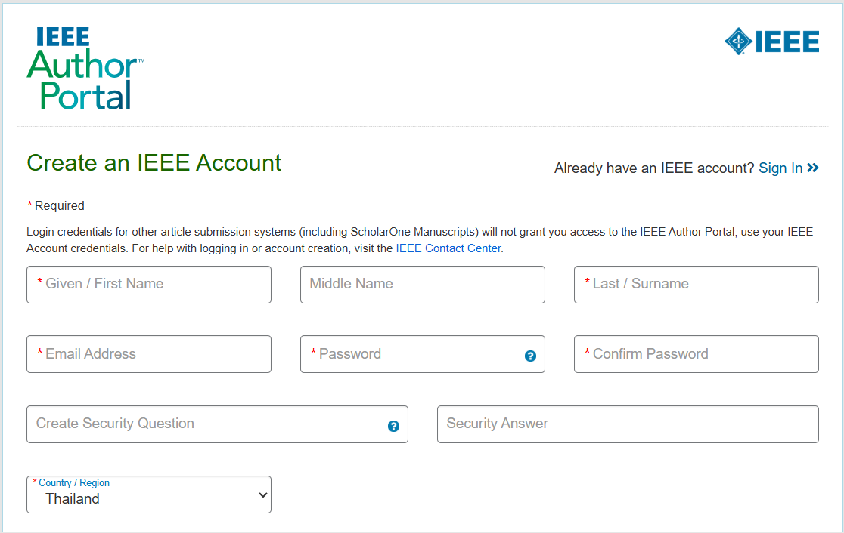
1
- After logging in, the author can click at the “Start submission” button as shown in below window.
2
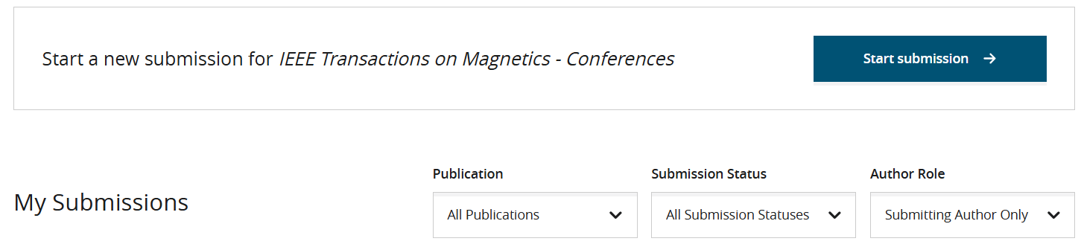

- Start a new submission with selecting the “Article Type” by clicking at the Article Type button as shown in below window.
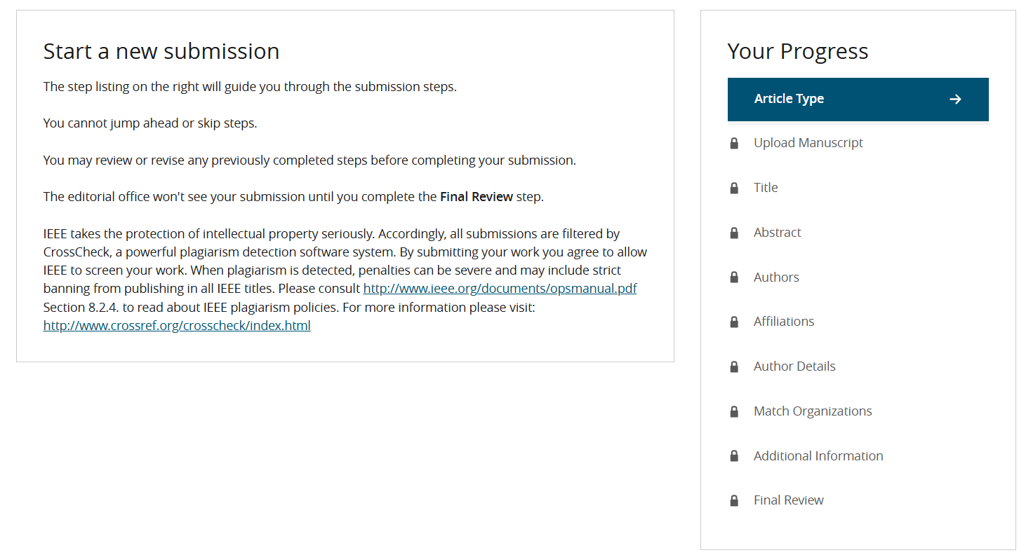
3

- There is possible various article types related the conferences. The author can click at drop-down button, and then select “TMRC 2026”
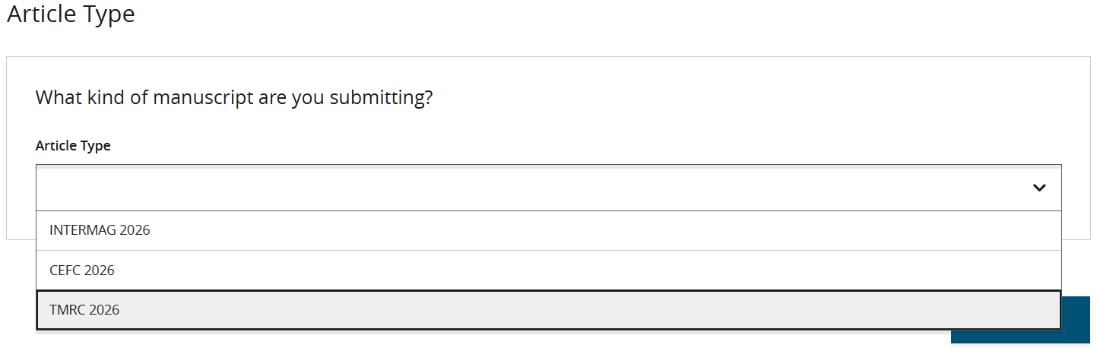
4

- The list of confirmation items will be appeared; the authors have to complete them before clicking at the “Confirm” button.

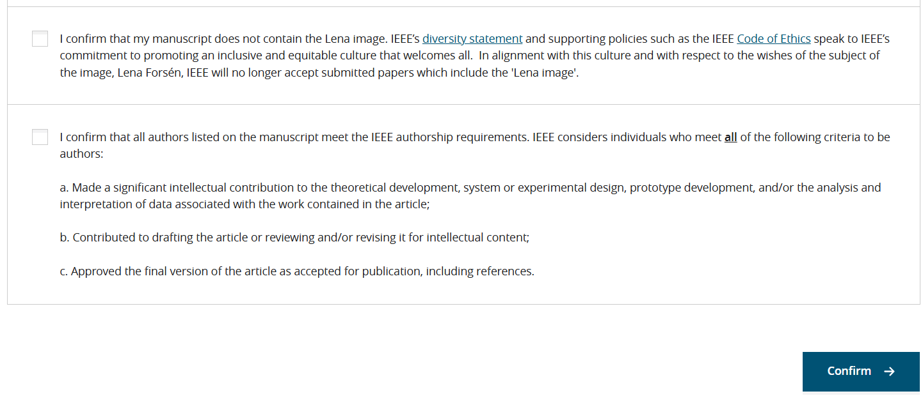
5

- In finally, the authors can complete their submission by following the “step listing” on the right of below window, which can guide them through the submission steps.
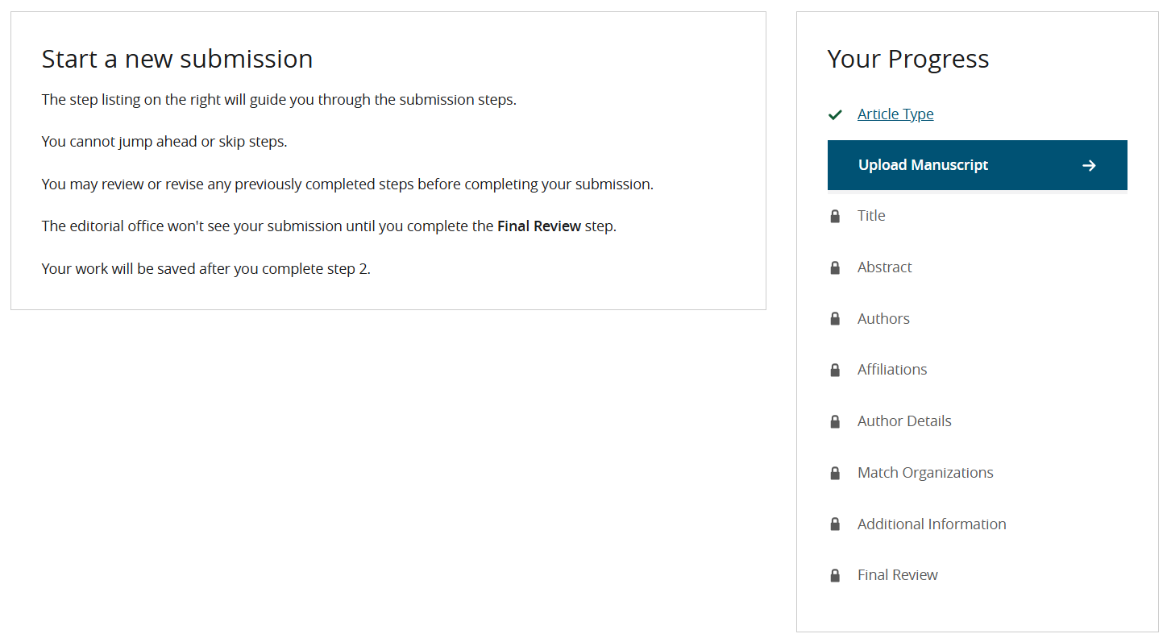
6

