Project SQL Queries

1. How many work orders did each Team do?

SELECT TEAM_CODE, COUNT(WO) AS TOTAL_WORK_ORDERS

FROM WORK_ORDERS

GROUP BY TEAM_CODE;

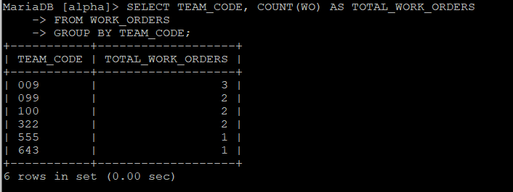

2. Show the addresses of the client locations that have unpaid quotes

SELECT CLOC_ADDRESS

FROM CLIENT_LOCATIONS, WORK_ORDERS

WHERE CLIENT_LOCATIONS.CLOC_NUM = WORK_ORDERS.CLOC_NUM

AND IS_PAID = 'N';

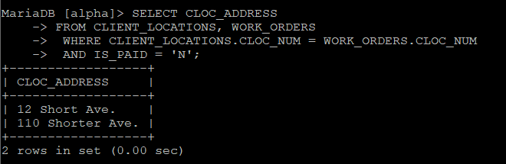

3. Which Team has the most absences?

SELECT TEAM_CODE, SUM(ABSENCE_NUM) AS MOST_ABSENCES

FROM EMPLOYEES

GROUP BY TEAM_CODE

HAVING SUM(ABSENCE_NUM) >= ALL (SELECT SUM(ABSENCE_NUM) AS TEMP

FROM EMPLOYEES

GROUP BY TEAM_CODE);

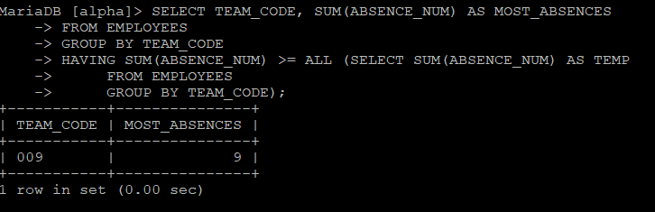

4. Show the Team Code and names of the employees in the team with the most absences

SELECT TEAM_CODE, E_FIRST, E_LAST

FROM EMPLOYEES

WHERE TEAM_CODE IN (

SELECT SUM(ABSENCE_NUM) AS MOST_ABSENCES

FROM EMPLOYEES

GROUP BY TEAM_CODE

HAVING SUM(ABSENCE_NUM) >= ALL (

SELECT SUM(ABSENCE_NUM) AS TEMP

FROM EMPLOYEES

GROUP BY TEAM_CODE));

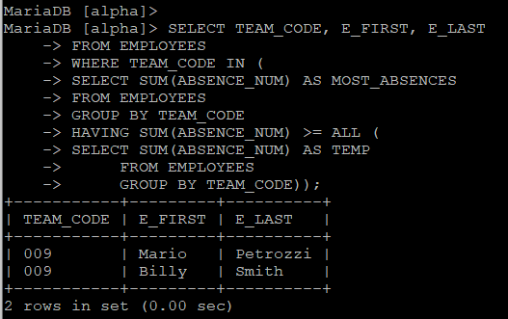

5. Show the names of all clients with more than 3 locations

SELECT CLIENT_NAME, COUNT(CLIENT_LOCATIONS.CLIENT_NUM) AS TOTAL_LOCATIONS

FROM CLIENT_LOCATIONS

INNER JOIN CLIENT

ON CLIENT.CLIENT_NUM = CLIENT_LOCATIONS.CLIENT_NUM

GROUP BY CLIENT_LOCATIONS.CLIENT_NUM

HAVING COUNT(CLIENT_LOCATIONS.CLIENT_NUM) > 3;

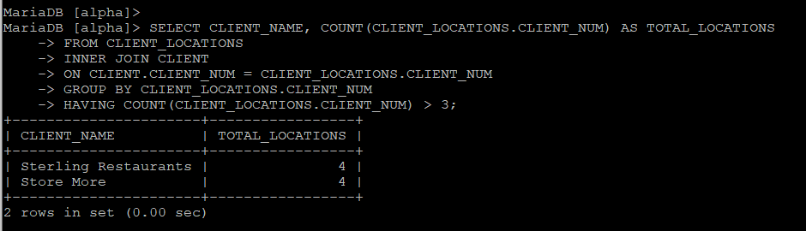

6. Show the Team Code, work type, company location address, number of employees, and employee names at each Company location

SELECT TEAMS.TEAM_CODE, WORK_TYPE, CL_ADDRESS, NUM_OF_E, E_FIRST, E_LAST

FROM TEAMS, COMPANY, EMPLOYEES

WHERE TEAMS.CL_CODE = COMPANY.CL_CODE

AND TEAMS.TEAM_CODE = EMPLOYEES.TEAM_CODE

GROUP BY E_FIRST

ORDER BY CL_ADDRESS;

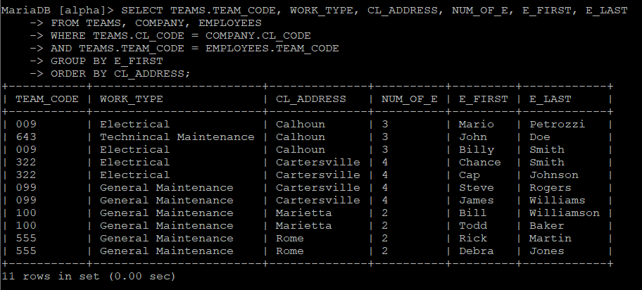

7. Show the names and clock-in/clock-out times of all employees that worked on 11/1/1999.

SELECT E_FIRST, E_LAST, CLOCK_IN, CLOCK_OUT

FROM EMPLOYEES, SHIFT_HOURS

WHERE EMPLOYEES.EMP_CODE = SHIFT_HOURS.EMP_CODE

AND SHIFT_DATE = '11/1/1999'

GROUP BY EMPLOYEES.EMP_CODE

ORDER BY E_LAST;

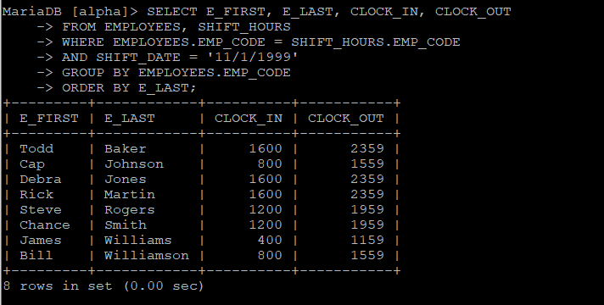

8. Create a view to show the Team code, service area, total labor hours, total worked orders, and the total order value of each Team.

CREATE VIEW TEAM_VALUE AS (

SELECT TEAMS.TEAM_CODE, SERVICE_AREA, SUM(LABOR_HOURS), COUNT(WO) AS TOTAL_ORDERS, SUM(TOTAL_QUOTE) AS TOTAL_ORDER_VALUE

FROM TEAMS, WORK_ORDERS

WHERE TEAMS.TEAM_CODE = WORK_ORDERS.TEAM_CODE

GROUP BY TEAMS.TEAM_CODE

ORDER BY TOTAL_ORDER_VALUE DESC, LABOR_HOURS DESC);

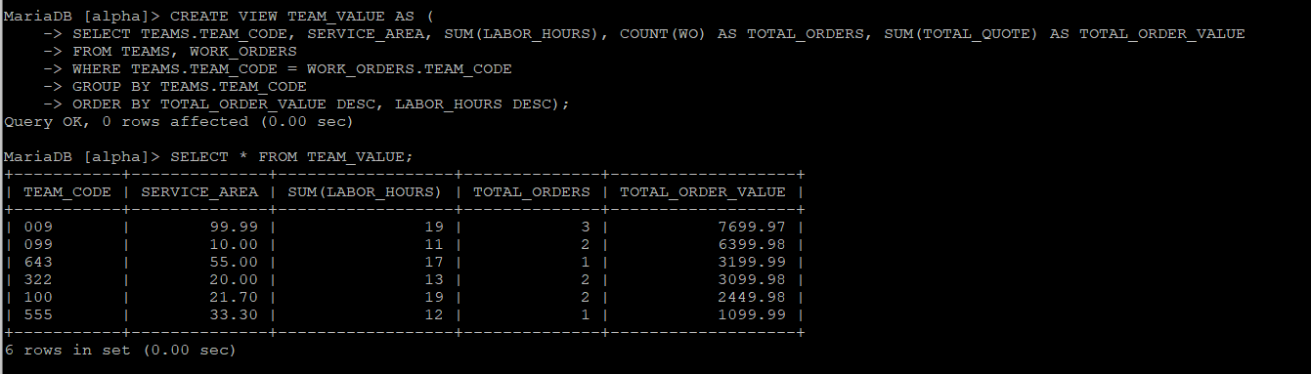

9. Create a view to show the Work Order number, first name, and last name of all employees on orders that have been paid.

CREATE VIEW WO_EMPLOYEES AS

SELECT WO, E_FIRST, E_LAST

FROM EMPLOYEES, WORK_ORDERS

WHERE WORK_ORDERS.TEAM_CODE = EMPLOYEES.TEAM_CODE

AND IS_PAID = 'Y'

ORDER BY WO;

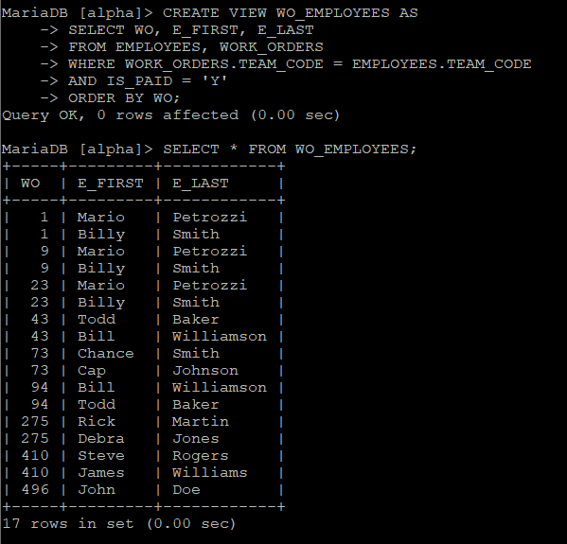

10. Show the sum of the total quote (total account) for each client

SELECT DISTINCT CLIENT_NAME, SUM(TOTAL_QUOTE) AS TOTAL_ACCOUNT

FROM CLIENT, WORK_ORDERS, CLIENT_LOCATIONS

WHERE CLIENT.CLIENT_NUM = CLIENT_LOCATIONS.CLIENT_NUM

AND CLIENT_LOCATIONS.CLOC_NUM = WORK_ORDERS.CLOC_NUM

GROUP BY CLIENT_NAME

ORDER BY TOTAL_ACCOUNT DESC;

