Custom Gifting Platform
B2B Flow — Build Handoff Specification (v1)
Prepared for the development team · Draft · Confidential
Contents

1. Scope & Locked Decisions
This document specifies the B2B order flow for v1. It reflects decisions already made; build to these unless explicitly changed.
Decision | Resolution
Launch audience | B2B first. Named buyers waiting. Optimize for getting real orders flowing, not breadth.
Inventory model | Light stock on a small predictable core; make-to-order the rest. NOT pure no-stock (no supplier single-units at trade price).
Browsing | Public, no account required. Account/login is required ONLY at Request Quote.
Product variety | Four sources: (a) stocked core blanks with full variant trees, (b) request-a-specific-item in the quote, (c) scraped UV blanks (marketplace) behind an admin gate, (d) scraped 3D models (CC0/CC-BY only) + owned models.
Two printer tracks | UV printer decorates existing blank objects (corporate gifts) — needs blank-goods supply. 3D printer fabricates objects from model files — needs filament inventory + licensed models. Different supply chains; do not force into one pipeline.
3D model licensing | Publish only CC0 / CC-BY scraped models (CC-BY = credit the creator) plus owned/commissioned models. No per-order licence buying (manual review takes days and would break quoted lead times). Licence tag is a mandatory publish gate.
Procurement | UV blanks: bought per confirmed order (marketplace retail) or replenished in bulk for core; mandatory stock re-check before production. 3D: printed in-house from filament — no blank purchase, only filament inventory. No automated marketplace checkout bots.
Pricing | Cost-plus, fully configurable from superadmin dashboard. The blank's 10% product markup does NOT cover make-to-order economics — margin comes from customization fee + markup on the real landed cost.
Scraped images | Shown as-is for v1 (flagged tech debt — to be replaced with cleared images later).
Price drift threshold | 10% (configurable).
CRITICAL ISOLATION RULE
Scraped products are a SEPARATE product class from core/variant products. A scraper failure, dead source, or stale-data problem must degrade only the scraped catalogue — it must NEVER block the core B2B flow your named buyers use. Build the two tracks independently.

2. Product Classes
The customer sees one catalogue. Internally, every product belongs to one of three classes that differ only in how stock and fulfilment are handled.
Class | Source | Stock handling | Fulfilment
Core (stocked) | ~8–15 predictable B2B blanks (drinkware, pens, power banks, notebooks, totes), with variant trees (colour/size/material). | Live stock-on-hand + reorder threshold. Bulk-bought at trade price. | Ships from shelf; reorder in bulk when low (human-approved draft PO).
Tail (make-to-order) | Off-catalogue / bespoke items, mostly B2C single units; also a B2B 'request a specific item' path. | No stock held. | Bought per order; priced with bespoke surcharge + longer lead time.
Scraped — UV blanks | Shopee / Lazada / etc. (marketplace), behind admin gate. | Indicative stock only (scraped, best-effort). Bought at marketplace retail per order. | Bought per confirmed order; mandatory stock re-check before production.
Scraped — 3D models | Thingiverse (primary, public API) + Cults3D (secondary, GraphQL API); MakerWorld optional. A design-file library, NOT a goods supplier. | No physical stock. The only inventory is your filament. The object is fabricated in-house from the model file. | Print to order from filament; no per-order purchase of a blank.
3D MODELS ARE NOT A SUPPLY SOURCE — AND CARRY A LICENCE GATE
MakerWorld/Printables provide design files, not products. Nothing physical ships to you — you fabricate the item from your own filament. The marketplace scrape/buy/stock-re-check flow does NOT apply to 3D.
Selling prints of a model commercially requires a valid licence; a free download is NOT permission to sell. For v1, only models tagged CC0 or CC-BY may be published (CC-BY requires crediting the creator). Anything NonCommercial (NC), unknown, or untagged is blocked. Owned/commissioned models with full rights are always allowed.

3. End-to-End B2B Flow
The diagram below shows the full customer-to-production path. Each stage is detailed in the sub-sections that follow.
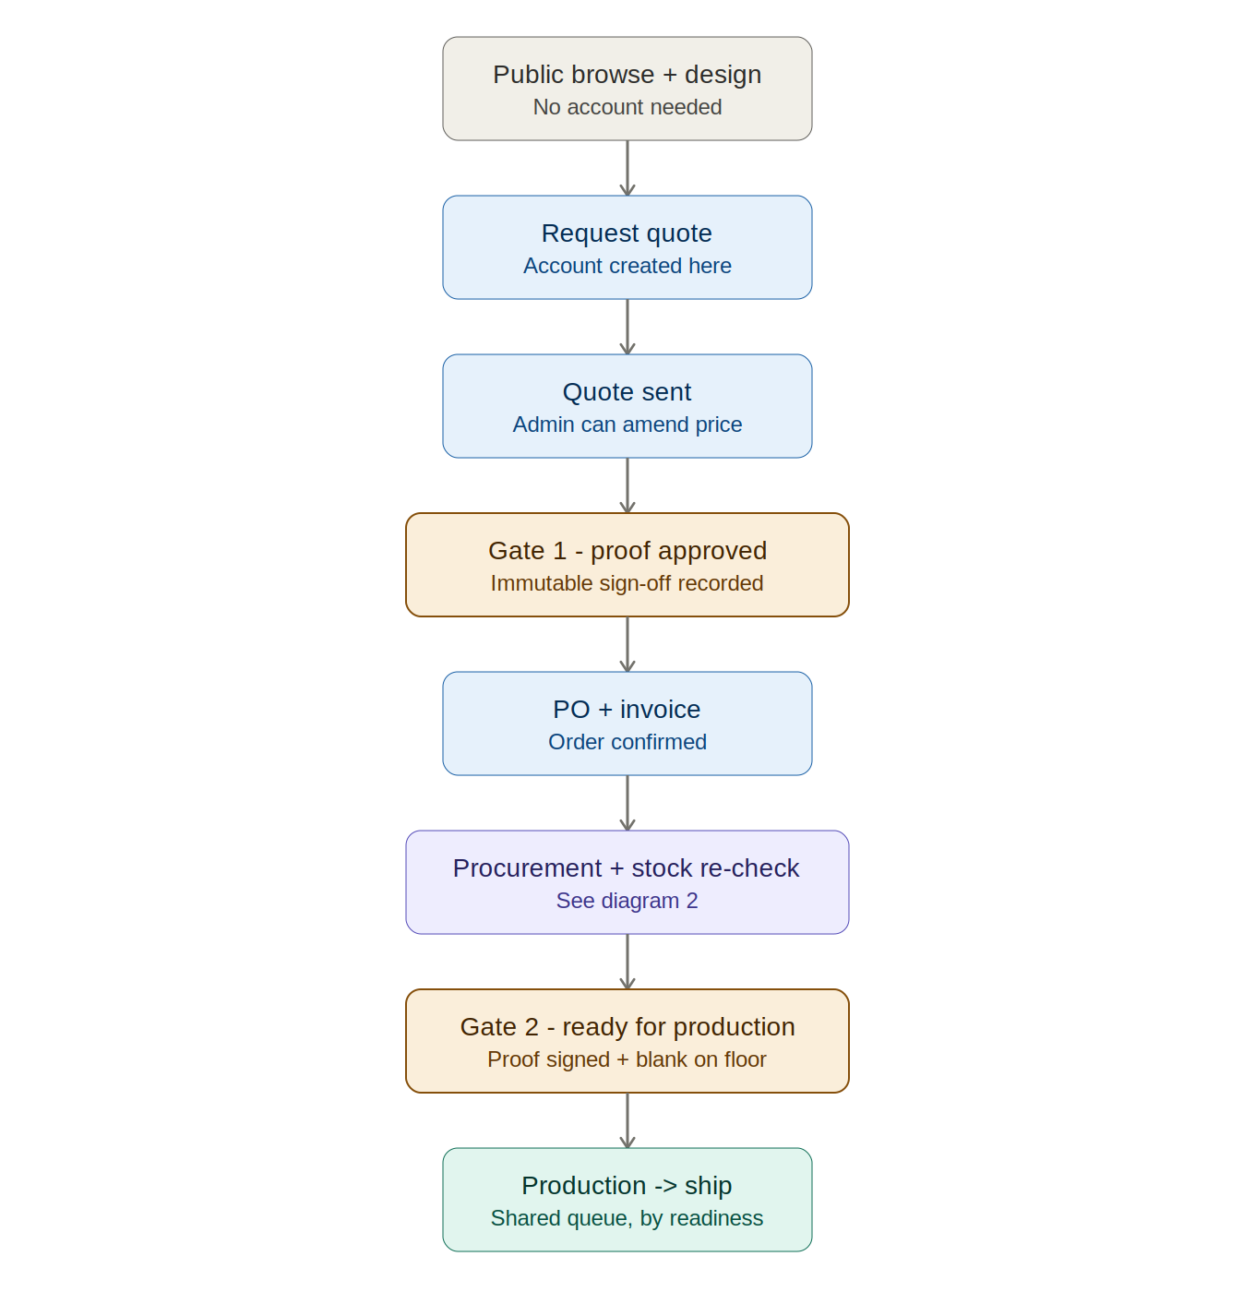
Figure 1 — Main B2B order flow, browse to production. Amber boxes are the two hard gates.

Stage 0 — Public browse (no account)
- Full catalogue, product pages, the on-screen designer, and a live price estimate are all public. No login to view or mock up.
- Account/login is triggered only at Request Quote, where a company identity, PO details, and a record to attach proof + invoice to are needed.
- Company account, once created, is flagged B2B → defaults to the quote-and-PO route (Stripe card checkout remains available for small orders if desired).

Stage 1 — Browse, design, configure
- Buyer selects product(s), sets quantity, uploads logo / specifies branding in the designer.
- Capture the production-grade artifact, not just a preview: print-resolution artwork, placement, size, and print method (UV vs 3D). This is the file the floor prints from — capture it now or it gets re-chased later.
- Buyer clicks Request Quote (default for B2B).

Stage 2 — Quote generation
- Draft quote = blank base cost + margin + per-logo customization fee + per-unit print cost + delivery, from the dynamic pricing config. Bulk pricing logic applies at/above the configured quantity threshold (e.g. 500 pcs).
- Lead time is stock-aware: Core in-stock → short; Core low or Tail/Scraped → includes procurement time.
- Admin can amend any price before sending the quote. This is a human backstop independent of scraping — it always works even if a scrape failed.
- v1 simplification (optional): route all quotes through human review and skip the auto-quote engine. Slower per quote, far less to build.

Stage 3 — Proof & sign-off (B2B-critical)
- You produce a formal visual proof of the branding on the product — distinct from the designer preview.
- Buyer reviews → requests changes (loop) → or approves.
- Approval is recorded immutably: who approved, exact artwork, timestamp. A logo wrong across 500 units is the costly mistake — the signed proof makes it the customer's call, not your liability.
- No production happens before an approved proof exists.

Stage 4 — PO & invoice
- On approval, buyer issues/uploads a PO; system generates an invoice. Terms per business rules (net-30, pay-on-invoice, or Stripe for small orders).
- Order state = Confirmed, awaiting readiness. Not yet ready for production.

Stage 5 — Procurement & stock re-check (the real protection)
Behaviour branches by product class. Stage 5 is the only authoritative stock/price read — the scraped estimate is never trusted as a promise.
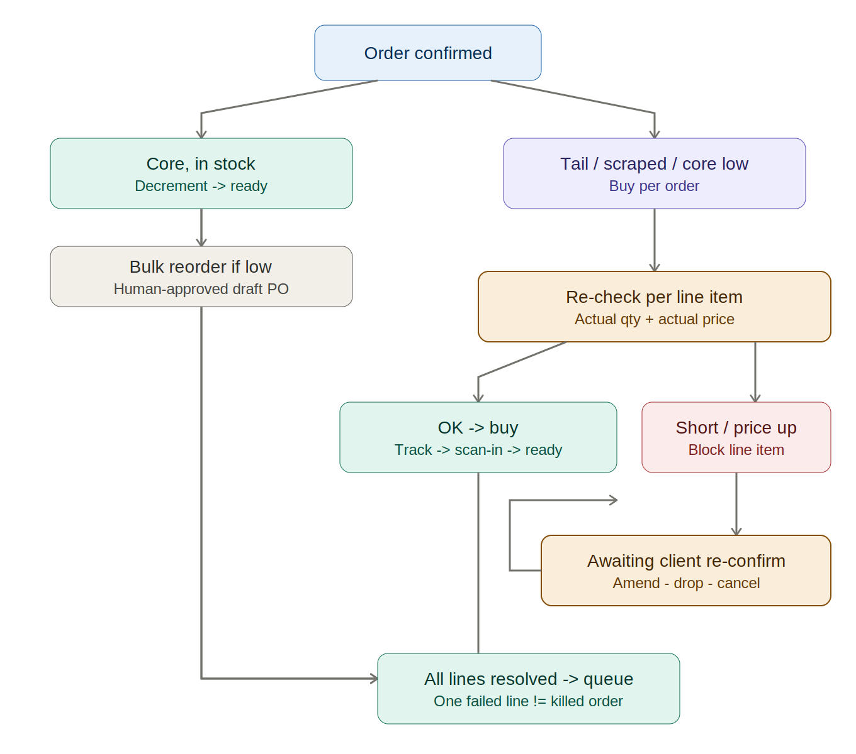
Figure 2 — Procurement branch and per-line-item stock/price re-check.

Core, in stock
- Decrement stock-on-hand by order qty → job flips straight to Ready for Production.
- If decrement crosses the reorder threshold → system raises a draft bulk PO to the wholesale supplier for human approval (legal, automatable reorder — not per-order, not a bot).

Core (short), Tail, or Scraped — buy per order
- Admin procures the blank(s): wholesale supplier for Core/Tail; marketplace retail for Scraped.
- Capture ACTUAL available qty and ACTUAL paid price at purchase. Per line item, not per order.
Per-line-item outcomes:
  - Qty OK & price OK → buy → track inbound → scan-in + QC on arrival → line item ready.
  - Qty short (e.g. ordered 5000, only 1000 left) → line item → Awaiting Client Re-confirmation (production blocked). Client chooses: amend qty / drop item / cancel. Only their choice releases it forward.
  - Price jumped beyond tolerance → re-quote that line → client approves or drops.
- Once all line items are resolved → job enters the production queue. A multi-item quote where one item fails does not kill the others.

Stage 6 — Production queue (shared)
- Build the queue shared from day one even though B2B launches first — B2C will feed the same queue, and rebuilding it later is wasteful.
- Readiness rule: a job is Ready only when (a) proof is signed AND (b) the blank is physically on your floor. Ordering is first-come-first-served by readiness time, not order-placed time — so an early-but-late-confirmed order can't jump ahead of one that was ready sooner.
- Short jobs can be slotted into gaps during long runs so machines never idle. No customer-type priority.
- Job carries everything the floor needs: print-ready file, placement, method, quantity.

Stage 7 — Production → ship → close
- Honest, minimal status stages drawn from real floor state: Confirmed → In Production → Shipped.
- Buyer notified at each transition; tracking sent on ship; order closed.

4. State Machine
Two gates block forward movement and are the whole point of the B2B flow:
- Proof Approved — nothing produced without recorded sign-off.
- Ready for Production — requires proof approved AND blank on floor.
Draft Quote → Quote Sent → [revision loop] → Proof Sent → [revision loop] → Proof Approved → PO / Invoice → Confirmed → [procurement + stock re-check if needed] → Ready for Production → In Production → Shipped → Closed
Side branches: Awaiting Client Re-confirmation (qty short / price jumped) sits between procurement and Ready, and resolves to amend / drop / cancel.

5. Scraped-Product Admin Gate
This module governs how scraped items reach the public catalogue. It is isolated from the core flow (see Section 1).
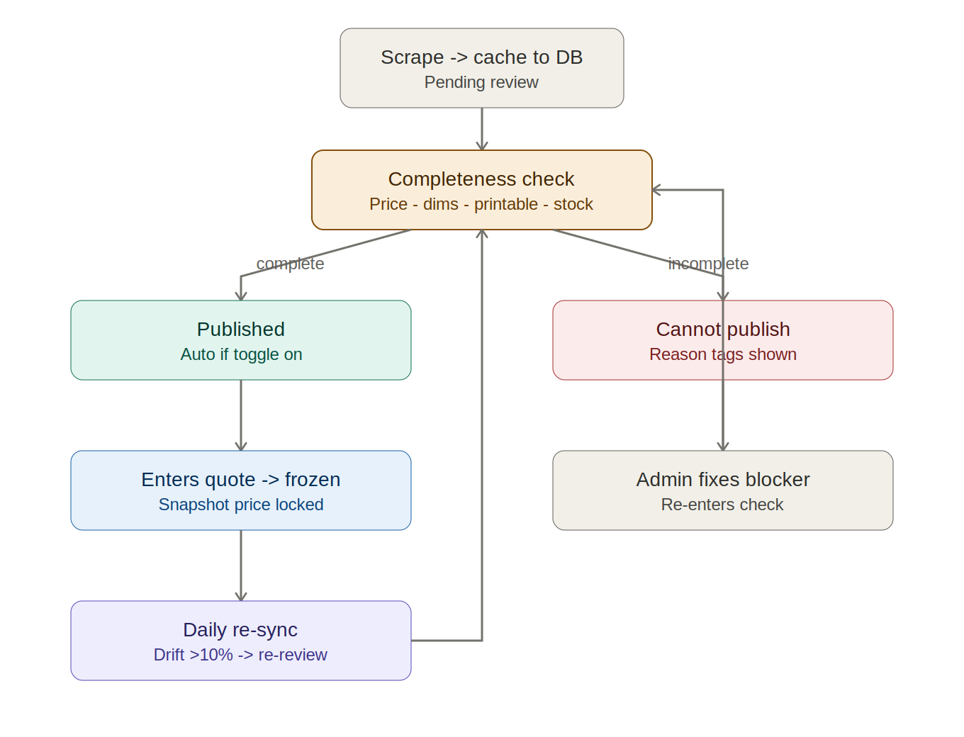
Figure 3 — Scraped UV-blank admin gate: ingest, completeness check, publish/hold, daily drift sync.

5A. Ingest
- Scrapers pull from marketplaces (Shopee/Lazada/etc): image, title, price, stock estimate, source URL, product ID. Run daily.
- 3dworldmaker (non-marketplace): pull what's available; price, dimensions, and shipping are always admin-entered.
- Everything scraped is cached into your own database. The app serves the catalogue from your DB, never live from the source — this gives stability and makes the freeze-on-quote rule trivial.
- New scrapes land in a Pending Review queue. Nothing is public until it passes the gate (or auto-publishes — see 5C).

5B. Completeness gate
An item is publishable only when ALL required fields are present and valid:
Field | Rule
Price | Auto-filled if scraped; mandatory manual entry if scrape failed.
Dimensions + weight | Required (drives shipping cost). Mandatory manual entry for 3dworldmaker.
Printable | Print method (UV/3D) confirmed AND fits max print size. Cannot publish if unprintable.
Stock estimate | Present. Always displayed to customers with an 'Estimate' label — never a guarantee.
Image | Shown as scraped for v1 (flagged tech debt).
Licence (3D models only) | Mandatory. Only CC0 or CC-BY publishes. CC-BY stores + displays creator credit. NC / unknown / untagged → blocked as 'Licence not verified'. Owned models bypass with a rights flag.

5C. Auto-publish toggle
- Global automation toggle: ON = complete items publish automatically; OFF = everything waits for manual approval.
- Per-item override: force-publish or hold a single item regardless of the global setting.
- Cannot Publish queue with reason tags surfaces exactly why an item is blocked so admin can act: Missing price · Missing dimensions · Not printable / size unknown · Stock unreadable · Source dead.
- Fixing the blocker auto-clears the item to public (if global ON) or to Ready-to-approve (if global OFF).
- Dashboard view: Published / Cannot Publish (with reasons) / In a Quote (frozen).

5D. Daily sync, drift & freeze-on-quote
- Freeze-on-quote: the moment an item enters a quote, snapshot its price/spec into the quote. Background sync may keep updating the catalogue record, but the quote reads its frozen snapshot — never moved under the client.
- Daily re-scrape updates the indicative stock and price of un-quoted published items.
- Price drift > 10% (configurable) → item flips to Cannot Publish → 'Needs re-review' and is auto-pulled from public until admin checks. Prevents selling on a stale price.
- Source URL dead → auto-unpublish + alert.
- Drift detection is best-effort: if a scrape fails, drift can't be detected. That is why the Stage-2 admin amend and the Stage-5 purchase re-check are the real guarantees — they work regardless of scraping.
PROTECTION STACK (weakest → strongest)
1. Daily scrape + drift flag — best-effort early warning; fails silently if the scrape fails.
2. Admin amends price before sending the quote — human catch.
3. Stage-5 purchase re-check — authoritative truth at the moment of buying; always works. This is what protects both you and the B2B client.

6. The 3D Print Track (separate from UV)
UV and 3D are different supply chains and must not share the procurement pipeline. The scrape / buy-blank / stock-re-check flow in Section 5 is UV-only. The 3D track below replaces it for 3D-printed B2B products.

6A. What the 3D track needs
- Filament inventory by material + colour (PLA, PETG, ABS, TPU, etc). This is the only physical stock for 3D — there is no blank to buy per order. Replenished in bulk from filament distributors (e.g. Polymaker, eSUN, local Indonesian distributors).
- A licensed model library, pulled via API. Primary source: Thingiverse public API (free; returns name, images, creator, files, and the per-model licence). Secondary: Cults3D GraphQL API (returns metadata + flags commercial-use licences). MakerWorld optional. Each model carries a rights status: CC0, CC-BY (with creator credit stored), or Owned/commissioned.
- Licence read from the API, gated automatically. The publish gate reads the per-model licence field and only passes CC0 or CC-BY (commercial-OK on Cults). NonCommercial, unknown, or untagged is blocked. This is automatable precisely because the APIs expose the licence — no manual per-model review, unlike a MakerWorld membership model.
- The model file itself (STL/3MF) — downloaded once the rights are clear, stored for production. No per-order marketplace purchase.

6B. 3D order flow
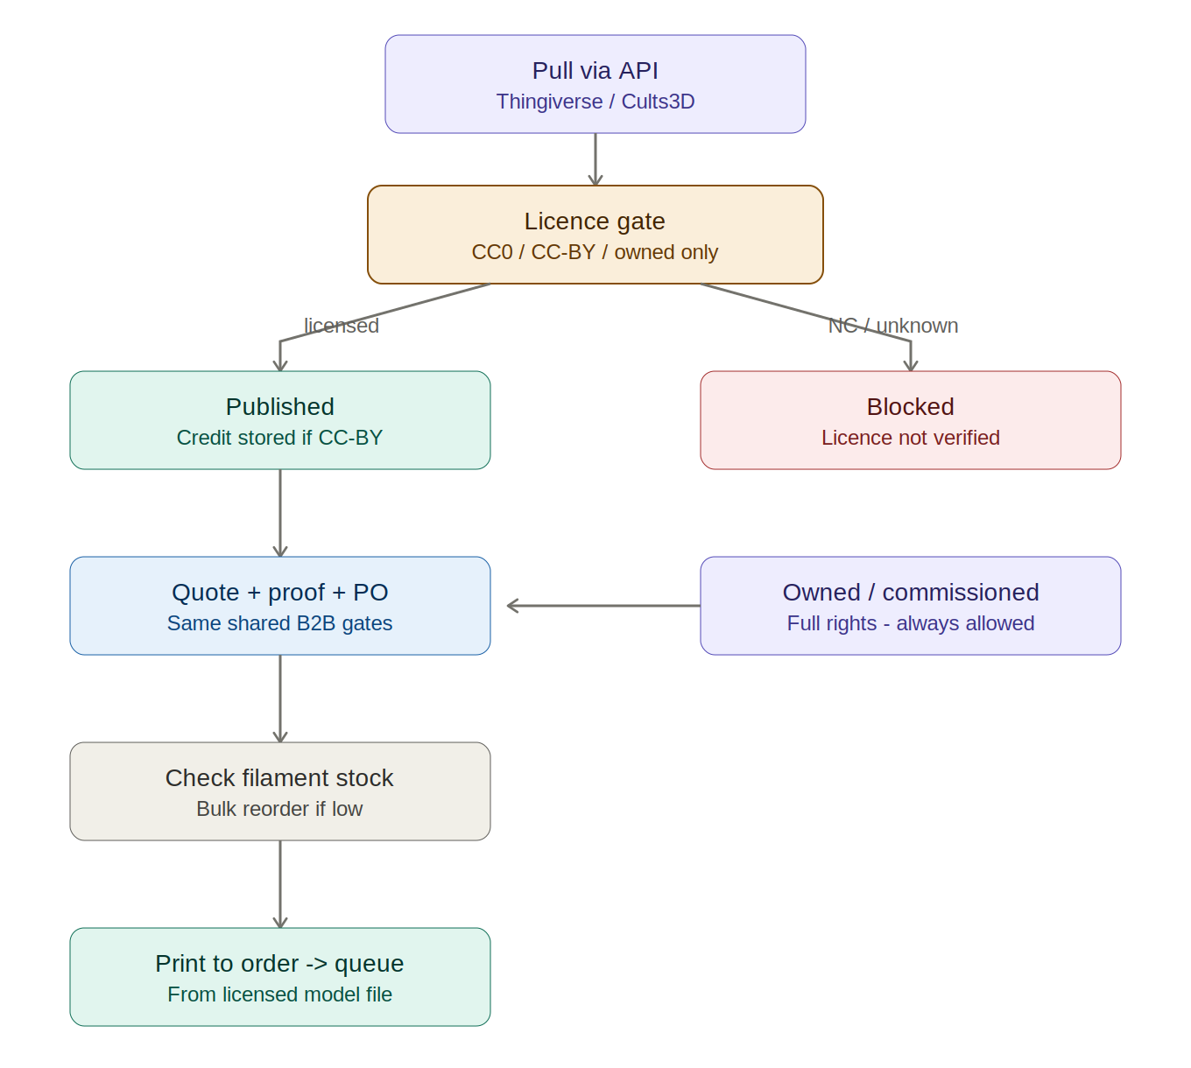
Figure 4 — 3D print track: API pull, licence gate, print-to-order from filament. Owned models bypass the gate.
- Customer selects a published 3D product (CC0/CC-BY/owned only) → designs/personalises as applicable → request quote.
- Quote + proof + PO as per the shared B2B flow (Sections 3–4). The proof gate and PO gate are identical.
- On confirmation: no blank to procure. Check filament stock for the required material/colour; if low, raise a bulk filament reorder (human-approved).
- Print to order from the licensed model file → finish/QC → job enters the same shared production queue as UV jobs.
WHY NOT 'PUBLISH NOW, LICENCE ON CONFIRMATION'
Buying the licence only after a client confirms fails twice: (1) displaying the model to advertise a sale already needs the commercial right, so you'd be exposed during the whole browse/quote window; (2) licence approval is manual and takes days, which would break the lead time you quoted. The fix is to publish only what you can already sell — CC0/CC-BY + owned — so the right exists before the model is ever shown.

7. Decisions Still Owed Before / During Build
- Pricing & margins: agree real costs and the markup once production figures are reviewed. The app keeps these dynamic in the superadmin dashboard.
- Proof production owner & SLA: who creates the proof and how fast. This is the step most likely to bottleneck B2B because it sits between the customer and their money — decide the turnaround now, not after launch.
- Admin gate + procurement owner & SLA: scraped-in-v1 means a real daily ops role exists at launch (reviewing pending items, buying per order, handling re-confirms). Confirm the person.
- Reorder thresholds per core blank, and which ~8–15 blanks make the core list (mix of domestic for short lead times and imported for longer).
- Pay-now vs quote cut-off rule (order size or other) — B2B accounts always default to quote-and-PO regardless.
- 3D model rights: confirm the launch 3D catalogue is CC0/CC-BY + owned models only. Decide whether to commission a small set of owned hero models, and/or pre-purchase commercial-licence memberships for 1–2 favoured creators so their models can be sold without per-order delay.

8. Suggested v1 Build Order
Lead with the shared spine, prove the flow, then layer complexity.
- Shared production queue + the two gates (Proof Approved, Ready for Production). The heart of operations.
- Public browse + designer + price estimate (no account).
- Core blanks with variant trees + 'request a specific item' field.
- Quote → proof + immutable approval → PO/invoice (quote can be human-reviewed in v1).
- Procurement + per-line-item stock re-check (the Stage-5 protection).
- Scraped UV-blank admin gate (ingest → completeness → auto-publish toggle → daily sync/drift), built isolated from the core track.
- 3D track: filament inventory + licensed-model library (CC0/CC-BY + owned) + print-to-order, feeding the shared queue. Licence gate is mandatory.
Deferred beyond v1: auto-quote pricing engine, demand-intelligence layer, cleared-image pipeline, B2C pay-now flow (feeds the same queue when added).

