CURRICULUM VITAE

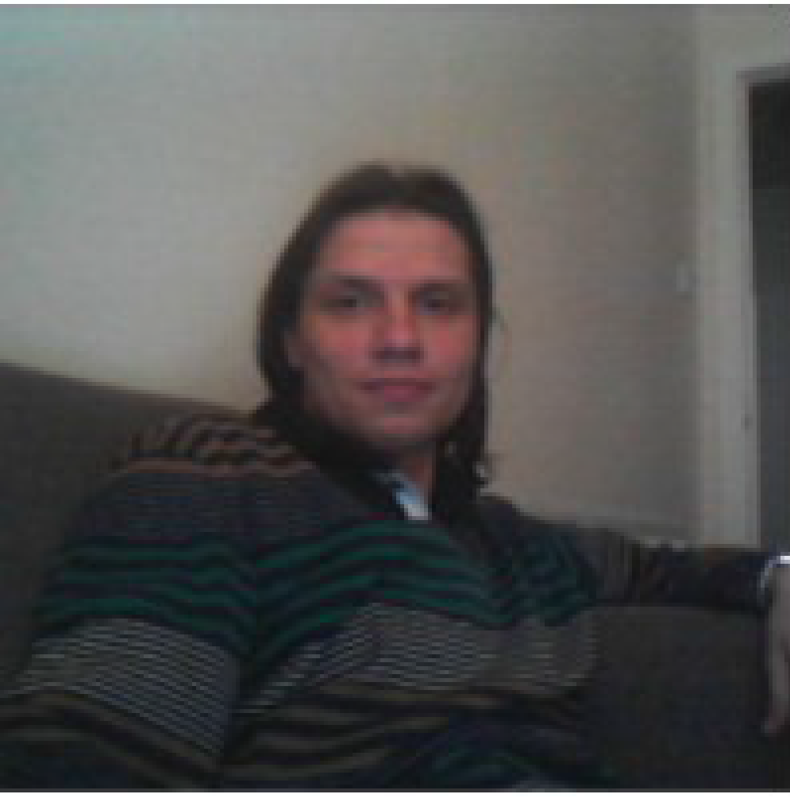
Name: Urmas Repinski
Date of Birth: 12. March 1981

Nationality: Russian
Citizenship: Estonia/EU

Contact Information:
Phone: +372 57 825645
E-mail: urrimus@hotmail.com
Skype: urimus
Homepage: https://urimus.github.io/about_me_eng.html

Education: 2009-2014 (not finished) PhD Computer Science, Tallinn University of Technology, Tallinn, Estonia.

2004 - 2006 MSc Computer Science, Tallinn University of Technology, Tallinn, Estonia

      - 1999 - 2004 BSc Computer Science, University of Tartu, Tartu, Estonia

About me:
Hello,

The project I worked on at the Tallinn Technical University - Forensic - was in C++, a scientific project. Sufficient description in the Summary, link in English http://www.informatik.uni-bremen.de/agra/eng/forensic.php

I have a Homepage on GitHub, fully functioning: https://urimus.github.io/about_me_eng.html
The page is also a portfolio.

Basically, the page code consists of Html + JavaScript, a little PHP (does not work on GitHub). Each HTML page uses a script https://urimus.github.io/scripts/pageResize.js
To display the Appearing Menu, the script https://urimus.github.io/scripts/showMenu.js is used.

Sections you may be interested in:
1. Site Map - https://urimus.github.io/site_map_eng.html?type=aboutme&sortby=name. JavaScript Code that makes this section work - https://urimus.github.io/scripts/showContents.js

2. News - News Feed NASA - https://urimus.github.io/news_eng.html?source=nasa&type=releases (also exists other News, complete list on Homepage in Section News). Relevant Code - https://urimus.github.io/scripts/showFeed.js.

3. The most voluminous section is the HTML editor, which allows you to modify the content of this site online directly from the same website. For the editor to work (https://urimus.github.io/html_editor_eng.html?pattern=spec/mo*&i=0) PHP support and also a password are required; it does not function on GitHub, but the corresponding JavaScript files are required to work on server that supports PHP further:
a. https://urimus.github.io/scripts/processSearchAndReplace.js
b. https://urimus.github.io/scripts/functionsAndConstants.js

Also know C++, JavaScript, PHP, HTML, Css, MySQL well, and studying Python.

Thank you,
Urmas Repinski.

Pdf CV - https://urimus.github.io/cv/CV_English_Urmas_Repinski.pdf

Employment Summary:

▪ General Worker – Factory Worker at Gap Personnel, Wrexham, UK, December 2015 - February 2016.
Address: 12 Charles Street, Wrexham, Wrexham Maelor, UK, LL13 8BT
Tel: 01978 366666
Email: wrexham@gap-personnel.com
- Various general worker tasks.
- The work were 8 hours per day, 5-6 days per week.
- Moved to Berlin.

▪ Web Developer – Laravel – AskAlpha, Bangkok, Thailand, July 2015 - August 2015.

Worked as Web Developer at AskAlpha, Bangkok, Thailand. My tasks were:
- Planning, Development, Code Writing and Documentation writing for the Car Rent/Insurance web site.
- Techniques used – Jquery, Laravel, Bootstrap.
- Unfortunately worked in this company 1 month only.

▪ General Worker – Kitchen Porter at Evolve Recruitment, London, November 2014 - January 2015.
Address: 4th Floor, Greenhill House, 90-93 Cowcross Street, London, UK, EC1M 6BF
Telephone: 0207 397 1260
Email: evolvelondon@evolvehospitality.co.uk
Worked as Kitchen Porter at Evolve Recruitment, London, UK. My tasks were:
- Dish washing, cleaning and helping in the kitchen.
- Part-time work.

▪ General Worker - Packer at Staffline Recruitment, May 2014 - October 2014.
Address: 21 Melford Rd, Righead Ind Est, Bellshill, Lanarkshire, UK, ML4 3LR
Phone Number: 01698 748016
Email: enquiries@staffline.co.uk
Worked as General Worker at Staffline Recruitment in Morrisons Warehouse, Bellshill, Schottland, UK. My tasks were:
- The work was 8 hours per day, 5-6 days per week.
- After moved to London.

▪ PHP Developer – Satron RD (TOP-Tronic)
May 2012 – July 2012

Worked as a PHP Developer in Satron RD, Estonia
- Responsible for Development of the Object-Oriented Structure for the PHP Software.
- The size of the code is above 5 thousands lines of code.
- Simple and reliable software for Editing Languages in Jura Coffee Machines.

▪ C++ Developer – Tallinn University of Technology
January 2010 – March 2012

In 2010 started to work as developer for Tallinn University of Technology. Project’s web page is at the address fp7-diamond.eu. The project were based on C++ object oriented model, model-based error localisation and mutation-based error correction of C designs, and is complete.
- Responsible for Development of the Object-Oriented Structure for the DIAMOND project.
- Responsible for development of error localisation and correction back-ends of the developed tool. The error correction used the developed Object-Oriented Structure – the model.
- Tested written structure with different C designs.
- The size of the tool is above 20 thousands lines of code and required over 50 C++ files.

▪ C++ Developer – Information Technology N
February 2009 – December 2009

In 2009 worked as a c++ developer in Information Technology Ń, Italian Company. Work were interesting and challenging, my task were to develop 3D modelling software, software were written using C++ Object Oriented Structure. Software will be used for measuring of the details in CNC machines.
- Responsible for Development of the Object-Oriented Structure for the 3D modelling project.
- Tested the 3D modelling software with different scenarios.
- Used 3D modelling tools like AutoCAD for Development.
- Size of the tool is above 5 thousands lines of code and required over 50 C++ files.

▪ Line operative - Food Factories in UK
January 2008 – March 2009

Worked as Line Operative at the Food Factories, Boston, UK. My tasks were:
- Work at the production line, line operative.
- 40 Hours per week.
- After moved to Tallinn.

▪ PHP Developer – Titanium Systems
November 2006 – December 2007

In 2006 worked as a PHP developer in Titanium Systems, Estonian Company. Developed Internet Car Booking System, Administrative Back-End, system were build using PHP/MySQL.
- Responsible for Development of Administrative Back-End of the Car Rental Internet Page.
- Used Standard Editors for HTML editing and testing.
- Implemented a lot of statistical calculation and visualisation using MySQL databases.
- Tested the developed product.

▪ Image Processing – Evotec Technologies
December 2003 – May 2006

In 2003 worked as a developer of the image processing tools in Evotec Technologies, German Company. Work were interesting, my task was to develop image processing scripts using Acapella image processing language. Developed scripts were used for processing of cell's photos.
- Responsible for Development of the Image Processing Scripts.
- Used Standard Algorithms for Development.
- Implemented a lot of statistical calculation and visualisations using the Acapella Programming language.
- Tested the developed product.

Publications:

- Repinski, Urmas (2012). Model-based Verification with Error Localization and Error Correction for C Designs. Программные продукты и системы, No 100, pp. 221 - 229.
- Репинский, Урмас (2012). Нахождение и исправление ошибок в С дизайнах. Программные продукты и системы, N 100, стр. 229 - 237.
- Repinski, Urmas; Raik, Jaan (2013). Comparison of Model-Based Error Localization Algorithms for C Designs. East-West Design & Test Symposium, (1 - 4). IEEE Computer Society Press.
- Bloem, Roderick; Drechsler, Rolf; Fey, Goerschwin; Finder, Alexander; Hofferek, Georg; Koenighofer, Robert; Raik, Jaan; Repinski, Urmas; Suelflow, Andre (2012). FoREnSiC - An Automatic Debugging Environment for C Programs. Haifa Verification Conference (1 - 6). IBM Research Labs, Haifa, Israel: IBM

Language Skills:

- Russian - native
- English – speaking – very good, reading – very good, writing – very good
- Estonian – speaking – very good, reading – very good, writing – very good
- German – speaking – low, reading – low, writing – good

