CURRICULUM VITAE

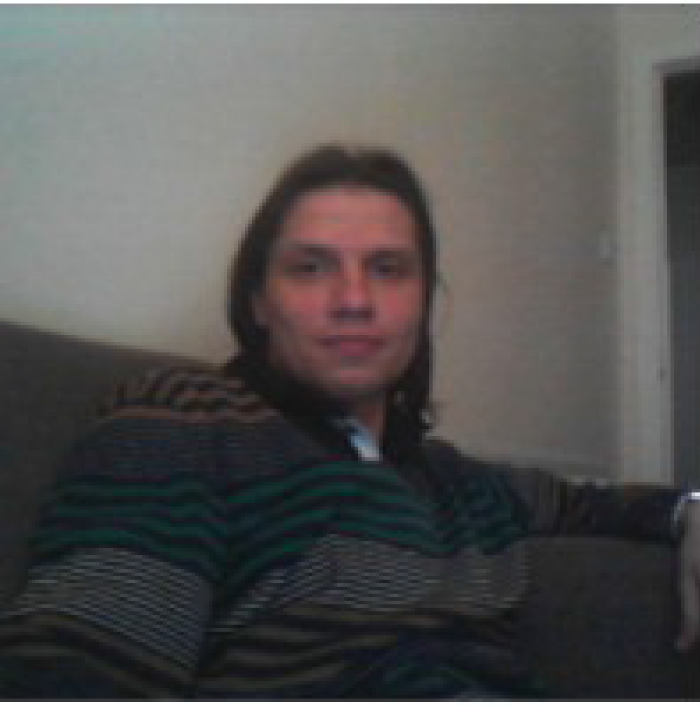

**Name:** Urmas Repinski

**Date of Birth:** 12. March 1981

**Nationality:** Russian

**Citizenship:** Estonia/EU

**Contact Information:**

**Phone:** +372 57 825645

**E-mail:** urrimus@hotmail.com

**Skype:**  urimus

**Homepage:** https://urimus.wasmer.app/about_me_eng.html

**Education:** 2009-2014 (not finished) PhD Computer Science, Tallinn University of Technology, Tallinn, Estonia.

2004 - 2006 MSc Computer Science, Tallinn University of Technology, Tallinn, Estonia

* + - 1. 1999 - 2004 BSc Computer Science, University of Tartu, Tartu, Estonia

**About me:** Hello,

I have a homepage on GitHub, fully functional: https://urimus.wasmer.app/about_me_eng.html

In general page’s code consists of Html+JavaScript, a little of PHP (on GitHub not functioning). For each HTML page’s work script is used: https://urimus.wasmer.app/scripts/pageResize.js

For showing of the PopUp menu script is used: https://urimus.wasmer.app/scripts/showMenu.js

Sections, that can interest you:

1. Site Map - https://urimus.wasmer.app/index_eng.html?type=aboutme&sortby=name . JavaScript Code, supports this section’s work - https://urimus.wasmer.app/scripts/showContents.js

2. News - Lenta.ru and BBC RSS Feed - https://urimus.wasmer.app/news_rus.html?type=world . Corresponding Code - https://urimus.wasmer.app/scripts/showFeed.js . For Feed reading library feednami is used (https://toolkit.sekando.com/docs/en/feednami) that works on JavaScript.

3. Most volumetric section - HTML editor, that allows to modify this page’s contents online directly from this site. For editor’s work (https://urimus.wasmer.app/html_editor_eng.html?pattern=*.html&i=0) PHP support is required and, also, password, on GitHub this is not functioning, but corresponding JavaScript for work on server, that supports PHP, following:

a. https://urimus.wasmer.app/scripts/processSearchAndReplace.js

b. https://urimus.wasmer.app/scripts/functionsAndConstants.js

Also know good C++, JavaScript, PHP, HTML, Css, MySQL, study Python.

For any personal information about me please refer to my homepage.

**Employment Summary:**

**▪ General Worker – Factory Worker at Gap Personnel, Wrexham, UK, December 2015 - February 2016.**

Address: 12 Charles Street, Wrexham, Wrexham Maelor, UK, LL13 8BT

Tel: 01978 366666

Email: wrexham@gap-personnel.com

- Various general worker tasks.

- The work were 8 hours per day, 5-6 days per week.

- Moved to Berlin.

**▪ Web Developer – Laravel – AskAlpha, Bangkok, Thailand, July 2015 - August 2015.**

Worked as Web Developer at AskAlpha, Bangkok, Thailand. My tasks were:

* Planning, Development, Code Writing and Documentation writing for the Car Rent/Insurance web site.
* Techniques used – Jquery, Laravel, Bootstrap.
* Unfortunately worked in this company 1 month only.

**▪ General Worker – Kitchen Porter at Evolve Recruitment, London, November 2014 - January 2015.**

Address: 4th Floor, Greenhill House, 90-93 Cowcross Street, London, UK, EC1M 6BF

Telephone: 0207 397 1260

Email: [evolvelondon@evolvehospitality.co.uk](mailto:evolvelondon@evolvehospitality.co.uk)

Worked as Kitchen Porter at Evolve Recruitment, London, UK. My tasks were:

* Dish washing, cleaning and helping in the kitchen.
* Part-time work.

**▪ General Worker - Packer at Staffline Recruitment, May 2014 - October 2014.**

Address: 21 Melford Rd, Righead Ind Est, Bellshill, Lanarkshire, UK, ML4 3LR

Phone Number: 01698 748016

Email: enquiries@staffline.co.uk

Worked as General Worker at Staffline Recruitment in Morrisons Warehouse, Bellshill, Schottland, UK. My tasks were:

* The work was 8 hours per day, 5-6 days per week.
* After moved to London.

**▪ PHP Developer – Satron RD (TOP-Tronic)**

**May 2012 – July 2012**

Worked as a PHP Developer in Satron RD, Estonia

* Responsible for Development of the Object-Oriented Structure for the PHP Software.
* The size of the code is above 5 thousands lines of code.
* Simple and reliable software for Editing Languages in Jura Coffee Machines.

**▪ C++ Developer – Tallinn University of Technology**

**January 2010 – March 2012**

In 2010 started to work as developer for Tallinn University of Technology. Project’s web page is at the address fp7-diamond.eu. The project were based on C++ object oriented model, model-based error localisation and mutation-based error correction of C designs, and is complete.

* Responsible for Development of the Object-Oriented Structure for the DIAMOND project.
* Responsible for development of error localisation and correction back-ends of the developed tool. The error correction used the developed Object-Oriented Structure – the model.
* Tested written structure with different C designs.
* The size of the tool is above 20 thousands lines of code and required over 50 C++ files.

**▪ C++ Developer – Information Technology N**

**February 2009 – December 2009**

In 2009 worked as a c++ developer in Information Technology Ń, Italian Company. Work were interesting and challenging, my task were to develop 3D modelling software, software were written using C++ Object Oriented Structure. Software will be used for measuring of the details in CNC machines.

* Responsible for Development of the Object-Oriented Structure for the 3D modelling project.
* Tested the 3D modelling software with different scenarios.
* Used 3D modelling tools like AutoCAD for Development.
* Size of the tool is above 5 thousands lines of code and required over 50 C++ files.

**▪ Line operative - Food Factories in UK**

**January 2008 – March 2009**

Worked as Line Operative at the Food Factories, Boston, UK. My tasks were:

* Work at the production line, line operative.
* 40 Hours per week.
* After moved to Tallinn.

**▪ PHP Developer – Titanium Systems**

**November 2006 – December 2007**

In 2006 worked as a PHP developer in Titanium Systems, Estonian Company. Developed Internet Car Booking System, Administrative Back-End, system were build using PHP/MySQL.

* Responsible for Development of Administrative Back-End of the Car Rental Internet Page.
* Used Standard Editors for HTML editing and testing.
* Implemented a lot of statistical calculation and visualisation using MySQL databases.
* Tested the developed product.

**▪ Image Processing – Evotec Technologies**

**December 2003 – May 2006**

In 2003 worked as a developer of the image processing tools in Evotec Technologies, German Company. Work were interesting, my task was to develop image processing scripts using Acapella image processing language. Developed scripts were used for processing of cell's photos.

* Responsible for Development of the Image Processing Scripts.
* Used Standard Algorithms for Development.
* Implemented a lot of statistical calculation and visualisations using the Acapella Programming language.
* Tested the developed product.

**Publications:**

1. Repinski, Urmas (2012). Model-based Verification with Error Localization and Error Correction for C Designs. Программные продукты и системы, No 100, pp. 221 - 229.
2. Репинский, Урмас (2012). Нахождение и исправление ошибок в С дизайнах. Программные продукты и системы, N 100, стр. 229 - 237.
3. Repinski, Urmas; Raik, Jaan (2013). Comparison of Model-Based Error Localization Algorithms for C Designs. East-West Design & Test Symposium, (1 - 4). IEEE Computer Society Press.
4. Bloem, Roderick; Drechsler, Rolf; Fey, Goerschwin; Finder, Alexander; Hofferek, Georg; Koenighofer, Robert; Raik, Jaan; Repinski, Urmas; Suelflow, Andre (2012). FoREnSiC - An Automatic Debugging Environment for C Programs. Haifa Verification Conference (1 - 6). IBM Research Labs, Haifa, Israel: IBM

**Language Skills:**

* Russian - native
* English – speaking – very good, reading – very good, writing – very good
* Estonian – speaking – very good, reading – very good, writing – very good
* German – speaking – low, reading – low, writing – good