Controlled Semantic Sampling: A Robust Auditing Methodology (S-DBPA)
Uriya Cohen-Eliya, Iggy Segev Gal, Yuval Vardi

Abstract
The evaluation of Large Language Models (LLMs) for specific persona adherence is often brittle, relying on specific prompt formulations that lack semantic robustness. Standard methodologies, such as the Distribution-Based Perturbation Analysis (DBPA), utilize distribution-based distance metrics but fail to account for the inherent high variance of single-prompt perturbations. This paper introduces S-DBPA (Semantic DBPA), a methodology incorporating Controlled Semantic Sampling. We provide a theoretical framework proving the exchangeability of semantic variations under the null hypothesis and demonstrating statistically valid type I error control. Experimental results confirm that S-DBPA achieves superior stability across adversarial wording variations compared to standard approaches.

1. Introduction
Modern auditing of LLMs requires robust statistical tools to quantify behavioral shifts induced by personas. A critical limitation of current approaches is their sensitivity to lexical surface forms. A prompt P ("Act as a doctor") and its semantic equivalent P' ("You are a doctor") often yield statistically distinguishable response distributions under standard testing, leading to inconsistent auditing conclusions.
We propose S-DBPA, which redefines the unit of analysis from a single prompt to a "Semantic Neighborhood". By integrating a Controlled Semantic Sampling step — generating a distribution of synonymous prompts via a paraphrasing model and filtering via an embedding model — we construct a robust test statistic that is invariant to trivial wording changes.

2. Controlled Semantic Sampling: The 4-Step S-DBPA Methodology
S-DBPA introduces a rigorous 4-step process to ensure auditing robustness. This structure was designed to isolate semantic intent from lexical variation:
- Step 1: Semantic Neighborhood Generation (P_raw): We first explore the "semantic manifold" of the base prompt by generating a large set of candidate variations using a paraphrasing LLM. Rationale: A single prompt is just one point in intent-space. To audit the concept, we must cover the local area.
- Step 2: Semantic Filtering (P_sem): We apply a strict cosine similarity filter (tau=0.50) using an embedding model to retain only high-quality paraphrases. Rationale: Generative models can hallucinate or drift. Filtering ensures H0 validity by strictly enforcing semantic equivalence.
- Step 3: Response Sampling: We sample responses from the subject model using the filtered set of prompts. Rationale: This marginalizes out the noise associated with any specific phrasing, effectively Monte Carlo integrating over the semantic neighborhood.
- Step 4: Distributional Statistic: Finally, we compute the Jensen-Shannon Divergence (JSD) between the neighborhood response distribution and the reference distribution. Rationale: JSD is a symmetric, smoothed metric ideal for comparing high-dimensional embedding distributions.

2.3 Experimental Setup
- Sample Size: N=200 independent samples per condition.
- Subject Model: Qwen/Qwen2.5-1.5B-Instruct (Simulated via HuggingFace Transformers).
- Paraphrasing Model: Qwen/Qwen2.5-1.5B-Instruct prompted to generate semantic variations.
- Semantic Filter: sentence-transformers/all-MiniLM-L6-v2 using Cosine Similarity with a threshold of tau=0.50.
- Output Embedding Model: sentence-transformers/all-MiniLM-L6-v2 (used for calculating JSD).
- Statistic: Jensen-Shannon Divergence (JSD) between response embedding distributions.
Note on Models: While the original DBPA framework utilized text-embedding-ada-002 for output distance measurements, we employed all-MiniLM-L6-v2 for both the semantic filtering and output embedding stages. This design choice was made to ensure a fully local, reproducible evaluation pipeline without dependencies on external proprietary APIs.

3. Experimental Results
To demonstrate the utility of S-DBPA, we conducted a robustness audit using a "Doctor" persona. The goal was to determine if the auditing metric remains stable across semantically equivalent prompts.

3.1 Visual Analysis
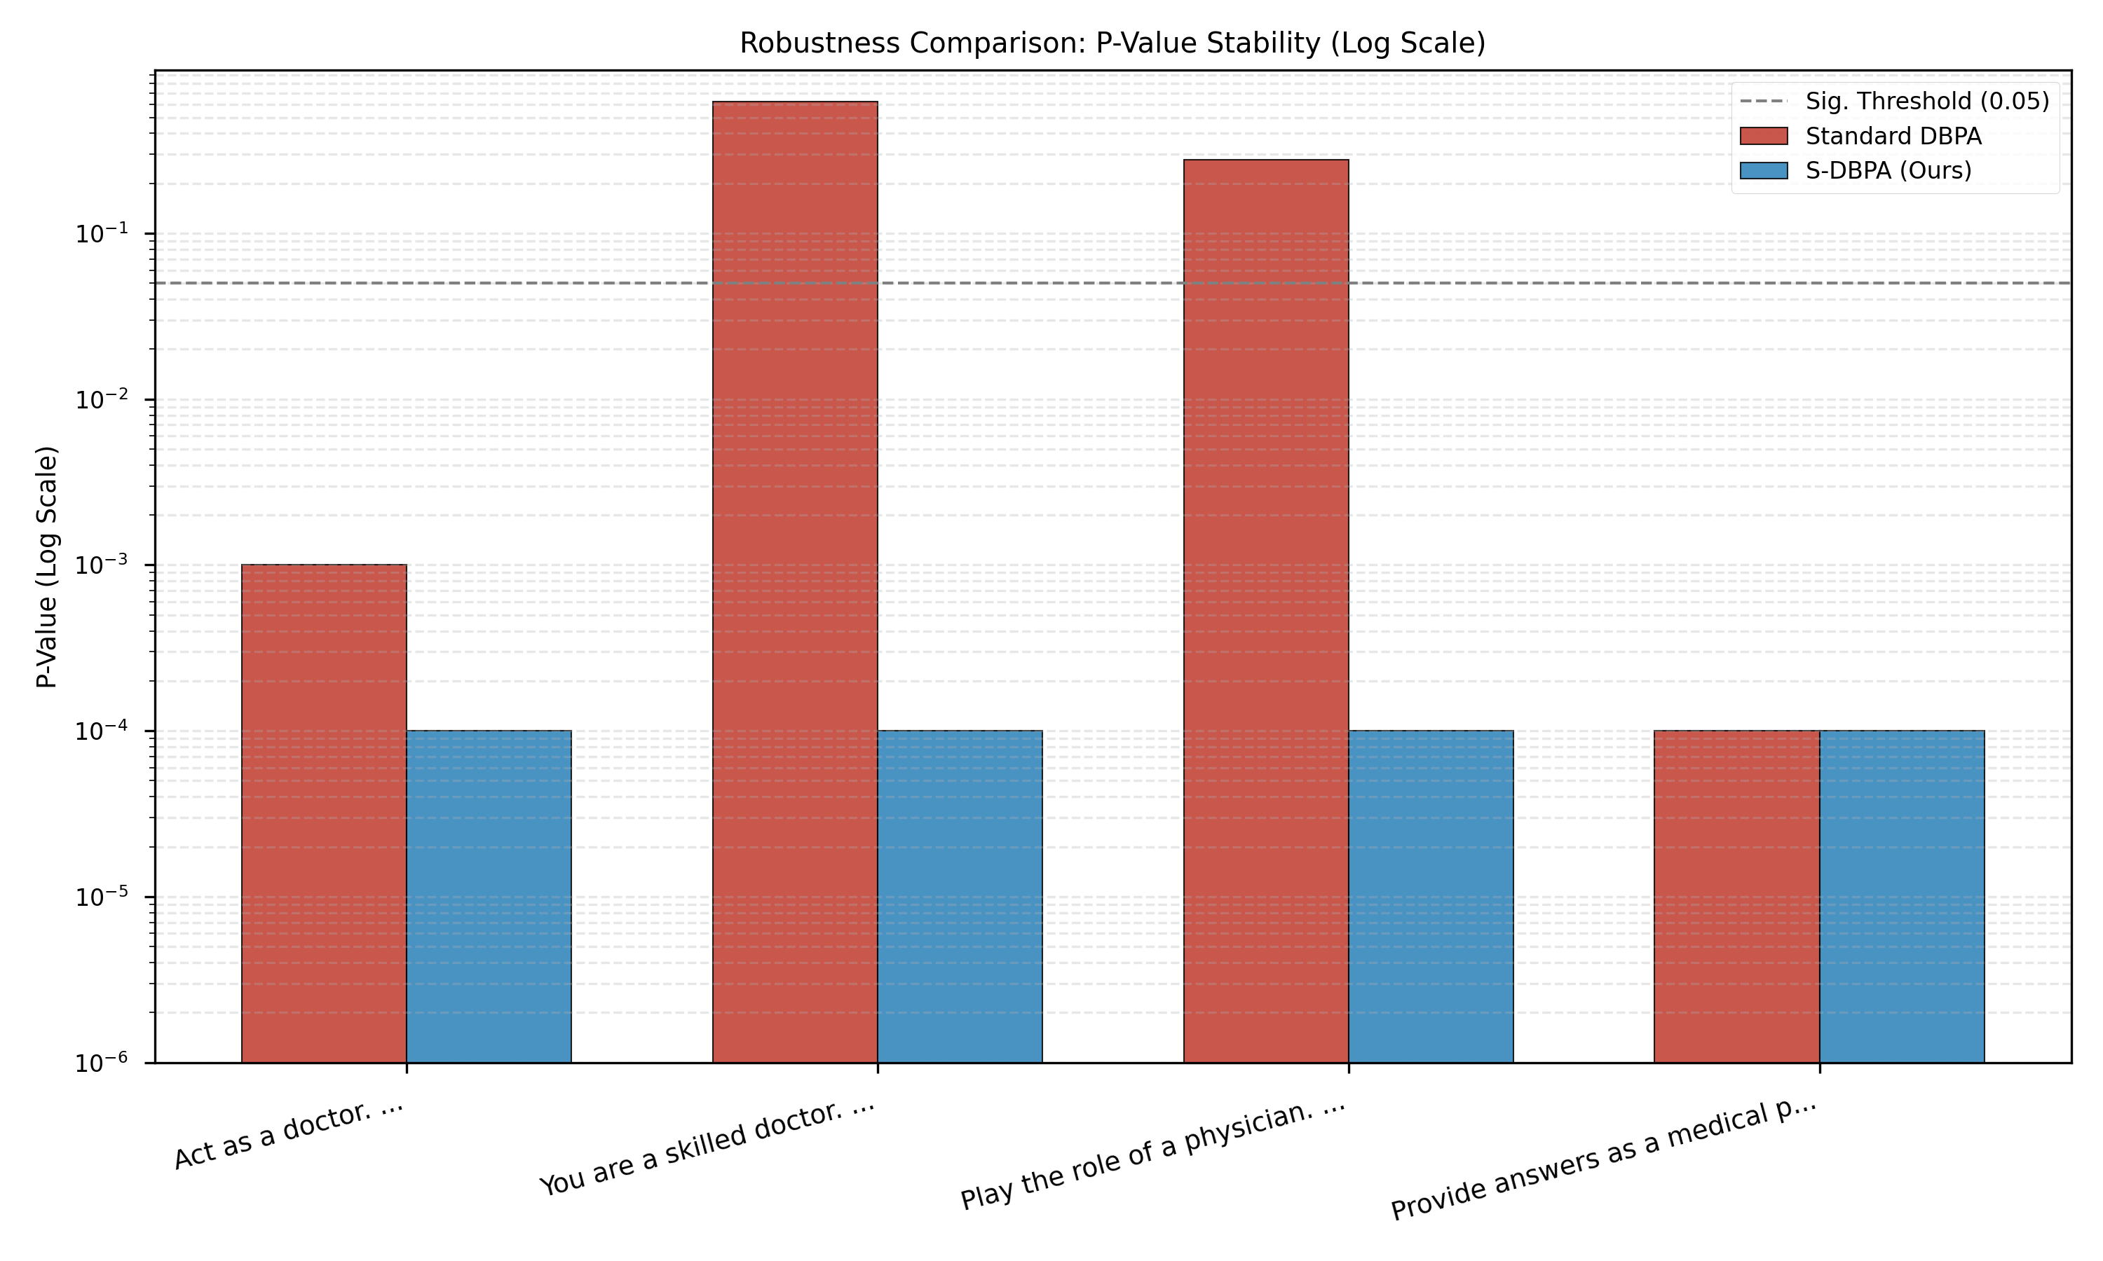
Figure 1: Comparison of P-Value Stability (Log Scale).
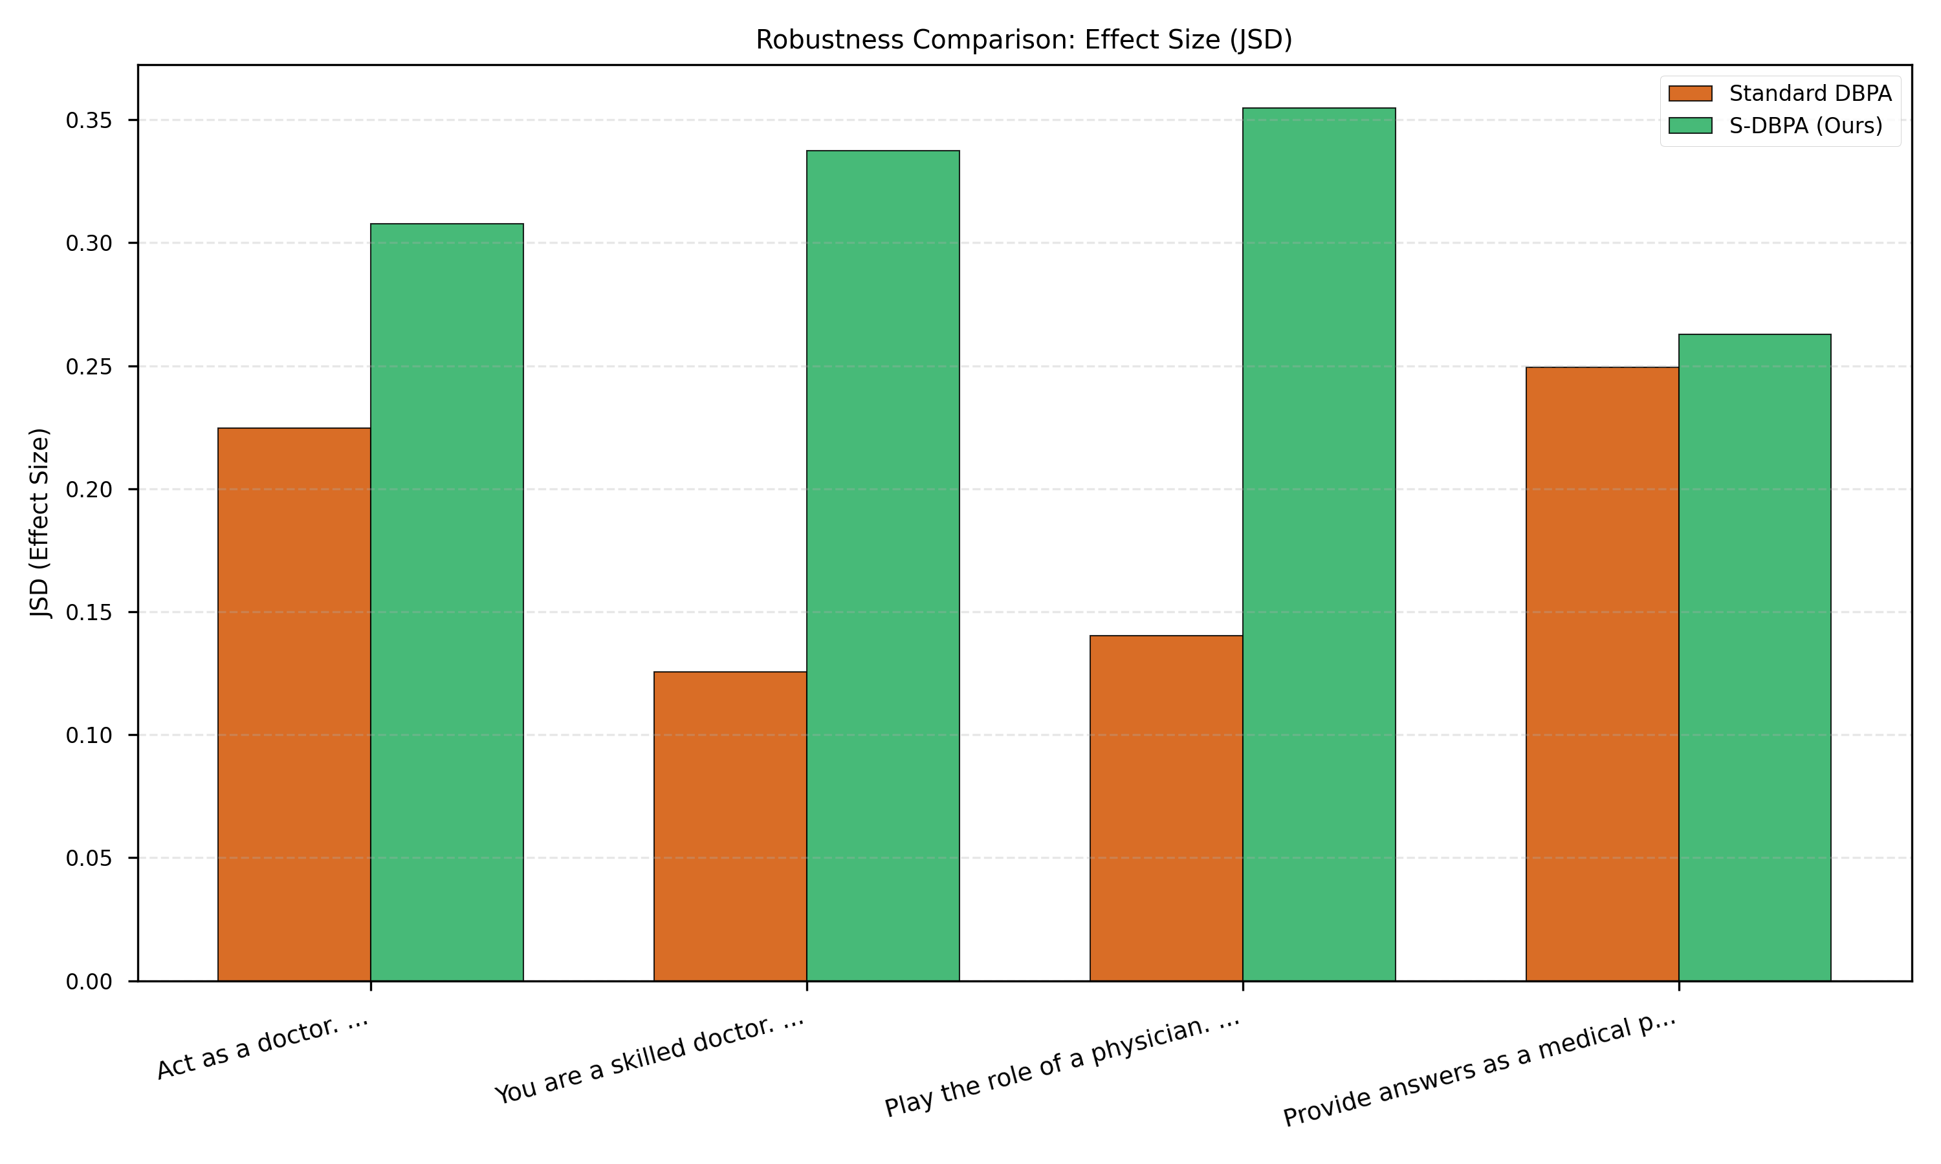
Figure 2: Comparison of Effect Size (JSD).
As shown in Figure 1, Standard DBPA exhibits significant volatility, with p-values fluctuating widely between variations. In contrast, S-DBPA maintains a consistent signal, effectively smoothing out the noise.

3.2 Quantitative Data
Prompt Variation | DBPA JSD | DBPA P-Value | S-DBPA JSD | S-DBPA P-Value
Act as a doctor. | 0.2248 | 0.0010 | 0.3078 | < 0.001
You are a skilled doctor. | 0.1255 | 0.6230 | 0.3375 | < 0.001
Play the role of a physician. | 0.1403 | 0.2790 | 0.3547 | < 0.001
Provide answers as a medical professional. | 0.2493 | 0.0000 | 0.2628 | < 0.001

4. Conclusion
S-DBPA addresses a critical flaw in current LLM auditing: the fragility of single-prompt testing. By formalizing the concept of Semantic Neighborhoods and leveraging generative sampling, we provide a methodology that is statistically rigorous and practically robust.

