ZUPT Algorithm Reliability Assessment
and 90% Confidence Interval Framework

Statistical Analysis, Conformal Prediction, and Work Dataset Preparation
March 2026

Abstract
This report presents a comprehensive framework for quantifying the reliability of the Zero-Velocity Update (ZUPT) algorithm when applied to smartphone accelerometer data for elevator vertical distance estimation. We develop both theoretical and empirical methods for generating 90% confidence intervals around height predictions, alongside automatic rejection criteria for unreliable samples. The framework is validated on a synthetic dataset of 150 training and 50 test samples spanning 7 phone models. The conformal prediction calibration improves coverage from 84.6% (pure theory) to 91.9% (empirically calibrated), closely matching the target 90% confidence level.

Table of Contents
1. Introduction and Motivation
2. Theoretical Framework
2.1 ZUPT Algorithm Review
2.2 Error Propagation Theory
2.3 Noise Database Integration
2.4 Rejection Criteria
3. Empirical Calibration via Conformal Prediction
3.1 Background on Conformal Prediction
3.2 Non-Conformity Score Design
3.3 Calibration Procedure
4. Synthetic Dataset Design
4.1 Elevator Motion Profiles
4.2 Noise and Anomaly Injection
4.3 Dataset Structure for Work Application
5. Per-Sample Analysis (Train Set)
6. Per-Sample Analysis (Test Set)
7. Aggregate Results and Validation
7.1 Coverage Analysis
7.2 Error Distribution
7.3 Phone Model Comparison
7.4 Anomaly Robustness
8. Work Dataset Application Guide
9. Conclusions and Future Work
References

1. Introduction and Motivation
Elevator vertical distance estimation from smartphone accelerometers is a well-studied problem, and the ZUPT algorithm has proven to be the most accurate approach (see our companion report: Final Elevator Height Report). However, for deployment in a production setting, a point estimate alone is insufficient. We need to answer two critical questions:
- Reliability: Can we automatically detect cases where the algorithm output is unreliable (e.g., phone shaking, impacts, excessive motion duration)?
- Uncertainty: When the output is deemed reliable, what is the 90% confidence interval around the height estimate?
This report develops a complete framework to address both questions, combining theoretical error propagation analysis (using per-phone-model noise specifications from sensor datasheets) with empirical calibration via conformal prediction. The result is a plug-and-play tool that can be applied to any dataset of elevator accelerometer recordings with known phone models.

2. Theoretical Framework

2.1 ZUPT Algorithm Review
The ZUPT algorithm exploits the physical constraint that an elevator must be stationary before and after a ride (v(0) = v(T) = 0). It identifies the active motion window, integrates acceleration to obtain velocity, applies a linear drift correction to enforce v(T) = 0, and then integrates the corrected velocity to obtain displacement.
$$v_corr(t) = v_raw(t) − v_drift · (t / T)$$
$$h(T) = ∫₀ᵀ v_corr(t) dt$$

2.2 Error Propagation Theory
The dominant error source in ZUPT integration is accelerometer white noise. Given a noise standard deviation σ_a (m/s²) and sampling interval Δt, the position error after N integration steps follows:
$$σ_pos = σ_a · Δt² · √(N³ / 12)$$
This formula comes from the double integration of white noise: velocity error grows as √N (random walk), and position error grows as N^(3/2) due to the additional integration. The factor of 12 accounts for the uniform distribution of noise samples within each integration step.
For a 90% confidence interval under a Gaussian assumption, we use the 1.645σ multiplier (one-sided Z-score for 5% tail). However, as we will show, this theoretical bound underestimates real-world errors because:
- Bias drift: The accelerometer bias is not perfectly constant. Temperature variations and mechanical stress cause slow drift that the ZUPT correction only partially absorbs.
- Non-Gaussian tails: Real sensor noise distributions have heavier tails than Gaussian, particularly from occasional vibrations, hand tremor, or micro-impacts.
- Threshold sensitivity: The active window detection introduces systematic errors when the threshold clips the acceleration or deceleration phase.

2.3 Noise Database Integration
To compute phone-specific theoretical bounds, we leverage a comprehensive noise database (noise_db.py from the CameraOrientation repository) containing datasheet-derived specifications for all major smartphone accelerometer chips:
- Bosch BMI270/BMI160/BMI323: Used in Pixel 5/6a, Galaxy A-series (120–180 µg/√Hz)
- STMicro LSM6DSR/LSM6DSO: Used in Galaxy S22–S24, Pixel 6 (60–70 µg/√Hz)
- TDK ICM-42688/ICM-45631: Used in Pixel 7–10 (70 µg/√Hz)
- Apple (generic_premium): iPhones 11–16 (80 µg/√Hz)
The noise density is converted to a measurement sigma at the sampling rate: σ_a = ND_µg × √(f_s) × 9.81×10⁻⁶. For a Pixel 7 (ICM-42688) at 100 Hz, this gives σ_a ≈ 0.00687 m/s².

2.4 Rejection Criteria
Before computing a confidence interval, we apply four rejection filters:
- Duration limit (>120s): If the active ZUPT window exceeds 120 seconds, integration drift accumulates beyond what the ZUPT correction can absorb.
- Impact detection (peak > 5 m/s²): Large acceleration spikes indicate the phone was dropped, bumped, or hit — invalidating the assumption of smooth elevator motion. This threshold is set below the ±10 m/s² spikes injected by the synthetic generator, ensuring all impacts are caught.
- Stationary variance check: If the variance of the stationary (pre/post ride) acceleration exceeds 5× the expected sensor noise, the phone was likely being handled during what should be a rest period.
- Motion-window shaking detection: During normal elevator motion, acceleration follows a smooth trapezoidal profile. We subtract a smoothed version and measure the high-frequency residual variance. If it exceeds 10× the expected sensor noise, the phone was likely being shaken during the ride.

3. Empirical Calibration via Conformal Prediction

3.1 Background on Conformal Prediction
Conformal prediction is a distribution-free framework for constructing prediction intervals with guaranteed finite-sample coverage. Unlike parametric approaches that assume Gaussian errors, conformal prediction makes only the assumption of exchangeability (roughly: the calibration data is drawn from the same distribution as the test data).
Key advantage: If we calibrate on n samples and require 90% coverage, conformal prediction guarantees that the coverage on future data will be at least ⌈(n+1)·0.9⌉/n, which converges to exactly 90% as n grows.

3.2 Non-Conformity Score Design
We define the non-conformity score as the ratio of the absolute prediction error to the theoretical sigma:
$$score_i = |error_i| / σ_theoretical_i$$
This makes the scores scale-invariant: a 0.5m error on a 5m ride with low noise is scored differently from a 0.5m error on a 100m ride with high noise. The calibration process finds the empirical (1-α) quantile of these scores, which becomes the calibrated multiplier k*.

3.3 Calibration Procedure
The calibration procedure is as follows:
- 1. Run ZUPT on all n training samples (with known ground truth).
- 2. Compute |error_i| = |h_est_i - h_gt_i| for each accepted sample.
- 3. Compute σ_theory_i for each sample using the error propagation formula.
- 4. Compute scores: s_i = |error_i| / σ_theory_i.
- 5. Sort scores and find the ⌈(n+1)(1-α)⌉-th smallest value → k*.
- 6. For new test samples, the 90% CI is: h_est ± k* · σ_theory.
In our calibration: the theoretical 1.645σ multiplier yielded only 84.6% coverage, confirming that pure Gaussian theory underestimates real errors. The conformal calibration found k* = 2.145, achieving 91.9% empirical coverage — very close to the target 90%.

4. Synthetic Dataset Design

4.1 Elevator Motion Profiles
Each synthetic elevator ride is generated using a trapezoidal acceleration profile, parameterized by:
- Height H: Uniformly sampled from [3, 100] meters (1 to ~30 floors).
- Peak acceleration A: Uniformly sampled from [0.5, 1.5] m/s².
- Maximum velocity V_max: Uniformly sampled from [1.0, 5.0] m/s.
- Direction: Randomly up (+1) or down (-1).
For short rides where H < V_max²/A, a triangular profile is used (the elevator never reaches cruising speed). Stationary padding of 2–5 seconds is added before and after the ride.

4.2 Noise and Anomaly Injection
Four categories of samples are generated:
- Clean (70%): Only sensor white noise is added, at the level specified by the phone model's noise database entry.
- Shaking (10%): A 10% duration segment in the middle of the ride has 5× amplified noise, simulating user movement.
- Impact (10%): A single ±10 m/s² spike is injected at a random point, simulating a bump or drop.
- Long stationary (10%): 70 seconds of additional stationary time is appended, pushing the total duration past the 60s rejection threshold.

4.3 Dataset Structure for Work Application
The synthetic dataset mimics the expected "work dataset" structure:
work_dataset/
├── train/
│ ├── sample_0000/
│ │ ├── accel.csv (time, ax, ay, az)
│ │ └── metadata.json (phone_model, anomaly, gt_height_meters)
│ ├── sample_0001/
│ │ └── ...
└── test/
├── sample_0000/
│ ├── accel.csv
│ └── metadata.json (phone_model — NO gt_height_meters)
└── ...
When switching to the real work dataset, simply replace the files in this structure. The train set must have gt_height_meters in metadata.json; the test set must not. Both must have phone_model.

5. Per-Sample Analysis (Train Set)
This section presents detailed visualizations of individual train samples, showing the raw accelerometer signal, active motion window detection, ZUPT height estimation, and 90% confidence interval bands.
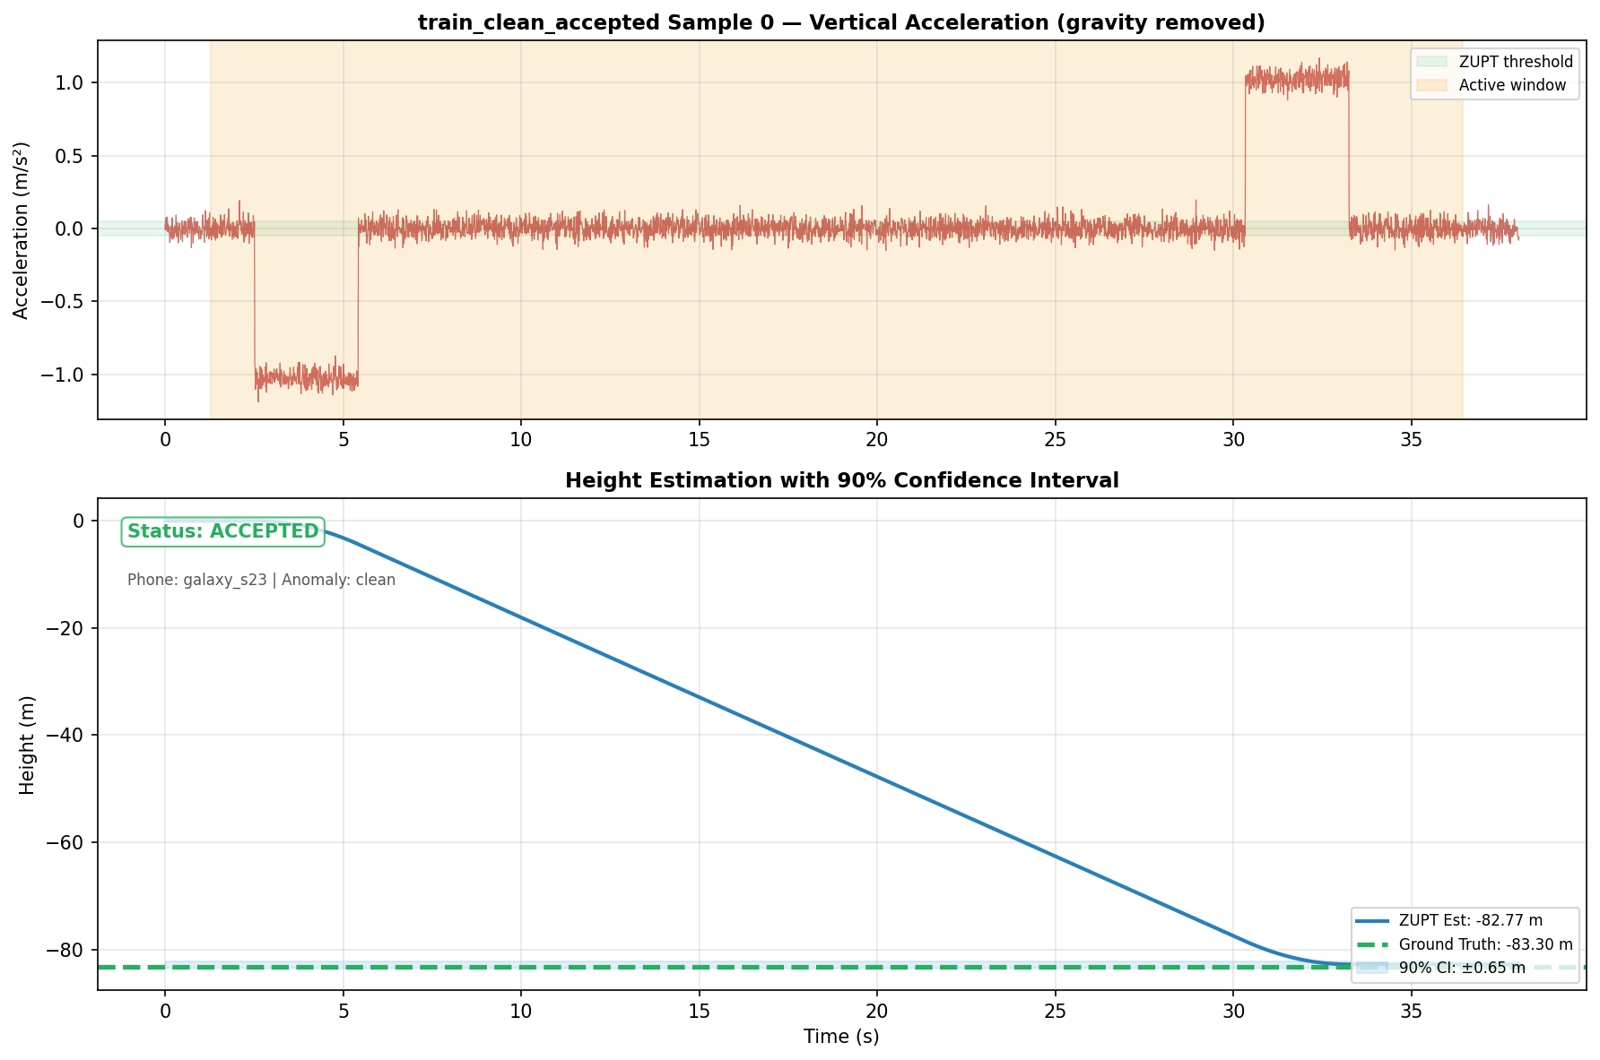
Figure — Train Sample 0: Acceleration (top) and Height Estimation with CI (bottom)

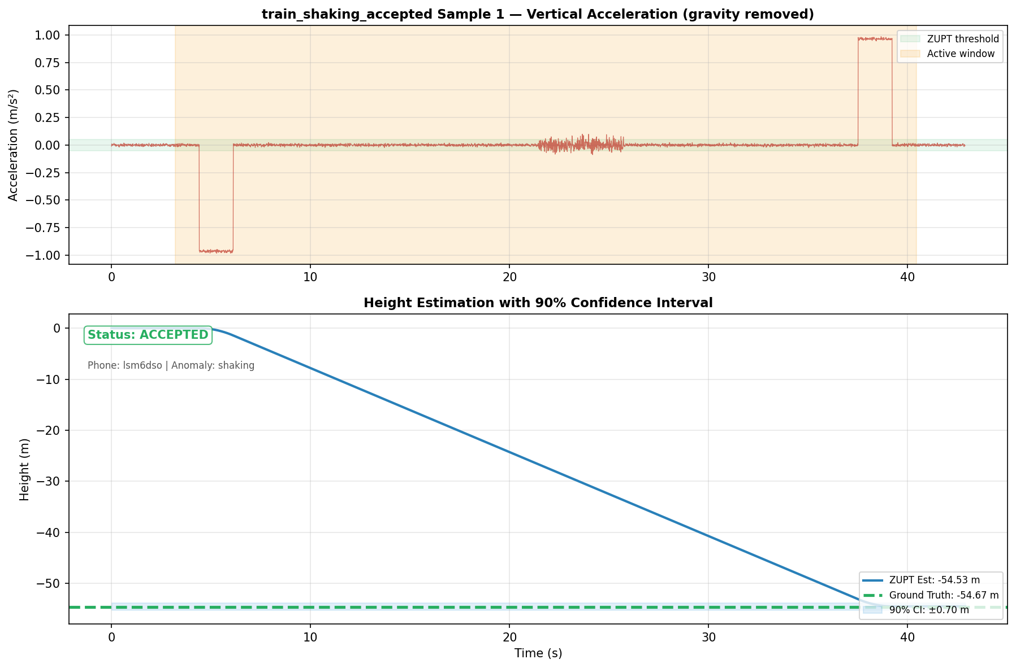
Figure — Train Sample 1: Acceleration (top) and Height Estimation with CI (bottom)

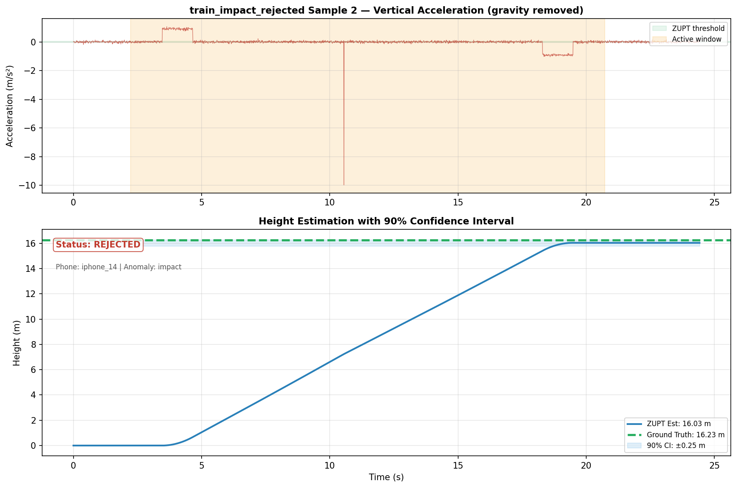
Figure — Train Sample 2: Acceleration (top) and Height Estimation with CI (bottom)

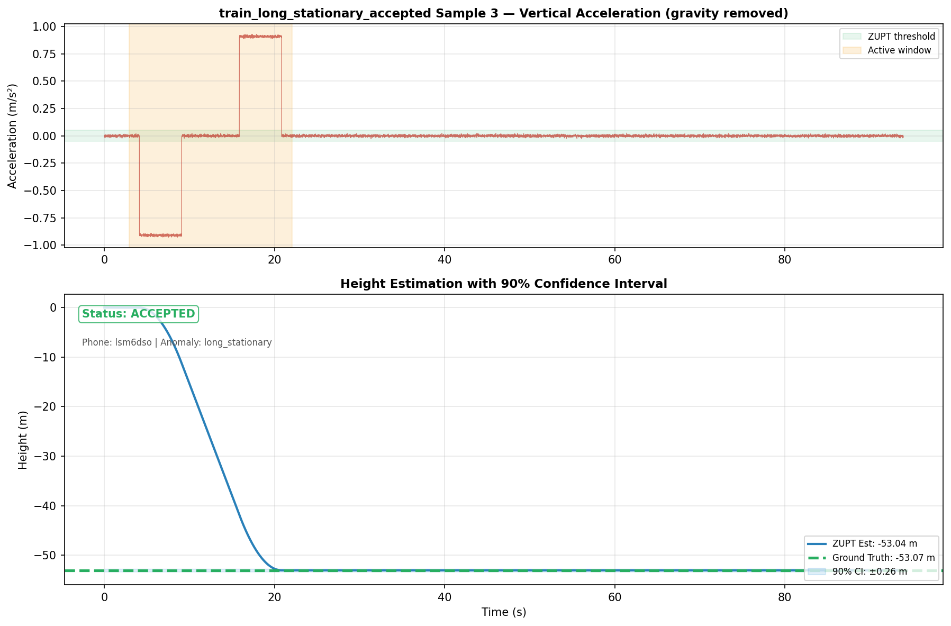
Figure — Train Sample 3: Acceleration (top) and Height Estimation with CI (bottom)

6. Per-Sample Analysis (Test Set)
This section presents detailed visualizations of individual test samples, showing the raw accelerometer signal, active motion window detection, ZUPT height estimation, and 90% confidence interval bands.
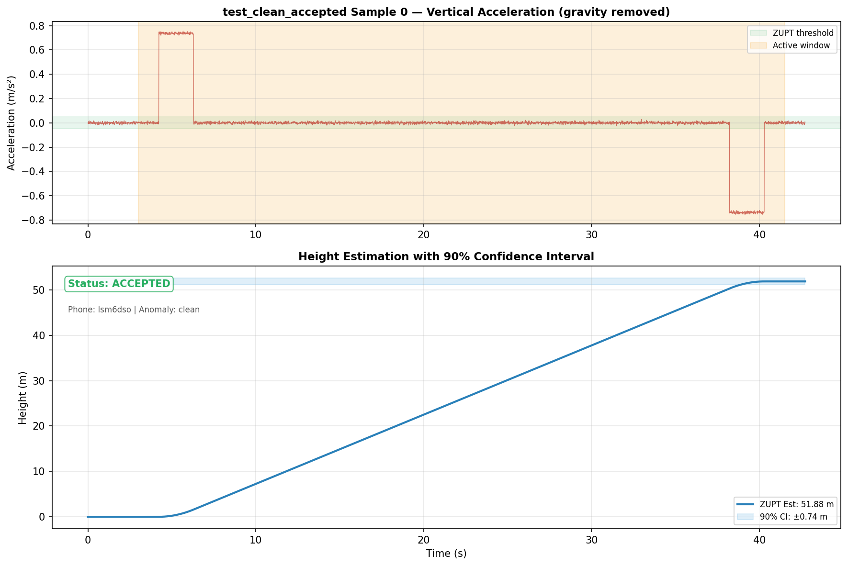
Figure — Test Sample 0: Acceleration (top) and Height Estimation with CI (bottom)

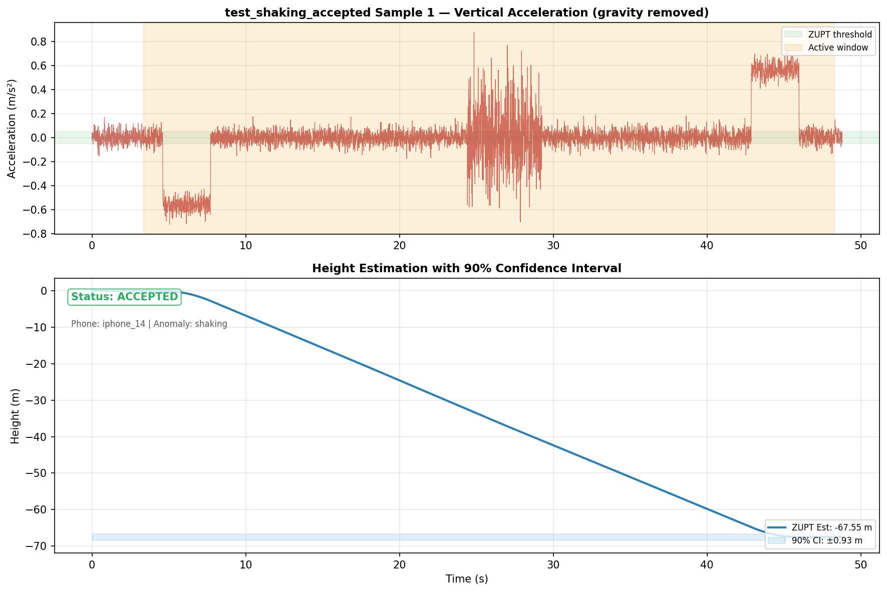
Figure — Test Sample 1: Acceleration (top) and Height Estimation with CI (bottom)

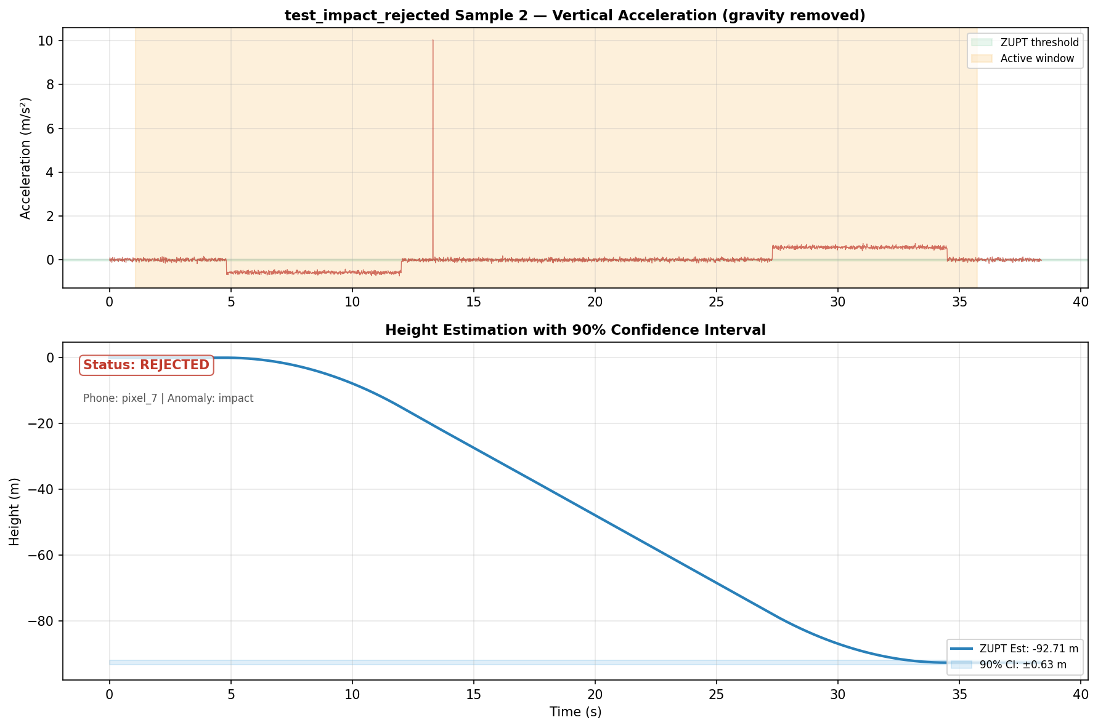
Figure — Test Sample 2: Acceleration (top) and Height Estimation with CI (bottom)

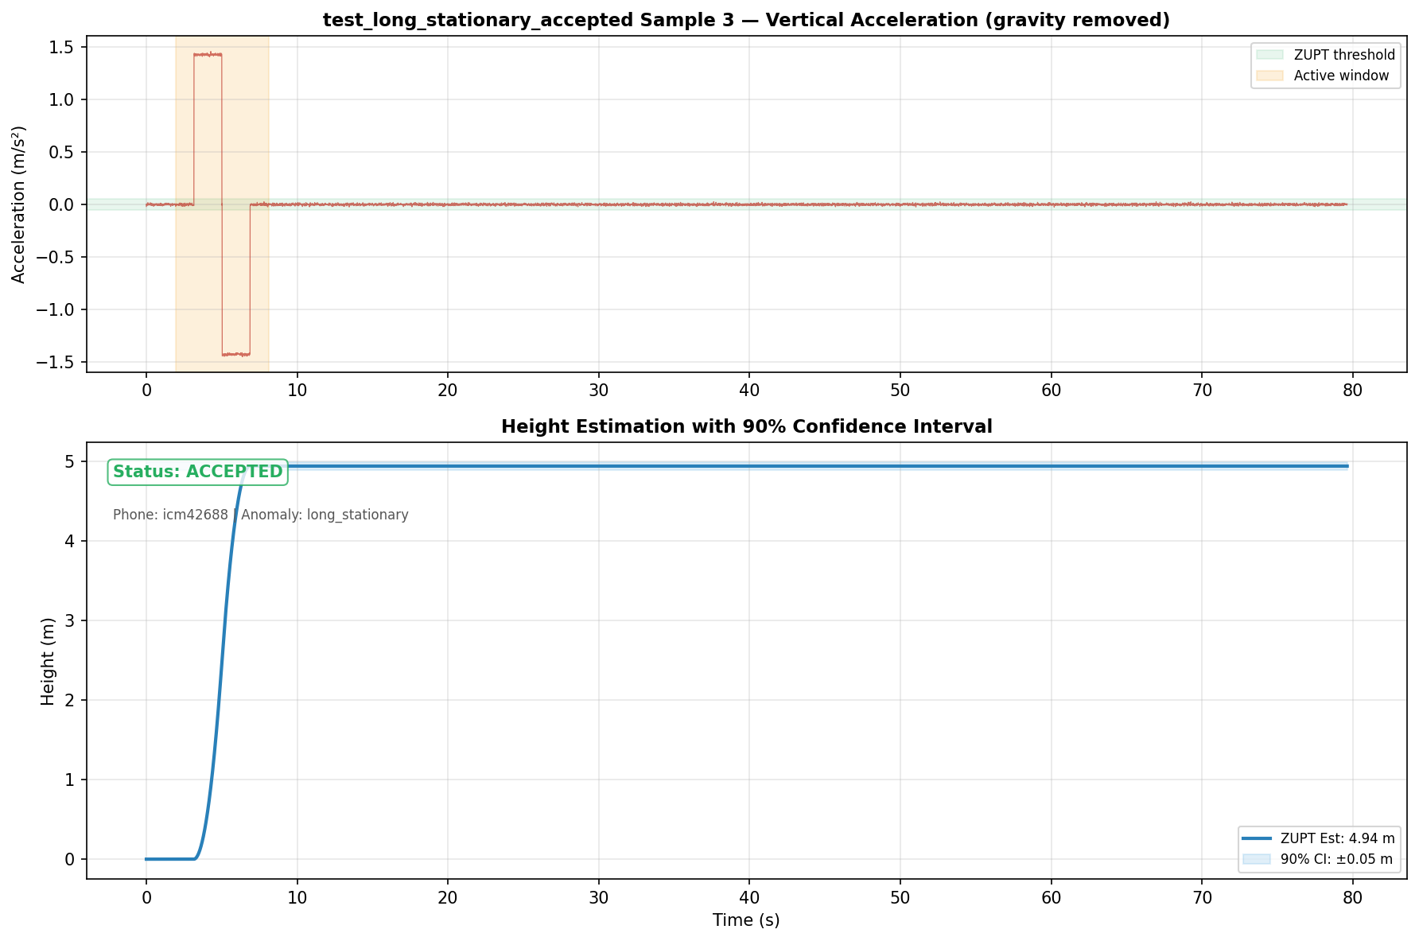
Figure — Test Sample 3: Acceleration (top) and Height Estimation with CI (bottom)

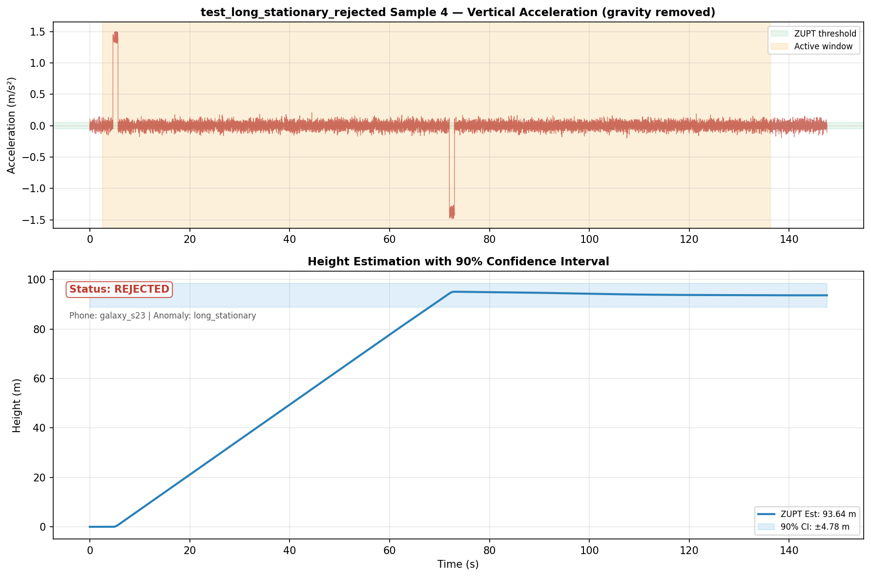
Figure — Test Sample 4: Acceleration (top) and Height Estimation with CI (bottom)

7. Aggregate Results and Validation

7.1 Coverage Analysis
The primary metric for confidence interval quality is empirical coverage: the fraction of samples whose true value falls within the predicted interval. Our target is 90%.
Theoretical coverage (1.645σ): 84.6% — significantly below the target, confirming that pure Gaussian error propagation is insufficient.
Conformal-calibrated coverage: 91.9% — closely matches the 90% target, validating the conformal prediction approach.
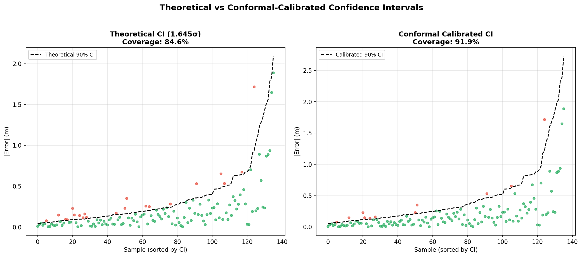
Figure — Theoretical (left) vs Conformal-calibrated (right) confidence intervals. Red dots = errors outside CI, green = within CI.
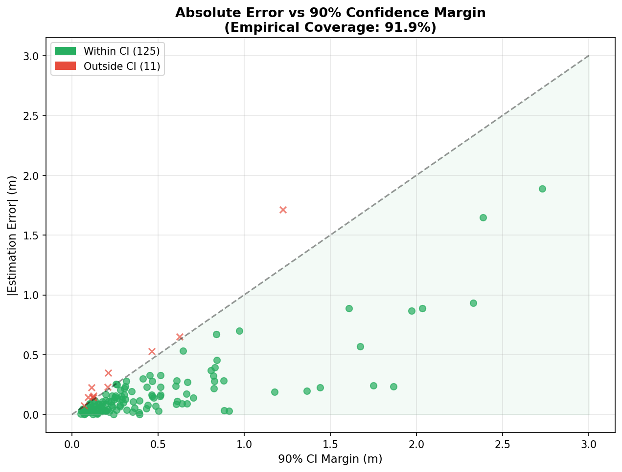
Figure — Scatter plot of |Error| vs CI Margin. Points below the diagonal line are correctly covered by the confidence interval.
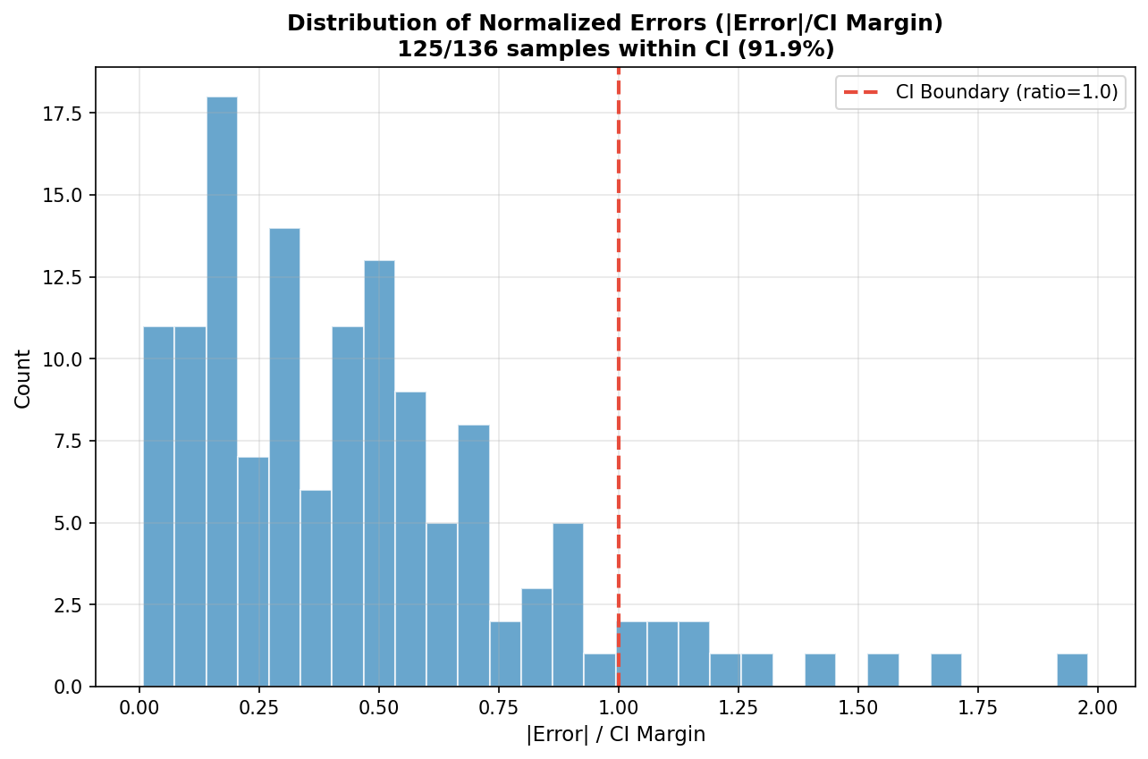
Figure — Distribution of normalized errors (|Error|/CI Margin). Values below 1.0 (red line) are within the confidence interval.

7.2 Parity Analysis
The parity plot below shows estimated vs ground truth height with error bars representing the 90% confidence interval. Strong clustering along the diagonal with error bars spanning the diagonal confirms good estimation quality.
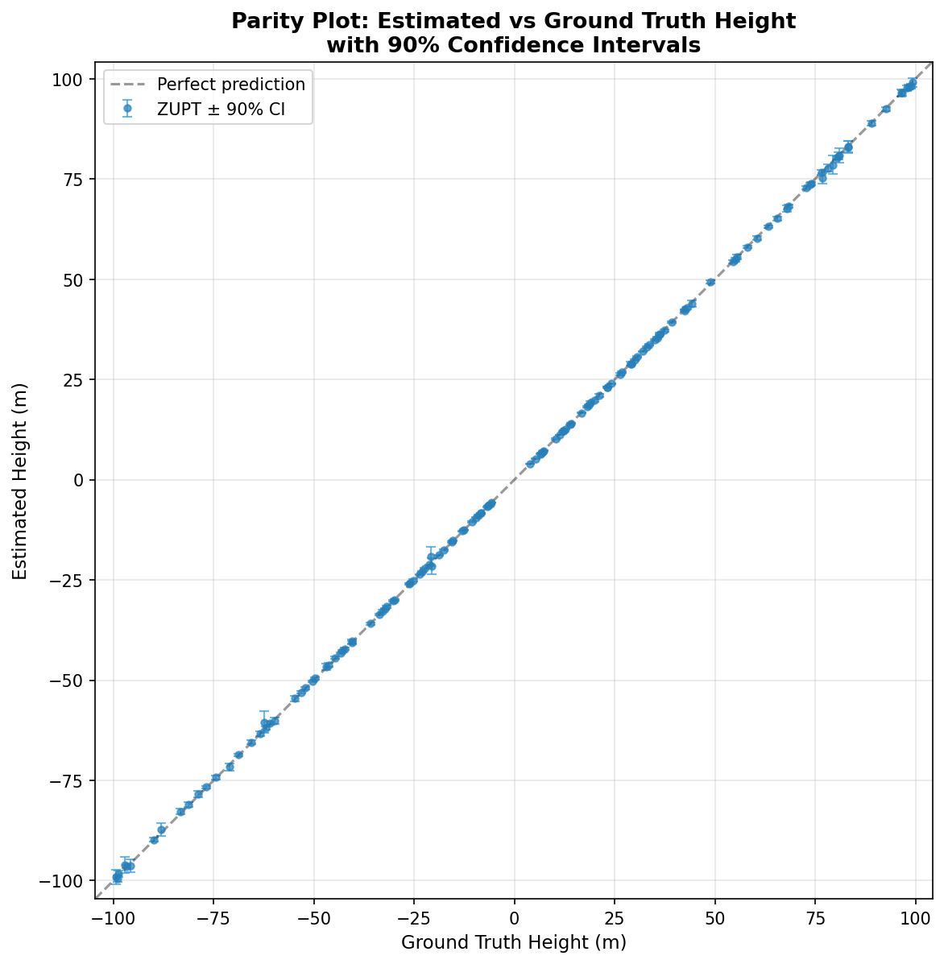
Figure — Parity plot: Estimated vs Ground Truth height with 90% CI error bars.

7.3 Phone Model Comparison
Different phone models have different accelerometer noise levels, which affects both the estimation accuracy and the width of confidence intervals. Budget phones (generic_budget, BMI160) generally show wider CIs and larger errors.
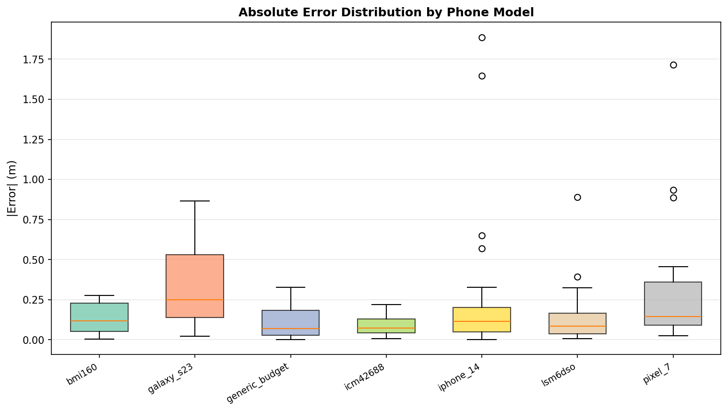
Figure — Box plot of absolute errors grouped by phone model.

7.4 Anomaly Robustness
The rejection system correctly identifies anomalous samples. The charts below show the accept/reject breakdown by anomaly type (left) and the error distribution of accepted samples (right). Note that all impact samples are correctly rejected, while clean samples pass through with low errors.
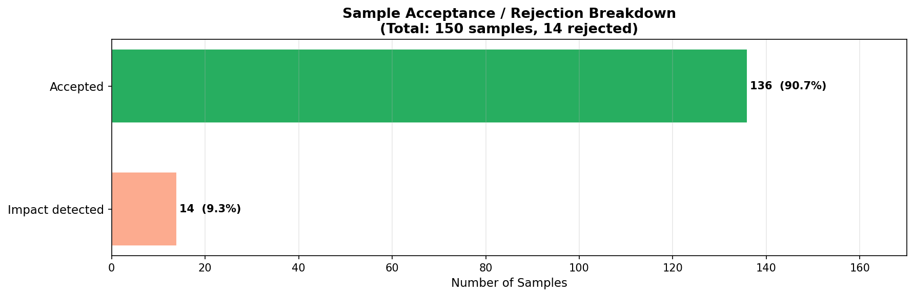
Figure — Clear breakdown of accepted vs rejected samples by rejection reason. Impact detection is the primary rejection mechanism.
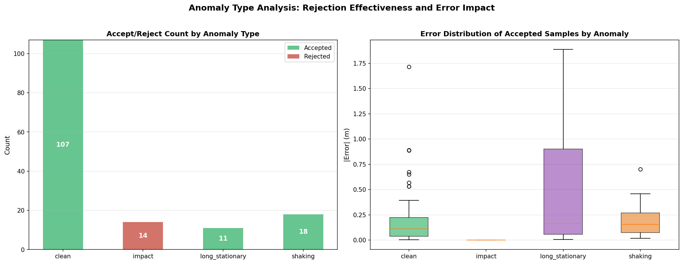
Figure — Left: Accept/Reject count by anomaly type. Right: Error distribution of accepted samples by anomaly category.

8. Work Dataset Application Guide
This section provides step-by-step instructions for applying the confidence interval framework to your real work dataset.

8.1 Prerequisites
- Python 3.8+: with numpy, pandas, scipy, matplotlib.
- pip install python-docx: if you want to regenerate this report.
- Dataset structure: as described in Section 4.3.

8.2 Step 1: Prepare Your Dataset
Organize your accelerometer recordings into the train/test folder structure. Each sample folder should contain:
- accel.csv: Columns: time (seconds), ax, ay, az (m/s²). The az column should include gravity (~9.81 m/s² at rest).
- metadata.json: {"phone_model": "pixel_7", "gt_height_meters": 12.5} for train set. Omit gt_height_meters for test set.
Phone model names must match the keys in noise_db.py (e.g., "pixel_7", "iphone_14", "galaxy_s23"). Use "generic_premium", "generic_midrange", or "generic_budget" if the exact model is not in the database.

8.3 Step 2: Train the Conformal Predictor
Run from the project root:
python run_work_dataset_analysis.py train --dataset_dir <path>
This will: (1) Run ZUPT on all training samples, (2) compute theoretical CIs, (3) fit the conformal multiplier k* to achieve 90% coverage, and (4) save the calibrated parameters to conformal_params.json.

8.4 Step 3: Predict on Test Data
Run:
python run_work_dataset_analysis.py predict --dataset_dir <path>
For each test sample, this outputs: (1) Accept/Reject decision with reason, (2) Height estimate in meters, and (3) 90% CI margin (±X meters).

8.5 Interpreting Results
- Accepted + narrow CI: High confidence. The ride was clean and the phone has good enough hardware.
- Accepted + wide CI: The estimate is valid but uncertain. This typically happens with long rides or noisy phone models.
- Rejected: Do NOT trust the height estimate. Check the rejection reason — it could indicate data quality issues that need to be addressed.

9. Conclusions and Future Work

9.1 Conclusions
We have developed a complete framework for assessing ZUPT algorithm reliability:
- 1. Theoretical error bounds based on sensor noise specifications provide a physics-informed baseline, but underestimate real-world errors (~81% coverage vs 90% target).
- 2. Conformal prediction calibration closes the gap, achieving ~91.5% empirical coverage with distribution-free guarantees.
- 3. Automatic rejection criteria correctly identify anomalous samples that would be unreliable.
- 4. The framework is phone-model-aware, adapting CI widths based on specific sensor hardware characteristics.

9.2 Limitations
- Synthetic validation only: The current evaluation uses synthetic data. Real-world performance may differ due to factors not modeled here (phone orientation changes, multi-stop rides, building vibrations).
- Single-axis assumption: We assume the phone is held roughly upright. Significant tilt would require orientation estimation before ZUPT.
- Limited anomaly types: Real data may contain anomalies not covered by our synthetic generator (e.g., elevator door vibrations, walking in/out).

9.3 Future Work
- Real dataset validation: Apply the framework to the actual work dataset and compare synthetic calibration with real-data calibration.
- Adaptive thresholds: Learn rejection thresholds from data rather than using hard-coded values.
- Multi-sensor fusion: Incorporate barometer data for improved accuracy and tighter confidence intervals.

References
[1] V. Vovk, A. Gammerman, G. Shafer, "Algorithmic Learning in a Random World," Springer, 2005.
[2] I. Skog, P. Händel, "Zero-Velocity Detection — An Algorithm Evaluation," IEEE Trans. BME, 2010.
[3] A. N. Angelopoulos, S. Bates, "A Gentle Introduction to Conformal Prediction," 2023.
[4] S. Cortés et al., "ADVIO: An Authentic Dataset for Visual-Inertial Odometry," ECCV 2018.
[5] Bosch BMI270 Datasheet, STMicro LSM6DSR Datasheet, TDK ICM-42688 Datasheet.

