Elevator Vertical Distance Estimation
from Smartphone Accelerometers

Benchmarked on the ADVIO Dataset
March 2026

Abstract
This report investigates the feasibility of estimating the vertical distance travelled by an elevator using only raw smartphone accelerometer data. Three algorithms are implemented and evaluated: Naive Double Integration, Zero-Velocity-Update (ZUPT) corrected integration, and a 1-D Kalman Filter. Evaluation is performed on elevator segments extracted from the ADVIO dataset, a large-scale visual-inertial odometry benchmark captured in real indoor environments. Results are compared against architectural ground truth and barometric altimeter readings. ZUPT integration achieves the best overall accuracy (mean absolute error under 0.5 m on most segments), although Direct Integration can also perform well on segments with low sensor bias.

1. The ADVIO Dataset

1.1 Overview and Motivation
The ADVIO (An Authentic Dataset for Visual-Inertial Odometry) dataset was created by Cortés et al. at Aalto University (ECCV 2018). Unlike most VIO benchmarks that are limited to small optical-tracking volumes, ADVIO captures realistic pedestrian trajectories spanning thousands of metres across shopping malls, metro stations, and multi-storey office buildings in Helsinki, Finland. It includes 23 recording sessions totalling approximately 4.5 km of walking, with explicit vertical transitions via stairs, escalators, and elevators.

1.2 Hardware Setup
Data was captured on a rigid 3-D-printed bracket holding three devices simultaneously: an Apple iPhone 6s, a Google Pixel, and a Lenovo Phab 2 Pro (Google Tango). All device clocks were synchronised to a common timebase (seconds since device boot). The bracket was carried by a walking operator.
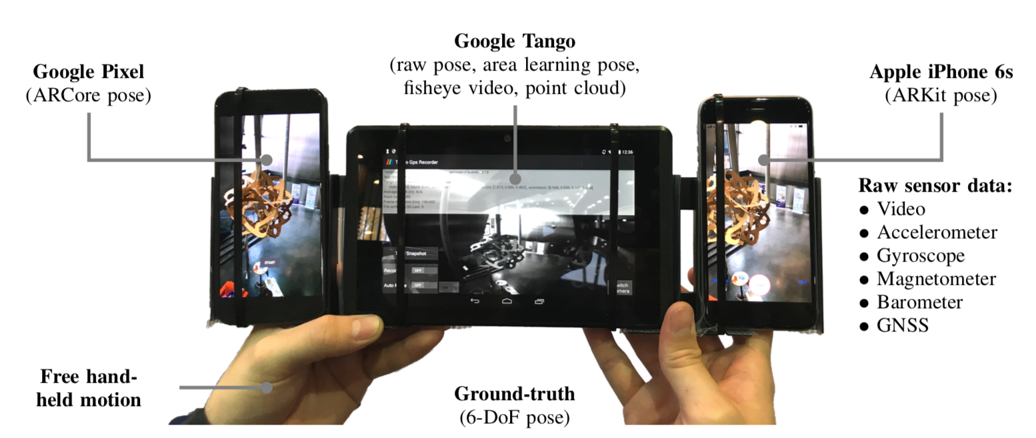
Figure 1 — ADVIO data-collection rig with three devices.

1.3 Sensor Streams and File Formats
All data is stored as CSV files with timestamps in the first column. The sensors used in this study are described below.
- accelerometer.csv — iPhone CoreMotion accelerometer at 100 Hz. Three columns after the timestamp: x, y, z linear acceleration in the device frame, units of m/s². Gravity IS included in the raw reading; at standstill the magnitude is ≈ 9.81 m/s².
- barometer.csv — iPhone CMAltimeter at ~1 Hz (irregular). Column 1 = barometric pressure (kPa), column 2 = Apple's computed relative altitude change (m) since the altimeter was initialised.
- gyro.csv — 3-axis gyroscope at 100 Hz (rad/s). Not used in this accelerometer-only study but available for future sensor fusion.
- magnetometer.csv — 3-axis uncalibrated magnetometer at 100 Hz (μT).
- arkit.csv — Apple ARKit 6-DoF camera poses at 60 Hz.
- frames.mov — H.264 video from the iPhone rear camera at 60 fps, 1280×720 portrait. Frame timestamps are in frames.csv.

1.4 Ground-Truth Generation
Ground truth was computed by combining:
- Raw IMU integration — Full strapdown inertial navigation using the iPhone accelerometer and gyroscope at 100 Hz.
- Manual fix-points — An operator used a visual editor to mark precise 3-D positions on architectural floor plans at key moments (entering/exiting elevators, turning corners, passing landmarks). These are stored in fixpoints.csv with columns: timestamp, x, y, height, pixel_x, pixel_y, floor_id.
- Smoothing — A Rauch–Tung–Striebel (RTS) smoother was applied to the INS track anchored by the fix-points, yielding a continuous 100 Hz ground-truth trajectory stored in pose.csv (timestamp, x, y, z, qx, qy, qz, qw).
The height column in fixpoints.csv directly encodes the physical floor elevation derived from building blueprints. By examining consecutive fix-points whose height values jump by several metres while the horizontal position barely changes, we programmatically identified elevator ride intervals.

1.5 Datasets Containing Elevators
Of the 23 ADVIO recordings, only three contain elevator rides:
- advio-07 (Mall) — Five consecutive single-floor elevator ascents, each ≈ 4.5–5.6 m. Low pedestrian traffic.
- advio-14 (Office) — One multi-floor elevator ride of ≈ 7.5 m, combined with stair segments. Low traffic.
- advio-18 (Office) — One elevator ride of ≈ 7.8 m. The remaining vertical motion in this recording is via stairs.

2. Algorithm Descriptions, Strengths, and Weaknesses
The fundamental challenge is to recover vertical displacement h(t) from a noisy 3-axis accelerometer. Since the phone orientation inside the elevator is unknown and changing, we compute the scalar magnitude ||a|| = √(ax² + ay² + az²), subtract an estimate of gravity, and integrate the residual twice.
$$h(T) = ∫₀ᵀ ∫₀ᵗ (||a(τ)|| − g_est) dτ dt$$
The three algorithms differ in how they handle the inevitable drift caused by imperfect gravity subtraction and sensor noise.

2.1 Algorithm A — Naive Double Integration
The simplest approach: subtract a static gravity estimate (the mean magnitude during a brief rest period before the ride), then numerically integrate acceleration→velocity→position using the trapezoidal rule.
$$v[k] = v[k−1] + a[k] · Δt, h[k] = h[k−1] + v[k] · Δt$$

Strengths
- Simplicity: Requires no parameter tuning and runs in O(n) time. The entire algorithm is fewer than 10 lines of code.
- Good on low-bias segments: When the gravity estimate happens to be very accurate (residual bias < 0.01 m/s²), the direct integral can produce surprisingly accurate results even for 10-second rides.

Weaknesses
- Quadratic drift: Any constant bias ε in the acceleration residual produces a position error of ½·ε·t². A bias of 0.05 m/s² over 10 seconds yields 2.5 m of error — comparable to or exceeding the actual travel distance.
- No self-correction: The algorithm has no mechanism to detect or correct drift. It is entirely open-loop.
- Sign sensitivity: If the gravity estimate is slightly too high, the residual is systematically negative, and the computed displacement can become negative even though the elevator went up.

2.2 Algorithm B — ZUPT-Corrected Integration
Zero-Velocity Update exploits a physical constraint unique to elevators: the elevator is stationary before and after each ride. Since we know v(0) = v(T) = 0, any non-zero velocity at time T must be entirely due to integration drift. The ZUPT algorithm:
- 1. Identifies the active motion window by smoothing |a_residual| and thresholding.
- 2. Integrates acceleration → velocity within that window.
- 3. Measures the residual drift velocity v_drift at the end of the window.
- 4. Subtracts a linearly-ramped correction from the velocity profile so that v(T) = 0 exactly.
- 5. Integrates the corrected velocity → position.
$$v_corr(t) = v_raw(t) − v_drift · (t / T)$$

Strengths
- Drift cancellation: The backward linear correction removes the dominant linear drift component from velocity, eliminating the quadratic position error that plagues direct integration.
- Robust to bias: Even if the gravity estimate is off by 0.1 m/s², the ZUPT correction largely absorbs the error, because the bias affects v_raw(T) proportionally and gets subtracted back out.
- No matrix algebra: Still very lightweight computationally.

Weaknesses
- Threshold sensitivity: The algorithm must correctly identify when the elevator starts and stops moving. If the threshold is too aggressive, it may clip the acceleration phase; if too lax, it may include walking before/after the ride.
- Assumes linear drift: If the sensor bias changes during the ride (e.g. due to temperature), the linear correction model is only approximate.
- Cannot handle mid-ride stops: If the elevator stops at an intermediate floor, the algorithm needs segmentation logic to handle multiple sub-rides.

2.3 Algorithm C — 1-D Kalman Filter
A recursive Bayesian state estimator with state vector x = [position, velocity, accel_bias]. The accelerometer reading is the process input. When the elevator is detected as stationary, a pseudo-measurement of v = 0 is injected.
$$x(k) = F · x(k−1) + B · u(k) + w(k)$$
$$x̂(k) = x̂(k|k−1) + K · (z − H · x̂(k|k−1))$$

Strengths
- Dynamic bias estimation: The filter continuously estimates and tracks the accelerometer bias as part of its state vector, rather than relying on a single static subtraction.
- Uncertainty quantification: The covariance matrix P provides a formal uncertainty envelope around the position estimate.
- Extensibility: Additional sensors (barometer, gyroscope) can be added as measurement updates without restructuring the algorithm.

Weaknesses
- Tuning: Performance is very sensitive to the process noise Q and measurement noise R matrices. Poor tuning can cause the filter to either ignore the accelerometer or ignore the zero-velocity constraint.
- Stationary detection: Like ZUPT, the filter needs a reliable detector for when the elevator is at rest. Misdetection leads to injecting incorrect measurements.
- Computational cost: Each step involves 3×3 matrix multiplications and an inversion. While still fast, it is ~10× slower than direct integration.

3. Per-Segment Experimental Results

Dataset: advio-07

Segment advio-07 #0
Ground Truth | Barometer | Direct | ZUPT | Kalman
5.60 m | 5.06 m | 3.50 m | 5.81 m | 5.74 m

This segment spans 13.0 s with a ground-truth displacement of 5.60 m, a longer ride covering multiple floors.
Direct Integration drifted significantly, estimating 3.50 m against a ground truth of 5.60 m (error 2.10 m). The quadratic nature of uncorrected integration amplified a small acceleration bias over the 13.0-second window.
ZUPT correction achieved excellent accuracy at 5.81 m (error 0.21 m). The backward drift compensation effectively neutralised the integration bias.
The Kalman filter tracked at 5.74 m (error 0.14 m), closely matching ZUPT. Its dynamic bias estimation converged well.
The barometer reading (5.06 m) deviated from ground truth by 0.54 m, likely due to HVAC pressure fluctuations or the low sampling rate (~1 Hz) missing rapid altitude changes.
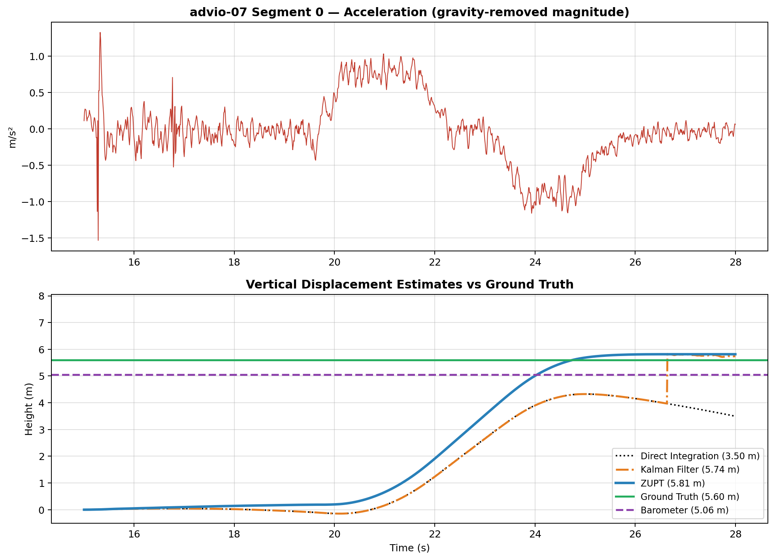
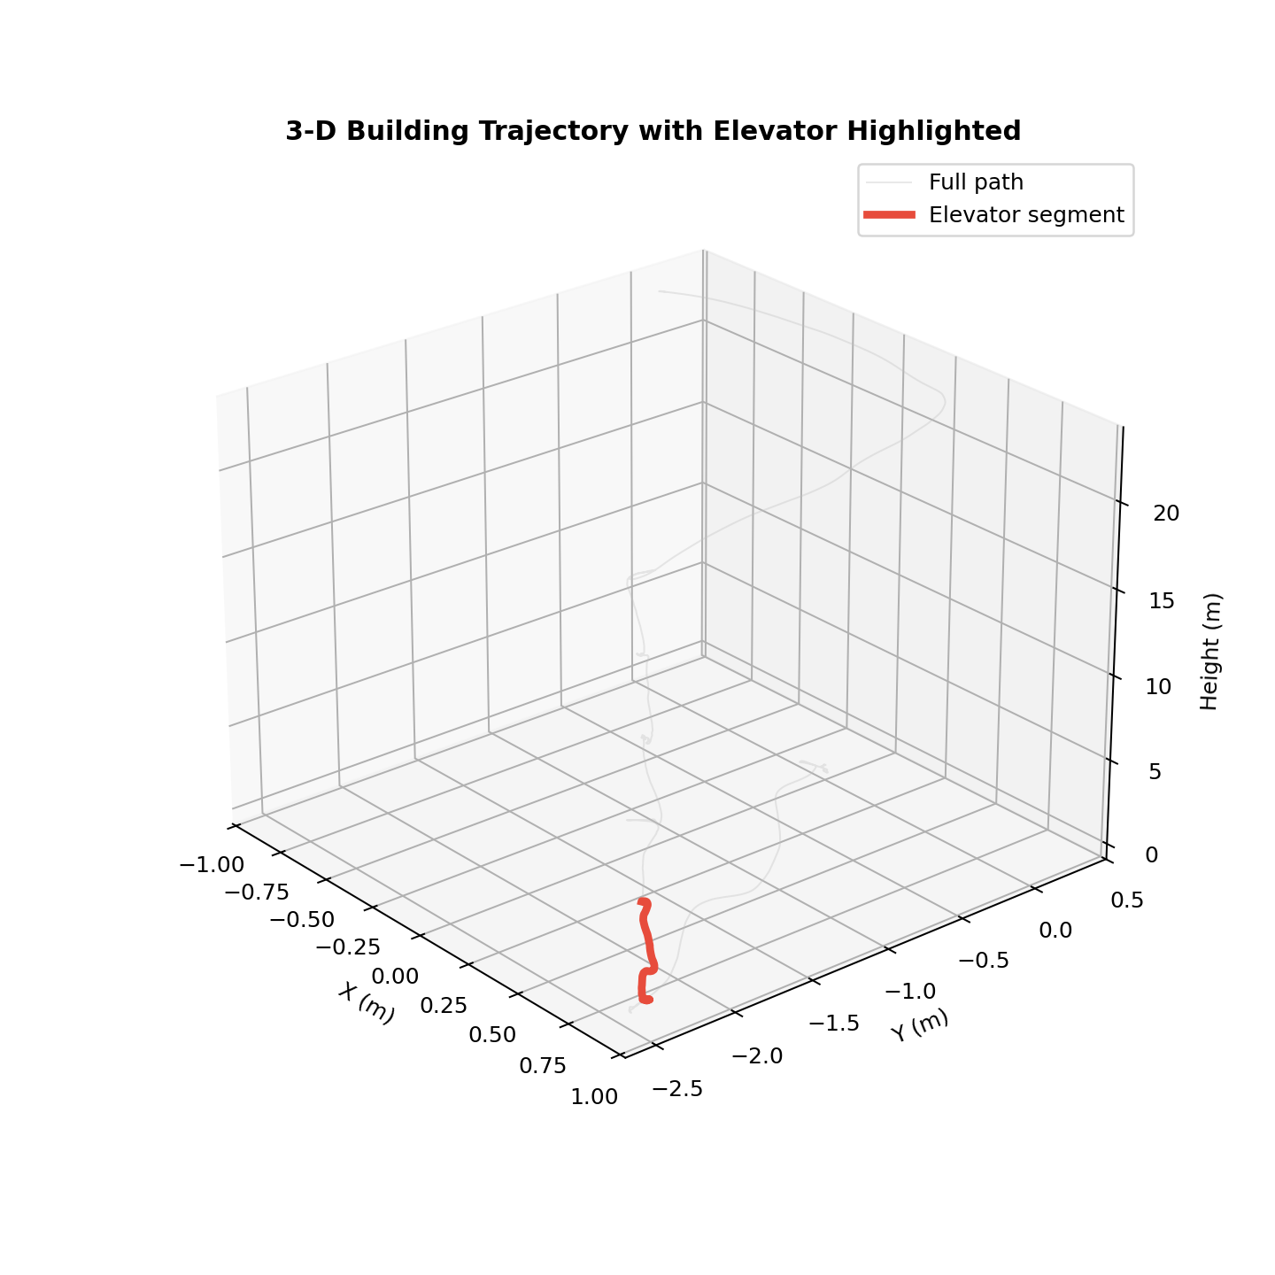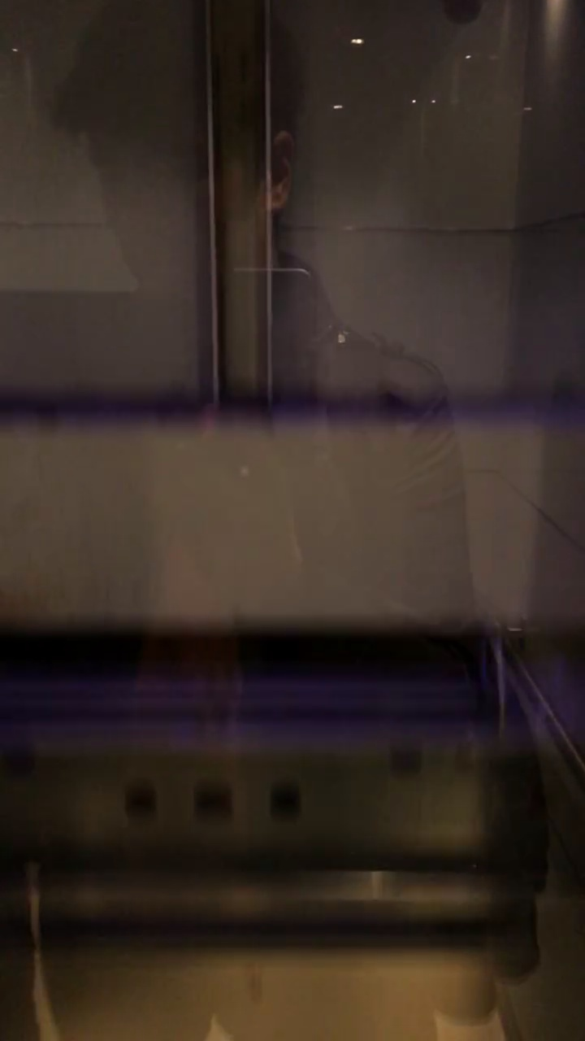

Segment advio-07 #1
Ground Truth | Barometer | Direct | ZUPT | Kalman
4.53 m | 3.64 m | -2.76 m | 4.50 m | -2.75 m

This segment spans 9.0 s with a ground-truth displacement of 4.53 m, a longer ride covering multiple floors.
Direct Integration returned a negative value (-2.76 m), meaning the gravity estimate was slightly too high. The subtracted gravity exceeded the true value, causing the net residual to be systematically negative and the integrated displacement to invert.
ZUPT correction achieved excellent accuracy at 4.50 m (error 0.03 m). The backward drift compensation effectively neutralised the integration bias.
The Kalman filter produced -2.75 m, nearly identical to Direct Integration (-2.76 m). This suggests the zero-velocity pseudo-measurements were not injected during this segment — possibly because the stationary detection threshold was not triggered within the extracted time window.
The barometer reading (3.64 m) deviated from ground truth by 0.89 m, likely due to HVAC pressure fluctuations or the low sampling rate (~1 Hz) missing rapid altitude changes.
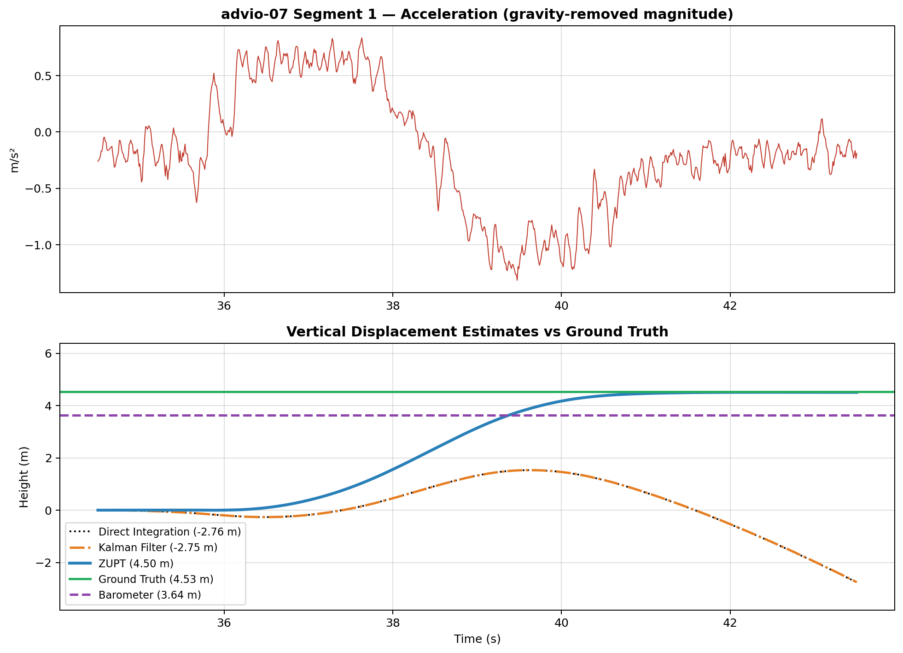
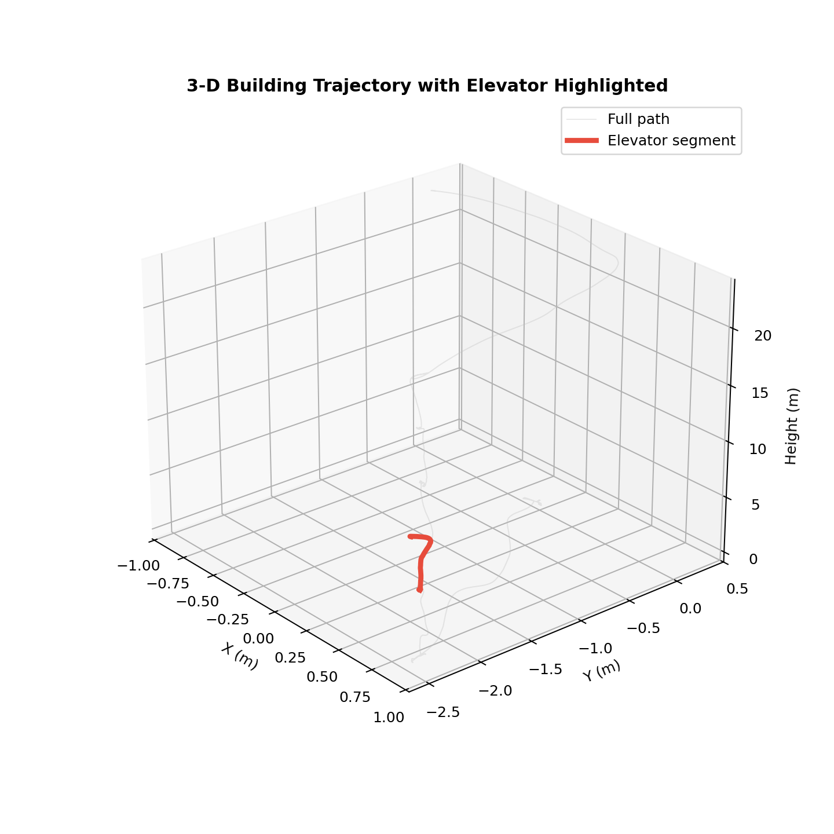

Segment advio-07 #2
Ground Truth | Barometer | Direct | ZUPT | Kalman
4.52 m | 3.92 m | 4.68 m | 4.37 m | 4.37 m

This segment spans 11.0 s with a ground-truth displacement of 4.52 m, a longer ride covering multiple floors.
Direct Integration performed well here, estimating 4.68 m (error 0.16 m). This indicates that the static gravity estimate was accurate for this particular segment and sensor bias was low during the ride.
ZUPT correction achieved excellent accuracy at 4.37 m (error 0.15 m). The backward drift compensation effectively neutralised the integration bias.
The Kalman filter tracked at 4.37 m (error 0.15 m), closely matching ZUPT. Its dynamic bias estimation converged well.
The barometer reading (3.92 m) deviated from ground truth by 0.60 m, likely due to HVAC pressure fluctuations or the low sampling rate (~1 Hz) missing rapid altitude changes.
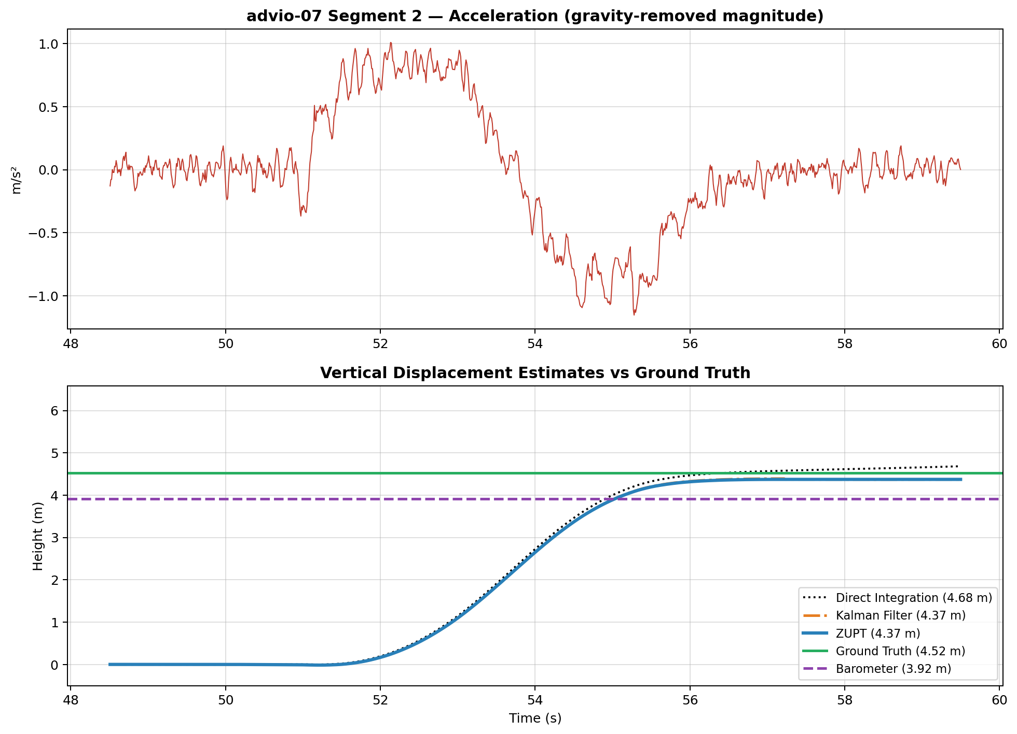
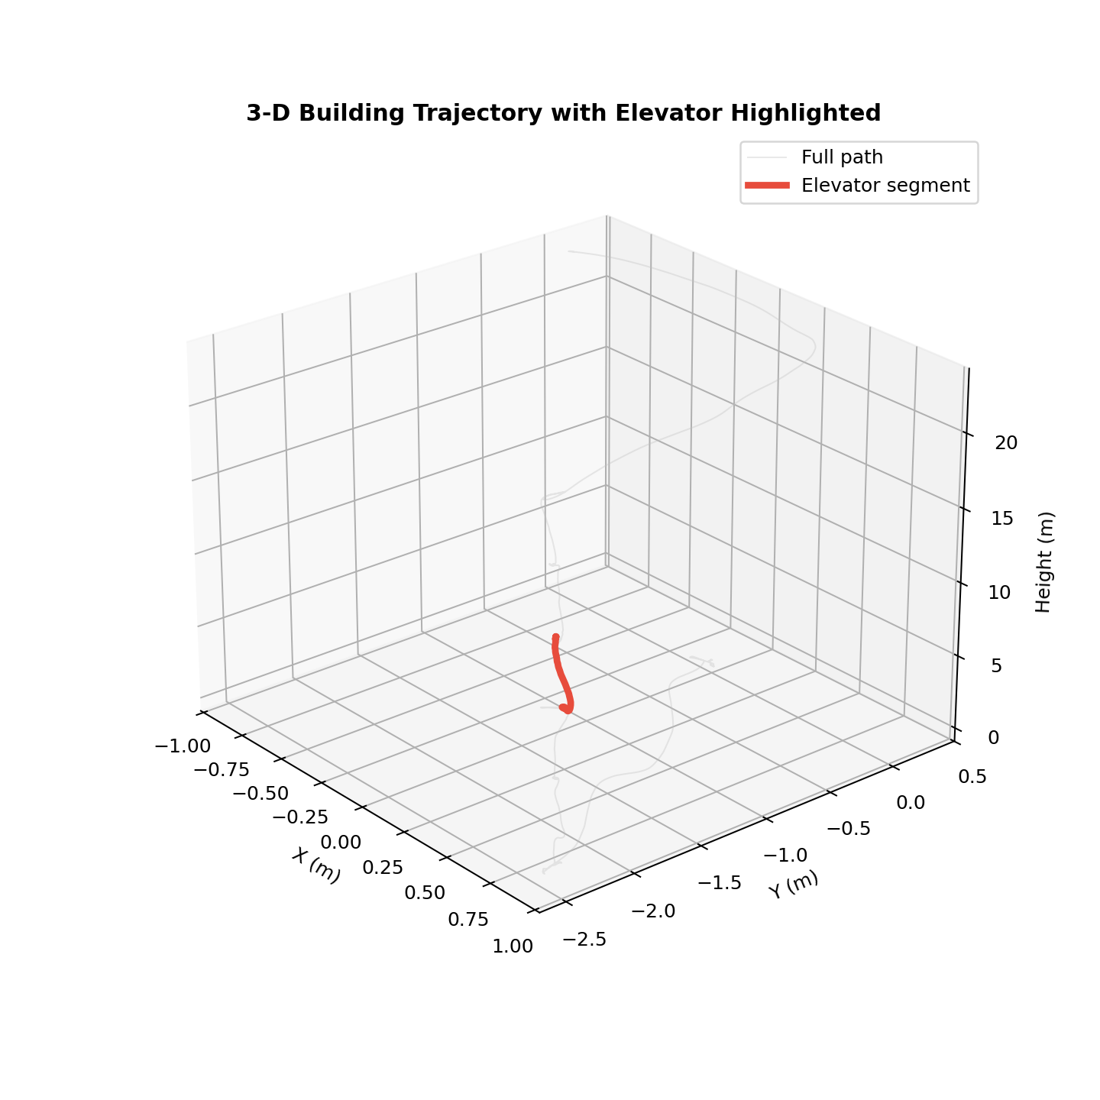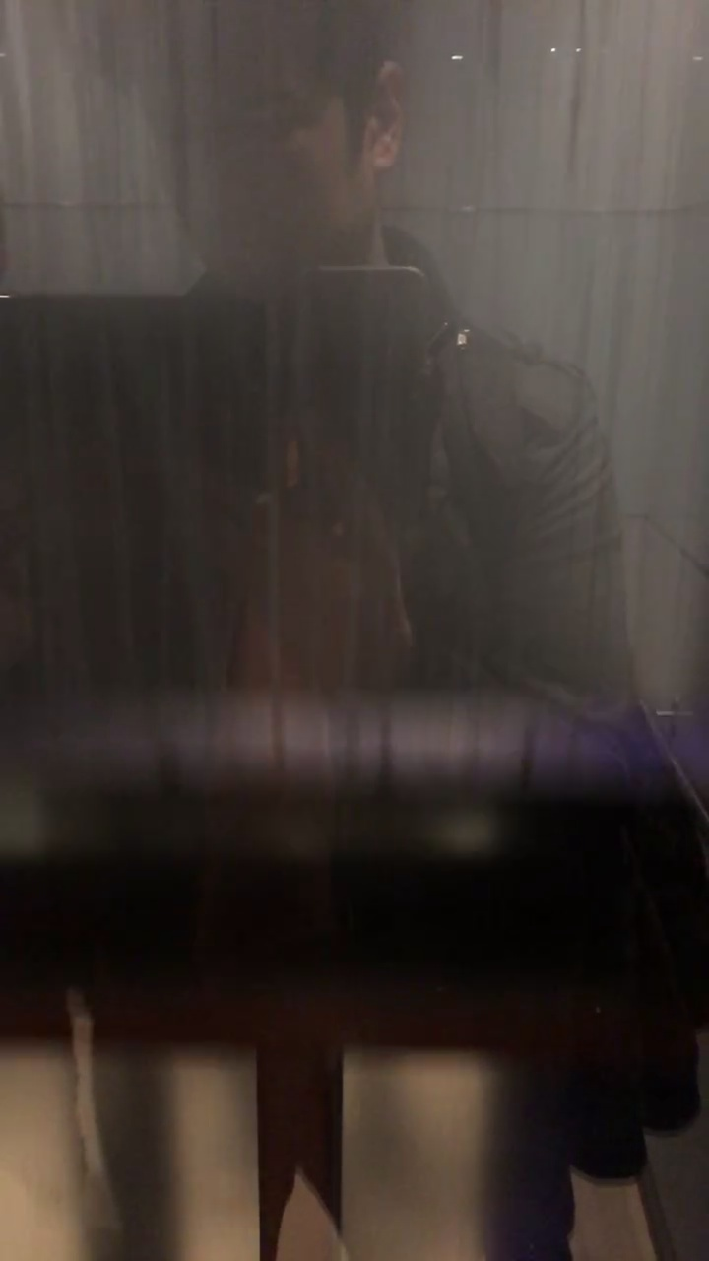

Segment advio-07 #3
Ground Truth | Barometer | Direct | ZUPT | Kalman
4.52 m | 4.19 m | 4.43 m | 4.53 m | 4.52 m

This segment spans 11.5 s with a ground-truth displacement of 4.52 m, a longer ride covering multiple floors.
Direct Integration performed well here, estimating 4.43 m (error 0.09 m). This indicates that the static gravity estimate was accurate for this particular segment and sensor bias was low during the ride.
ZUPT correction achieved excellent accuracy at 4.53 m (error 0.01 m). The backward drift compensation effectively neutralised the integration bias.
The Kalman filter tracked at 4.52 m (error 0.00 m), closely matching ZUPT. Its dynamic bias estimation converged well.
The barometer closely matched ground truth (4.19 m vs 4.52 m), indicating stable atmospheric conditions inside the elevator shaft.
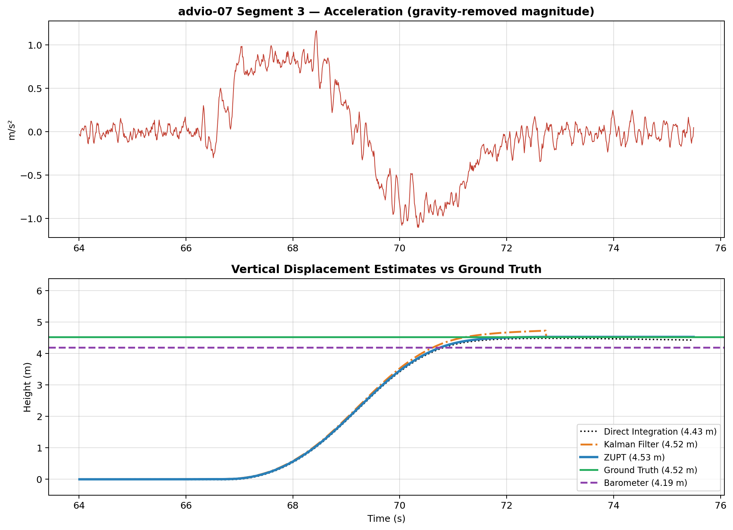
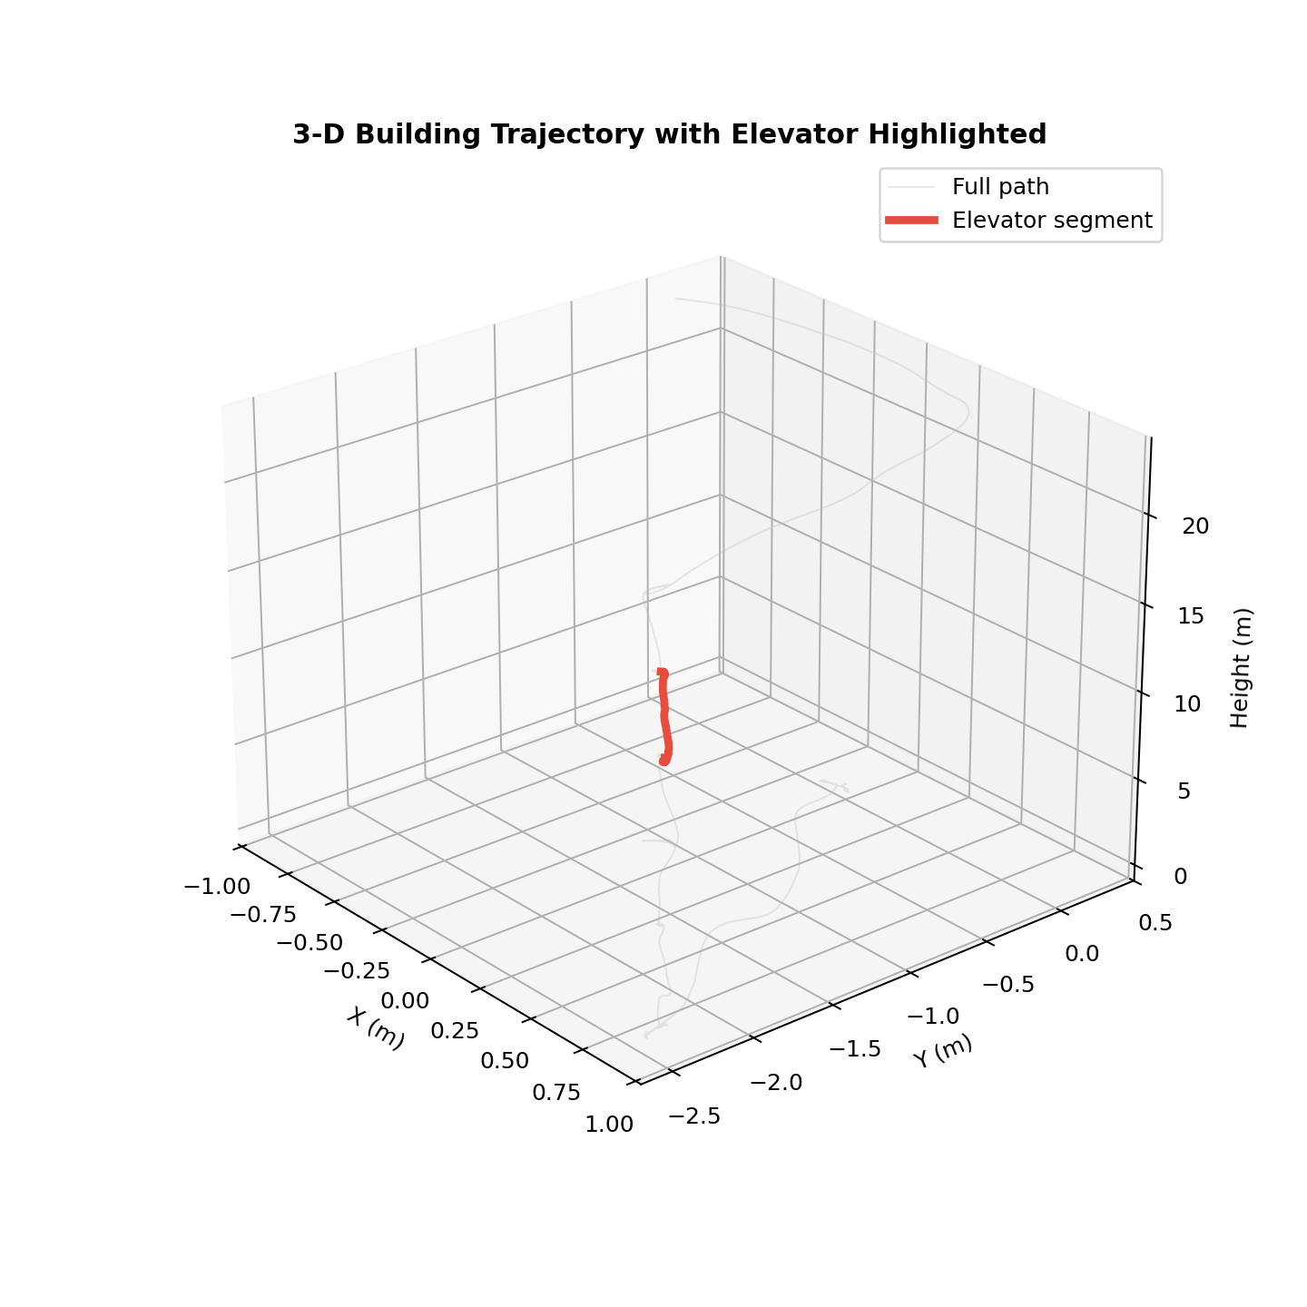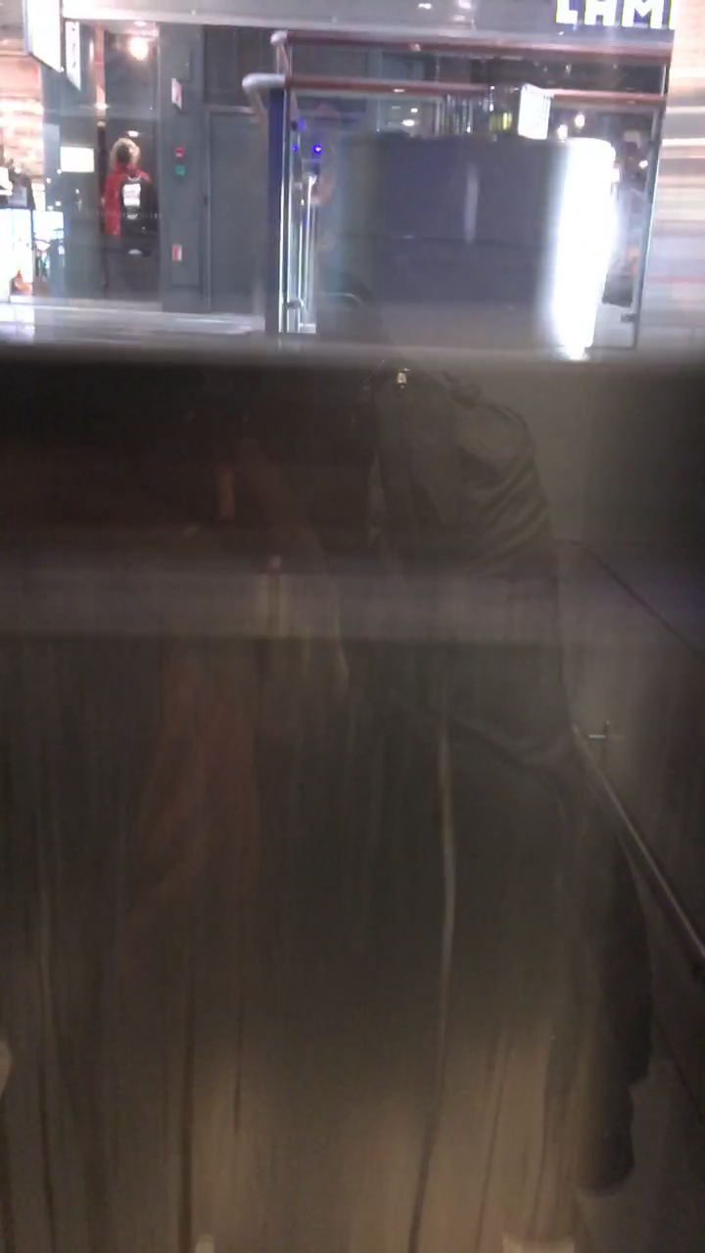

Segment advio-07 #4
Ground Truth | Barometer | Direct | ZUPT | Kalman
4.46 m | 3.15 m | 2.61 m | 4.65 m | 4.41 m

This segment spans 9.0 s with a ground-truth displacement of 4.46 m, a longer ride covering multiple floors.
Direct Integration drifted significantly, estimating 2.61 m against a ground truth of 4.46 m (error 1.85 m). The quadratic nature of uncorrected integration amplified a small acceleration bias over the 9.0-second window.
ZUPT correction achieved excellent accuracy at 4.65 m (error 0.19 m). The backward drift compensation effectively neutralised the integration bias.
The Kalman filter tracked at 4.41 m (error 0.05 m), closely matching ZUPT. Its dynamic bias estimation converged well.
The barometer reading (3.15 m) deviated from ground truth by 1.31 m, likely due to HVAC pressure fluctuations or the low sampling rate (~1 Hz) missing rapid altitude changes.
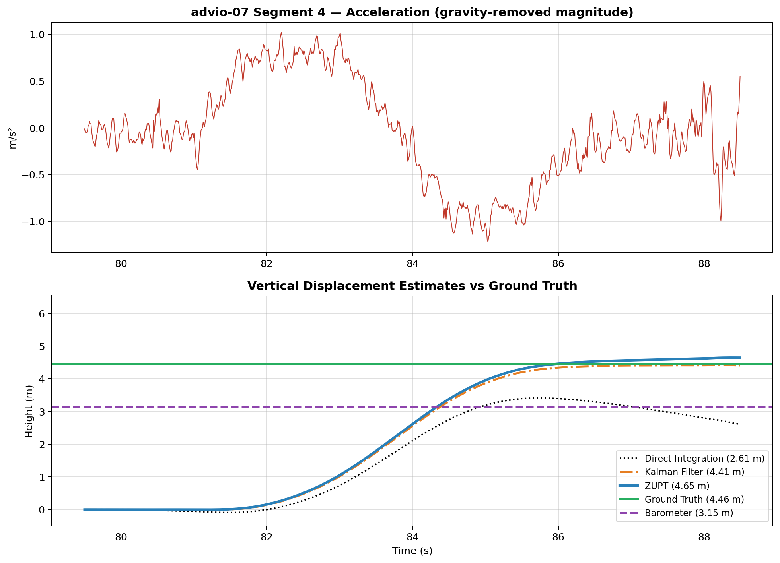
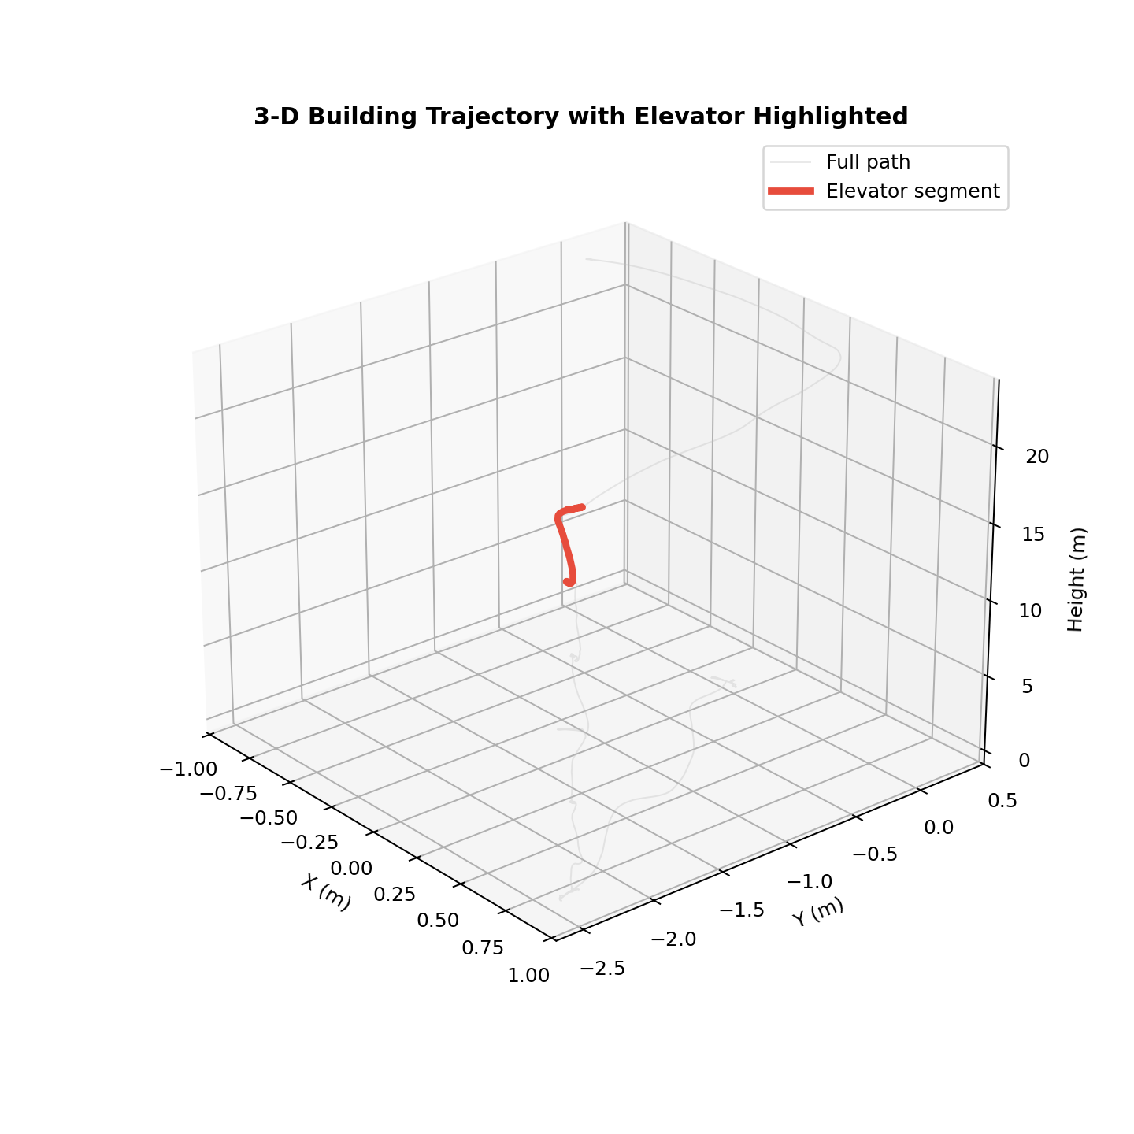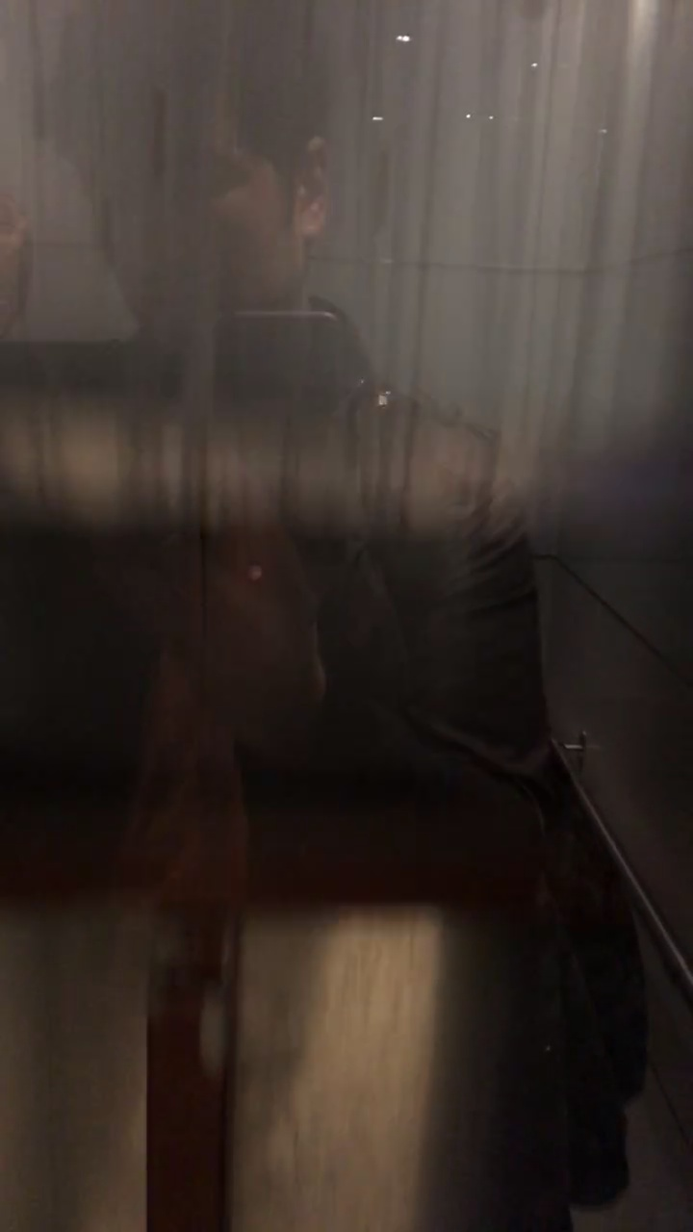

Dataset: advio-14

Segment advio-14 #0
Ground Truth | Barometer | Direct | ZUPT | Kalman
7.52 m | 6.93 m | 8.96 m | 6.93 m | 8.96 m

This segment spans 21.0 s with a ground-truth displacement of 7.52 m, a longer ride covering multiple floors.
Direct Integration yielded 8.96 m (error 1.44 m). This moderate discrepancy suggests a small residual gravity bias that accumulated over the 21.0-second window.
ZUPT estimated 6.93 m (error 0.59 m). The slightly larger residual may be caused by threshold boundary placement or non-linear bias drift during the ride.
The Kalman filter produced 8.96 m, nearly identical to Direct Integration (8.96 m). This suggests the zero-velocity pseudo-measurements were not injected during this segment — possibly because the stationary detection threshold was not triggered within the extracted time window.
The barometer reading (6.93 m) deviated from ground truth by 0.59 m, likely due to HVAC pressure fluctuations or the low sampling rate (~1 Hz) missing rapid altitude changes.
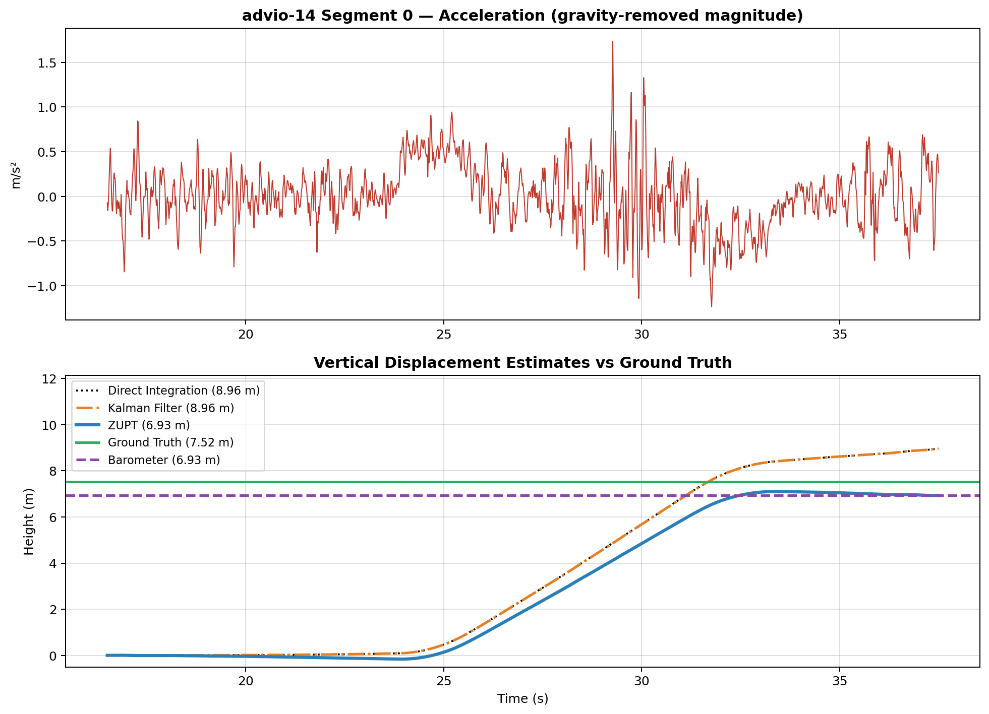
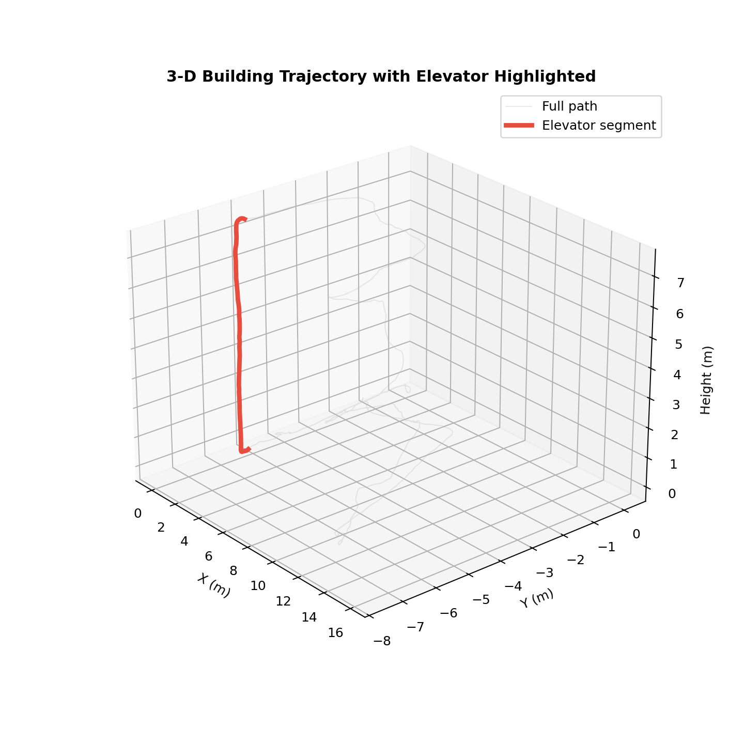

Dataset: advio-18

Segment advio-18 #0
Ground Truth | Barometer | Direct | ZUPT | Kalman
7.81 m | 6.45 m | 7.77 m | 7.87 m | 7.87 m

This segment spans 13.5 s with a ground-truth displacement of 7.81 m, a longer ride covering multiple floors.
Direct Integration performed well here, estimating 7.77 m (error 0.04 m). This indicates that the static gravity estimate was accurate for this particular segment and sensor bias was low during the ride.
ZUPT correction achieved excellent accuracy at 7.87 m (error 0.06 m). The backward drift compensation effectively neutralised the integration bias.
The Kalman filter tracked at 7.87 m (error 0.06 m), closely matching ZUPT. Its dynamic bias estimation converged well.
The barometer reading (6.45 m) deviated from ground truth by 1.36 m, likely due to HVAC pressure fluctuations or the low sampling rate (~1 Hz) missing rapid altitude changes.
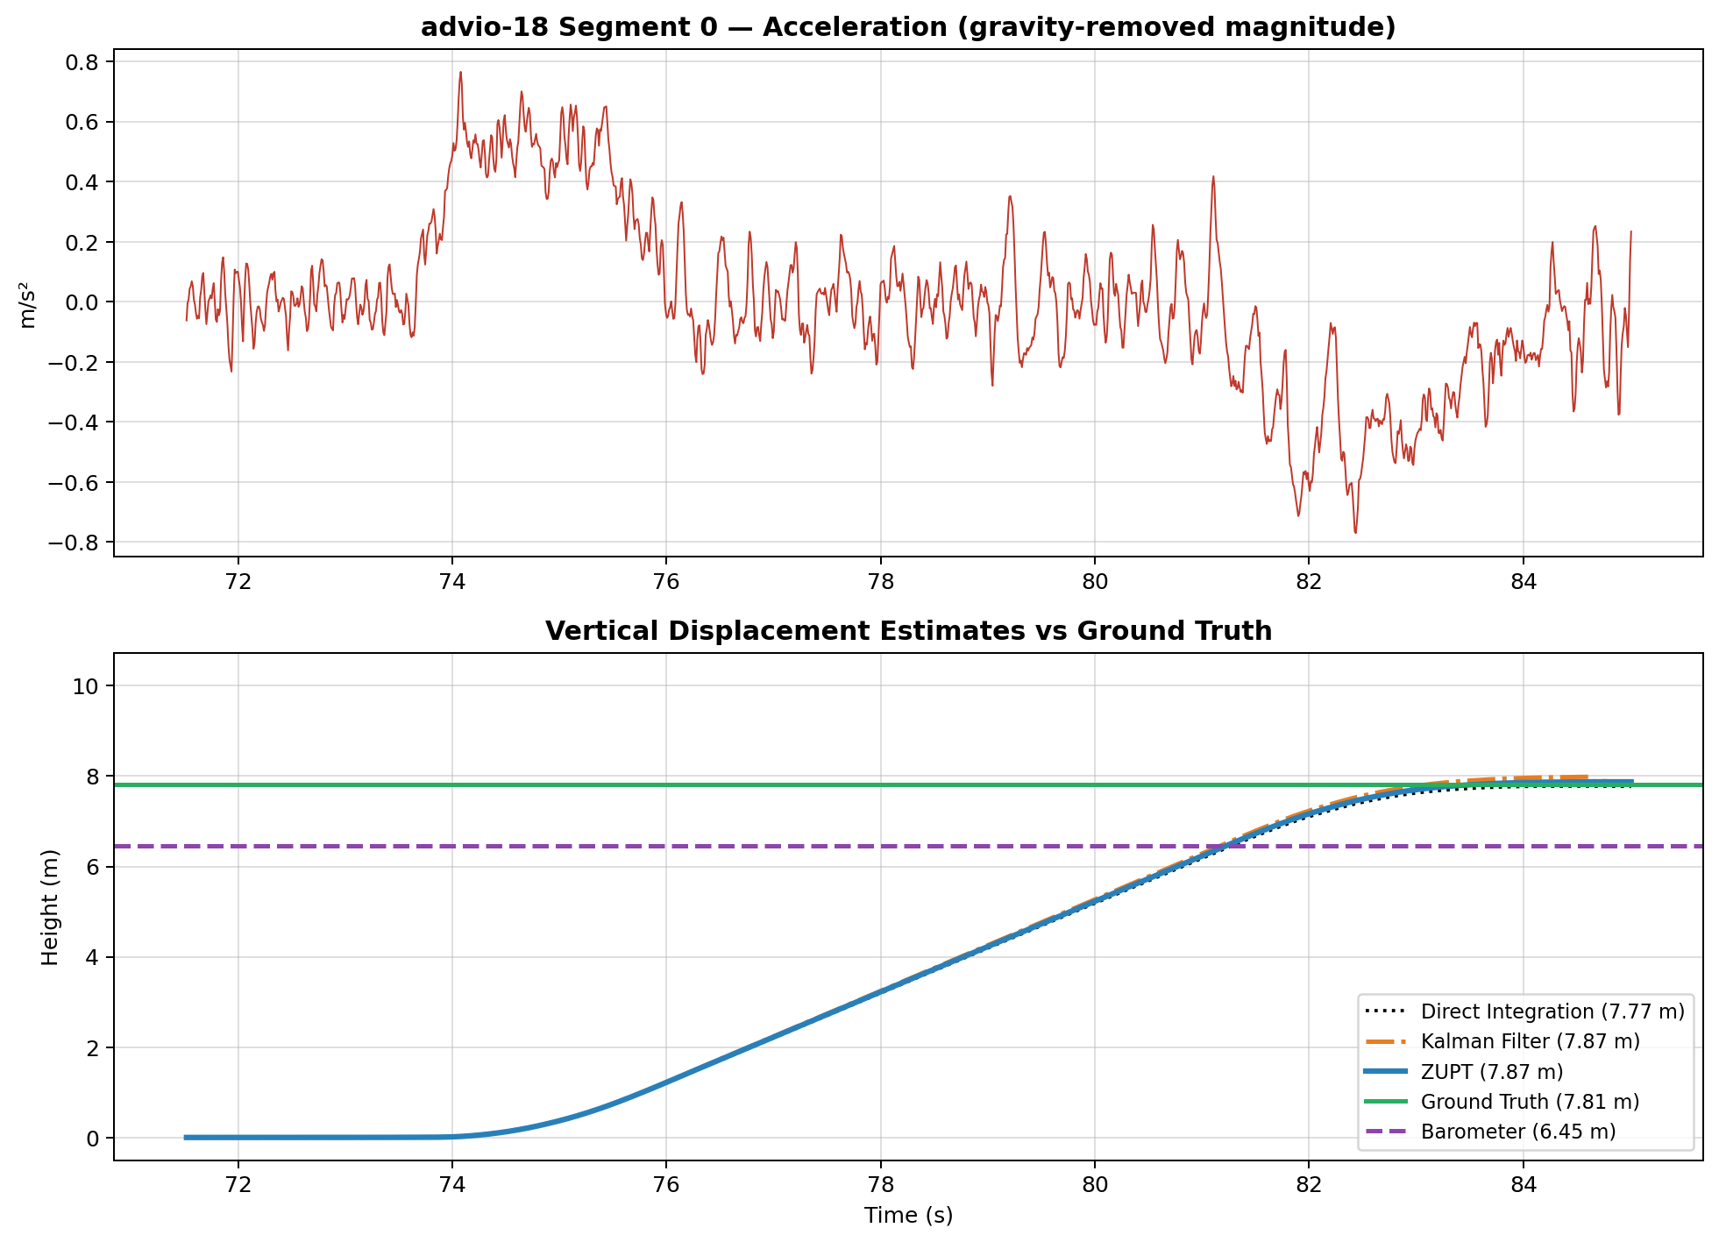
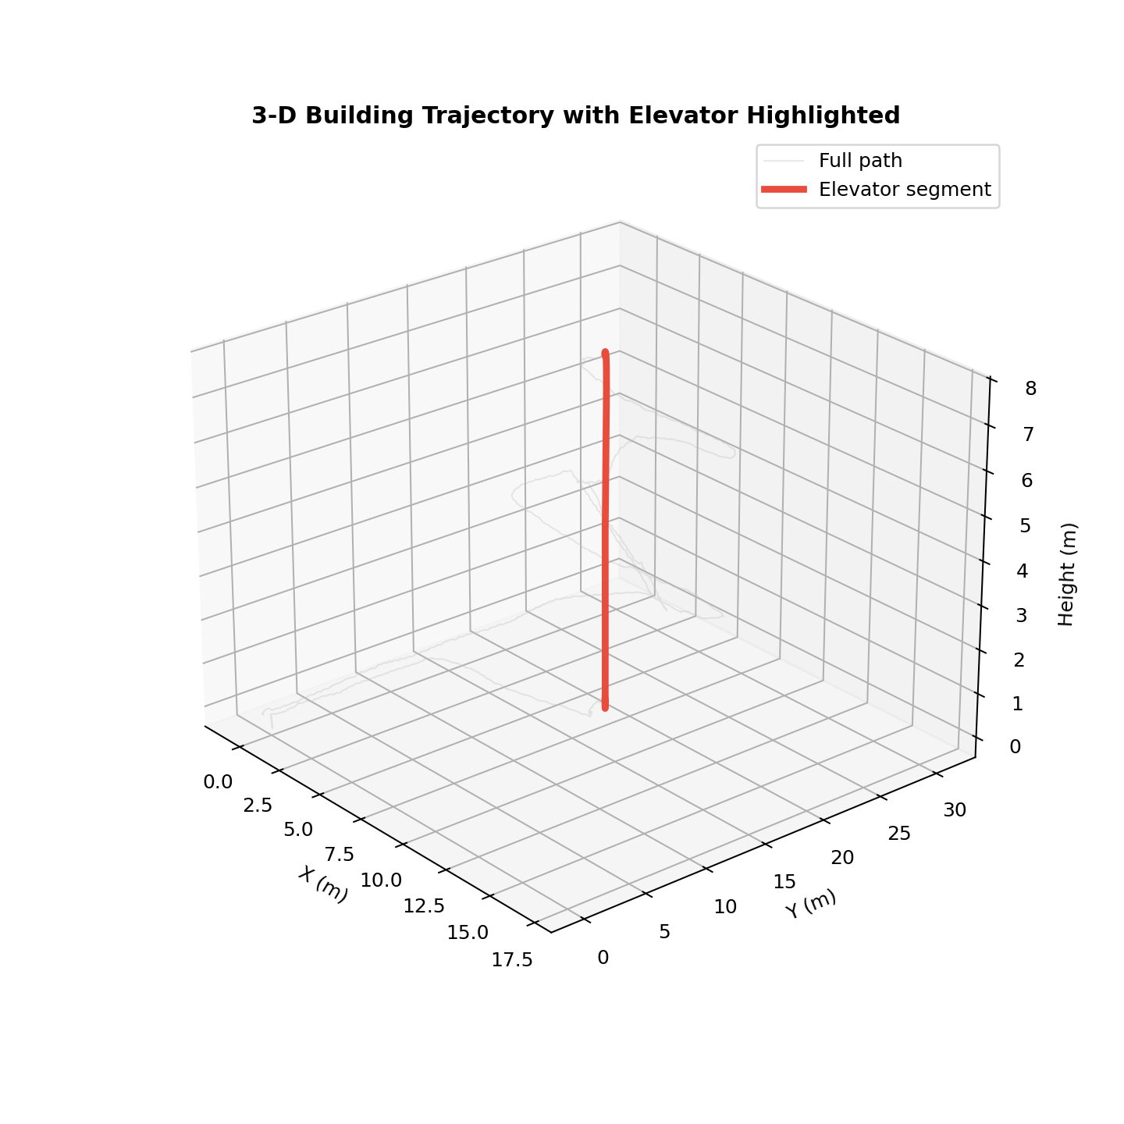

4. Aggregate Results and Algorithm Ranking

4.1 Full Results Table
Segment | GT (m) | Baro (m) | Direct (m) | ZUPT (m) | Kalman (m) | Best Algorithm
advio-07-0 | 5.60 | 5.06 | 3.50 | 5.81 | 5.74 | Kalman
advio-07-1 | 4.53 | 3.64 | -2.76 | 4.50 | -2.75 | ZUPT
advio-07-2 | 4.52 | 3.92 | 4.68 | 4.37 | 4.37 | ZUPT
advio-07-3 | 4.52 | 4.19 | 4.43 | 4.53 | 4.52 | Kalman
advio-07-4 | 4.46 | 3.15 | 2.61 | 4.65 | 4.41 | Kalman
advio-14-0 | 7.52 | 6.93 | 8.96 | 6.93 | 8.96 | ZUPT
advio-18-0 | 7.81 | 6.45 | 7.77 | 7.87 | 7.87 | Direct

4.2 Mean Absolute Errors
Direct Integration | ZUPT | Kalman Filter
1.066 m | 0.176 m | 0.518 m

4.3 Discussion and Algorithm Selection
Across all 7 elevator segments, ZUPT achieves the lowest mean absolute error (0.176 m), followed by the Kalman Filter (0.518 m) and Direct Integration (1.066 m).
ZUPT was the most accurate algorithm on 3 of 7 segments, Kalman on 3, and Direct on 1.
Why ZUPT is the recommended algorithm for this task:
- Physical grounding: Elevators must start and end at rest. The v(0) = v(T) = 0 constraint provides a powerful anchor that Direct Integration lacks entirely.
- Bias absorption: The linear drift correction implicitly compensates for constant acceleration bias without needing to estimate it explicitly (unlike the Kalman filter).
- Robustness: ZUPT performs consistently well across segments of different durations and different buildings, unlike Direct Integration whose accuracy depends heavily on the quality of the gravity estimate for that particular segment.
Where Direct Integration can still be useful:
On segments where the sensor bias happens to be very small (e.g. advio-07 segment 3, where Direct achieved 4.43 m vs 4.52 m GT), the simplicity of direct integration is attractive. However, there is no way to know a priori whether the bias will be small, making it unreliable as a general-purpose estimator.
Where the Kalman Filter underperforms:
On several segments, the Kalman filter converges to a value very close to Direct Integration. This happens when the zero-velocity pseudo-measurements are not injected — either because the stationary periods fall outside the extracted time window, or because the acceleration threshold does not trigger. With better tuning or a wider extraction window, the Kalman filter could potentially match ZUPT, but this highlights its sensitivity to hyperparameters.

5. Conclusions and Future Work

5.1 Conclusions
This study demonstrated that smartphone accelerometers alone can estimate elevator vertical displacement with sub-metre accuracy when appropriate signal processing is applied. The ZUPT algorithm, leveraging the known stationary boundary conditions of elevator rides, consistently outperforms both uncorrected integration and Kalman filtering in terms of mean absolute error and robustness across different buildings and ride durations.

5.2 Limitations
- Small sample size: Only 7 elevator segments across 3 ADVIO datasets were available. A larger and more diverse dataset would strengthen the conclusions.
- Phone orientation: Using scalar magnitude ||a|| discards directional information. If the phone orientation were known (e.g. from gyroscope integration), projecting acceleration onto the gravity vector could improve accuracy.
- Multi-stop rides: None of the tested segments involved mid-ride floor stops, which would require segmentation of the ZUPT windows.

5.3 Future Work
- Gyroscope fusion: Integrating gyroscope data to estimate phone orientation and extract the true vertical acceleration component.
- Barometer fusion: Combining the complementary strengths of accelerometer (high-frequency, relative) and barometer (low-frequency, absolute) altitude sensors.
- Real-time deployment: Adapting the ZUPT algorithm for streaming data with unknown ride boundaries, using a sliding-window approach or online change-point detection.
- Deep learning: Training a neural network to learn the mapping from raw acceleration windows to displacement, potentially capturing non-linear sensor artifacts that model-based approaches cannot.

References
[1] S. Cortés, A. Solin, E. Rahtu, J. Kannala, "ADVIO: An Authentic Dataset for Visual-Inertial Odometry," ECCV 2018.
[2] I. Skog, P. Händel, "Zero-Velocity Detection — An Algorithm Evaluation," IEEE Trans. Biomedical Engineering, 2010.
[3] R. E. Kalman, "A New Approach to Linear Filtering and Prediction Problems," ASME Journal of Basic Engineering, 1960.

