**Why beresheet crashed?**

First of all lets make some thing clear in order to get out of earth gravity you will need to fly at 11.2 kilometers per second and for the moon only 2.4 kilometer per second.

So for beresheet to get out of earth it had to cross that speed but because moon gravity much looser then earth so before getting to the moon the spaceship needs to lower her speed.

**How**?

For the spaceship to lower it speed it has to fly in the opposite direction.

So it will catch in the moon gravity (otherwise it will pass near the moon without stopping).

And when the beresheet team needed to do that the main engine stopped working and they had to reset him an act that didn’t took to much time but in that time it was too late to stop stop the sheep because it started to increase her speed and ended up crashing.

The main goal of the spaceship was to get to 5 meter above land and turn down all her engines then falling to the moon.

But 14 kilometers from earth it started to have problems with the acceleration and the main engine.

**Our Experiment Part 2.4**

In this project we tried to stick with Spaceil original plan which means that 30 km from the moon the spaceship starts to lower her speed by changing her angle and flying in the opposite direction as the spaceship gets 2 km from the moon in changes its angle to 0 and lowering her speed even more this action requires all the engines to work.

How does the simulation works ?

We have a loop that updates the data (LAT , ALT , Dist, Weight , Fuel etc..) .

The fuel and weight are calculated by the power given to the engines.

The distance is calculated from the spaceship to the landing point.

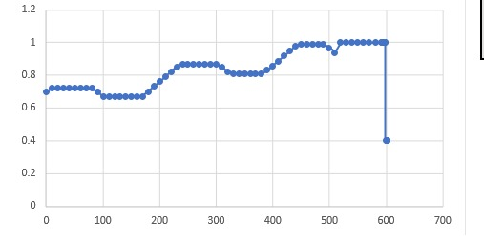

**NN**

**Time**

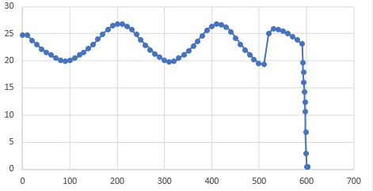

**VS**

**TIME**

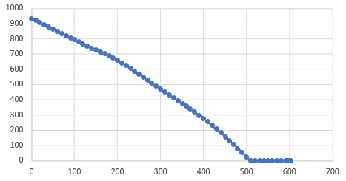

**HS**

**Time**

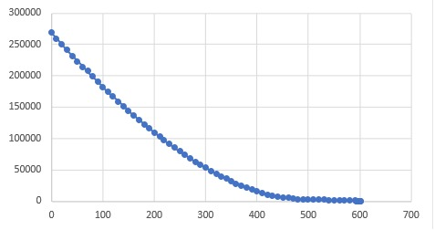

**Dist**

**Time**

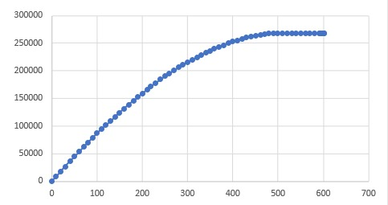 **Lat**

**Time**

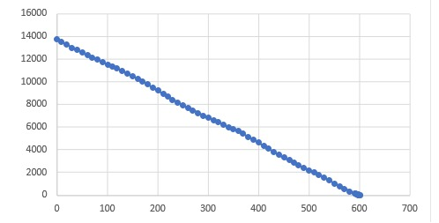

**Alt**

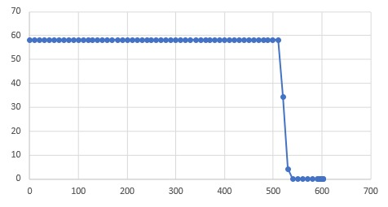 **Time**

**Ang**

**Time**

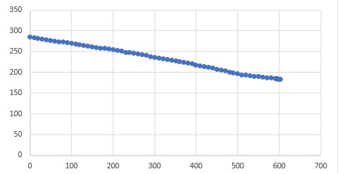

**Weight**

**Time**

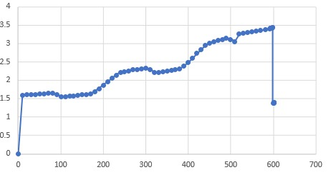

**Acc**

**Time**

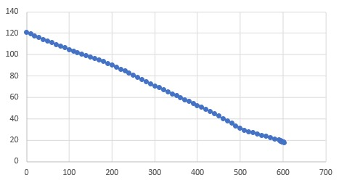

**Fuel**

**Time**