Ex.No.3 | CI Pipeline | URK23CS1263
18-12-2025

Aim:
To create a plain Python application, implement Continuous Integration using GitHub Actions to run tests with pytest, containerize the application using Docker, and automatically push the Docker image to Docker Hub.

Procedure:
- Create a project folder named python-ci-docker-lab and add the required files: app.py, tests/test_app.py, requirements.txt, Dockerfile, and .gitignore.
- Write the Python application code in app.py to define a simple add(a, b) function and print a sample output when executed directly.
- Create a test file tests/test_app.py and write unit tests using pytest to validate the add() function.
- Create a requirements.txt file and specify the pytest dependency (pytest==8.3.2).
- Create a Dockerfile to define the container configuration:
• Use python:3.11-slim as the base image.
• Set the working directory to /app.
• Copy requirements.txt and install dependencies.
• Copy the project files into the container.
• Define the command to run the application (CMD ["python", "app.py"]).
- Test the application locally (optional):
• Run the application using: python app.py
• Run tests using: pytest -q
• Build the Docker image using: docker build -t yourname/python-ci-lab:local .
• Run the container using: docker run --rm yourname/python-ci-lab:local
- Create a GitHub Actions workflow file at .github/workflows/ci-dockerhub.yml to automate CI/CD:
• Trigger workflow on push to main branch, pull requests, and tags.
• Set up Python 3.11 environment.
• Install dependencies and run pytest.
• Set up Docker Buildx and QEMU.
• Login to Docker Hub using repository secrets.
• Build and push the Docker image using docker/build-push-action.
- Initialize a Git repository and push the project to GitHub:
• git init
• git add .
• git commit -m "init lab"
• git branch -M main
• git remote add origin https://github.com/<your-username>/python-ci-docker-lab.git
• git push -u origin main
- Add GitHub repository secrets:
• DOCKERHUB_USERNAME (Docker Hub username)
• DOCKERHUB_TOKEN (Docker Hub access token)
- Verify the CI pipeline execution:
• Go to GitHub → Actions tab.
• View workflow logs to confirm tests passed and image was pushed successfully.
- Verify the Docker image on Docker Hub by checking:
docker.io/<DOCKERHUB_USERNAME>/python-ci-lab

Question:
- Create a new project folder
mkdir python-ci-docker-lab
cd python-ci-docker-lab
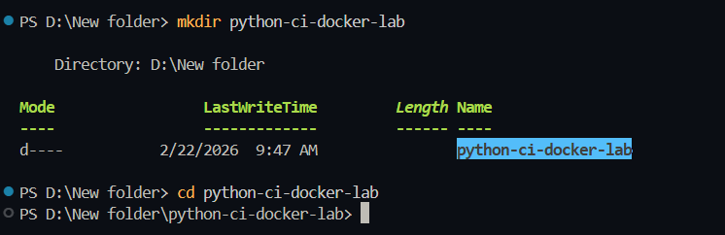
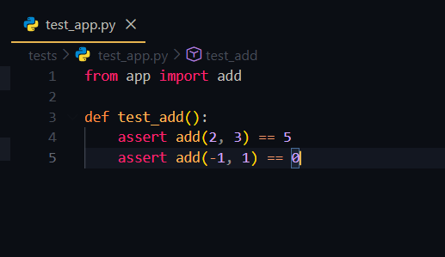
- Create application files
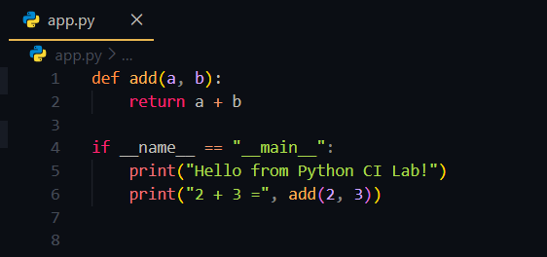
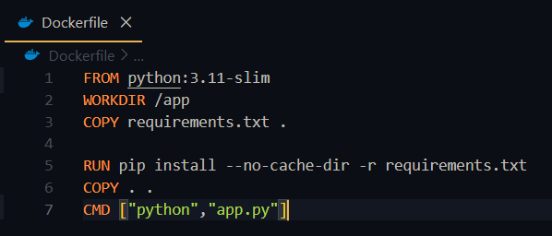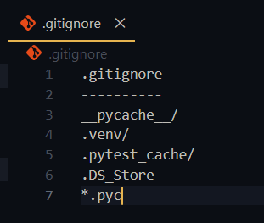

- Add GitHub Actions workflow
mkdir -p .github/workflows
.github/workflows/ci-dockerhub.yml
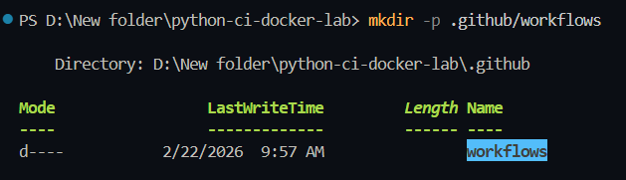

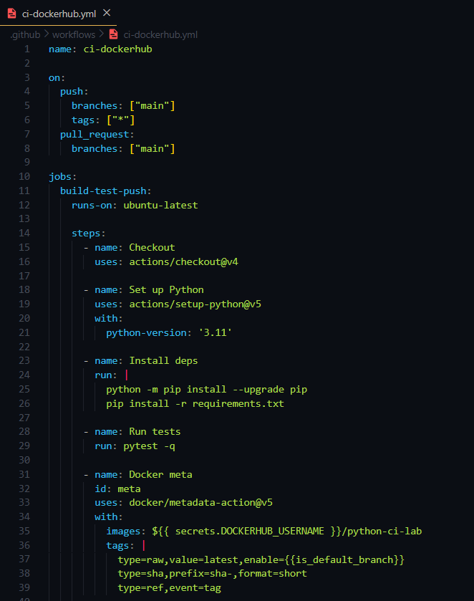
- Test locally
python app.py
pytest -q
docker build -t yourname/python-ci-lab:local .
docker run --rm yourname/python-ci-lab:local

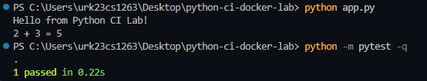
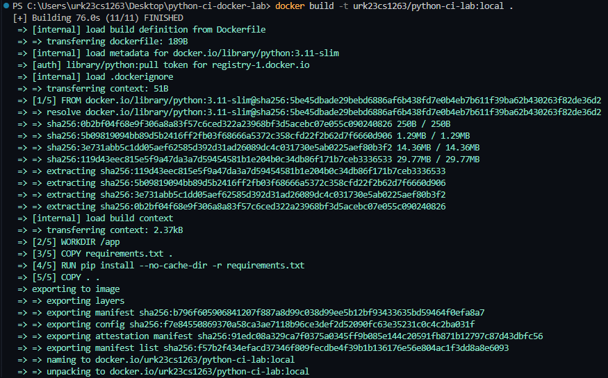
- Initialize Git & push to GitHub
git init
git add .
git commit -m "init lab"
git branch -M main
git remote add origin https://github.com/<your-username>/python-ci-docker-lab.git
git push -u origin main
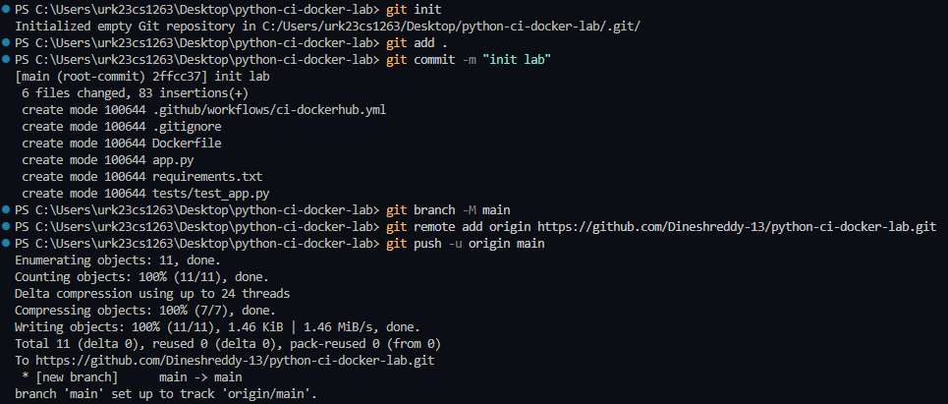

- Add GitHub Secrets
DOCKERHUB_USERNAME (urk23cs1263)
DOCKERHUB_TOKEN (Docker Hub access token)
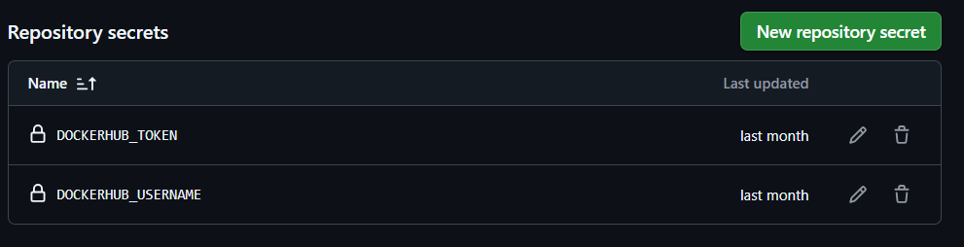
- Watch CI run
Go to GitHub → Actions tab → select workflow run → view logs.
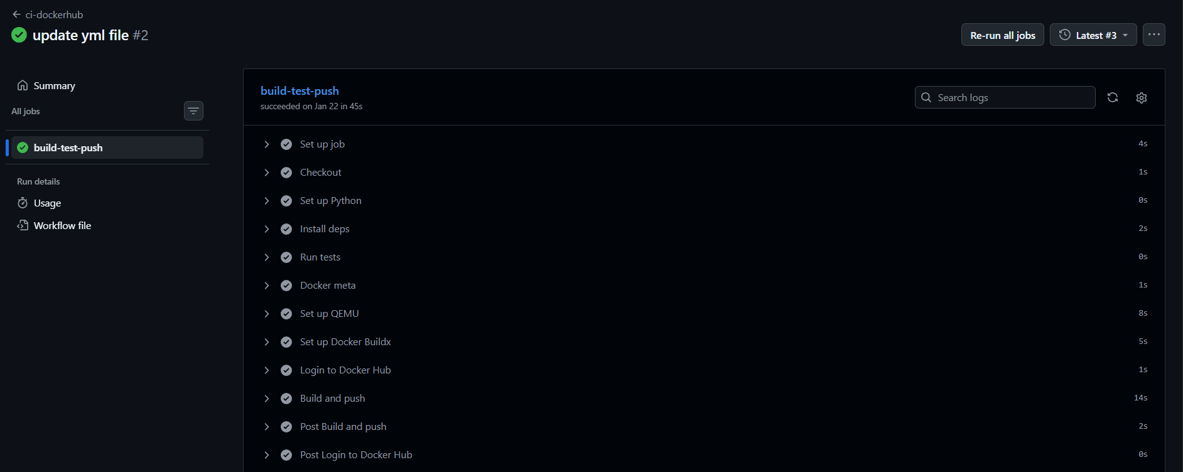

- Verify image on Docker Hub
docker.io/urk23cs1263/python-ci-lab
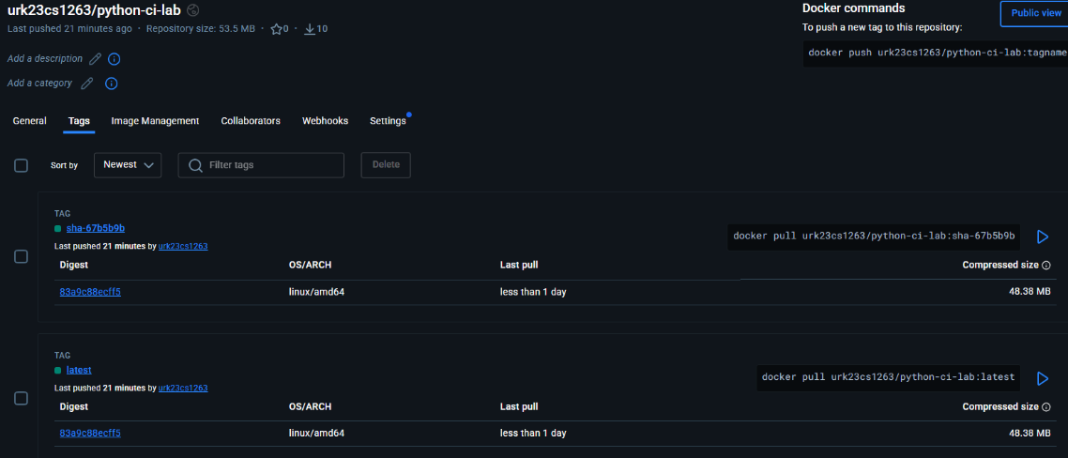

Program:
app.py
def add(a, b):
return a + b
if __name__ == "__main__":
print("Hello from Python CI Lab!")
print("2 + 3 =", add(2, 3))

test_app.py
from app import add

def test_add():
assert add(2, 3) == 5
assert add(-1, 1) == 0

Result: The plain Python application was successfully tested using pytest through GitHub Actions. The application was containerized using Docker, and the Docker image was automatically built and pushed to Docker Hub via the CI pipeline. The image was successfully pulled and executed on another system, confirming successful Continuous Integration and deployment.

