Ex.No.1 | Git Essentials:  Commit, Push, Merge, and Pull Requests | URK23CS1263
4-12-2025

Aim:
The aim is to demonstrate pushing changes to a GitHub repository, covering setup, managing visibility, and executing basic Git operations.

Procedure:
The aim of the experiment is to demonstrate the process of pushing changes to a GitHub repository. This involves:
1. Setting up Git: Ensure Git is installed on your computer.
2. Managing Repository Visibility: Understand the effects of making a repository private or public on GitHub.
3. Changing Repository Visibility: Learn how to change the visibility of a repository on GitHub.
4. Pushing Changes to the Repository: Make changes to a local repository, commit them, and push
them to the remote repository on GitHub.

- Open the terminal or command prompt and navigate to the desired project directory.
- Initialize a new Git repository using git init or clone an existing repository using git clone <repository_url>.
- Create or modify project files and add them to the staging area using git add.
- Commit the staged changes using git commit -m "commit message".
- Check the repository status using git status and view commit history using git log.
- Create and switch between branches using git branch and git checkout.
- Merge branches using git merge.
- Connect to a remote repository using git remote add origin, then push and pull changes using git push and git pull.

Question:
1. Initialize a new Git repository in the current working directory.
git config –global user.name “Dineshreddy-13”
git config –global user.email “bijjamdinesh@karunya.edu.in”
git init
2. Clone an existing remote GitHub repository to your local machine.
git clone https://github.com/Dineshreddy-13 /devops_lab_ex1.git
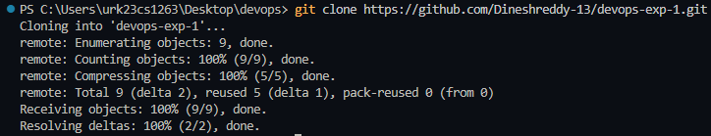
3. Add all modified and newly created files in the project to the staging area.
git add .
4. Commit the staged changes with the message: "Initial commit of the project".
git commit -m “add new files”
git push
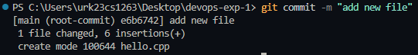

5. Check the current status of your repository and identify untracked or modified files.
git status
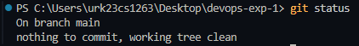

6. Display the commit history of the current branch.
git history
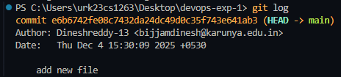
7. Create a new branch testbranch.
git branch feature/new-feature
8. Switch from the current branch to testbranch.
git checkout feature/new-feature
9. Create a new branch named test1branch and switch to it in a single command.
git checkout -b bugfix/fix-login
10. Merge the branch test1branch into the current branch.
git checkout main
git merge feature/new-feature
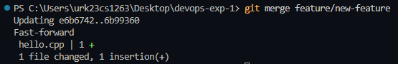
11. Connect your local repository to a remote repository using the name origin.
git remote add origin https://github.com/Dineshreddy-13 /devops_lab_ex1.git
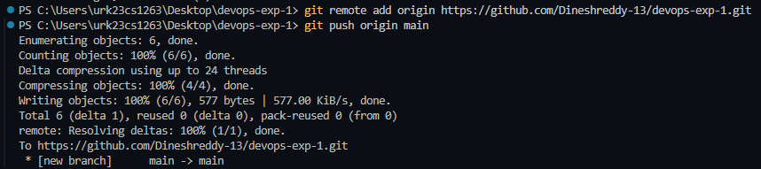
12. Push the main branch to the remote repository.
git push


13. Pull the latest changes from the main branch of the remote repository
git pull origin main
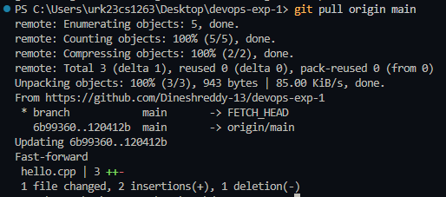

Result: The basic Git commands were executed successfully without errors. Repository operations such as initialization, staging, committing, branching, and merging were performed correctly.

