Ex.No.2 | Flask App Containerization and Docker  Hub Deployment | URK23CS1263
18-12-2025

Aim:
To create a Flask web application, containerize it using Docker, and deploy it to Docker Hub.

Procedure:
- Create a project folder named flask-docker-app and add the required files: app.py, requirements.txt, and Dockerfile.
- Write the Flask application code in app.py to create a simple web page and configure it to run on host 0.0.0.0 and port 5000.
- Create a requirements.txt file and specify the Flask version (Flask==2.2.5).
- Create a Dockerfile to define the container configuration:
- Use python:3.9-slim as the base image.
- Set the working directory.
- Copy the requirements file and install dependencies.
- Copy the application code.
- Expose port 5000.
- Define the command to run the Flask app.
- Build the Docker image using: docker build -t flask-docker-app .
- Run the Docker container using: docker run -p 5000:5000 flask-docker-app
- Open a browser and verify the application by visiting: http://localhost:5050
- Log in to Docker Hub using: docker login
- Tag the Docker image with your Docker Hub username.
- Push the Docker image to Docker Hub using docker push.
Question:
1.Create a Flask application (app.py) that displays a simple HTML page and runs on port 5000.
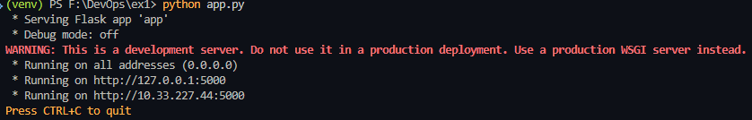
2. Create a requirements.txt file and specify the required dependency for the Flask application.
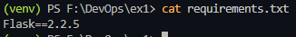
3. Write a Dockerfile to containerize the Flask application using the python:3.9-slim base image.
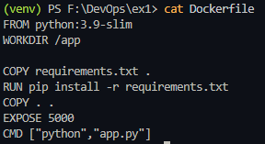
4. Build a Docker image named flask-docker-app from the project directory.
docker build -t flash-docker.app .
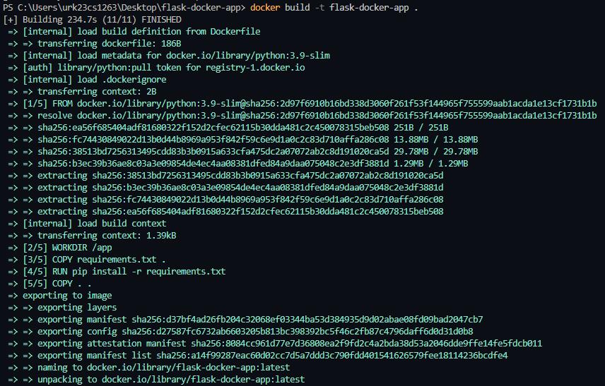

5. Run the Docker container and map the container port 5000 to a host port.
docker run -p 5050:5000 flask-docker-app
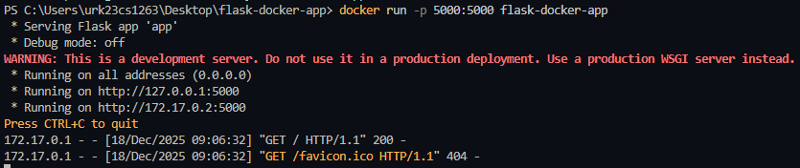
6. Verify that the Flask application is running successfully in the browser.
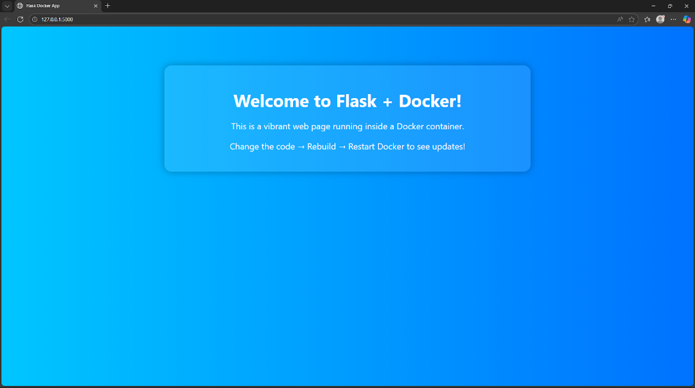
7. Log in to Docker Hub using the Docker CLI.
docker login
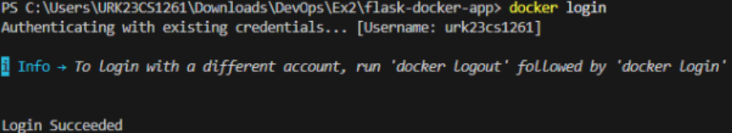
8. Tag the Docker image with your Docker Hub username.
docker tag flask-docker-app urk23cs1261/flash-docker-app:latest

9. Push the Docker image to Docker Hub.
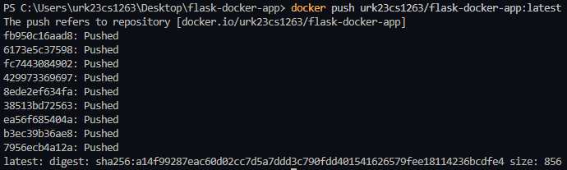

10. Pull the Docker image on another system and run the container to test deployment.
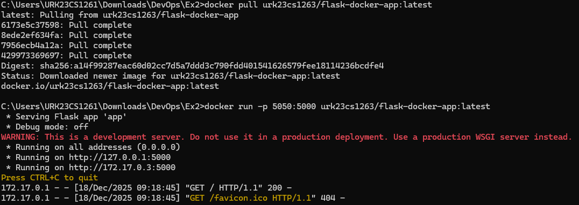

Program:
from flask import Flask, render_template_string
app = Flask(__name__)
HTML_TEMPLATE = """<!DOCTYPE html><html lang="en"><head><meta charset="UTF-8"><title>Flask Docker App</title><style>body {background: linear-gradient(to right, #00c6ff, #0072ff);color: white;font-family:'Segoe UI', Tahoma, Geneva, Verdana, sans-serif; text-align: center;padding-top: 100px;}h1 {font-size: 3em;margin-bottom: 0.2em;} p {font-size: 1.5em;}
.card {background: rgba(255, 255, 255, 0.1);padding: 2em;border-radius: 20px;box-shadow: 0 0 20px rgba(0,0,0,0.3);width: 50%;margin: auto;}</style></head><body>
<div class="card">
<h1> Welcome to Flask + Docker!</h1>
<p>This is a vibrant web page running inside a Docker container.</p>
<p>Change the code → Rebuild → Restart Docker to see updates!</p> </div></body></html> """
@app.route('/')
def home():
return render_template_string(HTML_TEMPLATE)
if __name__ == '__main__':
app.run(host='0.0.0.0', port=5000)

Result: The Flask application was successfully containerized and executed using Docker.
The Docker image was pushed to Docker Hub and pulled on another system, confirming successful deployment.

