Work on Ebola Treatments Speeds Up to Address Outbreak
Carol Pearson
August 13,2014
The World Health Organization has approved the use of experimental drugs for people who have Ebola, a virus that already has claimed more than 1,000 lives in western Africa.
The experimental Ebola serum that was used on American and Spanish missionaries is produced in California at the Mapp Biopharmaceutical laboratory. The manufacturer says it has run out of the serum, but is trying to increase production as quickly as possible.
Other groups also are working on treatments and vaccines.
Researchers at Newlink Genetics in Iowa say they have a vaccine that was 100 percent effective when given to monkeys. The company got a federal grant to ramp up its work and to speed up human testing.
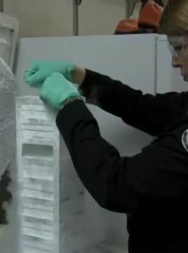
The U.S. National Institutes of Health has approved a grant to the University of Texas Medical Branch to develop effective treatments for Ebola. Professor Thomas Geisbert is the lead researcher.
"That grant really is to focus on what we believe are three of the most promising post-exposure treatments against Ebola," said Geisbert.
All have proven effective in testing on monkeys. Professor Geisbert says the next step is human trials.
“One of the goals for this project is to actually try to combine these different treatments, for example with HIV there’s been a lot of success in combining different anti-viral drugs that operate by different mechanisms of action, and we believe that this is something that may work for Ebola as well," said Geisbert.
Since 1976, there have been more than 15 Ebola outbreaks in sub-Saharan Africa, but no licensed treatments are available. Dr. Peter Hotez is an expert on tropical diseases. He founded the National School of Tropical Medicine at the Baylor College of Medicine in Texas.
"The problem is that it’s a neglected tropical disease, where there’s no real commercial market for it, the major multi-national firms have not invested in these products," said Hotez.
As a result, researchers have to depend on grants from government and private sources and progress goes a lot slower. Too slow and too late for more than 1,000 people.

