West African Immigrants Worry About Family, Friends as Ebola Spreads
Daniela Schrier
August 12,2014
NEW YORK— The deadly Ebola virus in West Africa has taken the lives of more than 1,000 people, according to the World Health Organization. In New York City, many Africans worry about their relatives and friends as the unprecedented outbreak sweeps through the region a continent away.
Haunting scenes of Ebola victims in West Africa are a common sight on television news. But for many West African immigrants living in New York City, the deadly outbreak is personal.
New York City is home to more than 70,000 people born in Western Africa. Many hail from countries hardest hit by Ebola, including Guinea, Liberia and Sierra Leone. Many still have family and friends in those nations.
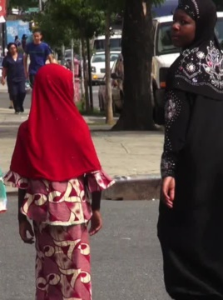
Like Leo Fraser, whose aunt who lives in Sierra Leone.
“Right now the family is figuring out how to get her more supplies, so she won't have to leave the home. You know, because the more she interacts with the general population the more she is at risk for contracting Ebola," said Fraser.
Ebola has no known cure. And the current West African outbreak is on pace to infect more people than all the previous outbreaks combined.
This is worrisome news in the Bronx, where half of the city’s West African population lives. Imam Mohamadou Soukona, leads his community, or jama’ah, in prayers and collects donations for the sick.
“The community in the jama’ah will make a doa to pray for the people who are infected with this disease," said Soukona.
The mosque’s public relations manager, Bakary Camara:
“As individuals here in this community, we warn our members to be careful of anyone that they think might come from these areas and advise them to make sure that they look and take doctors' advice - not to have bodily contact that will in a sense contract the disease," said Camara.
West African residents expressed hope the global effort to contain the disease will work, but also frustration they could not do more to help.

