x1 | x2 | y
0 | 0 | 0
0 | 1 | 1
1 | 0 | 1
1 | 1 | 0

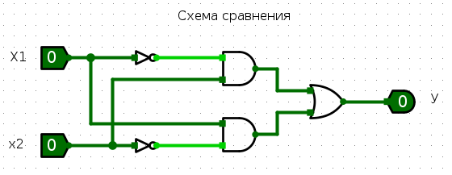

x1 | x2 | x | y
0 | 0 | 0 | 0
0 | 1 | 0 | 1
1 | 0 | 0 | 1
1 | 1 | 1 | 0

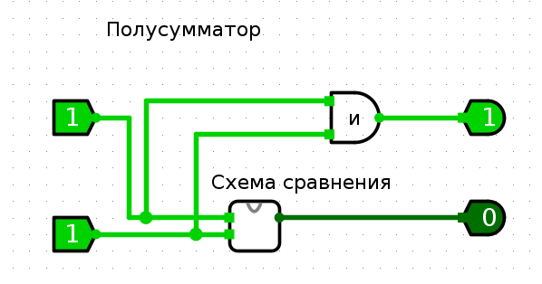

x1 | x2 | pi | P | S
0 | 0 | 0 | 0 | 0
0 | 0 | 1 | 0 | 1
0 | 1 | 0 | 0 | 1
0 | 1 | 1 | 1 | 0
1 | 0 | 0 | 0 | 1
1 | 0 | 1 | 1 | 0
1 | 1 | 0 | 1 | 0
1 | 1 | 1 | 1 | 1

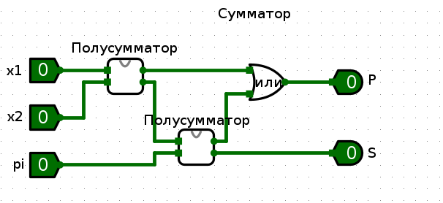

x1 | x2 | x | y
0 | 0 | 0 | 0
0 | 1 | 1 | 0
1 | 0 | 1 | 0
1 | 1 | 0 | 1

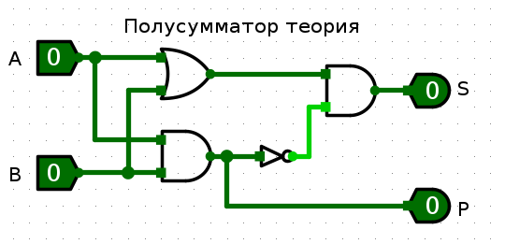

x1 | x2 | x3 | x | y
y0 | 0 | 0 | 0 | 0
0 | 0 | 1 | 0 | 1
0 | 1 | 0 | 0 | 1
0 | 1 | 1 | 1 | 0
1 | 0 | 0 | 0 | 1
1 | 0 | 1 | 1 | 0
1 | 1 | 0 | 1 | 0
1 | 1 | 1 | 1 | 1

