Name: Urmila Awasarmal
Roll no: 281078
Batch: A3

ASSIGNMENT 4

Problem Statement:
Apply appropriate ML algorithm on a dataset collected in a cosmetics shop showing details of customers to predict customer response for special offer. The cosmetics shop aims to optimize its marketing strategies by predicting customer responses to special offers.

Objective:
The objective of this project is to analyze customer behavior in a cosmetics shop and predict whether a customer will respond to a special offer. Using machine learning techniques, we will process and clean the dataset, extract meaningful features, and train an appropriate classification model. The model's performance will be evaluated using a confusion matrix, accuracy, precision, recall, and F1-score. The insights gained from this analysis will help in optimizing marketing strategies and improving customer engagement.

Libraries-used
1] import pandas as pd
For data loading, processing, and manipulation
2] from sklearn.model_selection import train_test_split
For splitting data into training and testing sets
3] from sklearn.ensemble import RandomForestClassifier
Machine Learning model for classification
4] from sklearn.metrics import confusion_matrix, accuracy_score, precision_score, recall_score f1_score
Performance evaluation metrics

1. Confusion Matrix
This matrix shows how well the model classifies responses. The structure is:
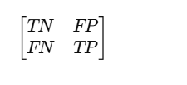

TN (True Negative): Customers correctly predicted as not responding to the offer.
FP (False Positive): Customers incorrectly predicted as responding when they did not.
FN (False Negative): Customers incorrectly predicted as not responding when they actually did.
TP (True Positive): Customers correctly predicted as responding to the offer.

2. Accuracy
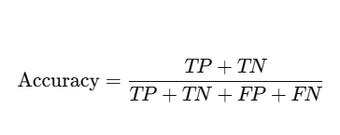
3. Precision
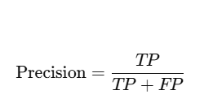
4. Recall
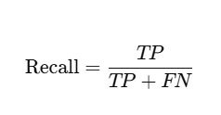
5. F1 score

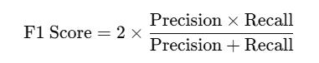

Conclusion
In above assignment we performed Dataset selection, Confusion Matrix and Metrics and calculated Accuracy ,Precision ,Recall , F-1 score. By applying machine learning algorithms to customer data, we can effectively predict responses to special offers, enabling targeted marketing strategies and improved customer engagement.

