

# LAB ASSESSMENT – 5

COMPUTER NETWORKS

SWE – 2003

**Submitted by:-**

Vaidya Urmila Suman

21MIS1098

**(a) Design a Client-Server LAN with Mesh Topology using Cisco Packet Tracer and check the PDU transmission between the nodes.**

**Step-by-Step Procedure :**

1. Design a circuit in cisco packet tracer with four switches, three PCs and one server and establish a client-server LAN with Mesh Topology.

2. Mention the IP addresses of all end devices (i.e., Server and PCs) as a note as shown in below diagram.

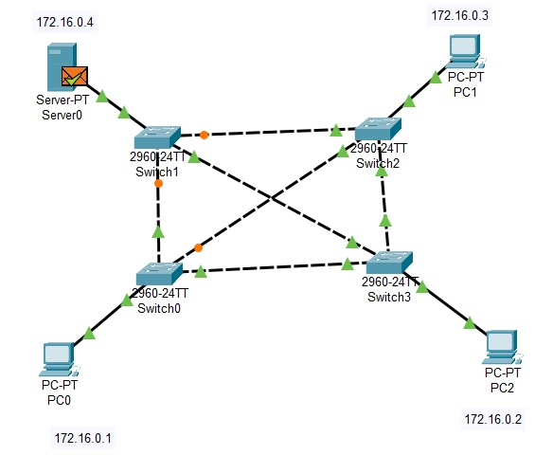

3. Configure the IP addresses of all four end devices present in the circuit.

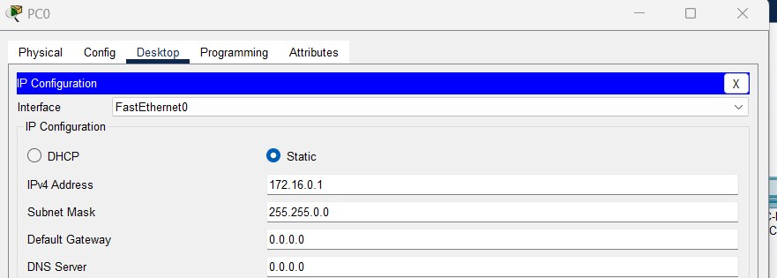

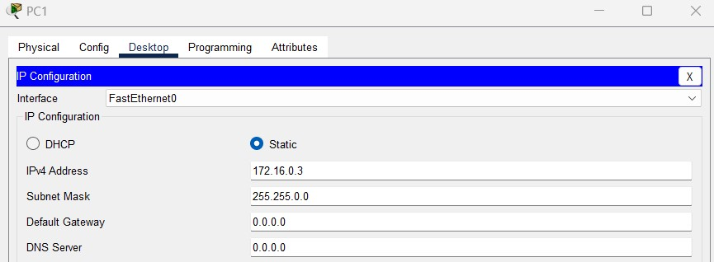

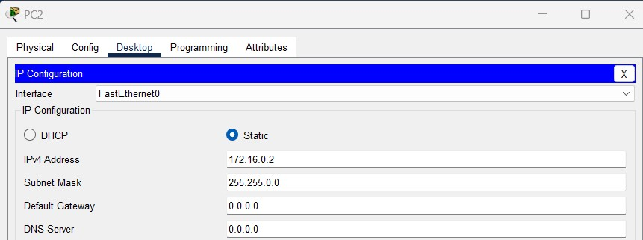

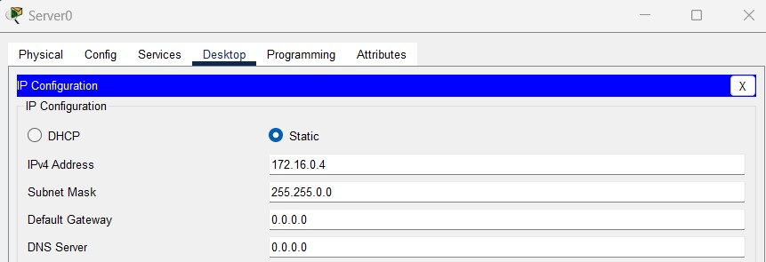

4. Send an ICMP packet from Server 0 to PC2 and observe the simulation of it step by step in simulation panel of cisco packet tracer.

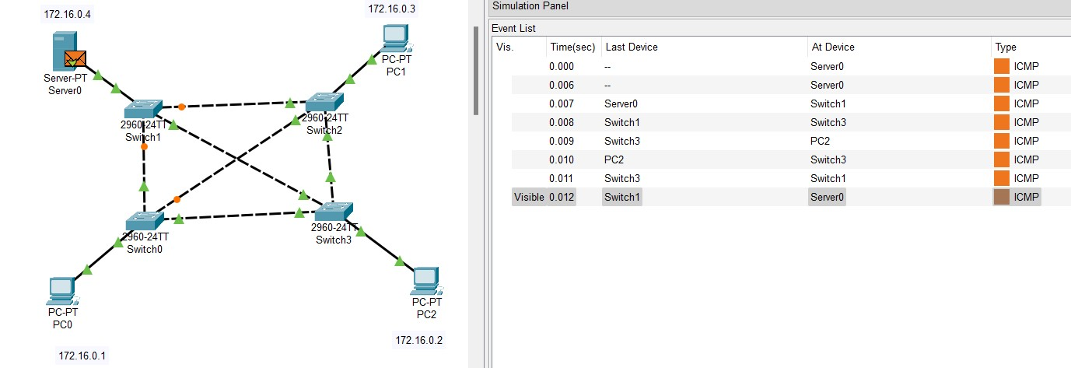

5. The simulation of ICMP packet from Server 0 to PC2 is successful , and Server 0 received acknowledgement from PC2 successfully.

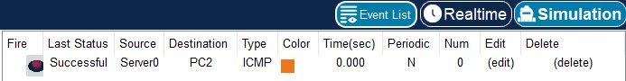

**(b) Configure ARP using CPT**

**Step-by-Step procedure :**

1. Design a circuit in cisco packet tracer with one switch, three PCs and one server.

2. Mention the IP addresses of all end devices (i.e., Server and PCs) as a note as shown in below diagram.

3. Click on inspect icon >> Click on PC0 >> Select ARP Table

4. Click on inspect icon >> Click on Server0 >> Select ARP Table

5. As you can see below both the ARP Tables are initially empty.

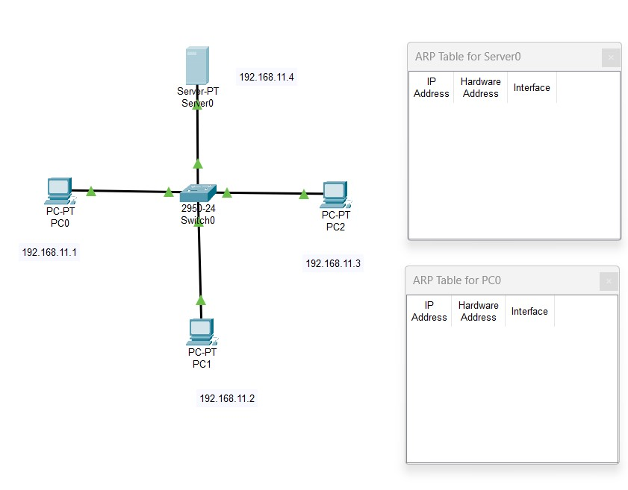

6. Configure all the end devices as given below.

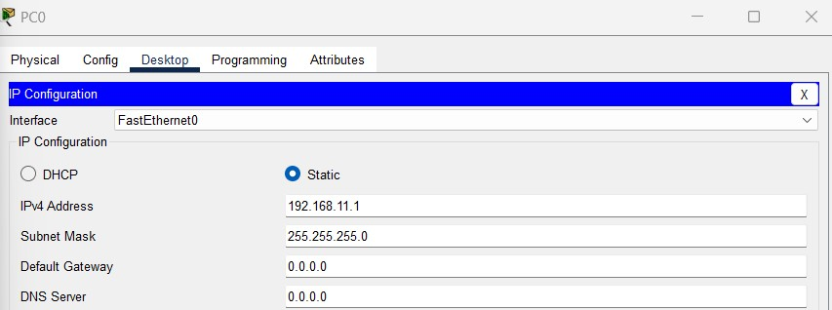

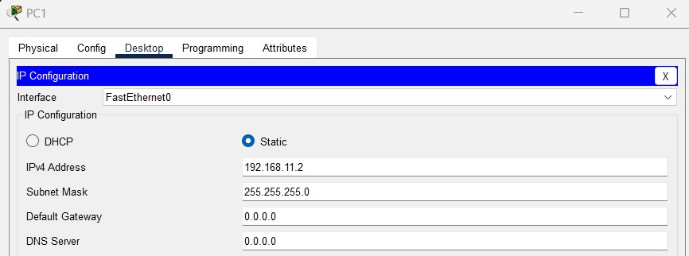

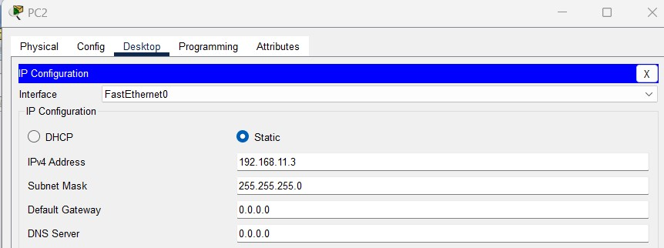

7. Click on PC0 >> PDU information >> Outbound PDU Details. You can see that we have the target IP and by configuring ARP we are going to fetch the MAC or hardware address of target i.e., Server 0.

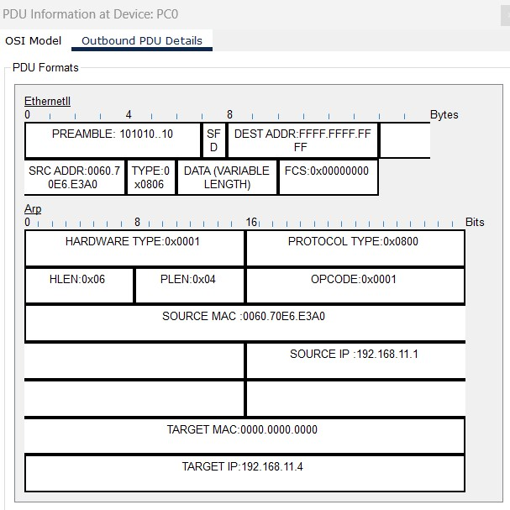

8. Now you have an ICMP packet and an ARP packet at source i.e., PC0

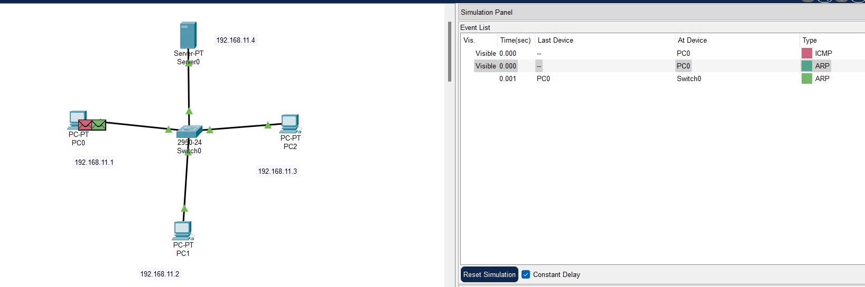

9. Now open simulation view and start simulating, ICMP packet will send ping requests to all the end devices and bring back acknowledgement to source.

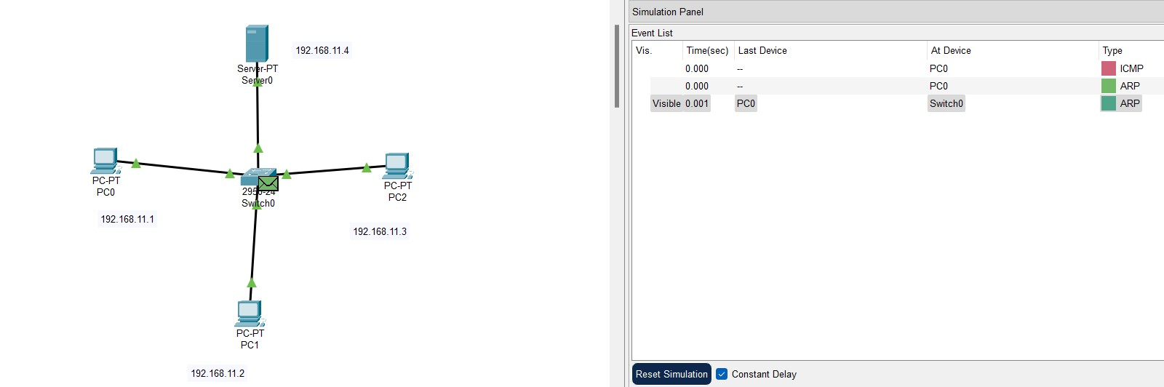

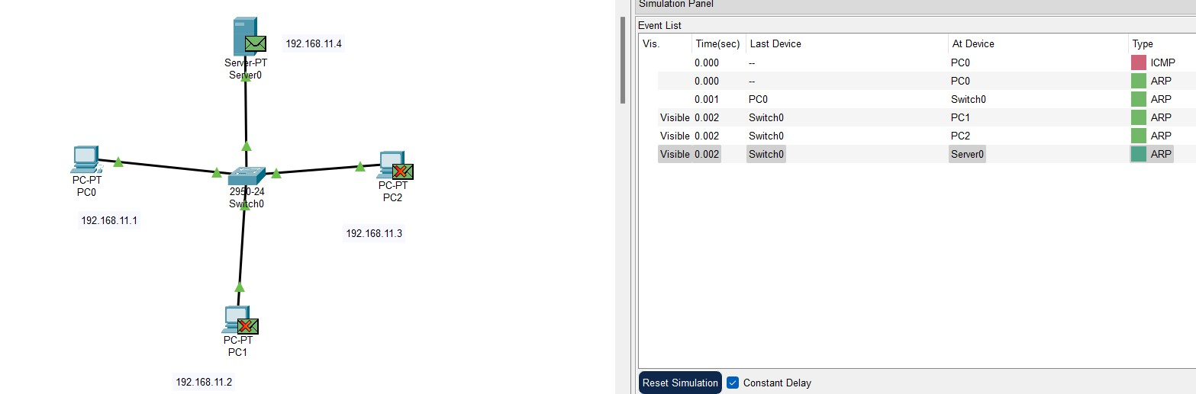

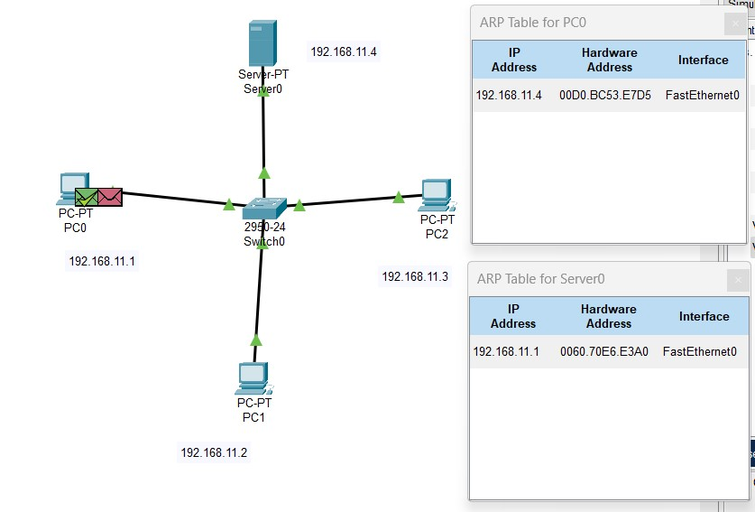

10. Now simulate ARP packet, it fetches the target MAC address i.e., hardware address of Server 0.

11. As a result, we can observe the unknown MAC address of Server 0 in ARP table of Server 0 by the ARP configuration.

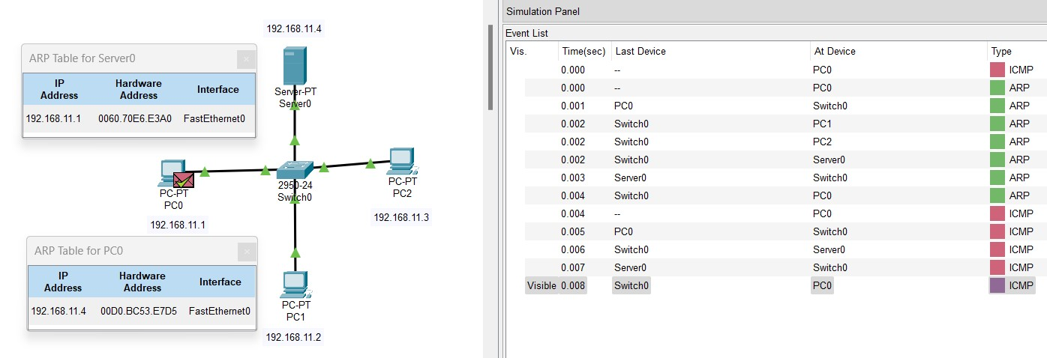

**(c) Design a network with OSPF using CPT**

**Step-by-Step procedure :**

1. Design a circuit in cisco packet tracer with two switches, two PCs and three routers to find the shortest path for a packet to travel.

2. Mention the IP addresses of all devices as a note as shown in below diagram.

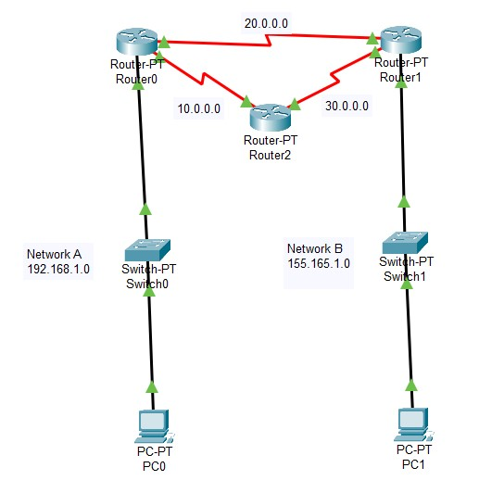

3. Configure the IP addresses and default gateways of both the PCs.

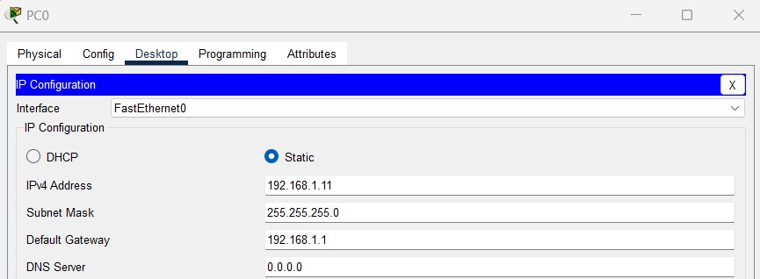

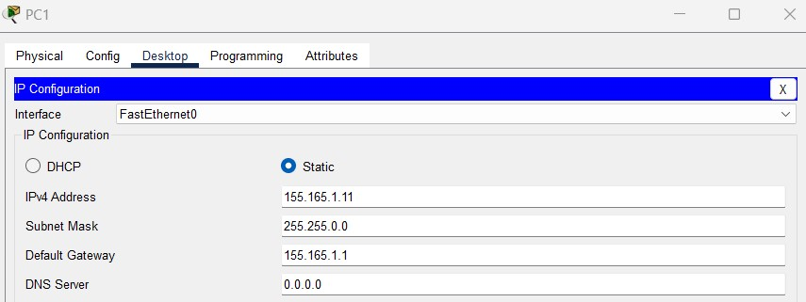

4. Configure the routers.

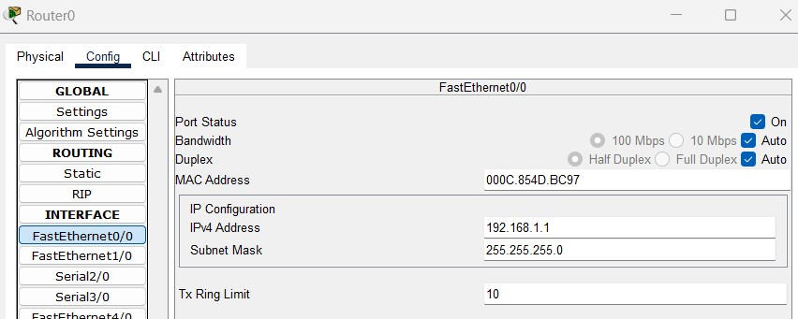

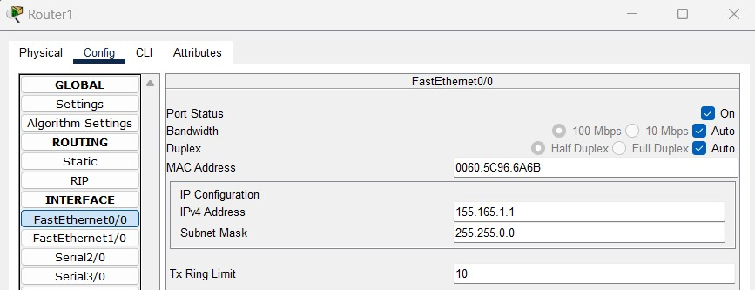

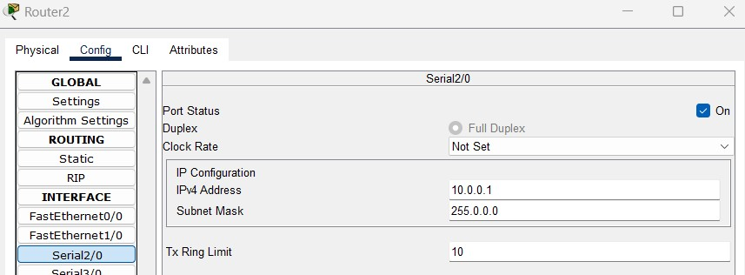

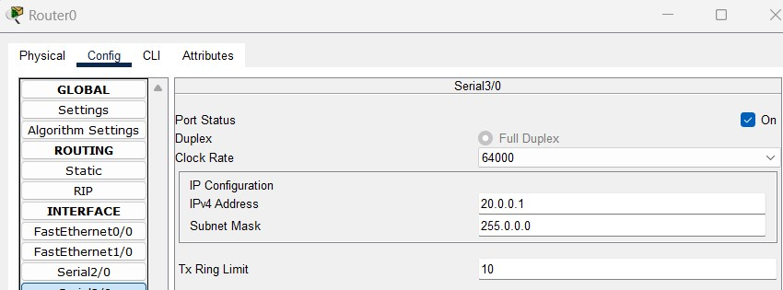

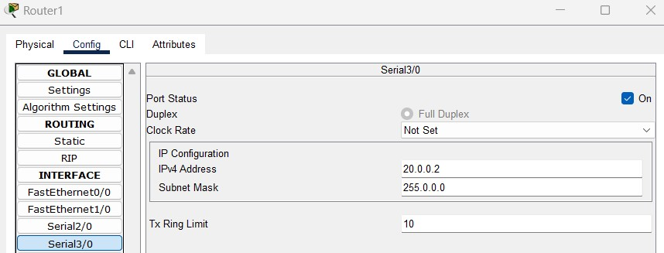

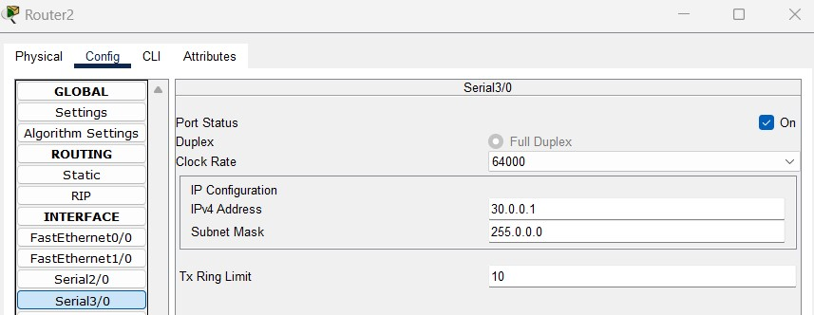

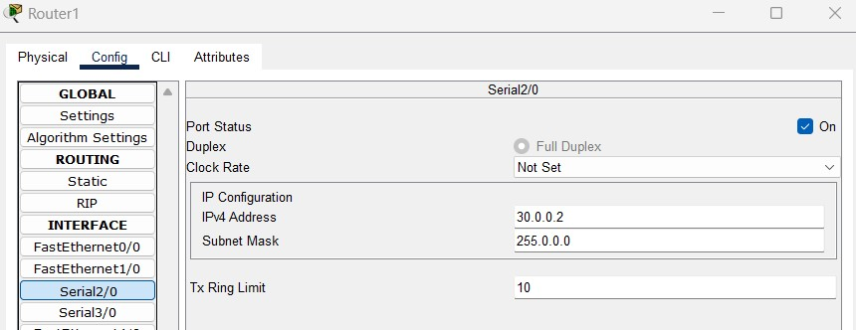

5. Open CLI of all three routers and establish OSPF.

6. Specify the networks connected to each router with syntax “network-IP address-wildcard mask-area 0”.

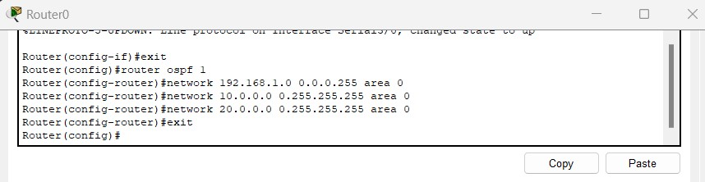

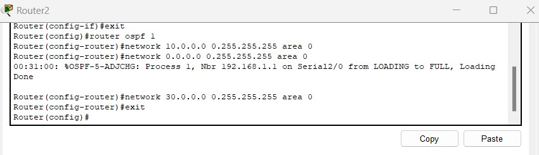

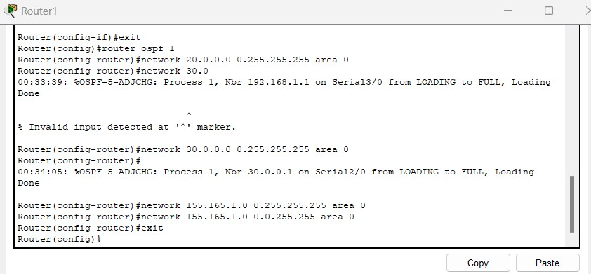

7. Now send an ICMP packet from PC0 to PC1 and ssimulate.

8. The path of the packet is PC0 >> Router 0 >> Router 1 >> PC1 >> Router 1 >> Router 0 >> PC0

9. As a result, the above path is the shortest path as the ICMP packet didn’t travelled through Router 2.

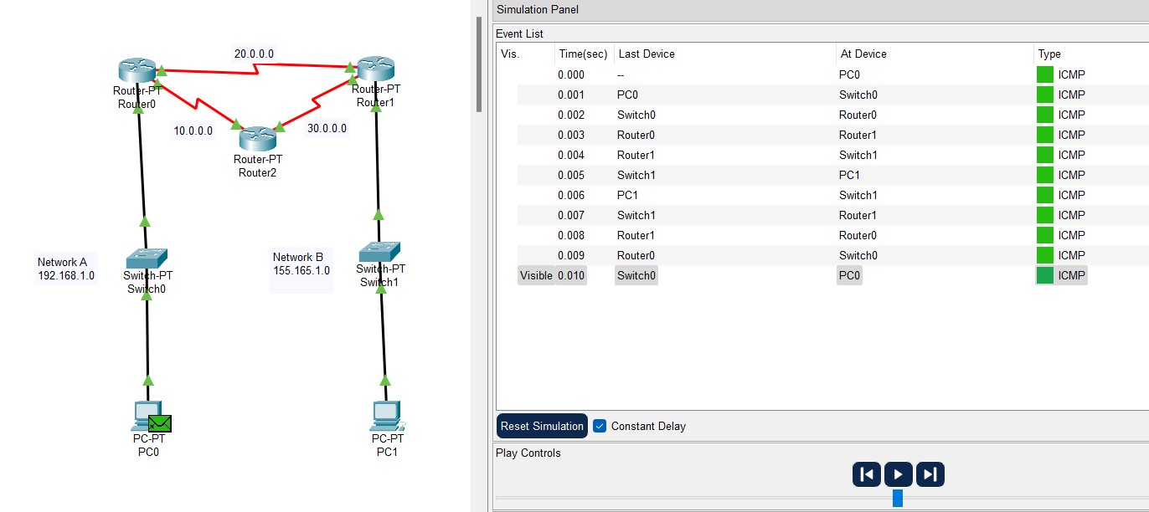

**(d) Implement a Packet Tracer script that configures a DHCP server and multiple DHCP clients. The DHCP server should provide IP addresses, subnet masks, and default gateways to the clients dynamically.**

**Step-by-Step procedure :**

1. Design a circuit in cisco packet tracer with one switch, two PCs and one server as given below.

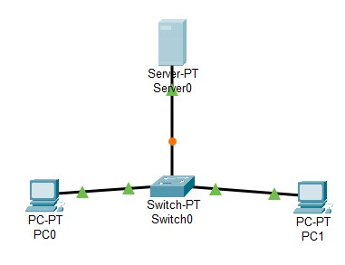

2. Do the below DHCP configuration for Server 0, so that server will allot the IP addresses , Default gateways and DNS Server to PC0 and PC1 dynamically.

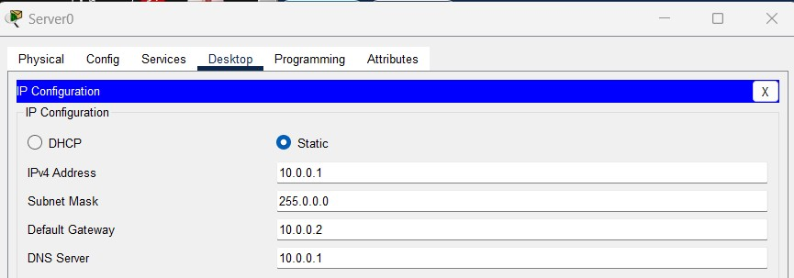

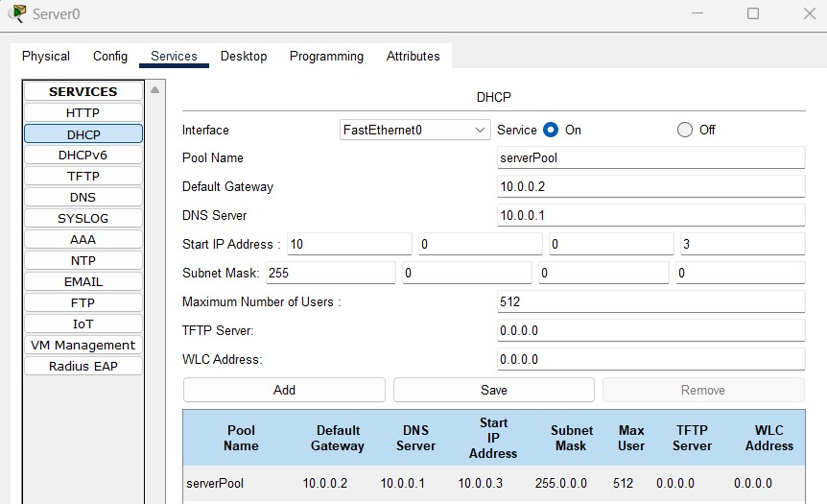

3. Configure PC0 and PC1 from Static to DHCP.

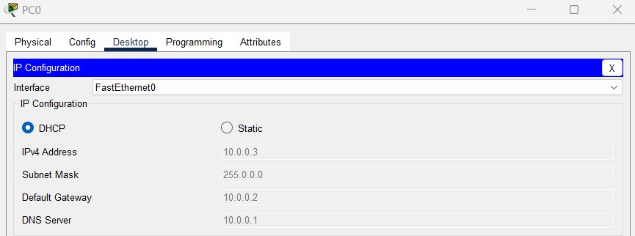

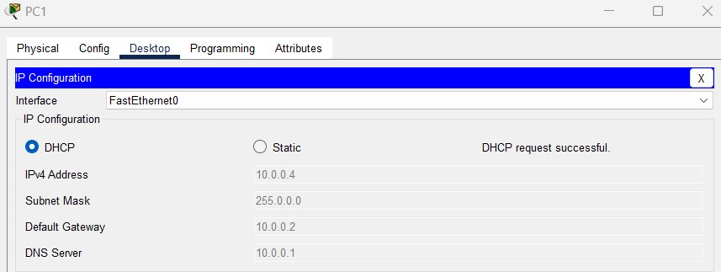

4. Send a packet from PC0 to PC1 , the transmission will be successful.



**(e) Write a Packet Tracer script that simulates a network with a virtual private network (VPN) connection. Configure a VPN tunnel between two routers and verify the connectivity between the networks.**

**Step-by-Step procedure :**

1. Take 3 routers and rename them as HQ (headquarters) , Branch and ISP. We are going to establish a VPN tunnel between HQ and Branch routers with the help of ISP.

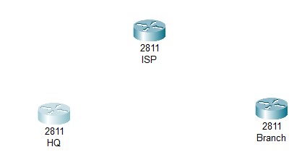

2. Configure each router HWIC-2T card and turn on the router in physical view.

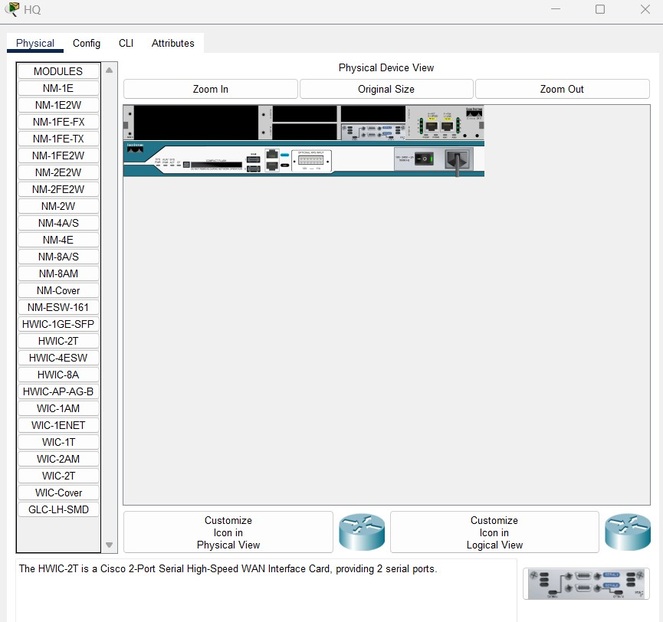

3. Design a circuit and mention the IP addresses as a note as in given below diagram.

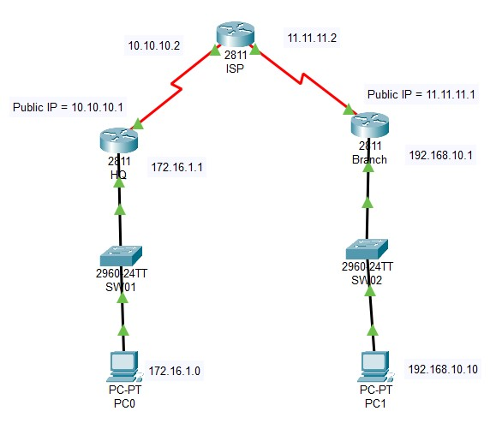

4. Configure PC0 and PC1.

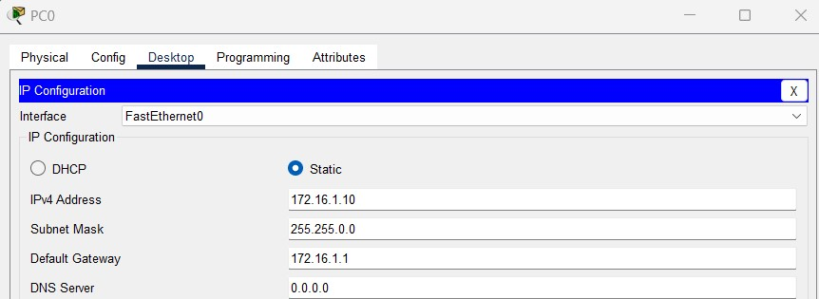

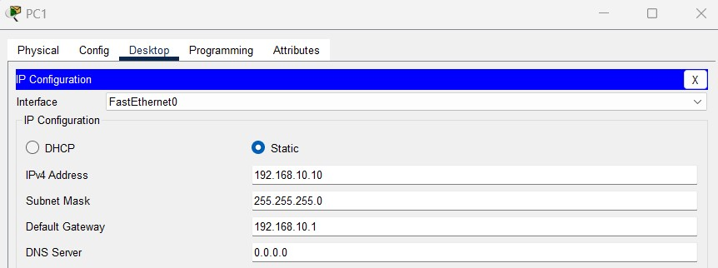

5. Configure all three routers in CLI.

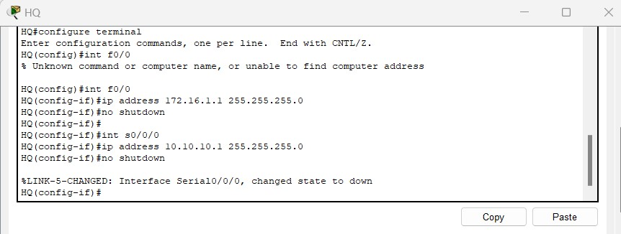

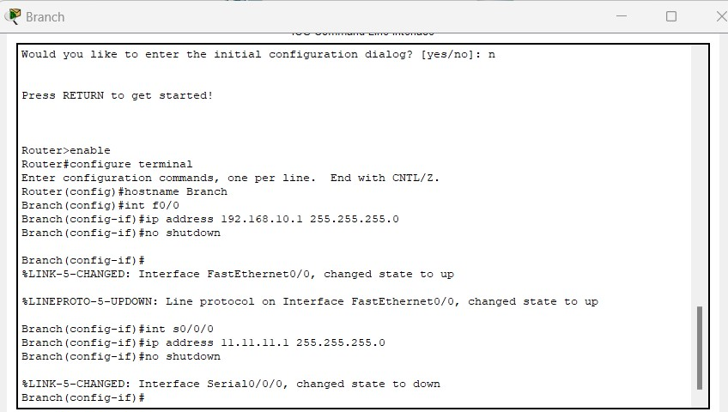

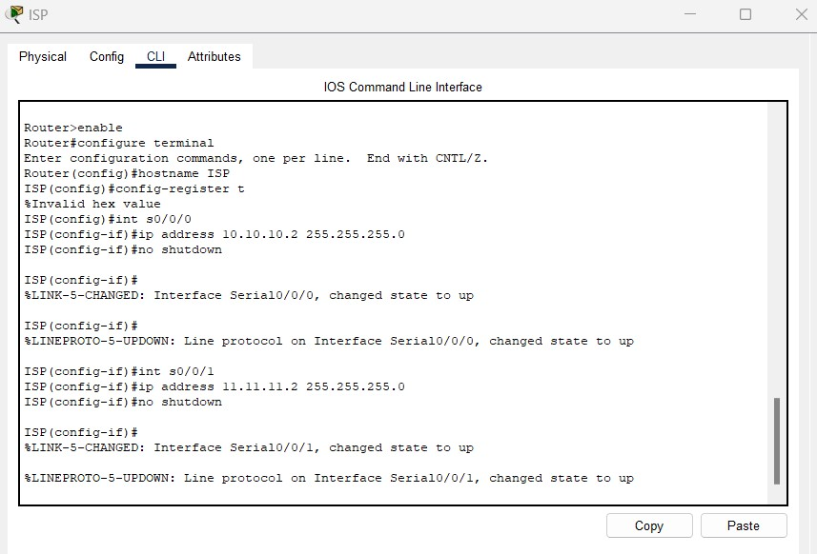

6. Configure default router on HQ and Branch , static router from ISP.

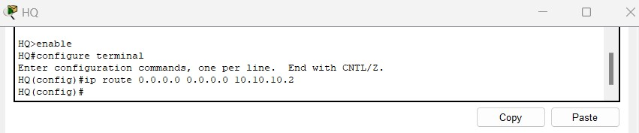

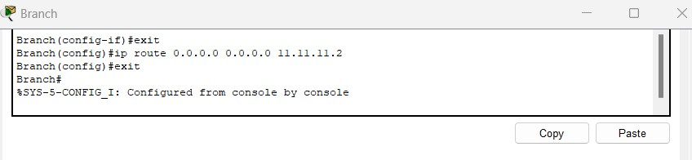

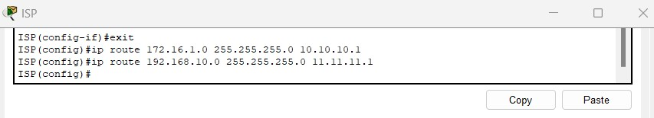

7. Ping PC0 and PC1 in command prompt

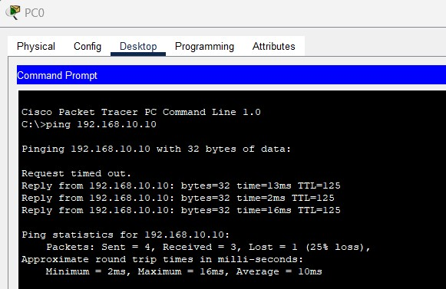

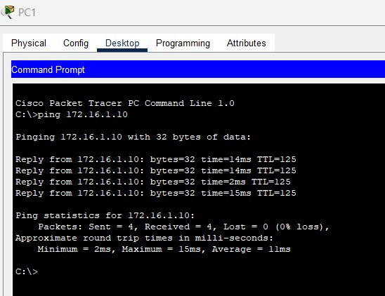

8. Configure ISAKMP policy for HQ and Branch routers.

9. Define IPsec Transform set.

10. Create Access list

11. Create Crypto Map for IPsec.

12. Apply the crypto map.

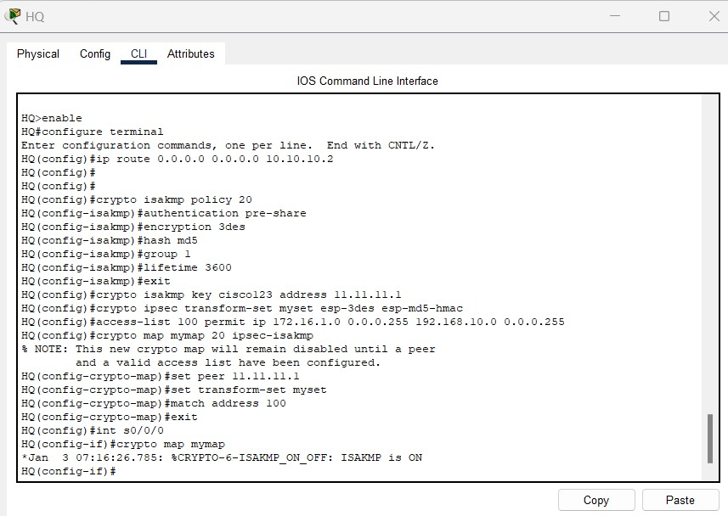

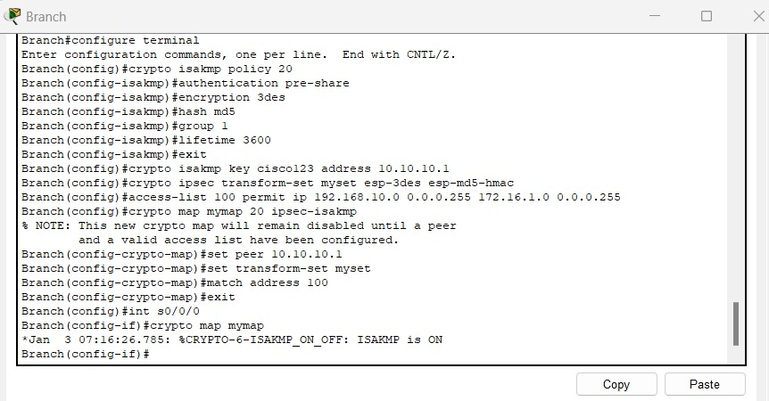

13. Test and Verify VPN.

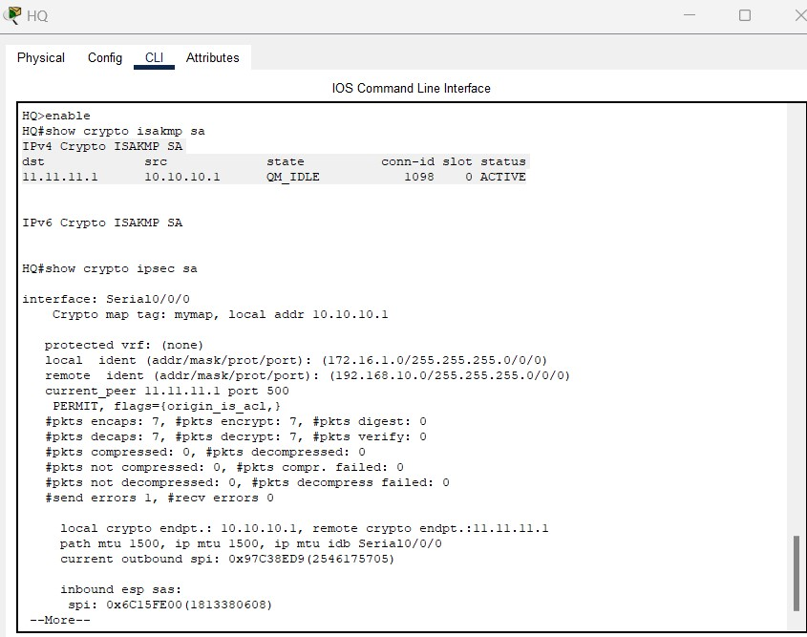

14. Now we can see that VPN tunnel is established between HQ and Branch routers , and the status is ACTIVE.