 | Online Tailoring Store  Technical Design Document
 | Prepared By / Last Updated By | Reviewed By | Approved By
Name
Role
Signature
Date

Table of Contents

1.0 Introduction 3
1.1 Purpose of this document 3
1.2 Project overview 3
2.0 Solution Summary 3
2.1 Scope 3
2.2 Assumptions 3
2.3 Dependencies 3
2.4 Risks 4
3.0 Schematic Diagram 4
4.0 System Design 6
4.1 Proposed design 6
4.2 Component inventory 6
5.0 Database Design 6
5.1 Data Model 6
5.2 Tables Structure 6
6.0 Appendices 6
6.1 Glossary 10
6.2 Other 11
7.0 Terms & Conditions 11
8.0 Change Log 11

Introduction

Purpose of this document
Online Tailoring Store is a platform for creating custom fitted clothing & tailoring services for its customers anytime, anywhere. We help our customers to personalize their tailoring needs online by helping them with style elements and garment fitting.

Project overview
This project captures the various concepts, techniques and skills learned and help to put them into practice using Spring Boot and JDBC.

Solution Summary

Scope
The scope of the system is explained through its following modules:
1. Customer has to register in the website and details are stored into database.
2. Customer can place orders, track order, search for tailor, and raise an issue.
3. Administrator details are stored in the database and can add category, dress type, resolve the issue and can view orders.
4. Tailor can update his profile, patterns and can view orders, feedback of completed orders.

Assumptions
The feedback questionnaire is generated by the system for the completed orders.

Dependencies
The dependencies used in the project are:
- Tomcat-jasper
- Hibernate Validator
- Servlet-API

Risks
In order to view the patterns/images uploaded by the tailor on the website, the server has to be restarted to view the uploaded pattern/image in the same session.

Schematic Diagram
A schematic, or schematic diagram, is a representation of the elements of a system using abstract, graphic symbols rather than realistic pictures. It gives an overview of overall system.
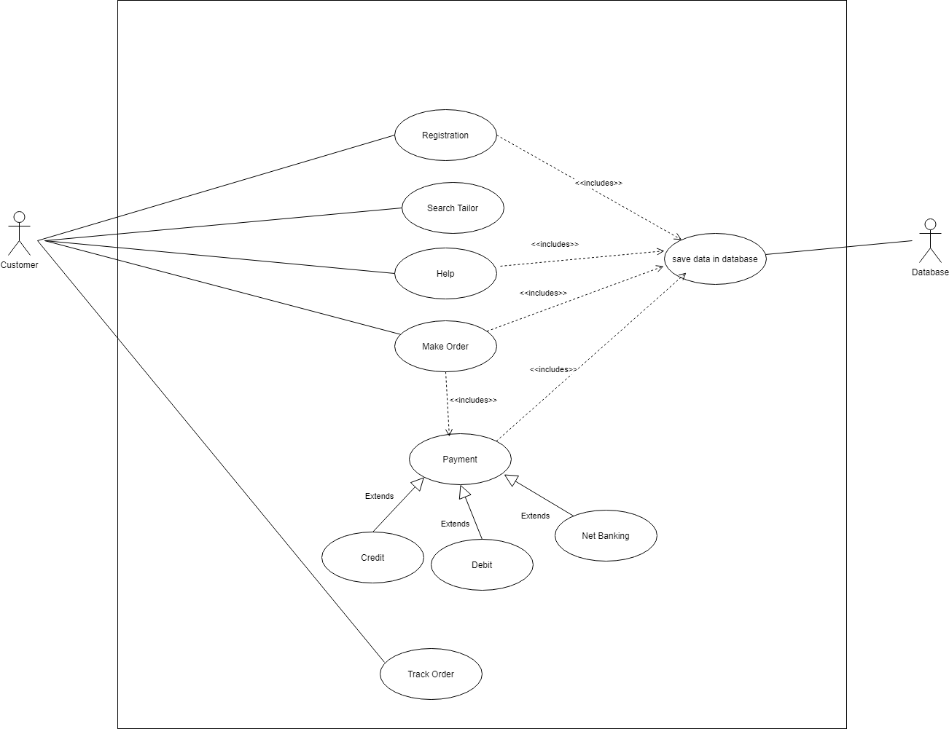
Use case diagram for customer
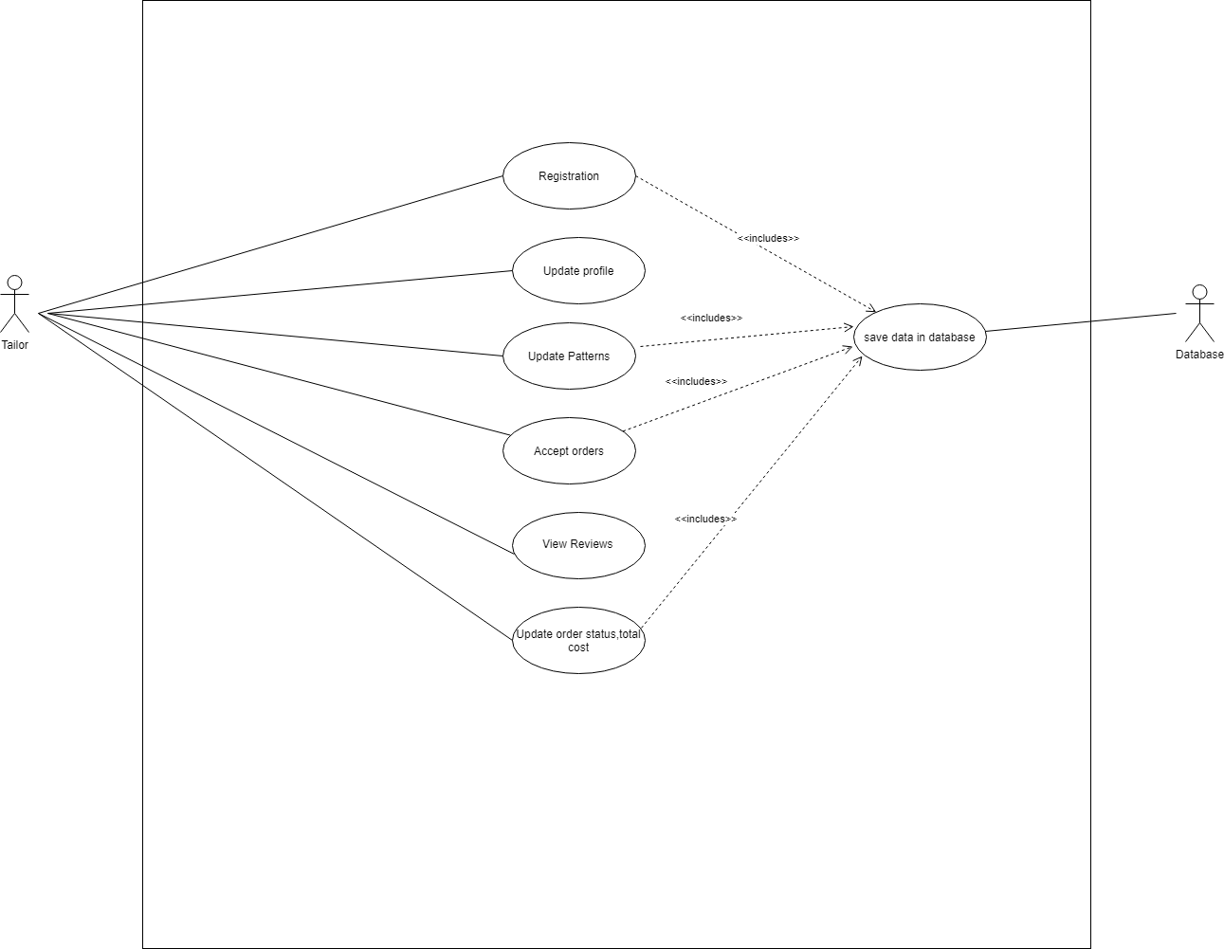
Use case diagram for tailor
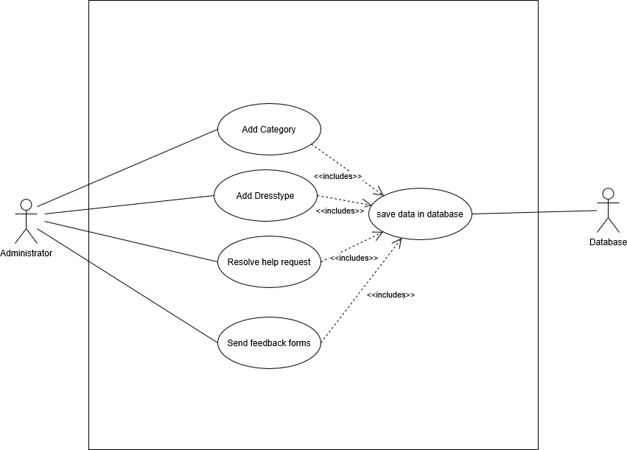
Use case diagram for administrator

System Design

Proposed design
Online Tailoring Store has two users’ customer and tailor. Both tailor and customer has to register in order to access the services. Customer can place order, search tailor, raise an issue and track the order. Tailor can update patterns, profile, accept or reject orders and can view feedback received from customers. Administrator is responsible for adding categories, dress type, resolving help request and sending feedback forms to the customer for completed orders.

Component inventory
The list of the components used for this project are:
- Eclipse
- MySQL workbench

Database Design

Data Model
In this project MySQL workbench has to be used to create table and store details in the database. A database names projecta046 has been created. It has different tables like customer table for storing customer details, tailor table for storing tailor details, security for storing security question of customers, categories table for men, women, boys, girls, administrator table for storing admin credentials, patterns table to store patterns uploaded by tailor, payment table to store payment details, queries table to store issues raised he customer, and feedback table to receive feedback from customers–.

Tables Structure
- customer
Column Name | Data Type | Length | Nulls | Key
firstname | varchar | 20 | YES
lastname | varchar | 20 | YES
dateofbirth | date | - | YES
gender | varchar | 10 | YES
contact number | varchar | 10 | YES
userid | varchar | 20 | YES | PRIMARY KEY
password | varchar | 20 | YES

- tailor
Column Name | Data Type | Length | Nulls | Key
firstname | varchar | 20 | YES
lastname | varchar | 20 | YES
dateofbirth | date | - | YES
gender | varchar | 10 | YES
contact number | varchar | 10 | YES
userid | varchar | 20 | YES | UNIQUE KEY
password | varchar | 20 | YES
shopname | varchar | 40 | YES
address | varchar | 50 | YES
workinghours | int | 10 | YES
services | varchar | 20 | YES
status | varchar | 10 | YES
tid | int | 10 | NO | PRIMARY KEY
- category
Column Name | Data Type | Length | Nulls | Key
cid | varchar | 20 | NO | PRIMARY KEY
cname | varchar | 20 | YES
- men ,women ,boys ,girls
Column Name | Data Type | Length | Nulls | Key
categoryid | varchar | 20 | YES | -
dressid | varchar | 20 | NO | -
dresstype | varchar | 10 | YES | -

- patterns
Column Name | Data Type | Length | Nulls | Key
tid | varchar | 20 | NO | -
category | varchar | 20 | YES | -
dresstype | varchar | 10 | YES | -
cost | number |  | YES | -
image | blob | - | YES | -
- makeorder
Column Name | Data Type | Length | Nulls | Key
orderid | int | 10 | NO | PRIMARY LEY
userid | varchar | 10 | NO | -
tailerid | varchar | 10 | YES | -
category | varchar | 20 | YES | -
dresstype | varchar | 20 | YES | -
pattern | varchar | 20 | YES
tfabric | varchar | 20 | YES
tmaterial | varchar | 20 | YES
tduration | int | - | YES
ttoplengths | int | - | YES
tamount | number | - | YES
tneck | int | - | YES
twaist | int | - | YES
tchest | int | - | YES
tshoulder | number | - | YES
bfabric | varchar | 20 | YES
bmaterial | varchar | 20 | YES
bduration | int | - | YES
btoplengths | int | - | YES
bamount | number | - | YES
bhip | int | -- | YES
bknee | int | - | YES
orderstatus | varchar | 20 | YES
dateofdelivery | date | - | YES
cost | number | - | YES
courier | varchar | 20 | YES
courierstatus | varchar | 20 | YES
feedback | varchar | 20 | YES

- payment:
Column Name | Data Type | Length | Nulls | Key
cname | varchar | 20 | YES | -
cnumber | number | 16 | YES | -
expmon | number | 2 | YES | -
expyear | number | 4 | YES | -
cvv | number | 3 | YES | -
paymentstatus | varchar | 10 | YES | -
- securityq
Column Name | Data Type | Length | Nulls | Key
user_id | varchar | 20 | NO | PRIMARY KEY
question1 | varchar | 20 | NO | -
question2 | varchar | 20 | NO | -
question3 | varchar | 20 | NO

- queries
Column Name | Data Type | Length | Nulls | Key
Issue | varchar | 20 | YES | -
Solotion | varchar | 20 | YES | -
Status | varchar | 10 | NO | -
- administartor
Column Name | Data Type | Length | Nulls | Key
userid | varchar | 20 | NO | PRIMARY KEY
password | varchar | 20 | NO
- dress type
Column Name | Data Type | Length | Nulls | Key
id | varchar | 20 | YES | -
category | varchar | 20 | YES | -
dresstype | varchar | 10 | YES | -

Appendices

Glossary
Acronyms | Definitions
NULL | NULL

Other

Terms & Conditions
Disclaimer: Please do not circulate or distribute this document outside of Cognizant Network, We have a Zero Tolerance Policy. Kindly adhere to 100% Compliance at all times.

Change Log
Please note that this table needs to be maintained even if a Configuration Management tool is used.
Version Number | Changes made
V<n.n> | <If the change details are not explicitly documented in the table below, reference should be provided here>
V<n.n> | Page no | Changed by | Effective date | Changes effected

