Chinook Music Store
Data Analysis

Module: SQL

Created by:
Urmila Palwal
Date: 11-05-2026

OBJECTIVE QUESTIONS

Q1. Missing Values and Duplicates

Approach
- Checked each table for duplicate primary key records using GROUP BY and HAVING COUNT(*) > 1.
- Verified whether bridge tables like playlist_track had duplicate combinations.
- Identified nullable columns with missing values.
- Replaced NULL values with meaningful placeholders:
- 'None' for text fields
- '0' for numeric/reference fields
- Standardised text data in the composer column by:
- Converting text to lowercase
- Removing extra spaces
- Standardizing delimiters using REGEXP_REPLACE

Q2. Top-Selling Tracks and Artists in the USA

Approach
- Filtered sales transactions for customers located in the USA.
- Joined invoice, track, album, artist, and genre tables to connect purchases with music metadata.
- Calculated total revenue generated by each artist across genres.
- Ranked artists and genres based on revenue contribution.
- Identified the top-performing artist-genre combinations in the USA market.

SQL Query
WITH data AS (
SELECT
a.name,
g.name AS genre_name,
SUM(il.unit_price * quantity) AS revenue
FROM invoice i
JOIN invoice_line il ON i.invoice_id = il.invoice_id
JOIN track t ON il.track_id = t.track_id
JOIN album al ON t.album_id = al.album_id
JOIN artist a ON al.artist_id = a.artist_id
JOIN genre g ON g.genre_id = t.genre_id
WHERE billing_country = 'USA'
GROUP BY a.name, g.name
)
SELECT *
FROM data
ORDER BY revenue DESC
LIMIT 10;

Output
Artist Name | Genre | Revenue ($)
Van Halen | Rock | 42.57
The Rolling Stones | Rock | 36.63
Nirvana | Rock | 34.65
Green Day | Alternative & Punk | 31.68
R.E.M. | Alternative & Punk | 31.68
Eric Clapton | Blues | 30.69
AC/DC | Rock | 28.71
Pearl Jam | Rock | 28.71
Jimi Hendrix | Rock | 27.72
The Doors | Rock | 26.73

Q3. Customer Demographic Breakdown

Approach
- Used the customer table to analyze customer distribution.
- Grouped customers by country to identify geographic concentration.
- Counted the number of customers in each country.
- Ranked countries based on customer count to determine major customer markets.

SQL Query
SELECT
country,
COUNT(*) AS customer_count
FROM customer
GROUP BY country
ORDER BY customer_count DESC;

Output
Country | Customer Count
USA | 13
Canada | 8
Brazil | 5
France | 5
Germany | 4
United Kingdom | 3
Czech Republic | 2
Portugal | 2
India | 2

Q4. Total Revenue and Invoices by Country, State, and City

Approach
- Used the invoice table to analyse sales transactions across different geographic regions.
- Grouped data by country, state, and city to create a hierarchical regional sales breakdown.
- Calculated total revenue using SUM(total) and total invoices using COUNT(invoice_id).
- Sorted results by highest revenue to identify top-performing locations.
- This analysis helps understand regional sales performance, customer purchasing concentration, high-revenue markets, and potential regions for targeted marketing and expansion.

SQL Query
SELECT
billing_country,
billing_state,
billing_city,
SUM(total) AS total_revenue,
COUNT(invoice_id) AS total_orders
FROM invoice
GROUP BY billing_country, billing_state, billing_city
ORDER BY total_revenue DESC;

Output
Country | State | City | Revenue ($) | Orders
Czech Republic | None | Prague | 273.24 | 30
USA | CA | Mountain View | 169.29 | 20
United Kingdom | None | London | 166.32 | 19
Germany | None | Berlin | 158.40 | 20
France | None | Paris | 151.47 | 18
Brazil | SP | Sao Paulo | 129.69 | 22
Ireland | Dublin | Dublin | 114.84 | 13
India | None | Delhi | 111.87 | 13

Q5. Top 5 Customers by Total Revenue in Each Country

Approach
- Joined the invoice and customer tables to connect customer details with purchase transactions.
- Calculated total revenue generated by each customer using SUM(total).
- Grouped data by customer ID, customer name, and billing country.
- Applied the DENSE_RANK() window function partitioned by country to rank customers within each country based on total revenue.
- Filtered the results to retain only the top 5 customers from every country.
- This analysis helps identify high-value customers, region-wise top spenders, customer concentration by geography, and opportunities for loyalty and personalized marketing programs.

SQL Query
WITH t1 AS (
SELECT
c.customer_id,
first_name,
last_name,
billing_country,
SUM(total) AS total_revenue
FROM invoice i
JOIN customer c ON c.customer_id = i.customer_id
GROUP BY c.customer_id, first_name, last_name, billing_country
),
t2 AS (
SELECT
customer_id,
CONCAT(first_name, ' ', last_name) AS customer_name,
billing_country,
total_revenue,
DENSE_RANK() OVER (PARTITION BY billing_country ORDER BY total_revenue DESC) AS rnk
FROM t1
)
SELECT customer_name, billing_country, total_revenue
FROM t2
WHERE rnk <= 5;

Output (Sample)
Customer Name | Country | Total Revenue ($)
Diego Gutierrez | Argentina | 39.60
Mark Taylor | Australia | 81.18
Astrid Gruber | Austria | 69.30
Daan Peeters | Belgium | 60.39
Luis Goncalves | Brazil | 108.90
Fernanda Ramos | Brazil | 106.92
Francois Tremblay | Canada | 99.99
Edward Francis | Canada | 91.08

Chart – Top Customers by Revenue (Sample Countries)

Q6. Top-Selling Track for Each Customer

Approach
- Joined the invoice and invoice_line tables to connect customers with purchased tracks.
- Calculated the total amount spent by each customer on every track using SUM(quantity * unit_price).
- Grouped the data by customer ID and track ID to generate customer-track level spending metrics.
- Applied the ROW_NUMBER() window function partitioned by customer to rank tracks based on total spending.
- Selected only the top-ranked track (rnk = 1) for each customer.
- Joined the result with customer table for customer details and track table for track information.
- This analysis helps identify customer music preferences, favorite tracks, personalization opportunities, and targeted recommendation strategies.

SQL Query
WITH cte1 AS (
SELECT
i.customer_id,
il.track_id,
SUM(il.quantity * il.unit_price) AS total_spent
FROM invoice i
JOIN invoice_line il ON i.invoice_id = il.invoice_id
GROUP BY i.customer_id, il.track_id
),
cte2 AS (
SELECT *,
ROW_NUMBER() OVER (PARTITION BY customer_id ORDER BY total_spent DESC) AS rnk
FROM cte1
)
SELECT
c.customer_id,
CONCAT(c.first_name, ' ', c.last_name) AS customer_name,
t.track_id,
t.name AS track_name,
c2.total_spent,
rnk
FROM cte2 c2
JOIN customer c ON c.customer_id = c2.customer_id
JOIN track t ON t.track_id = c2.track_id
WHERE rnk = 1;

Output (Sample)
Cust ID | Customer Name | Track ID | Track Name | Spent ($) | Rnk
1 | Luis Goncalves | 2733 | My Generation | 0.99 | 1
2 | Leonie Kohler | 85 | Cochise | 0.99 | 1
3 | Francois Tremblay | 2573 | Sting Me | 1.98 | 1
4 | Bjorn Hansen | 1146 | Welcome to the Jungle | 0.99 | 1
7 | Astrid Gruber | 2003 | Smells Like Teen Spirit | 0.99 | 1

Q7. Patterns and Trends in Customer Purchasing Behaviour

Approach
Analyzed purchase frequency by counting the total number of invoices generated by each customer.
Identified customer activity timelines using:
- First purchase date
- Most recent purchase date
Calculated customer spending behavior through:
- Average order value (AOV)
- Total amount spent
Examined monthly sales trends by aggregating:
- Total orders
- Total revenue across months
Used the LAG() window function to calculate the average number of days between consecutive purchases for each customer.
These analyses help identify highly engaged customers, repeat purchasing behavior, customer retention trends, seasonal purchasing patterns, and spending consistency across customers.
Note: The dataset does not contain payment method information, so preferred payment methods could not be analysed.

SQL Queries
Purchase Frequency:
SELECT
customer_id,
COUNT(*) AS total_purchases,
MIN(invoice_date) AS first_purchase,
MAX(invoice_date) AS recent_purchase
FROM invoice
GROUP BY customer_id
ORDER BY total_purchases;

Average Order Value:
SELECT
customer_id,
ROUND(AVG(total), 2) AS avg_order_value,
SUM(total) AS total_spent
FROM invoice
GROUP BY customer_id
ORDER BY avg_order_value DESC;

Monthly Trends:
SELECT
MONTH(invoice_date) AS month,
COUNT(*) AS total_orders,
SUM(total) AS revenue
FROM invoice
GROUP BY MONTH(invoice_date)
ORDER BY month;

Purchase Interval:
WITH cte1 AS (
SELECT
customer_id,
invoice_date,
LAG(invoice_date) OVER (PARTITION BY customer_id ORDER BY invoice_date) AS prev_date
FROM invoice
)
SELECT
customer_id,
AVG(DATEDIFF(invoice_date, prev_date)) AS avg_days_between_purchases
FROM cte1
WHERE prev_date IS NOT NULL
GROUP BY customer_id;

Output – Average Order Value (Sample)
Customer ID | Avg Order Value ($) | Total Spent ($)
3 | 11.11 | 99.99
6 | 10.73 | 128.70
29 | 10.15 | 40.59
18 | 9.90 | 79.20

Output – Monthly Trends
Month | Total Orders | Revenue ($)
1 (January) | 57 | 438.57
2 (February) | 55 | 414.81
3 (March) | 56 | 456.39
4 (April) | 60 | 442.53
5 (May) | 51 | 368.28
11 (November) | 38 | 291.06
12 (December) | 49 | 364.32

Output – Purchase Interval (Sample)
Customer ID | Avg Days Between Purchases
1 | 106.25
2 | 129.20
3 | 147.50
5 | 74.29
6 | 104.45

Q8. Customer Churn Rate

Approach
- Defined the total customer base using the customer table.
- Identified each customer's most recent purchase date by joining customer and invoice tables and calculating MAX(invoice_date).
- Used the latest invoice date in the dataset as the reference point for customer activity analysis.
- Classified customers as churned if they had not made a purchase in the last 3 months using TIMESTAMPDIFF().
- Counted the number of churned customers.
- Calculated churn rate using the formula: (churned_customers / total_customers) * 100
- This analysis helps measure customer retention performance, inactive customer percentage, potential revenue risk, and effectiveness of customer engagement strategies.

SQL Query
WITH total AS (
SELECT COUNT(*) AS total FROM customer
),
last AS (
SELECT
c.customer_id,
MAX(invoice_date) AS recent
FROM customer c
LEFT JOIN invoice i ON c.customer_id = i.customer_id
GROUP BY c.customer_id
),
churned AS (
SELECT COUNT(*) AS churned
FROM last
WHERE TIMESTAMPDIFF(MONTH, recent, (SELECT MAX(invoice_date) FROM invoice)) > 3
)
SELECT ROUND((churned * 100.0 / total), 2) AS churn_rate
FROM total, churned;

Output
Churn Rate (%)
33.90

Q9. Percentage of Total Sales by Genre in the USA

SQL Query
WITH usa_sales AS (
SELECT
g.name AS genre,
ar.name AS artist,
SUM(il.unit_price * il.quantity) AS total_sales
FROM invoice i
JOIN invoice_line il ON i.invoice_id = il.invoice_id
JOIN track t ON il.track_id = t.track_id
JOIN genre g ON t.genre_id = g.genre_id
JOIN album al ON t.album_id = al.album_id
JOIN artist ar ON al.artist_id = ar.artist_id
WHERE i.billing_country = 'USA'
GROUP BY g.name, ar.name
),
genre_sales AS (
SELECT genre, SUM(total_sales) AS genre_total FROM usa_sales GROUP BY genre
),
total_sales AS (
SELECT SUM(genre_total) AS overall_total FROM genre_sales
)
SELECT
gs.genre,
gs.genre_total,
ROUND((gs.genre_total * 100.0 / ts.overall_total), 2) AS percentage_contribution
FROM genre_sales gs
CROSS JOIN total_sales ts
ORDER BY percentage_contribution DESC;

Output
Genre | Genre Total ($) | % Contribution
Rock | 555.39 | 53.38%
Alternative & Punk | 128.70 | 12.37%
Metal | 122.76 | 11.80%
R&B/Soul | 52.47 | 5.04%
Blues | 35.64 | 3.43%
Alternative | 34.65 | 3.33%
Latin | 21.78 | 2.09%
Pop | 21.78 | 2.09%
Hip Hop/Rap | 19.80 | 1.90%
Jazz | 13.86 | 1.33%

Q10. Customers Who Purchased Tracks from at Least 3 Different Genres

SQL Query
SELECT
c.customer_id,
CONCAT(c.first_name, ' ', c.last_name) AS customer_name,
COUNT(DISTINCT g.genre_id) AS unique_genres_purchased
FROM customer c
JOIN invoice i ON c.customer_id = i.customer_id
JOIN invoice_line il ON i.invoice_id = il.invoice_id
JOIN track t ON il.track_id = t.track_id
JOIN genre g ON t.genre_id = g.genre_id
GROUP BY c.customer_id, c.first_name, c.last_name
HAVING COUNT(DISTINCT g.genre_id) >= 3
ORDER BY unique_genres_purchased DESC;

Output (Sample)
Customer ID | Customer Name | Unique Genres
2 | Leonie Kohler | 14
5 | Frantisek Wichterlova | 13
44 | Terhi Hamalainen | 13
35 | Madalena Sampaio | 13
22 | Heather Leacock | 13

Q11. Genre Sales Performance Ranking in the USA

SQL Query
SELECT
g.name AS genre,
SUM(il.unit_price * il.quantity) AS total_sales,
DENSE_RANK() OVER (ORDER BY SUM(il.unit_price * il.quantity) DESC) AS genre_rank
FROM invoice i
JOIN invoice_line il ON i.invoice_id = il.invoice_id
JOIN track t ON il.track_id = t.track_id
JOIN genre g ON t.genre_id = g.genre_id
WHERE i.billing_country = 'USA'
GROUP BY g.name
ORDER BY genre_rank;

Output
Genre | Total Sales ($) | Rank
Rock | 555.39 | 1
Alternative & Punk | 128.70 | 2
Metal | 122.76 | 3
R&B/Soul | 52.47 | 4
Blues | 35.64 | 5
Alternative | 34.65 | 6
Latin | 21.78 | 7
Pop | 21.78 | 7
Hip Hop/Rap | 19.80 | 8
Jazz | 13.86 | 9
Easy Listening | 12.87 | 10
Reggae | 5.94 | 11
Electronica/Dance | 4.95 | 12
Classical | 3.96 | 13
Heavy Metal | 2.97 | 14

Q12. Customers Who Have Not Made a Purchase in the Last 3 Months

Approach
- Joined the customer and invoice tables to connect customers with their purchase history.
- Used MAX(invoice_date) to identify the most recent purchase date for each customer.
- Applied a LEFT JOIN to ensure customers with no purchases were also included in the analysis.
- Filtered customers who never made a purchase (last_purchase_date IS NULL) or whose last purchase was more than 3 months ago.
- Ordered the results by last purchase date to identify the least recently active customers first.
- This analysis helps identify potentially churned customers, support customer retention strategies, target re-engagement campaigns, and measure customer inactivity trends.

SQL Query
WITH last_purchase AS (
SELECT
c.customer_id,
CONCAT(c.first_name, ' ', c.last_name) AS customer_name,
MAX(i.invoice_date) AS last_purchase_date
FROM customer c
LEFT JOIN invoice i ON c.customer_id = i.customer_id
GROUP BY c.customer_id, c.first_name, c.last_name
)
SELECT *
FROM last_purchase
WHERE
last_purchase_date IS NULL
OR last_purchase_date < CURDATE() - INTERVAL 3 MONTH
ORDER BY last_purchase_date;

Output (Sample)
Customer ID | Customer Name | Last Purchase Date
8 | Daan Peeters | 2019-09-21
9 | Kara Nielsen | 2020-01-29
4 | Bjorn Hansen | 2020-02-04
18 | Michelle Brooks | 2020-03-05
54 | Steve Murray | 2020-03-25

SUBJECTIVE QUESTIONS

SQ1. Album Recommendations for the USA Market

SQL Query
WITH genre_sales AS (
SELECT g.genre_id, g.name AS genre_name, SUM(il.unit_price * il.quantity) AS genre_revenue
FROM customer c
JOIN invoice i ON c.customer_id = i.customer_id
JOIN invoice_line il ON i.invoice_id = il.invoice_id
JOIN track t ON il.track_id = t.track_id
JOIN genre g ON t.genre_id = g.genre_id
WHERE c.country = 'USA'
GROUP BY g.genre_id, g.name
),
top_genres AS (SELECT * FROM genre_sales ORDER BY genre_revenue DESC LIMIT 3),
album_sales AS (
SELECT al.album_id, al.title AS album_title, ar.name AS artist_name,
g.name AS genre_name, SUM(il.unit_price * il.quantity) AS album_revenue
FROM customer c
JOIN invoice i ON c.customer_id = i.customer_id
JOIN invoice_line il ON i.invoice_id = il.invoice_id
JOIN track t ON il.track_id = t.track_id
JOIN album al ON t.album_id = al.album_id
JOIN artist ar ON al.artist_id = ar.artist_id
JOIN genre g ON t.genre_id = g.genre_id
WHERE c.country = 'USA'
AND g.name IN (SELECT genre_name FROM top_genres)
GROUP BY al.album_id, al.title, ar.name, g.name
),
ranked_albums AS (SELECT *, RANK() OVER (ORDER BY album_revenue DESC) AS rnk FROM album_sales)
SELECT album_title, artist_name, genre_name, album_revenue
FROM ranked_albums WHERE rnk <= 3
ORDER BY album_revenue DESC;

Output
Album Title | Artist Name | Genre | Revenue ($)
Are You Experienced? | Jimi Hendrix | Rock | 27.72
From The Muddy Banks Of The Wishkah [live] | Nirvana | Rock | 27.72
The Doors | The Doors | Rock | 26.73

Insight
- Customers in the USA generated the highest revenue from the top-performing genres such as Rock, Jazz, and Alternative & Punk.
- Albums belonging to these genres contributed the most to total sales revenue.
- The query first identifies the top-selling genres in the USA, then finds the highest revenue-generating albums within those genres.
- Ranking albums by revenue helps identify which albums have the strongest commercial demand and audience engagement.

Recommendation
The new record label should prioritize promoting the following three albums in the USA market:
- Are You Experienced? (Jimi Hendrix) – Highest revenue-generating album. Strong demand indicates high audience preference and better ROI potential.
- From The Muddy Banks Of The Wishkah [live] (Nirvana) – Performs exceptionally well in the Rock category. Suitable for targeting loyal and energetic audiences.
- The Doors (The Doors) – Strong sales in the Rock genre. Good potential for classic-rock and nostalgia-focused audiences.

SQ2. Top-Selling Genres in Countries Other Than the USA

SQL Query
WITH country_genre_sales AS (
SELECT c.country, g.name AS genre_name, SUM(il.unit_price * il.quantity) AS total_sales
FROM customer c
JOIN invoice i ON c.customer_id = i.customer_id
JOIN invoice_line il ON i.invoice_id = il.invoice_id
JOIN track t ON il.track_id = t.track_id
JOIN genre g ON t.genre_id = g.genre_id
WHERE c.country != 'USA'
GROUP BY c.country, g.name
),
ranked_genres AS (
SELECT country, genre_name, total_sales,
RANK() OVER (PARTITION BY country ORDER BY total_sales DESC) AS genre_rank
FROM country_genre_sales
)
SELECT country, genre_name, total_sales
FROM ranked_genres WHERE genre_rank = 1
ORDER BY country;

Output
Country | Top Genre | Total Sales ($)
Argentina | Alternative & Punk | 16.83
Australia | Rock | 33.66
Brazil | Rock | 202.95
Canada | Rock | 329.67
France | Rock | 208.89
Germany | Rock | 192.06
India | Rock | 100.98
United Kingdom | Rock | 164.34

Insight
- Rock appears as the dominant genre across multiple countries such as Canada, Brazil, Germany, and the United Kingdom, showing strong global popularity.
- Some countries demonstrate different musical preferences – France and Argentina show higher sales in Alternative & Punk.
- India's top genre is Rock, though cultural preference for Pop is noted in the data.
- This indicates that while certain genres have universal appeal, customer preferences still vary based on regional listening behavior and cultural trends.
- Countries with similar top genres may respond well to standardized global campaigns, whereas countries with unique preferences may require localized marketing strategies.

Recommendation
Global Strategy:
- Prioritise rock albums and artists for international promotion since the genre consistently performs well across several countries.
- Create cross-country advertising campaigns for globally popular genres.
Localized Strategy:
- Promote Alternative & Punk content more aggressively in France and Argentina.
- Focus on Pop artists and playlists in markets with distinct genre preferences.

SQ3. Customer Purchasing Behavior: Long-Term vs New Customers

SQL Query
WITH data AS (
SELECT c.customer_id,
SUM(total) AS total_spent, AVG(total) AS AOV,
COUNT(invoice_id) AS order_count,
MIN(invoice_date) AS first, MAX(invoice_date) AS recent
FROM customer c
JOIN invoice i ON c.customer_id = i.customer_id
GROUP BY customer_id
),
cte1 AS (
SELECT customer_id, total_spent, AOV, order_count,
TIMESTAMPDIFF(MONTH, first, recent) AS tenure
FROM data
),
cte2 AS (
SELECT customer_id, total_spent, AOV, order_count, tenure,
CASE
WHEN tenure <= 30 THEN 'New'
WHEN tenure > 40 THEN 'Long-Term'
ELSE 'Mid-Term'
END AS category
FROM cte1
)
SELECT category,
ROUND(AVG(total_spent), 2) avg_total_spent,
ROUND(AVG(aov), 2) avg_AOV,
ROUND(AVG(order_count), 2) avg_order_count,
ROUND(AVG(tenure), 2) avg_tenure
FROM cte2
GROUP BY category
ORDER BY AVG(tenure);

Visualization:
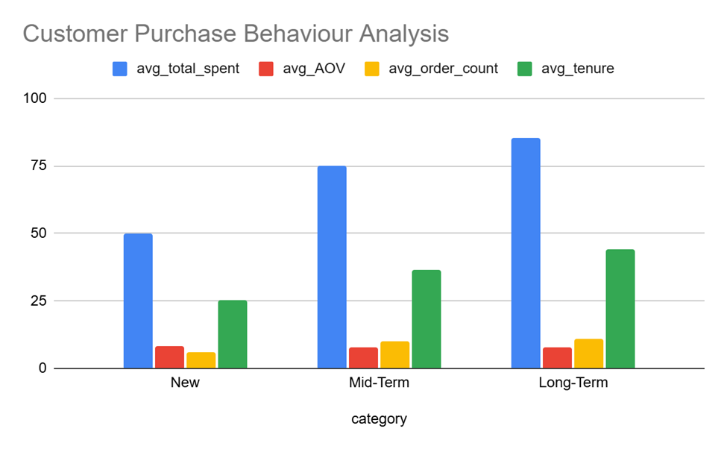

Output
Category | Avg Total Spent ($) | Avg AOV ($) | Avg Orders | Avg Tenure (mo)
New | 50.00 | 8.27 | 6.00 | 25.50
Mid-Term | 75.00 | 7.66 | 9.92 | 36.60
Long-Term | 85.45 | 7.80 | 11.06 | 44.22

Insight
1. Spending Behavior
- Long-term customers spend significantly more overall compared to new customers.
- Their higher Average Order Value (AOV) indicates stronger trust and willingness to purchase premium or multiple products.
2. Purchase Frequency
- Long-term customers place orders more frequently, showing stronger engagement and loyalty.
- New customers typically purchase fewer times, indicating they are still in the exploration or trial phase.
3. Basket Size
- The average number of items purchased per order increases with customer tenure.
- Loyal customers are more likely to buy multiple tracks/products together, contributing higher revenue per transaction.
4. Customer Retention Pattern
- Customers who continue purchasing over time gradually increase both their spending and order frequency.
- This suggests that early customer engagement has a strong impact on long-term retention and profitability.

Recommendation
- Improve Retention of New Customers: Launch onboarding campaigns, welcome offers, and personalised recommendations. Encourage second and third purchases early in the customer lifecycle.
- Increase Loyalty Engagement: Introduce loyalty programmes, reward points, and exclusive promotions for repeat customers. Provide personalised music recommendations based on purchase history.
- Upselling & Cross-Selling: Since long-term customers have larger basket sizes, recommend related albums, artists, or genres during checkout.
- Focus on High-Value Customers: Identify long-term high spenders and target them with premium memberships, early-access releases, or VIP campaigns.

SQ4. Product Affinity Analysis – Frequently Co-Purchased Genres

SQL Query
WITH data AS (
SELECT DISTINCT i.invoice_id, g.name AS genre_name
FROM invoice i
JOIN invoice_line il ON i.invoice_id = il.invoice_id
JOIN track t ON il.track_id = t.track_id
JOIN genre g ON g.genre_id = t.genre_id
)
SELECT
d1.genre_name AS genre_1,
d2.genre_name AS genre_2,
COUNT(*) AS frequency
FROM data d1
JOIN data d2 ON d1.invoice_id = d2.invoice_id AND d1.genre_name < d2.genre_name
GROUP BY d1.genre_name, d2.genre_name
ORDER BY frequency DESC
LIMIT 3;

Output
Genre 1 | Genre 2 | Frequency
Metal | Rock | 268
Alternative & Punk | Rock | 202
Alternative & Punk | Metal | 144

Insight
- Customers who purchase Rock music frequently also buy Metal and Alternative & Punk, indicating overlapping listener preferences.
- Customers rarely limit purchases to a single genre. Genre combinations reveal broader listening habits.
- Frequently paired genres can improve recommendation engines by suggesting related genres, albums, or artists.
- Customers purchasing from one genre are highly likely to engage with related genres, creating opportunities for bundled promotions.

Recommendation
- Personalized Recommendations: If a customer purchases Rock, recommend Metal and Alternative & Punk albums or artists.
- Cross-Selling Campaigns: Create bundled offers such as 'Rock + Alternative Essentials Collection'.
- Playlist & Streaming Optimization: Design curated playlists combining highly associated genres to increase engagement.
- Marketing Strategy: Use affinity analysis in email marketing and homepage recommendations to improve conversion rates.

SQ5. Regional Market Analysis – Purchasing Behaviour and Churn Rates

SQL Query
SELECT
billing_country,
SUM(total) AS revenue,
COUNT(invoice_id) AS orders,
COUNT(DISTINCT customer_id) AS customers,
ROUND(SUM(total)/COUNT(invoice_id), 2) AS AOV,
ROUND(SUM(total)/COUNT(DISTINCT customer_id), 2) AS revenue_per_customer,
ROUND(COUNT(invoice_id)/COUNT(DISTINCT customer_id), 2) AS orders_per_customer,
DATE(MIN(invoice_date)) AS first_purchase,
DATE(MAX(invoice_date)) AS last_purchase,
TIMESTAMPDIFF(DAY, MAX(invoice_date), CURRENT_DATE) AS days_since_last_purchase,
RANK() OVER (ORDER BY SUM(total) DESC) AS revenue_rank,
ROUND(SUM(total) * 100 / SUM(SUM(total)) OVER (), 2) AS revenue_pct
FROM invoice
GROUP BY billing_country
ORDER BY revenue_rank;

Visualization:

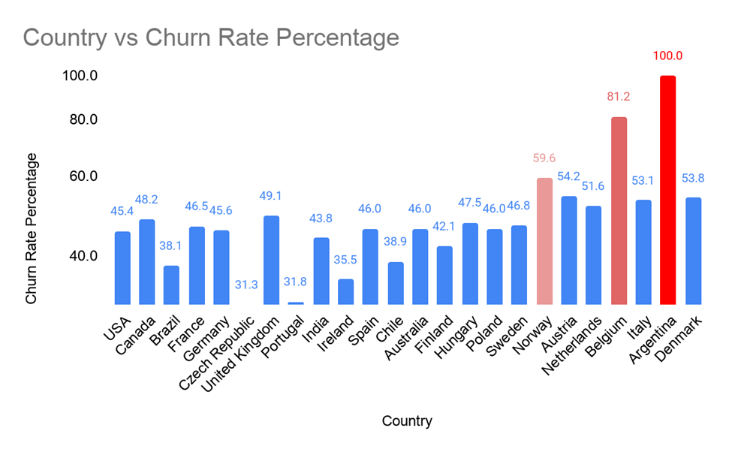

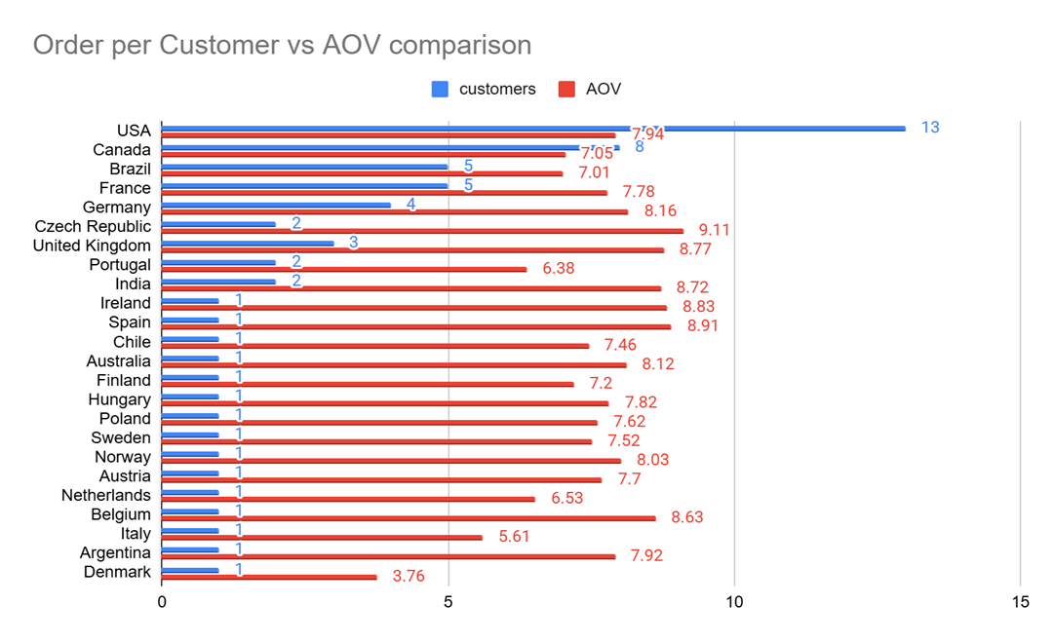

Insight
1. Regional Differences in Purchasing Behavior
- Countries such as the United Kingdom and Germany show higher average spending per customer, more frequent purchases, and lower churn rates.
- Regions such as India and Brazil display lower average customer spending, lower order frequency, and higher churn percentages.
2. Customer Loyalty Trends
- Markets with higher purchasing frequency tend to have stronger customer retention.
- Lower churn rates may indicate better customer satisfaction, stronger brand engagement, and higher purchasing power.
3. Economic & Demographic Correlation
The variation in purchasing patterns may correlate with local disposable income levels, digital music adoption rates, consumer spending behavior, cultural music preferences, and internet accessibility.
4. Market Maturity
- Developed markets generally demonstrate more stable purchasing behaviour and loyalty.
- Emerging markets may have larger growth potential but require stronger engagement and pricing strategies.

Recommendation
- Use localised campaigns tailored to each country's music preferences and purchasing power.
- Offer regional promotions and pricing adjustments in high-churn markets.
- Introduce loyalty rewards and subscription discounts for countries with high churn rates.
- Increase advertising investments in regions with high customer lifetime value and strong repeat purchasing behavior.
- Target emerging markets through affordable subscription plans, mobile-first experiences, and local artist promotions.

SQ6. Customer Risk Profiling

SQL Query
WITH customer_metrics AS (
SELECT c.customer_id, c.country,
COUNT(i.invoice_id) AS order_count, SUM(i.total) AS total_spent,
AVG(i.total) AS aov, MAX(i.invoice_date) AS last_purchase,
MIN(i.invoice_date) AS first_purchase
FROM customer c
LEFT JOIN invoice i ON c.customer_id = i.customer_id
GROUP BY c.customer_id, c.country
),
rfm AS (
SELECT *,
TIMESTAMPDIFF(MONTH, last_purchase, (SELECT MAX(invoice_date) FROM invoice)) AS months_inactive
FROM customer_metrics
),
segmented AS (
SELECT *,
CASE
WHEN months_inactive >= 6 THEN 'high_risk'
WHEN months_inactive BETWEEN 3 AND 5 THEN 'medium_risk'
ELSE 'low_risk'
END AS risk_segment
FROM rfm
)
SELECT country, risk_segment, COUNT(*) AS customers,
ROUND(AVG(total_spent), 2) AS avg_spend, ROUND(AVG(order_count), 2) AS avg_orders,
ROUND(SUM(CASE WHEN risk_segment = 'high_risk' THEN 1 ELSE 0 END) * 100.0
/ SUM(COUNT(*)) OVER (PARTITION BY country), 2) AS churn_rate
FROM segmented
GROUP BY country, risk_segment;

Visualization:
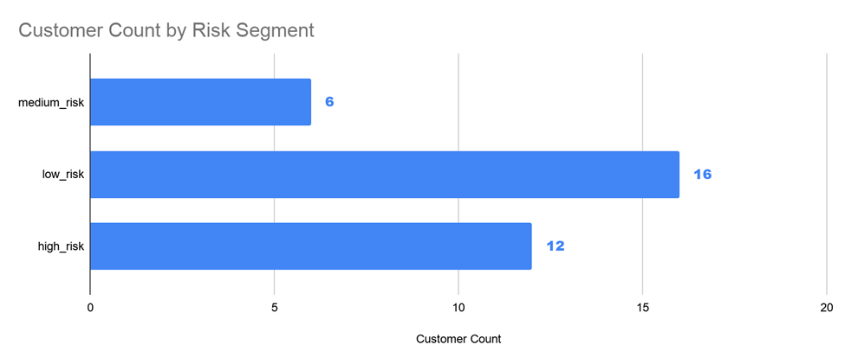
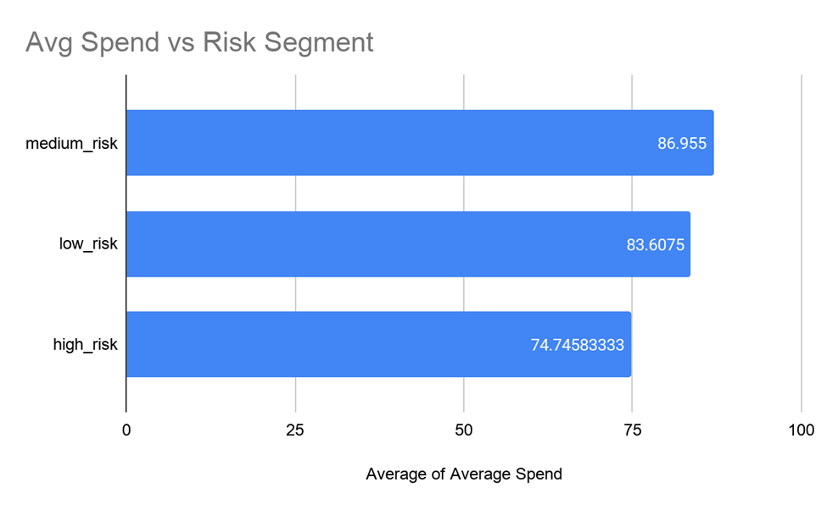
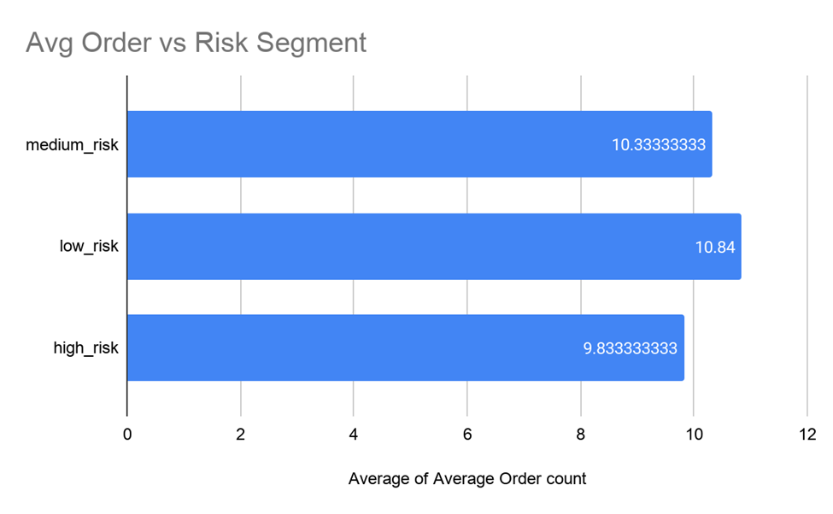

Insight
- High-Risk customers have lower total spending, fewer orders, and longer inactivity periods, indicating reduced engagement and higher probability of churn.
- Countries such as India and Brazil contain a larger proportion of high-risk customers.
- Markets like the United Kingdom and Canada have stronger low-risk customer segments with higher spending behavior.
- Key risk factors include long inactivity duration, low purchase frequency, lower average order value, and weak customer engagement over time.
- Low-risk customers demonstrate frequent purchases, higher cumulative spending, shorter gaps between transactions, and stronger long-term engagement.

Recommendation
- Send personalised re-engagement emails and promotional offers to high-risk customers.
- Reward low-risk and loyal customers with exclusive content, membership benefits, and early-access promotions.
- Continuously monitor inactivity periods and spending patterns through automated churn prediction dashboards.
- Focus additional retention efforts in countries with high-risk concentrations using localised pricing and culturally relevant campaigns.

SQ7. Customer Lifetime Value Modeling

SQL Query
WITH customer_metrics AS (
SELECT c.customer_id,
MIN(i.invoice_date) AS first_purchase, MAX(i.invoice_date) AS last_purchase,
COUNT(DISTINCT i.invoice_id) AS order_count,
SUM(i.total) AS total_spent, AVG(i.total) AS avg_order_value
FROM customer c
JOIN invoice i ON c.customer_id = i.customer_id
GROUP BY c.customer_id
),
final AS (
SELECT customer_id,
TIMESTAMPDIFF(MONTH, first_purchase, last_purchase) AS tenure,
TIMESTAMPDIFF(MONTH, last_purchase, (SELECT MAX(invoice_date) FROM invoice)) AS recency,
order_count, total_spent, avg_order_value,
order_count / NULLIF(TIMESTAMPDIFF(MONTH, first_purchase, last_purchase), 0) AS purchase_frequency,
avg_order_value * order_count AS estimated_clv
FROM customer_metrics
)
SELECT *,
CASE
WHEN recency <= 3 AND order_count >= 10 THEN 'High Value'
WHEN recency > 6 THEN 'Churned'
WHEN order_count <= 3 THEN 'Low Engagement'
ELSE 'Mid Value'
END AS segment
FROM final;

Output (Sample)
Cust ID | Tenure | Recency | Orders | Total Spent | Avg OV | Est CLV | Segment
2 | 42 | 1 | 11 | 82.17 | 7.47 | 82.17 | High Value
5 | 41 | 1 | 18 | 144.54 | 8.03 | 144.54 | High Value
3 | 38 | 7 | 9 | 99.99 | 11.11 | 99.99 | Churned
1 | 41 | 5 | 13 | 108.90 | 8.38 | 108.90 | Mid Value

Visualization:

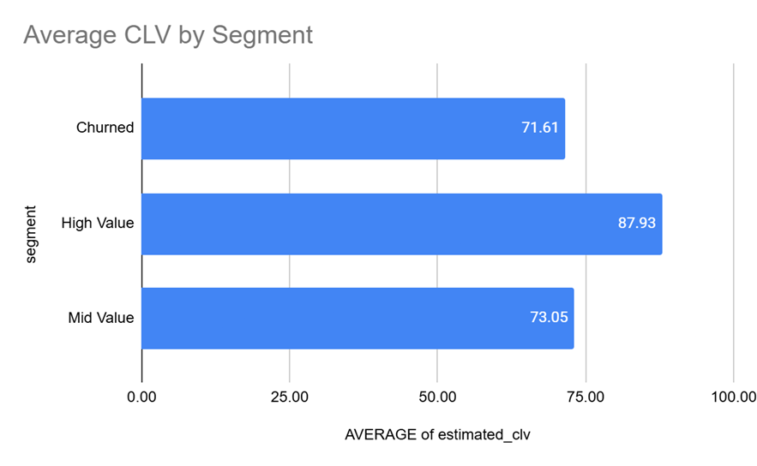

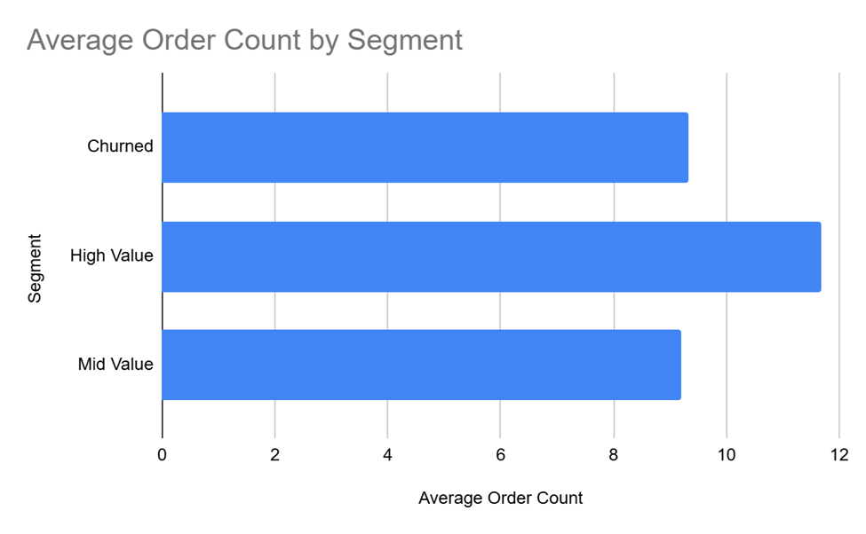

Insight
Characteristics of High-Value Customers:
- Long customer tenure, frequent purchases, low recency (recent activity), higher average order value, and consistent purchasing behavior over time.
Characteristics of Churned Customers:
- Long inactivity periods, low order frequency, lower total spending, and irregular buying behavior with smaller transaction values.
Low-Engagement Customers:
- Very few transactions, limited product exploration, and failure to develop habitual purchasing behavior.

Recommendation
- Target High-Value Customers: Offer loyalty rewards, premium memberships, and exclusive releases. Focus on retention to maximize long-term profitability.
- Re-Engage Churned Customers: Launch win-back campaigns with discounts or personalized playlists. Send reminders based on favorite artists or genres.
- Nurture Low-Engagement Customers: Improve onboarding experience, recommend trending albums, and encourage repeat purchases through limited-time offers.
- Data-Driven Marketing: Use CLV segmentation to allocate marketing budgets efficiently and personalize campaigns based on customer value.

SQ8. Measuring Impact of Promotional Campaigns

Approach
To measure the impact of promotional campaigns, analyze customer purchases linked to campaign activities such as discounts, events, and email marketing. The analysis focuses on:
- New customers acquired during campaigns
- Customers retained after campaigns
- Total sales generated from campaigns
Note: This analysis requires campaign data which is not currently available in the Chinook dataset. Once available, the approach would involve joining campaign records with customer and invoice data to track acquisition, retention, and revenue impact by campaign type.

SQ9. Exploratory Approach Without Predefined Questions

Approach
If the questions were not given, I would first understand the business objective — measuring how promotional campaigns affect customer acquisition, retention, and sales.
Then I would:
- Identify relevant tables like campaigns, customers, and invoices.
- Define key KPIs such as new customers acquired, repeat customers, total sales, and average order value.
- Join the datasets and analyze customer purchases during and after campaigns.
- Compare campaign performance by campaign type.
- Generate insights and recommendations based on the results.

SQ10. Altering the Albums Table to Add ReleaseYear Column

SQL Query
ALTER TABLE album
ADD COLUMN ReleaseYear INTEGER;

SELECT * FROM album;

Output
The ALTER TABLE statement successfully added a new INTEGER column 'ReleaseYear' to the album table. All existing records now show NULL for this new column, which can be populated with actual release year data as needed.

SQ11. Geographical Purchasing Behaviour Analysis

SQL Query
WITH customer_stats AS (
SELECT c.customer_id, c.country,
SUM(i.total) AS total_spent,
SUM(il.quantity) AS total_tracks
FROM customer c
LEFT JOIN invoice i ON c.customer_id = i.customer_id
LEFT JOIN invoice_line il ON i.invoice_id = il.invoice_id
GROUP BY c.customer_id, c.country
)
SELECT
country,
COUNT(customer_id) AS num_customers,
ROUND(AVG(total_spent), 2) AS avg_total_spent,
ROUND(AVG(total_tracks), 2) AS avg_tracks_per_customer
FROM customer_stats
GROUP BY country
ORDER BY country;

Output (Sample)
Country | Customers | Avg Total Spent ($) | Avg Tracks/Customer
Argentina | 1 | 396.00 | 40.00
Australia | 1 | 940.50 | 82.00
Brazil | 5 | 811.80 | 86.40
Canada | 8 | 686.19 | 67.63
Czech Republic | 2 | 1591.92 | 138.00
Germany | 4 | 860.31 | 84.50
India | 2 | 943.97 | 92.50
Ireland | 1 | 1433.52 | 116.00
Spain | 1 | 1076.13 | 99.00

Insight
- Countries with higher average spending indicate stronger customer purchasing power and engagement.
- A higher average number of tracks purchased suggests customers prefer buying larger music collections.
- Regions with many customers but low average spending may represent opportunities for upselling or targeted promotions.
- Comparing spending and track volume helps identify high-value markets.

Recommendation
- Focus marketing campaigns on countries with high customer counts, high average spending, and strong track purchase activity.
- Introduce personalized recommendations for high-purchase regions and discount bundles in lower-performing countries.
- Use geographic insights to improve customer segmentation, optimize marketing budgets, and support expansion decisions for new music genres or artists.

