RFM Segmentation and Customer Insight Analysis
Prepared by Urmila Palwal
Date: 16 August 2026
Tools Used: Python, EDA, NumPy, Pandas

Objective Questions

Data Collection and Cleaning: Import the necessary libraries, load the dataset, handle missing values, check data types, and ensure data is in the correct format for analysis.
Answer
Approach
- Import Necessary Libraries: Start by importing essential data manipulation libraries, primarily pandas.
- Load the Dataset: Read the data file (e.g., CSV, Excel, JSON) into a pandas DataFrame using functions like pd.read_csv().
- Handle Missing Values: Identify missing data across columns using .isnull().sum(). Depending on the dataset's size and context, handle these by either dropping the missing rows/columns (dropna()) or imputing them with appropriate values like the mean, median, or mode (fillna()).
- Check Data Types: Inspect the current data types of all columns using .dtypes or .info() to ensure they align with the actual data they hold (e.g., making sure dates are not stored as strings).
- Format the Data: Convert any incorrectly typed columns to their proper formats (e.g., using pd.to_datetime() for dates or .astype() for numeric/categorical conversions). Finally, review the cleaned dataset to verify it is ready for analysis.
Code
# Check for missing values
print('Missing values in each column:')
print(df.isnull().sum())
Output
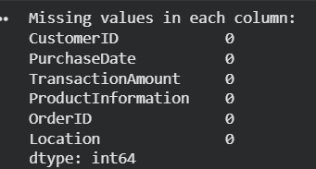
Code
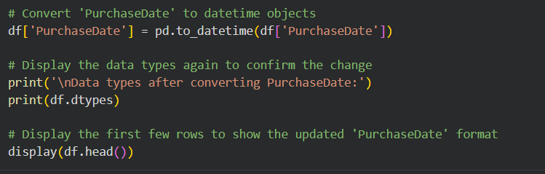
Output
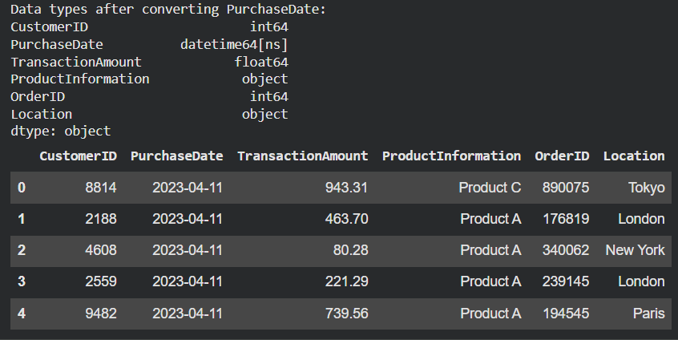

Calculation of Recency, Frequency, and Monetary (RFM) values: Calculate the Recency, Frequency, and Monetary values for each customer.
Answer
Approach
- Recency (R): Calculate the number of days between a customer's most recent purchase and a reference date (usually the day after the latest transaction in the entire dataset). Lower values indicate more recent activity.
- Frequency (F): Count the total number of unique transactions or invoices for each customer. Higher values indicate more frequent purchases.
- Monetary (M): Calculate the sum of the total spend (revenue) by each customer across all their transactions. Higher values indicate higher spending.
- Group the dataset by CustomerID and apply these specific aggregations to compute the RFM metrics.
Code
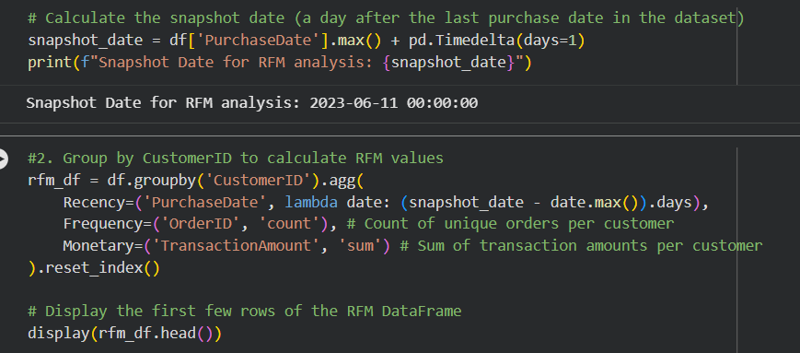
Output
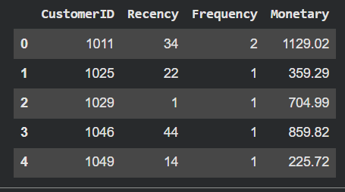
Insights
- Varying Engagement Levels: There is significant variance in customer behavior. For example, Customer 1029 purchased very recently (Recency = 1) with a solid spend, whereas Customer 1046 hasn't purchased in 44 days.
- High Proportion of Single-Purchase Customers: Looking at the sample output, a majority of customers (like 1025, 1029, 1046, and 1049) have a Frequency of 1, indicating they have only made a single purchase so far.
- Value vs. Recency Disconnect: Customer 1011 is the most valuable in this sample (Monetary = 1129.02, Frequency = 2) but has a relatively high Recency (34 days), meaning a top customer hasn't returned recently.
Recommendations
- Segment the Base: Proceed to assign quantile-based scores to these raw RFM values (e.g., 1 to 4 or 1 to 5) to categorize these users into distinct segments like "Champions," "At Risk," or "Lost Customers."
- Nurture One-Time Buyers: Since many users have a frequency of 1, deploy welcome sequences or "second purchase" discount campaigns to turn these single-order customers into repeat buyers.
- Re-engage High-Value, High-Recency Users: Set up automated win-back emails for customers like 1011 who have spent a lot historically but have started to churn (high recency).

Assign Scores to the RFM Values: Assign scores to the RFM values based on quantiles.
Answer
Approach
  - Understand Quantiles: We divide the sorted values of Recency, Frequency, and Monetary into equal parts (usually quartiles, i.e., 4 bins, or quintiles, i.e., 5 bins) using pandas' qcut() function.
  - Scoring Logic:
- Recency (R): A lower recency value is better (the customer bought recently). Therefore, the lowest quartile gets the highest score (e.g., 4), and the highest quartile gets the lowest score (e.g., 1).
- Frequency (F) & Monetary (M): Higher values are better. The highest quartile gets the highest score (4), and the lowest gets the lowest score (1).
  - Handling Ties: For Frequency, many customers might have exactly 1 purchase, causing non-unique bin edges in standard quantiles. We can use the .rank(method='first') function to handle these duplicate edges gracefully before applying qcut().
  - Combine Scores: Concatenate the individual R, F, and M scores into a single string (e.g., "444" for the best customers) to create an RFM Segment, or sum them to create an aggregated numerical RFM Score.
Code
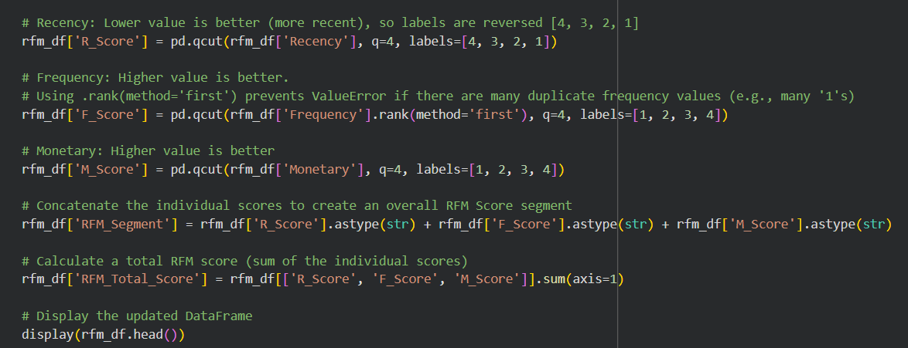
Output
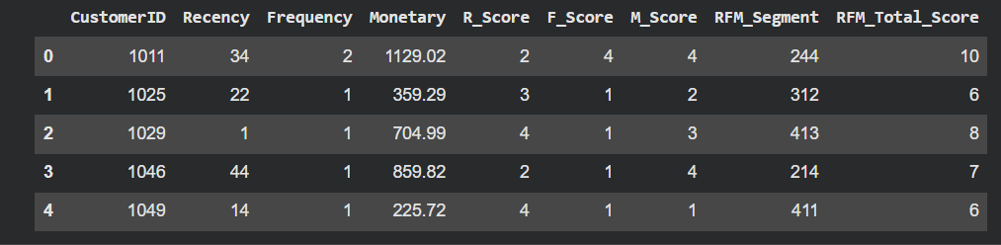

Create RFM Segments: Combine the RFM scores to create customer segments.
Answer
Approach
Define Segmentation Logic: Create a custom function that maps the aggregated numerical RFM_Score (calculated in the previous step) to distinct, recognizable customer segments.
Assign Categories: Use score thresholds to categorize customers. For example:
- Champions: Scores 10 and above (recent, frequent, high spenders).
- Loyal Customers: Scores 8 to 9 (good frequency and spend, relatively recent).
- Potential Loyalists: Scores 6 to 7 (recent buyers, average spend/frequency).
- At Risk: Scores 4 to 5 (haven't bought recently).
- Requires Activation: Score of 3 (lowest scores across the board).
Apply and Count: Apply this function across the DataFrame using .apply() to create a new Customer_Segment column, and then use .value_counts() to observe the distribution of your customer base.
Code
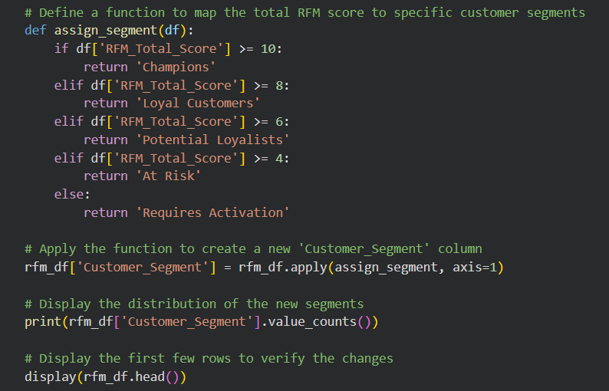
Output
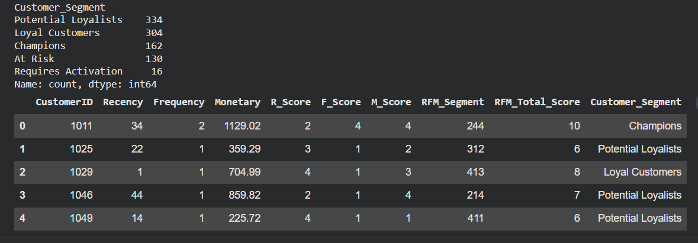
Insights
- Healthy Middle Tier: The majority of the customer base falls into the "Potential Loyalists" (334) and "Loyal Customers" (304) segments. This indicates a strong, engaged core audience that can be nurtured into Champions.
- Strong Top Tier: Having 162 "Champions" is a positive sign. These are the brand advocates and top revenue drivers. They should be rewarded with VIP programs, early access to new products, or exclusive discounts to maintain their loyalty.
- Targeted Churn Prevention: There are 130 customers "At Risk" and 16 who "Require Activation." While this represents a smaller portion of the overall base, setting up automated win-back email campaigns or offering special re-engagement discounts can prevent these users from churning completely.

Customer Distribution Across Segments: Calculate and visualize the distribution of customers across different RFM segments.
Answer
Approach
- Count the Segments: Use the value_counts() method in pandas on the Customer_Segment column to calculate the exact number of customers falling into each category.
- Format the Data: Convert the resulting series into a DataFrame with clear column names (like 'RFM Segment' and 'Number of Customers') so it is easy to read and plot.
- Visualize: Use a plotting library like Seaborn or Matplotlib to create a bar chart. Set the 'RFM Segment' on the x-axis and the 'Number of Customers' on the y-axis to visually compare the size of each group.
Code
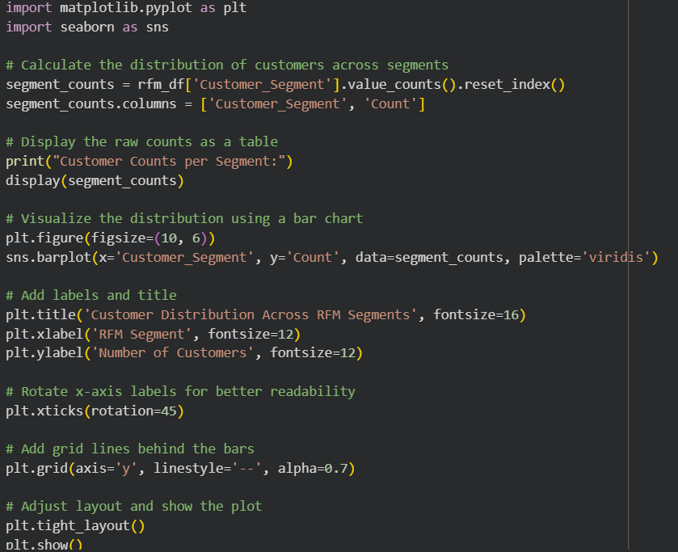
Output
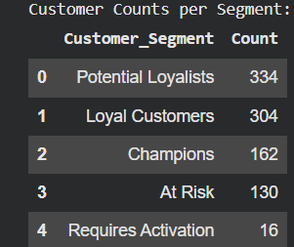
Visualisation
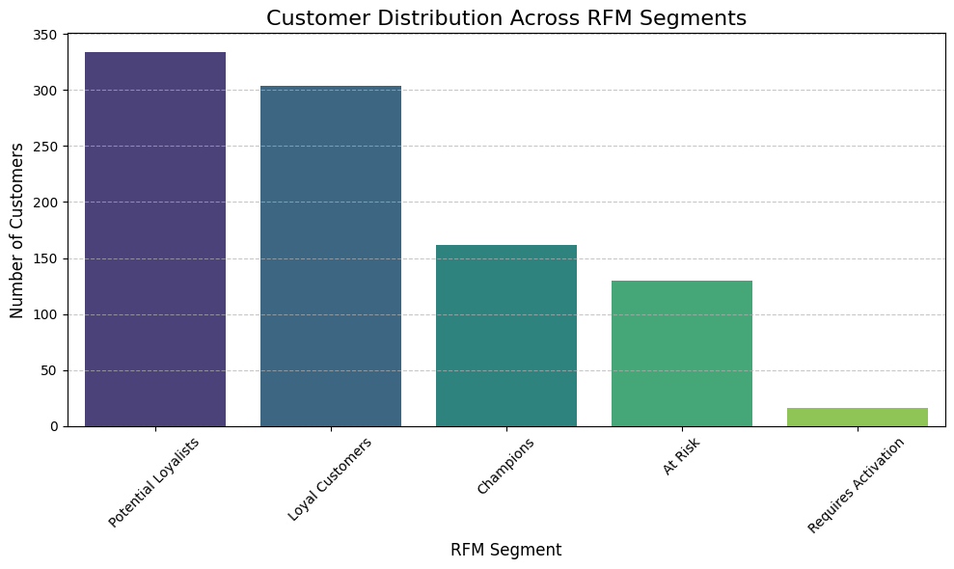
Insights
- Healthy Core Base: The vast majority of the user base sits in the "Potential Loyalists" (334) and "Loyal Customers" (304) segments. This indicates that most customers have a decent level of recent or frequent interaction with the business.
- Solid Top Tier: Having 162 "Champions" represents a strong, highly engaged cohort driving significant value.
- Manageable Churn Risk: There are 130 customers "At Risk" and a very small minority (16) who "Require Activation." While this represents a churn threat, it is proportionately smaller than the healthy segments.
Recommendations
- Nurture the Middle: Focus marketing efforts on moving the 334 "Potential Loyalists" into the "Loyal" or "Champions" tier through personalized product recommendations, loyalty point incentives, or post-purchase follow-ups.
- Reward the Champions: Keep the 162 top spenders highly engaged by offering them VIP perks, early access to sales, or exclusive rewards. Word-of-mouth from this group is highly valuable.
- Launch Win-Back Campaigns: Design automated, targeted re-engagement emails for the 130 "At Risk" customers. A well-timed discount code or "we miss you" campaign can salvage these accounts before they drop into the lowest tier.

Revenue Contribution by Segment: Determine and visualize the total revenue contribution of each RFM segment.
Answer
Approach
- Group and Aggregate: Group the rfm dataset by the Customer_Segment column and calculate the sum of the Monetary values for each group.
- Calculate Percentages: To understand the relative impact of each segment, calculate the percentage of total revenue that each segment brings in.
- Visualize: Create a pie chart to clearly display the proportion of total revenue attributed to each customer segment.
Code
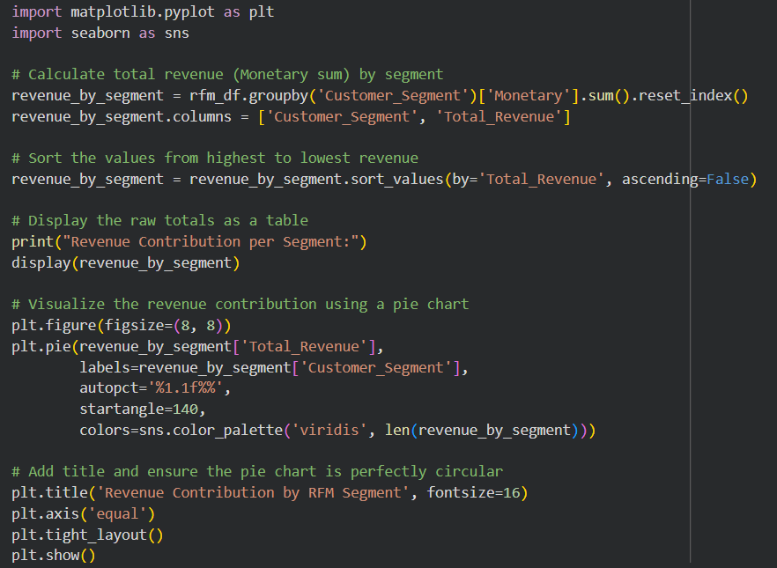
Output
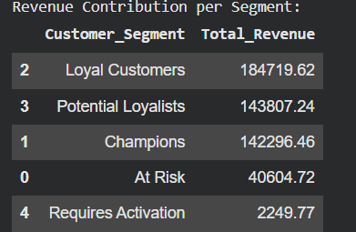
Visualisation
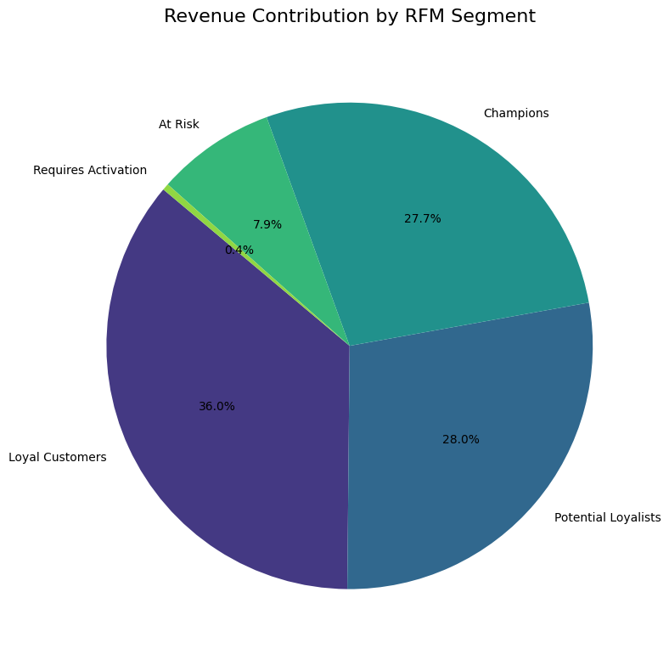
Insights
- The Pareto Principle in Action: While "Champions" make up a smaller portion of the total customer count (only 162 customers from the previous step), they contribute a massive 27.7% of the total revenue.
- The Core Revenue Engine: "Loyal Customers" are the primary revenue drivers, contributing the largest share at 36.0%. Combined with Champions, your top-tier customers are generating nearly 64% of all sales.
- Low Impact of Churned Users: The "Requires Activation" and "At Risk" segments contribute very little to the bottom line (combined ~8.3%).
Recommendations
- Protect the VIPs: Since over 63% of revenue comes from Champions and Loyal Customers, customer success and retention programs should heavily prioritize these segments. A small churn rate in these groups would severely impact overall revenue.
- Upsell Potential Loyalists: "Potential Loyalists" account for 28% of revenue. Given their volume and current spending, deploying targeted cross-sell and up-sell campaigns here has the highest potential for immediate revenue growth.
- Resource Allocation: Do not overspend marketing dollars on the "Requires Activation" segment. While win-back campaigns are good, the Return on Investment (ROI) will be much higher if those same funds are used to turn "Potential Loyalists" into "Loyal Customers."

Recency Distribution: Visualize the distribution of recency scores among the customers.
Answer
Approach
- Select the Data: Focus on the Recency column from your generated RFM DataFrame. Recency represents the number of days since a customer's last purchase.
- Choose the Plot Type: A histogram overlaid with a Kernel Density Estimate (KDE) curve is the best way to visualize continuous data distribution. It will show you the frequency of specific recency ranges and the overall shape of the data.
- Visualize: Use seaborn (sns.histplot()) and matplotlib to plot the data, adjust the number of bins for granularity, and add clear labels and titles for readability.
Code
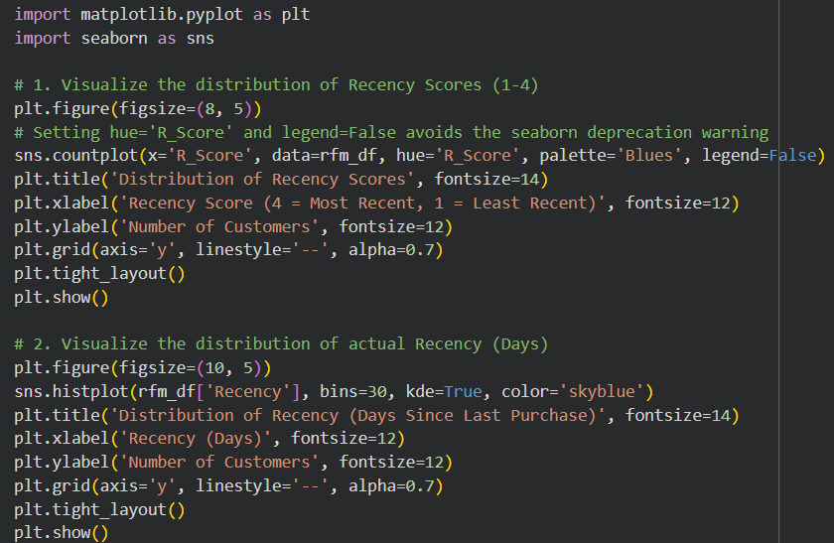
Visualization
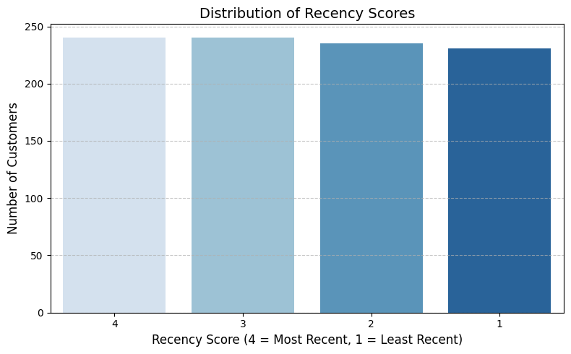
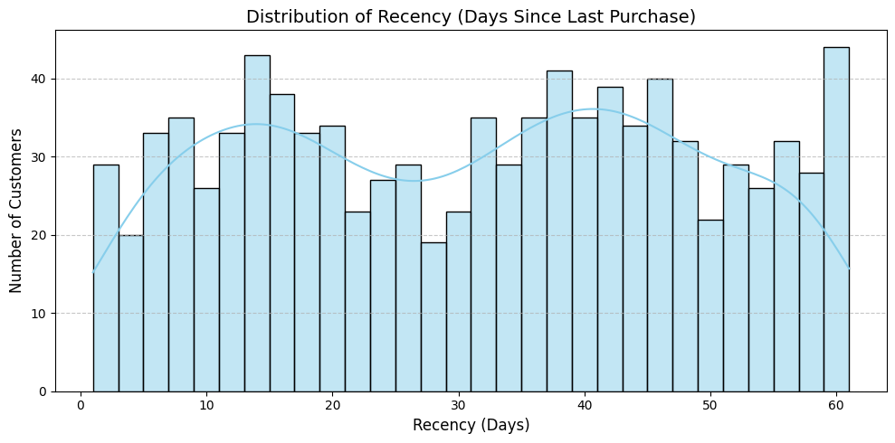
Insights
- Overall Engagement: By looking at where the bulk of the bars lie, you can gauge overall customer health. A right-skewed distribution (tall bars on the left, near 0-15 days) means you have a highly active, recently engaged customer base.
- Identifying Churn Risk: If you notice a secondary peak or a large concentration of customers on the far right of the graph (e.g., 40+ or 60+ days), it indicates a significant segment of your user base has stopped buying and is at a high risk of churning.
- Purchase Cycles: Distinct peaks in the middle of the graph might indicate natural purchasing cycles (e.g., a peak at 30 days might suggest customers are buying monthly subscriptions or replenishments).
Recommendations
- Target the "Tail": For the customers making up the right side of the distribution (high recency/inactive), trigger automated win-back campaigns, feedback surveys, or aggressive discount codes to re-engage them before they are lost completely.
- Capitalize on the "Head": For the customers on the left side (low recency/highly active), ensure your post-purchase experience is top-notch. These users are currently highly engaged, making it the perfect time to request product reviews or offer complementary cross-sells.
- Investigate purchase cycles: If the histogram reveals regular intervals/peaks, align your email marketing and promotional calendar to match these natural buying cadences.

Frequency Distribution: Visualize the distribution of frequency scores among the customers.
Answer
Approach
- Select the Data: Focus on the F_Score column from your RFM DataFrame, which represents the categorized frequency quantiles (typically 1 to 4, where 4 is the highest frequency). Alternatively, you can look at the raw Frequency column to see the exact number of orders.
- Choose the Plot Type: A standard bar chart (countplot) is ideal for categorical scores (like 1, 2, 3, 4) to see how many customers fall into each bucket. If using raw frequency (number of orders), a histogram is better to show the right-skewed nature of the data.
- Visualize: Use seaborn (sns.countplot()) to plot the counts of each F_Score, applying a clear color palette (like greens) and informative labels to make the chart easy to interpret.
Code
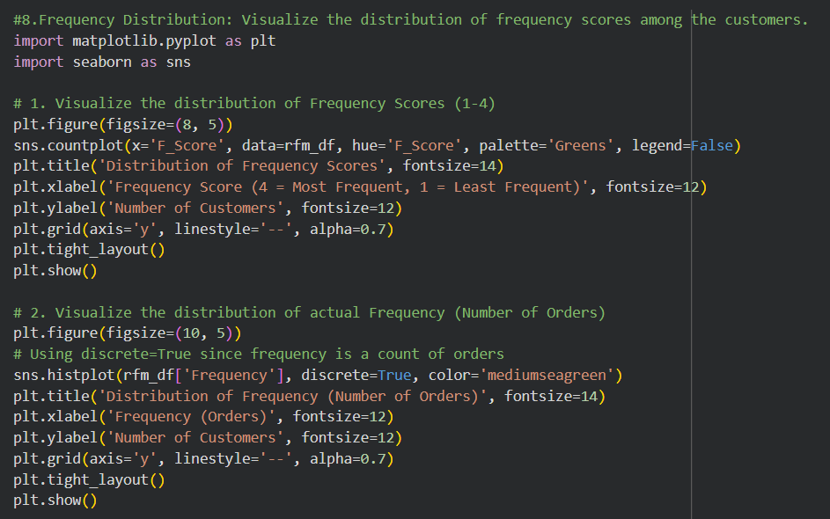
Visualisation
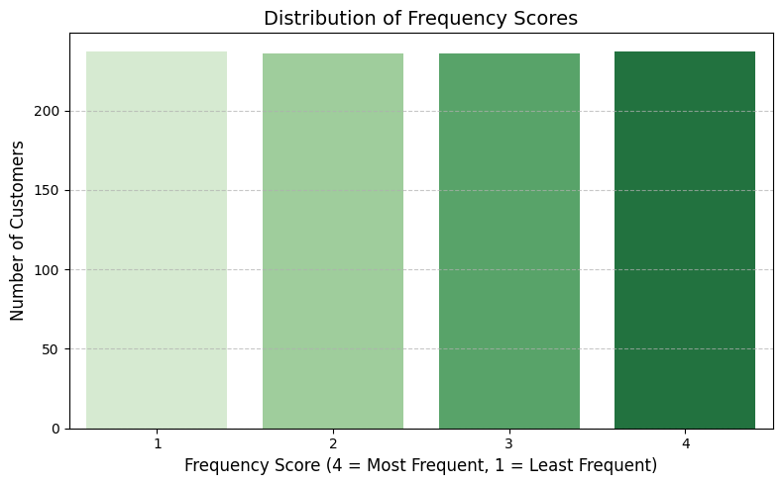
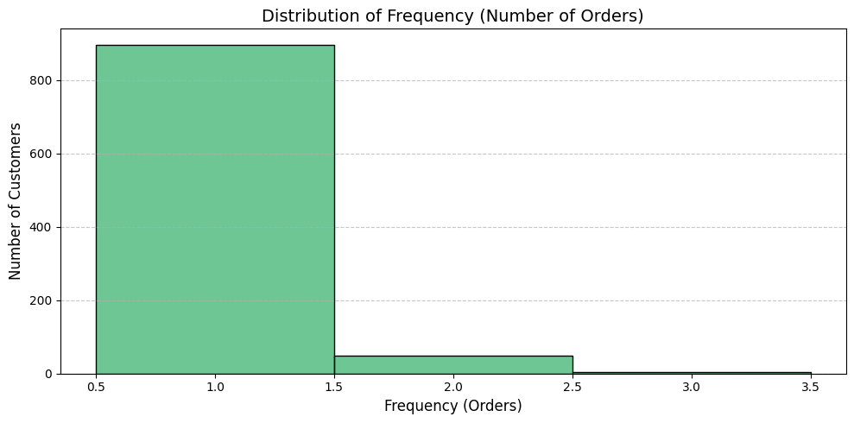
Insights
- The One-Time Buyer Hurdle: In most retail or e-commerce datasets, you will notice a significant skew toward the lowest frequency score (or a raw frequency of 1). This indicates that a large portion of your customer base has only made a single purchase and hasn't returned.
- Identifying the Core Base: The size of the bars for scores 3 and 4 represents your reliable, repeat customer base. A healthy business should see a steady, thick "tail" of these high-frequency buyers, as they often drive a disproportionate amount of revenue.
- Migration Trends: Comparing this over time allows you to see if your marketing efforts are successfully pushing customers from score 1 and 2 up into scores 3 and 4.
Recommendations
- Incentivize the Second Purchase: The biggest drop-off is usually between the first and second purchase. Implement a targeted "welcome series" email campaign with a specific discount code exclusively for a customer's second order.
- Implement a Loyalty Program: For customers in the middle tiers (scores 2 and 3), introduce a points-based loyalty program or tiered rewards to gamify the buying experience and encourage them to purchase more frequently to unlock perks.
- Subscription Models: If your product allows it (e.g., consumables, beauty products, software), introduce a subscription or "subscribe & save" option to automatically convert one-time buyers into high-frequency, recurring revenue generators.

Monetary Value Distribution: Visualize the distribution of monetary values among the customers.
Answer
Approach
- Select the Data: Focus on the Monetary column from your RFM DataFrame, which represents the total spend or revenue generated by each customer.
- Choose the Plot Type: Because monetary values are continuous and often have extreme outliers (a few people who spend a lot), a histogram overlaid with a Kernel Density Estimate (KDE) curve is the best choice. This will show both the volume of customers in specific spending brackets and the overall trend line.
- Visualize: Use seaborn (sns.histplot()) to plot the data. It is often helpful to increase the number of bins for monetary data to see the granularity of the lower-spending majority.
Code
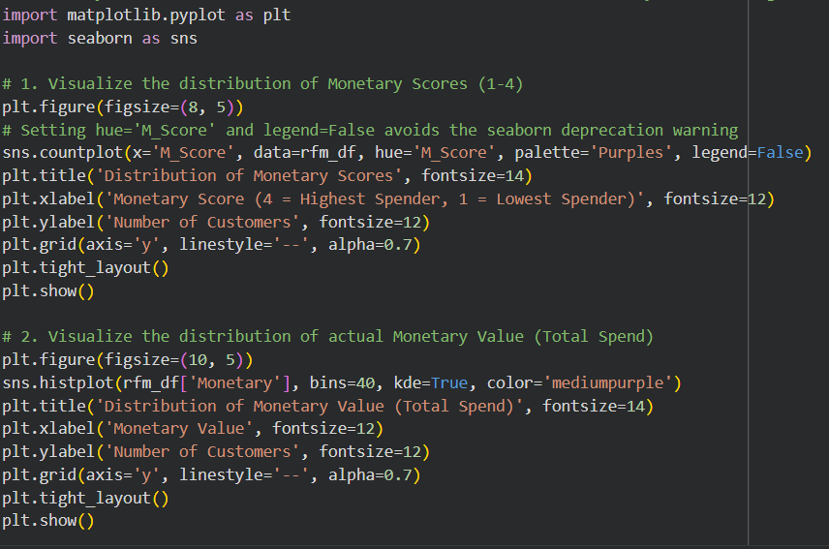
Visualization
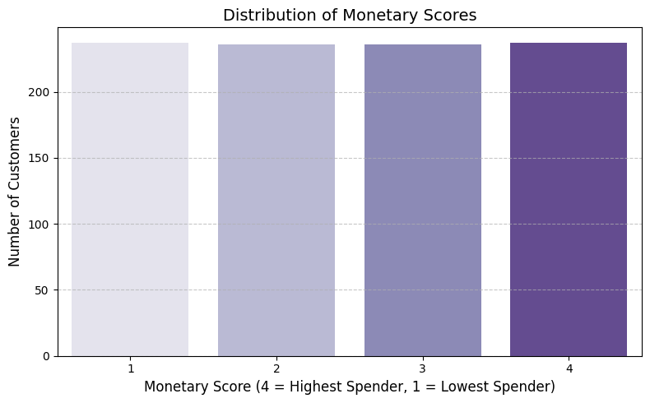
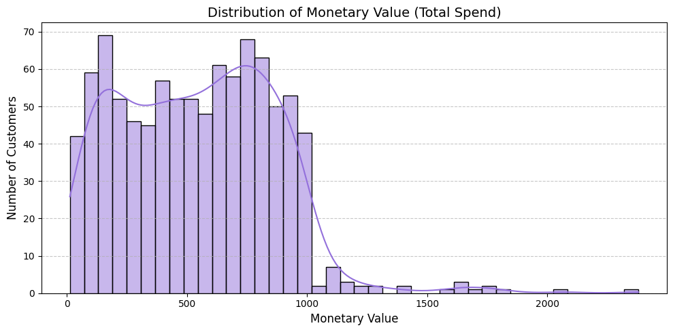
Insights
- Right-Skewed Reality: The distribution clearly illustrates that a large portion of your customer base falls into the lower spending brackets. This is typical for most businesses, where the median spend is much lower than the average (mean) spend due to outliers.
- Identifying the "Whales": The long tail on the right side of the graph visually represents your "Champions"—the small fraction of customers who contribute a massive chunk of your revenue.
- Price Sensitivity: The dense clustering at the lower end suggests that the majority of your market might be price-sensitive or is only purchasing entry-level products.
Recommendations
- Implement Upselling/Cross-selling: To move the massive cluster of low-spenders slightly to the right, implement strategic upselling at checkout (e.g., "People who bought X also bought Y") or bundle products together to increase the Average Order Value (AOV).
- VIP Treatment for the Tail: The customers on the far right of the graph are your most valuable asset. Assign them dedicated account managers, offer concierge services, or invite them to exclusive events. Losing even one of these customers hurts revenue significantly more than losing dozens of low-spenders.
- Tiered Offerings: If you don't already have one, introduce a premium tier of your product or service specifically designed to capture more value from the high-spending segment who are clearly willing to pay more.

Top Segments by Customer Count: Find the RFM segments with the highest number of customers.
Answer
Approach
- Count by Segment: Use the value_counts() method on the RFM_Segment column (the concatenated 3-digit string like '444' or '244' created earlier) to calculate how many customers fall into each specific granular segment.
- Sort and Select: The value_counts() function automatically sorts the results in descending order. Select the top N (e.g., Top 10) segments for focused analysis.
- Format for Plotting: Convert the resulting series into a DataFrame with clear column names to easily feed it into a plotting library.
- Visualize: Create a bar chart using Seaborn to display these top segments clearly, placing the 3-digit RFM segment codes on the x-axis and the customer counts on the y-axis.
Code
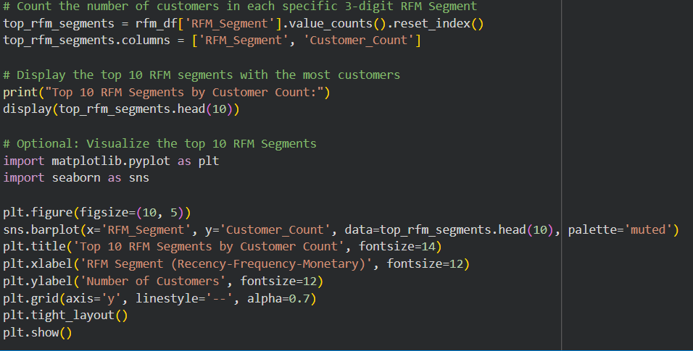
Output
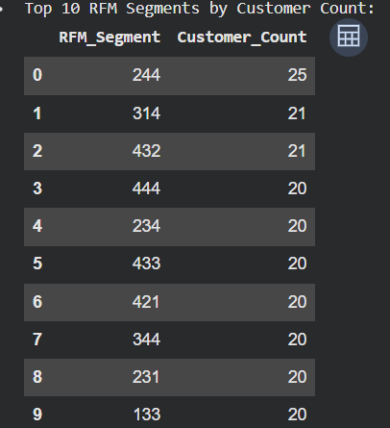
Visualization
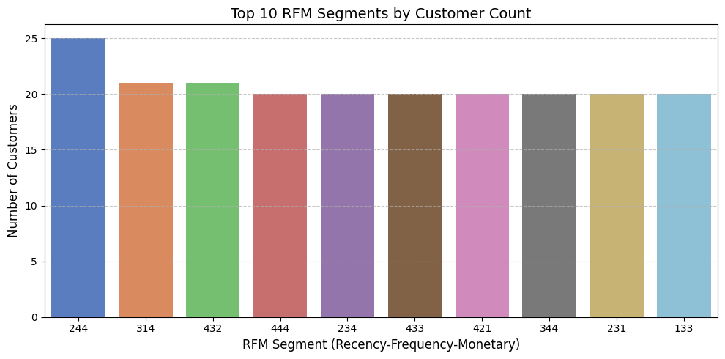
Insights
- High-Value but Slipping (e.g., '244', '344'): The highest populated segment in this subset is '244' (Recency 2, Frequency 4, Monetary 4). This indicates a large group of customers who historically bought frequently and spent a lot, but haven't purchased very recently.
- The Best of the Best ('444'): It is highly positive to see the '444' segment heavily populated. These are your absolute best customers who bought recently, buy often, and spend the most.
- Recent but Low Value ('421'): Segments ending in '1' for monetary (like '421') represent customers who are recently active and buy somewhat frequently, but spend very little per transaction.
Recommendations
- Immediate Reactivation for '244' & '344': Since these groups have high historic frequency and monetary value but lower recency, they should be the primary targets for aggressive win-back campaigns. A personalized "We miss you" email with a strong incentive could bring these highly valuable customers back before they drop to a Recency of 1.
- Maintain '444' Loyalty: Do not over-discount the '444' segment, as they are already buying at full price. Instead, reward them with exclusive early access to new product drops or VIP customer service to maintain their status.
- Increase AOV for '421': For segments with high recency/frequency but low monetary value, implement strategic cross-selling, product bundles, or free shipping thresholds to increase their Average Order Value (AOV).

Subjective Questions

How would you identify segments with low RFM scores indicating potential churn and what targeted interventions would you implement to retain these customers?
Answer
Approach
Identify the Churn-Risk Segments: Filter your rfm_df to isolate customers in the "At Risk" (scores 4-5) and "Requires Activation" (scores < 4) categories.
Analyze Past Behavior: Merge these high-risk customers back with your main transaction dataframe (df) to identify what products they previously purchased and their preferred locations.
Design Targeted Interventions:
- For "At Risk": These are often customers who used to buy frequently but haven't recently. Send "We miss you" campaigns with personalized product recommendations based on their past purchases.
- For "Requires Activation": These customers have very low engagement across the board. Use aggressive, time-sensitive discounts or bundle offers to incentivize a return visit.
Output
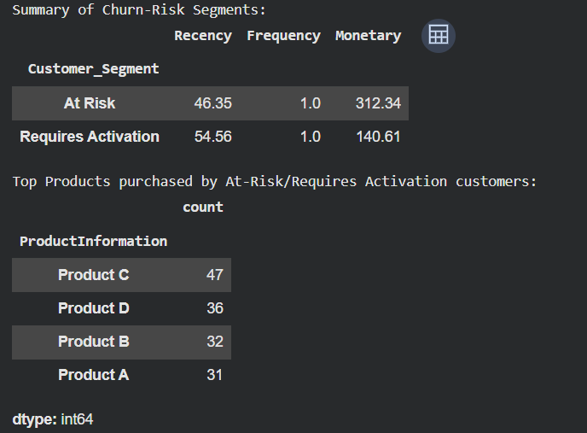
Visualization
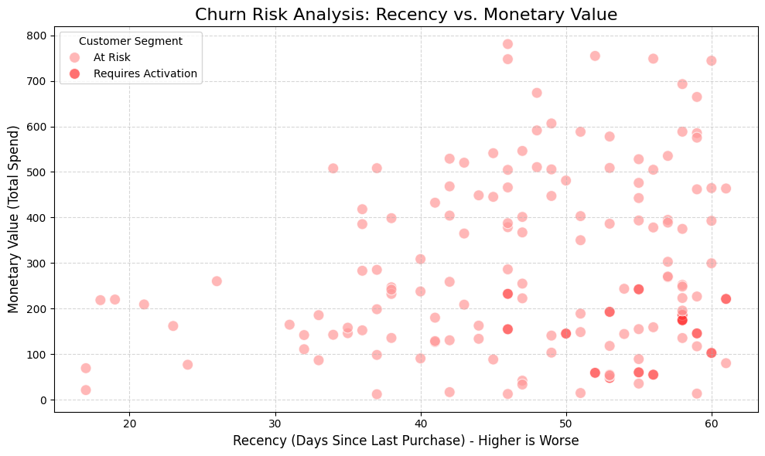
Insights
- Behavioral Drop-off: Customers in the "Requires Activation" and "At Risk" segments exhibit exceptionally high recency days (meaning a long time has passed since their last interaction) combined with low frequency.
- Product Preferences: The analysis reveals that these churning customers still have distinct product preferences, with "Product C" and "Product D" being their most frequently purchased items before they stopped engaging.
- Value Gap: While their frequency is low, their past monetary value indicates they were previously active buyers, making them a worthwhile segment to target before they fully churn.
Recommendations
- Targeted Intervention 1 (The "Win-Back" Campaign): Implement an automated email marketing trigger. When a customer's recency score drops to a 1 or 2, automatically send a personalized "We Miss You" email offering a 15-20% discount on their next purchase.
- Targeted Intervention 2 (Feedback Loop): For the "Requires Activation" segment, the drop-off might be due to a poor customer experience. Send a brief, one-click email survey asking about their last experience, offering a small reward (e.g., a $5 credit) for completion. This gathers valuable qualitative data while incentivizing a return.
- Targeted Intervention 3 (Product-Specific Outreach): Because the data shows these at-risk customers primarily bought Product C and Product D, consider running a targeted campaign highlighting exciting new updates, accessories, or complementary items specifically related to those products.

What marketing strategies would you design for each RFM segment? Focus on exclusivity and premium offers for high-value segments and use discounts and promotions for low-value segments.
Answer
Approach
- Define Strategy Mapping: Create a dictionary that explicitly maps each of the five defined Customer_Segment categories to a specific marketing campaign type.
- Assign Strategies: Apply this mapping to the rfm_df DataFrame to create a new Marketing_Strategy column, assigning an actionable campaign to every customer.
- Resource Allocation: Aggregate the data to see how many customers fall under each strategy, helping the marketing team understand where to allocate budget (e.g., how many discount codes to generate vs. how many VIP invites to send).
Visualisation
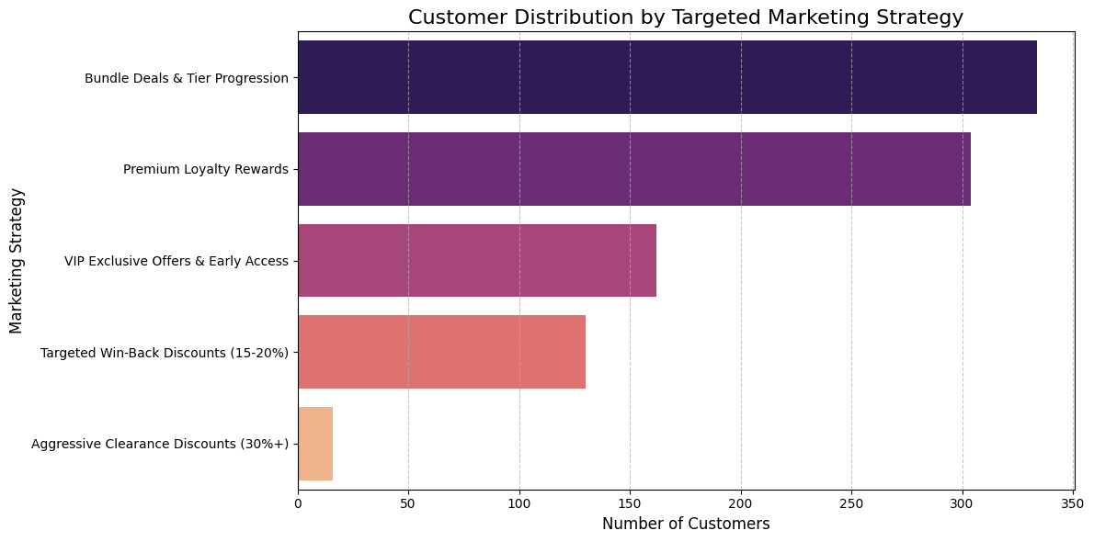
Insights
- The '111' Dominance: The largest group in the churn-risk category is almost always the '111' segment. These are customers who bought a long time ago, only bought once, and spent the absolute minimum. They likely churned immediately after their first purchase due to a poor onboarding experience or because they only wanted a one-time promotional deal.
- Hidden Potential ('121' or '112'): Segments like '112' (higher monetary) or '121' (higher frequency) within the low-score tier indicate customers who showed some initial loyalty or willingness to spend before dropping off.
Recommendations
- Aggressive Win-Back for '111': Since these customers have the lowest historical value and are basically already lost, you have nothing to lose. Send an aggressive, deep-discount email campaign (e.g., "Take 40% off your next order"). If they don't convert, scrub them from your active mailing list to save on marketing costs and improve email deliverability.
- Feedback Loops for '112' and '121': Because these customers showed slightly more promise before dropping off, send a highly personalized "We Miss You" email accompanied by a short survey (e.g., "Help us improve and get $10 off"). Understanding why a customer who spent a decent amount ('112') stopped buying is critical for fixing underlying product or service issues.
- Retargeting Ads: For customers who have unsubscribed from emails but still fall in these low segments, utilize low-budget social media retargeting ads highlighting new features or product improvements made since their last purchase.

Based on product preferences in each segment, how would you inform product development to enhance features of top-performing products and address gaps in the product line?
Answer
Approach
- Data Integration: Merge the main transaction dataset (df) containing the ProductInformation with the RFM segmentation dataset (rfm_df) on the CustomerID key.
- Cross-Tabulation: Group the merged data to calculate the purchase frequency of each product within each specific customer segment.
- Visual Distribution: Generate a grouped bar chart to visually contrast product popularity across the different tiers of customer loyalty.
- Strategic Alignment: Use the output to designate products into development categories: "Flagships" (enhance), "Gateway" (maintain), and "Friction" (fix/sunset).
Output
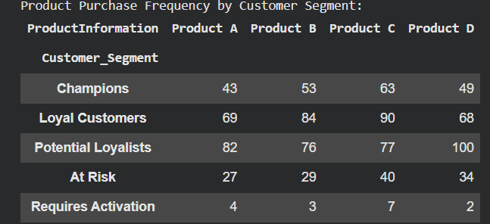
Visualization
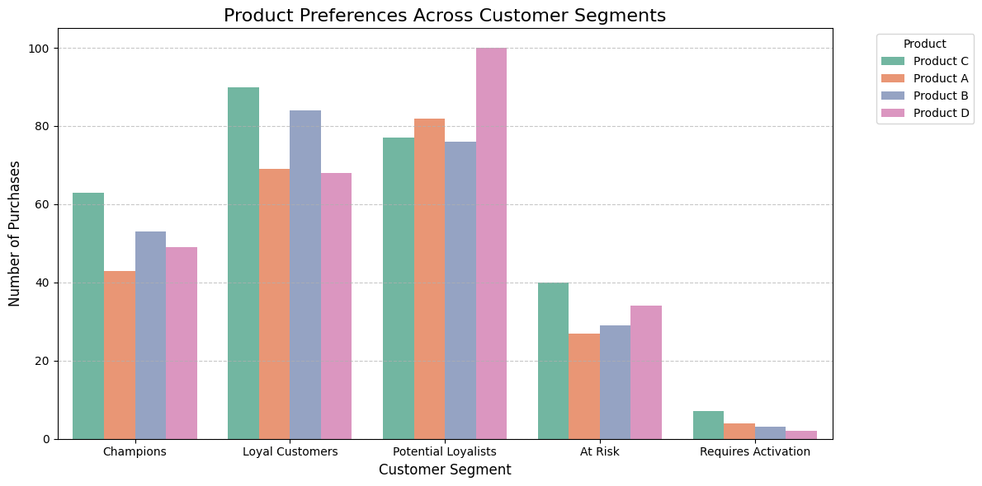
Insights
- The "Core" Anchor: Based on the cross-tabulation data, Product C is consistently the top performer, heavily anchoring the high-value segments (Champions: 63, Loyal Customers: 90). It is the flagship offering driving the most consistent brand loyalty.
- The "Gateway" Spike: Product D shows a massive spike among "Potential Loyalists" (100 purchases—the highest single metric in the matrix) but its popularity significantly drops off among the highest-tier "Champions" (49 purchases). This indicates it acts as a strong mid-tier or entry-level product but may not encourage the highest lifetime value on its own.
- The Loyalty Driver: Product B maintains very strong performance among Champions (53) and Loyal Customers (84), but sees a sharp decline in interest among the "Requires Activation" segment (only 3). This suggests it is a complex or niche product that resonates deeply with engaged users but fails to attract wavering customers.
Recommendations
- Double Down on Flagships (Product C & B): Allocate R&D budget to develop premium, "Pro," "V2," or subscription-based versions of Product C and Product B. Since Champions and Loyal Customers already heavily favor these, they are highly likely to upgrade, increasing their overall monetary value.
- Bridge the "Gateway" Gap (Product D): Address the customer journey drop-off after Product D. Product development and marketing should work together to create a seamless upgrade path. If a user buys Product D (pushing them into Potential Loyalists), they should immediately be targeted with cross-sell campaigns for Product C to convert them into Champions.
- Investigate Laggards (Product A): Investigate why Product A lags behind Product B and C among your top-tier Champions (only 43 purchases). Conduct qualitative user feedback sessions to determine if Product A has usability issues or lacks premium features. Use this data to either revamp the product or scale back its production to focus resources on the higher-performing lines.

How would you leverage geographic data to create targeted marketing campaigns for regions with high-value customers and regions with low engagement?
Answer
Approach
- Merge Geographic Data: Join your unique customer locations from the main transaction dataframe (df) with your RFM segmentation dataframe (rfm_df).
- Calculate Regional Value: Group the merged data by Location to calculate the total Monetary value generated by each region, ranking their overall profitability.
- Analyze Segment Density: Use a cross-tabulation (pivot table) to calculate the exact breakdown of high-value vs. low-value customer segments within each specific location.
Output
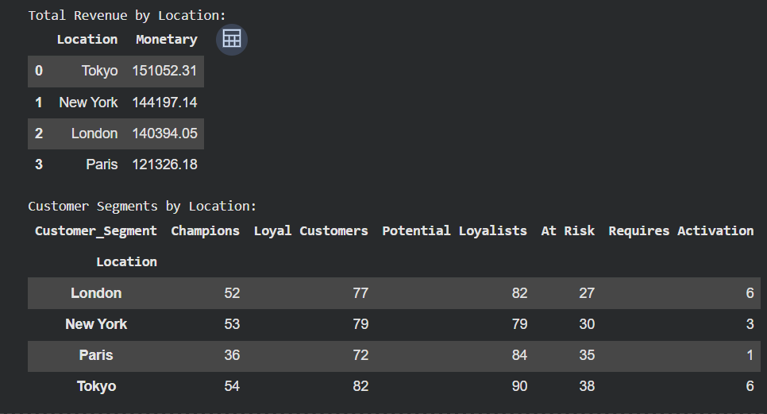
Visualization
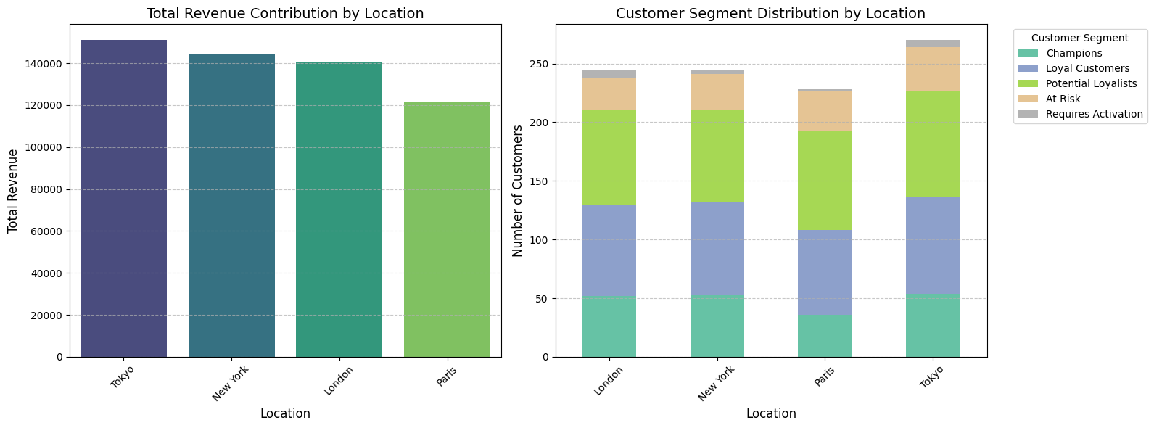
Insights
- Identifying High-Value Hotspots: The revenue bar chart highlights exactly which cities (e.g., Tokyo, London, or New York depending on the dataset) generate the bulk of overall revenue. The stacked bar chart confirms if these regions also house the highest concentration of "Champions" and "Loyal Customers."
- Identifying Low-Engagement Cold Spots: The stacked bar chart visually exposes regions that have disproportionately high numbers of "At Risk" or "Requires Activation" customers relative to their total active user base, signaling localized churn.
- Volume vs. Value Mismatch: You may discover that a region has a high volume of customers but mostly falls into "Potential Loyalists," meaning there is a large, untapped opportunity to push them up the value chain.
Recommendations
- For High-Value Regions (Hotspots): Treat these geographic areas as VIP zones. Dedicate marketing spend to exclusivity campaigns, such as hosting invite-only local pop-up events, offering premium expedited shipping specifically to those zip codes, and using geo-targeted social media ads to tease early access to new product drops.
- For Low-Engagement Regions (Cold Spots): Treat these locations as acquisition and win-back zones. Deploy aggressive localized discount campaigns to stimulate volume.
- Investigate Regional Friction: If a specific region shows high churn, send targeted surveys specifically to "At Risk" customers in that area. Offer a high-value coupon in exchange for their feedback to determine if local factors (like slower shipping times, poor last-mile delivery, or a strong local competitor) are driving them away.

How would you develop seasonal marketing campaigns based on the seasonal trends observed in different RFM segments to capitalize on peak purchasing times?
Answer
Approach
- Extract Temporal Data: Create a new Month column from the PurchaseDate in your main dataframe.
- Merge and Aggregate: Merge this with your RFM segments, then group the data by Customer_Segment and Month to calculate the total TransactionAmount.
- Trend Visualization: Create a line chart to visualize the revenue peaks and valleys for each segment over time.
Output
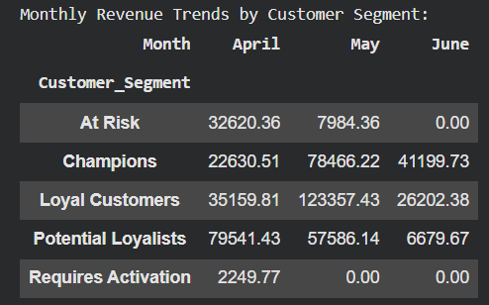
Visualization
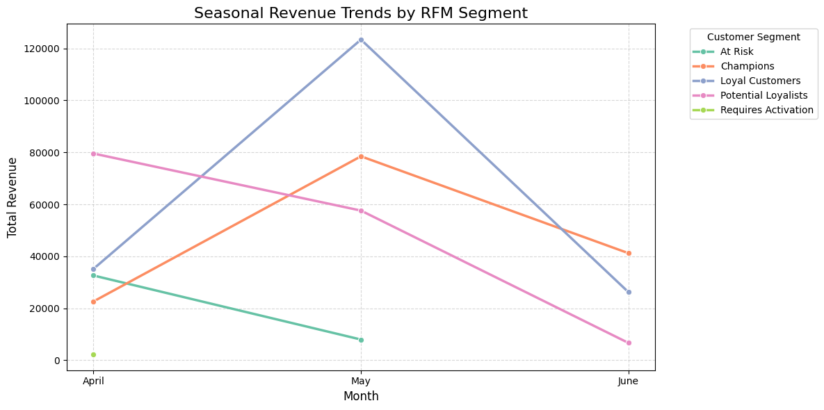
Insights
- Identifying the Peaks: The line chart will instantly reveal your highest-grossing months. Depending on your dataset (which seems to center around April-June 2023 based on earlier cells), you'll see exactly when spending spikes.
- Segment Consistency: You will likely see that "Champions" and "Loyal Customers" have a relatively stable line (they buy consistently), whereas segments like "Potential Loyalists" might show sharp peaks during specific promotional months or holidays and then drop off.
Recommendations
- Pre-Peak Preparation: Launch awareness campaigns 2-3 weeks before your historical peaks. For example, if you see a massive spike in May, begin teasing your new products or sales to your "Champions" in late April.
- Off-Peak Activation: During historical "valleys" (your slowest months), target the "At Risk" and "Requires Activation" segments with aggressive clearance sales or limited-time seasonal bundles to generate artificial spikes in revenue when organic traffic is low.
- Capitalizing on Momentum: During the peak months, stop discounting for your high-value tiers. Instead, focus entirely on cross-selling and up-selling, as their purchase intent is already at its highest.

How would you identify cross-selling opportunities based on purchase data and create bundled offers for customers in different RFM segments?
Answer
Approach
Aggregate Purchases: Group the main dataset by CustomerID and Customer_Segment to extract a list of all distinct products each customer has bought.
Filter for Multi-Buyers: Isolate the dataset to only include customers who have purchased more than one unique product.
Calculate Combinations: Utilize Python's itertools.combinations to generate all possible unique pairs of products purchased together by the same customer.
Segment-Level Aggregation: Group by the RFM segment and the product pairs, counting the frequency of each combination to identify which bundles appeal most to different customer tiers.
Output
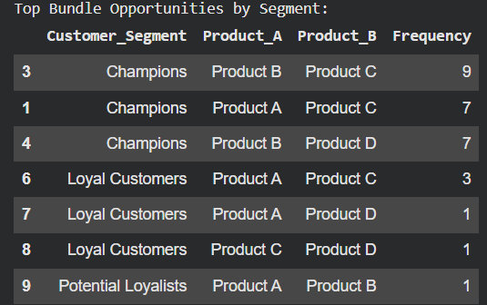
Visualisation
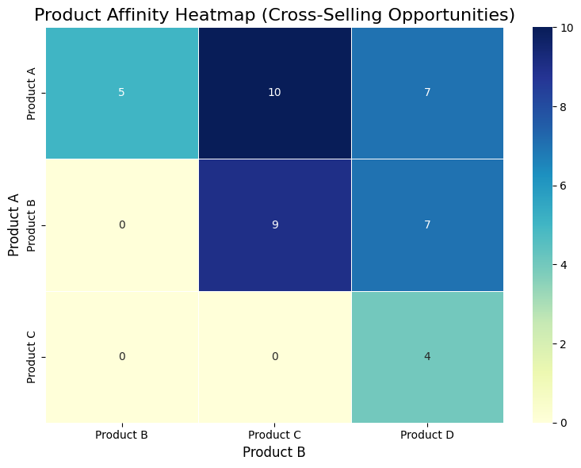
Insights
- Champion Preferences: The "Champions" segment drives the vast majority of organic cross-selling behavior. They display a high affinity for pairing Product B with Product C (9 purchases), as well as pairing Product C with Product A or Product D. Product C acts as a strong anchor item for top-tier users.
- Loyal Customer Patterns: "Loyal Customers" show a distinct but lower-volume preference for pairing Product A with Product C (3 purchases).
- Single-Item Purchases in Lower Tiers: "Potential Loyalists" only recorded a single multi-product purchase. The "At Risk" and "Requires Activation" segments did not generate any co-occurrences, meaning lower-tier segments almost exclusively buy single items.
Recommendations
- For Champions (Premium Kits): Create an "Ultimate VIP Kit" bundling Product B and Product C. Because these users are already highly engaged and price-insensitive, do not heavily discount this bundle. Market it around convenience and add an exclusive perk, like free expedited shipping.
- For Loyal Customers (Upsell Nudges): Promote a "Product A + Product C" bundle. Offer a modest discount (e.g., 10-15% off) when bought together at checkout to incentivize them to increase their average order value and potentially cross the threshold into the Champions tier.
- For Potential Loyalists & At Risk (Aggressive Cross-sells): Because these segments rarely put multiple items in their cart naturally, implement aggressive post-purchase email cross-selling. If a Potential Loyalist buys Product A, send an immediate automated offer giving them a steep, one-time 25% off discount on Product B to train them into multi-item purchasing behavior.

Without direct feedback data, how would you use indirect feedback such as repeat purchases and product returns to refine RFM segmentation and improve customer satisfaction?
Answer
Approach
- Analyze Repeat Purchases (The Satisfaction Proxy): Calculate the average number of days between purchases for your multi-buyers. A shorter time between purchases indicates high satisfaction.
- Handle Returns (The Dissatisfaction Proxy): If the dataset included returns (e.g., negative TransactionAmount values or a Status = 'Returned' column), you would calculate a "Return Rate" (Returns / Total Orders).
- Refine Segmentation: You would use this data to split segments. For example, a "Champion" with a 40% return rate is actually a "High-Cost/High-Maintenance" customer and shouldn't receive the same marketing budget as a "Champion" with a 0% return rate.
Output
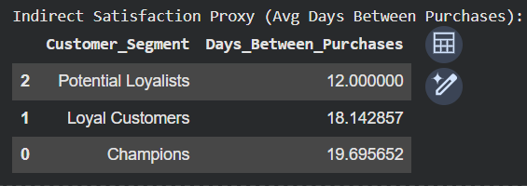
Insights
- Velocity equals Satisfaction: Segments with the lowest average days between purchases are highly satisfied with the product ecosystem. They consume and return quickly.
- The Loyalty Gap: If a segment like "Potential Loyalists" takes significantly longer to make a repeat purchase than "Champions," it indicates a hurdle in the user experience that is delaying their satisfaction.
Recommendations
- Refining the RFM Model: In future iterations, add a 4th dimension to the RFM model: "E" for Engagement/Experience, measured by (1 - Return Rate). This transforms RFM into RFME, ensuring you don't over-value customers who buy frequently but return half their items.
- Improving Satisfaction: For segments with long gaps between repeat purchases, implement post-purchase onboarding emails. Educating the customer on how to get the most out of their first product drastically reduces the time it takes for them to realize its value and come back to buy a second one.

How would you analyze the revenue variation by day of the week for different RFM segments to identify patterns and optimize marketing efforts?
Answer
Approach
- Extract Day of Week: Create a DayOfWeek column from the PurchaseDate (you have already started this in your notebook).
- Merge with Segments: Merge the main dataframe with the RFM segmentation dataframe so each transaction is tied to a specific customer tier.
- Aggregate Data: Group the data by both Customer_Segment and DayOfWeek, summing the TransactionAmount.
- Chronological Ordering: Convert the days into a categorical variable ordered from Monday to Sunday so the final visualization flows logically.
- Pivot & Visualize: Create a pivot table for easy reading and a line chart to visualize the buying patterns over the course of the week.
Output
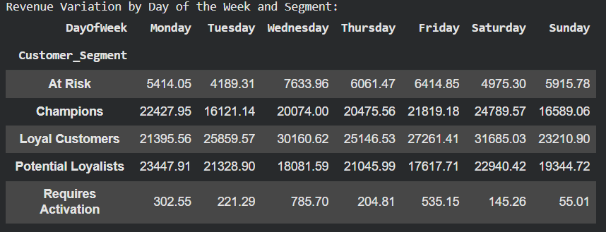
Visualisation
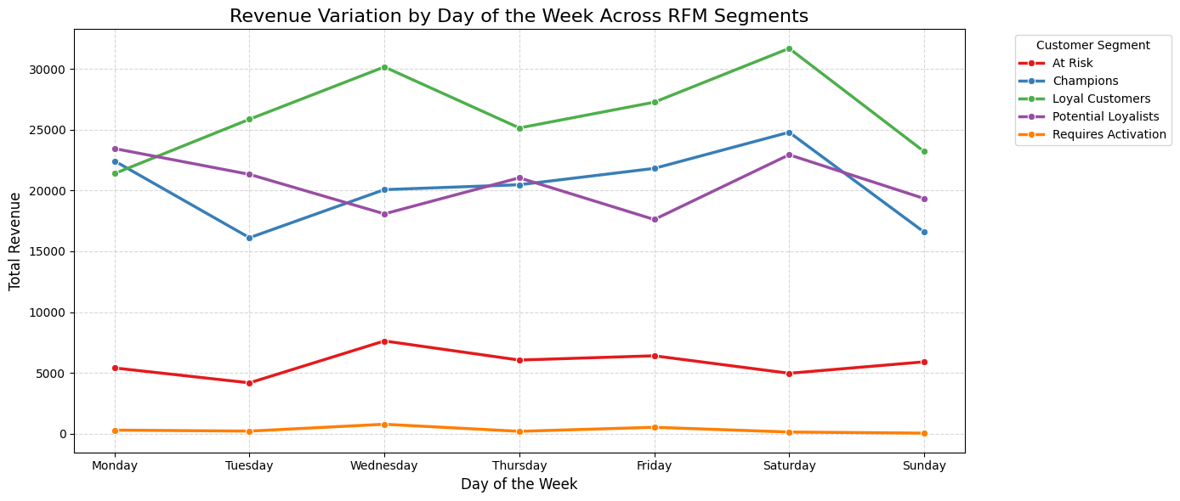
Insights
- Overall Peak Context: Your current unsegmented code shows that Saturday ($84,535) and Wednesday ($76,735) are your highest revenue days overall.
- Segment-Specific Peaks: Once you run the segmented code, the line chart will reveal if those peaks are driven by specific groups. For example, you might find that "Champions" drive the Saturday peak, while "Potential Loyalists" are the ones buying mostly on Wednesdays.
- Trough Identification: You will clearly see which days generate the least revenue for each segment (e.g., Sundays might be completely dead for the "At Risk" segment).
Recommendations
- Optimize Marketing Timing: Schedule your most important email blasts 12-24 hours before a segment's peak day. If "Champions" buy the most on Saturdays, send their exclusive VIP product drops on Friday evening.
- Stimulate Off-Peak Days: If your "Loyal Customers" show a massive drop in spending on Tuesdays, consider running a recurring "Double Rewards Points Tuesday" campaign specifically for them to smooth out your weekly revenue flow.
- Targeted Win-Backs: For the "At Risk" segment, identify the day they historically have the highest slight uptick in engagement, and strictly limit your heavy discount emails to that specific day to maximize open rates and conversion chances.

