Contents
Day 1 3
Orientation 3
Introduction 3
Session 1 3
Day 2 4
Session 2 – Part 1 4
Reference work 4
Session 2 – Part 2 5
Reference work 5
Session 2 – Part 3 5
Reference work 5
Tasks 6
Day 3 7
Part 1 7
Session 5 7
Reference work 7
Task 8
Day 3 & 4 8
Session 6 8
Reference work 8
Task 9
Day 5 & 6 10
Reference work (before session) 10
Session 7A 10
Session 7B 10
Reference work 10
Session 8 10
Reference work 10
Tasks 10
Reference work (reading before session) 11
Session 9 11
Reference work (before task) 11
Tasks 11
Day 7 13
Reference work (before session) 13
Session 10 13
Reference work (before task) 13
Tasks 13
Day 8 - 9 14
Session 11 14
Task 14
Day 10 & 11 15
Research 15
Tasks 15
Day 12-15 16
Session 12 16
Session 14 16
Session 15 16
Reference work (before task) 16
Tasks 16
Day 16 18
Part I 18
Session 13 18
Session 16A 18
Session 17 18
Part II 18
Project specific training (Script # / Backbone) 18

Day 1

Orientation
- About Zeus
- Rules and Regulations

Introduction
- Notepad++
- Browsers

Session 1
- GIT

Day 2

Session 2 – Part 1
- Introduction to web development
  - Web page
  - Notepad ++
  - Browser
- Introduction to HTML
- Basic HTML page - HTML DOC structure
- doctype
- Understanding Common HTML Terms
- Root of the HTML document
- HEAD & title
- Self-closing tags
- Block and Inline elements

Reference work
- What is a doctype and what is its importance?
- List correct attribute used to add following elements to the page, and explain why they are needed:
  - title
  - anchor
  - div
  - para
  - image
  - h1- h6
- form the HTML element given below which are self-closing which are not, which are block element and which are inline elements
  - div
  - para
  - anchor
  - image
  - head
  - body
  - span
  - em
  - strong
  - h2
- Which element is used to add list to a HTML page, explain different types with examples.

Session 2 – Part 2
- Introduction to input element
- Introduction to DOM
- Introduction to Visual Web Developer

Reference work
- What is the form element, list and explain following attributes of the form element:
  - Method
  - Action
- Explain input element with all possible value of type attributes.

Session 2 – Part 3
- Introduction to browser’s developer tool – Only to add/edit HTML
  - Chrome and IE
- Introduction to VM

Reference work
- What is the keyboard short cut to open the developer tool in the browsers listed below?
  - IE
  - Chrome
  - Firefox
  - Safari
- Which tag is used to specify character encoding for HTML page?
- For HTML page generally which character encoding is used and why?

Tasks
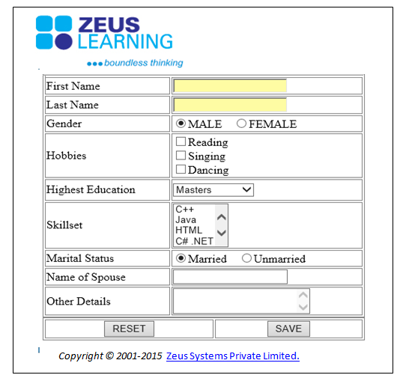

- Create new HTML page – form-elements.html
  - Click on Zeuslearning logo should open a Zeuslearning.com in new web page – please don’t use onclick attribute.
  - Make all labels (first Name, last name ..) bold.
  - First name and last name should not be more than 32 characters.
  - Add an element to the page to accept the password.
  - Zeus Systems Private Limited should link to working email address (where someone can click the link and send you e-mail such as YourZeusId@zeuslearning.com)

- By using tool at the URL given below, validate all the html document created previously
http://validator.w3.org/

Day 3

Part 1

Session 5
- Defining and applying style to HTML elements
- Adding comments to CSS
- Inline/embedded/external CSS
- selectors - element, ID, class, universal, descendant, child
- Working with the CSS box model
- Using pseudo-class and pseudo-element selectors
- Grouping selectors
- Positioning - static, relative, absolute, fixed
- float property
- clear property
- box-sizing - content-box, border-box, padding-box

Reference work
- What is the "Box Model" in CSS? Which CSS properties are parts of it?
- Describe what a “reset” CSS file does and how it’s useful. Are you familiar with normalize.css? Do you understand how they differ?
- What are the various techniques for clearing floats?
- What is the difference between inline, inline-block, and block?
- Describe z-index and how stacking context is formed.
- Style applied to Elements with same id.
- How padding is applied when we provide value with 3 parameters?
- List down the behavior of different combination of position values in a parent-child relation element.
- List down the pseudo-classes available with the browser compatibility.

Task
- Using Div create following (Do not hardcode positions)
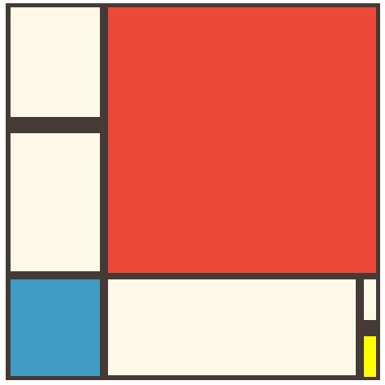

Day 3 & 4

Session 6
- Understanding CSS inheritance
- adjacent selector +
- subsequent sibling ~
- attribute selector a[title]
- Important
- Sprite
- Web fonts
- Optimizing CSS

Reference work
- What is CSS Grid, explain with example.
- What is web accessibility? If you want to make your page accessible which font unit will you use?
- List common web safe fonts between Windows and Mac System. Explain font stack.
- List which format of web font is supported by which browser.
- What is browser reflow and repaints.

Task
- Recreate the screenshot using HTML and CSS:
  - Use the font family "Georgia" for the main headline and make it uppercase.
  - For all other text use default font.
  - On hover of underline text change the text color to red.

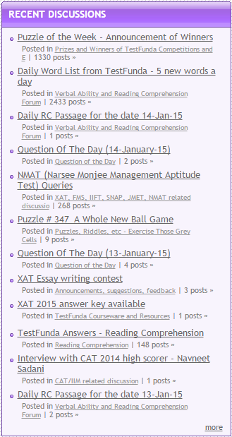

Day 5 & 6

Reference work (before session)
- Different data types in JavaScript.
- Array and Array methods in JavaScript.
- Check various ways to define functions in JavaScript.
- How function overloading is achieved in JavaScript.
- “new” and “delete” keywords

Session 7A
Writing re-usable and modular code.

Session 7B
- What is JavaScript? How is it different from other languages?
- Understanding Data Types
- Type casting
- Array and Date object
- Window Object

Reference work
- For what purpose the in operator can be used?
- Write operator precedence for all types of operators.
- How to check a property exists in an object?
- How to find the browser name and version on the client side?
- How to navigate to different pages?
- List and explain the methods of Math and Window objects.
- Why should we use literal notation for variables defining?

Session 8
- Functions
- What is Hoisting
- Naming conventions
- “new” and “delete” keywords
- Adding comments
- Pass by Reference and Pass by Value

Reference work
- Check how functions should handle variable number of parameters as input
- Can functions be added to existing data types?
- Can we redefine a function definition again? What about redefining native functions?
- Is it a good idea to send anonymous function or a reference of a function expression as a parameter to other function?
- When defining a function within a function, are local variables of the outer function available to the inner function?
- What does funcName.call and funName.apply methods do?

Tasks
Perform validation to the Form created in Day 2 and show an alert if all passed.
- The ‘First Name’ field should have focus by default.
- ‘Highest Education’ will have the following values: “Masters”, “Bachelors”, “High School” and “None of these”.
- ‘Name of Spouse’ is editable only when ‘Marital Status’ is set to “Married”.
- When the RESET button is pressed all the fields are cleared and focus shifts to ‘First Name’.
- When the SAVE button is pressed:
- If any field is empty, alert the message “Please enter a [field name]” and set focus to the appropriate element.
- Check that the name and spouse name does not contain any white spaces.
- If one or more of these fields are incorrectly entered, show an appropriate message and set the focus to the first incorrectly filled-up field.
- If all the rules are followed, display a message as “Thank You”.

Reference work (reading before session)
- Creating classes in JavaScript
- Check “instanceof” operator’s usage

Session 9
- DOM navigation and manipulation
- Object Oriented JavaScript
- Intro to RegExp
- “use strict”
- Number and String functions
- Determining whether a variable has a value
- Basics of JavaScript Debugging

Reference work (before task)
- Check how to create a singleton class
- Check “eval” and “with” usage (Just for knowledge)
- Add “use strict” directive to your existing code and check for any errors
- How to detect type of an Array object and a Date object?
- Check what is document.body and document.documentElement
- Check nodeName and nodeType properties on the nodes
- Check document’s method “createElement”, element’s methods “appendChild”, “insertBefore”, “removeChild” and “replaceChild”
- Explore other methods of console
- Check how to build regular expressions, when to use “g” flag, common mistakes when using same RegExp object with multiple strings

Tasks
- To the form created previously - Add ‘Date of Birth’ and ‘Email’ field to employee form - use RegEx validations to validate the following:
- Date of Birth: The input should be in dd/mm/yyyy format only.
- Email: Should contain at least 2 characters/numbers, followed by @, followed by at least 2 characters, followed by .(dot), followed by 2-3 characters. No other special characters should be allowed.

- Save Button should save data in javascript array, if all validations were successful . Add a View button to the page. View will show all saved records in the table as shown below.
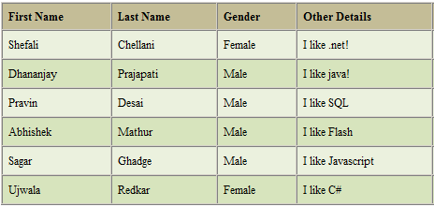

Day 7

Reference work (before session)
What is an event in JavaScript?

Session 10
- Events
- Error Handling

Reference work (before task)
- What events are fired on load and unload of an HTML page.
- List down corresponding touch events in place of mouse events for touch based devices.

Tasks
- After a page is completely loaded, through JavaScript set the src of an image tag to point to http://sylvan.zeuslearning.com/img/geocities-montage.jpg. While the image is loading, show a message “Loading Image” on the page, below the image tag. Remove this message once the image is loaded completely.
- Show a confirmation dialog if the user tries to close the page.
- Create a container div of size 600x600px, containing a child div element of size 200x200px. Implement following features
  - Child div element should be draggable
  - Change size of div on pinching
  - Move div to the centre of container on double tap

Day 8 - 9

Session 11
- SetInterval & setTimeout.
- JavaScript is synchronous or asynchronous

Task
Create an interactive view as shown below.

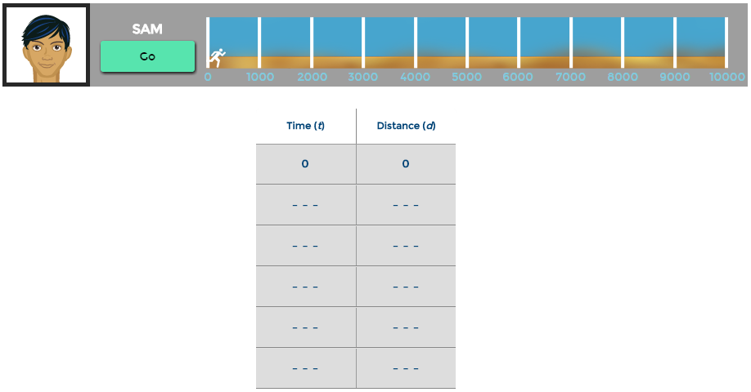
The task needs to be done using a single Timer object approach. On clicking of Go Button, do the following:
- The runner sequence must be initiated. Use the png sequence “running-sequence.png”.
- The runner will travel from 0 meter to 10000 meters.
- The table has 2 columns Time(t) and Distance(d). Do the following for data table.
  - By default, there will be 11 data-rows. The first row will consist of 0,0 and the remaining rows will be filled with “---”. Only 6 data-rows should be visible at a time.
  - On every 1000 meters, a row will be updated with appropriate data.
- On completion of the run, the Go will be changed to Reset, which will reset the interactive to its default state.

The time taken to complete the run must be selected randomly from the range between 3 secs to 8 secs.

Day 10 & 11

Research
CSS3 Transform, Transition and Animation
- Learn features of CSS3 transform, transition and animation and learn how to use it
- Accelerated Transformation/Transition

Tasks
Generate bouncing-ball animation effect
- Using animation key-frame model
- Using requestAnimationFrame

Day 12-15

Session 12
- Working with “this”
- Closure
- Callbacks

Session 14
- Introduction to web Architecture
- Client Server Communication
- HTTP response codes
- Caching - Concept, how to clear cache, client role and server role
- Introduction to Fiddler

Session 15
- XML and JSON
- AJAX

Reference work (before task)
Check handling of special characters in URL

Tasks
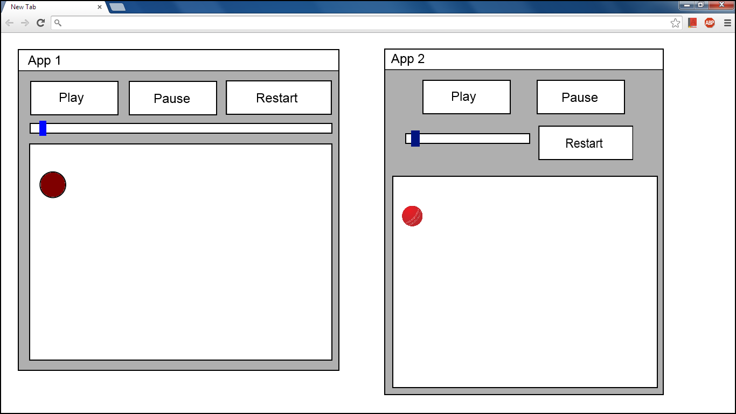
- Dynamically generate above output from XML file. The file structure should be something like below
<ui>
<app rect=”....” title=”app1”>
<button .. > Play </button>
<button .. > Pause </button>
<slider .. > Speed controller </slider>
<bb_board> Bouncing Ball - Board </bb_board>
</app>
<app rect=”....” title=”app2”>
< Similar to above - second instance of app >
</app>
</ui>

Note: The web-application should have following classes:
  - Ajax file downloader: to download XML-UI file
  - Dynamic-UI generator: accepts XML string, and create HTML DOM objects dynamically and place them in some given parent element
  - Bouncing-ball animation container: white board should export play, pause and stop features to control bouncing-ball animation
  - Class for each control
- Add localisation i.e all string (here control text) in your page should set from an external json file. NO hardcoding of strings in your code. Support english and hindi language. You should fetch English text from “en_US.json” and Hindi from “hi_IN.json”. Which language to use should be fetched from query string “lang” parameter.

Day 16

Part I

Session 13
- Introduction to jQuery
- Using selectors and filters in jQuery
- Handling events using jQuery
- jQuery chaining and queueing
- Effects and animations using jQuery
- DOM manipulation and navigation using jQuery
- jQuery UI
- jQuery Plugins
- jQuery Pitfalls

Session 16A
- MVC

Session 17
- Bug Tracking Tool
- Debugging Tools/Techniques/Approach

Part II

Project specific training (Script # / Backbone)

