Uroflowmetry Update List

2019-12-09

1. Android App

* Updated the splash screen

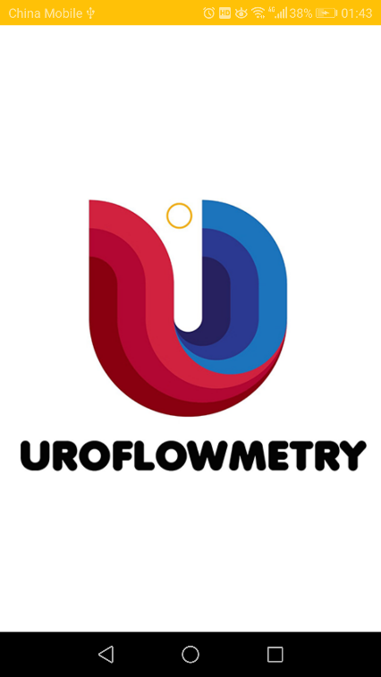 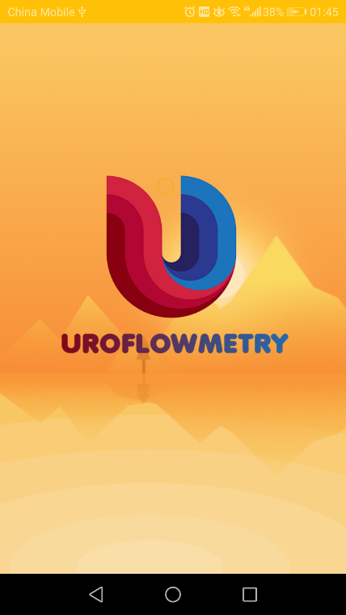

Old Version New Version

* Added the “Login&Send” page  
  After login, you can send the measured data from android app to web server.  
  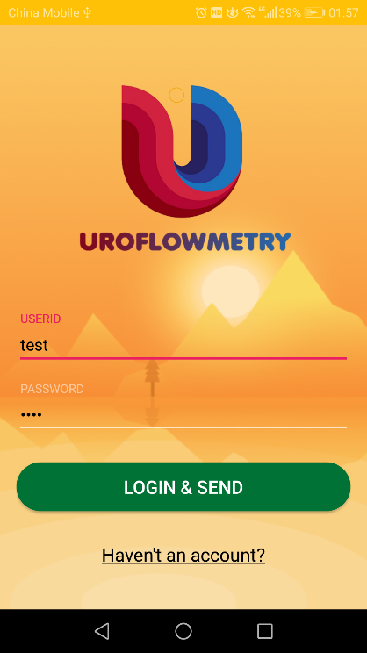
* Added the “Signup” page  
  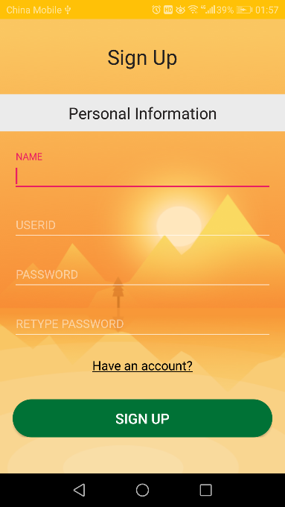

1. Web Application

* Added Login Page

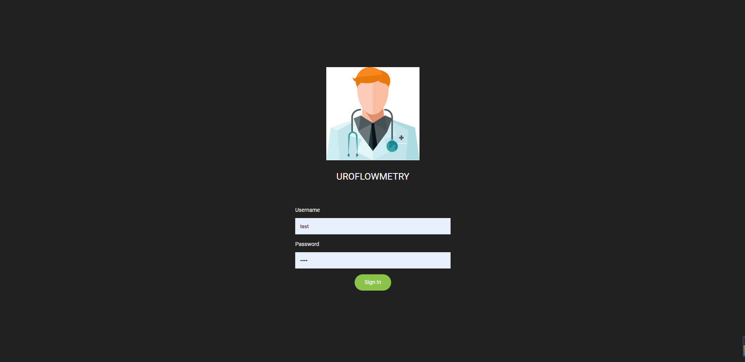

* Added the same page as “Data Centre” page of android app  
  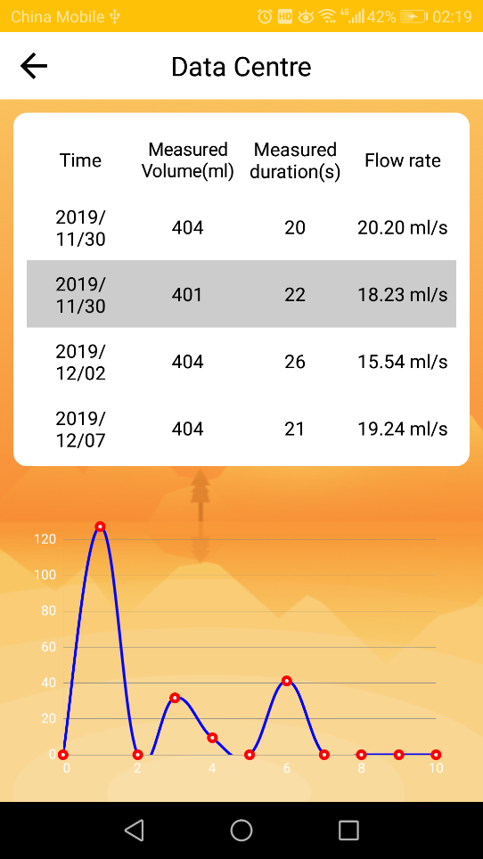  
   “Data Centre” page of android app  
    
  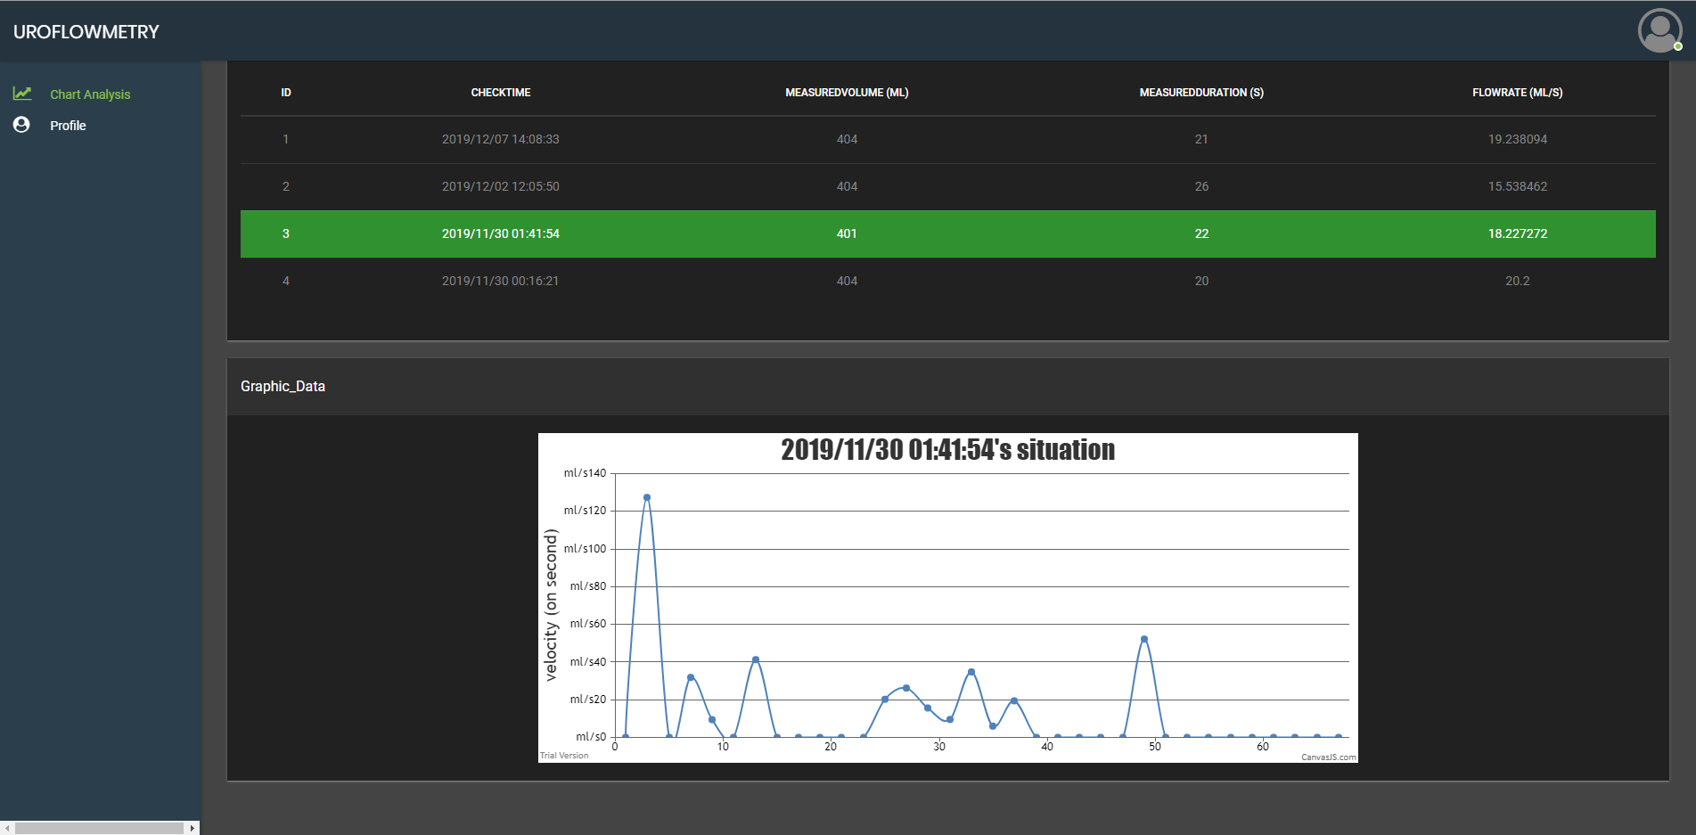  
   “Chart Analysis” Page of web
* Added the profile page from “profile” of android app.  
  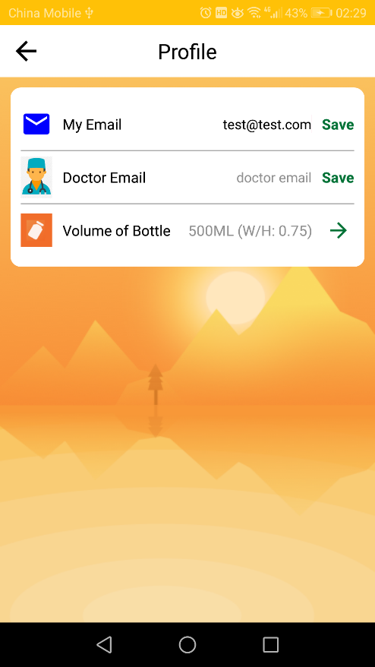  
   “Profile” page of android app  
    
  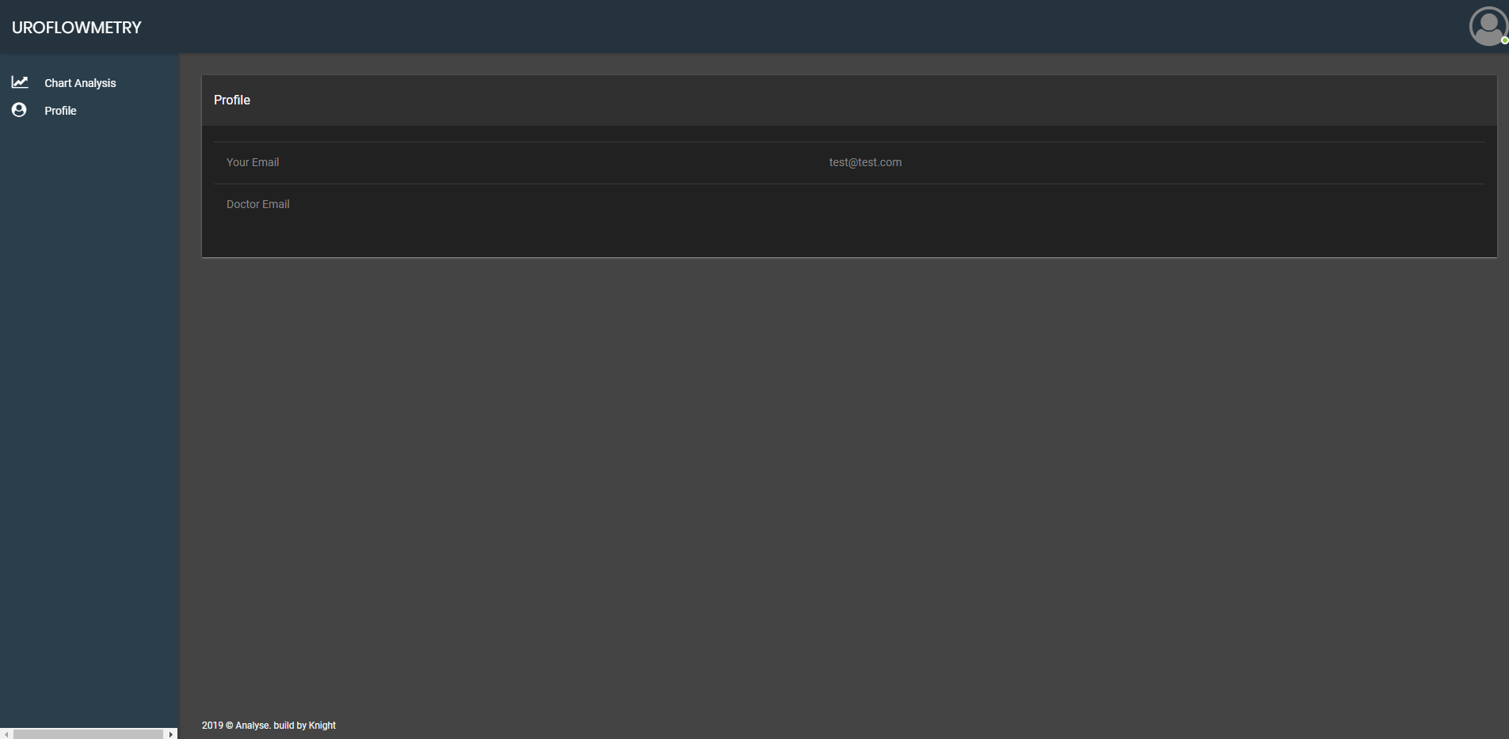  
   “Profile” page of Web