1. Install Android Studio.

<https://developer.android.com/studio/?gclid=CjwKCAjw3c_tBRA4EiwAICs8Cu0o2G3S4MF_OW_iRGmaMDvjK8EcZVUwHoOp4FSFvn-lPNdUq3tIHBoC-jMQAvD_BwE>

2. Run Android Studio

3. File/Open

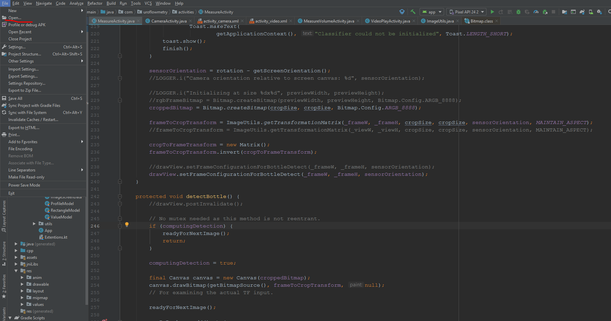

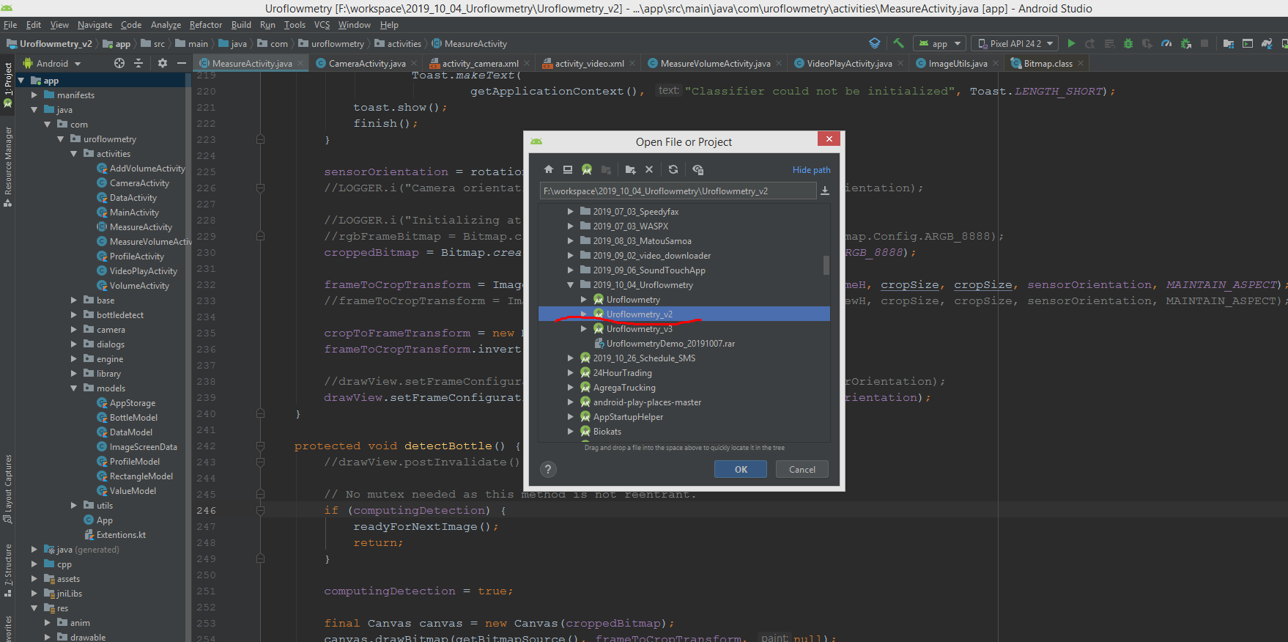

4. Run our project

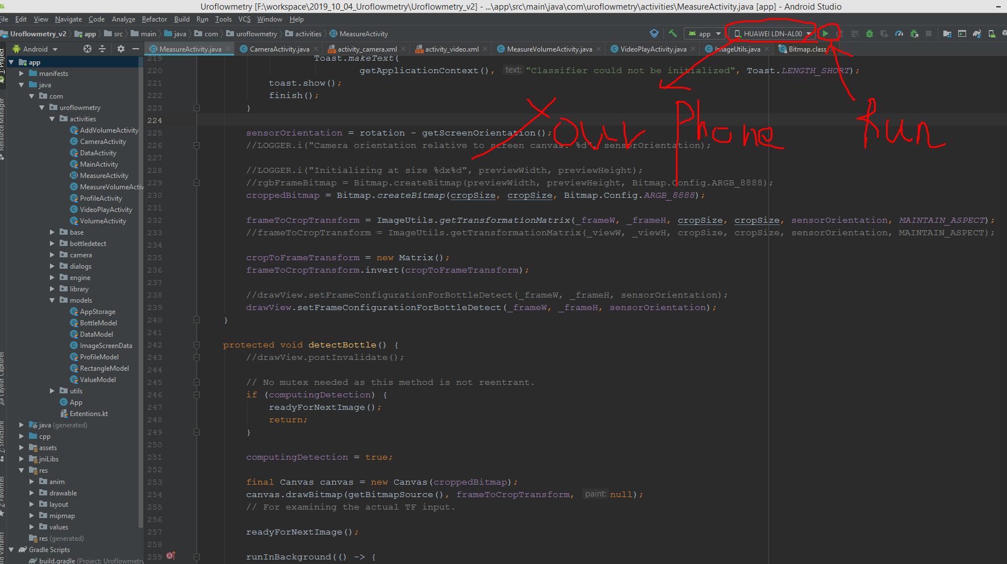

If you can’t find your phone here, You should google it. You should enable your phone as Developer mode.

App Icons Size

LDPI should be 36 x 36.

MDPI should be 48 x 48.

TVDPI should be 64 x 64.

HDPI should be 72 x 72.

XHDPI should be 96 x 96.

XXHDPI should be 144 x 144.

XXXHDPI should be 192 x 192.

Splash screen size

**LDPI**:  
* Portrait: 200 x 320 px

**MDPI**:  
* Portrait: 320 x 480 px

**HDPI**:  
* Portrait: 480 x 800 px

**XHDPI**:  
* Portrait: 720 x 1280 px

**XXHDPI**:  
* Portrait: 960 x 1600 px

**XXXHDPI**:  
* Portrait: 1280 x 1920 px

Logo Size

It depends on logo size of Screen.

You can reference the percentage of logo/Screen size from above splash screen size.