WEEK 1 LAB

First LLM API Call
Using OpenAI
Step-by-step setup and implementation in Visual Studio Code

Lab focus | Connect a Python program to an LLM using the OpenAI API
Language | Python(version 3.14 or above*)
Environment | Reuse the existing .venv
Main files | main.py, .env, .gitignore, requirements.txt

Assumption: You already have a valid OpenAI API key.

1. Learning objectives
By the end of this lab, you will be able to:
- Explain the role of an API key when connecting a Python application to an LLM.
- Install and use the OpenAI Python SDK in an existing virtual environment.
- Store an API key securely in a .env file instead of hard-coding it in Python.
- Send a prompt to an OpenAI model and display the generated response.
- Recognize and troubleshoot common setup, authentication, quota, and model errors.

2. Prerequisites
- Visual Studio Code installed.
- Python installed and available through the existing project virtual environment.
GenAI-> Lab-> week1

MLenv
Genenv

Create virtual environment using: Python -m venv .environment_name
Activate the virtual environment: .environment_name\Scripts\Activate
.genai\Scripts\Activate

- An OpenAI API key/Gemini API Key created through the OpenAI/Gemini Platform.
- Internet connectivity.
- Your existing Week 1 project folder and .environment_name
Important: ChatGPT access and OpenAI API access are separate. A ChatGPT subscription or free ChatGPT account does not automatically provide API credits. API usage may require billing or available credits. Check the current API billing and pricing information before running requests.
Project Structure
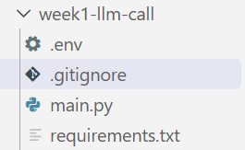

3. Open the existing project in VS Code
Use the project folder already created for this lab:
C:\KLH\2026-2027\Subjects\Y25-GenAI\LAB_Experiments\week1-llm-call
In VS Code, select File → Open Folder and open the folder above. Then open Terminal → New Terminal.
Your terminal should show the existing virtual environment as active, for example:
(.venv) PS C:\KLH\2026-2027\Subjects\Y25-GenAI\LAB_Experiments\week1-llm-call>
If the prompt does not show (.venv), activate the existing environment. From the week1-llm-call folder, the environment in your current setup is in the parent LAB_Experiments folder:
..\.venv\Scripts\Activate.ps1
Do not create a second virtual environment. This lab reuses your existing .venv.

4. Create the .env file and store the API key
- In the VS Code Explorer, right-click the project folder and choose New File.
- Name the file exactly .env (not .env.txt).
- Add the following line, replacing the placeholder with your own API key:
OPENAI_API_KEY=your_actual_openai_api_key
Do not add quotation marks unless your provider specifically requires them. Do not share the key in screenshots, messages, source code, or Git repositories.
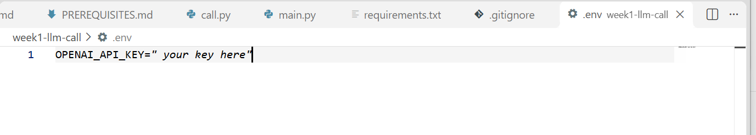
OR

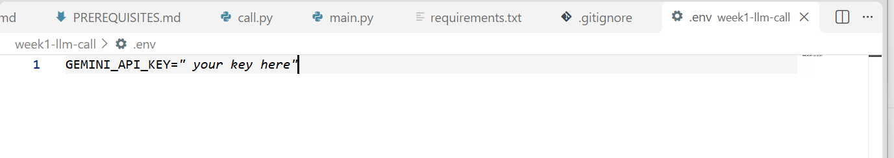
The .env file should be in the same project folder as main.py. The python-dotenv package reads the variable from this file.

5. Create a .gitignore file
Create a file named .gitignore in the project folder and add:
.env
.venv/
__pycache__/
.pytest_cache/
This prevents the API key file and generated environment/cache files from being committed to Git. If a key is accidentally published, revoke it and create a replacement.

.gitingore
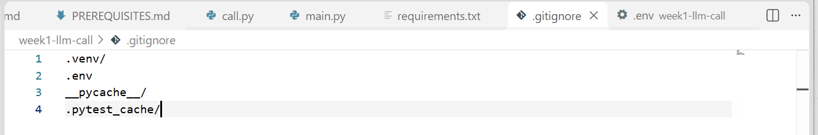

6. Create main.py
Create a file named main.py in the same folder as .env. Copy the complete code below:
import os
from dotenv import load_dotenv
from openai import OpenAI
# Load variables from the .env file
load_dotenv()
# Read the API key securely from the environment
api_key = os.getenv("OPENAI_API_KEY")
if not api_key:
raise ValueError(
"OPENAI_API_KEY was not found. Check that .env exists "
"and contains OPENAI_API_KEY=your_key."
)
# Create the OpenAI client
client = OpenAI(api_key=api_key)
# Send a prompt to the model
response = client.responses.create(
model="gpt-5.5",
input="What is Artificial Intelligence? Explain in simple words."
)
# Display the generated answer
print("\nLLM Response:")
print(response.output_text)

This example uses the OpenAI Responses API and the model ID gpt-5.5 as an illustrative model choice. Model availability and API access depend on your account. If the model is unavailable to your project, select a model that is listed as available to your API account and replace the model value.

Note: Code for Gemini API Key
main.py
from dotenv import load_dotenv
from google import genai
import os

# Step 1: Load API key from .env
load_dotenv()

# Step 2: Read Gemini API key
api_key = os.getenv("GEMINI_API_KEY")

if not api_key:
raise ValueError("Gemini API key not found!")

# Step 3: Initialize Gemini client
client = genai.Client(api_key=api_key)

# Step 4: Make first LLM call
response = client.models.generate_content(
model="gemini-3.8-flash",
contents="What is Artificial Intelligence? Explain in simple words."
)

# Step 5: Display response
print("\nLLM Response:")
print(response.text)

7. Run the program
Save main.py and .env. In the VS Code terminal, confirm that (.venv) is active and run:
python main.py
Expected result: the terminal prints a heading named LLM Response followed by a natural-language explanation of Artificial Intelligence. The exact wording will vary because model output is generated dynamically.
If the program runs successfully, you have completed your first Python-to-LLM API request.

Sample Output
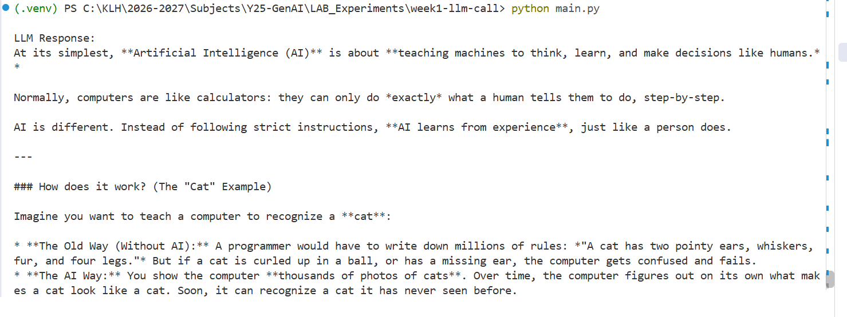

8. Understand the program
Code element | Purpose
import os | Provides access to environment variables.
from dotenv import load_dotenv | Imports the function that loads values from the .env file.
from openai import OpenAI | Imports the OpenAI Python SDK client.
load_dotenv() | Loads variables defined in the local .env file into the process environment.
os.getenv("OPENAI_API_KEY") | Reads the API key without writing the secret directly in the Python source.
OpenAI(api_key=api_key) | Creates an authenticated API client.
client.responses.create(...) | Sends the prompt to the selected model through the Responses API.
response.output_text | Gets the generated text from the response.

9. Try different prompts
Change only the input text in client.responses.create() and run python main.py again.
input="Explain Generative AI with two real-world examples."
input="What is a Large Language Model? Explain for a first-year engineering student."
input="Differentiate Artificial Intelligence, Machine Learning, and Deep Learning."
Observe how the response changes when the prompt is more specific. Keep the model parameter unchanged while experimenting with prompts.

10. Common errors and troubleshooting
Error | What to check
ModuleNotFoundError: No module named 'openai' | Activate the existing .venv and run: python -m pip install openai.
ModuleNotFoundError: No module named 'dotenv' | Run: python -m pip install python-dotenv.
OPENAI_API_KEY was not found | Check that .env is in the same folder as main.py, that the variable is spelled OPENAI_API_KEY, and that the file is not named .env.txt.
401 Authentication / invalid API key | Check that the key is copied correctly, belongs to the OpenAI Platform, and has not been revoked. Never paste the key into a chat for debugging.
429 quota / billing / rate-limit error | Check API billing, available credits, usage limits, and rate limits in your OpenAI Platform account. A ChatGPT plan does not automatically fund API usage.
Model not found / model access error | Check the models available to your API project and replace the model ID with one your project can access.
Connection or timeout error | Check internet connectivity, VPN/proxy restrictions, and try again after a short interval.

11. create requirements.txt
To record the direct packages used in this lab, create requirements.txt with:
requirements.txt
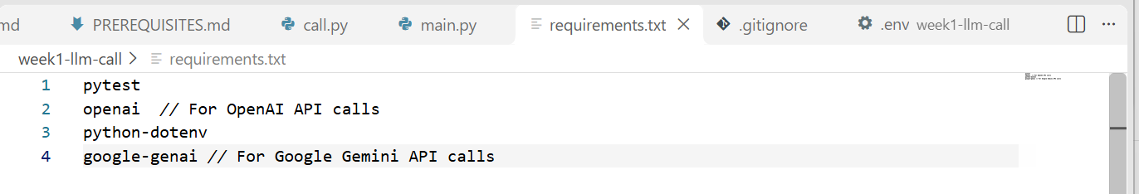
openai
python-dotenv
Install these dependencies later with:
python -m pip install -r requirements.txt

End of Week 1 Lab Guide

