Loan Default Project
Author: Urooj Syeda
# Suppress dplyr summarise grouping warning messages
options(dplyr.summarise.inform = FALSE)
## Add R libraries here
library(tidyverse)
library(tidymodels)
library(dplyr)
library(ggplot2)
library(tidymodels)
library(skimr)
library(vip)
# Load data
loans_df <- readRDS("C:/Users/urooj/Downloads/loan_data.rds")

Data Analysis
This data set contains information on over 4,000 individuals who secured a personal loan in 2017 from a national bank. The bank has experienced record levels of customers defaulting on their loans in the past couple of years and this is leading to large financial losses. The objective of this project is to explore the factors that lead to loan default and develop a machine learning algorithm that will predict the likelihood of an applicant defaulting on their loan in the future. For this project, I thought of 6 relevant questions that would allow me to explore the relationship between loan_default and the other variables in the loan_df fata set. The goal of my analysis is to discover which variables drive the differences between customers who do and do not default on their loans.

Summary Table
loans_df %>%
group_by(loan_purpose) %>%
summarise(n_customers = n(),
customers_default = sum(loan_default == 'yes'),
default_percent = 100 * mean(loan_default == 'yes'))
## # A tibble: 5 × 4
## loan_purpose n_customers customers_default default_percent
## <fct> <int> <int> <dbl>
## 1 debt_consolidation 1218 308 25.3
## 2 credit_card 879 470 53.5
## 3 medical 635 384 60.5
## 4 small_business 853 221 25.9
## 5 home_improvement 525 147 28

Data Visulatization
default_rates <- loans_df %>%
group_by(loan_purpose) %>%
summarise(n_customers = n(),
customers_default = sum(loan_default == 'yes'),
default_percent = 100 * mean(loan_default == 'yes'))
ggplot(data = default_rates, mapping = aes(x = loan_purpose, y = default_percent)) +
geom_bar(stat = 'identity', fill = '#006EA1', color = 'white') +
labs(title = 'Loan Default Rate by Purpose of Loan',
x = 'Loan Purpose',
y = 'Default Percentage') +
theme_light()
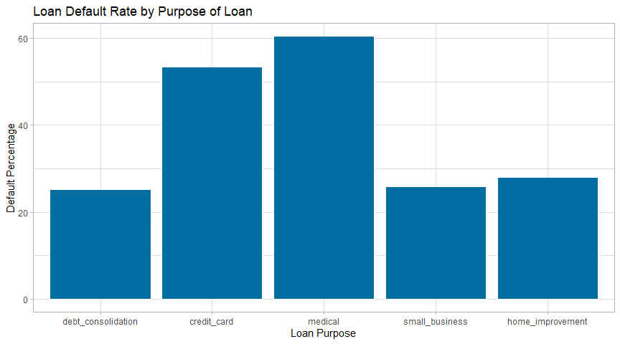

Question 1
Question: Do higher interest rates contribute to a higher number of customers defaulting on their loans?
Answer: Yes. As we can clearly identify from the following data analysis, we can see that the customers with the higher interest rates are the ones who are most likely to default their loans, with the group of customers with the highest interest rates all fall into the ‘yes’ defaulted distribution. We can also see that the distributions differ in that all of the customers who did not default on their loans had lower interest rates overall and the ones who did had overall higher interest rates. We can also see from our summary table that 93% of customers within the highest interest rate group were likely to default. This is a huge difference compared to the customers with the lowers amounts, who have a 0% default percent of all customers within that group.It is reasonable to assume that customers will most likely default on their loans if their interest rates are high.
#creating a summary statistics table and binning interest rates
interest_rate_summary <- loans_df %>%
mutate(interest_rate_bin = cut(interest_rate,
breaks = quantile(interest_rate, probs = seq(0,1,0.25), na.rm = TRUE), include.lowest = TRUE)) %>%
group_by(interest_rate_bin) %>%
summarise(n_customers = n(),
customers_default = sum(loan_default == 'yes'),
default_percent = 100 * mean(loan_default == 'yes'))
interest_rate_summary
## # A tibble: 4 × 4
## interest_rate_bin n_customers customers_default default_percent
## <fct> <int> <int> <dbl>
## 1 [4.72,8.22] 1045 0 0
## 2 (8.22,11.2] 1040 250 24.0
## 3 (11.2,13.8] 1034 355 34.3
## 4 (13.8,20] 991 925 93.3
#creating the plot
ggplot(loans_df, aes(x = interest_rate, fill = loan_default)) +
geom_histogram(position = "identity", alpha = 0.6, binwidth = 1, color = "white") +
labs(title = "Distribution of Interest Rates by Loan Default Status",
x = "Interest Rate",
y = "Count") +
scale_fill_manual(values = c("yes" = "blue", "no" = "orange")) +
theme_light()
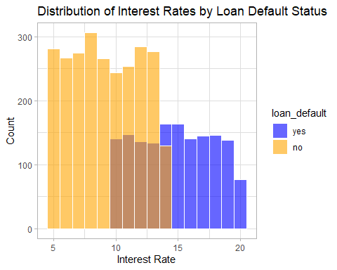 ## Question 2
Question: Is there a relationship between the borrower’s homeownership status and if the borrower defaulted on their loan?
Answer: According to the data visualizations, it is clear to see that there is not that much of a difference on loan default based on homeownership status of the borrower. However, we can see that borrowers who rent their homes are the most likely to default on their loans, and the borrowers who own or pay mortgage are less likely to.
#creating the summary statistics table
homeownership_summary <- loans_df %>%
group_by(homeownership) %>%
summarise(n_customers = n(),
customers_default = sum(loan_default == 'yes'),
default_percent = 100 * mean(loan_default == 'yes'))
homeownership_summary
## # A tibble: 3 × 4
## homeownership n_customers customers_default default_percent
## <fct> <int> <int> <dbl>
## 1 mortgage 1937 628 32.4
## 2 rent 1666 713 42.8
## 3 own 507 189 37.3
#creating a bar graph to visualize the data
ggplot(data = homeownership_summary, aes(x = homeownership, y = default_percent)) +
geom_bar(stat = 'identity', fill = 'darkblue', color = 'white') +
labs(title = 'Loan Default Rate by Homeownership',
x = 'Homeownership Status',
y = 'Default Percentage') +
theme_light()
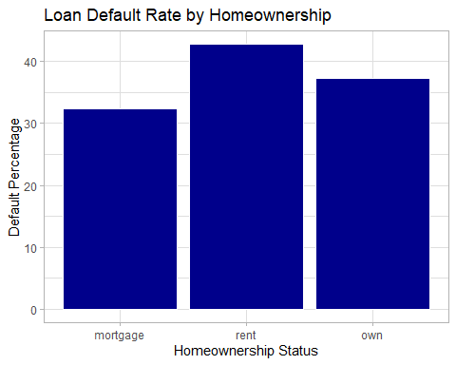 ## Question 3
Question: Does the debt-to-income ratio of borrowers at application time have any relationship to whether or not the borrower defaulted on their loan?
Answer: Based on our data visualization and summary statistics, we can see that those with a larger debt-to-income ratio are more likely to default on their loans compared to those with a lower debt-to-income ratio. However, there are clear exceptions; as we can see from our data visualization; that there is a outlier with a very high debt-to-income ratio that has not defaulted on their loans. However, overall, we can say that mean debt-to-income ratio is higher of those who defaulted than those who did not.
#creating a summary table
loans_df %>%
group_by(loan_default) %>%
summarise(mean_dti = mean(debt_to_income, na.rm = TRUE),
median_dti = median(debt_to_income, na.rm = TRUE),
sd_dti = sd(debt_to_income, na.rm = TRUE),
count = n())
## # A tibble: 2 × 5
## loan_default mean_dti median_dti sd_dti count
## <fct> <dbl> <dbl> <dbl> <int>
## 1 yes 22.5 21.4 12.7 1530
## 2 no 18.6 17.0 14.9 2580
#creating a violin plot for the data
ggplot(loans_df, aes(x = loan_default, y = debt_to_income, fill = loan_default)) +
geom_violin(trim = FALSE, alpha = 0.6) +
labs(title = "Distribution of Debt-to-Income Ratio by Loan Default",
x = "Loan Default",
y = "Debt-to-Income Ratio") +
scale_fill_manual(values = c("yes" = "green", "no" = "red")) +
theme_light()
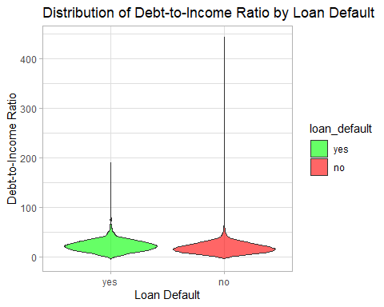

Question 4
Question: Are there differences in loan default rates by loan amount?
Answer: Yes, there are differences as we can note from the summary table and the data visualization. We can see overall that the distribution of borrowers who did default on their loans were distributed higher among the loan amounts. And those that did not default on their loans were distributed lower on borrowed amount. We can also see that those who defaulted on their loans had a higher median and higher overall statistics among the five number summary as compared to those who did not. This could suggest that customers who borrow a higher amount are more likely to default on their loans than those who did not.
loans_df %>%
group_by(loan_default) %>%
summarise(mean_loan_amount = mean(loan_amount, na.rm = TRUE),
median_loan_amount = median(loan_amount, na.rm = TRUE),
sd_loan_amount = sd(loan_amount, na.rm = TRUE),
count = n())
## # A tibble: 2 × 5
## loan_default mean_loan_amount median_loan_amount sd_loan_amount count
## <fct> <dbl> <dbl> <dbl> <int>
## 1 yes 17448. 16000 9460. 1530
## 2 no 16245. 14000 10343. 2580
ggplot(loans_df, aes(x = loan_default, y = loan_amount, fill = loan_default)) +
geom_boxplot(alpha = 0.7) +
labs(title = "Loan Amount by Loan Default",
x = "Loan Default",
y = "Loan Amount") +
scale_fill_manual(values = c("yes" = "pink", "no" = "lightblue")) +
theme_light()
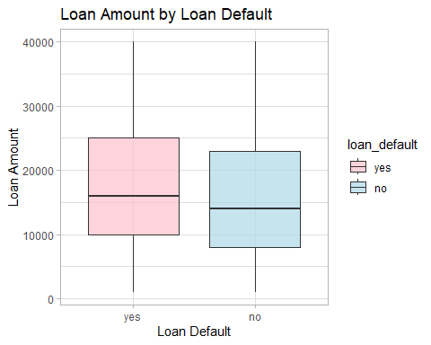 ## Question 5
Question: Is there a relationship between missed payments from the last two years and defaulting?
Answer:We can see that of customers who missed their payments in the last two years, about 45% of them defaulted on their loans. Constrastingly, of the customers who did not miss their payments in the last two years, about 36% defaulted on their loans.This suggests a relationship between the two variables, that customers who have missed their payments in the last two years are more likely to default on their loans.
#creating a summary table
missed_payment_summary <- loans_df %>%
group_by(missed_payment_2_yr) %>%
summarise(n_customers = n(),
customers_default = sum(loan_default == 'yes'),
default_percent = 100 * mean(loan_default == 'yes'))
missed_payment_summary
## # A tibble: 2 × 4
## missed_payment_2_yr n_customers customers_default default_percent
## <fct> <int> <int> <dbl>
## 1 yes 470 212 45.1
## 2 no 3640 1318 36.2
#creating a stacked bar plot
ggplot(loans_df, aes(x = missed_payment_2_yr, fill = loan_default)) +
geom_bar(position = "fill", color = "white") +
labs(title = "Proportion of Defaults by Missed Payments (2 Years)",
x = "Missed Payments in Last 2 Years",
y = "Proportion",
fill = "Loan Default") +
scale_fill_manual(values = c("yes" = "purple", "no" = "gray")) +
scale_y_continuous(labels = scales::percent) +
theme_light()
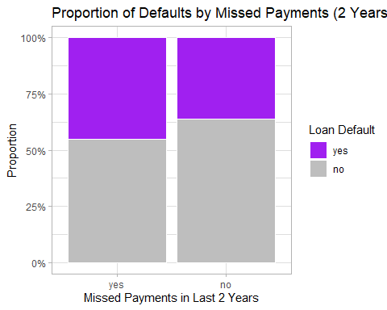 ## Question 6
Question: Are there differences in loan default rates by term length?
Answer: As evidenced by the following data analysis, there does seem to be a significant difference in loan default rates among term lenghts. We can see that much higher percentage of customers defaulted on five-year loans rather than customers who had three-year loans. This means that customers who took out loans for a longer term and more likely to default on their loans.
#creating a summary table
term_summary <- loans_df %>%
group_by(term) %>%
summarise(n_customers = n(),
customers_default = sum(loan_default == 'yes'),
default_percent = 100 * mean(loan_default == 'yes'))
term_summary
## # A tibble: 2 × 4
## term n_customers customers_default default_percent
## <fct> <int> <int> <dbl>
## 1 three_year 2588 693 26.8
## 2 five_year 1522 837 55.0
#creating a bar plot
ggplot(term_summary, aes(x = term, y = default_percent)) +
geom_bar(stat = "identity", fill = "#006EA1", color = "white") +
labs(title = "Loan Default Rate by Term Length",
x = "Term Length",
y = "Default Percentage") +
theme_light()
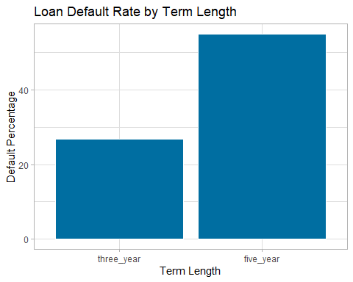 # Predictive Modeling

Model 1
#first, i split up the data into training and test sets.
set.seed(123)
loan_split <- initial_split(loans_df, prop = 0.8, strata = loan_default)
loan_train <- training(loan_split)
loan_test <- testing(loan_split)
#then, I create a recipe
loan_recipe <- recipe(loan_default ~ ., data = loan_train) %>%
step_impute_median(all_numeric_predictors()) %>%
step_impute_mode(all_nominal_predictors()) %>%
step_other(all_nominal_predictors(), threshold = 0.01) %>%
step_dummy(all_nominal_predictors()) %>%
step_zv(all_predictors()) %>%
step_normalize(all_numeric_predictors())
#cross-validation for tuning
set.seed(123)
loan_folds <- vfold_cv(loan_train, v = 5, strata = loan_default)
#Model 1 - Logistic Regression Model
log_reg_model <- logistic_reg() %>%
set_engine("glm") %>%
set_mode("classification")
log_reg_workflow <- workflow() %>%
add_model(log_reg_model) %>%
add_recipe(loan_recipe)
log_reg_fit <- fit(log_reg_workflow, data = loan_train)
log_reg_model
## Logistic Regression Model Specification (classification)
##
## Computational engine: glm

Model 2
#Model 2: Random Forest Model
tree_model <- decision_tree(
cost_complexity = tune(),
tree_depth = tune()
) %>%
set_engine("rpart") %>%
set_mode("classification")
#creating the workflow
tree_workflow <- workflow() %>%
add_model(tree_model) %>%
add_recipe(loan_recipe)
set.seed(123)
tree_grid <- grid_random(
parameters(tree_model),
size = 10
)
## Warning: `parameters.model_spec()` was deprecated in tune 0.1.6.9003.
## ℹ Please use `hardhat::extract_parameter_set_dials()` instead.
## This warning is displayed once every 8 hours.
## Call `lifecycle::last_lifecycle_warnings()` to see where this warning was
## generated.
tree_tuned <- tune_grid(
tree_workflow,
resamples = loan_folds,
grid = tree_grid,
metrics = metric_set(roc_auc)
)

Model 3
#Model 3: Decision Tree (with turnin)
#split the data
set.seed(123)
data_split <- initial_split(loans_df, prop = 0.8, strata = loan_default)
train_data <- training(data_split)
test_data <- testing(data_split)
#create recipe
loan_recipe <- recipe(loan_default ~ ., data = train_data) %>%
step_impute_median(all_numeric_predictors()) %>%
step_dummy(all_nominal_predictors(), -all_outcomes())
#first step is to make the decision tree model with the tune functions
tree_model <- decision_tree(
cost_complexity = tune(), # pruning parameter
tree_depth = tune(), # max depth of the tree
min_n = tune() # min observations per node
) %>%
set_engine("rpart") %>%
set_mode("classification")
#creating the workflow
tree_workflow <- workflow() %>%
add_model(tree_model) %>%
add_recipe(loan_recipe)
#setting up crossvalidation
set.seed(123)
loan_folds <- vfold_cv(train_data, v = 5, strata = loan_default)
#Extract tunable parameters
tree_params <- hardhat::extract_parameter_set_dials(tree_model)
set.seed(123)
tree_grid <- grid_random(tree_params, size = 10)
#tuning model
set.seed(123)
tree_tune <- tune_grid(
tree_workflow,
resamples = loan_folds,
grid = tree_grid,
metrics = metric_set(roc_auc)
)
#Select the best model
tree_best <- select_best(tree_tune, metric = "roc_auc")
#finalize workflow
tree_final <- finalize_workflow(tree_workflow, tree_best)
#fitting the full model to the training data
tree_fit <- fit(tree_final, data = train_data)
#Evaluate the model on the test set
tree_predictions <- predict(tree_fit, test_data, type = "prob") %>%
bind_cols(predict(tree_fit, test_data)) %>%
bind_cols(test_data %>% select(loan_default))
#Plotting the ROC curve
library(yardstick)
tree_roc <- roc_curve(tree_predictions, truth = loan_default, .pred_yes)
autoplot(tree_roc)
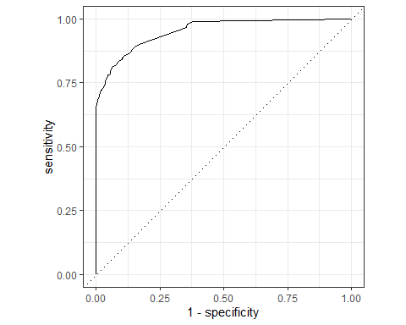
#Get the area under curve
roc_auc(tree_predictions, truth = loan_default, .pred_yes)
## # A tibble: 1 × 3
## .metric .estimator .estimate
## <chr> <chr> <dbl>
## 1 roc_auc binary 0.953
— End of the Project —

