The paper title should be written here, using this style (DO NOT CAPITALISE)
  - Lois Lane ¹, Clark Kent ¹*, Van Helsing ², Jimmy Olsen ¹, Mina Harker ²
  - ¹ The name of the Institution, Address, City, Country
  - ² The Other Institution, Address, City, Country

  - * Corresponding author's e-mail: clark.kent@institution.edu
ORCID IDs are mandatory for all authors and must be provided in the ORCID IDs section, before the Abstract, e.g.:

ORCID IDs
- Lois Lane - https://orcid.org/0000-0002-1825-0097
- Clark Kent - https://orcid.org/0000-0002-1825-0097
- Van Helsing - https://orcid.org/0000-0002-1825-0097
- Jimmy Olsen - https://orcid.org/0000-0002-1825-0097
- Mina Harker - https://orcid.org/0000-0002-1825-0097
Make sure to provide the full ORCID profile URL. For each URL, verify that it leads to the correct author’s profile.
Abstract
The editor gives instructions on properly formatting the paper using this Microsoft Word template in this document. This document contains predefined prepared styles for sections, such as the title, authors and affiliation, ORCID ID numbers, abstract and keywords, as well as headings of up to three levels that are supported by the conference proceedings style, section text, tables, captions, figures, code listings, formulas and references.
The Sinteza Conference allows up to 5 authors per paper. Every paper must define the corresponding author.
The ORCID IDs section must contain the correct and full ORCID Profile URL for each author. The example above uses a single URL for all authors to provide a simple example. Be sure to modify the text and URL. Maximum 5 authors.
Also, the document shows how to properly cite references in the paper using Microsoft Word 2007 or newer versions. All citations must be made in the IEEE citation and referencing style. Further instructions are given herein.
Do not reformat the document by changing its paper size, margins, base font size, colours, column count, headers and footers, etc. Leave all page settings unmodified. This is very important if you want the paper processed without delay and to reduce the risk of rejection due to technical inadequacy in the submission.
The abstract should not exceed 250 words, as counted by Microsoft Word. To check the word count, select the content of the abstract and find the word count in the bottom-left section of this window, in the status bar.
Keywords
Sinteza Template, Word, Styles, Instructions for Author, Maximum Five Keywords

Introduction
Follow these instructions to properly prepare the paper for submission to the Sinteza Conference. First, modify the paper's title in the title section. Do not delete the entire title and then type a new one because you might accidentally remove the applied style (Title) required for the paper title. Instead, edit the paper title inline and remove unnecessary parts. The title must not span more than 3 lines of text and must be styled properly. Below the title, modify the list of authors. There may be no more than five authors. Use the appropriate numbering with a superscript when authors are affiliated with at least two different institutions. If all authors are from the same institution, no superscript marking is required for the institution, only for the corresponding author. See the example in this template. Make sure to mark the corresponding author with an asterisk as shown. Below the list of affiliations, enter the corresponding author's e-mail address. Update the abstract and keywords. Keep the correct styles in these two sections (Abstract and Keywords). There may be no more than five keywords in the keywords section. The abstract must not be longer than 250 words, as counted by Microsoft Word when all the text in the abstract is selected.
Do not use the TAB character (key) to indent the first line of each paragraph. This is done automatically for all paragraphs styled with the correct style, called Paragraph, in the style list. This style automatically sets the appropriate font size, text colour, spacing and required first-line indentation. If you accidentally modify the style, select the paragraph and click the Paragraph style in the style picker. The style picker is available at the top of the Word window. This will automatically set all the properties. Do not remove line numbers from the article. They are required for the review process, where reviewers will refer to them in their comments.

Types of content
The paper's primary content type is text. Ensure that it is properly styled using the predefined Paragraph style.
All available predefined styles can be found in the top ribbon, Home section, Styles sub-section. See Figure 1.
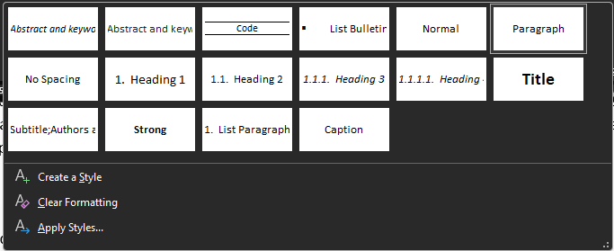
Figure 1 - The listing of available predefined Styles in this Template

Numbered and unnumbered lists
Aside from textual content, you may want to place numbered lists or bullet lists (unnumbered).
Numbered lists should be styled so that the number is followed by a single period, with the right alignment of numbers and justified alignment of the lines of text, i.e.:
- Use single line spacing for text elements in lists (as in this example);
- No additional spacing (margins or padding) between list items is allowed to expand the paper’s length;
- If the text is longer than the width of the page, the text should be aligned with the beginning of the first line, as demonstrated in this example.
  - Deeper order lists use letters of the English alphabet;
  - You should use lowercase letters;
  - Individual items are separated with a semi-colon;
  - You may mix ordered (numbers or letters) and unordered (bullet list styles) for lines; and
  - The final item ends with a period (like this one).
- Make sure to use a semicolon at the end of each line in the numbering;
- Do not use more than two list levels (numbers and lowercase letters);
- Use "and" before the last item (like in this example); and
- This is the last one with a period at the end.
Always reset the paragraph style at the end of the list by selecting the appropriate Paragraph style again.
When you want to create a simple unordered list, or a bullet list, use the square bullet type for the first level and filled circles for the second. Do not have more than two levels of items in any list. For example:
- This is the first item with sub-items:
- The second-level list item should also use a square bullet symbol, indented within the parent;
- Do not mix square, round, solid, opaque and other bullet styles; and
- The last one in this level.
- The second item, without sub-items, and
- The final item of this list.

Code listings, Pseudo-codes and Algorithms
Occasionally, you may want to add a listing to the paper. For example, if the paper addresses computer programming and shows a sample of the code, you can use the predefined Code style from the style picker. Make sure to caption the code listing below the code by using the appropriate Insert Caption option in Word and label the listing as shown. Do not insert code listings as images/screenshots. Listings must be correctly formatted text.
If the listing contains source code, be mindful of line breaks and format your source code in such a way to avoid unintended line breaks, unreadable source code line continuity, ambiguous line start/termination, and never add unnecessary line breaks (empty lines), tabs wider than 2-4 space characters, etc. If possible, instead of using tabs, use spaces, e.g. 2 spaces for each TAB, to avoid incorrect formatting or automated TAB jumping in Word.
#include <stdio.h>

int main() {
printf("Hello friend!\n");

return 0;
}
Listing 1 - An example of a program written in C.
When referring to code listing or any captioned content in the paper, make sure to use Word’s Cross-reference option by selecting it from the Captions section of the References menu. If you want to refer to a listing in your text, make sure to include only the Label and Number in the reference. This will result in the hyperlinked reference text, i.e. Listing 1 shows an example of a small program written in the C programming language. The listing reference is active. This means that you can use the Ctrl + Click option on Listing 1 to jump right to the caption for this referenced listing. Do not abbreviate the caption labels, i.e. List., Eq., Tab., etc.
Use the Listing style also for program outputs, such as console logs, error logs, text dumps of program or memory content (e.g., HEX-formatted binary output), and any other text-based program output.
$ df -PTH
Filesystem Type Size Used Avail Use% Mounted on
/dev/root ext4 23G 1.7G 22G 8% /
devtmpfs devtmpfs 250M 0 250M 0% /dev
tmpfs tmpfs 253M 0 253M 0% /dev/shm
tmpfs tmpfs 102M 62k 102M 1% /run
tmpfs tmpfs 5.3M 0 5.3M 0% /run/lock
Listing 2 – An example of a UNIX command and its output
Listing 2 illustrates an example of a UNIX command and its output, correctly formatted with spaces used instead of tab characters, with a single line height and no unnecessary spacing.

Tables
When you need to add a table to the paper, make sure to use the predefined "Sinteza Table Style" from the Styles Picker. Here is an example of a table formatted using that style. Note that the table caption is below the table. Make sure your tables are as compact as possible.
Place your tables within the text of the section they are referenced in. The editorial team will place the table in the final formatted version of the paper to best fit.
Never add tables as images into the paper body. All tabular content must be prepared as a proper text table.
Table 1 - A sample table
Column 1 | Column 2 | Column 3 | Table properties
Left aligned | 1,000.00 RSD | + + + | Tables span the full width of the page.
Textual data | 11,000.00 RSD | + + | Table captions are above the table.
 | N/A RSD | + - - - | Table rows are as compact as possible.
Some name | N/A RSD | + + - - | Table headings are aligned with their content.
Final row | Right aligned | - - - | Make sure to use the "Sinteza Table Style" format.
As shown in Table 1, the table has only horizontal borders. The header row has thicker borders than the rest of the table, and its last row is below it. Borders do not separate columns. The header row uses bold font-weight, and the text in the header cells is centred. The remaining cells are aligned as required, depending on the content type. The font size for all the content within the table is 9 pts, single-spaced. If required, you may merge table cells to represent the data, as seen in Table 2.
Table 2 - An example of a table with many columns and merged cells, only when necessary.
First column | Second column | Third column | Fourth column | Fifth column
If you need more space... | You may create... | A section in two columns... | And place... | The table is there.
This is just an example. | 3 | 25 | 15 | 21
1110 0001 | 1101 0010 | 0001 1000 | 1001 1001 | 1011 1100
0A DC E0 99 | AA E4 04 30 | 20 20 D3 FF | FF FF E3 E9 | 9C C1 76 53
Left-aligned text | Cantered text | Right-aligned text |  | <- Empty table
Avoid merging cells | Unless it is absolutely necessary to have merged cells in your tables...
Citations in cells are ok [1] | Place citations | just after | the text they | refer to.
Here | The | Sample | Table | Ends
All tables placed in the paper must be referenced in the text and explained.

Figures and Illustrations
If you need to add figures or illustrations to the paper, you will be captioning them with the label Figure, using the same caption style as shown for listings and tables. The Figure/Illustration/Picture captions will be placed below the figure. Ensure you add high-quality, high-resolution images to the document (at least 800x800px) without borders drawn within the image or applied as styles to the image holder object in the Word document.
To allow for better blending into the background, embed images with transparent or white backgrounds, such as PNGs, or at least JPEGs with white backgrounds. Do not add underlying background layers in different colours, borders around charts, figures, illustrations, etc. All figures must be referenced and explained in the text.
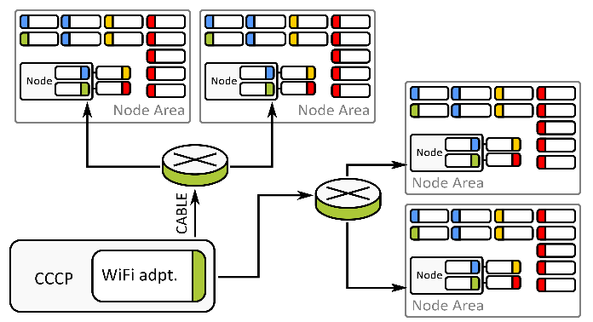
Figure 2 - An example of a figure/illustration.
Figures should be centred, with captions below them in the figure caption style, as in Figure 2. Make sure to refer to each figure in the paper and explain it in the text. If a figure is not strictly necessary, consider not using it.

Equations
When adding equations or formulas, use the Microsoft Word Equation Editor or MathType.
Do not embed them as images into the document. Never save the document in Legacy Word format (.DOC). Always use the new .DOCX format, supported by all versions of Microsoft Word from 2007 onwards. Caption the equations or a set of multiple equations below them. Use the Equation label. Single formulas should be centred. When creating a group of equations with a single caption, ensure each equation is listed in its own row. Align each equation to the left and label them with regular brackets aligned to the right.
$$t^{'}=t\left(\frac{1}{\sqrt{1-\frac{v^{2}}{c^{2}}}}-\sqrt[3]{\frac{2-v^{2}}{1-c^{t}}}\right)$$
Equation 1 - An example of a single formula
Equation 1 shows how to style the equation when it is used/stands on its own and is not a part of a group. In this case, there is no need for numbering.
${\hat{L}}_{x}=-iħ\left(y\frac{∂}{∂z}-z\frac{∂}{∂y}\right)$ (1)
${\hat{L}}_{y}=-iħ\left(z\frac{∂}{∂x}-x\frac{∂}{∂z}\right)$ (2)
${\hat{L}}_{z}=-iħ\left(x\frac{∂}{∂y}-y\frac{∂}{∂x}\right)$ (3)
Equation 2 - A group of equations.
Equation 2 shows how to style the equations when they are a part of a group. Align them to the left and label them with (1) The first equation, (2) The second equation and (3) The third equation, explaining each of them in the order of appearance in the group. Immediately after the group of equations, explain each equation by referring to it with numbers placed in regular brackets, in the natural order. If an equation in the group spans multiple rows, place its numbering to the right at/in the last line that the equation occupies.

Citations
The most important parts of the text of any academic paper are citations and references that corroborate the statements and facts mentioned in the paper. [2] Use the IEEE citation and referencing style. Read the IEEE style guide [1] concerning citing and referencing, available here. In Microsoft Word, add the citations using the Reference > Insert Citation option. Fill out the required sections for the selected appropriate type of cited source and insert a reference in the place where you have cited the source. Make sure to set the Citation and Bibliography Style to IEEE 2006 or newer.
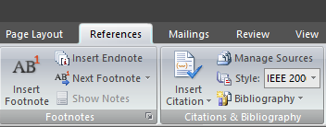
Figure 3 - The References menu and Citation submenu.
Figure 3 shows the part of Microsoft Word`s top ribbon named "References" with a sub-section named "Citation & Bibliography" (shown on the right). The source you have already cited exists and should be picked from the list to create a new reference. If you want to add a reference to a new source, select the "Add New Source" option, as shown in Figure 4.
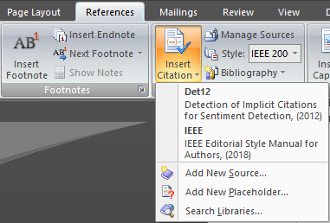
Figure 4 - The Insert Citation option.

Conclusion
The Conclusion section of the paper contains the closing words and compact statements that emanate as conclusions from the complete body of the text presented in the paper. It should be no longer than 300 words, as counted by Microsoft Word (the status bar).

Acknowledgements
Suppose you need to acknowledge the help of institutions, research funders, or other third parties not listed as individual or corporate authors. In that case, you should do so in a separate section named Acknowledgements, which comes after the Conclusion and before the References.

References
The References section should not be numbered (manually remove the numbering from this section and insert all references in the IEEE style). All the referenced sources should appear in the order of the first citation in the paper, numbered from 1 to N with right alignment, where N is the total number of the cited sources, enclosed in square brackets. All the sources listed in the reference section must be cited in the paper, and all citations must be listed in the reference section. To generate the list of references, use the Microsoft Word option at References > Bibliography > Insert Bibliography. Make sure that the section text is properly formatted. The font size should be 9pt, with single-line spacing within a single source and spacing between multiple sources.

[1] | IEEE, IEEE Editorial Style Manual for Authors, IEEE, 2018.
[2] | “Detection of Implicit Citations for Sentiment Detection,” in Proceedings of the Workshop on Detecting Structure in Scholarly Discourse, Jeju Island, Korea, 2012.

