Pilgrim Data Exploration

Roopa, Daniel, Anabelle, URos

September 25, 2017

#######removing NA's by reading in differently #######################################  
data <- read.csv("C:/Users/Uros Randelovic/Documents/R workspace/BUS 111/data.csv",  
 stringsAsFactors=F, na.strings=c(NA,"NA"," NA"))  
  
#initial look at the data  
head(data, n=10)

## ï..ID X9Profit X9Online X9Age X9Inc X9Tenure X9District X0Profit  
## 1 1 21 0 NA NA 6.33 1200 NA  
## 2 2 -6 0 6 3 29.50 1200 -32  
## 3 3 -49 1 5 5 26.41 1100 -22  
## 4 4 -4 0 NA NA 2.25 1200 NA  
## 5 5 -61 0 2 9 9.91 1200 -4  
## 6 6 -38 0 NA 3 2.33 1300 14  
## 7 7 -19 0 3 1 8.41 1300 0  
## 8 8 59 0 5 8 7.33 1200 -65  
## 9 9 493 0 4 9 15.33 1200 855  
## 10 10 -158 0 6 8 4.33 1100 -20  
## X0Online X9Billpay X0Billpay  
## 1 NA 0 NA  
## 2 0 0 0  
## 3 1 0 0  
## 4 NA 0 NA  
## 5 0 0 0  
## 6 0 0 0  
## 7 0 0 0  
## 8 0 0 0  
## 9 0 0 0  
## 10 0 0 0

tail(data, n=10)

## ï..ID X9Profit X9Online X9Age X9Inc X9Tenure X9District X0Profit  
## 31625 31625 226 0 NA NA 8.83 1200 -52  
## 31626 31626 8 0 5 4 22.08 1300 7  
## 31627 31627 -59 1 5 9 3.50 1200 -4  
## 31628 31628 -85 0 3 5 5.91 1200 -32  
## 31629 31629 209 0 7 8 10.75 1200 230  
## 31630 31630 -50 0 5 5 3.75 1200 1  
## 31631 31631 458 0 3 8 12.08 1300 423  
## 31632 31632 -83 0 6 4 15.83 1200 -60  
## 31633 31633 92 1 1 6 5.41 1200 170  
## 31634 31634 124 0 3 6 17.50 1300 150  
## X0Online X9Billpay X0Billpay  
## 31625 0 0 0  
## 31626 0 0 0  
## 31627 1 0 0  
## 31628 0 0 0  
## 31629 0 0 0  
## 31630 0 0 0  
## 31631 1 0 0  
## 31632 0 0 0  
## 31633 1 0 0  
## 31634 0 0 0

names(data)

## [1] "ï..ID" "X9Profit" "X9Online" "X9Age" "X9Inc"   
## [6] "X9Tenure" "X9District" "X0Profit" "X0Online" "X9Billpay"   
## [11] "X0Billpay"

str(data)

## 'data.frame': 31634 obs. of 11 variables:  
## $ ï..ID : int 1 2 3 4 5 6 7 8 9 10 ...  
## $ X9Profit : int 21 -6 -49 -4 -61 -38 -19 59 493 -158 ...  
## $ X9Online : int 0 0 1 0 0 0 0 0 0 0 ...  
## $ X9Age : int NA 6 5 NA 2 NA 3 5 4 6 ...  
## $ X9Inc : int NA 3 5 NA 9 3 1 8 9 8 ...  
## $ X9Tenure : num 6.33 29.5 26.41 2.25 9.91 ...  
## $ X9District: int 1200 1200 1100 1200 1200 1300 1300 1200 1200 1100 ...  
## $ X0Profit : int NA -32 -22 NA -4 14 0 -65 855 -20 ...  
## $ X0Online : int NA 0 1 NA 0 0 0 0 0 0 ...  
## $ X9Billpay : int 0 0 0 0 0 0 0 0 0 0 ...  
## $ X0Billpay : int NA 0 0 NA 0 0 0 0 0 0 ...

#visualy explore the data in table format  
View(data)

# dropping the N/A

data <- data[complete.cases(importData[c("X9Profit","X0Profit","X0Online","X0Billpay","X9Inc","X9Online","X9Age","X9Tenure")]),]

## Error in complete.cases(importData[c("X9Profit", "X0Profit", "X0Online", : object 'importData' not found

str(data)

## 'data.frame': 31634 obs. of 11 variables:  
## $ ï..ID : int 1 2 3 4 5 6 7 8 9 10 ...  
## $ X9Profit : int 21 -6 -49 -4 -61 -38 -19 59 493 -158 ...  
## $ X9Online : int 0 0 1 0 0 0 0 0 0 0 ...  
## $ X9Age : int NA 6 5 NA 2 NA 3 5 4 6 ...  
## $ X9Inc : int NA 3 5 NA 9 3 1 8 9 8 ...  
## $ X9Tenure : num 6.33 29.5 26.41 2.25 9.91 ...  
## $ X9District: int 1200 1200 1100 1200 1200 1300 1300 1200 1200 1100 ...  
## $ X0Profit : int NA -32 -22 NA -4 14 0 -65 855 -20 ...  
## $ X0Online : int NA 0 1 NA 0 0 0 0 0 0 ...  
## $ X9Billpay : int 0 0 0 0 0 0 0 0 0 0 ...  
## $ X0Billpay : int NA 0 0 NA 0 0 0 0 0 0 ...

#plotting data  
library(corrplot)

## Warning: package 'corrplot' was built under R version 3.3.3

corrplot(cor(data), method="number",shade.col=NA, tl.col="black", tl.srt=45)

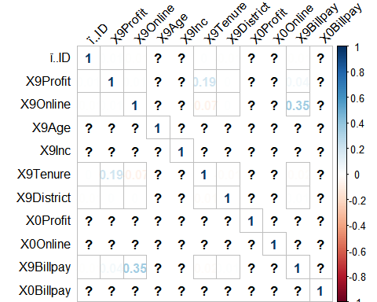

###split the data###  
smp_size <- floor(0.75 * nrow(data))  
## set the seed to make your partition reproductible  
set.seed(123)  
train_ind <- sample(seq_len(nrow(data)), size = smp_size)  
#separate specific sets of data  
train <- data[train_ind, ]  
test <- data[-train_ind, ]  
head(train)

## ï..ID X9Profit X9Online X9Age X9Inc X9Tenure X9District X0Profit  
## 9098 9098 135 1 3 5 1.25 1200 167  
## 24937 24937 -15 1 5 9 9.58 1200 -43  
## 12937 12937 12 1 3 5 3.25 1200 301  
## 27931 27931 -14 1 7 5 5.83 1200 -46  
## 29747 29747 -120 1 3 8 6.50 1200 14  
## 1441 1441 750 0 3 6 18.25 1100 747  
## X0Online X9Billpay X0Billpay  
## 9098 1 0 0  
## 24937 1 0 0  
## 12937 1 1 0  
## 27931 1 0 0  
## 29747 1 0 1  
## 1441 0 0 0

#plotting test and train  
corrplot(cor(test), method="number",shade.col=NA, tl.col="black", tl.srt=45)

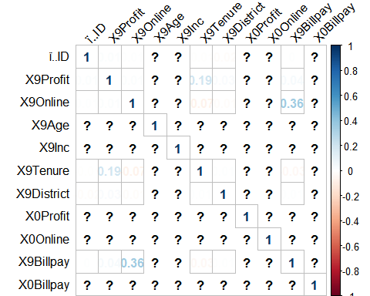

corrplot(cor(train), method="number",shade.col=NA, tl.col="black", tl.srt=45)

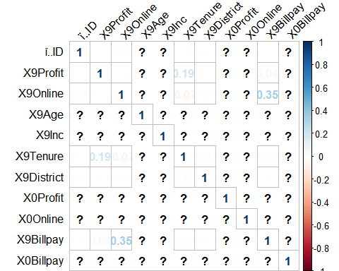

From the plot we can see that Bill pay correlates with Online variable. Interestingly the correlation between online and profitability is almost non existent. Correlation with age is only .14 while tenure and income are around the same number.

Online and age have a negative .21 correlation which signifies that younger customers are more likely to be online and thus have a higher bill collection.

Below we develop the model to predict profitability and try to include just age and either the people are online or not. Before we develop the model we explore the variance of profits using a box plot

boxplot(train$X9Profit~X9Age,data=train, main="Profits 2009",   
 xlab="Age Group", ylab="Profits")

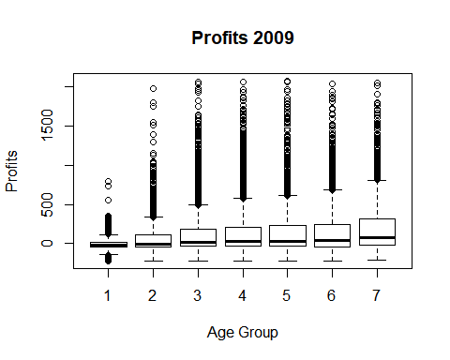

fit <- lm(X9Profit ~ X9Age + X9Online, data=train)  
summary(fit) # show results

##   
## Call:  
## lm(formula = X9Profit ~ X9Age + X9Online, data = train)  
##   
## Residuals:  
## Min 1Q Median 3Q Max   
## -417.56 -161.51 -90.94 68.18 1965.49   
##   
## Coefficients:  
## Estimate Std. Error t value Pr(>|t|)   
## (Intercept) 20.802 5.951 3.495 0.000474 ***  
## X9Age 25.569 1.323 19.332 < 2e-16 ***  
## X9Online 26.345 6.499 4.054 5.06e-05 ***  
## ---  
## Signif. codes: 0 '***' 0.001 '**' 0.01 '*' 0.05 '.' 0.1 ' ' 1  
##   
## Residual standard error: 282.8 on 17520 degrees of freedom  
## (6202 observations deleted due to missingness)  
## Multiple R-squared: 0.02092, Adjusted R-squared: 0.02081   
## F-statistic: 187.2 on 2 and 17520 DF, p-value: < 2.2e-16

Since the R squared metric indicates that the model does not really do a great job in explaining the data we try to include more variables to try to explain the data better:

fit <- lm(X9Profit ~ X9Age + X9Online + X9Billpay + X9Tenure, data=train)  
summary(fit)

##   
## Call:  
## lm(formula = X9Profit ~ X9Age + X9Online + X9Billpay + X9Tenure,   
## data = train)  
##   
## Residuals:  
## Min 1Q Median 3Q Max   
## -475.85 -156.60 -82.71 66.96 1992.39   
##   
## Coefficients:  
## Estimate Std. Error t value Pr(>|t|)   
## (Intercept) 11.3119 5.9302 1.907 0.0565 .   
## X9Age 15.5553 1.4393 10.807 < 2e-16 ***  
## X9Online 15.2562 6.8832 2.216 0.0267 *   
## X9Billpay 85.3630 17.0485 5.007 5.58e-07 ***  
## X9Tenure 4.5922 0.2747 16.715 < 2e-16 ***  
## ---  
## Signif. codes: 0 '***' 0.001 '**' 0.01 '*' 0.05 '.' 0.1 ' ' 1  
##   
## Residual standard error: 280.4 on 17518 degrees of freedom  
## (6202 observations deleted due to missingness)  
## Multiple R-squared: 0.03778, Adjusted R-squared: 0.03756   
## F-statistic: 171.9 on 4 and 17518 DF, p-value: < 2.2e-16

We get slightly better measure of R squared but non the less still a very low number compared to what it should be.

In the next assignment we will look at what happened to the customers that we decided to drop, their profitability, age, online or not and tenure since they might be the key to maybe not increasing the profitability of each customer but rather work on customer retention with smoother service. Even though we do not suspect that being online will have a great impact on profits in either case, but other variables in combination should have a higher correlation.