MongoDB / Mysql
For Node.js we want to use database so you can use Mongo db or Mysql , But most of use Mongo db

MongoDB is an open-source document database and leading NoSQL database. MongoDB is written in C++.

What is mongodb
- No sql database / means we can not write select & query
- Data store in collection/ object
- Collection don’t have row and column
- Data stored in form of object
Database
Database is a physical container for collections. Each database gets its own set of files on the file system. A single MongoDB server typically has multiple databases.

Collection / table
Collection is a group of MongoDB documents. It is the equivalent of an RDBMS table. A collection exists within a single database. Collections do not enforce a schema. Documents within a collection can have different fields. Typically, all documents in a collection are of similar or related purpose.

Document
A document is a set of key-value pairs. Documents have dynamic schema. Dynamic schema means that documents in the same collection do not need to have the same set of fields or structure, and common fields in a collection's documents may hold different types of data.

Database : bakery
Collection : “product”: [{ }]
Document: “product”: [{name:”cup cake”,}]

==================================================================
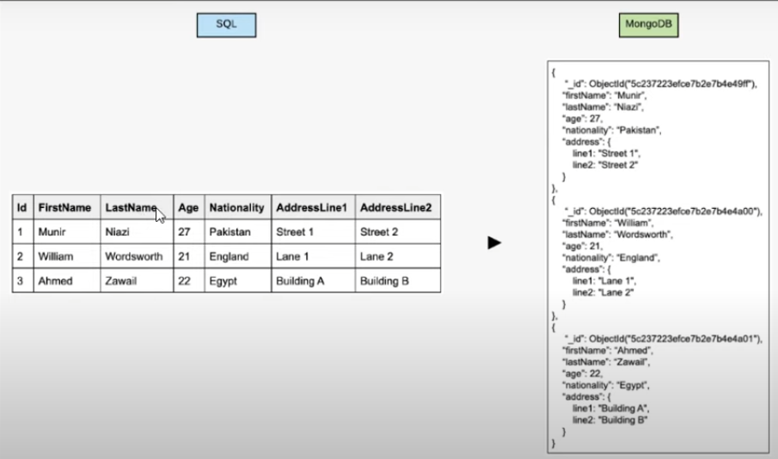

The following table shows the relationship of RDBMS terminology with MongoDB.
RDBMS | MongoDB
Database | Database
Table | Collection
Tuple/Row | Document
column | Field
Table Join | Embedded Documents
Primary Key | Primary Key (Default key _id provided by MongoDB itself)
Database Server and Client
mysqld/Oracle | mongodb
mysql/sqlplus | mongo

Download & Install
https://www.mongodb.com/try/download/community-edition
Next -> next : Installed
C:\Program Files\MongoDB\Server\6.0 in this folder
Data & bin is the most important folder in it.

Note : MongoDB AFTER 6 VERSION mongo command not work

Check installed or not:
cmd : mongodb —-version
Use Mongosh in Mongodb Compass
Manage Database by command in mongosh
========================================
Note : Below use in mongodb compass
Cmd :show dbs // show collections //show all db or collections
Cmd : use databasename // Go in Database
Cmd : db.dropDatabase()
Cmd : db.createCollection(‘users’) // create collection /table
Cmd : show collections // show all collection /table
Cmd : db.users.drop() // delete collection /table
Cmd : db.collections // show collection /table List
Cmd : db.users.insert({"name":"tutorials point"}) // add column
db.customer.insertMany([{"name":"rajesh nagar","mobile":"9722041171","email":"rajeshnagar@gmail.com","password":"1234"}])

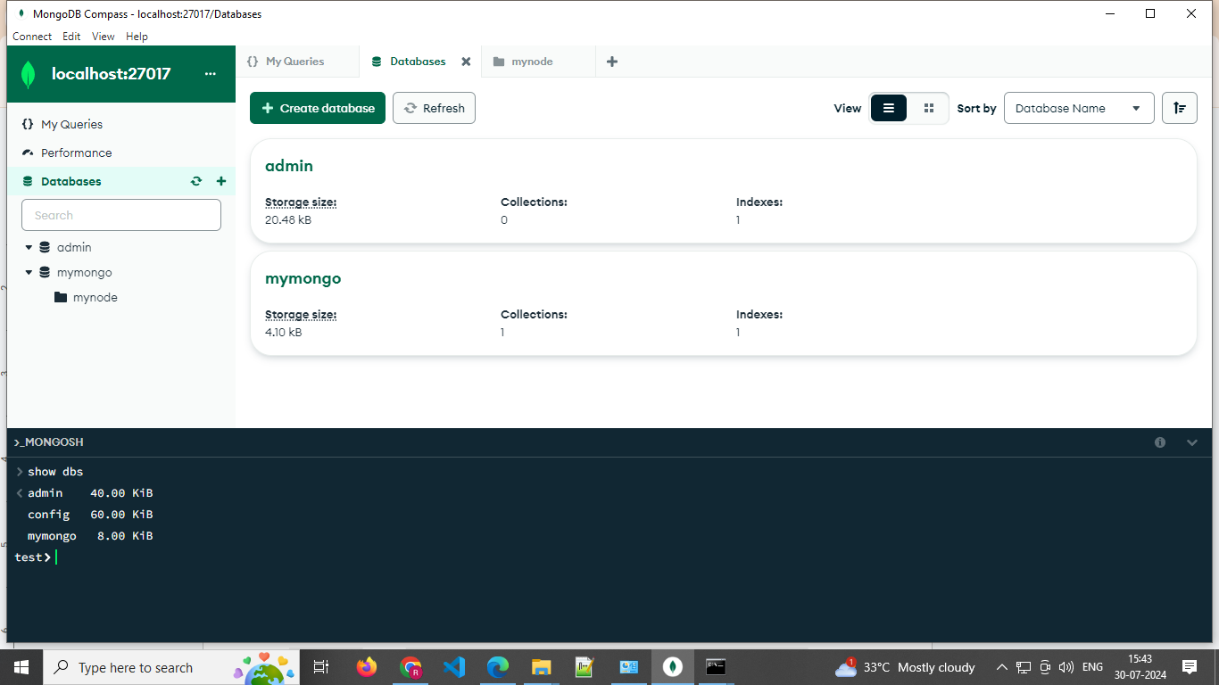

Note: If some time not install proper due to path not set then
Copy bin folder path & search env=> advance=> env variable => path => add new path
Mongo Compass : GUI TOOLS LIKE MYSQL
CREATE : DATABSE
CREATE : COLLECTION // LIKE SQL TABLE
Cmd : mongod --version // 6.01 version //old only mongo

Database Create

Create Database > Database Name > collection name
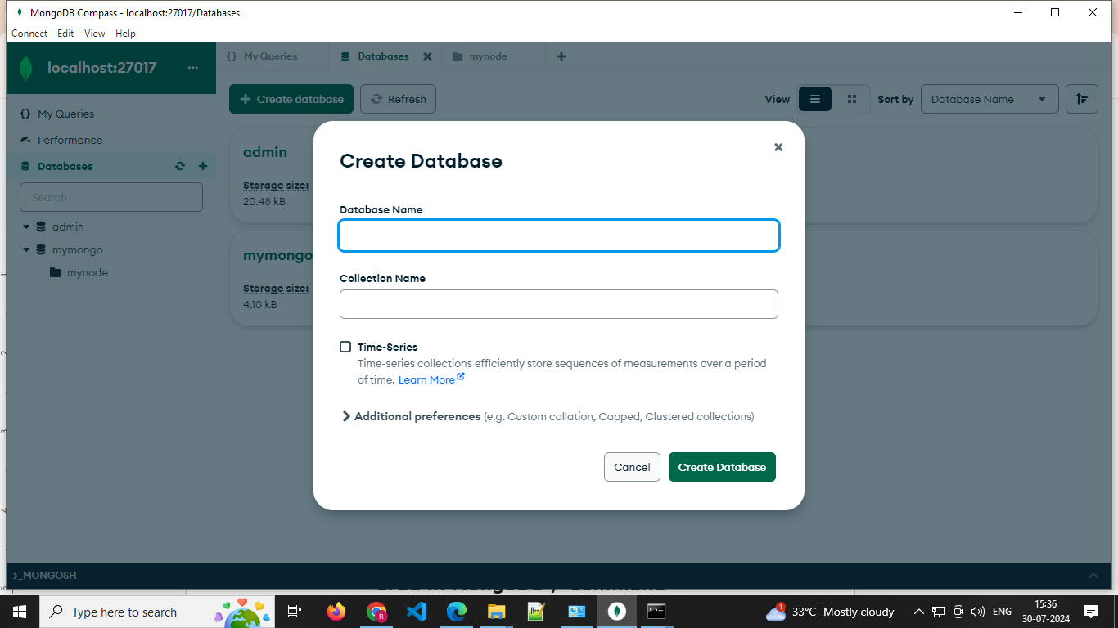

Que : Diffe between mongo & mysql
Ans 👍

Que : Mongo Path env setup
Ans:

Que Mongo gui tools
Ans: Mongodb Compass

Crud in MongoDB / Command

create a new database : use DATABASE_NAME
Show all db : show dbs

Your created database (mydb) is not present in list. To display database, you need to insert at least one document into it.
>db.movie.insert({"name":"tutorials point"})

db.dropDatabase()

Basic syntax of createCollection() command is as follows −
db.createCollection(name, options)

>db.createCollection("mycollection")

{ "ok" : 1 }

=================================================================
>show collections

In MongoDB, you don't need to create a collection. MongoDB creates a collection automatically, when you insert some document.
>db.tutorialspoint.insert({"name" : "tutorialspoint"}),
WriteResult({ "nInserted" : 1 })

Basic syntax of drop() command is as follows −
db.COLLECTION_NAME.drop()

Example : Insert

db.createCollection("post")
> db.post.insert([
{
title: "MongoDB Overview",
description: "MongoDB is no SQL database",
by: "tutorials point",
url: "http://www.tutorialspoint.com",
tags: ["mongodb", "database", "NoSQL"],
likes: 100
},
{
title: "NoSQL Database",
description: "NoSQL database doesn't have tables",
by: "tutorials point",
url: "http://www.tutorialspoint.com",
tags: ["mongodb", "database", "NoSQL"],
likes: 20,
comments: [
{
user:"user1",
message: "My first comment",
dateCreated: new Date(2013,11,10,2,35),
like: 0
}
]
}
])

The insertOne() method
db.empDetails.insertOne(
{
First_Name: "Radhika",
Last_Name: "Sharma",
Date_Of_Birth: "1995-09-26",
e_mail: "radhika_sharma.123@gmail.com",
phone: "9848022338"
})

The insertMany() method
db.empDetails.insertMany(
[
{
First_Name: "Radhika",
Last_Name: "Sharma",
Date_Of_Birth: "1995-09-26",
e_mail: "radhika_sharma.123@gmail.com",
phone: "9000012345"
},
{
First_Name: "Rachel",
Last_Name: "Christopher",
Date_Of_Birth: "1990-02-16",
e_mail: "Rachel_Christopher.123@gmail.com",
phone: "9000054321"
},
{
First_Name: "Fathima",
Last_Name: "Sheik",
Date_Of_Birth: "1990-02-16",
e_mail: "Fathima_Sheik.123@gmail.com",
phone: "9000054321"
}
]
)

The find() Method
To query data from MongoDB collection, you need to use MongoDB's find() method.
>db.COLLECTION_NAME.find() // sele * from table

The pretty() Method
To display the results in a formatted way, you can use pretty() method.

Syntax
>db.COLLECTION_NAME.find().pretty()

Find By column
db.mycol.find({<key1>:<value1>}})

AND in MongoDB
>db.mycol.find({ $and: [ {<key1>:<value1>}, { <key2>:<value2>} ] })

> db.mycol.find({$and:[{"by":"tutorials point"},{"title": "MongoDB Overview"}]}).pretty()

OR in MongoDB
>db.mycol.find({$or:[{"by":"tutorials point"},{"title": "MongoDB Overview"}]}).pretty()

Using AND and OR Together
db.mycol.find({"likes": {$gt:10}, $or: [{"by": "tutorials point"},
{"title": "MongoDB Overview"}]}).pretty()

NOR in MongoDB
db.empDetails.find(
{
$nor:[
40
{"First_Name": "Radhika"},
{"Last_Name": "Christopher"}
]
}
).pretty()

NOT in MongoDB
db.empDetails.find( { "Age": { $not: { $gt: "25" } } } )
{
"_id" : ObjectId("5dd6636870fb13eec3963bf7"),
"First_Name" : "Fathima",
"Last_Name" : "Sheik",
"Age" : "24",
"e_mail" : "Fathima_Sheik.123@gmail.com",
"phone" : "9000054321"
}

MongoDB Update() Method

Syntax
The basic syntax of update() method is as follows −
>db.COLLECTION_NAME.update(SELECTION_CRITERIA, UPDATED_DATA)

>db.mycol.update({'title':'MongoDB Overview'},{$set:{'title':'New MongoDB Tutorial'}})

>db.mycol.updateOne({'title':'MongoDB Overview'},{$set:{'title':'New MongoDB Tutorial'}})

The remove() Method
MongoDB's remove() method is used to remove a document from the collection. remove() method accepts two parameters. One is deletion criteria and second is justOne flag.
- deletion criteria − (Optional) deletion criteria according to documents will be removed.
- justOne − (Optional) if set to true or 1, then remove only one document.
Basic syntax of remove() method is as follows −
>db.COLLECTION_NAME.remove(DELLETION_CRITTERIA)
>db.mycol.remove({title:'MongoDB Overview'})
Or
>db.mycol.deleteOne({title:'MongoDB Overview'})

Remove Only One
If there are multiple records and you want to delete only the first record, then set justOne parameter in remove() method.
>db.COLLECTION_NAME.remove(DELETION_CRITERIA,1)

Remove All Documents
> db.mycol.remove({})

MongoDB Query Operators
There are many query operators that can be used to compare and reference document fields.

Comparison
The following operators can be used in queries to compare values:

- $eq: Values are equal
db.User_info.find({ age: { $eq: 21 } })
- $ne: Values are not equal
db.User_info.find({ department: { $ne: "IT" } })
- $gt: Value is greater than another value
db.User_info.find({ marks: { $gt: 80 } })
- $gte: Value is greater than or equal to another value
db.User_info.find({ age: { $gte: 22 } })
- $lt: Value is less than another value
db.User_info.find({ salary: { $lt: 25000 } })
- $lte: Value is less than or equal to another value
db.User_info.find({ marks: { $lte: 70 } })
- $in: Value is matched within an array
db.User_info.find({ city: { $in: ["Ahmedabad", "Delhi"] } })

Logical
The following operators can logically compare multiple queries.
- $and: Returns documents where both queries match
db.User_info.find({
$and: [
{ department: "IT" },
{ marks: { $gt: 80 } }
]
})
- $or: Returns documents where either query matches
db.User_info.find({
$or: [
{ department: "IT" },
{ marks: { $gt: 90 } }
]
})
- $nor: Returns documents where both queries fail to match
db.User_info.find({
$nor: [
{ department: "IT" },
{ marks: { $gt: 80 } }
]
})
- $not: Returns documents where the query does not match
db.User_info.find({
marks: { $not: { $gt: 80 } }
})

Evaluation
The following operators assist in evaluating documents.
- $regex: Allows the use of regular expressions when evaluating field values
Note : Find names starting with “U”
db.User_info.find({
name: { $regex: "^U" }
})
Note : Names ending with “a”
db.User_info.find({
name: { $regex: "a$" }
})
Note : Case-insensitive search
db.User_info.find({
name: { $regex: "rana", $options: "i" }
})
Note : Contains “sh”
db.User_info.find({
name: { $regex: "sh" }
})

- $text: Performs a text search
Step 1 : Create text index
db.User_info.createIndex({ bio: "text" })
Step 2 : Perform text search
Note : Search for "MongoDB"
db.User_info.find({
$text: { $search: "MongoDB" }
})
Note : Search multiple words
db.User_info.find({
$text: { $search: "full stack" }
})
Note : Phrase search
db.User_info.find({
$text: { $search: "\"MongoDB expert\"" }
})

- $where: Uses a JavaScript expression to match documents
Note : Department is IT and Marks is Greater than 80
db.User_info.find({
$where: "this.department == 'IT' && this.marks > 80"
})

MongoDB Update Operators
There are many update operators that can be used during document updates.

Fields
The following operators can be used to update fields:
- $currentDate: Sets the field value to the current date
Note : Add lastModified field
db.User_info.updateOne(
{ _id: 1 },
{ $currentDate: { lastModified: true } }
)
Note : Set as Timestamp
db.User_info.updateOne(
{ _id: 2 },
{ $currentDate: { lastLogin: { $type: "timestamp" } } }
)
- $inc: Increments the field value
Increase marks by 5
db.User_info.updateOne(
{ _id: 1 },
{ $inc: { marks: 5 } }
)
Decrease salary by 2000
db.User_info.updateOne(
{ _id: 3 },
{ $inc: { salary: -2000 } }
)
Note : Increment multiple fields
db.User_info.updateOne(
{ _id: 4 },
{ $inc: { marks: 2, salary: 1000 } }
)
- $rename: Renames the field
db.User_info.updateMany(
{},
{ $rename: { "marks": "totalMarks" } }
)
- $set: Sets the value of a field
Note : Update department
db.User_info.updateOne(
{ _id: 5 },
{ $set: { department: "IT" } }
)
Note : Add new field grade
db.User_info.updateOne(
{ _id: 2 },
{ $set: { grade: "A" } })
Note : Update multiple fields
db.User_info.updateOne(
{ _id: 6 },
{
$set: {
city: "Bangalore",
isActive: false
}
}
)
- $unset: Removes the field from the document
db.User_info.updateOne(
{ _id: 3 },
{ $unset: { salary: "" } }
)

Array
The following operators assist with updating arrays.
- $addToSet: Adds distinct elements to an array
db.User_info.updateOne(
{ _id: 1 },
{ $addToSet: { skills: "Express" } }
)
Note : Add multiple values
db.User_info.updateOne(
{ _id: 1 },
{ $addToSet: { skills: { $each: ["HTML", "CSS"] } } })
- $pop: Removes the first or last element of an array

Value | Action
1 | Remove last element
-1 | Remove first element

Note : Remove last element
db.User_info.updateOne(
{ _id: 1 },
{ $pop: { skills: 1 } }
)
Note : Remove first element
db.User_info.updateOne(
{ _id: 1 },
{ $pop: { skills: -1 } }
)
- $pull: Removes all elements from an array that match the query
Note : Remove specific value
dbUser_info.updateOne(
{ _id: 1 },
{ $pull: { skills: "React" } }
)
Note : Remove multiple values
db.User_info.updateOne(
{ _id: 1 },
{ $pull: { skills: { $in: ["HTML", "CSS"] } } })
- $push: Adds an element to an array
Note : push specific element
db.User_info.updateOne(
{ _id: 1 },
{ $push: { skills: "TypeScript" } }
)
Note : push multiple elements
db.User_info.updateOne(
{ _id: 1 },
{ $push: { skills: { $each: ["Docker", "Kubernetes"] } } }
)

