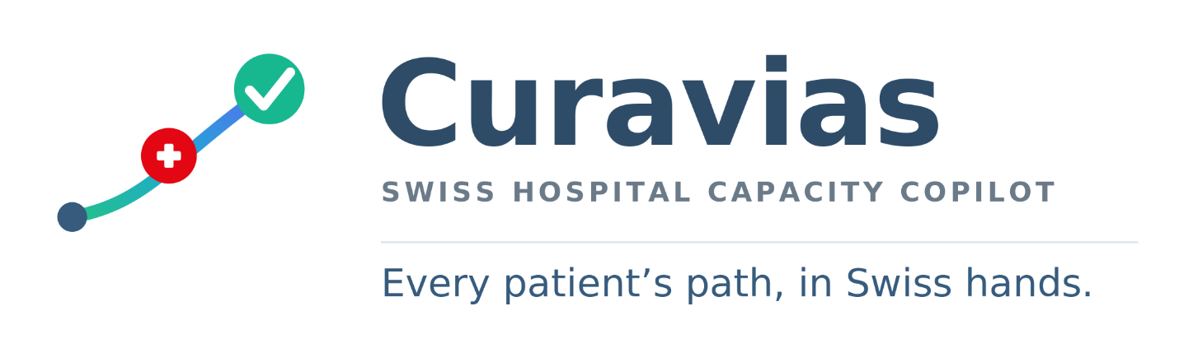

Curavias
  - Swiss Hospital Capacity Copilot
Every patient’s path, in Swiss hands.
Brand Guidelines
Brand Kit v2 — Green Primary
Prepared by Urs Rüegg
10 July 2026

Table of Contents
Curavias — Brand Guidelines (Brand Kit v2) 1
1. Vision & Mission 1
2. The Idea Behind the Mark 2
3. Logo System 2
4. Colour System (Fluent UI conformant) 2
5. Typography 3
6. Legal & Clearance Notes 3
7. Kit Contents 4

Curavias — Brand Guidelines (Brand Kit v2)

Swiss Hospital Capacity Copilot — the official brand kit for solution branding
Field | Value
Product name | Curavias
Meaning | cura (care) + via (path) = “the care pathway”
Domain | curavias.ch
Descriptor | Swiss Hospital Capacity Copilot
Tagline | Every patient’s path, in Swiss hands.
Powered by | Microsoft
Version | Brand Kit v2 (green-primary)

1. Vision & Mission
Vision (North Star). A Switzerland where every hospital steers all of its capacity — beds, operating rooms, staff, rooms and equipment — as one intelligent, real-time system. Where every patient reaches the right place at the right time, clinicians are freed from firefighting, and hospitals can foresee and rehearse tomorrow’s pressure before it arrives — from a single ward to the whole canton.
Mission. Curavias gives Swiss hospitals one trustworthy AI Hospital Command Center for capacity — an ontology-grounded copilot and what-if simulation platform that forecasts demand, coordinates discharge, steers beds, OR, staff, rooms and equipment, and rehearses crises — with Swiss data residency, grounded and auditable AI, and Swiss precision.

2. The Idea Behind the Mark
Curavias means “the care pathway.” The icon shows a three-step patient journey rising to success:
Start (entry into care) → Care (the Swiss/medical cross) → Success (a green check — the patient made well).
This is the platform’s whole purpose in one glyph: moving every patient along a clear pathway to a successful outcome. Swissness comes from the diagonal white / federal-blue split and the Swiss cross (à la MeteoSwiss).

3. Logo System
Asset | File | Use
App icon | icon/curavias-icon.svg | App tile, PWA, store listings (Swiss cross + journey)
Standalone symbol | logo/curavias-symbol.svg | Avatars, favicons-in-context, watermarks
Horizontal logo | logo/curavias-logo.svg | Default logo (symbol + wordmark + descriptor)
Logo with tagline | logo/curavias-logo-tagline.svg | Hero, cover, presentations
Favicons / app tiles | icon/favicons/curavias-{16…1024}.png | Browser/app icons
Usage. Keep clear space around the logo (≥ the height of the symbol’s success node). Place on white or very light backgrounds. Don’t recolour the journey nodes, stretch/skew the mark, or crowd it. SVG is the scalable master; PNG are previews. For production, convert the wordmark to outlines.

4. Colour System (Fluent UI conformant)
Primary = Success Green #17B890 (the journey’s success). Secondary = Curavias Blue #365B7D (the icon panel and wordmark). Full 16-step ramps, Fluent v9 tokens, Power BI theme and the accessibility model are in color/Curavias-Fluent-Color-System.md and shipped as code in color/.
Role | HEX | Notes
Primary — Green | #17B890 | Primary buttons, active/selected, success — always dark text on green
Secondary — Blue | #365B7D | Nav, headers, white-text CTAs, wordmark
Danger — Swiss Red | #E30613 | Error/critical only (also the logo care-cross)
Warning — Amber | #E8A200 | Warnings (added for completeness)
Info — Teal | #1FA9D6 | Informational chips/tips
Accent — Violet | #5A6CF0 | Decorative / data-viz
Text — Ink / Slate | #2E4C68 / #6B7A88 | Primary / secondary text
Critical accessibility rule: green #17B890 is bright — white text on it fails WCAG AA (2.5:1). Use dark text on green (7.6:1 AAA); use blue for any solid white-text button. Green links on white use the darker brand[50]. This is pre-wired in color/curavias-theme.ts.
Colour deliverables in color/: curavias-theme.ts (Fluent v9 theme), curavias-tokens.json, curavias-tokens.css, curavias-powerbi-theme.json, curavias-color-swatches.png.

5. Typography
- Wordmark & headings: Segoe UI Bold (Microsoft’s brand typeface). Fallbacks: Helvetica Neue, Arial.
- Descriptor: Segoe UI Semibold, uppercase, letter-spaced.
- Body / UI: Segoe UI (Fluent default).

6. Legal & Clearance Notes
- Swiss coat of arms. Use the Swiss cross / flag (as in the assets), not the federal shield — the shield is reserved for the Confederation. Ensure the brand is not misleading as to official origin; obtain legal review before public release.
- Name / domain. curavias.ch is registered; complete trademark clearance (CH/EU, healthcare-IT & software classes) before production use.
- Microsoft / Copilot. The mark is original (inspired by, not copied from, Microsoft assets). Use of “Copilot” and “Powered by Microsoft” follows Microsoft brand & partner guidelines.

7. Kit Contents
brandkitv2/
├─ Curavias-Brand-Guidelines.(md|docx) ← this document
├─ README.(md|docx) ← quick index
├─ logo/ curavias-logo, -logo-tagline, -symbol (.svg + .png)
├─ icon/ curavias-icon (.svg + .png) + favicons/ (16–1024 px)
└─ color/ curavias-theme.ts, -tokens.json, -tokens.css,
curavias-powerbi-theme.json, curavias-color-swatches.png,
Curavias-Fluent-Color-System.(md|docx)
Brand Kit v2 supersedes the earlier “Helvion” concept and the C-series icon explorations (kept under ../branding/ for reference only).

